Arrival (2016): Extraterrestrial Communication as a Model for Advanced NLP Challenges

Yoana Cook - W215913890@student.hccs.edu
Rida Kashan - W217447825@student.hccs.edu
Francisco Medina- W211144006@student.hccs.edu
Richard Rodriguez - W1428896@student.hccs.edu.


Department of Computer Science, Houston City College

Deep Learning Artificial Intel-14405 ITAI-2376
Prof. Patricia McManus
02.11.2026

Introduction: First Contact as a Computational Linguistics Problem
Arrival’s treatment of first contact is approached as a linguistics problem rather than dramatic set piece. Throughout the film Dr. Louise Banks tries to learn the Heptapod language in a way that invalidates nearly every assumption about language we make in NLP. She has no shared vocabulary, culture, or even phonology to anchor her understanding of meaning. In some sense she’s working with the raw language induction problem: without labels, priors to work off of, or even the guarantee that human notions of grammar apply.
Essentially Louise is learning language from absolute scratch and those in charge don’t see the merit in her methods.
Why is this scenario so interesting? Because Louise isn’t simply translating, she’s learning to communicate. This means contending with everything from grounding individual symbols to learning grammar from scratch. The film cleverly uses Louise’s struggle as a kind of worst‑case scenario NLP problem. She illustrates weaknesses in our approach to semantic grounding, intent inference, tokenization, and sequential assumptions.
Let’s take a look at the Heptapod language through a computational lens.

Structural Properties of Heptapod Language
The Heptapod language system is iconic for a reason. Non‑linear, holistically written, and completely foreign. Reading Heptapod works isn’t phonetic or processed left-to-right, each circular glyph maps to an entire proposition at once.
Applied to NLP this blows up every model we know. Autoregressive models like Transformers and RNNs expect sequential input. Tokenization itself doesn’t make sense in a language without discreet tokens, or orders.
For all intents and purposes the computational analogue of the Heptapod writing system is a semantic graph or even hypergraph.
Humans don’t read sentences, they read meanings mapped onto a structural semantic framework.
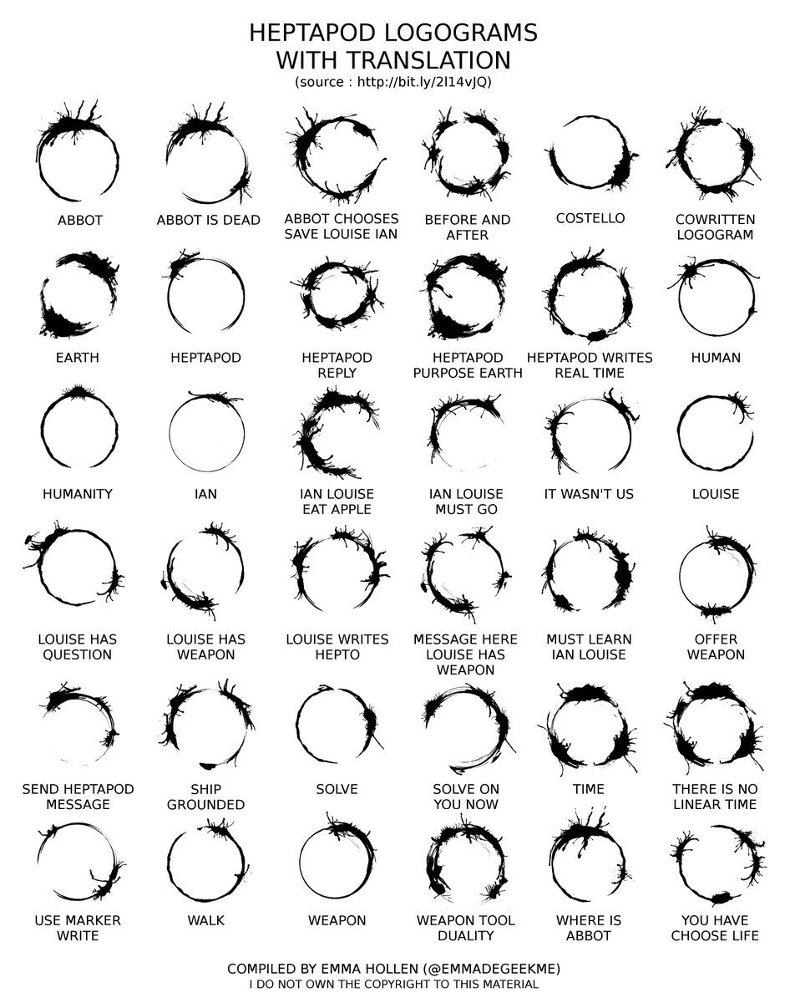

Symbol Grounding and Multimodal Alignment
A large part of Louise’s success can be attributed to how she begins grounding individual symbols with the Heptapods. Pointing, gesturing, and otherwise creating associations that can be used as an input basis.
This is symbol‑grounding problem applied to learning a language. Models like CLIP show us the power of aligning two modalities (text & images), but Louise takes it one step further by interacting with another species to align their language with reality.
It’s easy to gloss over this when training on web text, but there’s something powerful about Louise’s ability to test hypotheses and experiment with communication like this.
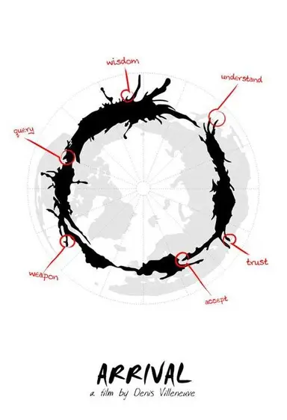

Lexical Ambiguity and Semantic Underspecification
The movie hinges around the translation of a word that was later understood to mean something totally different. Turns out that mysterious symbol the Heptapods kept using when the negotiators were kidnapped meant gift and not weapon as Louise translated it.
Ambiguity is a hard problem in NLP. Words rarely have one specific meaning; they generally have many and use context to disambiguate. You could even make the argument that state of the art language models with access to plenty of context still don’t have common‑sense knowledge we take for granted. They can be monumentally confused when sociological nuances are the key bit of missing context.
Miscommunication is dangerous, especially when intent isn’t clear.

Failure of Sequential Tokenization Assumptions
Heptapod writing challenges the idea of “tokens” altogether. Since it has no word order, no syntactic separators, and doesn’t use symbols that could be called tokens we are left with only one option:
Heptapod writing resembles a graph more than any sequence. Nodes encapsulate semantic roles and edges define relationships between concepts. It forces us to think about language understanding from the perspective of graphs and semantic networks rather than text sequences.

Pragmatics, Intent, and Sociocultural Modeling
Much of Arrival deals with the idea that meaning is derived not from pure symbolic communication, but from intent behind the symbols. We misunderstand the Heptapods throughout the film not because we can’t decode their message, but because we fail to comprehend the reason for their communication.
Pragmatics are a hard problem for AI. NLP systems don’t (yet) understand theory‑of‑mind, social intent, or cultural nuance the way humans do. Language doesn’t exist in a vacuum, it’s a social process of communication built on shared frames of reference and assumptions.
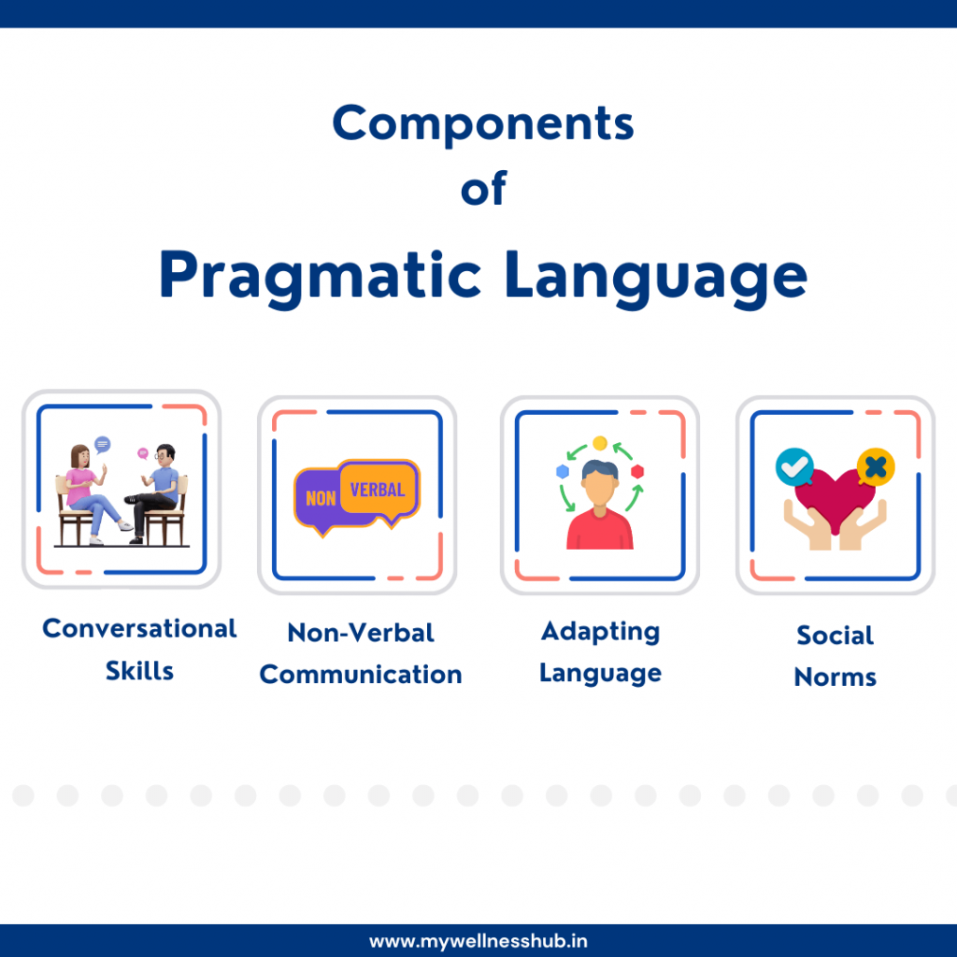

Distributional Learning and Corpus Construction
To an extent Louise creates her own training corpus when learning Heptapod language, but it isn’t passive. Rather than sitting and watching every piece of Heptapod writing she can, she engineers the experience by setting up scenes and asking questions.
It’s active learning applied to first contact. Louise is essentially searching for the data she needs, rather than allowing it to find her.
This lets her do rudimentary distributional semantic analysis, sure. But she’s also showing us the limits of distributional learning. Co‑occurrence patterns can help you guess at a word’s meaning, but without grounding that interactive element you’ll never truly understand it.
Implicit in her approach is that building a corpus isn’t passive, humans play an active role in deciding what data matters.

Cognitive Transformation and Representation Learning
Of course, none of this is reality, and that allows Arrival to take liberties with how learning the heptapod language restructures Louise’s cognition. Just as our models behavior is shaped by their internal representations of the world, so too does she start experiencing time non‑linearly.
Embodied experience shapes how we reason, and in the world of Arrival this extends to language as well.

Implications for NLP Research
So where do we go from here? The ideas presented in Arrival are already roads being explored in NLP research.
• Building world models for grounded multimodal representation learning.
• Developing graph‑structured semantic representations.
• Integrating pragmatic and sociocultural intent into NLP systems.
Language Models don’t have world models, or a representation of agent intent. As a result we’re seeing pushes into Embodied AI, Social AI, and Neuro-symbolic AI research. Arrival posits that true language understanding requires AI systems that can reason about the world, the speaker, and reason about why they are saying something.

Conclusion
Arrival pushes us to see language as more than mapping symbols to meanings, or even labels. Language learning isn’t passive, nor is communication. Louise Banks demonstrates time and again you can’t understand a language without grounding, context, and intersubjective meaning. You can decode the symbols but without pragmatic and sociocultural insight you aren’t really communicating.
The Heptapod language challenges nearly every idea about how we process, use, learn language. From its visual presentation to the non‑linear experience of reading/hept it forces us to reconsider every heuristic built into modern NLP systems.
Arrival has the potential to be more than science fiction, but a call to action to build the next generation of NLP. Rather than building bigger datasets and larger models we should be investing resources into understanding language as it exists: as a grounded, contextual, and profoundly relational activity.

References
- Arrival. (2016). Directed by Denis Villeneuve. Paramount Pictures. Available through Houston Public Library on Hoopla: https://www.hoopladigital.com/
- Danlu Chen1, Freda Shi2, Aditi Agarwal1, Jacobo Myerston1, Taylor Berg-Kirkpatrick1, 1UC San Diego, 2University of Waterloo. “Comparing Visual and Textual Representations of Ancient Logographic Writing Systems for NLP.” LogogramNLP, 2024, logogramnlp.github.io/.
- Ceycey. “Do You Feel like a Different Person When Speaking Another Language? | by Ceycey | Medium.” Medium, 28 Apr. 2023, medium.com/@itsceycey/do-you-feel-like-a-different-person-when-speaking-another-language-8299ccec1b58.
- Leen, Michael. “Arrival (2016) Science Fiction Movie Poster.” Pinterest, 26 Jan. 2017, www.pinterest.com/pin/arrival-2016--57843176444661443/.

