Case Study: Leveraging Artificial General
Intelligence (AGI) in Transportation and Logistics

Francisco Medina
ITAI 2372: Artificial Intelligence Applications
Module 12, Assignment 12
Professor Sridhar Ganti
Houston Community College
July 2026
AI Assistance Statement: This report was researched and drafted with the assistance of Claude (Anthropic). Sources were located and verified through web research, and all claims are cited to their original reporting. The analysis, proposal, and conclusions reflect the student's own reasoning.

Introduction
Artificial General Intelligence, often shortened to AGI, describes a system that can perform most cognitive tasks at roughly the level of a typical human, rather than excelling narrowly at one job it was built and trained for. Google DeepMind’s most recent framework, published in June 2026, defines AGI specifically as a system that achieves median human-level performance across most cognitive tasks, a deliberately different bar from today’s frontier models, which the same research group says have not yet reached that threshold (“From AGI to ASI”). Every AI system in wide use today, including the ones already reshaping transportation and logistics, is narrow: built, trained, and validated for one job, and unable to reliably transfer what it has learned to a job it was not built for. This report examines what a genuinely general intelligence, one that could reason across driving, warehouse operations, and supply chain planning the way a human logistics manager moves between problems, might mean for an industry that is already investing billions in narrow automation but still struggling with the same handful of unsolved problems. This report argues that transportation and logistics’ persistent long-tail and cross-domain coordination problems both trace back to the same root cause, the narrowness of every AI system currently deployed, and that only a genuinely general reasoning layer, not another narrow tool, can close that gap.
Industry Analysis: Transportation and Logistics
Transportation and logistics already runs on narrow AI. Waymo operates paid autonomous rides across specific neighborhoods in the San Francisco Bay Area, Los Angeles, Phoenix, Austin, Atlanta, and Miami, with new service recently launched in Nashville, but every one of these deployments is geofenced to a mapped, pre-validated service area rather than open everywhere (“Where Are We with Driverless Cars”). Most consumer vehicles on the road today carry Level 2 driver assistance at most, meaning adaptive cruise control and lane-keeping that still require a human to supervise constantly (“Autonomous Vehicles 2026”). Autonomous trucking is following the same pattern of promising pilot corridors, but according to Nauto’s Stefan Heck, the technology is advancing faster than the industry’s ability to prove it is safe enough for large-scale, unsupervised deployment (“The Biggest Gap”).
The central obstacle holding narrow AI back is what researchers call the long-tail problem. The overwhelming majority of driving is routine and well represented in training data, but a small, unpredictable slice of situations, a pedestrian stepping out from behind a parked truck, a couch that fell off a moving truck, a traffic officer waving cars through a red light with hand signals, falls far outside anything a model has seen before (“Edge Cases in Autonomous Driving”). Researcher Krzysztof Czarnecki has warned that a vision-only system deployed without additional safeguards for these situations would cause real accidents, and no amount of additional training data fully closes the gap, because the scenarios genuinely cannot be enumerated in advance (“Autonomous Driving Environmental Perception”). Regulation has not kept pace either. Liability is gradually shifting from human drivers to automated driving system providers for Level 3 vehicles and above, but rules still vary sharply by state, and few frameworks yet address what happens when one company’s reasoning system operates across many regulatory jurisdictions at once (“Autonomous Vehicle Regulations”). This is also not only a driving problem. Warehouse robotics, freight routing, and supply chain forecasting each run on their own separately trained models, and none of them can reason about problems outside their own narrow domain. A routing algorithm cannot help diagnose a warehouse robotics failure, and a warehouse system has no way to reason about a new tariff disrupting the supply chain it feeds. The industry is automating one narrow task at a time rather than solving the underlying reasoning problem that connects all of them.
Table 1. Narrow AI vs. Artificial General Intelligence (AGI)
Dimension | Narrow AI (Today) | AGI (Proposed)
Task scope | One trained task (driving, routing, forecasting) | Reasons across many task domains at once
Novel scenarios | Fails or disengages outside training distribution | Reasons from general knowledge, like a human
Adapting to new domains | Requires a new model and retraining | Transfers reasoning without retraining
Current status | Deployed at scale (geofenced) | Not yet achieved by any system (“From AGI to ASI”)
Source: compiled from Morris et al. and “From AGI to ASI.”
AGI Application Proposal
AGI differs from today’s AI along exactly the dimension that keeps tripping up autonomous vehicles: generality. Google DeepMind’s 2023 Levels of AGI framework measures systems along two axes, performance and breadth of task coverage, and places today’s most capable models at an early, inconsistent stage of generalization even though they already exceed human performance on many individual tasks (Morris et al.). The framework labels progress through five stages, from “emerging” systems that show sparks of generalization but remain inconsistent, roughly where today’s large language models sit, up through “competent,” “expert,” “virtuoso,” and finally “superhuman” performance across essentially every cognitive task (Morris et al.). The company’s own 2026 follow-up work is blunter still: as of that report, no system has been publicly recognized as reaching median human-level performance across most cognitive tasks, the bar the researchers set for AGI itself (“From AGI to ASI”). The distinguishing feature that matters most for this industry is transfer: a genuinely general system would not need a separate training run for every new scenario, sub-domain, or edge case. It could draw on broad world knowledge and common-sense reasoning the way a human driver instinctively slows down for an unfamiliar hazard, without ever having seen that exact hazard before.
I propose an AGI-Orchestrated Logistics System: a single reasoning system sitting above the narrow AI tools already running trucking routes, warehouse robots, last-mile delivery, and supply chain forecasting, rather than a system that replaces any of them outright. Where today’s long-haul trucking AI, warehouse robotics, and demand-forecasting software are built, trained, and validated separately, an AGI layer would reason across all of them at once. If a highway closes unexpectedly, the same reasoning that replans a truck’s route could flag the downstream effect on a warehouse’s incoming shipment schedule and adjust customer delivery estimates in the same pass, without engineers manually wiring the three systems together for that specific scenario. On the driving side itself, the same general reasoning that lets a human driver handle a stalled car in a construction zone it has never seen before is exactly the capability that would let an AGI-based perception system respond sensibly to a genuinely novel edge case rather than defaulting to conservative disengagement.
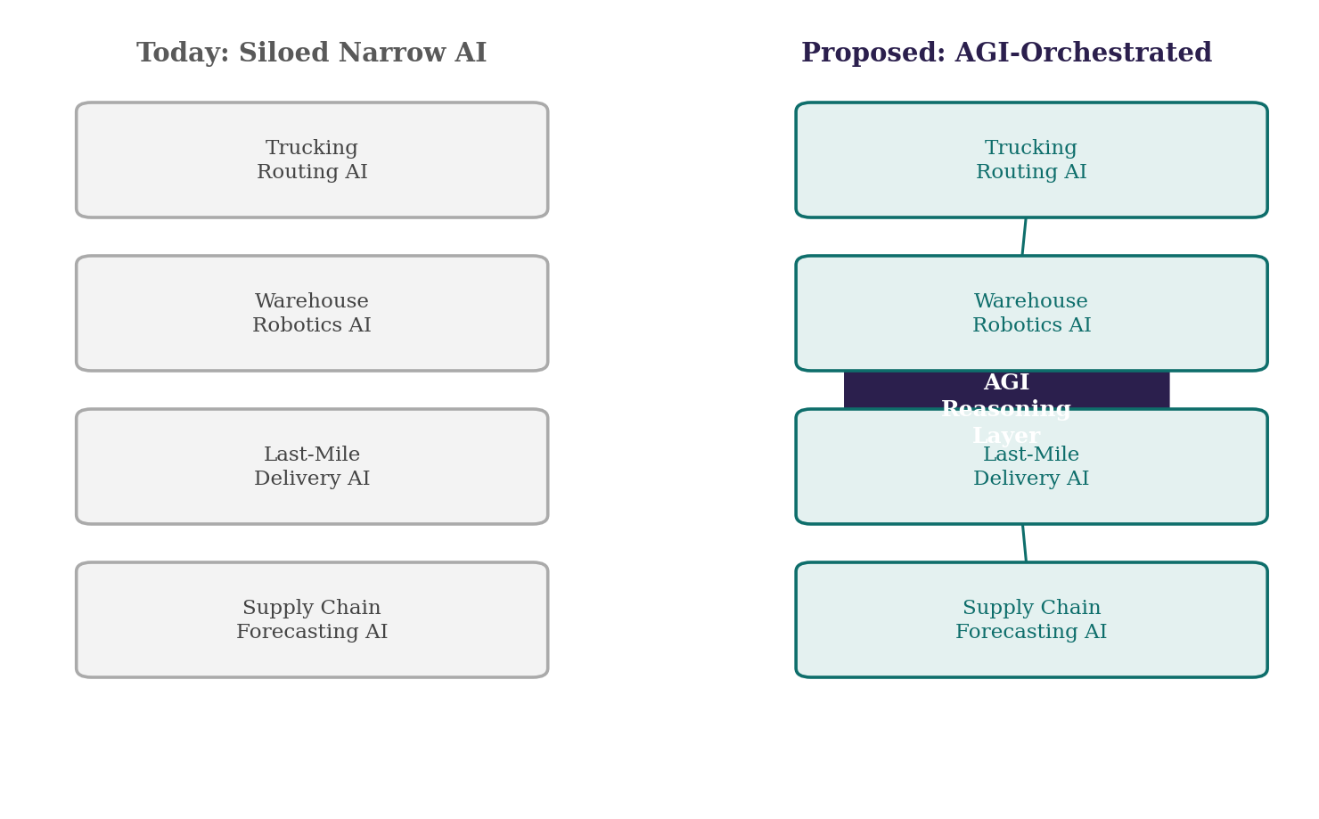
Figure 1. Today’s siloed narrow AI systems vs. a proposed AGI reasoning layer.
The clearest benefit is solving the long-tail problem at its root rather than patching around it. Instead of curating ever larger edge-case datasets and hoping the next one is covered, a system with genuine common-sense reasoning could handle scenarios it has never specifically encountered, which is the single biggest barrier keeping Level 4 and 5 autonomy geofenced to a handful of cities (“Where Are We with Driverless Cars”). The second benefit is resilience at the network level. A supply chain shock, a new tariff, a natural disaster, a factory fire, currently requires human planners and separate narrow systems to work out the downstream effects by hand. A general reasoning layer could trace those effects across trucking, warehousing, and delivery in one motion, the same way a human logistics executive reasons across a whole operation rather than one silo at a time.
The most immediate concern is workforce impact. Roughly 2.1 million heavy-duty truck drivers work in the United States today, and while widely repeated claims that automation threatens nearly all of them are overstated, a UC Berkeley Labor Center analysis puts the realistic number of long-distance driving jobs at meaningful risk of displacement at around 294,000, concentrated in the truckload, less-than-truckload, and parcel segments where the job is mostly driving with little specialized work attached (“Driverless?”). A second risk is concentration of failure. A narrow system that fails, fails in one place; a single general reasoning layer coordinating trucking, warehousing, and delivery simultaneously creates a single point of failure across the whole network if its reasoning goes wrong in a new way. This is genuinely difficult to test for in advance, since the entire premise of AGI is that it handles situations no one specifically anticipated, which means the scenarios most likely to expose a dangerous flaw are, by definition, the ones no test suite thought to include. There is also a data privacy dimension: a reasoning layer with visibility across driving, warehousing, and delivery would necessarily aggregate an unprecedented amount of operational and location data across an entire company’s logistics network, raising the stakes of any breach or misuse well beyond what any single narrow system collects today. Finally, this entire proposal depends on a technology that does not yet exist. DeepMind’s own research agenda treats making AGI behave safely as a distinct, unsolved problem sitting between defining AGI and building it, which means the safety and alignment questions have to be resolved before a system like this could responsibly coordinate anything as consequential as the freight that carries most of the country’s goods (“What Is Google DeepMind’s AGI-to-ASI Paper”).
Conclusion
Transportation and logistics is a useful test case for what AGI would actually change, because the industry’s current ceiling is not a lack of investment or ambition, it is the narrowness of every system it has built so far. Waymo’s geofenced service areas, autonomous trucking’s stalled safety validation, and the disconnected software running warehouses and supply chains all trace back to the same limitation: systems that only work inside the exact boundaries of their training. An AGI-Orchestrated Logistics System would not be a bigger version of any one of these tools; it would be the reasoning layer connecting them, capable of handling the genuinely novel the way a human professional does. That capability would also concentrate real risk, to jobs, to safety validation, and to a supply chain that would depend on a technology whose own creators say does not yet safely exist. The upside is real, but so is the reason to move carefully.

Works Cited
“Autonomous Driving Environmental Perception and Decision-Making.” Web of Proceedings, ICCEME 2025, 2025, https://webofproceedings.org/proceedings_series/ESR/ICCEME%202025/E26.pdf.
“Autonomous Vehicle Regulations: 2026 Landscapes and Adoption Timelines.” The Tech Trends, 2 May 2026, https://thetechtrends.tech/autonomous-vehicle-regulations/.
“Autonomous Vehicles 2026: Where Self-Driving Cars Stand Today.” AutoVerse USA, 8 Dec. 2025, https://autoverseusa.com/autonomous-vehicles-2026-where-self-driving-cars-stand-today/.
“Driverless? Autonomous Trucks and the Future of the American Trucker.” UC Berkeley Labor Center, 8 Apr. 2026, https://laborcenter.berkeley.edu/driverless/.
“Edge Cases in Autonomous Driving: Detection and Handling Guide.” Kognic, 17 Feb. 2026, https://www.kognic.com/articles/edge-cases-autonomous-driving.
“From AGI to ASI: Four Pathways, Six Bottlenecks, and One Truth.” HappyRock, 10 June 2026, https://www.happyrock.cloud/blog/deepmind_agi_asi/.
Morris, Meredith Ringel, et al. “Levels of AGI for Operationalizing Progress on the Path to AGI.” arXiv, 5 Jan. 2024, https://arxiv.org/html/2311.02462v2.
“The Biggest Gap in Driverless Trucking Isn’t Tech. It’s Safety Validation.” Heavy Duty Trucking, 29 May 2026, https://www.truckinginfo.com/news/the-biggest-gap-in-driverless-trucking-isnt-tech-its-safety-validation.
“What Is Google DeepMind’s AGI-to-ASI Paper? Four Pathways to Superintelligence Explained.” MindStudio, 2025, https://www.mindstudio.ai/blog/google-deepmind-agi-to-asi-paper-four-pathways-superintelligence.
“Where Are We with Driverless Cars in the U.S. (2026).” Traffic Safety Resource Center, 16 Feb. 2026, https://www.trafficsafetystore.com/blog/where-are-we-with-driverless-cars-in-the-u-s-2026/.

