Case Study: Advantages of Using AI in the
Manufacturing Industry

Francisco Medina
ITAI 2372: Artificial Intelligence Applications
Module 11, Assignment 11
Professor Sridhar Ganti
Houston Community College
July 2026
AI Assistance Statement: This report was researched and drafted with the assistance of Claude (Anthropic). Sources were located and verified through web research, and all claims are cited to their original reporting. The analysis, proposal, and conclusions reflect the student's own reasoning.

Introduction
Manufacturing is in the middle of a fast, well-documented shift toward AI-driven operations. The World Economic Forum’s Global Lighthouse Network, an initiative co-founded with McKinsey & Company that tracks the world’s most advanced production sites, has grown from 189 factories and supply chains in January 2025 to more than 238 by June 2026 (“New Global Lighthouse Sites”). Sites recognized in the most recent cohorts reported an average labor productivity increase of 40 percent and a 48 percent reduction in lead times, with AI and generative AI enabling roughly half of each site’s leading use cases (“Global Lighthouse Network 2025”).
Siemens sits on the Global Lighthouse Network’s advisory board alongside McKinsey, Schneider Electric, and Foxconn, and the company treats AI less as an experiment than as core operating infrastructure across its factory network (“New Global Lighthouse Sites”). This report examines Siemens’ Electronics Works Amberg (EWA) in Germany, one of the company’s most closely studied digital factories and a formal Harvard Business School teaching case since 2017 (Lal and Johnson). Amberg shows what AI can deliver on the factory floor at extraordinary scale. It also shows, through a recent academic study of that same plant, that the harder problem is not building the AI but getting the people running the factory to trust it. Building on both halves of that story, this report proposes an AI application aimed squarely at the trust problem. This report argues that Amberg’s central limitation is not technical accuracy but a trust gap between an AI model that predicts correctly and a workforce that cannot see why, and that Siemens’ next AI investment should be an explainability layer built around its own quality culture, not a more accurate model.
Case Study Analysis: Siemens Electronics Works Amberg
The Problem or Challenge Addressed
Siemens’ Electronics Works Amberg manufactures Simatic programmable logic controllers and related automation products, running one of the most complex production environments in the industry. The plant makes roughly 1,200 different product variants for more than 60,000 customers, handles about 350 production changeovers a day, and commits to a 24-hour lead time on new orders (“Siemens”). Amberg also operates inside an unusually demanding quality culture: lean quality management methods such as 8D root-cause analysis are, in one manager’s words, part of every employee’s daily life, and the plant has little tolerance for failure (Van Giffen et al.). That combination created a specific bottleneck. At the end of printed circuit board production, x-ray inspection of soldered joints was becoming a chokepoint, and the plant faced a choice: spend roughly €500,000 on a second x-ray machine, or find another way to verify quality at the pace production demanded (Van Giffen et al.).
AI Technologies or Tools Used
Rather than buy new hardware, Siemens engineers trained a machine learning model to predict, from existing process parameters, whether a soldered joint was likely to be fault-free without needing an x-ray scan at all (Van Giffen et al.). The model runs on Industrial Edge devices inside Siemens’ Totally Integrated Automation (TIA) environment, so predictions happen at the machine itself rather than after a round trip to the cloud, and flagged boards are still routed to full x-ray testing while cleared boards move straight through (“Siemens”). Amberg applies the same logic to predictive maintenance. When an unexplained fault kept appearing on a PCB milling spindle, engineers isolated two process parameters, including the spindle’s rotational speed, that reliably predicted the failure before it happened, letting maintenance be scheduled proactively instead of reactively (“Siemens”). These systems sit inside a much larger digital backbone: about 2,800 networked Simatic components already control production, and roughly 50 million process and product data points are evaluated every day to keep the line tuned (“Siemens”). In March 2026, Siemens announced a further €200 million expansion of the Amberg campus through 2030, adding a cleanroom production line where driverless transport systems, humanoid robots, and AI vision inspection feed defect data directly back into the plant’s digital twin (“Siemens’ €200M Amberg”).
Outcomes and Benefits Achieved
The results are difficult to match elsewhere in the industry. Amberg manufactures to a quality standard of 99.9990 percent, equivalent to roughly 11 defective components per million produced, while running about 75 percent of its value chain through machines and robots with minimal human intervention (“Siemens”; Van Giffen et al.). The plant maintains 99 percent traceability from supplier to customer and an overall equipment effectiveness score of 75 percent, a demanding measure of how much of a machine’s available time is spent making good parts at full speed (Van Giffen et al.). The x-ray prediction model alone let Siemens avoid the roughly €500,000 hardware purchase it was originally facing, while still catching the boards that genuinely needed inspection (Van Giffen et al.). At full scale, Amberg turns out about 17 million Simatic products a year, meaning by Siemens’ own account roughly one product leaves the plant every second, across more than 1,000 product variants (“Siemens”). These are not small efficiency gains bolted onto an otherwise ordinary factory; they are the kind of results that stand behind Siemens’ fiscal 2025 revenue of €78.9 billion and its ability to fund a further €200 million expansion of the Amberg site through 2030 (“Siemens’ €200M Amberg”).
Challenges or Risks Encountered
Amberg’s success comes with a well-documented catch. A 2026 study published in Information Systems Journal, based on five years of fieldwork and 29 interviews with Siemens practitioners, found that AI’s biggest obstacle at Amberg was not technical but cultural (Van Giffen et al.). Lean quality management runs on transparency: workers can trace exactly how a defect was found and why, using structured methods like 8D root-cause analysis the plant has relied on for years. AI quality models do not offer that same transparency. Workers initially hesitated to trust the new x-ray-prediction system because they could see its conclusions but not the reasoning behind them, which conflicted with a quality culture built on being able to explain every decision (Van Giffen et al.). The researchers frame this as one of three underlying paradoxes running through AI adoption in lean manufacturing: human-driven versus AI-driven decision-making, transparency versus opacity, and specification-driven versus discovery-driven approaches to quality itself (Van Giffen et al.). They also point to two organizational gaps behind the cultural one: too few people on the shop floor have the mixed data-science-and-quality-management skill set the new tools require, and plant leadership did not always communicate clearly enough to build worker buy-in before rolling AI tools out (Van Giffen et al.). None of this erased Amberg’s results, but it shows that even a highly successful AI deployment can leave a trust gap the technology itself does not close.
Not every manufacturer has managed that gap as carefully. In 2018, Tesla CEO Elon Musk publicly admitted that the company had gone too far automating production of the Model 3 sedan, tweeting that excessive automation at Tesla was his own mistake and that humans are underrated (“Elon Musk Says”). The factory had built an elaborate robotic conveyor system for final assembly that could not reliably handle the small variations of real production, and Tesla eventually tore it out and brought human workers back onto the line (“Elon Musk Says”). Business analysts studying the episode later concluded that Tesla had overestimated what automation could do and underestimated how well humans adapt to the unpredictable, physical realities of a factory floor (“Tesla’s Problem”). Amberg never chased that same finish line. The plant holds automation at roughly 75 percent of its value chain rather than pushing toward 100 percent, deliberately keeping people in the loop on the quality decisions its culture still requires them to trust (“Siemens”; Van Giffen et al.). The contrast suggests Amberg’s advantage came less from how much it automated than from how carefully it calibrated automation to what its people and its process could actually support.
Table 1. Siemens Electronics Works Amberg at a Glance
Metric | Figure
Quality standard | 99.9990% (about 11 defects per million)
Overall equipment effectiveness (OEE) | 75%
Value chain run by machines/robots | ~75%
Product variants manufactured | ~1,200
Production changeovers per day | ~350
Annual output | ~17 million Simatic products/year
Supply chain traceability | 99%
Capital cost avoided (x-ray AI model) | ~€500,000
2026 campus expansion (through 2030) | €200 million
Source: compiled from “Siemens” (Siemens Global), Van Giffen et al., and “Siemens’ €200M Amberg Smart Factory.”
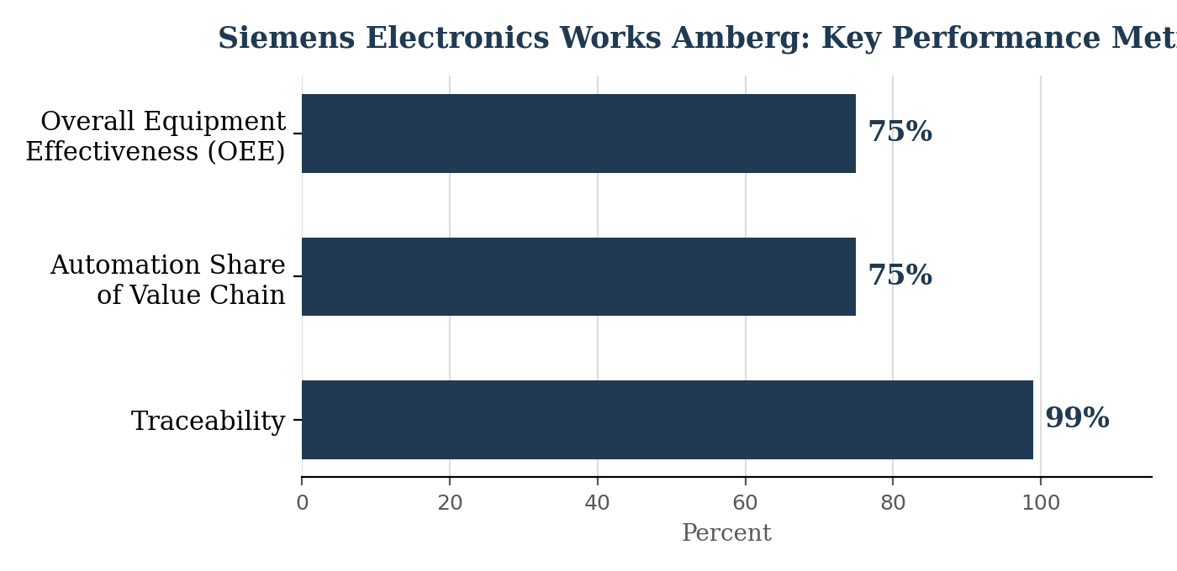
Figure 1. Traceability, automation share, and OEE at Amberg, visualized from Table 1.
Proposal for Innovation: An 8D-Aligned Explainable AI Quality Assistant
Proposed Application
Amberg’s own case study points to exactly where the next investment should go. If the core problem is that AI’s predictions are accurate but unexplained, then the next AI application should not be a better predictor, it should be a better explainer. I propose an 8D-Aligned Explainable AI Quality Assistant (EQA): a layer added on top of existing AI quality-prediction models, like the x-ray and milling-spindle systems already running at Amberg, that translates each prediction into the plant’s own lean vocabulary instead of a bare pass or fail score. Rather than telling a quality engineer only that a board is likely to fail, the EQA would use feature-attribution techniques to identify which process parameters most influenced that prediction, then map those parameters onto the plant’s existing 8D root-cause categories, the same framework quality teams already use to investigate defects manually. A flagged board would arrive with a short, structured explanation, such as a note that it was flagged primarily due to solder temperature variance consistent with a process-parameter-drift 8D category, rather than an unexplained probability score. The goal is not to replace the model Amberg already trusts for its predictions, but to give the humans supervising it a reason to trust it too.
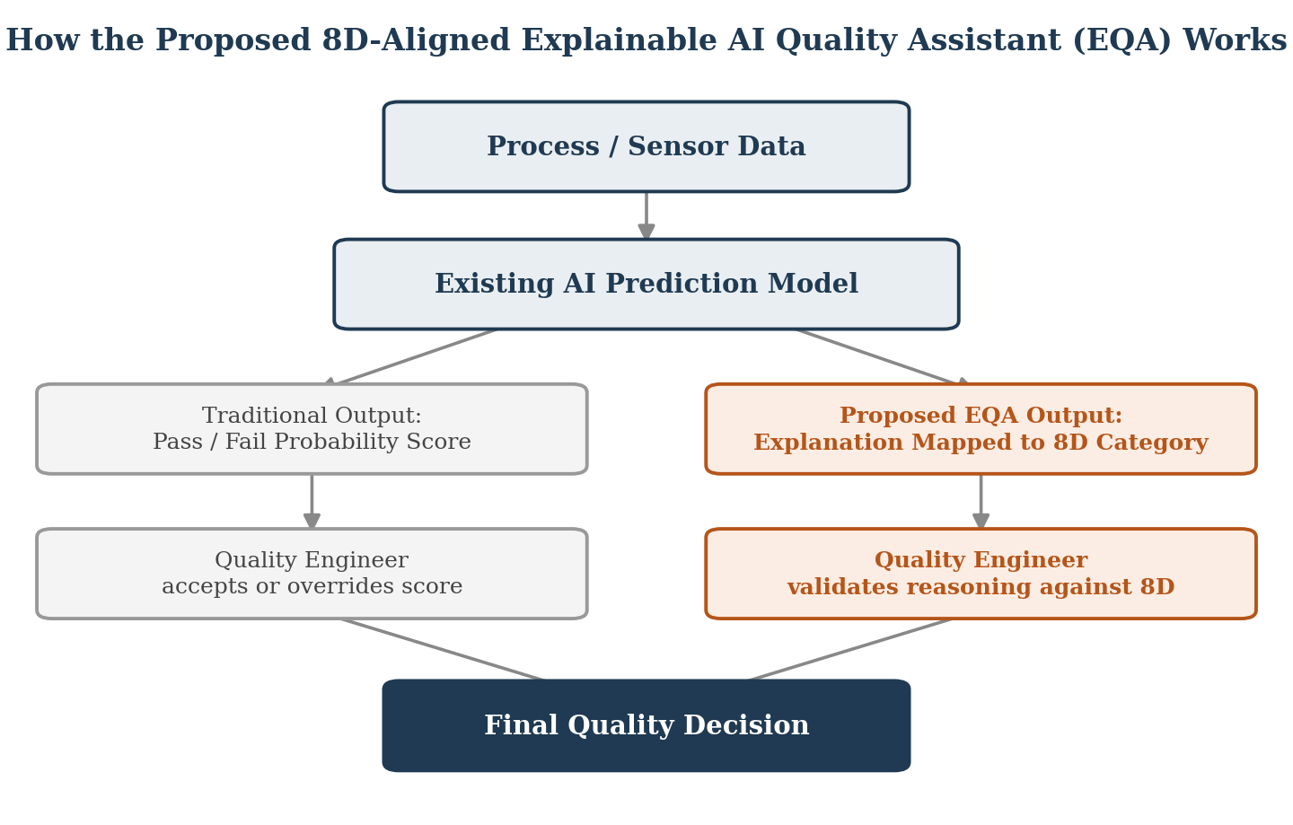
Figure 2. The same prediction model, routed through two different outputs.
Justification and Anticipated Benefits
This is not a purely hypothetical fix. The Information Systems Journal study that documented Amberg’s trust gap explicitly frames the transparency-versus-opacity tension as one of the central paradoxes standing in the way of AI adoption in lean manufacturing, which means closing that specific gap addresses the paradox the researchers themselves identified rather than a generic complaint about AI (Van Giffen et al.). Siemens is also already positioned to support the human side of this change. Separate Siemens research on workforce reskilling and digital learning describes how the company invests in people-centric training to help its workforce adapt to new digital tools, treating technology adoption as a learning process rather than a one-time rollout (“Siemens, People Centricity”). An Explainable AI Quality Assistant would give that existing training infrastructure something concrete to teach: not just how to read an AI alert, but how to map it onto the 8D method quality engineers already know well. If it works as intended, the expected payoff is faster adoption of future AI tools across Siemens’ wider factory network, since each new model would arrive already speaking the plant’s own quality language instead of asking workers to learn to trust a black box from scratch.
Anticipated Challenges
The proposal has real limits. Feature-attribution methods can themselves be misleading, producing an explanation that sounds plausible but does not actually reflect how the underlying model reached its conclusion, which risks manufacturing false confidence rather than genuine trust. Building and validating explanations that map cleanly onto 8D categories would also require the same blend of data science and quality management expertise that the original study found was already in short supply on Amberg’s shop floor (Van Giffen et al.). There is a training cost too: quality engineers would need to learn a new interface on top of the 8D process they already know, and that only pays off if leadership frames it as a skill worth having rather than one more mandatory rollout. None of these problems are disqualifying, but they mean the technical fix and the cultural fix have to be built together, not one after the other.
Table 2. Traditional AI Alert vs. Proposed 8D-Aligned EQA
Feature | Traditional AI Alert | Proposed 8D-Aligned EQA
Output | Pass/fail probability score | Structured explanation mapped to an 8D category
Basis for trust | Model accuracy alone | Model accuracy plus human-readable reasoning
Skill required to use | Statistical literacy | Familiarity with the 8D framework already used on the floor
Role of quality engineer | Accepts or overrides a score | Validates reasoning against known root-cause categories
Conclusion
Siemens’ Electronics Works Amberg shows what AI can achieve on a factory floor operating at extraordinary scale and precision: a defect rate near zero, a workforce spared a costly hardware purchase, and a plant confident enough in its own results to justify a further €200 million expansion. It also shows, through the researchers who spent five years studying that same plant, that AI’s hardest problem in manufacturing is rarely the algorithm itself. It is convincing the people running the line that an unexplainable prediction deserves the same trust as a method they can walk through step by step. An Explainable AI Quality Assistant built around Amberg’s own 8D framework would not solve every challenge AI raises for lean manufacturing, but it would target the specific one Siemens’ own case study identified: the gap between a model that works and a workforce that believes it.

Works Cited
“Elon Musk Says ‘Humans Are Underrated,’ Calls Tesla’s ‘Excessive Automation’ a ‘Mistake.’” TechCrunch, 13 Apr. 2018, https://techcrunch.com/2018/04/13/elon-musk-says-humans-are-underrated-calls-teslas-excessive-automation-a-mistake/.
“Global Lighthouse Network 2025: World Economic Forum Recognizes 12 New Sites Driving Holistic Transformation in Manufacturing.” World Economic Forum, 16 Sept. 2025, https://www.weforum.org/press/2025/09/global-lighthouse-network-2025-world-economic-forum-recognizes-12-new-sites-driving-holistic-transformation-in-manufacturing/.
Lal, Rajiv, and Scott F. Johnson. “The Digital Factory – Siemens: Electronic Works Amberg.” Harvard Business School, Case 518-054, Nov. 2017, https://www.hbs.edu/faculty/Pages/item.aspx?num=53442.
“New Global Lighthouse Sites Demonstrate How AI Is Rewiring Manufacturing and Supply Chains.” World Economic Forum, 22 June 2026, https://www.weforum.org/press/2026/06/new-global-lighthouse-sites-demonstrate-how-ai-is-rewiring-manufacturing-and-supply-chains/.
“Siemens, People Centricity and CRISP Manufacturing.” The Future Factory, 18 Nov. 2025, https://www.thefuturefactory.com/insights/siemens-people-centricity-crisp-manufacturing.
Siemens. “Future Technologies Are Contributing to the Success of the Siemens Electronics Works Amberg.” 31 July 2025, https://www.siemens.com/global/en/company/stories/industry/electronics-digitalenterprise-futuretechnologies.html.
“Siemens’ €200M Amberg Smart Factory: AI, Robots and Digital.” SCI.AI, 4 Mar. 2026, https://news.yrules.com/en/archives/5281.
“Tesla’s Problem: Overestimating Automation, Underestimating Humans.” IMD, 16 Oct. 2025, https://www.imd.org/research-knowledge/strategy/articles/teslas-problem-overestimating-automation-underestimating-humans/.
Van Giffen, Benjamin, et al. “The Culture Clash of AI Adoption in Lean Quality Management. Resolving the Tensions at Siemens Electronics Works Amberg.” Information Systems Journal, vol. 36, no. 3, 2026, pp. 315-339, https://doi.org/10.1111/isj.70006.

