****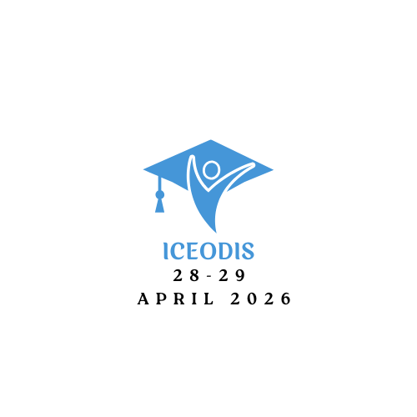

**ICEODIS 2026**

**THE 1st OF THE INTERNATIONAL**

**CONFERENCE ON ELECTRONIC, OPTICAL DEVICES**

**AND INTELLIGENT SYSTEMS**

**April 28-29, 2026 - Taza - Morocco**

L S I

Title: International Conference on Electronic, Optical Devices and Intelligent Systems

First Author1* , Second Author2 , Third Author3,ect

1* Laboratory of Engineering Sciences, USMBA, Fez, Morocco.

2 Laboratory of Engineering Sciences, USMBA, Fez, Morocco.

3 Laboratory of Engineering Sciences, USMBA, Fez, Morocco.

Corresponding_[author@usmba.ac.ma](mailto:author@usmba.ac.ma)

**Abstract**

The abstract must be concise **(one page maximum, format A4)**, written in clear English with proper grammar and spelling. It should include approximately 4 to 5 cited references within the text [1]. Authors are strongly advised to thoroughly verify their abstracts, particularly author names and affiliations, before submission to prevent last-minute corrections [2]. ICEODIS 2026 will reject abstracts that are not in English or fail to meet basic scientific standards [3]. The conference’s official language is English; no simultaneous interpretation will be provided [4]. Authors must therefore be prepared to present their work in English during the conference [5].

**Keywords:** First Keyword, Second Keyword, Third Keyword, Forth Keyword.

**References**

1. Author F (2025) Article title. Journal 2(5) : 99–110.
2. Author F, Author S (2025) Title of a proceedings paper. In: Editor F, Editor S (eds.) Proceedings Title, pp. 1–13. Springer, Heidelberg.
3. Author F, Author S, Author T (2025) Book title. 2nd edn. Publisher, Location.
4. Author F (2025) Contribution title. In: 9th International Proceedings on Proceedings, pp. 1–2. Publisher, Location.
5. LNCS Homepage, <http://www.springer.com/lncs>, last accessed 2025/01/08.