**SCREENSHOT OF SUCCESSFUL DATA LOAD**

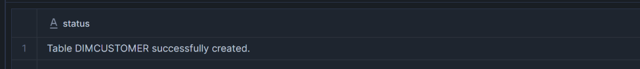

------------------------------------------------------------------------------------------------------------------------

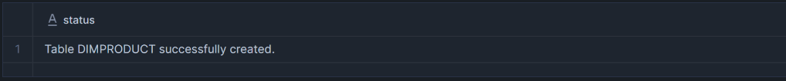

\

------------------------------------------------------------------------------------------------------------------------



------------------------------------------------------------------------------------------------------------------------

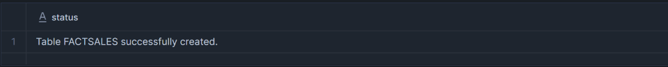

------------------------------------------------------------------------------------------------------------------------



------------------------------------------------------------------------------------------------------------------------

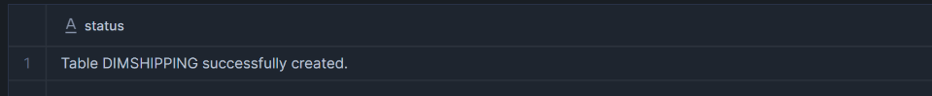

**ER Diagram showing table relationships**

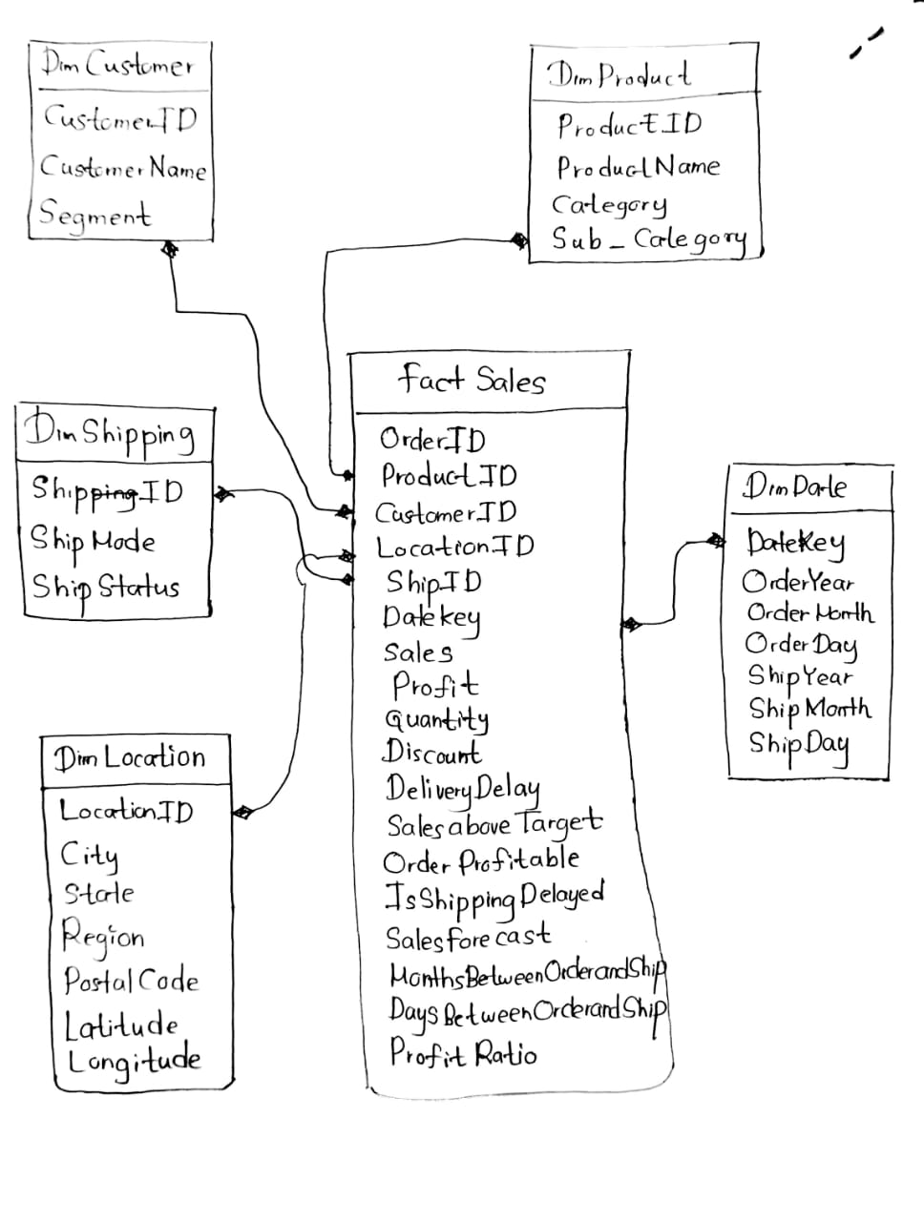

We selected a Star Schema for our data warehouse design because it is ideal for analytical workloads and business intelligence reporting. The star schema consists of a central FactSales table surrounded by dimension tables such as DimCustomer, DimProduct, DimShipping, DimLocation, and DimDate.

* Simplicity: Easy to understand and implement, especially for reporting users.
* Performance: Supports fast queries and aggregations due to fewer joins and denormalized dimensions.
* Scalability: Can handle large volumes of transactional data efficiently.
* Analytical Flexibility: Enables slicing and dicing of data across different business dimensions (e.g., customer segment, shipping method, geography, time, etc.).

**SQL SCRIPTS**

USE DATABASE ASSIGNMENT;

USE SCHEMA STARSCHEMA;

-- Create Dimension Tables

CREATE OR REPLACE TABLE DimCustomer (

CustomerID STRING PRIMARY KEY,

CustomerName STRING,

Segment STRING

);

SELECT * FROM DIMCUSTOMER;

CREATE OR REPLACE TABLE DimProduct (

ProductID STRING PRIMARY KEY,

ProductName STRING,

Category STRING,

Sub_Category STRING

);

SELECT * FROM DIMPRODUCT;

CREATE OR REPLACE TABLE DimShipping (

ShipID INT PRIMARY KEY,

ShipMode STRING,

ShipStatus STRING

);

SELECT * FROM DIMSHIPPING;

CREATE OR REPLACE TABLE DimLocation (

LocationID STRING PRIMARY KEY,

City STRING,

State STRING,

Region STRING,

PostalCode STRING,

Latitude FLOAT,

Longitude FLOAT

);

SELECT * FROM DIMLOCATION;

CREATE OR REPLACE TABLE DimDate (

DateKey DATE PRIMARY KEY,

OrderYear INT,

OrderMonth INT,

OrderDay INT,

ShipYear INT,

ShipMonth INT,

ShipDay INT

);

SELECT * FROM DimDate;

-- Create Fact Table

CREATE OR REPLACE TABLE FactSales (

OrderID STRING,

ProductID STRING,

CustomerID STRING,

LocationID STRING,

DateKey DATE,

Sales FLOAT,

ShipID INT,

Profit FLOAT,

Quantity INT,

Discount FLOAT,

IsShippingDelay Boolean,

SalesaboveTarget FLOAT,

OrderProfitable BOOLEAN,

IsShippingDelayed BOOLEAN,

SalesForecast INT,

MonthsBetweenOrderAndShip INT,

DaysBetweenOrderAndShip INT,

ProfitRatio FLOAT,

FOREIGN KEY (CustomerID) REFERENCES DimCustomer(CustomerID),

FOREIGN KEY (ProductID) REFERENCES DimProduct(ProductID),

FOREIGN KEY (LocationID) REFERENCES DimLocation(LocationID),

FOREIGN KEY (ShipID) REFERENCES DimShipping(ShipID),

FOREIGN KEY (DateKey) REFERENCES DimDate(DateKey)

);

SELECT * FROM FactSales;

**SUCCESSFULLY CONNECTED SNOWFLAKE AND NOTEBOOK TO PULL DATA**

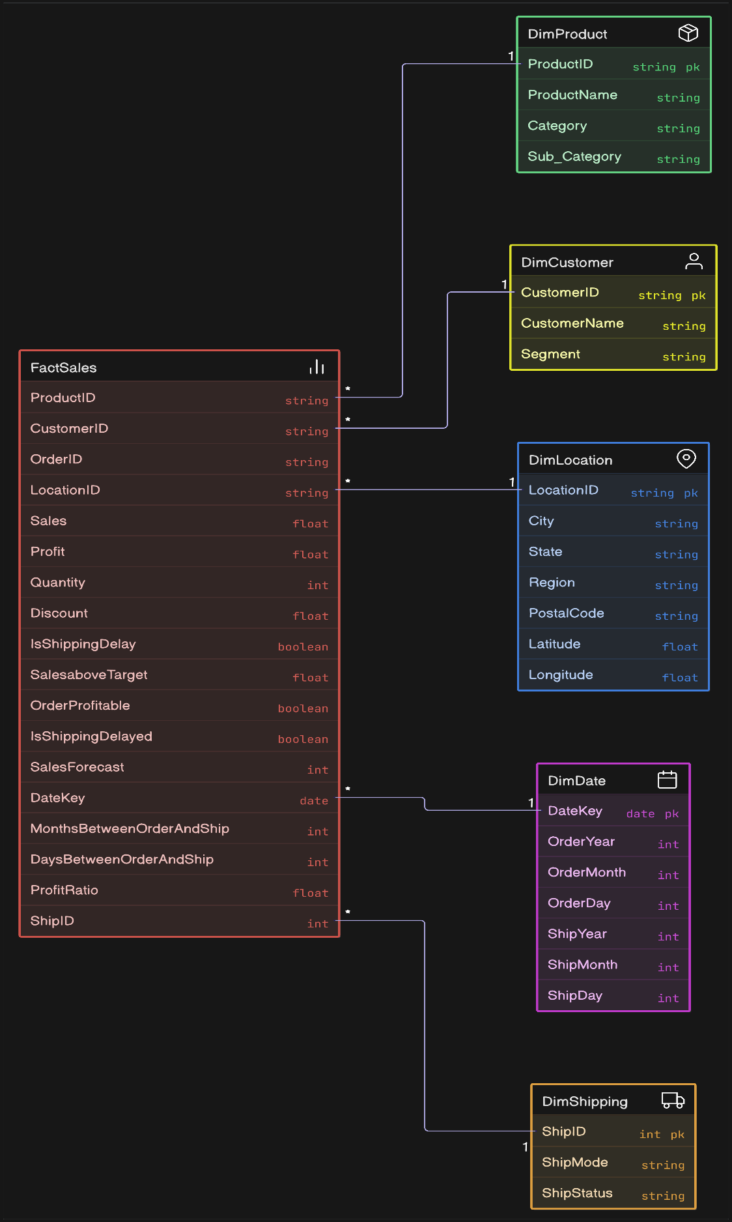**ER DIAGRAM SHOWING TABLE RELATIONSHIPS**

**POWER BI**

**Modeling data in POWER BI**

