Paper Title: 0 - Sample paper title
P1: Sample question.
Answer:
Sample answer.

P 2: Sample_Looooooooooooooooooooooooooooooooooooooooooooooooooooonooooooooooooooooooooooooooooooooooooooooooooooog_question.
Answer:
Sample answer Line 1.
Sample answer Line 2.
…
Sample answer Line n.
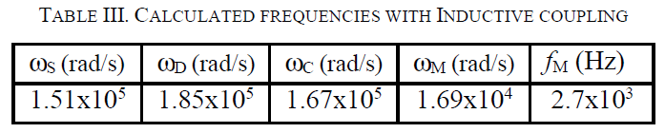

Paper Title: Another sample paper title
p3: Sample question.
Answer:
Sample answer.
Sample image:
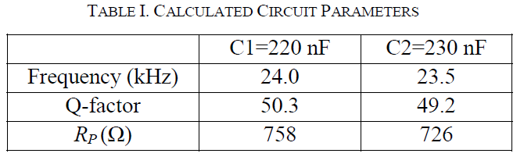

P: Sample_Looooooooooooooooooooooooooooooooooooooooooooooooooooonooooooooooooooooooooooooooooooooooooooooooooooog_question.
Answer:
Sample answer Line 1.
Sample answer Line 2.
…
Sample answer Line n.


