Class diagram

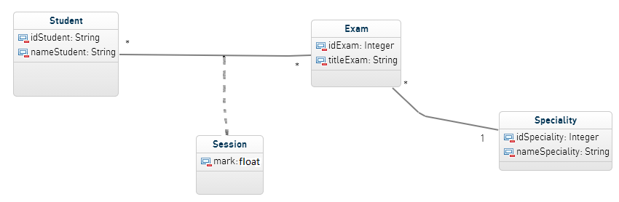

Validation of the exam

1. Full publish the project you must have exactly this schema

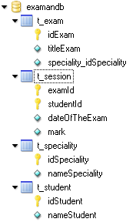

1. Turn on the _01TestAcademicYearInitDB test you should have :

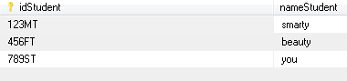

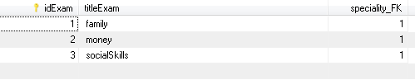

1. Turn on the _02TestAcademicYearPrepareSession test you should have :

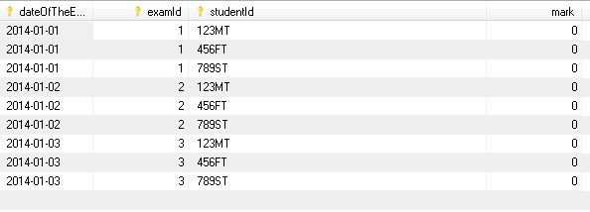

1. Turn on the _03TestAcademicYearAssignMarks test you should have :

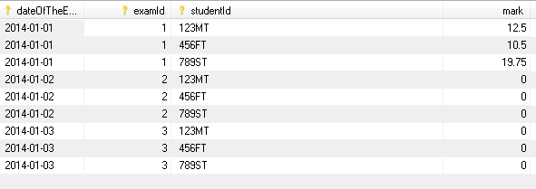

Good luck