Grogsile Interactive Studios

Design Document

for

TouMan

A TouHou-inspired production

Table of Contents

Game Overview 3

Idea 3

Influences 3

TouHou 3

Diablo 3

Nex Machina 4

Competition 5

Target Audience 5

The Game World 6

Setting 6

Levels 6

Story 6

Back Story 6

Game Narrative 6

Characters 6

Hero/Protagonist 6

Allies 7

Enemies 7

NPCs and AI 7

Music and Sound Effects 7

Background Music 7

Sound Effects 7

Summary 7

# Game Overview

## Idea

The general idea for this production is an arcade survival shooter. The premise is that you, as a player, must survive the waves of unknown entities that randomly spawn across the room and eventually make their way to the player’s character. The game should implement different views so that there are some forms of levels and a feeling of progression. The game should also become harder as time goes on. There should be pick-ups spawning at random locations or dropped from defeated enemies that benefit the player temporarily. The main camera is placed above the player, giving a view of the whole room.

## Influences

### TouHou

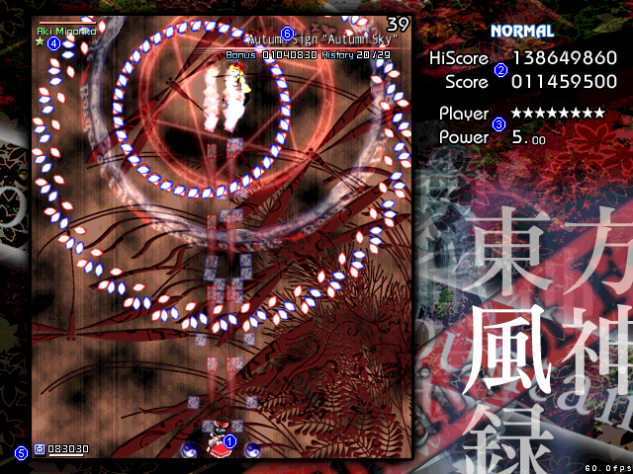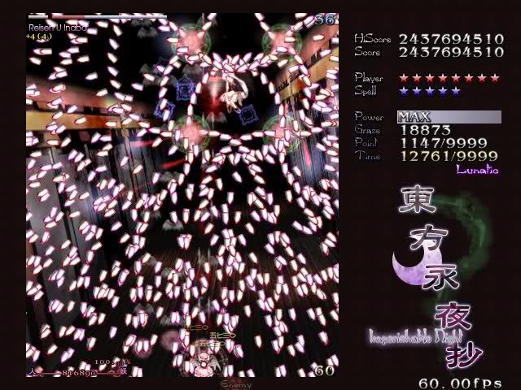

**TouHou** is a highly strategic top-down arcade that categorises itself as a ‘bullet-hell’ game. My game will likely not have as many particles and not be as action-packed as games in the TouHou series because it takes great skill to fare well as a player.

### Diablo

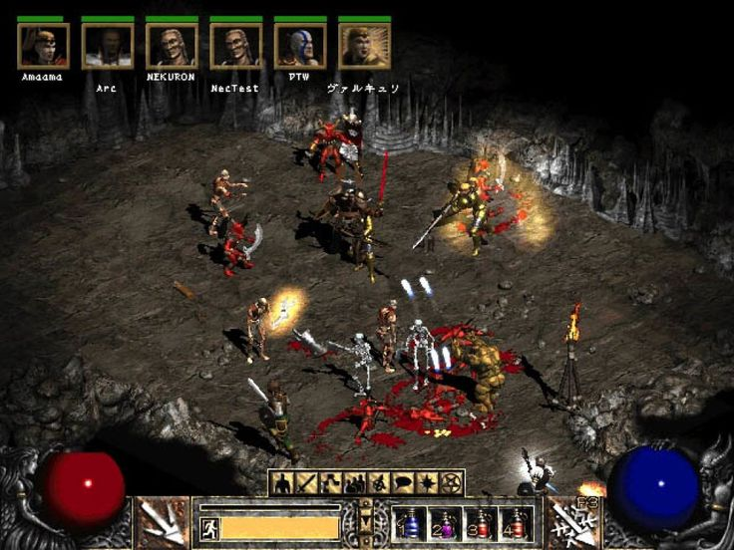Diablo has always been a favourite of mine in terms of gameplay and narrative. In this game, the player starts at level 1 and has to fight through hordes of enemies in order to complete an objective. How to make that happen is up to the player.

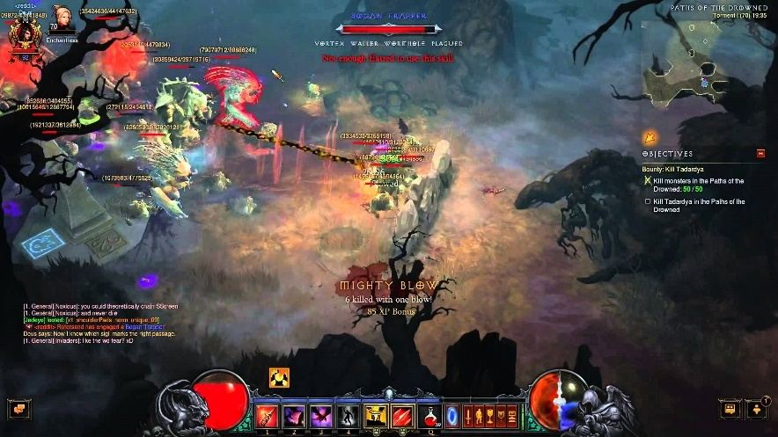The player’s character is customisable in that the gear they wear make out their strength and how they look, and it can be “transmogrified” in exchange for in-game currency to look like what the player desires.

### http://cdn.akamai.steamstatic.com/steam/apps/404540/ss_e4cf72153fabf52c9a728319aaa7c349e8645650.1920x1080.jpg?t=1505984942http://cdn.akamai.steamstatic.com/steam/apps/404540/ss_90683abe46ede861efaba86ff6126b625a544441.1920x1080.jpg?t=1505984942Nex Machina

Nex Machine is an arcade shooter that has one main objective: clear the level. The game is constructed in levels and features a variety of different enemies and bosses that each utilise different weapons and mechanics to try to kill the player. It also has random pick-ups that give the player character an edge, such as varying special weapons like the laser or the sword.

## Competition

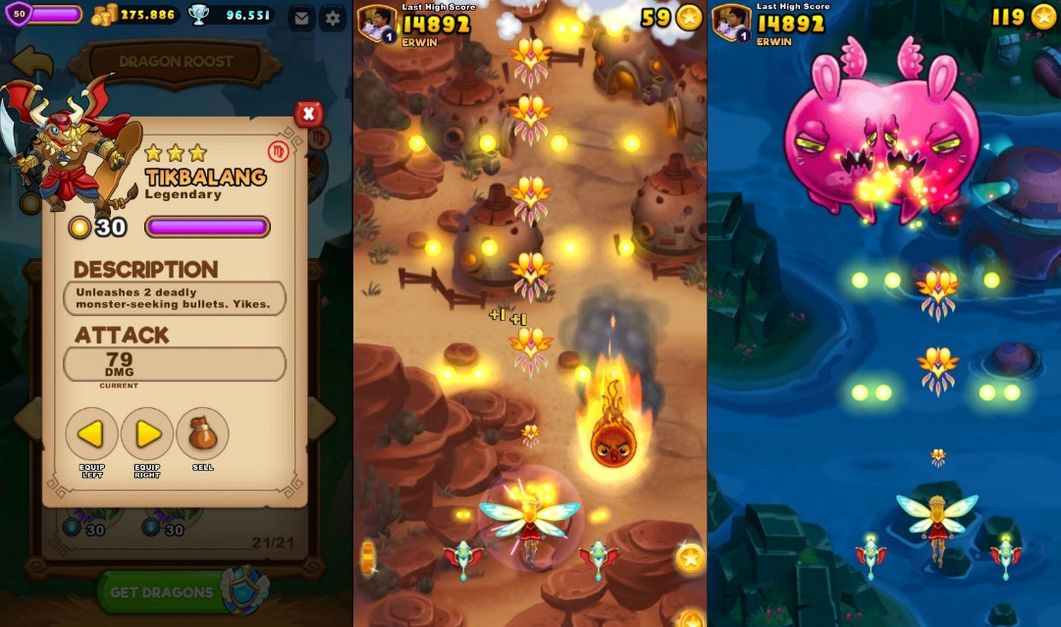Current games in the ‘bullet-hell’ and ‘arcade’ that can be found on the Steam Store include:

* Nex Machina
* Undertale
* Alien Swarm
* Relic Hunters Zero
* 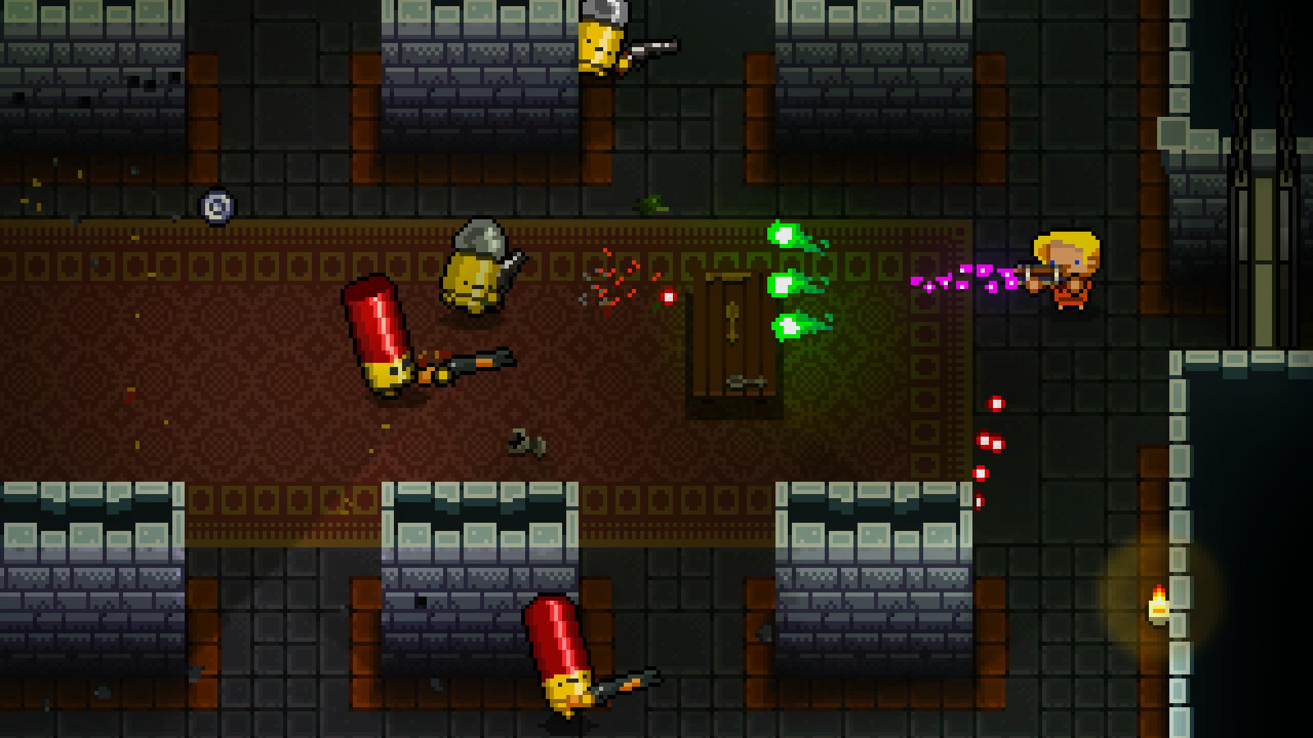Enter The Gungeon

EverWing is a mobile arcade bullet-hell game

* Realm of the Mad God
* Endless Space
* EverWing

Enter The Gungeon is a mix between a top-down arcade shooter and a dungeon crawler

## Target Audience

My target audience will likely mostly include fans of the following genres:

* Bullet-Hell Shooters
* Top-Down Games
* Arcade
* Survival

This game requires some precise timing and hand-eye coordination, so younger players will likely have an easier time at defeating the game.

## C:\Users\Medallyon\AppData\Local\Microsoft\Windows\INetCache\Content.Word\keyboard-layout.pngControls

|  |  |
| --- | --- |
| W, A, S, D | Movement |
| Mouse (or Left, Right, Up, Down Arrows) | Direction of shooting |
| Left Mouse Button (or Space) | Primary Shooting Method |
| Right Mouse Button (or F) | Secondary Shooting Method (Special Weapons) |

# The Game World

## Setting

The setting for the game is from a top-down narrative. The game employs some random-number-generation to spawn enemies at random locations. The initial setting is Earth, where it progresses in tandem with the levels. This means that background sprites will change depending on the current level, therefore altering the setting. It will progress from its initial setting on Earth into the deep void of Space.

## Levels

I believe that for the game I aim to develop, levels are more of a virtual concept. What I mean by this is that there will only be a single room which progresses in terms of difficulty. The enemies will be controlled via a global controller, and their strength is based on the current score of the player. This means that the higher the score, the harder the enemies will become. This, in my opinion, makes the game much more variable and exciting, instead of having static levels that contain enemies of a static strength.

# Story

## Back Story

Aliens are invading Earth! You are the commanding officer of the united anti-alien force of Earth, and must protect the planet from the invaders. It is your duty to kill any enemies on your way and drive them back to space. You may use any means necessary (e.g. enemy item drops and buffs) to complete your objective.

## Game Narrative

The player will be spawning in the centre of the level, with the background moving horizontally across the screen, giving an illusion of movement. Enemy entities will spawn on the left side of the room, which will shoot in the general direction of where the player is currently located. After every few waves of enemies, a boss wave will show up that is harder than normal enemies.

# Characters

* <https://opengameart.org/content/complete-spaceship-game-art-pack>
* 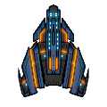<http://millionthvector.blogspot.co.uk/p/free-sprites.html>

## Hero/Protagonist

The player is the protagonist, which will be portrayed by this sprite. This object will have access to normal bullets, special bullets, and special pick-ups that may aid him in combat, such as lasers and rockets.

## Allies

Allies will be instantiated by pick-ups, and will only be a temporary assistance to the player. These will mainly come in forms of airships that spawn next to the hero character and will shoot in the same direction as the player.

## Enemies

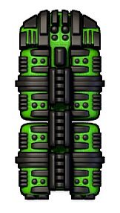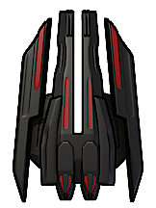There is a whole spectrum of different characters, thanks to the free sprites I got from the websites noted earlier. Due to this, I will be able to create a variety of enemies with different mechanics. There will be small enemies that follow a static path, enemy spaceships that try to shoot the player, and bigger enemies such as bosses which are represented by space stations. All enemies will have Health Points, where the amount of health depends on the type of enemy.

## NPCs and AI

The general AI will be very simple. I will probably create an enemy that chases the player, which is easily done in GameMaker. Another enemy will likely be able to track the player’s motion and shoot in their direction.

# Music and Sound Effects

## Background Music

I have no primary resources available in terms of music and sound effects, but I imagine that a soundtrack for something like a classic space shooter is appropriate for this game. Inspirations for this game’s background music would be from the ‘synth-wave’ genre, for example the official soundtracks from Far Cry 3: Blood Dragon or Nex Machina.

## Sound Effects

Basic stock sound effects will be included in this game. I do not know of many sources for good sound effects, but if I must, I will create them myself somehow. I aim to have simple sound effects for actions like shooting lasers and rockets. The motion of the player should also somehow be transmitted via audio, perhaps with a loop of an engine sound.

# Summary

In summary, I believe that I have a very good chance at creating a game that reflects my interests as a computer game developer at the current moment. I will be using GameMaker Studio instead of GameMaker 8.1 because of the limitations that come with 8.1. I reckon that I could develop a game that could potentially be marketed on indie websites and perhaps even Steam Greenlight.