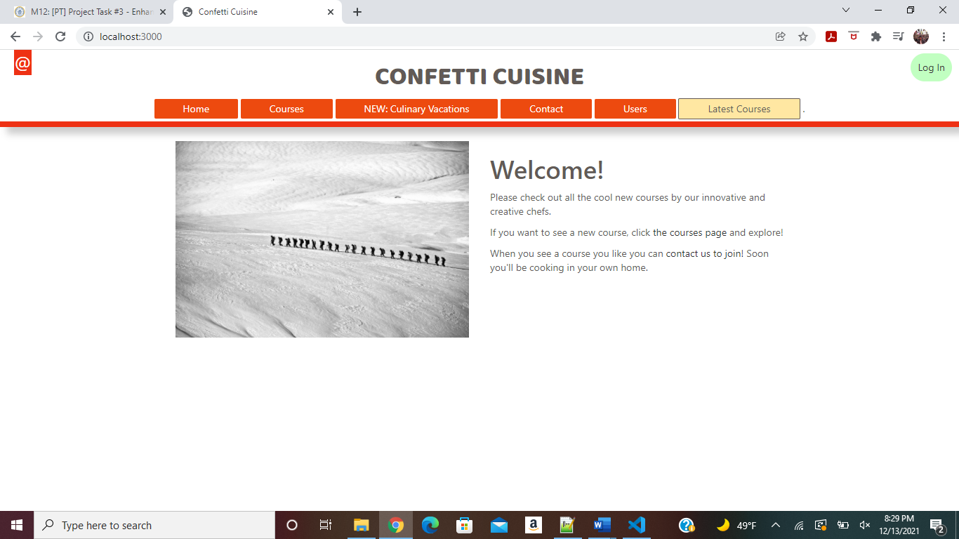

Without Login Homepage

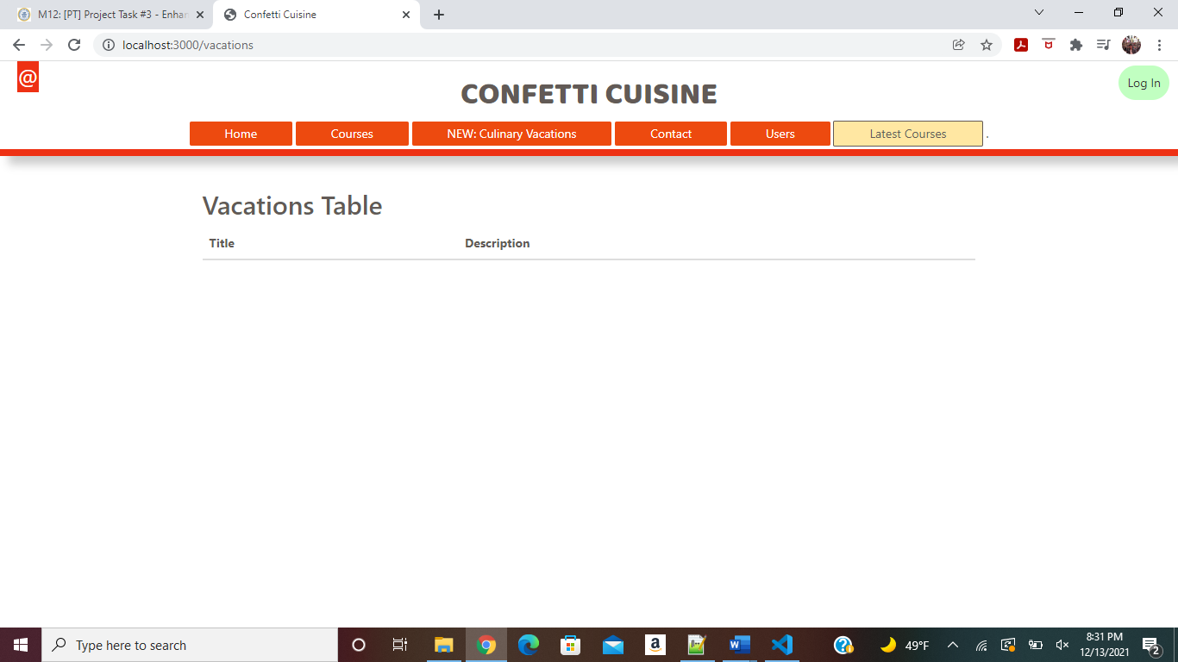

No records Currently

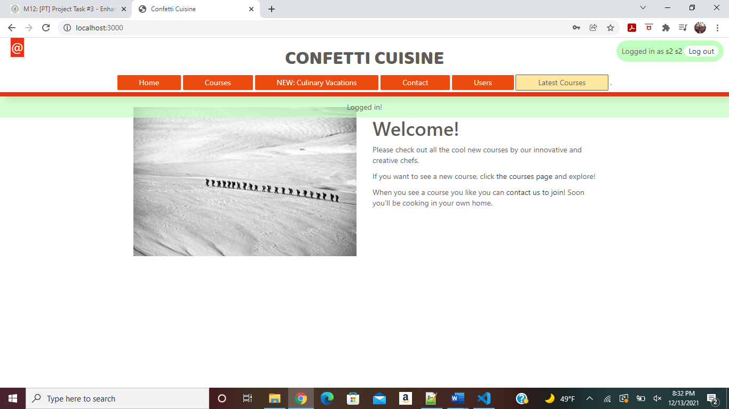

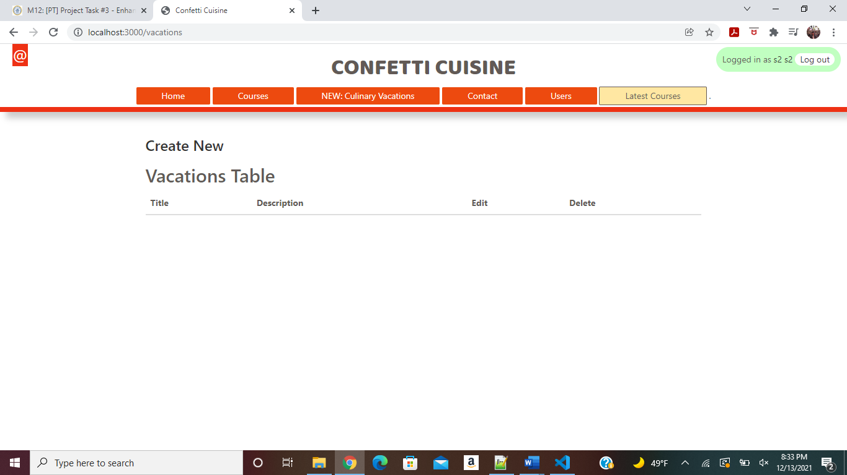

Create /Edit/Delete Option shown to only Logged In User ([s5@s5.com/s2](mailto:s5@s5.com/s2))

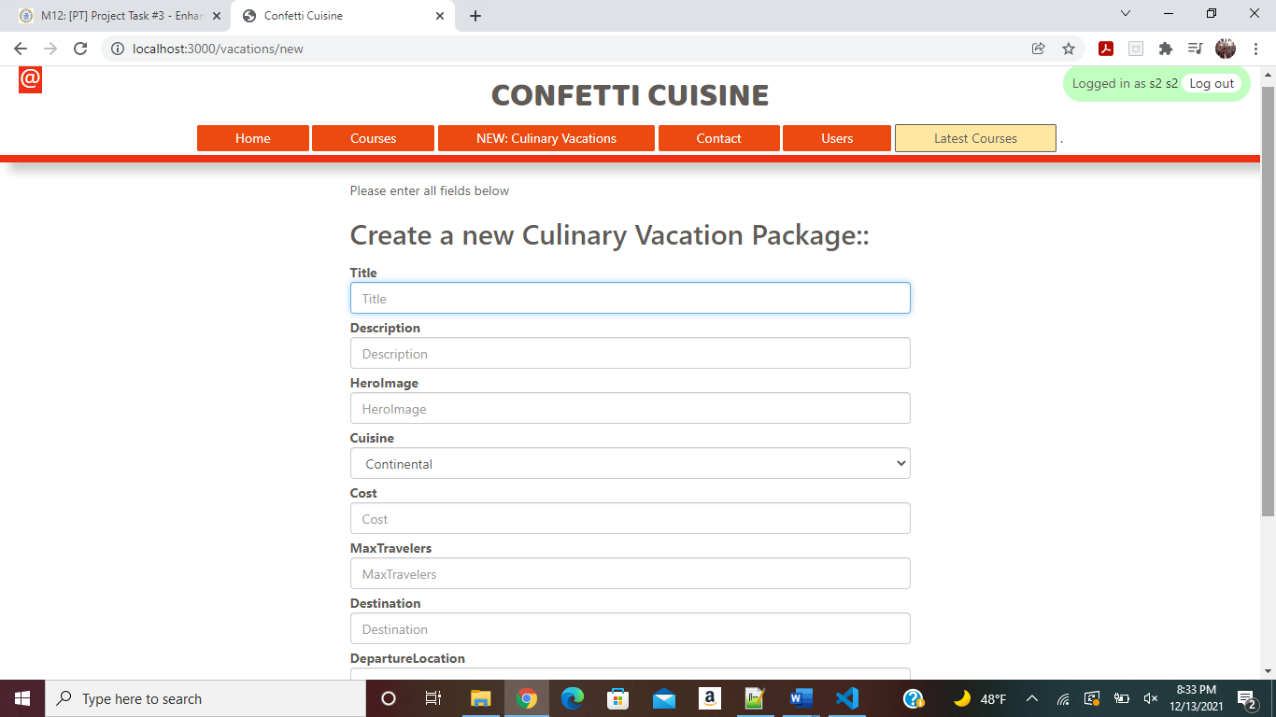

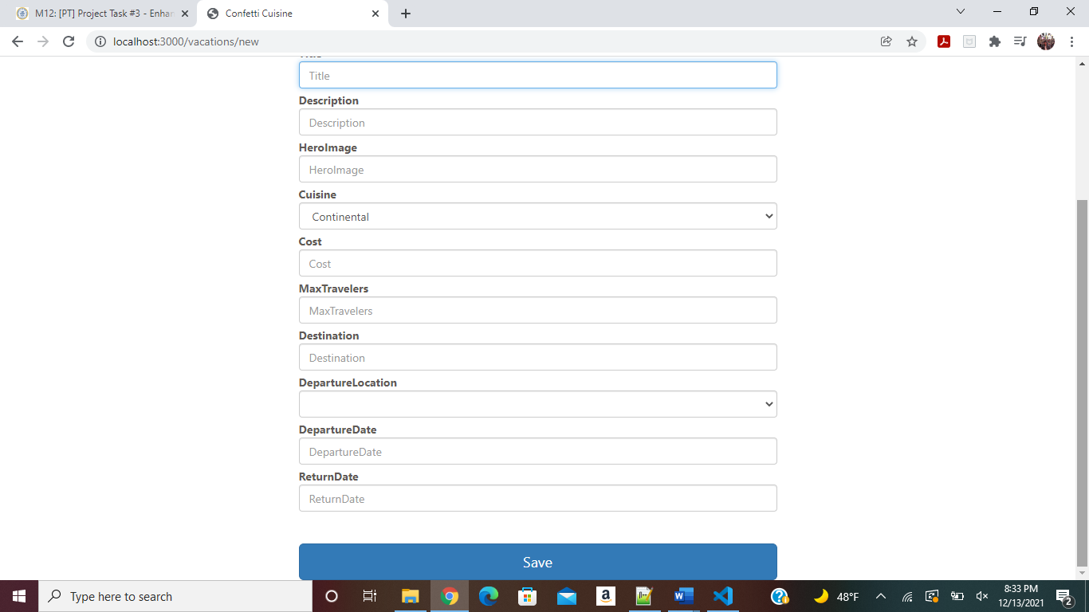

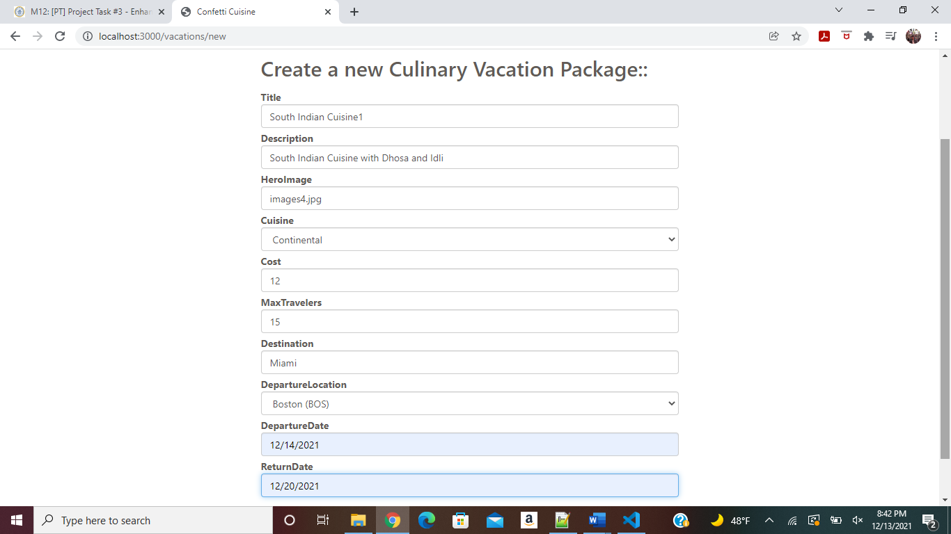

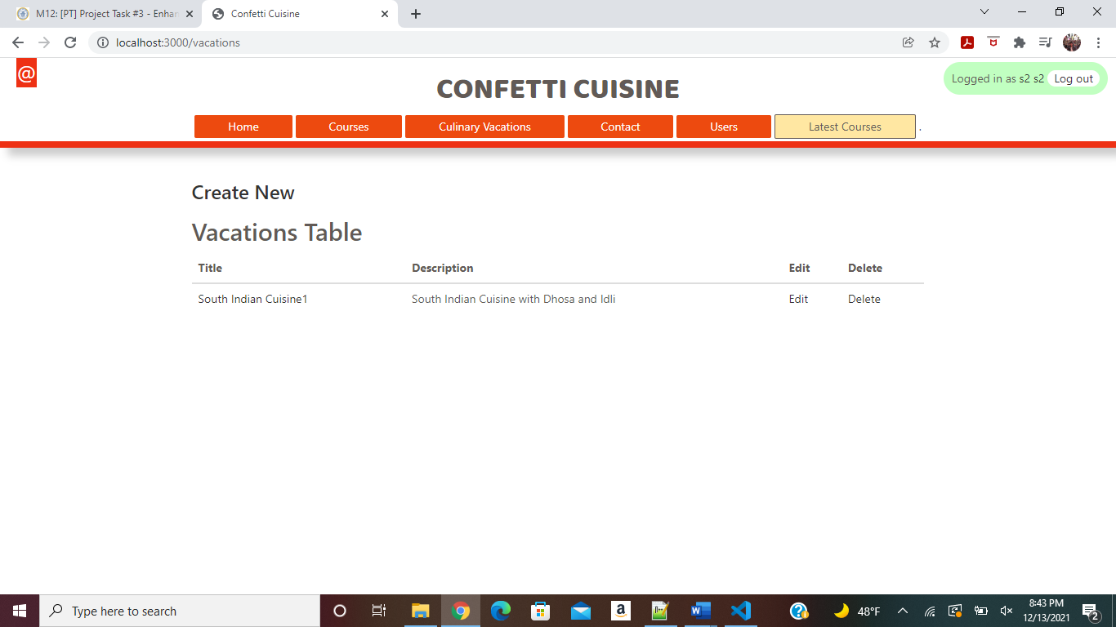

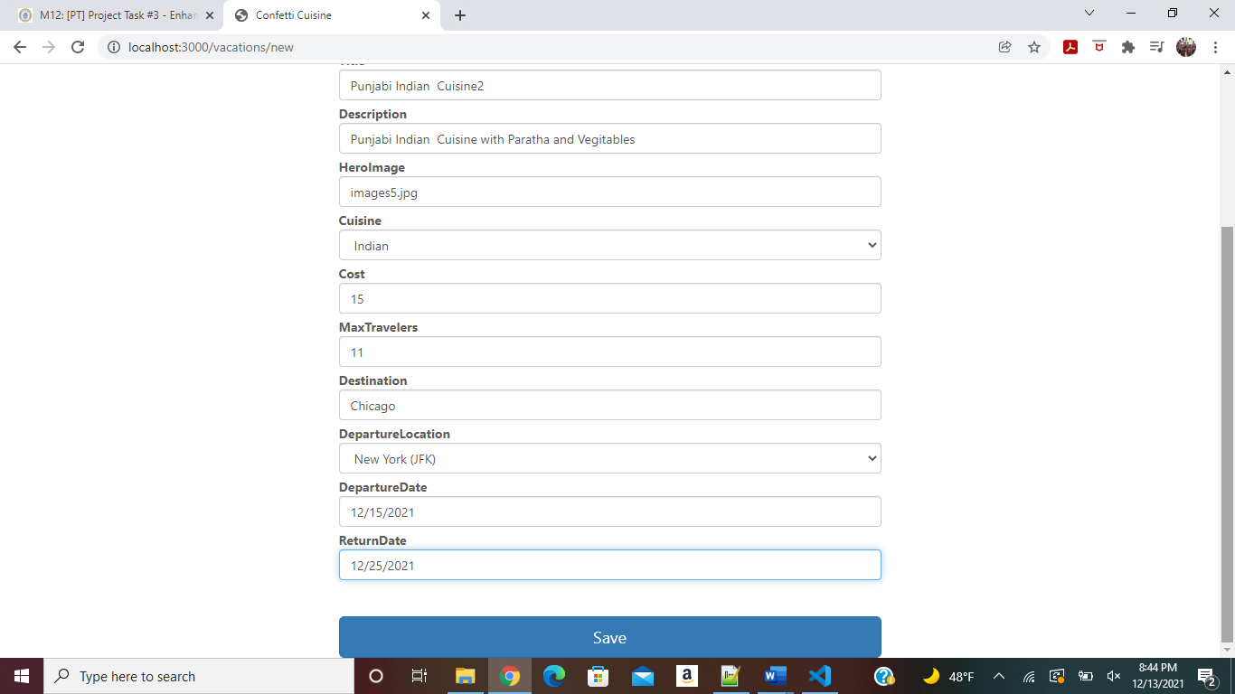

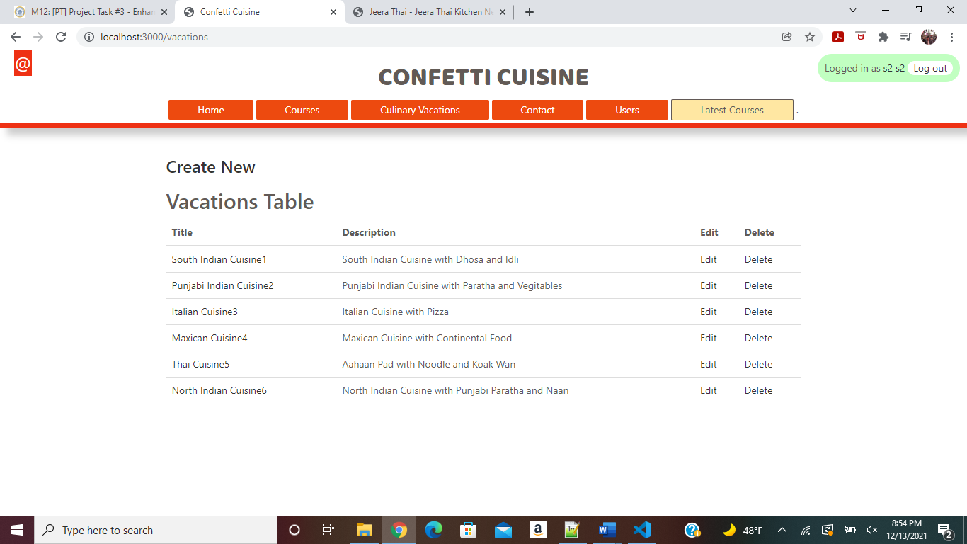

Session for Authenticated User implemented and session parameter passed to respective page and

Based on that session parameter (isauthenticated) , user shown with option Create/Edit/Delete

Only Logged in User can Create /Edit/Delete Vacations

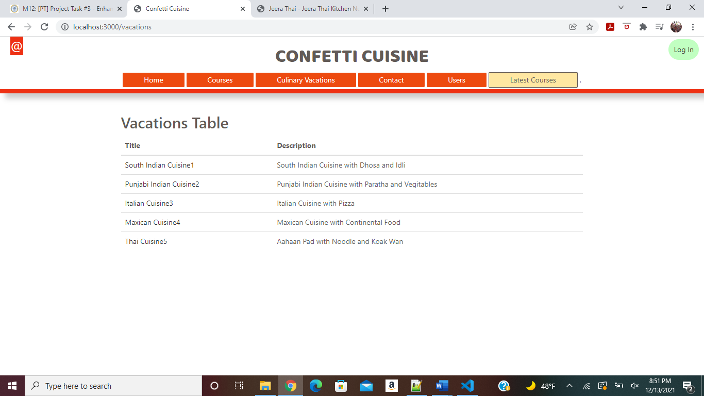

Without login for other (Not Authenticated User) can only View Culinary Vacations

Authenticated Logged in User Can Edit Culinery Vacation as below:

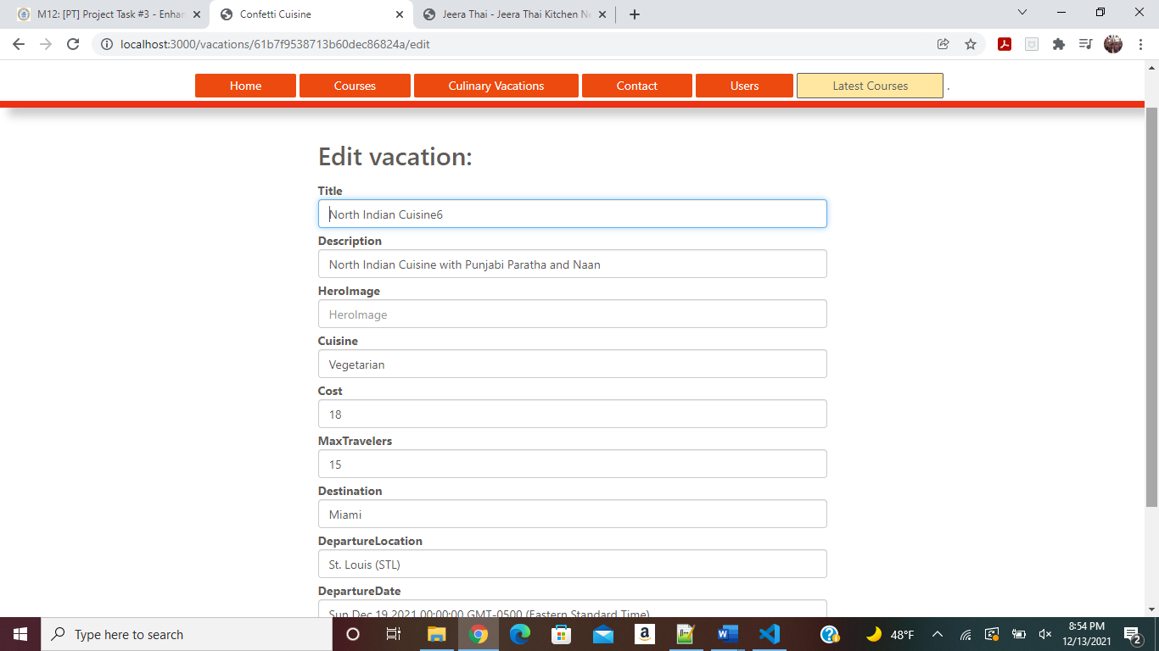

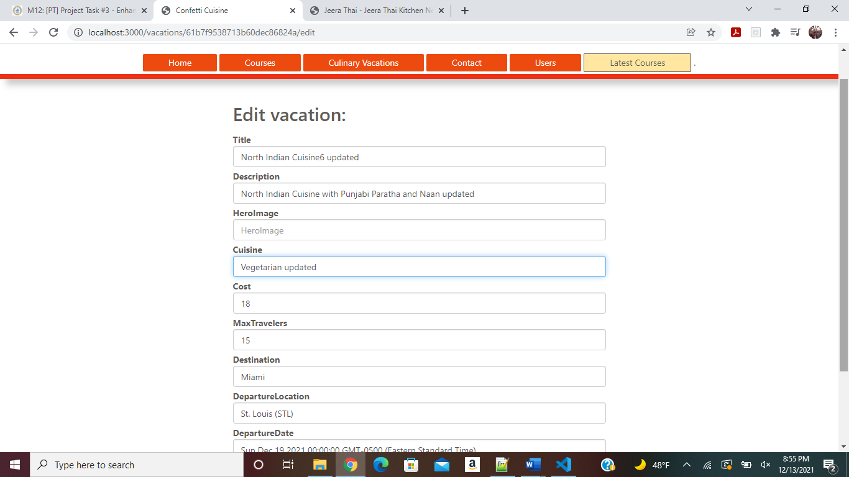

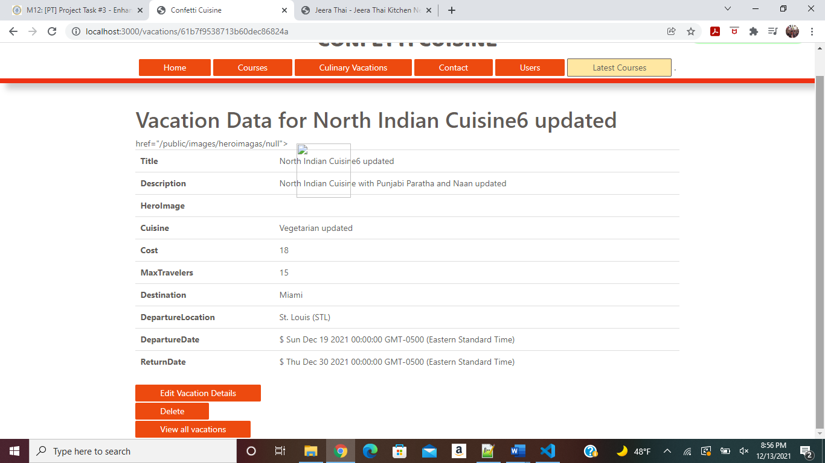

As shown above on this page Edit, Delete and View Option shown for logged in User.

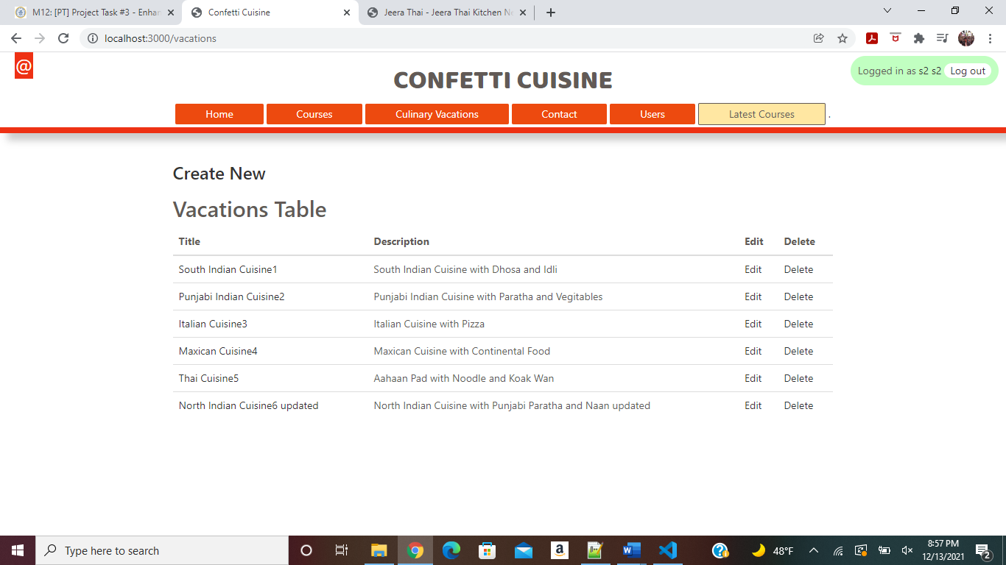

Updated Vacations can be viewed as above

[North Indian Cuisine6 updated](http://localhost:3000/vacations/61b7f9538713b60dec86824a) is now deleted and as shown below alert message for delete shown

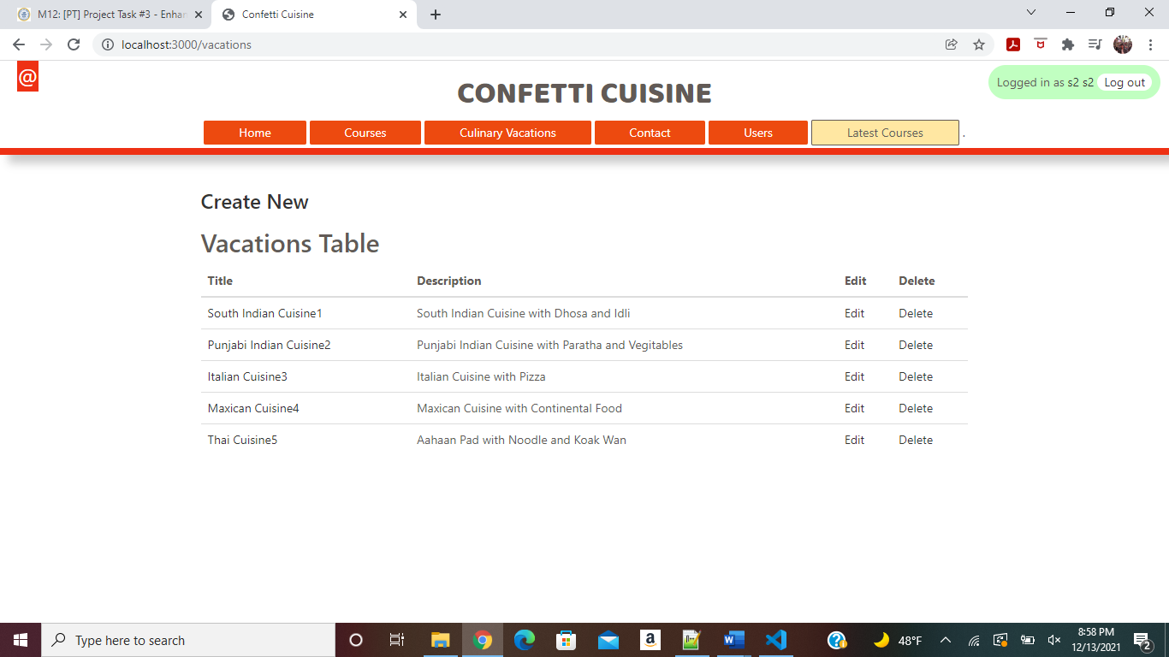

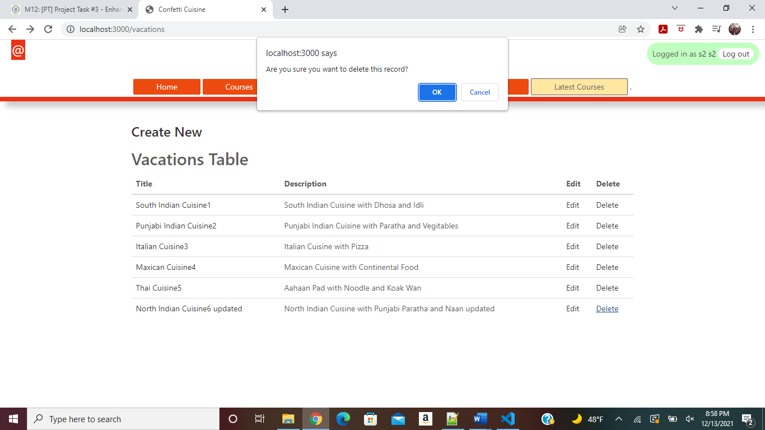

Record deleted as above

User logged out as shown below

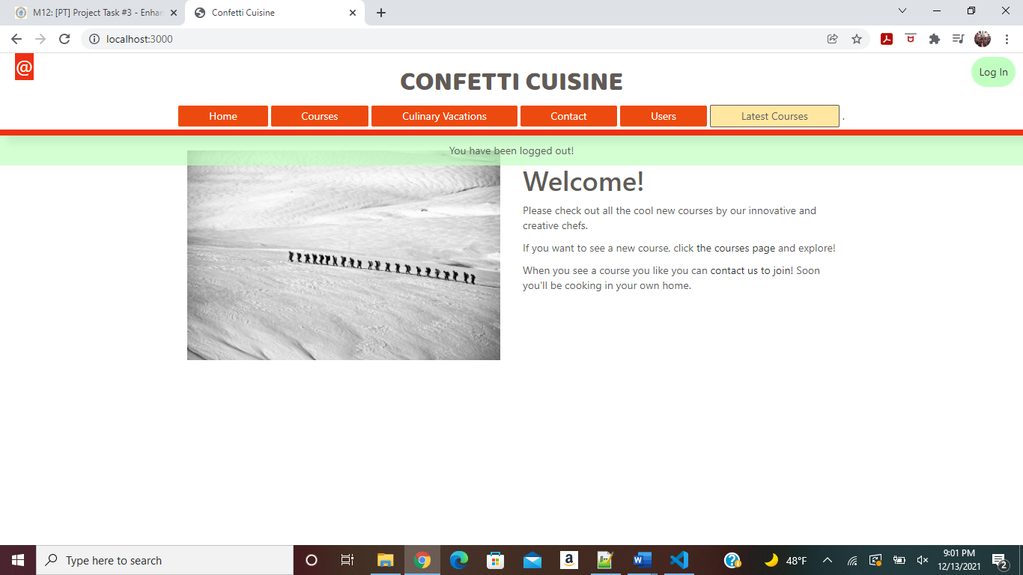

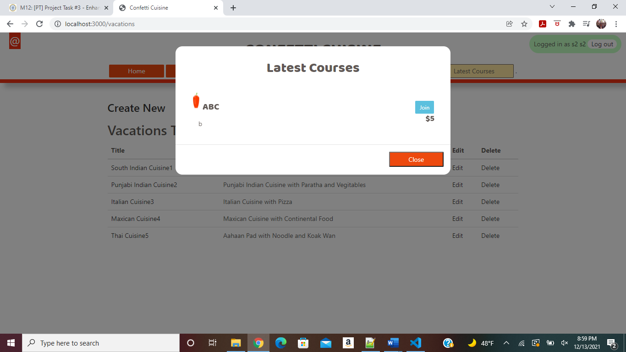

Latest Courses also shown to the Users