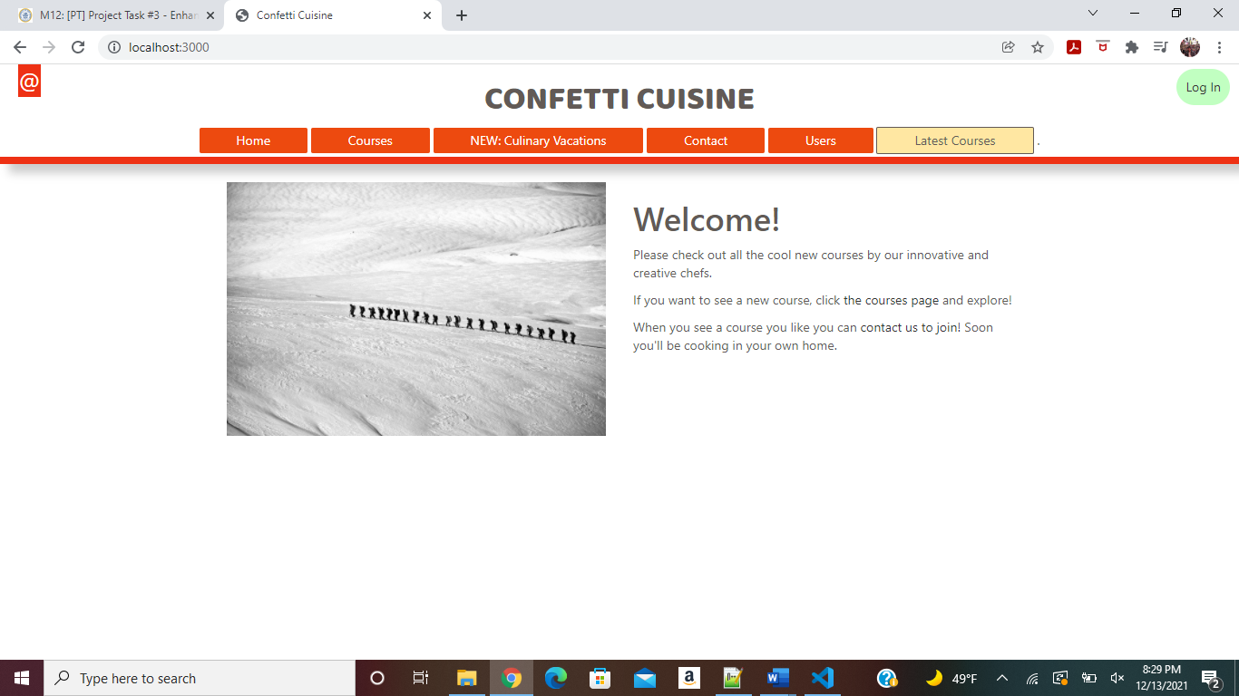

Without Login Homepage

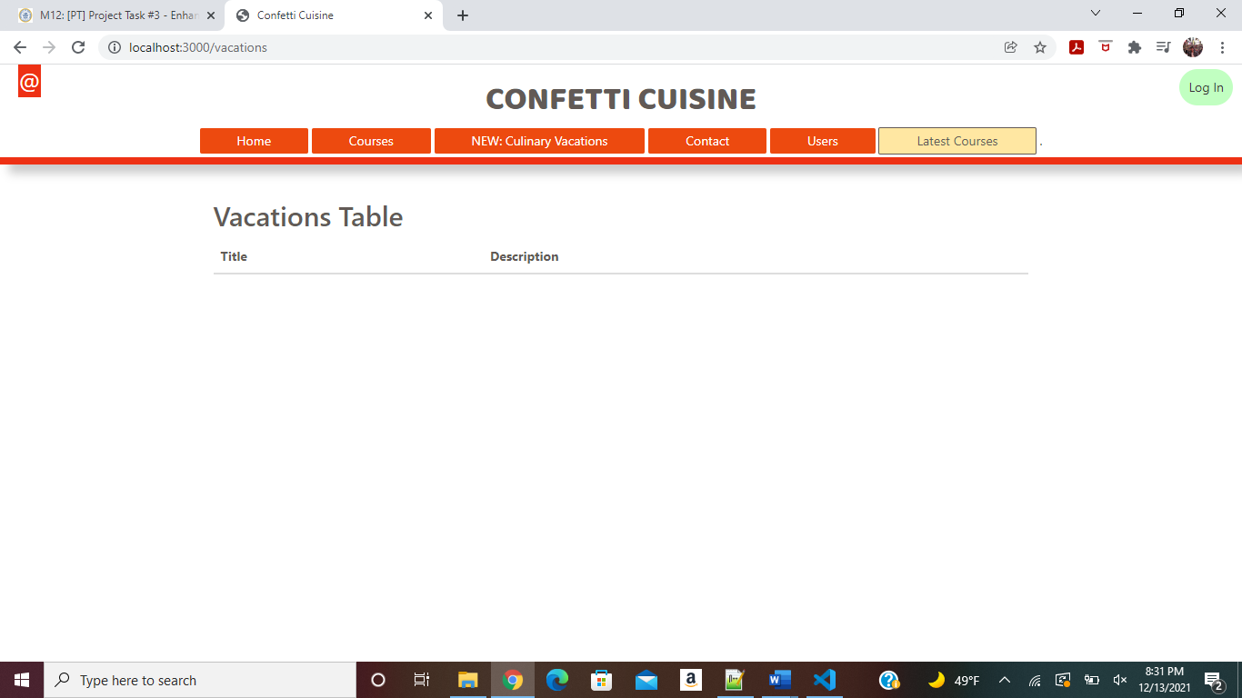

No records Currently

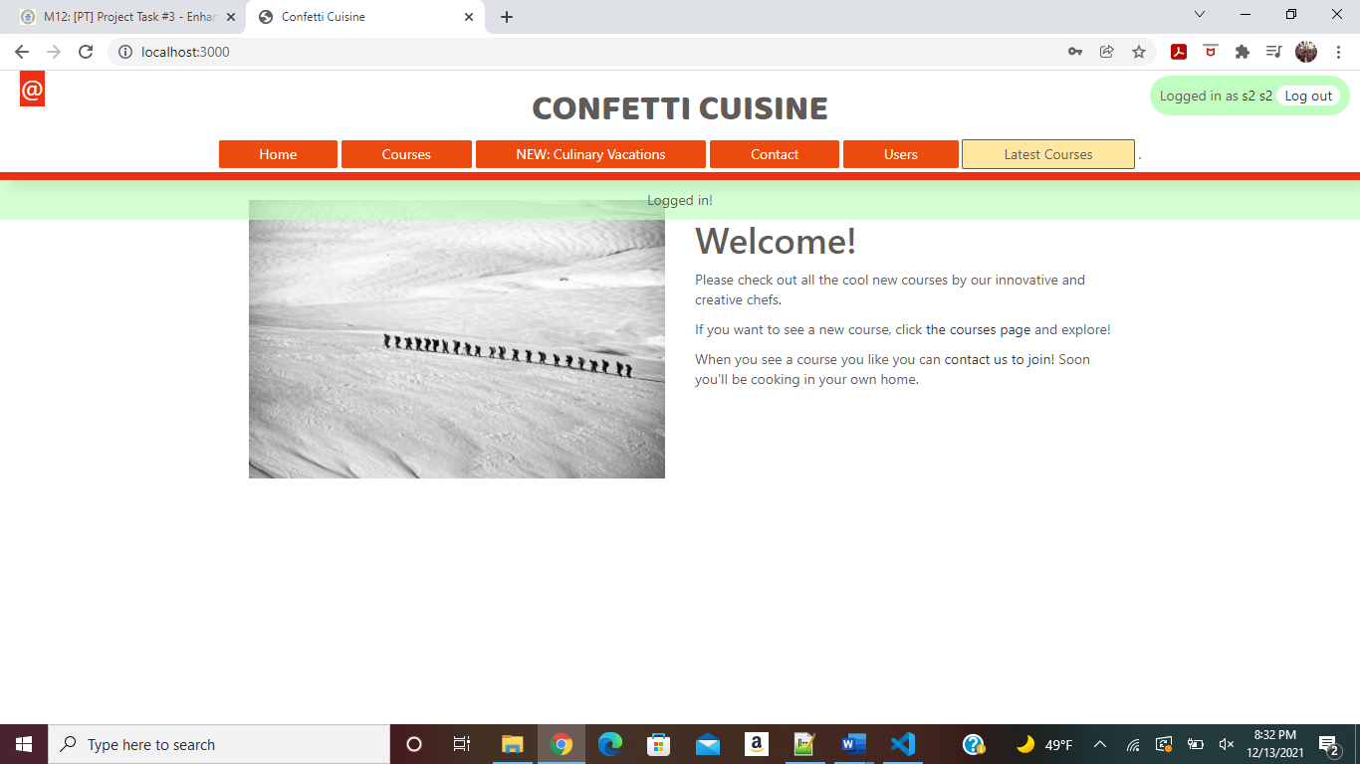

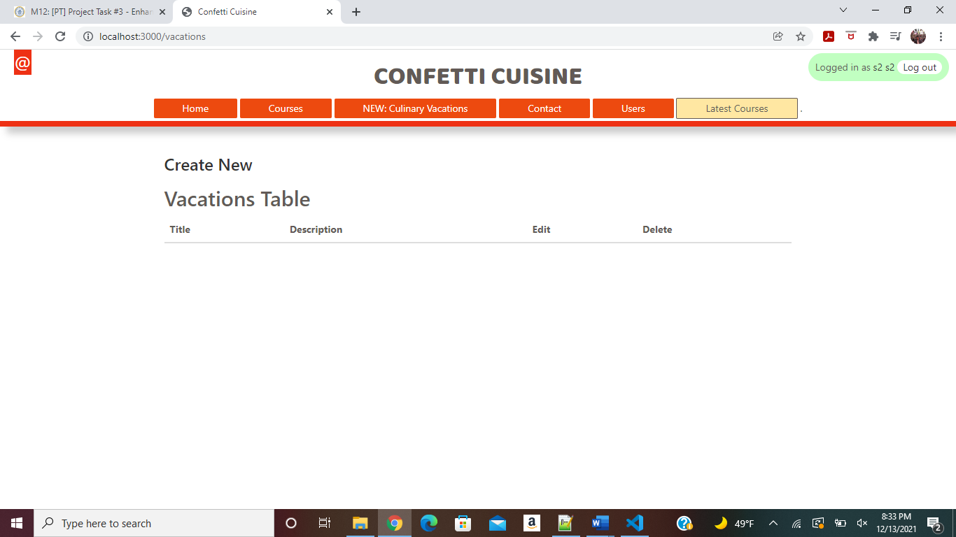

Create /Edit/Delete Option shown to only Logged In User ([s5@s5.com/s2](mailto:s5@s5.com/s2))

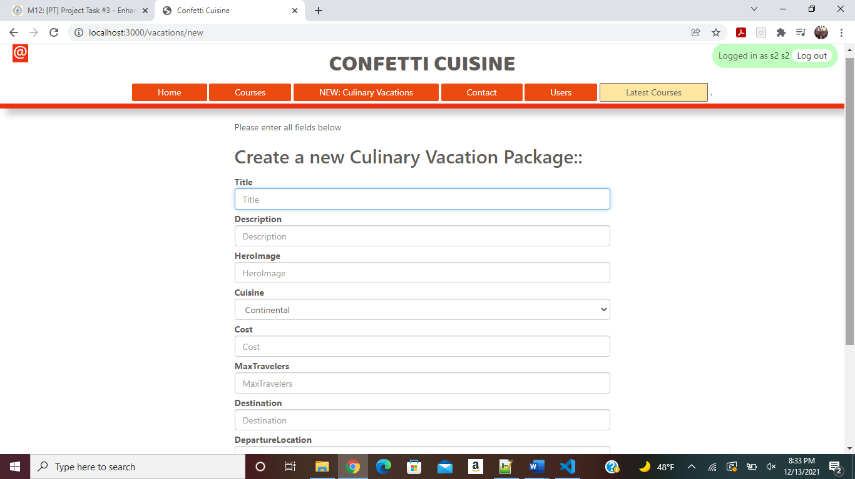

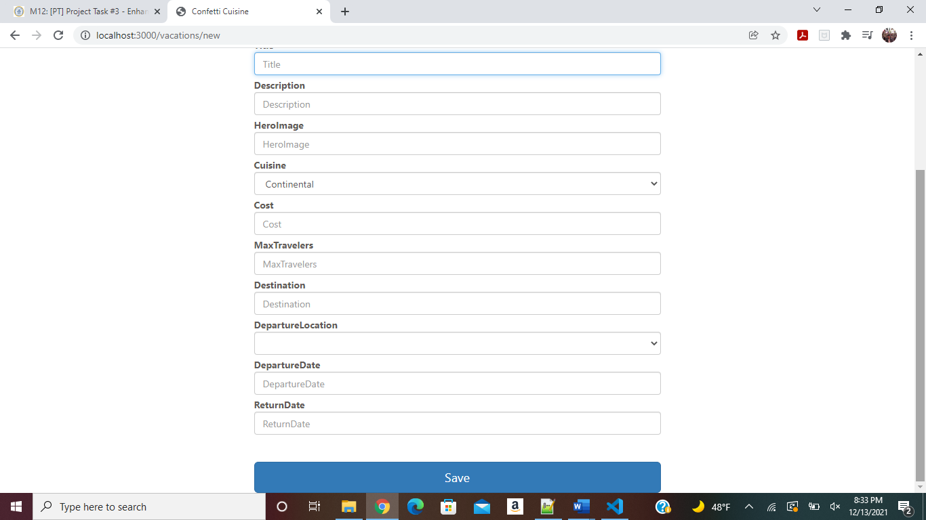

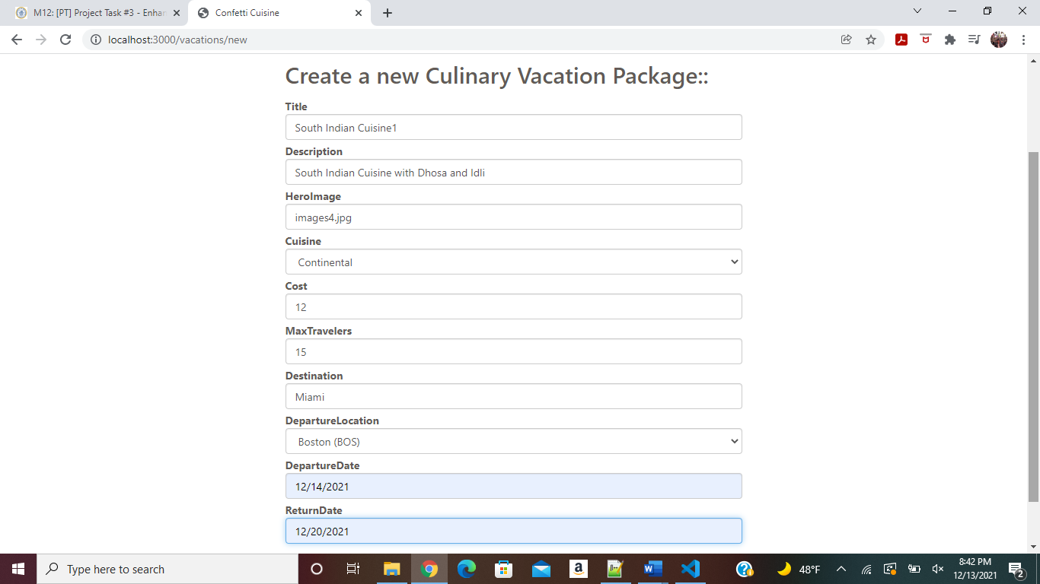

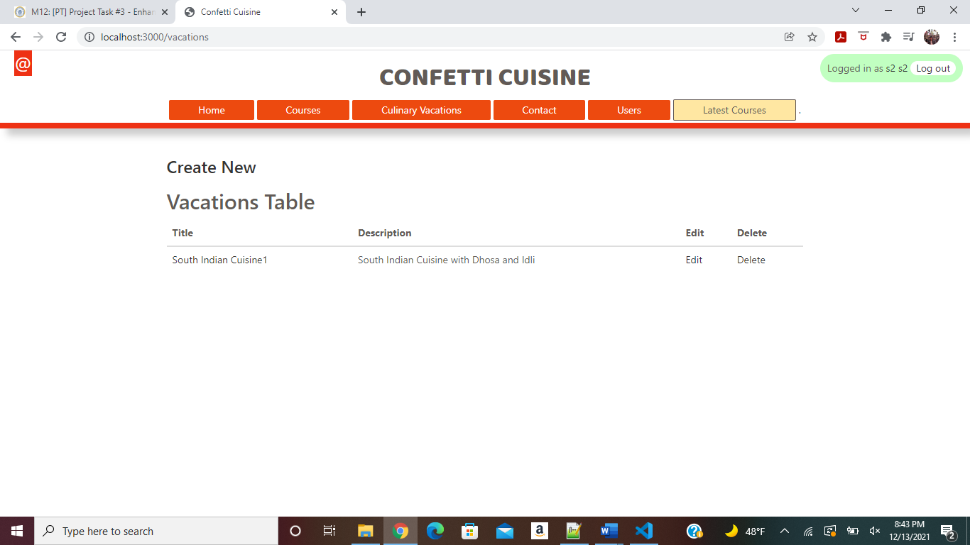

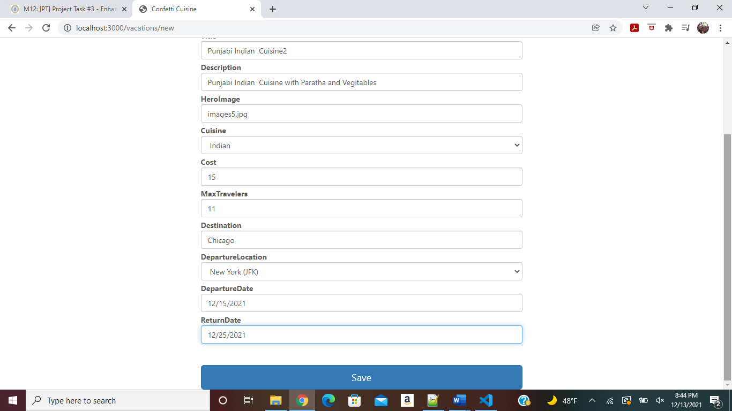

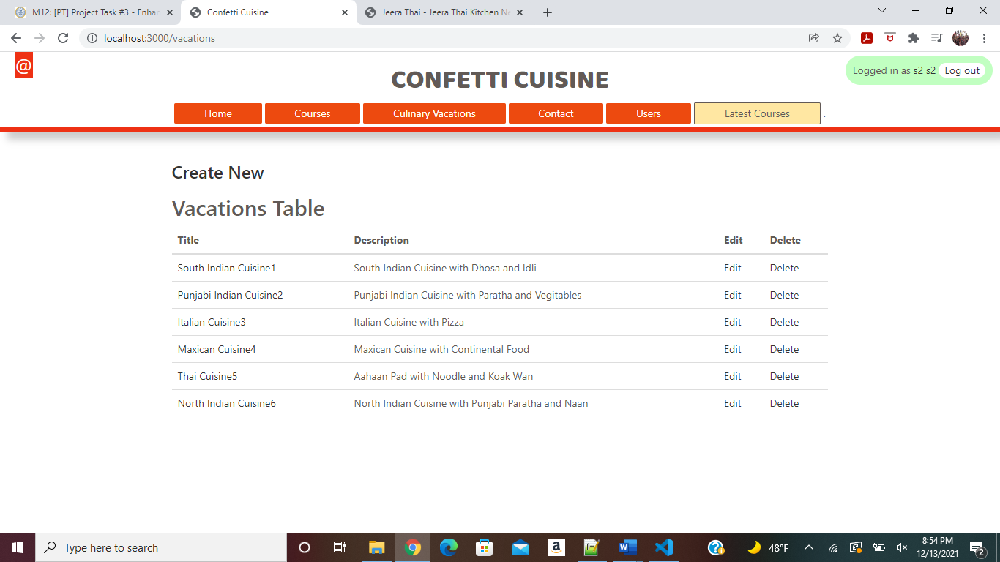

Session for Authenticated User implemented and session parameter passed to respective page and

Based on that session parameter (isauthenticated) , user shown with option Create/Edit/Delete

Only Logged in User can Create /Edit/Delete Vacations

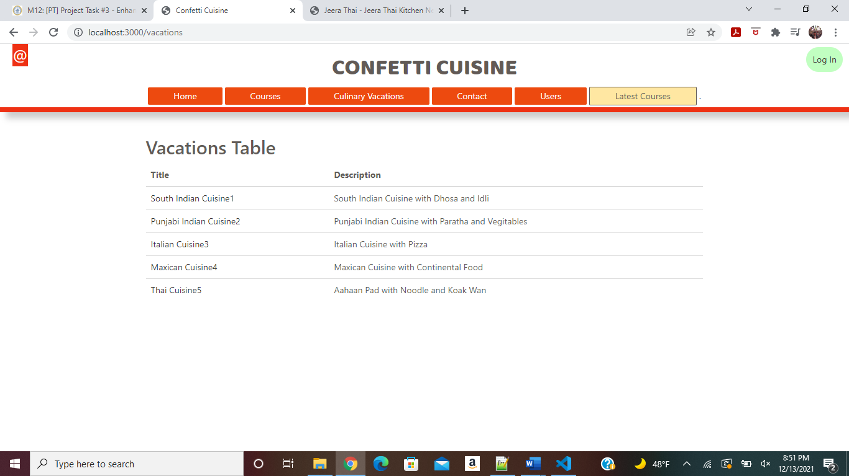

Without login for other (Not Authenticated User) can only View Culinary Vacations

Authenticated Logged in User Can Edit Culinery Vacation as below:

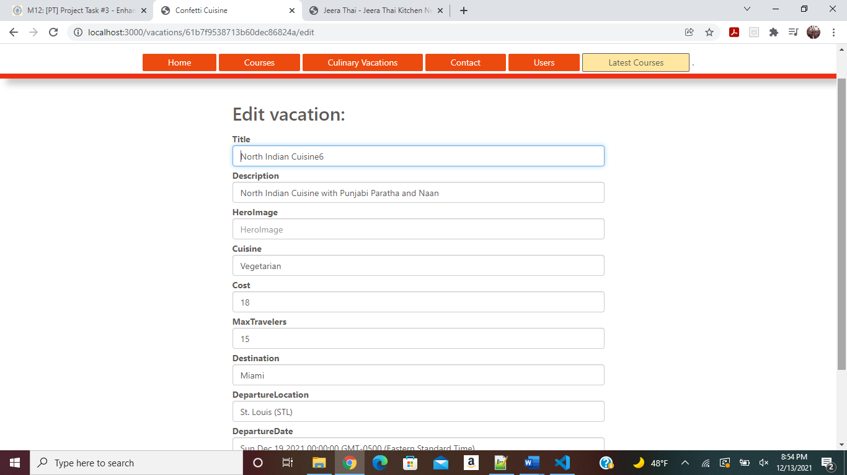

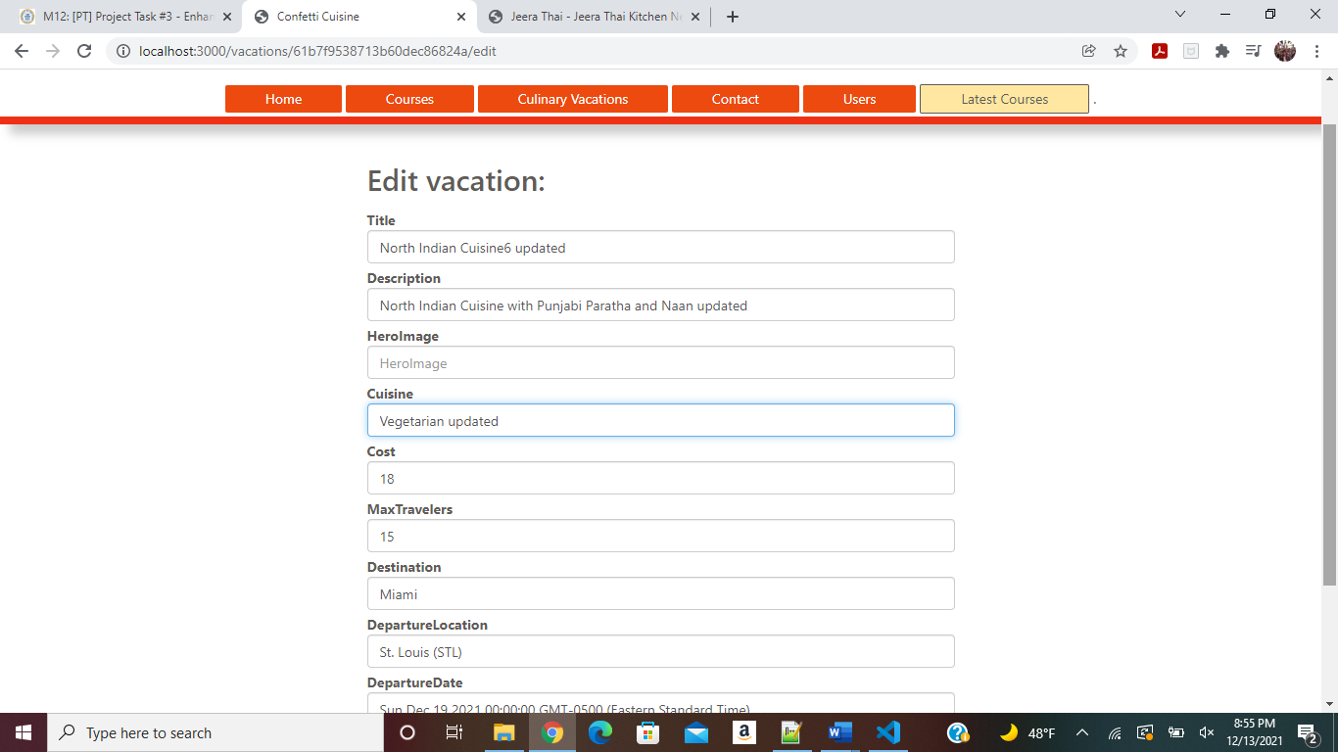

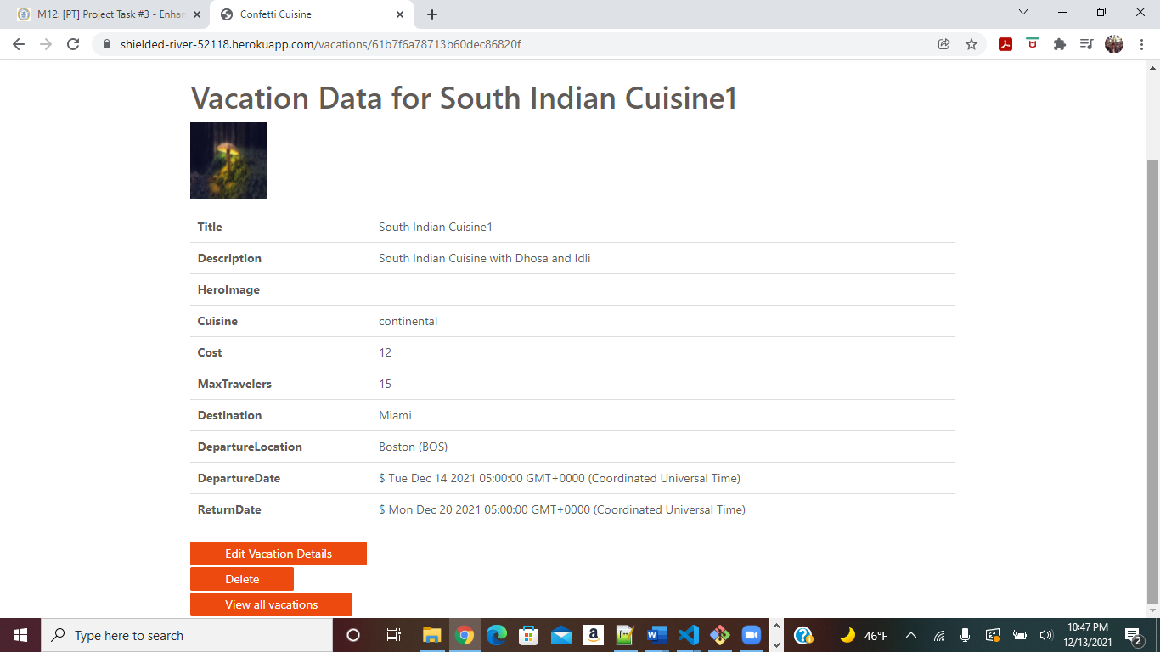

Hero image is shown for the respective Cuisine

As shown above on this page Edit, Delete and View Option shown for logged in User.

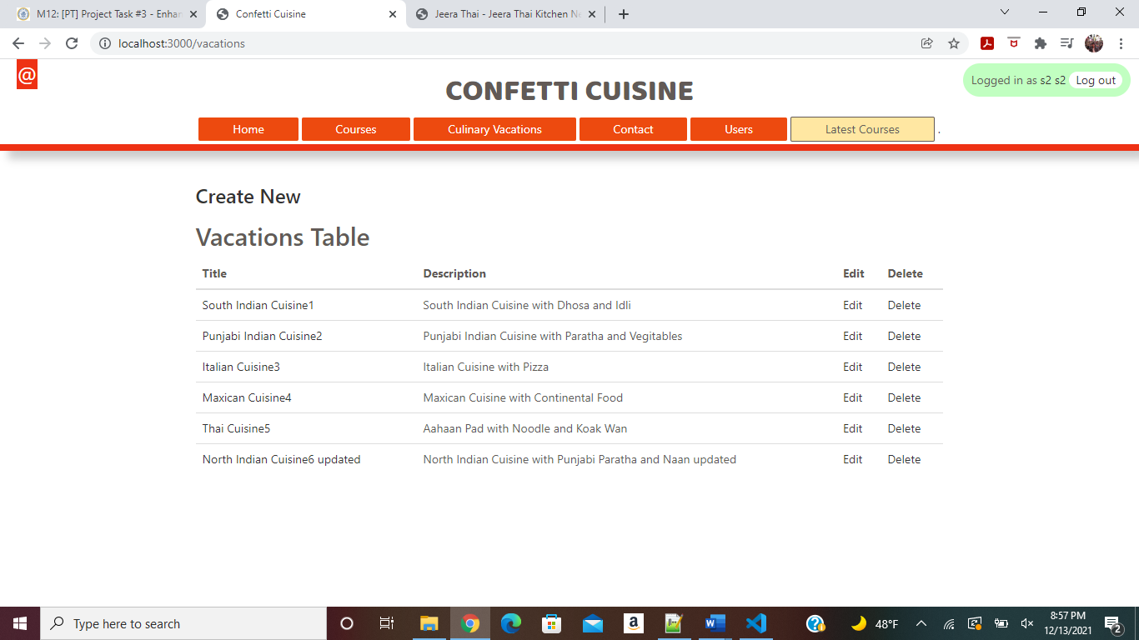

Updated Vacations can be viewed as above

[North Indian Cuisine6 updated](http://localhost:3000/vacations/61b7f9538713b60dec86824a) is now deleted and as shown below alert message for delete shown

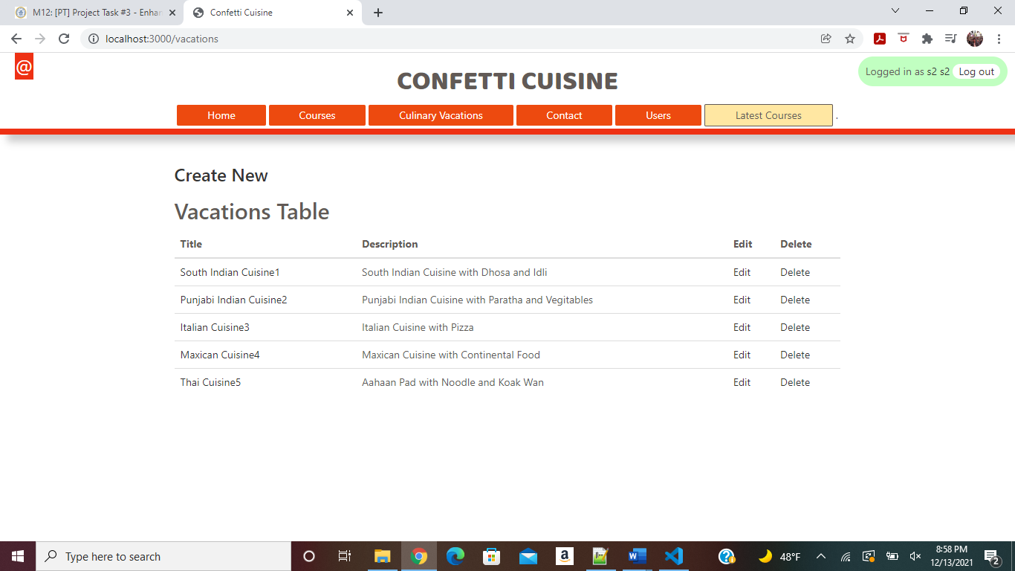

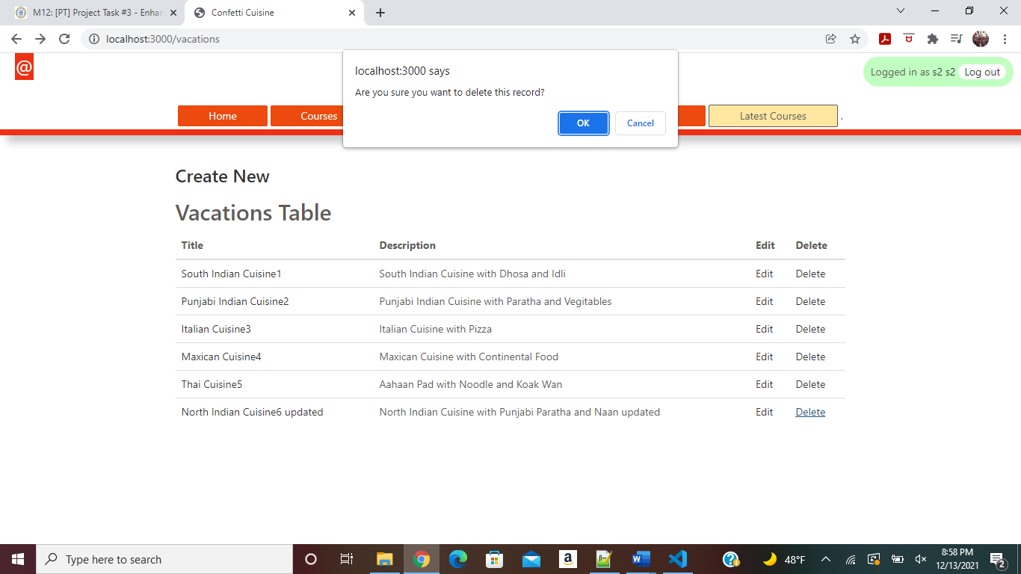

Record deleted as above

User logged out as shown below

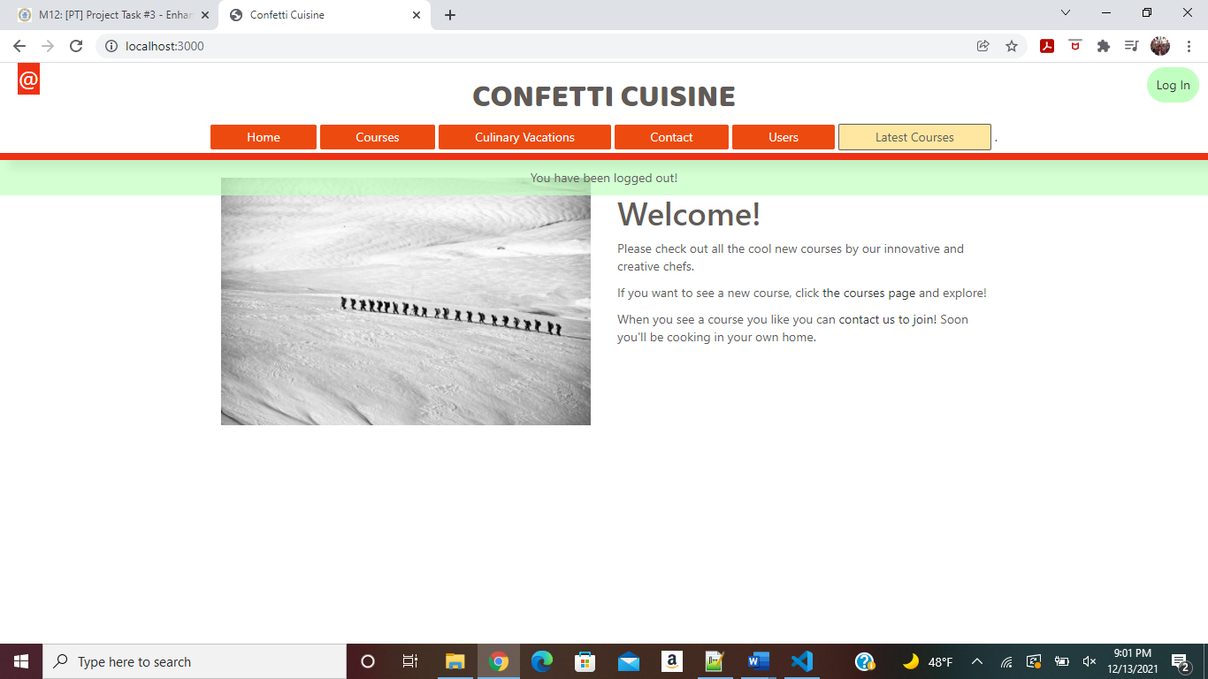

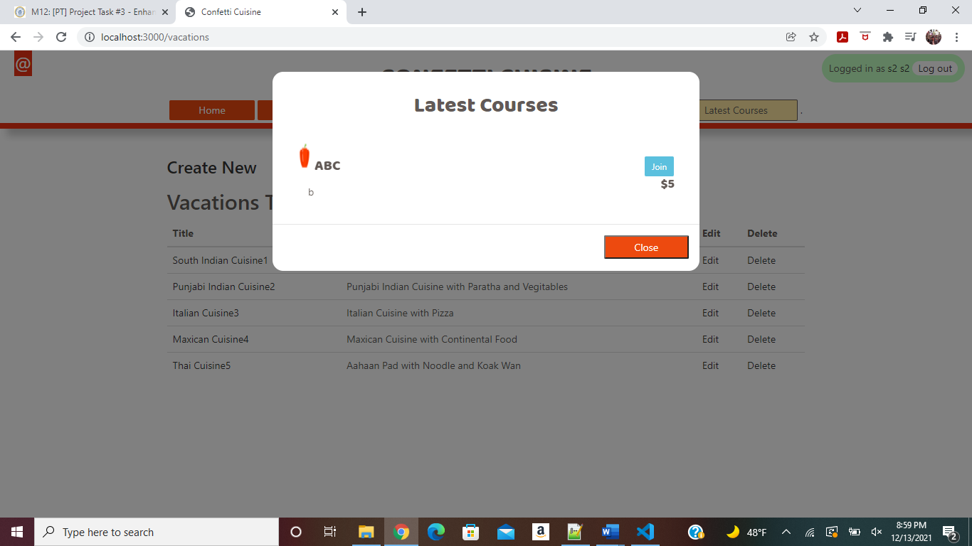

Latest Courses also shown to the Users