|  |  |
| --- | --- |
|  | **ezIOmeter**  **User Guide**  **v1.0.0.0** |

# Disclaimers

**INTEL CORPORATION MAKES NO WARRANTY OF ANY KIND WITH REGARD TO THIS MATERIAL, INCLUDING, BUT NOT LIMITED TO, THE IMPLIED WARRANTIES OF MERCHANTABILITY AND FITNESS FOR A PARTICULAR PURPOSE. INTEL CORPORATION ASSUMES NO RESPONSIBILITY FOR ANY ERRORS THAT MAY APPEAR IN THIS DOCUMENT. INTEL CORPORATION MAKES NO COMMITMENT TO UPDATE OR TO KEEP CURRENT THE INFORMATION CONTAINED IN THIS DOCUMENT.**

**THIS SPECIFICATION IS COPYRIGHTED BY AND SHALL REMAIN THE PROPERTY OF INTEL CORPORATION. NO LICENSE, EXPRESS OR IMPLIED, BY ESTOPPEL OR OTHERWISE TO ANY INTELLECTUAL PROPERTY RIGHTS IS GRANTED HEREIN.**

**INTEL DISCLAIMS ALL LIABILITY, INCLUDING LIABILITY FOR INFRINGEMENT OF ANY PROPRIETARY RIGHTS, RELATING TO IMPLEMENTATION OF INFORMATION IN THIS SPECIFICATION. INTEL DOES NOT WARRANT OR REPRESENT THAT SUCH IMPLEMENTATIONS WILL NOT INFRINGE SUCH RIGHTS.**

**NO PART OF THIS DOCUMENT MAY BE COPIED OR REPRODUCED IN ANY FORM OR BY ANY MEANS WITHOUT PRIOR WRITTEN CONSENT OF INTEL CORPORATION.**

INTEL CORPORATION RETAINS THE RIGHT TO MAKE CHANGES TO THESE SPECIFICATIONS AT ANY TIME, WITHOUT NOTICE.

Legal Notices

Intel Open Source License

Copyright (c) 2001 Intel Corporation

All rights reserved.

Redistribution and use in source and binary forms, with or without

modification, are permitted provided that the following conditions are met:

Redistributions of source code must retain the above copyright notice,

this list of conditions and the following disclaimer.

Redistributions in binary form must reproduce the above copyright notice,

this list of conditions and the following disclaimer in the documentation

and/or other materials provided with the distribution.

Neither the name of the Intel Corporation nor the names of its contributors

may be used to endorse or promote products derived from this software

without specific prior written permission.

THIS SOFTWARE IS PROVIDED BY THE COPYRIGHT HOLDERS AND CONTRIBUTORS ``AS IS''

AND ANY EXPRESS OR IMPLIED WARRANTIES, INCLUDING, BUT NOT LIMITED TO, THE

IMPLIED WARRANTIES OF MERCHANTABILITY AND FITNESS FOR A PARTICULAR PURPOSE

ARE DISCLAIMED. IN NO EVENT SHALL THE INTEL OR ITS CONTRIBUTORS BE LIABLE

FOR ANY DIRECT, INDIRECT, INCIDENTAL, SPECIAL, EXEMPLARY, OR CONSEQUENTIAL

DAMAGES (INCLUDING, BUT NOT LIMITED TO, PROCUREMENT OF SUBSTITUTE GOODS OR

SERVICES; LOSS OF USE, DATA, OR PROFITS; OR BUSINESS INTERRUPTION) HOWEVER

CAUSED AND ON ANY THEORY OF LIABILITY, WHETHER IN CONTRACT, STRICT LIABILITY,

OR TORT (INCLUDING NEGLIGENCE OR OTHERWISE) ARISING IN ANY WAY OUT OF THE

USE OF THIS SOFTWARE, EVEN IF ADVISED OF THE POSSIBILITY OF SUCH DAMAGE.

Copyright (c) 2015, Intel Corporation

All rights reserved.

Redistribution and use in source and binary forms, with or without modification, are permitted provided that the following conditions are met:

1. Redistributions of source code must retain the above copyright notice, this list of conditions and the following disclaimer.

2. Redistributions in binary form must reproduce the above copyright notice, this list of conditions and the following disclaimer in the documentation and/or other materials provided with the distribution.

3. Neither the name of the copyright holder nor the names of its contributors may be used to endorse or promote products derived from this software without specific prior written permission.

THIS SOFTWARE IS PROVIDED BY THE COPYRIGHT HOLDERS AND CONTRIBUTORS "AS IS" AND ANY EXPRESS OR IMPLIED WARRANTIES, INCLUDING, BUT NOT LIMITED TO, THE IMPLIED WARRANTIES OF MERCHANTABILITY AND FITNESS FOR A PARTICULAR PURPOSE ARE DISCLAIMED. IN NO EVENT SHALL THE COPYRIGHT HOLDER OR CONTRIBUTORS BE LIABLE FOR ANY DIRECT, INDIRECT, INCIDENTAL, SPECIAL, EXEMPLARY, OR CONSEQUENTIAL DAMAGES (INCLUDING, BUT NOT LIMITED TO, PROCUREMENT OF SUBSTITUTE GOODS OR SERVICES; LOSS OF USE, DATA, OR PROFITS; OR BUSINESS INTERRUPTION) HOWEVER CAUSED AND ON ANY THEORY OF LIABILITY, WHETHER IN CONTRACT, STRICT LIABILITY, OR TORT (INCLUDING NEGLIGENCE OR OTHERWISE) ARISING IN ANY WAY OUT OF THE USE OF THIS SOFTWARE, EVEN IF ADVISED OF THE POSSIBILITY OF SUCH DAMAGE.

Copyright (c) 2002-2015 Math.NET

Permission is hereby granted, free of charge, to any person obtaining a copy of this software and associated documentation files (the "Software"), to deal in the Software without restriction, including without limitation the rights to use, copy, modify, merge, publish, distribute, sublicense, and/or sell copies of the Software, and to permit persons to whom the Software is furnished to do so, subject to the following conditions:

The above copyright notice and this permission notice shall be included in all copies or substantial portions of the Software.

THE SOFTWARE IS PROVIDED "AS IS", WITHOUT WARRANTY OF ANY KIND, EXPRESS OR IMPLIED, INCLUDING BUT NOT LIMITED TO THE WARRANTIES OF MERCHANTABILITY, FITNESS FOR A PARTICULAR PURPOSE AND NONINFRINGEMENT. IN NO EVENT SHALL THE AUTHORS OR COPYRIGHT HOLDERS BE LIABLE FOR ANY CLAIM, DAMAGES OR OTHER LIABILITY, WHETHER IN AN ACTION OF CONTRACT, TORT OR OTHERWISE, ARISING FROM, OUT OF OR IN CONNECTION WITH THE SOFTWARE OR THE USE OR OTHER DEALINGS IN THE SOFTWARE.

* Other brands and names are the property of their respective owners.

**Table of Contents**

Disclaimers 2

Revision History 6

Terms and Acronyms 6

Related Documentation 6

Related Tools 6

Reference 7

1. ezIOmeter Overview 9

1.1 System Requirements 10

1.2 Installation 12

2. How to Use ezIOmeter 14

*Note: Sections 3.1-3.3 are for advanced users and are completely optional (to customize and configure ezIOmeter) 16

*3.1 Settings Configuration File ( settings.conf ) 16

*3.2 IOmeter Configuration Files ( .icf ) 19

*3.3 Running ezIOmeter Command Line 20

4. How to Uninstall ezIOmeter 23

5. Troubleshooting 24

6. FAQ 25

7. How to Contribute 27

# Revision History

| Revision Number | Description | Name | Revision Date |
| --- | --- | --- | --- |
| 0.1 | Initial release | Odle, Andrew  Somers, Jaron | June 2015 |
| 0.2 | Update reflecting revision of ezIOmeter for improved user experience | Pathak, Hersh | July 2015 |

|  |  |
| --- | --- |
| **Term** | **Definition** |
| AHCI | Advanced Host Controller Interface |
| API | Application Programming Interface |
| ATA | Advanced Technology Attachment |
| DIPM | Device Initiated Power Management |
| GB | Gigabyte |
| HDD | Hard Disk Drive |
| KB | Kilobytes |
| I/O | Input/Output |
| IOPS | Input/Output Operations Per Second |
| MB | Megabytes |
| NCQ | Native Command Queuing |
| RAID | Redundant Array of Independent Disks |
| SATA | Serial Advanced Technology Attachment |
| SSD | Solid-State Drive |
| NVMe | Non-Volatile Memory Express |

# Terms and Acronyms

# Related Documentation

| Title | Location | |
| --- | --- | --- |
| NVM Express | | <http://www.nvmexpress.org> |

# Related Tools

| Date or Rev. # | Title | Location |
| --- | --- | --- |
| 1.1 | IOmeter | <http://www.iometer.org/> |

# Reference

Here are the general details of ezIOmeter 2015. Each number represents an area on the UI that can help you use ezIOmeter 2015.

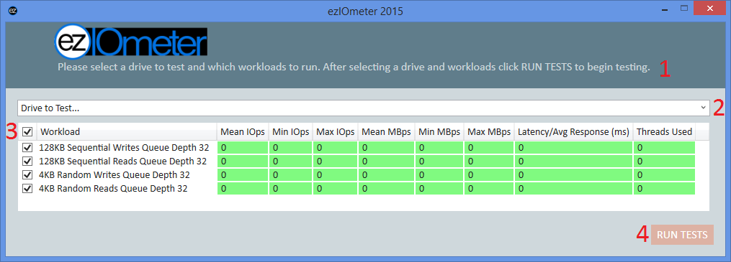

1. General Instructions to begin testing a drive.
2. Drop down list of testable drives
3. Checked boxes indicate a workload to run on a selected drive.
4. Click “RUN TESTS” to run the selected test(s) on the specified drive.

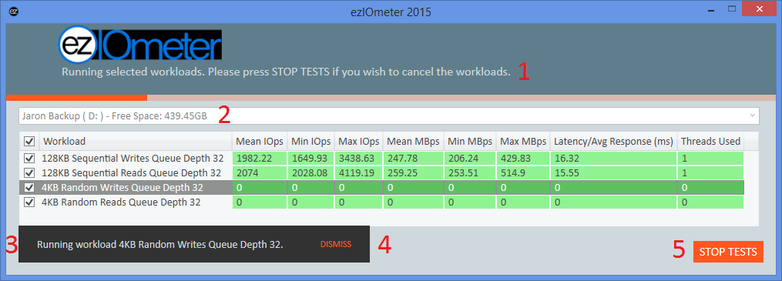

1. General Instructions to stop all tests.
2. The drive currently being tested.
3. The workload currently running
4. To hide the “Running workload …” message, click “DISMISS”
5. To stop all workloads, click “STOP TESTS”

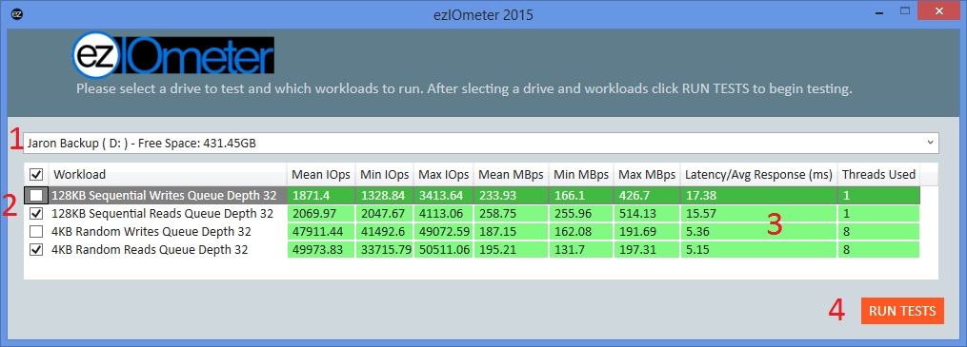

1. The drive selected for testing
2. The selected workloads
3. Previous testing results
4. Select RUN TESTS to run the selected tests.

# ezIOmeter Overview

ezIOmeter is a Windows-based client benchmark tool optimized for NVMe* storage devices. ezIOmeter utilizes Iometer 1.1’s command line functionality to run industry trusted Iometer tests. ezIOmeter currently supports 64-bit Windows 7, 8, 8.1, 10 operating systems.

ezIOmeter was created to simplify the user experience when using IOmeter. IOmeter has an infamous reputation on being difficult to use. This is one solution to provide NVMe* testing capability while also being easy and fast to use.

This guide is intended for publications, OEMs, technical analysts, and individuals who plan to test or evaluate Client NVMe based drives for performance benefits and features. This guide gives specific and detailed instruction on how to use ezIOmeter.

This guide is significant due to the technology transition from AHCI (SATA) based SSDs to NVMe* /PCIe* based SSDs. Performance benchmarks originally designed for SATA SSDs are not optimized for NVMe SSDs. Hence, the results reflected in these benchmarks may never read maximum performance values stated in the product specification. NVMe allows multiple CPU queues with deep queue depths (up to 64K outstanding IOs). To date, NVMe* benchmark tools are lacking in numbers compared to AHCI (SATA) benchmarking tools.

For the latest on NVMe technology, go to <http://www.nvmexpress.org/>.

# 1.1 System Requirements

To ensure optimal tool performance, your system will need to meet the following hardware and software requirements.

Note: ezIOmeter depends upon the .Net 4.5 ( <http://www.microsoft.com/en-us/download/details.aspx?id=30653> ) runtime. ezIOmeter also has a runtime dependency upon the MathNet (<http://www.mathdotnet.com/>) numerics library (This lib might be removed from the ezIOmeter package or the dependency upon the library removed at a later time.)

| Title | Requirement Summary |
| --- | --- |
| System Recommendation for best drive performance  (optional) | For optimal performance analysis of the drive, we recommend having a CPU with four cores (with hyper-threading) or more to fully utilize NVMe capabilities.  Many items can impact storage subsystem performance. Virus scanners and other various Windows based services can induce run to run variation.  Make sure no other programs, such as a video card control panel, virus scanning software, etc., are running in the background at the same time as the workload. To ensure consistency, be sure to disable the following:   * Screen Saver – Disabled * Power Management – High Performance   + Turn off the Display - Never   + Put the Computer to Sleep – Never   + Hibernate after - Never * Windows Defender/System Protection – Disabled * Automatic Windows Updates – Disabled * Disk Defragmentation – Disabled   Any other Virus Protection – Disabled |

OPTIONAL:

The objective is to disable any automatic services which may interrupt or disrupt the performance test. Once complete, the next step is to set up permissions for IOMeter:

* Open the directory to IOMeter, right click on the IOMeter.exe icon and click Properties.
* Click on the Compatibility tab and check Run this program as an administrator.
* Click Apply.
* Repeat for Dynamo.exe.

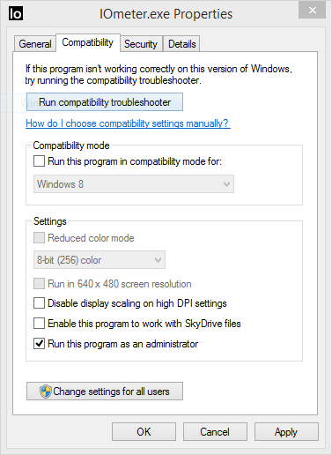 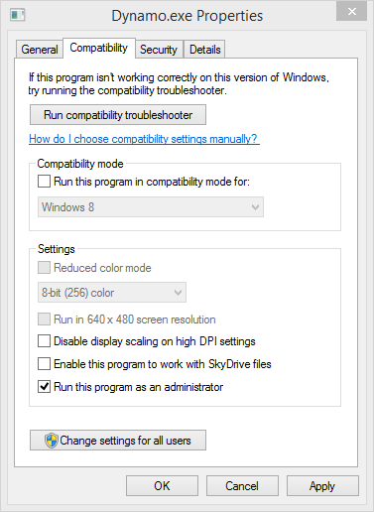

* Once complete, double click on **IOMeter** and accept the terms and conditions.

# 1.2 Installation

Note: The default install location is (C:\Program Files(x86)\ezIOmeter )

1. Locate ezIOmeterSetup.exe on your computer.
2. Double click the file
3. Run “**ezIOmeterSetup.exe**”
4. Click **Yes** if prompted with a **User Account Control** prompt.
5. Click **Next >**.

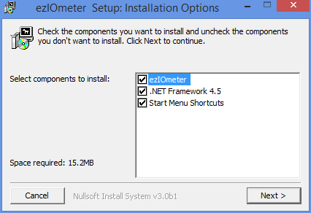

1. Click **Install**

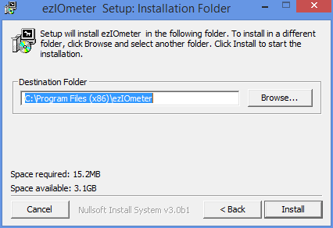

1. Click **Close**

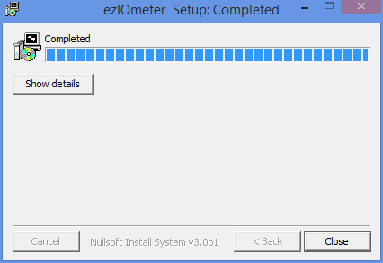

**You are now ready to use ezIOmeter!**

# 2. How to Use ezIOmeter

1. Launch **ezIOmeter** from your start menu.

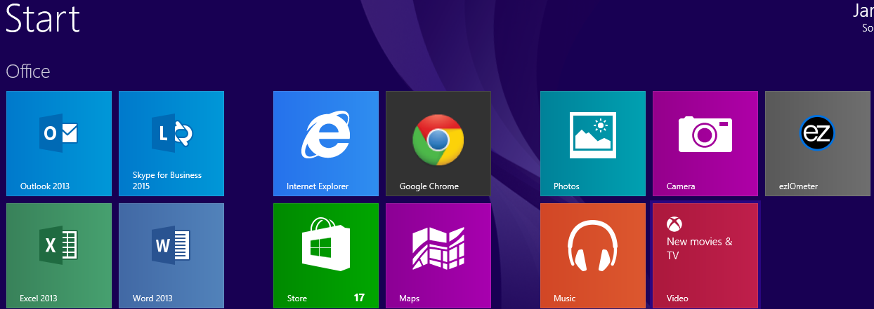

1. Click **Yes** if prompted with a **User Account Control** prompt.
2. Select the “**Drive to Test…”** which is the drive the benchmark will test.

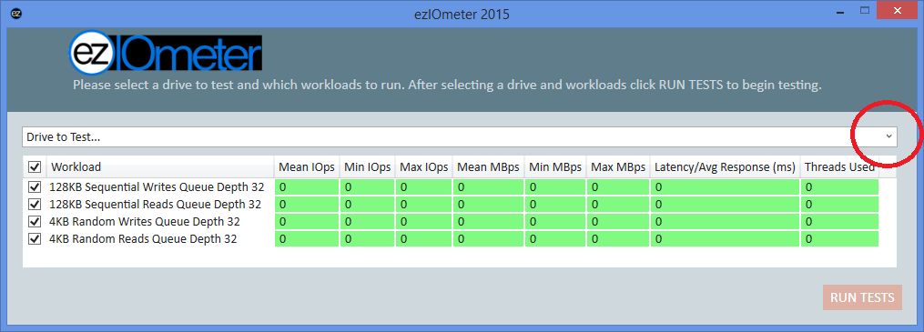

*Note: For* ***optimal*** *results, the selected drive* ***must*** *be connected to the computer as a secondary drive and* ***must*** *be partitioned and visible in Windows* before drive will be testable.*

1. Select the workloads to run by selecting or deselecting the check boxes.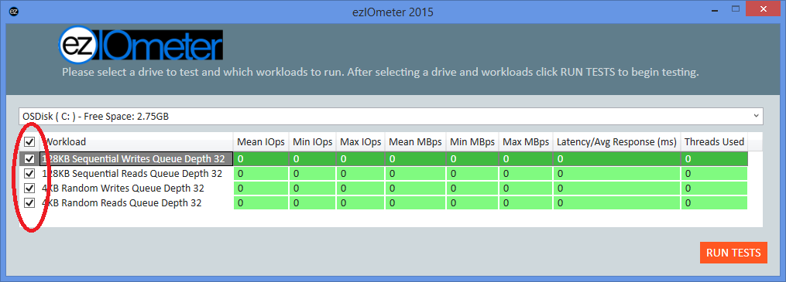
2. .Click **RUN TESTS** to run the benchmark.

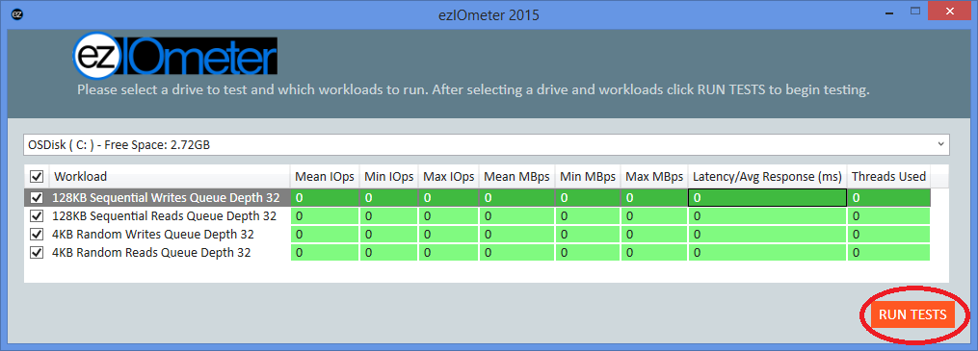

# *Note: Sections 3.1-3.3 are for advanced users and are completely optional (to customize and configure ezIOmeter)

# *3.1 Settings Configuration File ( settings.conf )

The settings file can be found at the **ezIOmeter install path**. The **settings.conf** file is used to modify ezIOmeter’s runtime settings.

Example settings.conf:

*# Number of seconds each workload is run.*

*workload_duration_sec=120*

*# A comma seperatd list to determine what order to run workloads.*

*# Note: Use same name as .icf but wihtout the extension.*

*workload_run_order=128KB Sequential Writes Queue Depth 32,128KB Sequential Reads Queue Depth 32,4KB Random Writes Queue Depth 32,4KB Random Reads Queue Depth 32*

*# Number of seconds to wait before preforming the next workload.*

*sleep_between_tests_sec=5*

*# Mean IOps*

*mean_iops_bucket_order=backward*

*mean_iops_bucket0=999999999*

*mean_iops_bucket1=999999999*

*# Stdev IOps*

*stdev_iops_bucket_order=backward*

*stdev_iops_bucket0=999999999*

*stdev_iops_bucket1=999999999*

*# Min IOps*

*min_iops_bucket_order=backward*

*min_iops_bucket0=999999999*

*min_iops_bucket1=999999999*

*# Max IOps*

*max_iops_bucket_order=backward*

*max_iops_bucket0=999999999*

*max_iops_bucket1=999999999*

*# Mean MBps*

*mean_mbps_bucket_order=backward*

*mean_mbps_bucket0=999999999*

*mean_mbps_bucket1=999999999*

*# Stdev MBps*

*stdev_mbps_bucket_order=backward*

*stdev_mbps_bucket0=999999999*

*stdev_mbps_bucket1=999999999*

*# Min MBps*

*min_mbps_bucket_order=backward*

*min_mbps_bucket0=999999999*

*min_mbps_bucket1=999999999*

*# Max MBps*

*max_mbps_bucket_order=backward*

*max_mbps_bucket0=999999999*

*max_mbps_bucket1=999999999*

*# Latency*

*latency_bucket_order=backward*

*latency_bucket0=999999999*

*latency_bucekt1=999999999*

**workload_duration_sec:**

The **workload_duration_sec** is used to determine the number of seconds that a particular workload will be run for.

**workload_run_order:**

The **workload_run_order** is used to determine the order that the IOmeter workloads will be run in. The accepted value for the **workload_run_**order is s a **comma** **separated list** (With no spaces) of .icf file names. The .icf file names must match the names in the list minus the file extension to work correctly.

**sleep_between_tests_sec:**

The **sleep_between_tests_sec** is used to determine the number of seconds to let the system settle before running the next workload.

**mean_iops_bucket_order, stdev_iops_bucket_order, min_iops_bucket_order, max_iops_bucket_order, mean_mbps_bucket_order,** **stdev_mbps_bucket_order, min_mbps_bucket_order, max_mbps_bucket_order and latency_bucket_order:**

**Note: The bucket order functionality has been left out by default via the bucket values. All results are left green for evaluation purposes. The functionality is left for the user to decide how they want to evaluate their storage devices.**

The **x_bucket_order** (x being the name of the bucket order) is used to determine if the value is within the specified bucket range and if the value has to be above or below the specified range value. Setting the **x_bucket_order** to **forward** means that the values have to be above the specified bucket values in order to be within that bucket range. Setting the **x_bucket_order** to **backward** means that the values have to be below the specified bucket values in order to be within that bucket range.

**mean_iops_bucket0, stdev_iops_bucket0, min_iops_bucket0, max_iops_bucket0, mean_mbps_bucket0, stdev_mbps_bucket0, min_mbps_bucket0, max_mbps_bucket0 and latency_bucket0:**

The **x_bucket0** (x being the name of the bucket) is used to determine if the collected value is within the specified target range.

Collected test values **must** be **above** the specified **x_bucke0** but below **x_bucket1** to be placed into the next threshold category and be assigned a background color of yellow

* If **x_bucket_order** is assigned a value of **forward** then **x_bucket0** represents the threshold for the lowest category and is assigned a background color of red. I.E.
  + 0 ≤ Result < x_bucket0 would be red.
  + x_bucket0 ≤ Result < x_bucket1 would be yellow.
  + x_bucket1 ≤ Result would be green.
* If **x_bucket_order** is assigned a value of **backward** then **x_bucket0** represents the threshold for the highest category and is assigned a background color of green. I.E.
  + 0 < Result ≤ x_bucket0 would be green.
  + x_bucket0 < Result ≤ x_bucket1 would be yellow.
  + x_bucket1 < Result would be red.

# *3.2 IOmeter Configuration Files ( .icf )

The **IOmeter Configuration Files** are the setting files that make up the individual workloads. These files can be modified using **iometer.exe** witch can be found at **ezIOmeter install path\IOmeter**.

*Note: The name of the* ***Test Description*** *must match the name in the* ***settings.conf*** *file for the* ***workload_run_order*** *list.*

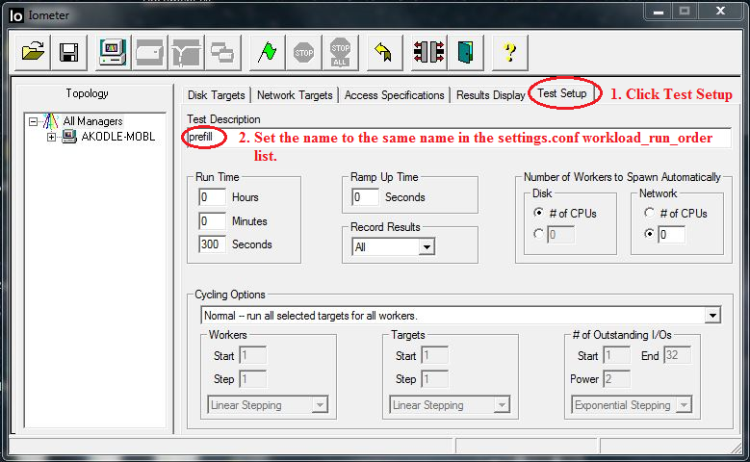

# *3.3 Running ezIOmeter Command Line

1. Launch a **cmd** window with **Elevated Privileges**.

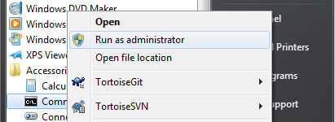

1. Click **Yes** if prompted with a **User Account Control** prompt.
2. Navigate to “**C:\Program Files (x86)\ezIOmeter”**

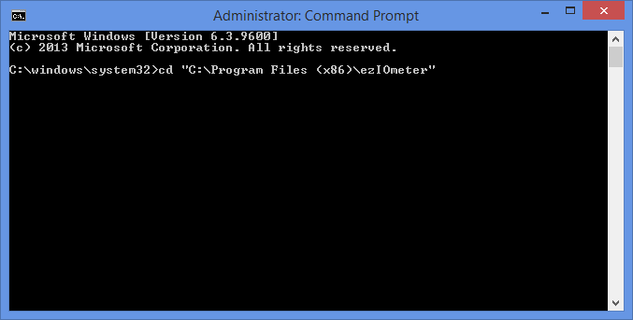

1. Run **“ezIOmeter.exe /D d”** to run ezIOmeter targeting the **D:** drive connected to the computer as a secondary drive.

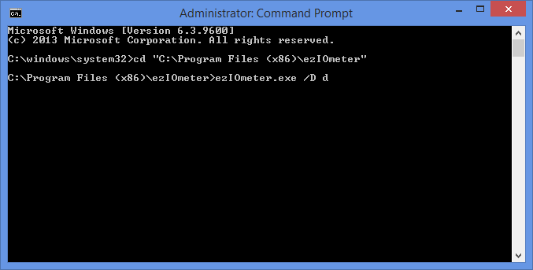

1. Click **OK**, if prompted to open a port.
2. **Wait** for the benchmark to complete.

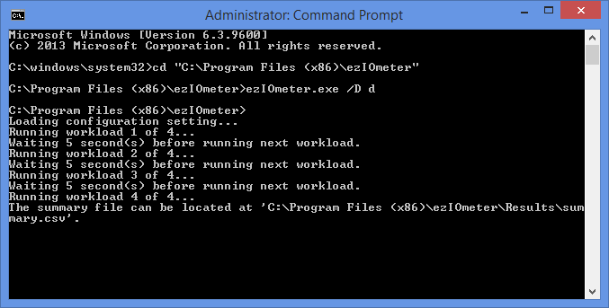

1. Open the **summary.csv** file located at **“C:\Program Files (x86)\ezIOmeter \Results\”** to view the summary data (Intel 320 series example run).

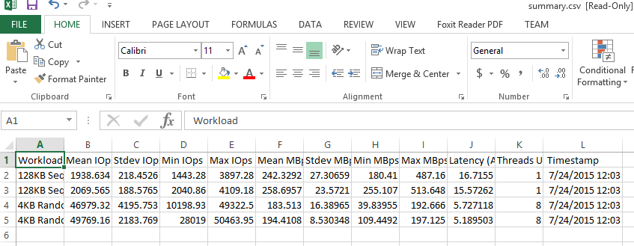

# 4. How to Uninstall ezIOmeter

1. Locate the uninstall.exe file in (C:\Program Files(x86)\ezIOmeter\uninstall.exe ).

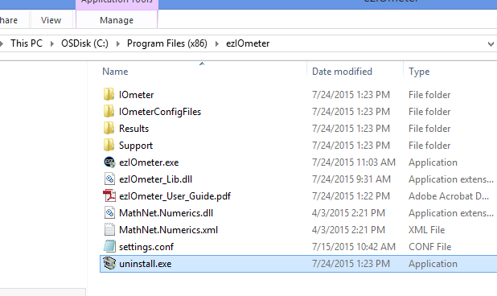

1. Double click and follow on-screen instructions to uninstall

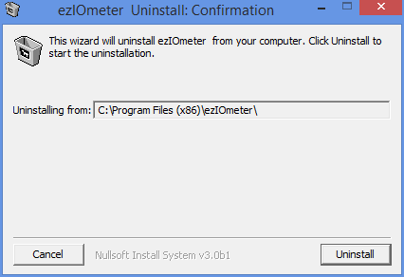

# 5. Troubleshooting

1. When testing for the first time, ezIOmeter may need to prepare the drive for testing. This can take up to an additional five minutes.
2. If the drive you intend to test is not being picked up in the ezIOmeter drop down menu, ensure that the drive is properly attached to the computer and is formatted. The storage drive must be formatted in order to be tested.
3. You will need to restart ezIOmeter if you unplug a storage device while ezIOmeter is running.
4. If you “Stop Tests’ before a drive is done preparing, manually exit out of Dynamo.
5. An 8GB test file (“iobw.tst”) is created when you run tests using ezIOmeter. ezIOmeter attempts to delete the “iobw.tst” file after and before every test run. If you click “Stop Tests” before a drive is prepared, ezIOmeter cannot delete the file because Dynamo is using it to prepare the drive. You will either have to start up another test again and run all the way through to delete the file or manually delete the file. This file is typically located at the root directory of the tested drive.

# FAQ

* 1. Where is ezIOmeter installed by default?

C:\Program Files(x86)\ezIOmeter

* 1. Where is the configuration settings file located?

C:\Program Files(x86)\ezIOmeter\settings.conf

* 1. Where can I find a summary of my results?

C:\Program Files(x86)\ezIOmeter\Results\summary.csv

* 1. How do I know if my drive is preparing or actually running a test (performing I/O)?
     1. There is a second application that opens once testing and preparing begins. Dynamo is the application that works alongside IOmeter. Here you can view Dynamo’s output.
     2. If Dynamo’s Console displays “Preparing Disks….” Then the drive is being prepared. For example: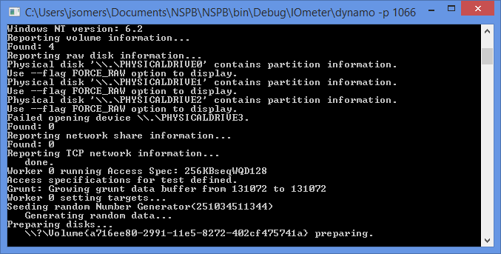
     3. If Dynamo’s console displays “Beginning to perform I/O…” then the test is being ran. For example,

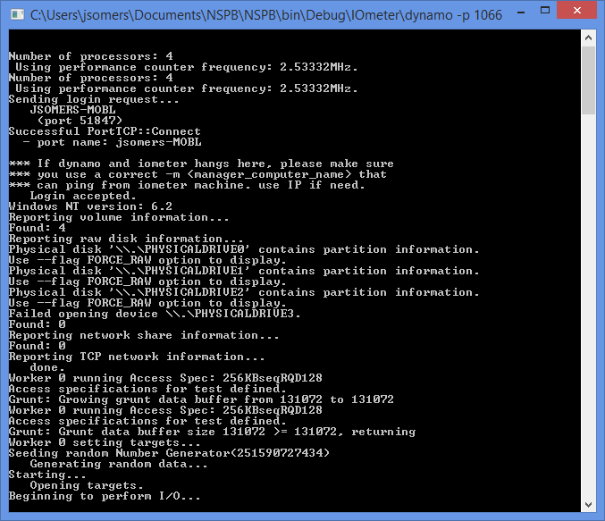

# How to Contribute

Below indicates the steps you can take to contribute to the progression of ezIOmeter!

<TBD once github is setup>