Linux Programming
Practice lab
Name:M.CHAITHANYA
reg.no:17MIS1015

Scripts:

apt-get install sl
sl
sl is for:
You might be aware of command ‘ls‘ the list command and use it frequently to view the contents of a folder but because of miss-typing sometimes you would result in ‘sl‘, how about getting a little fun in terminal and not “command not found“.
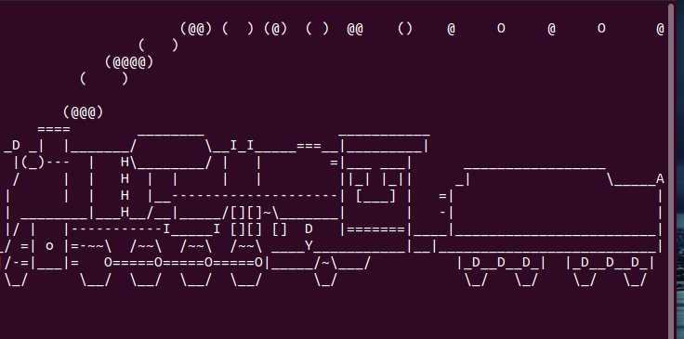

Rev commond:

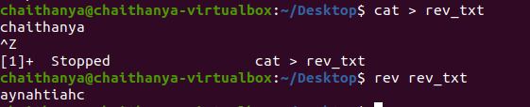

factor Comand in Linux: prints all the prime factors of the number

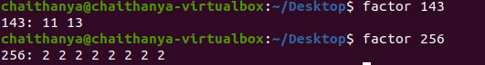
yes Command in Linux: it prints out the given string continously . If no string is given then it prints y
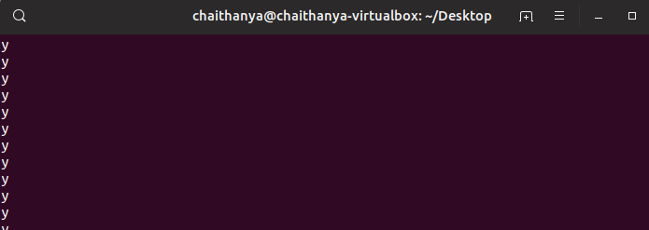
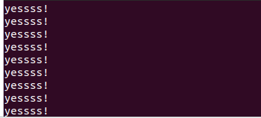

Removes all files with the extension .txt from the current directory. Here, yes outputs a constant stream of "y" characters, and that output is piped to the rm -i command, which prompts for confirmation before deleting each file. The y characters from the yes command will respond "yes" to each prompt automatically.

Here, the yes command outputs "n" in a constant stream to the rm -i command, answering "no" to all the same questions. Therefore, this command deletes no files.

Write a C program to implement Simple reader – writer algorithm using shared memory segment with semaphore

read.c
#include <iostream>
#include <sys/ipc.h>
#include <sys/shm.h>
#include <stdio.h>
using namespace std;

int main()
{
// ftok to generate unique key
key_t key = ftok("shmfile",65);

// shmget returns an identifier in shmid
int shmid = shmget(key,1024,0666|IPC_CREAT);

// shmat to attach to shared memory
char *str = (char*) shmat(shmid,(void*)0,0);

printf("Data read from memory: %s\n",str);

//detach from shared memory
shmdt(str);

// destroy the shared memory
shmctl(shmid,IPC_RMID,NULL);

return 0;
}

write.c

#include <iostream>
#include <sys/ipc.h>
#include <sys/shm.h>
#include <stdio.h>
using namespace std;

int main()
{
// ftok to generate unique key
key_t key = ftok("shmfile",65);

// shmget returns an identifier in shmid
int shmid = shmget(key,1024,0666|IPC_CREAT);

// shmat to attach to shared memory
char *str = (char*) shmat(shmid,(void*)0,0);

cout<<"Write Data : ";
cin>>str;

printf("Data written in memory: %s\n",str);

//detach from shared memory
shmdt(str);

return 0;
}
Output:
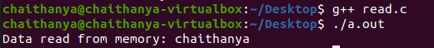

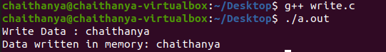

HOT Question
•Write a bash shell script to monitor the health of your system. Let the details be stored and archived in any folder of your choice.

r.sh
top -b -d 1 -n 5 >> r.txt
echo " "
echo "Memory Stats"
free -m >> r.txt
echo " "
echo "Netw. Stats"
netstat >> r.txt
echo " "
echo "CPU Load and Vmstat"
vmstat -s >> r.txt
Output:
