IEEE FSB RAS SBC (TUNISIA) × IEEE AESS (JORDAN) ROBOTICS BOOTCAMP
Session 04: Robot Communication, Beacons & Spatial Memory
Comprehensive Technical Monograph, Lecture Compendium & Guest Speaker Script
Invited Guest Speaker: Mouhamed Boughrara | Senior Autonomous Robotics Systems Engineer
Target Audience: IEEE Engineering Students, RAS & AESS Members | Series: Session 04 / 04 (Capstone Finale)
Accompanying Slide Deck: Robotics_Fundamentals_Session_04_Robot_Communication_Beacons_Spatial_Memory.pptx

1. Executive Summary & Series Synthesis
The 4-part joint robotics bootcamp co-hosted by the IEEE FSB RAS Student Branch Chapter (Tunisia) and IEEE Aerospace and Electronic Systems Society (Jordan) was designed as a comprehensive progressive curriculum. Across the first three sessions, earlier instructors and mentors guided the participants through fundamental single-robot disciplines, setting the stage for this capstone keynote:
- Session 01 (Wireless Communication): Taught by earlier instructors to establish data link fundamentals: RF protocols, packet serialization, CRC validation, latency constraints, and baud rate optimization.
- Session 02 (Embedded Robotics and Robot Control): Taught by earlier mentors to address physical actuation: brushed/brushless motors, H-bridge driver topology, encoder decoding, and closed-loop PID control.
- Session 03 (Autonomous Navigation, Localization and Mapping): Delivered in the prior session to introduce single-agent spatial intelligence: 2D LiDAR SLAM, AMCL particle filtering, costmap layers, and Nav2 path planning.
- Session 04 (Swarm Synthesis & Spatial Memory — Today's Capstone): Delivered by invited guest speaker Mouhamed Boughrara to synthesize those foundational building blocks into a distributed multi-agent swarm architecture utilizing ROS 2 DDS middleware, Ultra-Wideband (UWB) beacon trilateration, active safety envelopes, and persistent topological world memory.
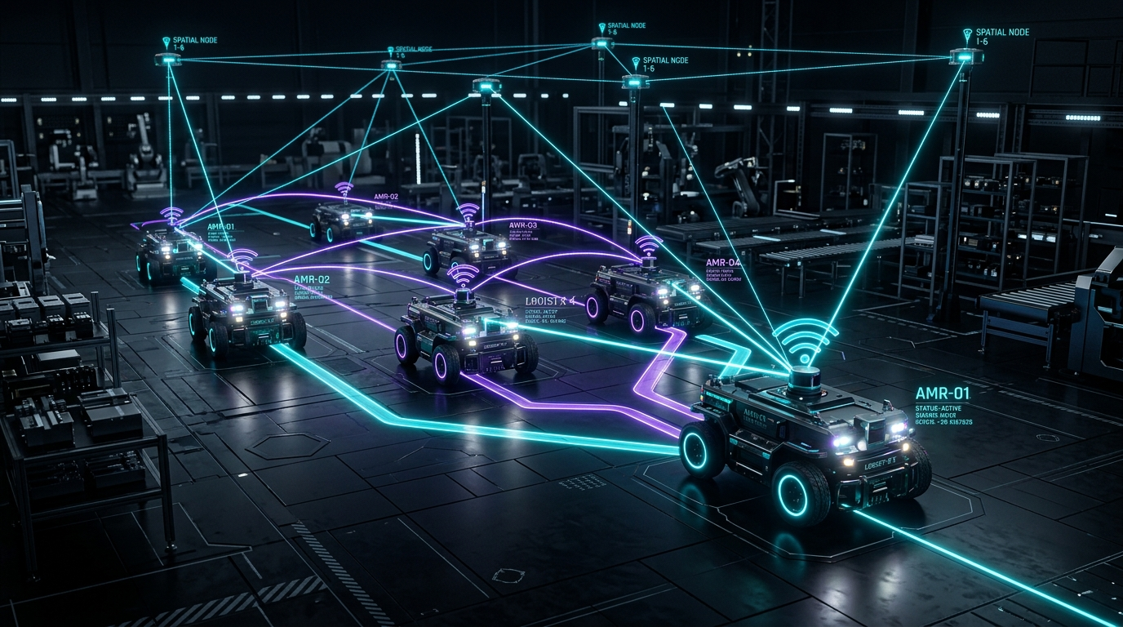
Figure 1: Cybernetic 3D conceptual architecture of multi-AMR cooperative swarm communicating across spatial localization beacons via illuminated data links.

2. Slide-by-Slide Technical Guide & Guest Speaker Scripts

Slide 1: Title Slide — Swarm Synthesis
• Slide Title: Robot Communication, Beacons & Spatial Memory
• Subtitle: Synthesizing Multi-Robot Coordination and Persistent World Models
• Attribution: Mouhamed Boughrara | IEEE FSB RAS SBC (Tunisia) × IEEE AESS (Jordan)
🎙️ Guest Speaker Spoken Script — Slide 1
"Marhaba and good evening everyone! A warm welcome to all the engineering students, IEEE members, and robotics enthusiasts joining us tonight from IEEE FSB RAS Student Branch Chapter in Tunisia, IEEE Aerospace and Electronic Systems Society in Jordan, and across the MENA region.
I am Mouhamed Boughrara. I work as an Autonomous Systems Engineer and Tech Lead, and it is an absolute honor to join you tonight as your guest speaker for this fourth and final session of our joint robotics bootcamp.
Over the past three sessions, your instructors and mentors guided you through the fundamental building blocks of autonomous robotics: you explored Wireless Communication, Embedded Robotics and Robot Control, and most recently Autonomous Navigation, Localization and Mapping.
That is a fantastic foundation. But when the IEEE organizing committees invited me to speak for this capstone finale, they asked me: 'Mouhamed, how do we take our students from a single autonomous robot to an industrial multi-robot fleet?' Because in modern robotics—whether in automated warehouse logistics, search-and-rescue response, or planetary exploration—a single robot is never enough. In industry, robots operate as cooperative teams. Tonight, we connect everything you learned into a complete, scalable swarm architecture. Let's dive in!"

Slide 2: Bootcamp Synthesis & Session Objectives
The roadmap bridges local motor control and single-agent mapping into a multi-agent distributed system characterized by three core technological pillars:
- Pillar 1 — Inter-Robot DDS Communication: Topic synchronization, peer-to-peer discovery, domain segmentation, and bandwidth throttling.
- Pillar 2 — Beacon-Based Localization: Absolute Time-of-Flight (TOF) UWB ranging and 6-DOF ArUco visual docking.
- Pillar 3 — Distributed Spatial Memory: Persistent global occupancy grids, topological waypoint graphs, and multi-robot map merging.
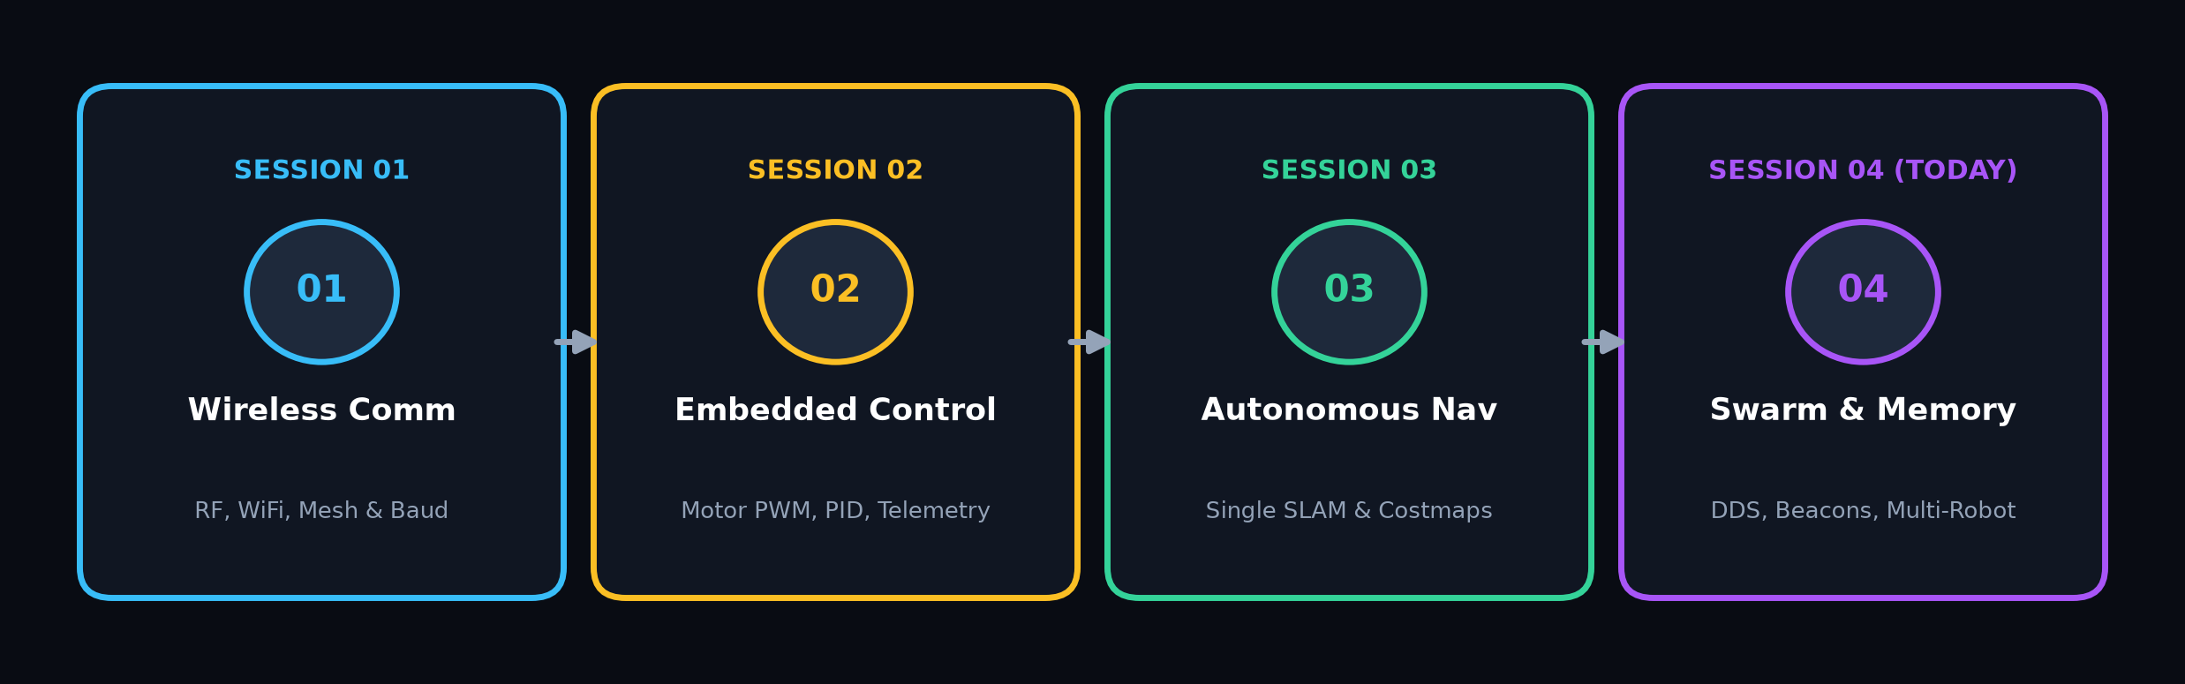
Figure 2: 4-Stage horizontal bootcamp progression tracking Sessions 1 (Wireless) -> 2 (Control) -> 3 (SLAM) -> 4 (Swarm Memory).
🎙️ Guest Speaker Spoken Script — Slide 2
"Look at this 4-step roadmap across Slide 2. Let's appreciate the journey your bootcamp organizers designed for you:
In Session 01, you covered Wireless Communication. In Session 02, you stepped into the physical hardware: Embedded Robotics and Robot Control. In Session 03, you tackled Autonomous Navigation, Localization and Mapping.
Now, look at where we stand today in Session 04. My goal tonight as your guest speaker is to synthesize those three foundations into three advanced multi-robot pillars: Inter-Robot DDS Communication, Beacon-Based Localization, and Distributed Spatial Memory.
💬 Chat Poll: Quick question for everyone who followed the previous sessions: When you were learning about Robot Control in Session 2 or Navigation in Session 3, what felt like the biggest challenge? [A] Motors drawing sudden surge current and browning out the microcontroller, [B] Wheel odometry drifting away as soon as the robot turned, or [C] Network packets dropping when moving away from the access point. Drop A, B, or C in chat right now!"

Slide 3: Multi-Robot Communication Infrastructure (ROS 2 & DDS)
Traditional robotic systems built on ROS 1 depended on roscore—a centralized master node. If roscore dropped, the entire fleet stalled. ROS 2 solves this by adopting Data Distribution Service (OMG DDS) as its middleware layer.
- Decentralized P2P Discovery: Robots discover each other automatically over UDP multicasting without single-point broker bottlenecks.
- Domain Segmentation: Utilizing ROS_DOMAIN_ID (e.g., Domain 42) to isolate swarm telemetry from broader campus Wi-Fi broadcast noise.
- Quality of Service (QoS) Strategy: Critical state (/robot_state) uses Reliable + Transient Local durability to prevent packet loss. High-rate sensors (/scan) use Best Effort + Volatile durability to prevent network buffer bloat and latency spikes.
- Network Attenuation Simulator: Modeling packet dropouts (1–5%) and simulated Rayleigh signal fading as inter-robot Euclidean distance expands.
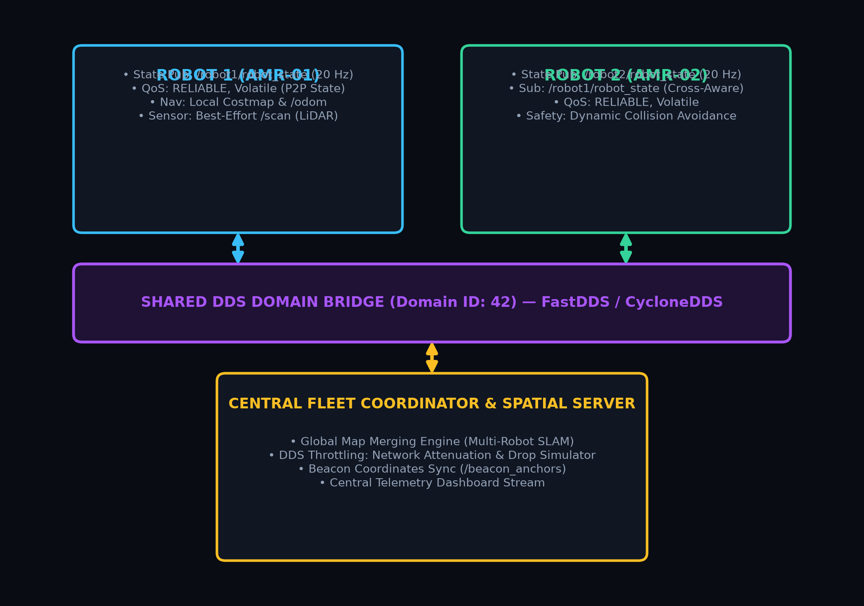
Figure 3: System architecture diagram displaying two ROS 2 nodes on separate robots exchanging Twist and Odometry over a shared DDS domain bridge.
🎙️ Guest Speaker Spoken Script — Slide 3
"Let's build upon the Wireless Communication concepts you explored in Session 1, but scale them up to ROS 2 multi-agent robotics.
If you configure RELIABLE QoS for a 30 Hz raw LiDAR point cloud over Wi-Fi, you will saturate your wireless bandwidth. Unacknowledged packets will queue up, latency will spike, and your robot will react to obstacles that were there two seconds ago! For dense sensor data, you must always choose BEST_EFFORT.
Quick networking check for the chat: If Robot A is broadcasting on ROS_DOMAIN_ID=10 and Robot B is listening on ROS_DOMAIN_ID=20, both on the exact same Wi-Fi router... can they hear each other's topics? Drop YES or NO in chat!
I see unanimous 'NO's! Exactly right! And remember this during your senior design projects: when your teammate runs into the lab shouting 'ROS 2 is broken, nothing is publishing!', check your ROS_DOMAIN_ID before you spend three hours reinstalling Ubuntu!"

Slide 4: Beacon-Based Relative & Absolute Localization
Wheel odometry accumulates unbounded integration drift over time due to wheel slip, floor traction changes, and mechanical tolerances. To bound this error, absolute external anchors are required.
- Ultra-Wideband (UWB) Anchors: Emits sub-nanosecond pulses across wide RF bands (3.5–6.5 GHz). Two-Way Time-of-Flight (TWR) yields centimeter-level distance ranging (< 10 cm), penetrating dust, smoke, and optical occlusions.
- Visual Fiducials (ArUco / AprilTag): 6-DOF relative transformation (T_tag^cam in SE(3)) estimated via monocular RGB cameras and Perspective-n-Point (PnP) solving.
- Trilateration Mathematical Formulation: Each anchor provides a distance constraint d_i = sqrt((x - x_i)^2 + (y - y_i)^2) + eps_i. Non-linear least squares optimization solves for the optimal 2D coordinates (x, y) over 3+ static anchors.
- Extended Kalman Filter (EKF) Fusion: Combines high-rate wheel odometry prediction (50 Hz) with asynchronous absolute UWB beacon distance correction updates.
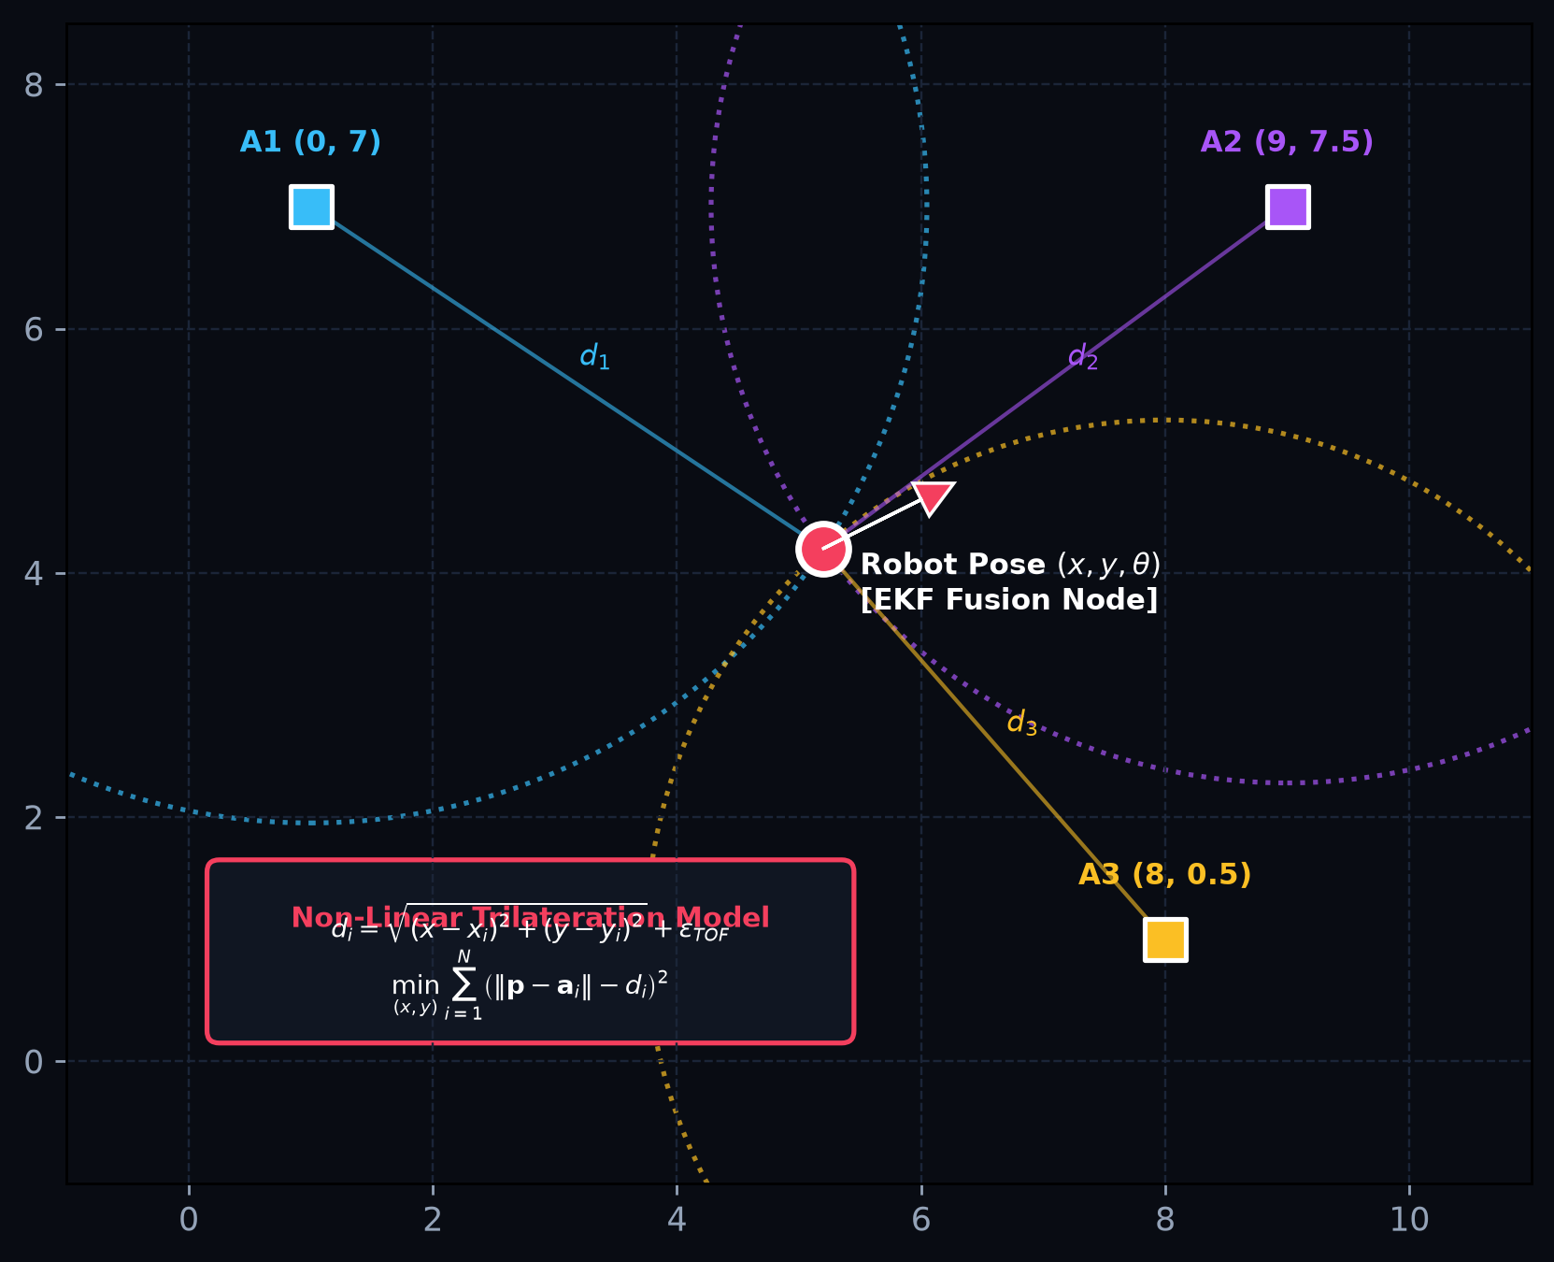
Figure 4: Technical schematic of mobile robot inside a room with 3 static corner beacons (anchors), showing intersection circles and EKF fusion block.
🎙️ Guest Speaker Spoken Script — Slide 4
"In Session 2, you learned about wheel encoders and motor control. And in Session 3, you saw how odometry feeds into localization. Here is the hard truth every autonomous systems engineer faces: pure wheel odometry always drifts.
To achieve robust, all-day autonomy, we introduce external spatial anchors: UWB anchors for smoke/dust penetration and ArUco markers for millimeter-precise docking. What is a Kalman Filter in plain English? A Kalman Filter is an emotionally mature algorithm: it doesn't fully trust your noisy sensor measurements, but it also doesn't fully trust its own mathematical physics model. It balances the two with healthy skepticism—which is the best mindset for any robotics engineer!"

Slide 5: Spatial Memory & Persistent World Models
Autonomous mobile fleets require a multi-tiered spatial memory architecture that separates short-term dynamic obstacles from long-term topological environment features.
- Local Dynamic Rolling Memory: High-rate (20–50 Hz) rolling costmap (e.g., 4m x 4m) centered on base_link. Clears dynamic obstacles (pedestrians, forklifts) via voxel ray-tracing with zero disk persistence.
- Global Metric Memory: Persistent Occupancy Grids where each cell stores log-odds occupancy probability: Free (0), Occupied (100), Unknown (-1), saved in SQLite/PGM files across reboots.
- Topological Graph Memory: Sparse graph G = (V, E) of navigable waypoints (Charging Station, Aisle 3, Docking Bay) and edge traversal costs.
- Multi-Robot Map Merging: Iterative Closest Point (ICP) scan matching and Procrustes analysis aligns separate origin frames into a unified global coordinate system.
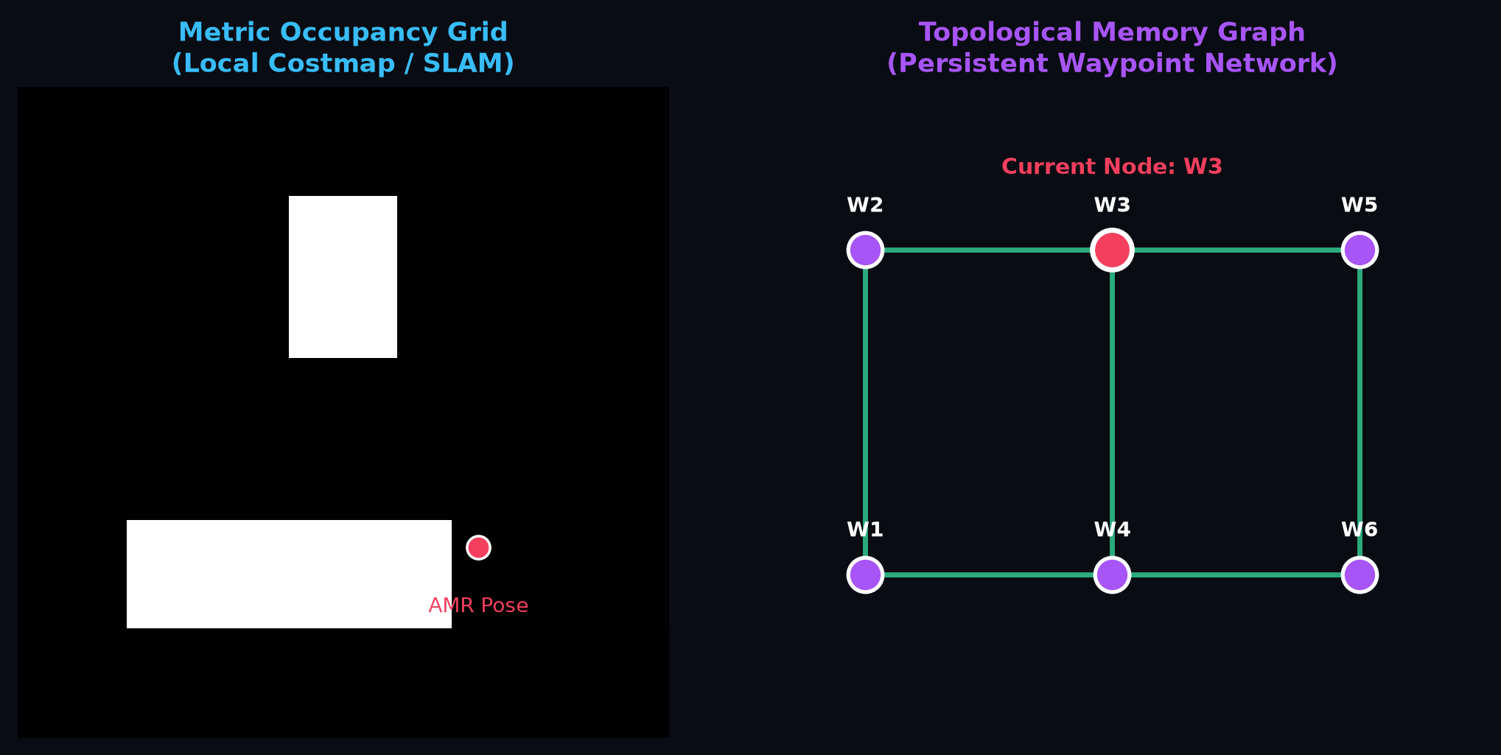
Figure 5: Side-by-side comparison diagram illustrating a metric occupancy grid on the left and a topological memory graph overlay on the right.
🎙️ Guest Speaker Spoken Script — Slide 5
"In Session 3, your instructors introduced you to 2D SLAM and costmaps. But in commercial systems, what happens when a robot reboots or a team of 10 robots enters a large facility? You cannot have each robot start from zero every morning.
We separate short-term rolling costmaps from long-term topological waypoint graphs. When multiple robots explore different wings of a building, we use Multi-Robot Map Merging (ICP scan matching) to fuse their maps into one global coordinate system. What one robot explores becomes shared memory for the entire fleet!
💬 Audience Poll: If you are managing 20 AMRs in a 50,000 m² warehouse, would you stream full dense point clouds over Wi-Fi continuously, or would you synchronize a sparse topological waypoint graph? Drop 'POINT CLOUD' or 'GRAPH' in chat!"

Slide 6: Algorithmic Logic — Pure Pursuit & Safety Envelopes
Path tracking must accommodate both vehicle kinematics and active physical safety constraints in dense industrial environments.
- Pure Pursuit Kinematics: Computes instantaneous steering curvature kappa = (2 * sin(alpha)) / L using lookahead distance L.
- Speed-Adaptive Lookahead: L(v) = k_v * v + L_min, dynamically contracting for tight corners at low speeds and expanding at cruising velocity to prevent path oscillation.
- Skid-Steer ICR Adaptation: 4-wheeled skid-steer AMRs experience significant lateral tire scrub. Effective track width is modeled as B_eff = chi * B (with chi = 1.35). Corrected yaw rate command: omega = chi * (v_R - v_L) / B.
- Emergency Stop Zone (< 0.45 m): Immediate zero-twist command dispatch (v=0, omega=0) and hardware e-brake latch, completely bypassing high-level planners.
- Proximity Corridor (0.45 m to 1.20 m): Dynamic linear velocity attenuation v = v_cmd * ((r - 0.45) / 0.75) coupled with artificial potential field lateral repulsion.
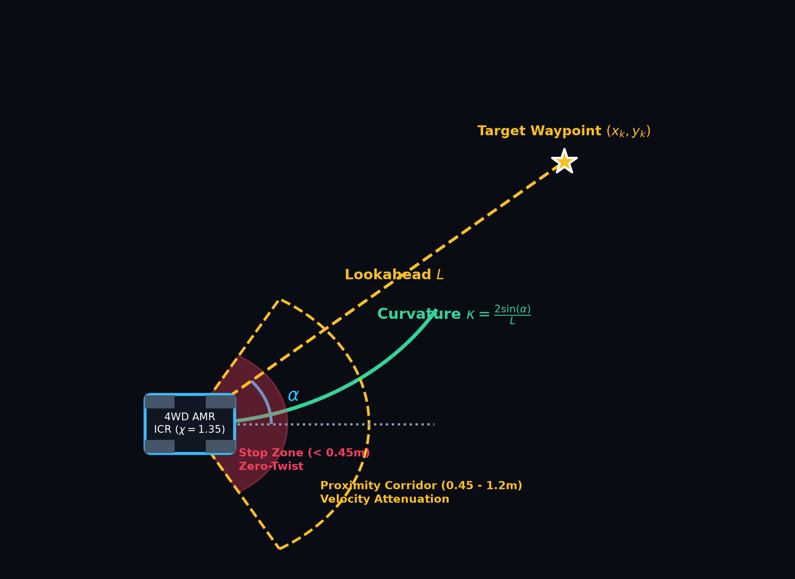
Figure 6: Pure pursuit kinematics diagram showing lookahead vector L, steering angle alpha, ICR slip compensation, and concentric dual safety envelope rings.
🎙️ Guest Speaker Spoken Script — Slide 6
"Now let's connect the Robot Control math from Session 2 with the Navigation concepts from Session 3 to execute paths safely.
In skid-steer vehicles, the wheels must slip laterally against the floor to execute a turn. To compensate for wheel scrub, we introduce an Instantaneous Center of Rotation (ICR) scaling factor chi = 1.35. Without this factor, your robot will suffer severe understeer during sharp turns!
And remember the number one rule of robotics safety: 'Hope is not a control strategy!' If your safety architecture depends on a high-level Python AI script running on an operating system before your 60 kg steel robot hits a concrete pillar... keep your soldering iron ready!"

Slide 7: Simulation Architecture in NVIDIA Isaac Sim 5.0
High-fidelity simulation enables comprehensive validation of multi-agent kinematics, sensor pipelines, and networking prior to physical deployment.
- USD Stage Engineering: Modular Universal Scene Description (USD) hierarchy segregating Warehouse Environment, UWB Anchors, AMR Articulations, and RTX Sensor Prims.
- PhysX 5 Dynamics: Accurate rigid-body tire-ground friction parameters (mu_static = 0.85, mu_kinetic = 0.65) and Continuous Collision Detection (CCD) preventing mesh tunneling.
- RTX Synthetic LiDAR: GPU-accelerated raytracing generates 360-degree point clouds and laser scans (/scan) at 60 FPS with zero CPU overhead.
- OmniGraph ROS 2 Bridge: Direct shared-memory binding of ROS 2 Context, Twist subscriber, Odometry publisher, and TF broadcasters.
- Workstation Performance Tuning: Decoupled 120 Hz physics sub-stepping with 60 Hz rendering ensures real-time simulation factor (RTF >= 1.0).
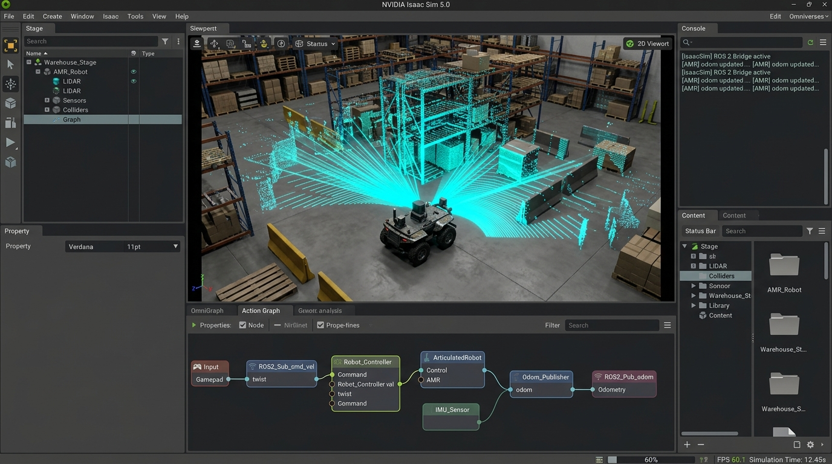
Figure 7: NVIDIA Isaac Sim 5.0 stage featuring synthetic RTX LiDAR point cloud rays and OmniGraph ROS 2 action node editor overlay.
🎙️ Guest Speaker Spoken Script — Slide 7
"How do we test multi-robot coordination, UWB trilateration, and path planning without risking hardware collisions in the lab? We build a physics-accurate digital twin using NVIDIA Isaac Sim 5.0.
PhysX 5 models realistic friction: static friction 0.85 and kinetic friction 0.65. With OmniGraph, we connect USD articulation joints directly to native ROS 2 topics in shared memory with zero serialization overhead! When your navigation stack outputs /cmd_vel, Isaac Sim reads it instantly, applies motor torque, and publishes /odom back to ROS 2."

Slide 8: Real-Time Network & Map Overlay Visualization
Production swarm operations require centralized operational visibility and diagnostic telemetry streaming.
- Dedicated Telemetry Companion: Lightweight Python/Qt/Web telemetry companion bridging ROS 2 DDS diagnostics to operators.
- Dynamic Robot Markers: Real-time tracking of AMR (x, y, theta) coordinates with oriented velocity vectors and battery SOC status.
- Static Beacon Overlay: Visual anchors displaying active UWB ranging rays, estimated trilateration confidence, and anchor health.
- Active Data Link Mesh: Animated glowing links indicating active DDS packet exchange between robots and base coordinator.
- Fleet Diagnostic Metrics: Live graphs for linear velocity, yaw rate, battery SOC, and localization discrepancy monitor (|p_odom - p_ekf|).
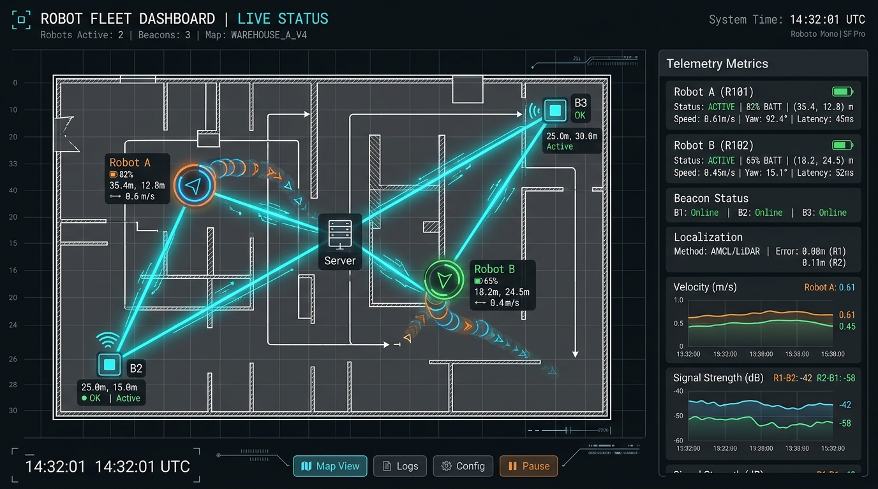
Figure 8: Dark-theme UI dashboard mockup showing 2D floorplan grid, color-coded robot nodes, dynamic line connections, and telemetry panels.
🎙️ Guest Speaker Spoken Script — Slide 8
"When deploying multiple AMRs in production, operators cannot look at terminal logs. You need a unified operational canvas. Look at the live map on Slide 8: Circular telemetry markers for Robot A and B, fixed square beacon anchors, and an animated data mesh color-coded by link latency.
And take special note of the Localization Discrepancy Metric (|p_odom - p_ekf|). If this metric spikes above 0.3 meters, the dashboard immediately alerts operators that a robot is experiencing severe wheel slip!"

Slide 9: Real-World Deployment & Hardware Considerations
Bridging the Sim-to-Real gap requires rigorous embedded hardware hardening, noise filtering, and failsafe architectures.
- Sim-to-Real Friction Transitions: Handling floor transitions (linoleum to concrete) and motor backlash.
- RF Multipath Interference: Industrial metallic shelving units reflect UWB RF pulses, causing non-line-of-sight (NLOS) errors; mitigated via Mahalanobis distance outlier rejection gating in the EKF.
- Power Domain Isolation: Isolated DC-DC converters and optocouplers prevent motor surge voltage dips (24V down to 14V) from browning out onboard single-board computers.
- Hardware Watchdog Co-Processor: Independent STM32 microcontroller cuts H-bridge motor power if ROS 2 DDS heartbeat ceases for > 200 ms.
- Industrial Applications: High-density warehouse fulfillment fleets (50+ AMRs), search-and-rescue response teams, and environmental monitoring swarms.
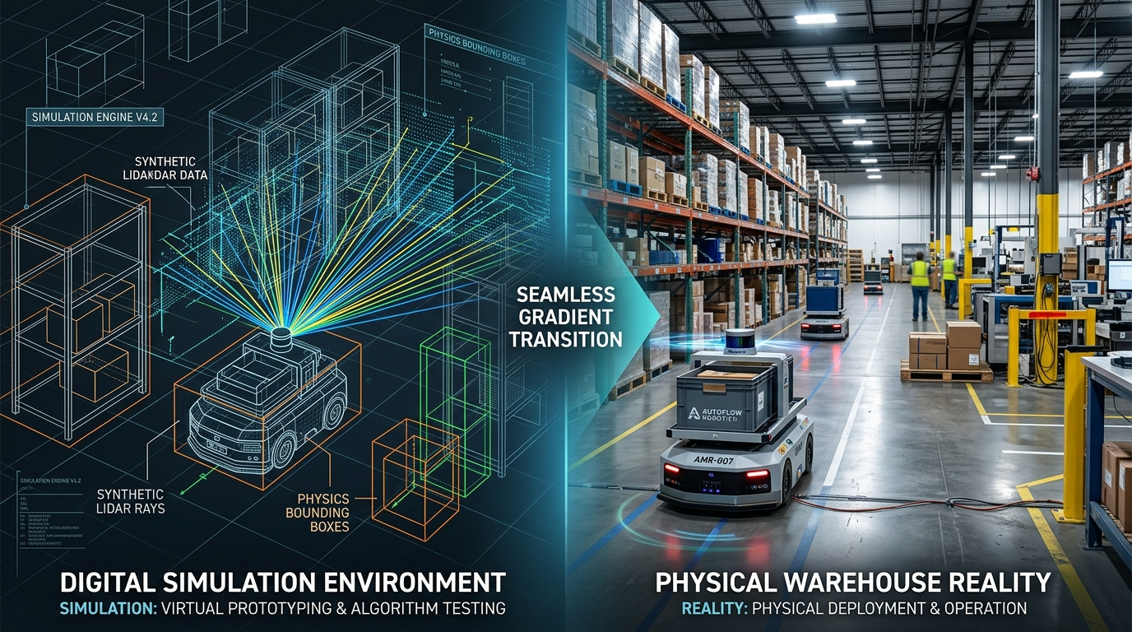
Figure 9: Split graphic contrasting synthetic digital simulation environment on left with physical industrial warehouse AMRs on right.
🎙️ Guest Speaker Spoken Script — Slide 9
"Now we arrive at what every robotics engineer must master: The Sim-to-Real Gap. Never power your single-board computer from the same unisolated power rail as your high-current drive motors! When four skid-steer motors draw stall current during an abrupt pivot, bus voltage can momentarily drop from 24V down to 14V. The motors will continue spinning, but your Jetson will brown out, reboot, and your robot will keep rolling blind! Always use isolated DC-DC converters and optocouplers.
And remember the classic robotics law of demos: 'The probability of hardware failure is directly proportional to the number of IEEE distinguished guests standing in the room.' That's why hardware watchdogs and failsafes exist—so you can demo with confidence!"

Slide 10: Conclusion, Resources & Q&A
The session concludes with key engineering synthesis principles, open-source resources, and an interactive Q&A forum.
- Key Takeaway 1 (DDS Middleware): Peer-to-peer transport with tailored QoS policies enables resilient swarm consensus without centralized broker bottlenecks.
- Key Takeaway 2 (Drift-Free Fusion): Fusing UWB Time-of-Flight ranging with persistent spatial memory completely bounds odometric drift.
- Key Takeaway 3 (Spatial Memory Hierarchy): Decoupling short-term dynamic costmaps from persistent topological graphs provides multi-session fleet intelligence.
- Key Takeaway 4 (Simulation Validation): Isaac Sim 5.0 GPU pipelines expose kinematics and network bottlenecks before burning physical hardware.

Figure 10: High-contrast QR code linking directly to open-source ROS 2 packages, Isaac Sim USD stages, and lecture materials.
🎙️ Guest Speaker Spoken Script — Slide 10
"We have reached the conclusion of our four-session robotics journey! To every student and engineer who participated throughout this bootcamp with IEEE FSB RAS in Tunisia and IEEE AESS in Jordan: Look at Slide 10: Scan the QR code on your screen right now! It takes you directly to our open-source GitHub repository where you can download all ROS 2 packages, Isaac Sim USD stages, and slide decks.
Thank you to the organizing committees of IEEE FSB RAS SBC and IEEE AESS Jordan for inviting me as your guest speaker, and congratulations to all of you for completing this comprehensive bootcamp. The floor is now open—let's take your questions!"

3. Interactive Q&A Technical Solutions
Q1: Why use UWB instead of LiDAR AMCL if LiDAR SLAM already provides map localization?
Guest Speaker Solution: LiDAR AMCL matches laser scans against geometric features (walls and pillars). However, in featureless corridors (long symmetrical warehouse aisles), LiDAR suffers from geometric degeneracy along the longitudinal axis—it knows it is inside the aisle, but cannot resolve its position along the corridor. Furthermore, dynamic occlusions (e.g., two forklifts parked alongside the robot) block 80% of LiDAR rays, causing particle filter dispersion. UWB Time-of-Flight ranging is independent of optical features and occlusion, providing an absolute geometric constraint that anchors the EKF.
Q2: How do we handle clock synchronization between robots exchanging timestamps over DDS?
Guest Speaker Solution: If Robot A sends a pose stamped at t = 10.5s, but Robot B's system clock is at t = 10.2s, Robot B interprets the message as arriving from the future and rejects it. In multi-robot swarms, unsynchronized system clocks corrupt TF trees. We deploy Chrony or PTP (Precision Time Protocol / IEEE 1588) over the wireless network, synchronizing hardware clocks across all robots to sub-millisecond precision.
Q3: In Isaac Sim 5.0, what is the biggest pitfall when importing custom CAD models from SolidWorks or Fusion 360?
Guest Speaker Solution: Two major pitfalls: First, using high-poly visual CAD meshes as collision geometries will overwhelm the PhysX solver; simplified convex hulls or primitive bounding boxes (cylinders/boxes) must be substituted. Second, CAD exports frequently assign arbitrary center-of-mass and inertia matrices (I_xx, I_yy, I_zz). If wheel inertia is set to zero or unphysically small values, the PhysX 5 solver experiences severe numerical instability, causing the robot model to launch into orbit upon contact.

4. Presentation & Hardware Deliverables Matrix
Deliverable Component | Technical File / Asset | Format / Standard
Presentation Slide Deck | Robotics_Fundamentals_Session_04_Robot_Communication_Beacons_Spatial_Memory.pptx | PowerPoint 16:9
Speaker Notes & Script (MD) | Robotics_Session_04_Speaker_Notes_and_Speech.md | Markdown
Comprehensive Document (.docx) | Robotics_Fundamentals_Session_04_Complete_Guide_and_Speech.docx | Word Document
Process Flow Schematic | slide2_flow.png | PNG 300 DPI
ROS 2 DDS Network Bridge | slide3_dds.png | PNG 300 DPI
UWB Trilateration Schematic | slide4_uwb.png | PNG 300 DPI
Spatial Memory Comparison | slide5_memory.png | PNG 300 DPI
Pure Pursuit & Safety Rings | slide6_pursuit.png | PNG 300 DPI
Isaac Sim Simulation Render | isaac_sim_architecture_1790546827074.jpg | JPEG 1080p
Telemetry Dashboard Mockup | network_map_dashboard_1790547198118.jpg | JPEG 1080p
Sim-to-Real Industrial Visual | sim_to_real_amr_1790547468806.jpg | JPEG 1080p
Open Source Resource QR | qr_resources.png | PNG High Contrast

