**Ideation Phase**

**Empathize & Discover**

|  |  |
| --- | --- |
| Date | 31 October |
| Team ID | NM2025TMID02536 |
| Project Name | Laptop Request Catalog Item in Service Now |
| Maximum Marks | 4 Marks |

Empathy Map

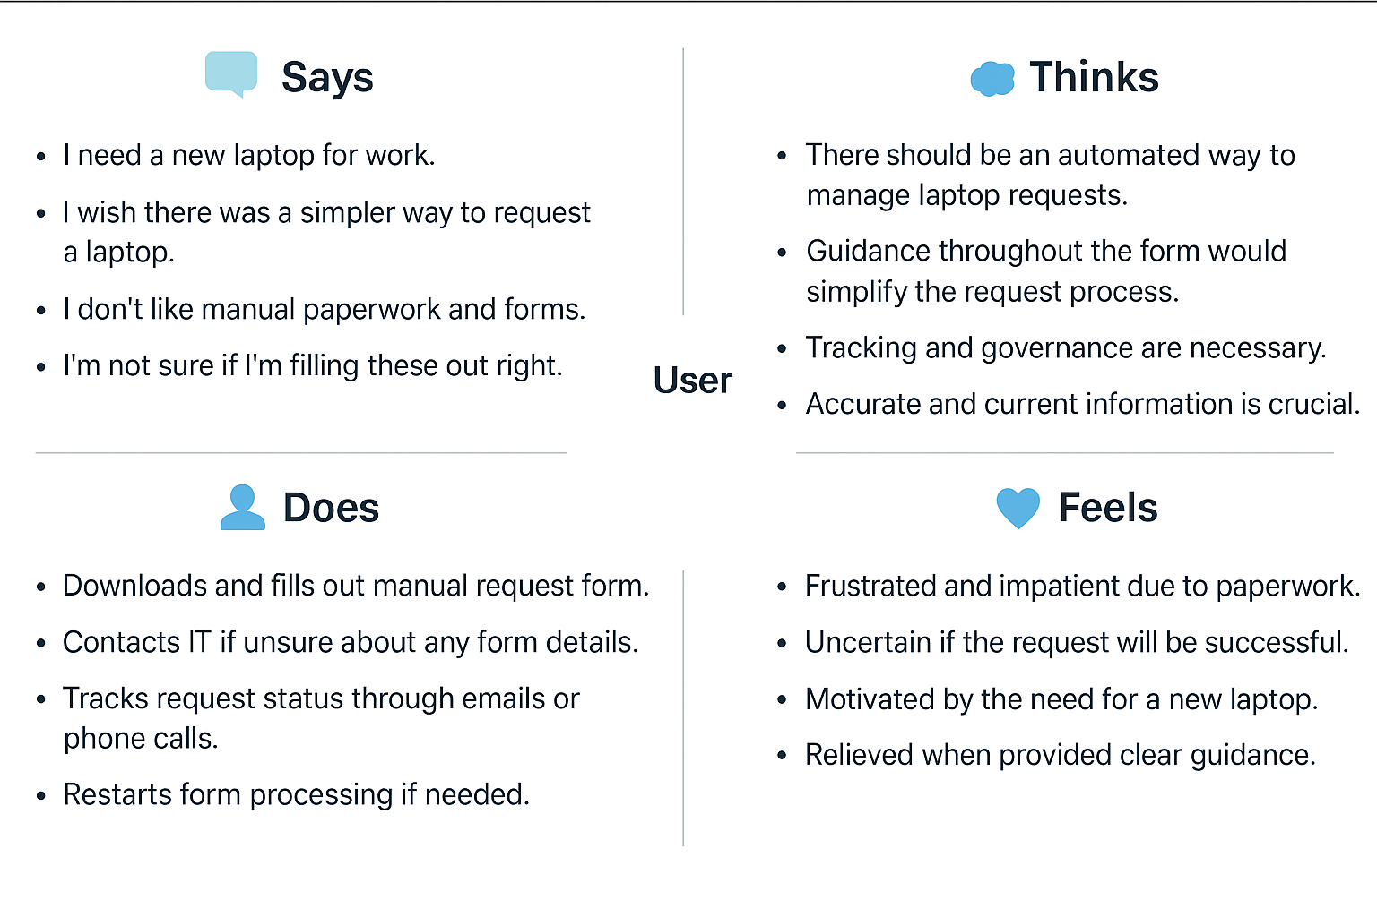

|  |  |
| --- | --- |
| Pain | Gain |
| * Manual laptop request process is time-consuming and error-prone. * Lack of automation leads to repeated data entry and delays. * Employees are unsure about approval status or form completion accuracy. * No dynamic fields or guidance make the form confusing. | * Automated laptop request process through ServiceNow Catalog Item. * Dynamic form fields and guidance ensure accurate and complete submissions. * Real-time tracking and notifications improve transparency. * Simplified approvals with workflow automation reduce delays. |