Shared Condition Overview
  - Use cases

Versions
Date | Author initials | Version | Amendment
July 2024 | TRI/TMS | 1.0.0 | First draft
Sep 2024 | TRI/TMS | 1.1.0 | Final version after review
Nov 2024 | RCH | 1.1.1 | Changed multiple references to Sundhed.DK in the document to generalize it and corrected reference for technical specifications.
Table of contents
1 Background and purpose 2
2 References and terms 2
3 Use Case diagram 3
4 Use cases 5

Background and purpose
This document contains use case descriptions for the implementation of the "ConditionList" standard.
The use cases describe a detailed process of the user’s interaction with the system in various situations. The background for the use cases are business rules prepared by the Danish Health Data Authority (Sundhedsdatastyrelsen, SDS). The use cases connect content requirements with business rules and are intended to ensure a consistent implementation and use of the standard "ConditionList".
The target group for these use cases is the system suppliers and managers who will participate in the initial implementation and use of the ConditionList standard: PLSP, the Danish Health Data Authority and sundhed.dk, as well as other users of the standard after the initial implementation.

References and terms
The use case descriptions should be read in conjunction with the following set of documentation for shared condition overviews:
Documentation | Version | Link/reference | Description
General technical use cases | 1.0 | https://medcomdk.github.io/dk-medcom-document/#11-use-cases | Technical use case descriptions for the application of MedCom's FHIR standard “ConditionList”
Standard documentation | 1.0 | https://medcomdk.github.io/dk-medcom-conditionlist | User stories describing user's needs and wishes  FHIR implementation guide describing technical requirements  Mapping between logical data model and “ConditionList”  Test documentation and protocols
Contents and Business Rules | 0.1 | https://www.nspop.dk/display/ESP/Indhold+og+forretningsregler+Diagnoser | Data governance, logical data model and business rules for the shared condition overview

Terms | Description
Electronic Medical Record (EMR) system | The general Practitioner’s (GP) patient medical record system.
User actor | System user, i.e. persons using the described systems via the user interface.
System actor | System supplier and manager. Responsible for all system functions and infrastructure.
Diagnosis | A disease or condition selected from a classification system by the doctor. Described with a code and a designating text. Diagnoses are registered in the EMR and can be selected to be shared via the condition overview.
Condition overview | An overview of the patient's diagnoses shared via NSP/DDS to be viewed on e.g. sundhed.dk.
Diagnosis Card | The condition overview is called the "Diagnosis card" within the user interface of the GP’s EMR systems.
NSP/DDS | National Service Platform and Document Sharing Service. Infrastructure that ensures the sharing of data between the EMR systems.
OnDemand | Sharing data on demand. Data is retrieved and displayed only when creating a query from a user actor. Data is only displayed but not stored in the receiving system.
MinSpærring | NSP service which allows the patient to block the sharing of data from DDS. Managed by SDS via the Consent Service
Sundhed.dk, patient | Website giving patients access to their own health data from selected sources in the EMR’s of the healthcare system in the initial implementation.
The Patient Handbook | Website where patients can search and read patient-oriented information about health and diseases
Sundhed.dk, professional | Website where authorized healthcare professionals have access to the patient's Health Record in the initial implementation.
The Doctor's Handbook | Website where you can find up-to-date information on health, diseases, diagnosis and treatment. The information is targeted at doctors and other healthcare professionals
PL Forum | Primary Sector Supplier Forum association of four medical practice system suppliers
PLSP | The Primary Sector Supplier Service Platform collects, presents and/or disseminates data from the GP EMR systems that are members of PL-forum
MinLæge (MyDoctor) App | The app for mobile devices where the patient can view data from the GP’s EMR and communicate with the clinic

Use Case diagram
The use cases below describe the user actor's interaction with the systems, and thus focuses on the business part of the data flow that rely on MedCom's FHIR standard. These use cases are marked with dark green color in the figure below. The technical use cases that lie after or between the user actor's interaction with the systems are marked in light green in the figure below and are described in the document "General technical use cases".
The Danish Health Data Authority (SDS) is responsible for describing and testing the use cases marked with blue color in the figure below, as well as testing reading access given by the Consent Service (not included in figure 1).
The grey use case regarding the display of the condition overview in the MinLæge App is already in operation and does not use MedCom's FHIR standard. It is therefore not described in this document, but is part of the figure, as it is an important part of the overall data flow.

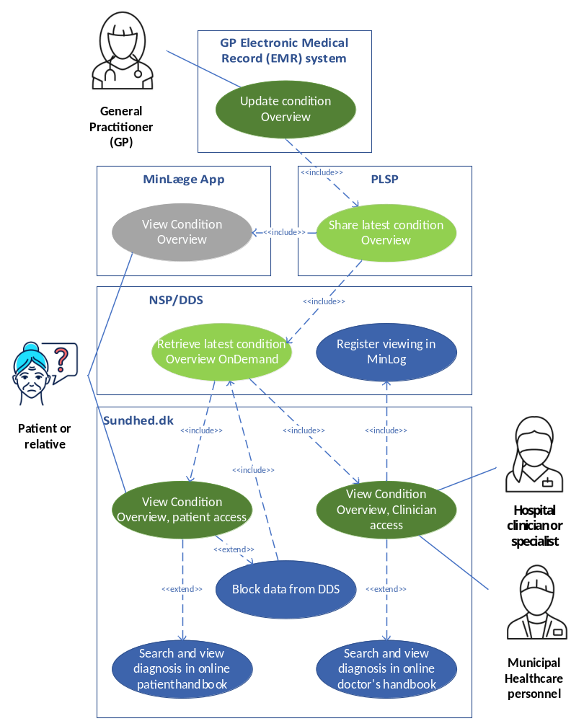
Figure 1: Use cases for sharing the condition overview from the GP EMR systems to sundhed.dk in the initial implementation.

Use cases
Use case S1 | Update Condition Overview (Diagnoses Card)
Initiating actor | User actor (general practitioner)
Purpose | To update the patient's Diagnosis Card in their EMR system and share the Condition Overview via PLSP
Starting conditions/prerequisites | User actor has contact with the patient and/or receives discharge summary
Initiating event | User actor opens the patient's EMR and Diagnosis Card in their EMR system
Possible actions | User actor registers one or more new diagnoses that are added to the Diagnosis Card
 | User actor updates one or more existing diagnoses on the Diagnoses Card (e.g. adding end date and/or changing category from "current" to “relevant”)
 | User actor deletes one or more diagnoses from the Diagnosis Card
 | User actor approves the Diagnosis Card
 | System actor shares Diagnosis Card to PLSP
Result | User actor has changed the sum and/or content of diagnoses on the Diagnosis Card that is shared to PLSP
Alternative actions | N/A
Corrective actions | N/A
Observations | See technical specifications for details on generating the complete FHIR document. Data is added to ConditionList, on PLSP when a datarequest is received.

Use case R1 | See diagnosis overview
Initiating actor | User actor
Purpose | Viewing the patient's condition overview in the patient’s view in a user interface.
Starting conditions/prerequisites | The user actor has access to the patient's condition overview in a user interface.
Initiating event | User actor opens condition overview in the patient’s view in a user interface.
Actions | - System actor ensures that the user actor has the necessary authentication to see the condition overview
 | - The system actor performs a system call to the infrastructure to retrieve the patient's condition overview
 | - System actor receives the patient's condition overview and displays the data to the user actor
 | - User actor views the patient's condition overview in a user interface.
Result | The user actor has viewed the patient's latest condition overview from the GP’s EMR system in the patient's view in a user interface.
Alternative actions | R1. A1: The patient has no diagnoses on the condition overview
Corrective actions | N/A
Observations | Regarding action 4:  If the user actor is a patient, or a person with the patient’s legal consent to view the patient’s data, the condition overview must be shown in the patient’s view in a user interface. If the user actor is a clinician or other professional healthcare personnel, the condition overview must be shown in the professional clinician’s view in a user interface.  The condition overview in the patient’s view in a user interface should include instructions that refers the patient to contact their GP if they have questions about the viewed data – or lack thereof.

Alternativ use case R1. A1 | No diagnosis in the diagnosis summary
This use case is an alternative to use case: | R1
Actions | - System actor ensures that the user actor has the necessary authentication to see the condition overview
 | - The system actor performs calls to the infrastructure to retrieve the patient's condition overview
 | - System actor receives feedback about missing data and generates a message informing the user actor of the empty condition overview on the user interface
 | - The user actor reads a message in the view in a user interface, which states that the patient does not have any diagnoses registered in his or her condition overview.
Result | User actor has read the message in the patient’s view in a user interface, which informs the user actor that the condition overview from the GP’s EMR system does not contain any data
Observations | The condition overview in the patient’s view in a user interface should include instructions that refers the patient to contact their GP if they have questions about the viewed data – or lack thereof.

