dbt Learning Program
Week 4 Recap & Week 5 Guide
Hooks

This guide walks through everything covered in Week 4 and introduces the new concepts for Week 5, with diagrams for each major idea. Week 4 was about not repeating yourself inside a model; Week 5 is about the work that happens around a model — the SQL dbt runs for you once the build itself is finished.

What's Inside
- Part 1 — Week 4 Recap: the net_amount macro, its two call sites, and the fct_orders rollup
- Part 2 — Week 5 Guide: hooks, {{ this }}, and why an index needs IF NOT EXISTS, explained with diagrams
- Part 3 — Walkthrough of all three Week 5 tasks with code
- Part 4 — Mistakes to Avoid, Word List, and Quick Quiz

Part 1 — Week 4 Recap: A Reusable Macro
Week 4 was about noticing repetition and pulling it into one place. Both ideas come straight back this week: the index you're about to add lives on fct_order_items, and the GRANT you'll write is the same instinct applied to configuration instead of SQL.

What You Actually Built in Week 4

1. The net_amount Macro
You created macros/net_amount.sql — a parameterized snippet of SQL taking quantity, unit_price, and discount_pct, and returning (quantity * unit_price * (1 - discount_pct / 100.0)). The arguments are column names passed in as strings, so Jinja splices them straight into the compiled SQL rather than evaluating them as values.

2. Two Call Sites, One Formula
You replaced the hardcoded formula in fct_order_items in both places it appeared: the net_amount column itself, and again inside the margin calculation. The output was required to stay byte-for-byte identical — it was a refactor, not a logic change.

3. A Second Fact Table: fct_orders
You applied the same reuse instinct at a larger scale, rolling fct_order_items up to the order grain with group by order_id + sum(), left joining onto stg_orders for the header columns, and adding order_total = net_revenue + shipping_fee. That gave you a second fact table (155 rows) built on the first (313 rows) instead of re-deriving the revenue math from staging a third time.

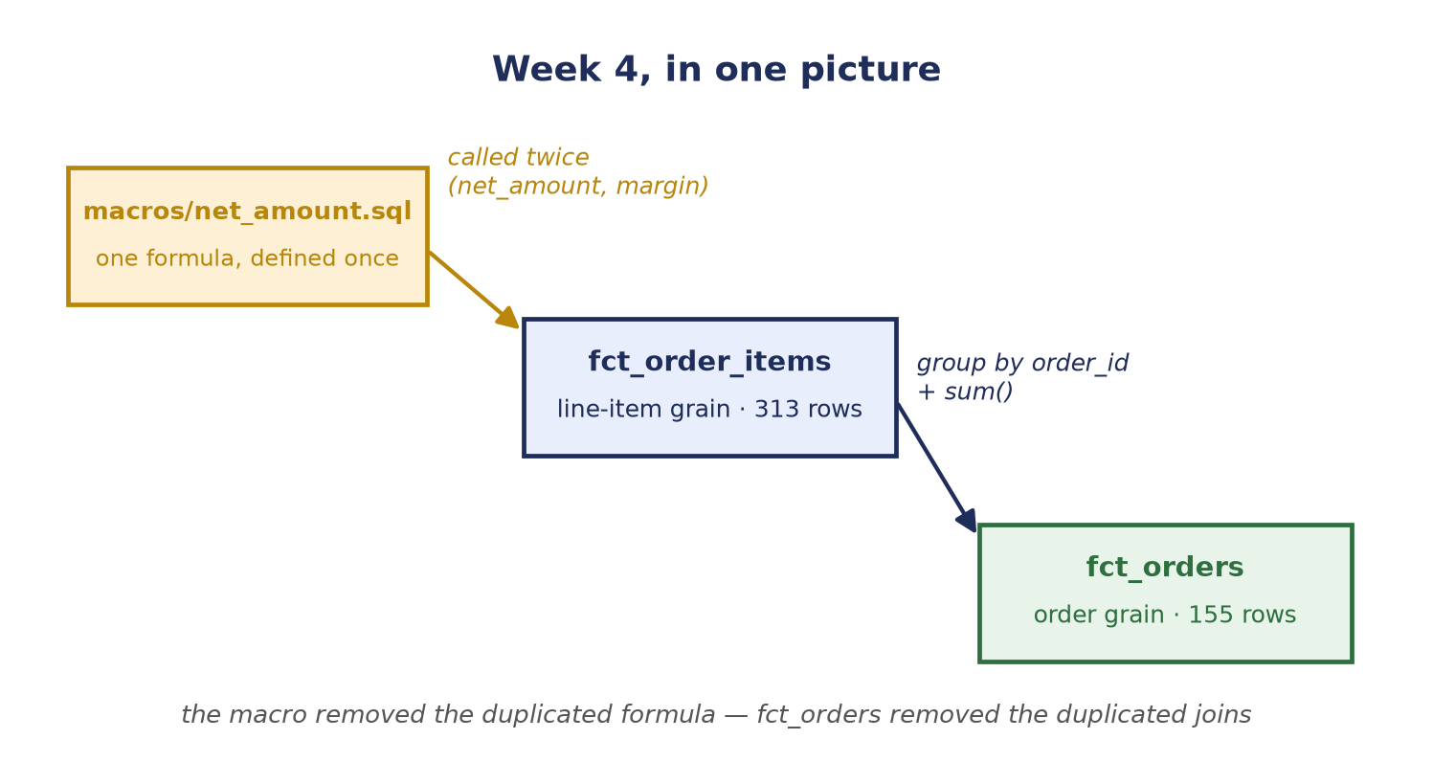
Figure 1 — Recap: one macro serving two call sites, and one fact table rolled up into a second at a coarser grain. Both are the same idea — build it once, reuse it.

Self-Check Before Moving On
If any of these feel shaky, it's worth revisiting the Week 4 material before starting Week 5:
- Why do the arguments to net_amount() need to be passed in as quoted strings?
- Name both places in fct_order_items that call the net_amount() macro.
- Why is fct_orders built from fct_order_items rather than from stg_order_items directly?

Part 2 — Week 5: Hooks
Budget: roughly 2 hours. Everything you've written so far has been a select statement — you describe the shape of the data and dbt works out how to build it. But some things a warehouse needs can't be expressed as a select at all: creating an index, granting permissions, vacuuming a table, writing an audit row. Hooks are how dbt lets you attach that kind of SQL to a model's build.

What's New This Week (In Plain Terms)

A Hook Is SQL That Runs Around the Build
A post-hook is a snippet of SQL dbt sends to Postgres immediately after a model finishes building, inside the same run. There's a pre_hook too, which runs before — you won't need it this week, but it's the same mechanism.
Analogy: the model is the recipe, and the hook is the note stuck to the bottom of the card that says "and when it comes out of the oven, dust it with sugar." It isn't part of cooking the dish, but it happens every single time you make it, automatically, without anyone having to remember.

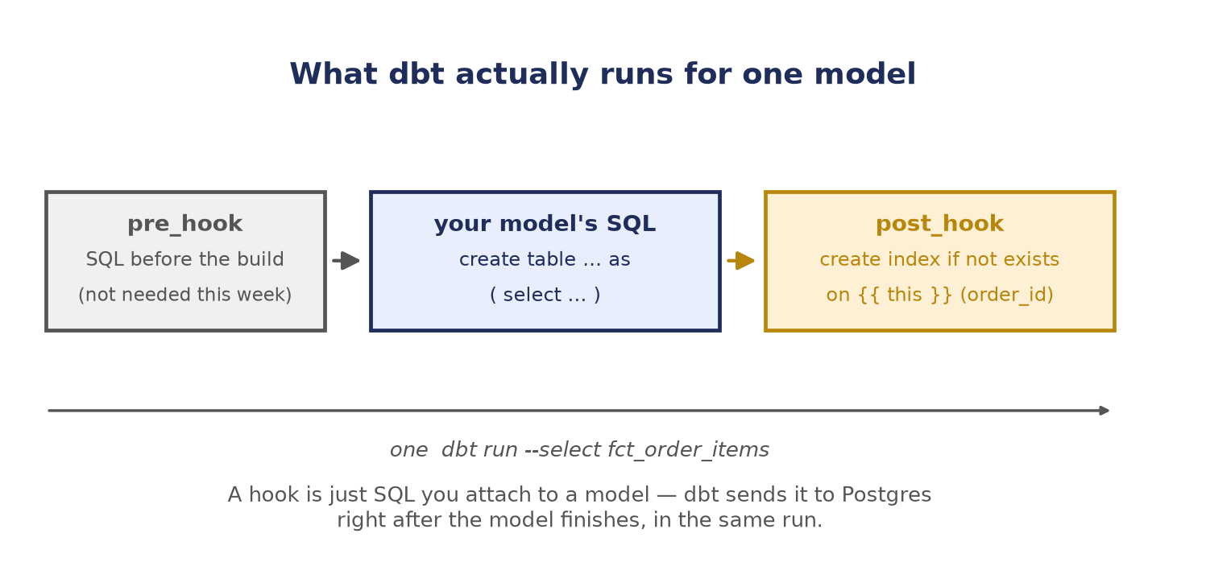
Figure 2 — What dbt runs for a single model: the optional pre-hook, then the model's own SQL, then the post-hook — all in one dbt run.

Where Hooks Live (and Why the Spelling Changes)
A hook can be declared in two places, and the two spellings are different — this catches everyone out once. Inside a model's config() block it's post_hook, with an underscore, and it applies to that one model. In dbt_project.yml it's +post-hook, with a hyphen and a leading +, and it applies to every model underneath that path.
The key thing: hooks stack, they don't override. If a model has its own post_hook and the project defines a +post-hook, dbt runs both. Adding the project-level grant in Task 5.2 will not clobber the index hook from Task 5.1.

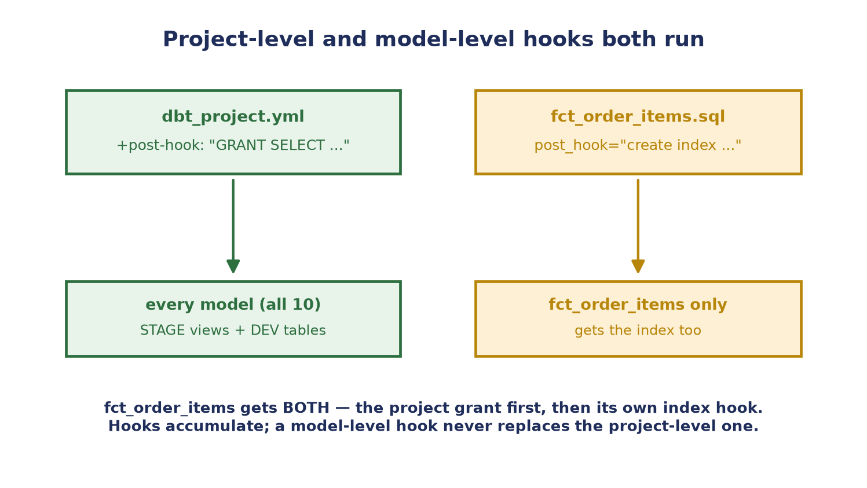
Figure 3 — The project-level grant applies to all ten models; the index hook applies only to fct_order_items. That one model gets both.

{{ this }} — the Model's Own Address
Inside a hook, {{ this }} resolves to the fully-qualified, correctly-quoted name of the model dbt just built — "ecommerce"."DEV"."fct_order_items". Always use it instead of typing the schema out by hand: the same hook then stays correct in every target, and it keeps working if the schema configuration ever changes.
Why the nested braces are fine: writing {{ this }} inside a {{ config(...) }} block looks like it shouldn't work, but dbt stores hooks as plain strings and renders them later, at the moment the hook actually runs. By then the model has been built and dbt knows exactly what {{ this }} refers to.

Why an Index — and Why IF NOT EXISTS
fct_orders joins fct_order_items on order_id every time it builds. An index on order_id gives Postgres a shortcut to the matching rows instead of reading the whole table. But note that the hook fires on every single dbt run, so a plain create index would succeed the first time and then error on the second with "relation already exists". Adding if not exists makes the hook idempotent — safe to run any number of times. This matters especially here because fct_order_items is incremental, so the table (and its index) survives between runs.

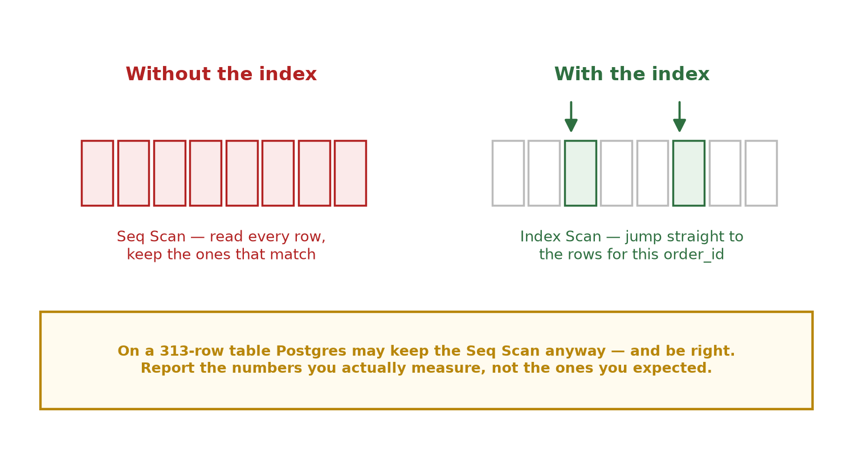
Figure 4 — What the index buys you, and the honest caveat: on a table this small Postgres may well decide a sequential scan is cheaper anyway.

Part 3 — Task Walkthrough

Task 5.1 — Post-Hook: Create an Index (50 pts)
Add a post_hook to the config() block at the top of models/dev/fct_order_items.sql, alongside the incremental settings you added in Week 2:
{{ config(
materialized='incremental',
unique_key='order_item_id',
post_hook="create index if not exists idx_fct_order_items_order_id on {{ this }} (order_id)"
) }}

Build it, then build it a second time — the second run is the one that catches a missing if not exists:
dbt run --select fct_order_items --profiles-dir .

Confirm the index actually landed by asking Postgres directly, rather than trusting that the run was green:
select indexname, indexdef
from pg_indexes
where tablename = 'fct_order_items';

Deliverable: fct_order_items builds, a second run also succeeds, and idx_fct_order_items_order_id appears in pg_indexes.

Task 5.2 — Project-Level GRANT Hook (35 pts)
Right now only the dataops user can read your tables, so a BI tool connecting as anyone else would see nothing. Rather than adding a GRANT to all ten models by hand, declare it once in dbt_project.yml, at the dbt_learning: level so it covers both the STAGE and DEV layers:
models:
dbt_learning:
+post-hook: "GRANT SELECT ON {{ this }} TO PUBLIC;"

stage:
+schema: STAGE
+materialized: view

dev:
+schema: DEV
+materialized: table

Quote the string: a bare YAML value can't begin with {, so leaving the quotes off makes the file fail to parse before a single model runs. Put the +post-hook at the dbt_learning: level — nesting it under dev: only would leave every STAGE view ungranted.

Then rebuild everything and confirm the hook didn't break any model:
dbt run --profiles-dir .

Deliverable: the +post-hook in dbt_project.yml, and a full dbt run still green — every model in both schemas now grants read access as it builds.

Task 5.3 — Measure the Index (15 pts)
An index you never measured is a guess. Time the join both ways and write down what you actually saw. First drop the index so you're measuring the "before" state:
drop index if exists "DEV".idx_fct_order_items_order_id;

Now time the join. Look at the Execution Time line at the bottom of the output, and note which scan type Postgres chose — Seq Scan or Index Scan:
explain analyze
select *
from "DEV".fct_order_items f
join "DEV".fct_orders o on f.order_id = o.order_id;

Put the index back by re-running the model, then run the exact same EXPLAIN ANALYZE again and record both numbers in a new file, week_5/notes.md.
Report what you actually measure: this is a 313-row table, so the numbers will be small and the planner may still pick a sequential scan — on tiny tables that is genuinely the cheaper choice. "No meaningful improvement, because the table is too small for the planner to bother" is a correct, full-credit answer as long as your real numbers back it up. Run each query two or three times and use the later timings; the first run pays for a cold cache.

Deliverable: week_5/notes.md containing the query you ran, your before and after execution times, and a sentence on what changed in the plan.

Grading Your Work
Once all three tasks are complete, run:
python scripts/grade_assignment.py --week 5

Fix any items marked with an X and re-run the grader until everything passes.

Part 4 — Mistakes to Avoid, Word List, and Quick Quiz

Mistakes to Avoid
- Hardcoding the schema instead of {{ this }} — writing on "DEV".fct_order_items works on your machine and silently breaks in any other target. {{ this }} is always correct.
- Leaving out if not exists — the first dbt run passes and the second fails with "relation ... already exists". Always run twice before calling the task done.
- Using pre_hook for the index — on a full refresh the table doesn't exist yet when the pre-hook fires, so the index has nothing to attach to.
- Nesting +post-hook under dev: only — the five STAGE views then never get granted, which is half the point of putting the hook at the project level.
- Forgetting the quotes around the YAML hook string — YAML tries to read {{ this }} as a mapping and the whole file fails to parse, with an error that doesn't obviously point at your hook.
- Assuming the project hook replaces the model's post_hook — it doesn't. Hooks accumulate, so fct_order_items runs both.
- Writing down the timings you expected rather than the ones you got — a suspiciously clean 10x speedup on a 313-row table is a red flag, not a good result.

Word List
Term | Meaning
Hook | SQL that dbt runs around a model's build rather than as part of it — before it (pre) or after it (post).
post_hook | The model-level spelling, used inside a {{ config(...) }} block; applies to that one model.
+post-hook | The project-level spelling, used in dbt_project.yml; applies to every model beneath that path.
{{ this }} | Jinja for the fully-qualified name of the model currently being built — schema, quoting and all.
Idempotent | Safe to run any number of times with the same result. create index if not exists is idempotent; create index is not.
Index | A lookup structure that lets the database find matching rows without reading the whole table.
Seq Scan / Index Scan | The two plan choices in EXPLAIN output: read every row, versus jump straight to the matching ones.
EXPLAIN ANALYZE | Runs a query and reports the plan Postgres chose plus the real time it took.
GRANT | The SQL permission command; GRANT SELECT lets another role read a table or view.

Quick Quiz
Answer these before moving on to Week 6 — if any answer doesn't come quickly, go back and re-read that section rather than guessing.
- What's the difference between post_hook in a model and +post-hook in dbt_project.yml?
- fct_order_items has its own post_hook and the project defines one too. Which of them runs?
- Why does the index hook need if not exists, when you only create the index once?
- Why use {{ this }} instead of writing "DEV".fct_order_items into the hook?
- Your EXPLAIN ANALYZE still shows a Seq Scan after the index exists. Is that a failure? Why or why not?
Questions or stuck on something? Reach out before spending too long on one blocker — the goal this week is understanding what dbt does around your models, not just getting green checkmarks from the grader.

