Appendix. Bayesian estimation of the Marburg virus serial interval
Table of contents

Overview
This appendix documents the Bayesian serial-interval analysis: the double-interval-censored likelihood, the gamma and lognormal delay families and their priors, MCMC settings, convergence diagnostics, model comparison by leave-one-out cross-validation, prior and posterior predictive checks, and a comparison with the published literature. Maximum-likelihood equivalents are in the R reference implementation (R/estimate_serial_interval.R, primarycensored).

Data and transmission pairs
Infector–infectee pairs were reconstructed from two-case chains, published case narratives, and digitized transmission-tree figures, each tagged with a confidence tier (high, medium, low) and its basis (data/marburg_transmission_pairs.csv). The serial interval of a pair is onset(infectee) – onset(infector) in days. Because both onsets are recorded to the day, the observed integer delay is doubly interval-censored.

Model
For a pair with observed integer delay n, fix the infector onset day at 0 with a within-day offset a ~ Uniform(0, 1) (the primary event). The infectee true onset falls in day n, i.e. in [n, n+1). For a delay density f with CDF F, the pair likelihood is
$$Pr\left(N=n\right)=\int_{0}^{1}{\left[F\left(n+1−a\right)−F\left(n−a\right)\right]} da,$$
with F(t) = 0 for t –< 0. The primary offset is marginalized by 64-node midpoint quadrature. Two delay families are fit, both parameterized by the mean – mu (days) so estimates are directly comparable: a gamma (shape k, so SD = mu/sqrt(k), CV = 1/sqrt(k)) and a lognormal (sdlog – sigma, meanlog set so E[T] = mu, CV = sqrt(exp(sigma^2) – 1)).
Priors (weakly informative, centered on an ~8-day Marburg serial interval): mu ~ LogNormal(log 8, 0.6); gamma k ~ LogNormal(log 2, 0.7); lognormal sigma ~ HalfNormal(0.5). Inference used the NUTS sampler (NumPyro): 4 chains, 1000 warmup and 2000 sampling iterations each (8000 posterior draws), seed 1834.

Posterior estimates
Appendix Table 1. Gamma posterior serial-interval estimates (median, 95% credible interval).
Subset | Pairs | Mean SI, d (95% CrI) | SD, d (95% CrI) | CV (95% CrI)
high only | 13 | 10.9 (8.9–13.4) | 3.9 (2.6–6.4) | 0.36 (0.24–0.56)
high+medium | 26 | 11.3 (9.6–13.3) | 4.6 (3.4–6.5) | 0.41 (0.31–0.55)
all incl low | 27 | 11.7 (10.1–13.9) | 5.0 (3.8–7.0) | 0.42 (0.33–0.57)

Appendix Table 2. Lognormal posterior serial-interval estimates (median, 95% credible interval).
Subset | Pairs | Mean SI, d (95% CrI) | SD, d (95% CrI) | CV (95% CrI)
high only | 13 | 10.9 (9.4–12.9) | 3.0 (2.0–5.4) | 0.28 (0.18–0.46)
high+medium | 26 | 11.4 (9.9–13.4) | 4.3 (3.1–6.7) | 0.38 (0.29–0.54)
all incl low | 27 | 11.8 (10.2–13.9) | 4.7 (3.5–7.3) | 0.40 (0.31–0.56)

Convergence diagnostics
All parameters converged (R-hat = 1.00; bulk and tail effective sample sizes in the thousands from 8000 draws). Diagnostics are shown for the gamma model; the lognormal fits converged equally well.
Appendix Table 3. MCMC convergence diagnostics (gamma model).
Subset | Parameter | Mean | SD | ESS (bulk) | ESS (tail) | R-hat
high only | mu | 10.945 | 1.136 | 4253 | 4159 | 1
high only | sd | 4.02 | 1.007 | 4412 | 4338 | 1
high only | cv | 0.367 | 0.081 | 4261 | 4622 | 1
high only | shape | 8.481 | 3.606 | 4261 | 4622 | 1
high+medium | mu | 11.366 | 0.93 | 5216 | 4697 | 1
high+medium | sd | 4.688 | 0.781 | 5462 | 4767 | 1
high+medium | cv | 0.413 | 0.06 | 5294 | 5215 | 1
high+medium | shape | 6.242 | 1.771 | 5294 | 5215 | 1
all incl low | mu | 11.807 | 0.986 | 5473 | 4511 | 1
all incl low | sd | 5.091 | 0.833 | 6342 | 4942 | 1
all incl low | cv | 0.431 | 0.06 | 6599 | 4962 | 1
all incl low | shape | 5.68 | 1.52 | 6599 | 4962 | 1

Model comparison: gamma vs lognormal
The two families were compared by Pareto-smoothed importance-sampling leave-one-out cross-validation (PSIS-LOO). The lognormal has the higher expected log predictive density in every subset, but the difference is small relative to its standard error (dELPD < 1 with SE(d) of comparable size, Appendix Table 4, Appendix Figure 1), so the two families are not distinguishable on these data. This agrees with the maximum-likelihood AIC comparison (Appendix Table 5), which also favors the lognormal marginally. Gamma is retained as the primary model for consistency with the generation-interval convention used in the reproduction-number calculation.
Appendix Table 4. PSIS-LOO comparison of gamma and lognormal. dELPD is the difference from the best model; SE(d) its standard error.
Subset | Family | Rank | ELPD (LOO) | p_LOO | dELPD | SE(d) | Weight
high only | lognormal | 0 | -33.14 | 1.67 | 0 | 0 | 1
high only | gamma | 1 | -33.91 | 0.96 | 0.76 | 0.97 | 0
high+medium | lognormal | 0 | -73.49 | 1.66 | 0 | 0 | 1
high+medium | gamma | 1 | -74.5 | 1.45 | 1.02 | 0.56 | 0
all incl low | lognormal | 0 | -78.56 | 1.56 | 0 | 0 | 1
all incl low | gamma | 1 | -79.58 | 1.36 | 1.02 | 0.6 | 0
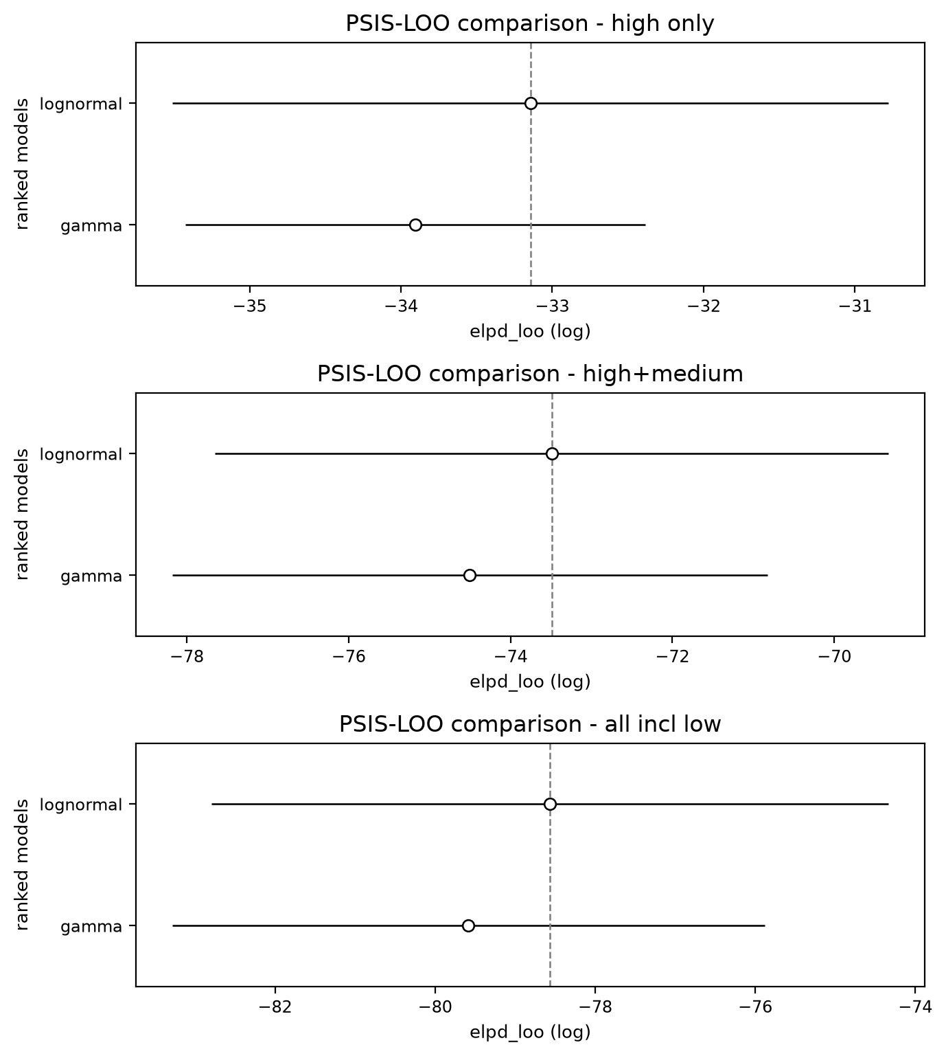
Appendix Figure 1. PSIS-LOO comparison per subset. Open circles, ELPD; whiskers, standard error; dashed line, best model.
Appendix Table 5. Maximum-likelihood family comparison (R, primarycensored; double interval-censored).
Subset | Mean SI, d | CV | Best (AIC) | AIC gamma | AIC lognormal | AIC Weibull
high only | 11.25 | 0.224 | lognormal | 60.11 | 59.97 | 61.55
high+medium | 11.81 | 0.344 | lognormal | 148.76 | 147.52 | 152.52
all incl low | 12.22 | 0.365 | lognormal | 159.02 | 157.63 | 162.68

Effect on the reproduction number
The Monte Carlo R0 uses the Wallinga–Lipsitch relation R0 = 1 / M(–r), where M is the moment-generating function (Laplace transform) of the generation interval and r the growth rate. For a gamma generation interval this has the closed form R0 = (1 + r Tg / kappa)^kappa with kappa = 1/CV^2, which is what the current pipeline uses (R/estimate_R0_montecarlo.R). A lognormal generation interval has no closed-form MGF, so adopting it would require evaluating M(–r) = E[exp(–r T)] numerically (for example by quadrature over the lognormal density) at each Monte Carlo draw. Because the two families are indistinguishable by LOO and give near-identical means and CVs, the gamma closed form is retained; the numerical-Laplace-transform route is the correct extension if a lognormal generation interval is preferred.

Predictive checks
The prior predictive distribution covers the observed serial-interval range before fitting (Appendix Figure 2). The posterior predictive distribution reproduces the central mass of the observed delays; residual spread in the tails is consistent with the small sample and the star-shaped dependence among pairs that share the Tanzania index (Appendix Figure 3).
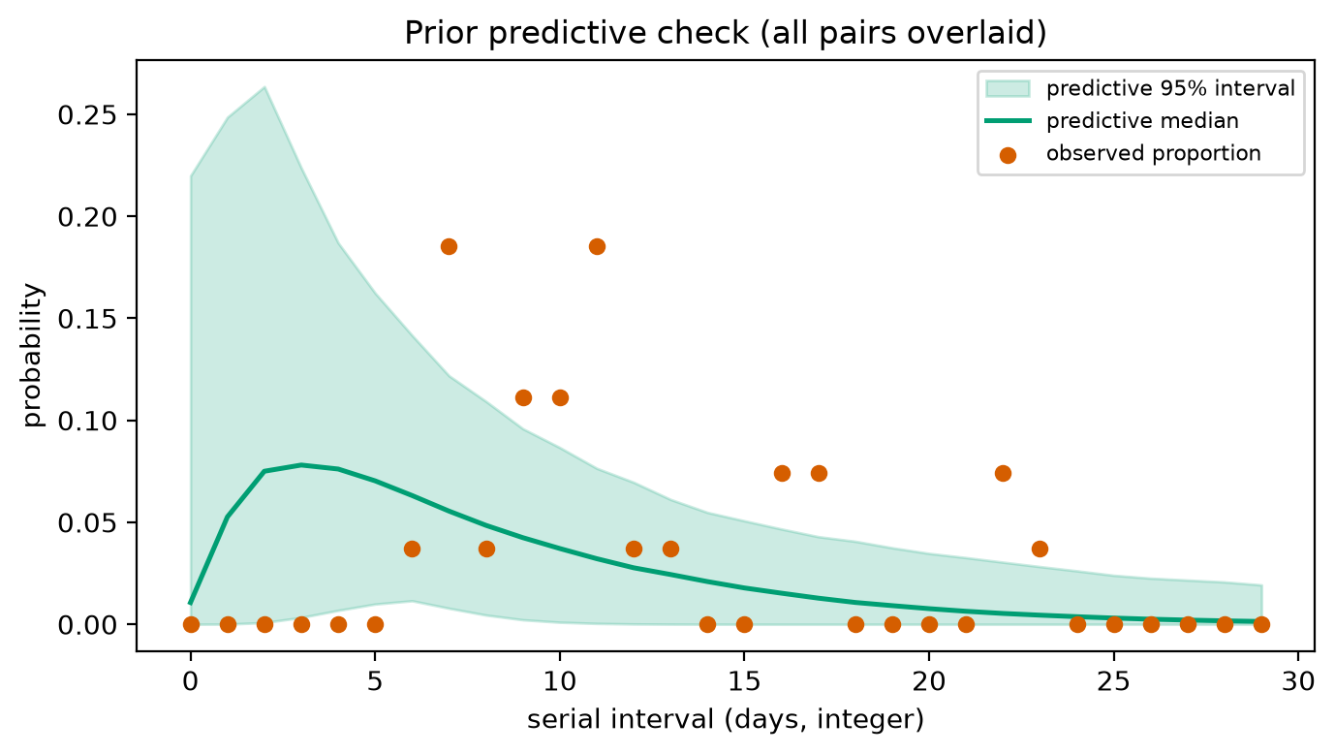
Appendix Figure 2. Prior predictive check, all pairs overlaid.
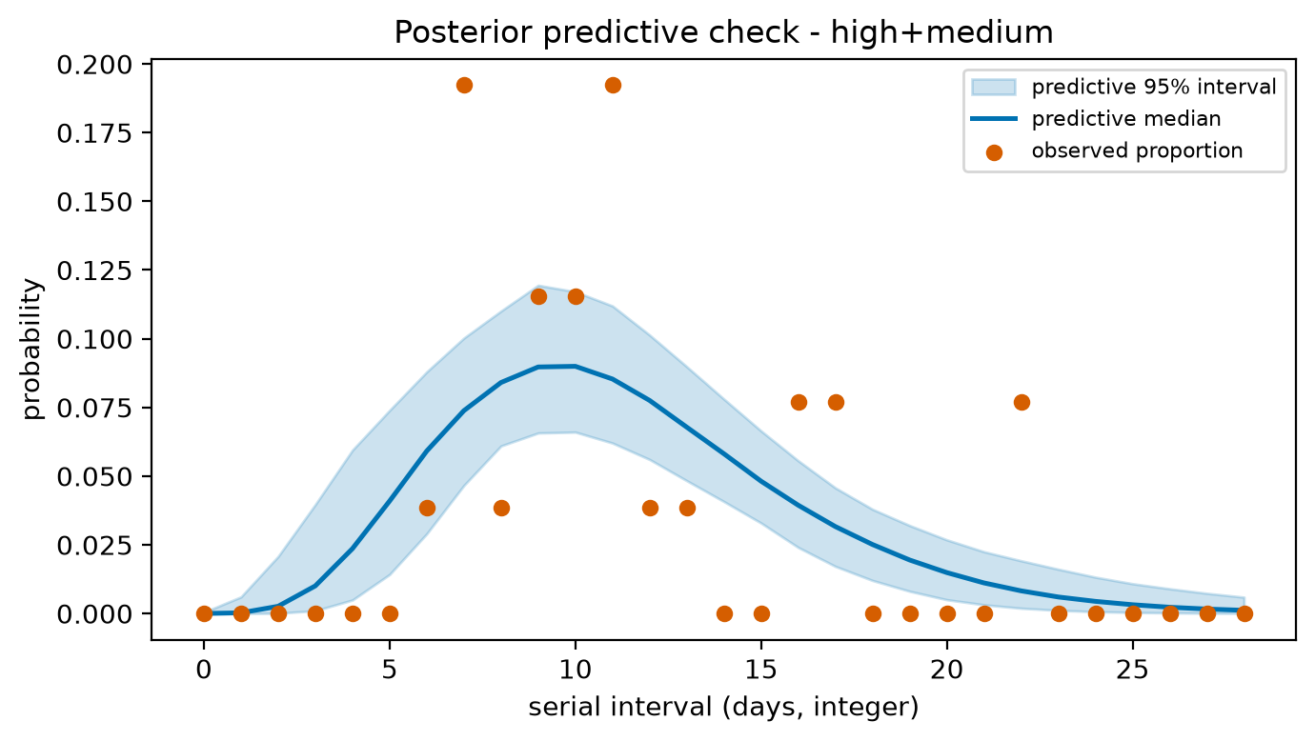
Appendix Figure 3. Posterior predictive check, high+medium subset (gamma). Points, observed proportions; line and band, predictive median and 95% interval.

Posterior and sampling diagnostics (gamma, high+medium subset)
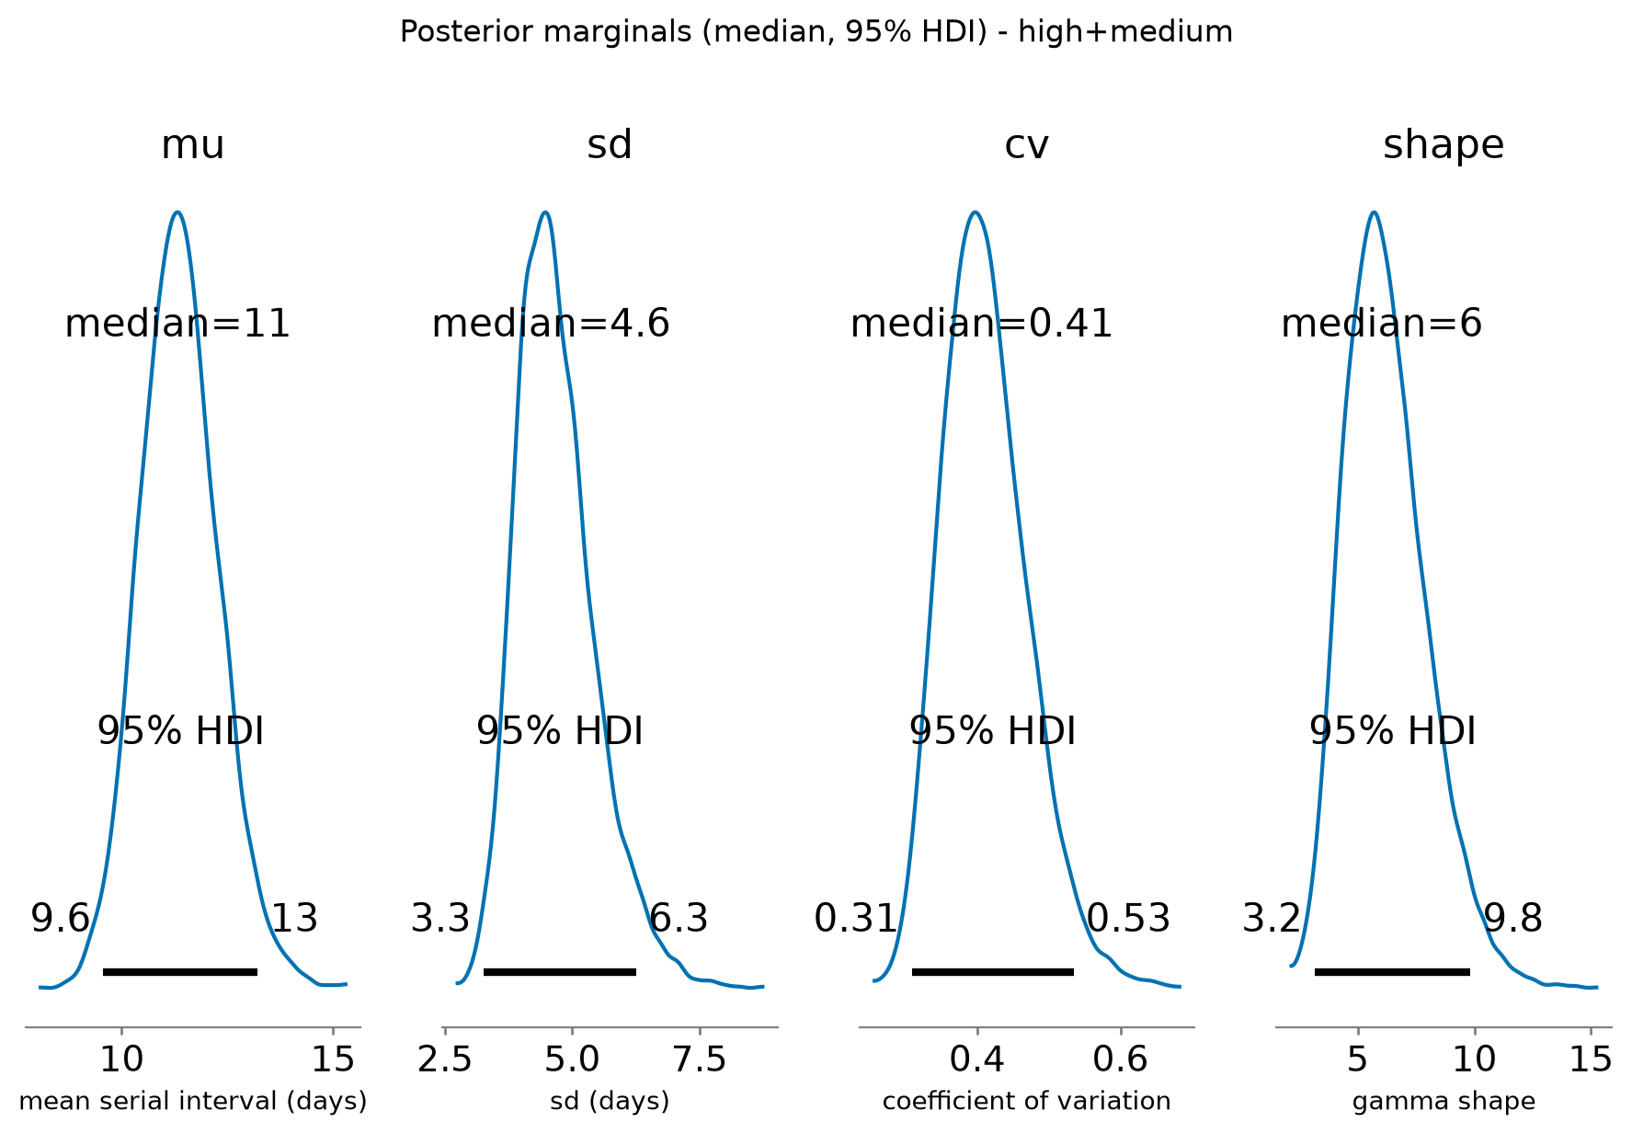
Appendix Figure 4. Posterior marginals with 95% highest-density intervals.
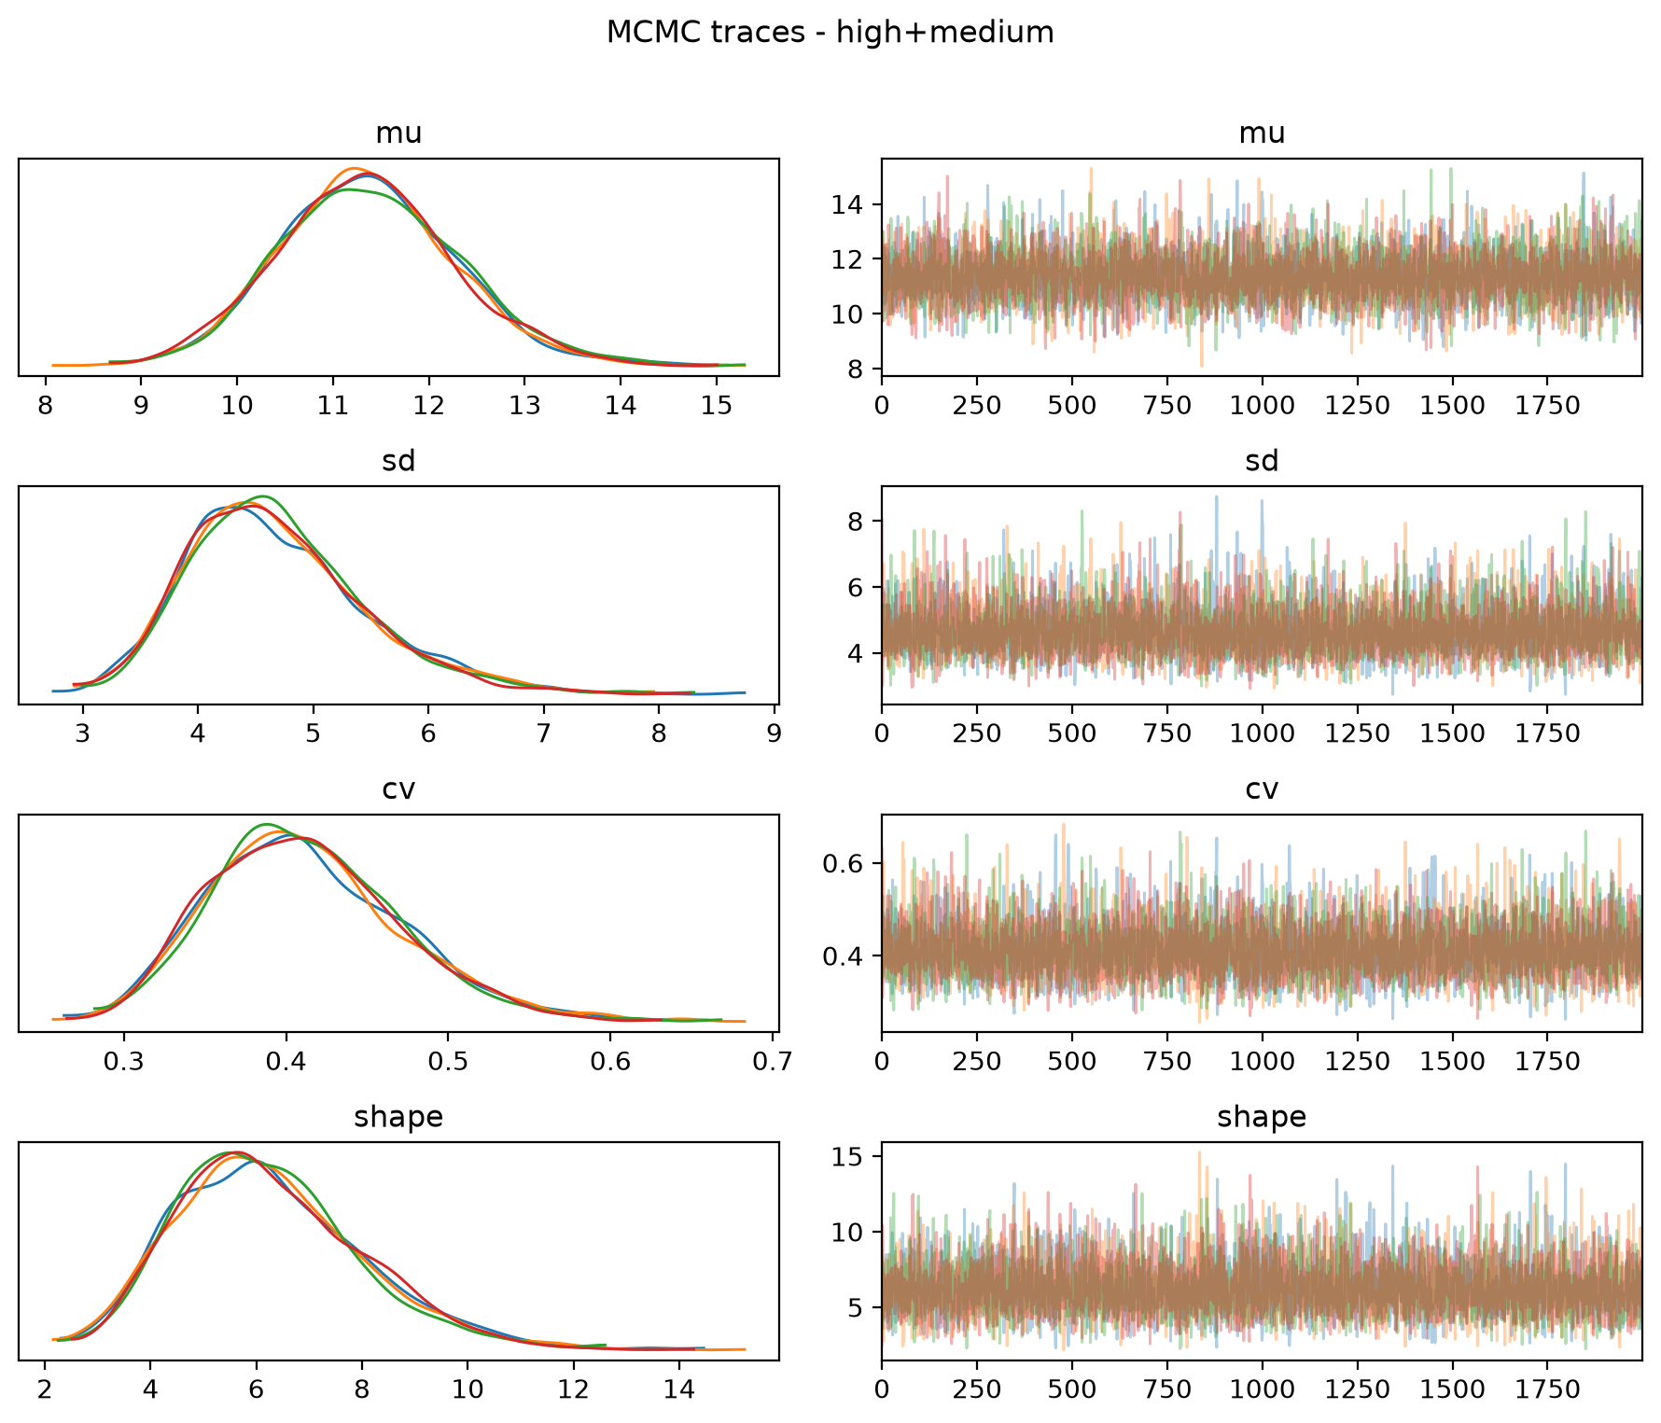
Appendix Figure 5. MCMC traces and marginal densities by chain.
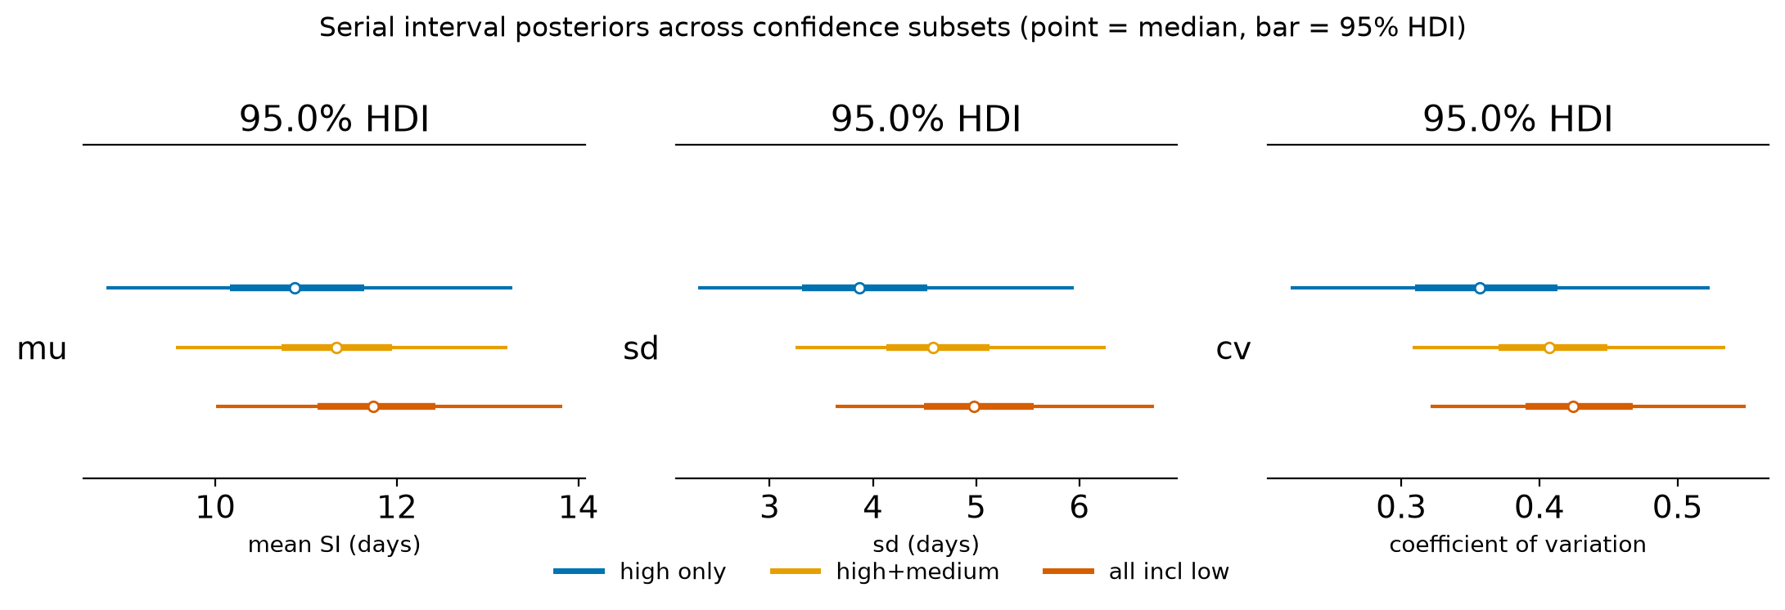
Appendix Figure 6. Gamma serial-interval posteriors across confidence subsets (point, median; bar, 95% HDI).
Rank plots and per-subset trace, posterior, and predictive figures for the high-only and all-pairs subsets are in outputs/figures/.

Transmission-pair timelines
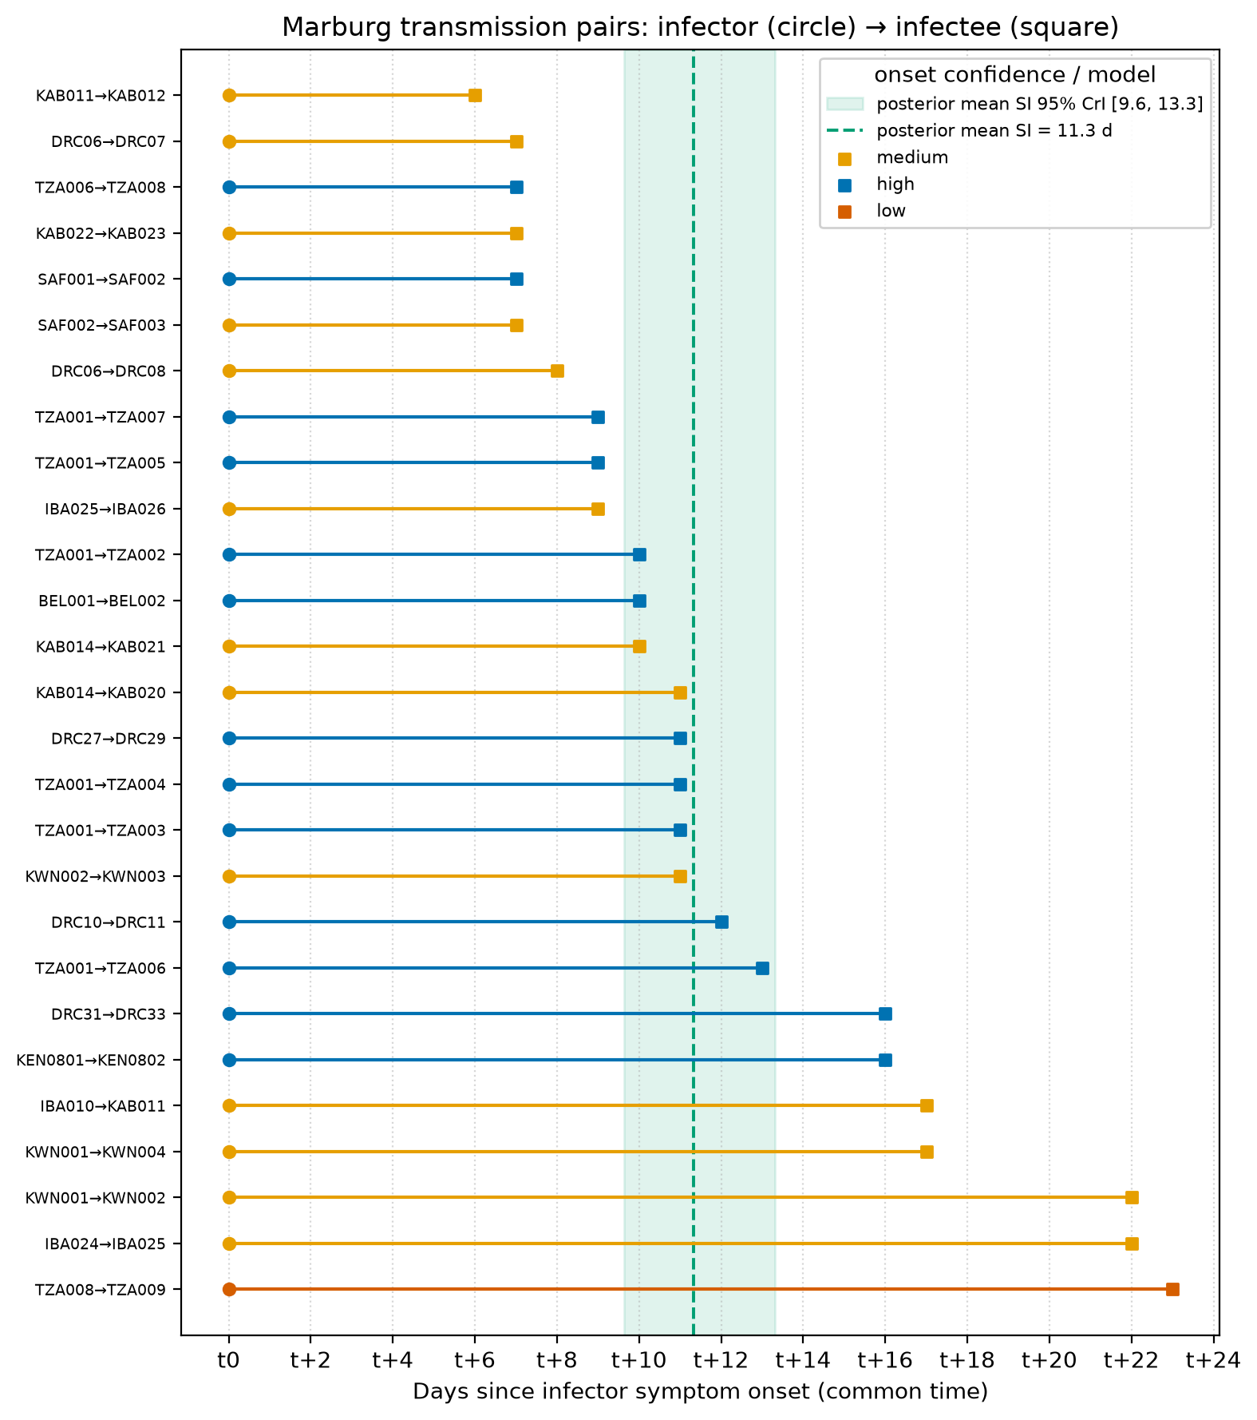
Appendix Figure 7. Each pair aligned to a common t0 (infector onset, circle) to the infectee onset (square), sorted by serial interval and colored by onset confidence; green band, posterior mean serial interval.

Comparison with the literature
Estimates from the reconstructed pairs run longer than the pooled published mean (Qian et al. 2023, 9.2 d); the Ebola Zaire value is a comparator, not Marburg (Appendix Figure 8, Appendix Table 6).
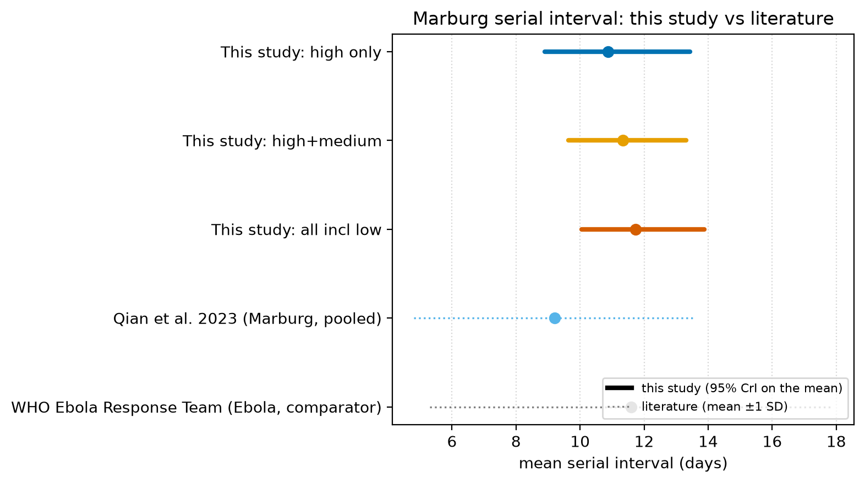
Appendix Figure 8. Marburg serial interval, this study versus literature. Thick bars, 95% credible interval on the mean; dotted, literature mean +/- 1 SD.
Appendix Table 6. Serial interval, this study versus published estimates.
Source | Population | Family | Mean, d | 95% lo | 95% hi | SD, d | CV | DOI
This study (NumPyro, double-censored) | Marburg, high only | gamma | 10.87 | 8.9 | 13.44
This study (NumPyro, double-censored) | Marburg, high+medium | gamma | 11.33 | 9.64 | 13.31
This study (NumPyro, double-censored) | Marburg, all incl low | gamma | 11.74 | 10.06 | 13.89
Qian et al. 2023, medRxiv preprint | Marburg (all 15 outbreaks, pooled line lists) | gamma | 9.2 |  |  | 4.4 | 0.478 | 10.1101/2022.06.17.22276538
WHO Ebola Response Team, NEJM 2014 (cited in Qian Table 1) | Ebola Zaire (comparator, NOT Marburg) | gamma | 11.6 |  |  | 6.3 | 0.543 | 10.1056/NEJMoa1411100

Source of the difference from Qian et al. 2023
Qian et al. estimated their serial interval from 26 infector–infectee pairs identified in five outbreaks (DRC, Kenya, South Africa, Belgrade, Uganda 2012) by fitting a gamma to the raw onset-to-onset differences, without interval censoring, using whole-outbreak linelists. Two points follow. First, the difference is not the censoring method: restricting our pairs to those same five outbreaks gives 16 pairs with a naive mean of 11.0 d (SD 4.6), still well above 9.2 d, and our SD there matches theirs. Second, it is not outbreak coverage: our newer outbreaks (Tanzania 2023, Uganda 2017) move the pooled estimate only slightly. The gap is pair ascertainment: Qian identified 26 pairs in those five outbreaks where we identified 16, and their more inclusive linelist pairing (largest in the ~150-case DRC 1999-2000 linelist) yields shorter intervals, whereas we used explicit, sequence- or figure-confirmed transmission-tree links. A direct pair-by-pair comparison was not possible: the data repository cited in Qian et al. (github.com/GeorgeYQian/MVD-Branching- Process-Model-Repository) returns HTTP 404 and is no longer available.

Leave-one-outbreak-out sensitivity
Refitting the gamma mean with each outbreak dropped in turn (high+medium set) leaves the pooled mean between 11.1 and 12.4 d, all credible intervals overlapping the full estimate (Appendix Figure 9, Appendix Table 7). No single outbreak drives the result; dropping Uganda 2017 (the longest-SI outbreak) still leaves the mean near 11.1 d, above the Qian value.
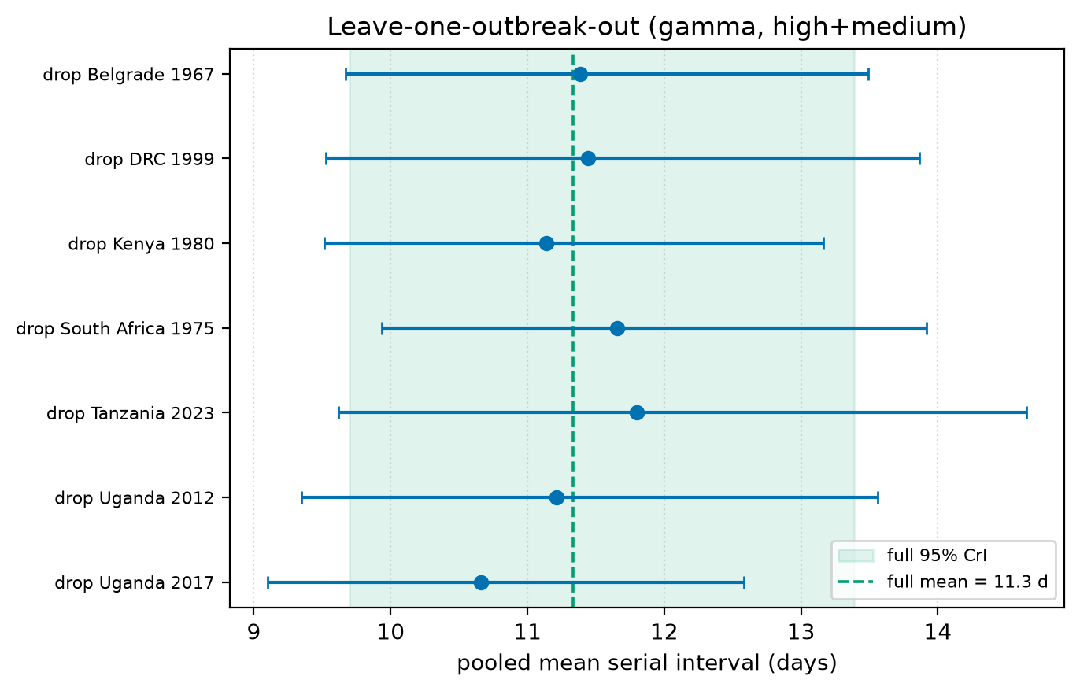
Appendix Figure 9. Pooled mean serial interval (gamma, high+medium) as each outbreak is dropped. Green band and line, full-sample 95% CrI and median.
Appendix Table 7. Leave-one-outbreak-out pooled mean serial interval.
Dropped outbreak | Pairs | Mean SI, d (95% CrI)
none (full) | 26 | 11.3 (9.7–13.4)
Belgrade 1967 | 25 | 11.4 (9.7–13.5)
DRC 1999 | 21 | 11.4 (9.5–13.9)
Kenya 1980 | 25 | 11.1 (9.5–13.2)
South Africa 1975 | 24 | 11.7 (9.9–13.9)
Tanzania 2023 | 19 | 11.8 (9.6–14.7)
Uganda 2012 | 19 | 11.2 (9.3–13.6)
Uganda 2017 | 23 | 10.7 (9.1–12.6)

Reproducibility and data availability
All stochastic code is seeded with 1834. Bayesian estimation used Python 3.13.5 (numpyro 0.21.0, jax 0.11.1, arviz 0.23.4, numpy 2.5.3, pandas 3.0.5); the maximum-likelihood reference used R with the primarycensored package. Python dependencies are pinned in uv.lock. Source data (data/marburg_transmission_pairs.csv, per-outbreak line lists) and all code (python/, R/, julia/) are in the project repository; tables and figures in this appendix are regenerated from them by task py:appendix.

