PRINCIPLE This SOP describes the processes automatically launch once sequencing runs are complete.

SCOPE This applies to the bioinformatics personnel of the NGS Lab.

MATERIALS
- N/A

DEFINITIONS

Term | Definition
SNV | Single Nucleotide Variants
Indel | Insertions or Deletion
MAF | Mutation Allele Frequency

PROCEDURE
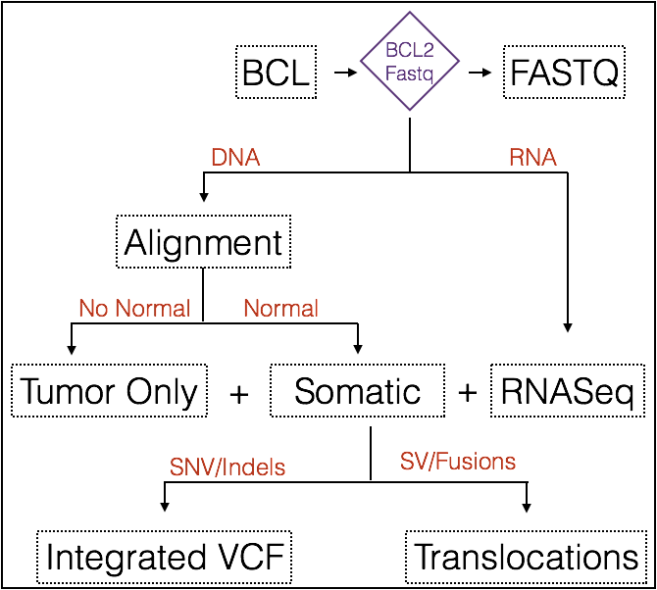
Figure 1: Procedure Overview

1) DNA Alignment
Align Reads to Reference Genome and Collect Alignment and Sequence QM. Described in more detail in the Alignment Workflow SOP
executable | nextflow
input | Sample sheet, Illumina output directory, reference genome
output | Bam and quality metrics
command | nextflow run –with-timeline –w work_directory alignment.nf –design samplesheet.txt –capture RefGenomeGRCh38.bed –input input_directory –output output_directory & > nextflow_alignment.log &

2) Tumor Only Variant Detection
Determines variants from tumor samples, where no normal control is available. Described in more detail in the Tumor-Only Workflow SOP

executable | nextflow
input | Output folder from the alignment workflow and design file describing mapping between samples and files
output | VCF
command | nextflow -C /project/PHG/PHG_Clinical/clinseq_workflows/nextflow.config run -with-timeline -w $workdir /project/PHG/PHG_Clinical/clinseq_workflows/tumoronly.nf --design $outdir\/design_tumor_only.txt --capture $capture --input $outnf --output $outnf &> $outnf\/nextflow_tumoronly.log

3) Somatic Variant Detection
Determines variants from tumor samples, where a normal control is available. Described in more detail in the Somatic Workflow SOP

executable | nextflow
input | Output folder from the alignment workflow and design file describing mapping between samples and files
output | VCF
command | nextflow -C /project/PHG/PHG_Clinical/clinseq_workflows/nextflow.config run -with-timeline -w $workdir /project/PHG/PHG_Clinical/clinseq_workflows/somatic.nf --design $outdir\/design_tumor_normal.txt --capture $capture --input $outnf --output $outnf &> $outnf\/nextflow_somatic.log

4) RNASeq Analysis
Determines variants gene fusion events, variants and relative abundance of genes in RNASeq datasets. Described in more detail in the RNASeq Workflow SOP.

executable | nextflow
input | Sample sheet, Illumina output directory, reference genome
output | Gene-Fusions, VCF and Gene Counts
command | nextflow -C /project/PHG/PHG_Clinical/clinseq_workflows/nextflow.config run -with-timeline -w $workdir /project/PHG/PHG_Clinical/clinseq_workflows/rnaseq.nf --design $outdir\/design.txt --input $outdir --output $outnf --markdups $mdup &> $outnf\/nextflow_rnaseq.log

IMPLEMENTATION

The Workflow used in this SOP can be downloaded here: https://git.biohpc.swmed.edu/brandi.cantarel/clinseq_workflows

USAGE

check_new_run.pl

This script checks for new sequencer sample sheet files to identify new sequencer run, using the seuquencer run id (prjid), this script involves the initiation of the workflow described in this SOP by:

init_workflow.pl –p projectId

Once the data analysis is complete for RNASeq and DNASeq for a sample, the data from these analyses are then combined into variants and translocations datasets.

1. Integration of variants

perl integrate_vcfs.pl $subjectid $samplename $tumorid $somatic $rnaseqid

where $subjectid is the subject name, $samplename is an optional alternative id for the subject, $tumorid is the internal id for the tumor, $somatic is the internal id for the somatic variant call and $rnaseqid is the internal id for the rnaseq. This program labels variants that are identified in the RNASeq datasets and the status of the passing of quality metrics. The output is a VCF file.

2. Integration of translocations

integrate_translocations.pl -v $annotatedSV -f $starfusionFile

where $annotatedSV is the predicted translocations from the DNASeq analysis and $starfusionFile is the predicted gene fusions from the RNASeq analysis. The output is a tab-delimited file describing translocations.

RESULT REPORTING CRITERIA

SNVs and Indels

SNVs and Indels will be reported if they meet the following criteria: (1) There are greater than 20 reads that cover the genomic region; (2) if a known variation site associated with CANCER (COSMIC Hotspot) >3 supporting reads and > 1% MAF (3) if a novel variant site >8 supporting reads and > 5% MAF; (4) for somatic mutations, the MAF in the tumor samples must be 5 times higher than the MAF of the normal control sample and (5) Clinical relevance will be determined using the Philips Intellispace Knowledgebase software.

Fusions and Translocations

- Translocation and gene fusion will be reported if they meet the following criteria: (1) breakpoint are on different chromosomes or are on the same chromosome > 10MB in linear distance; (2) if a known fusion then has > 3 RNA supporting reads or > 20 DNA supporting reads; (3) if a novel fusion > 5 RNA supporting reads or > 100 DNA supporting reads; (4) is in a gene that is in a known list of known gene fusion partners.

RELATED DOCUMENTS
Document ID# | Title of Document
SOP-2835 | DNA Analysis
SOP-2836 | RNA Analysis

COMMENTS
- N/A

REFERENCES
- N/A

HISTORY OF DOCUMENT
History of Document
Version | Date | Description of Change | Authored/Revised by

ATTACHMENTS
N/A

