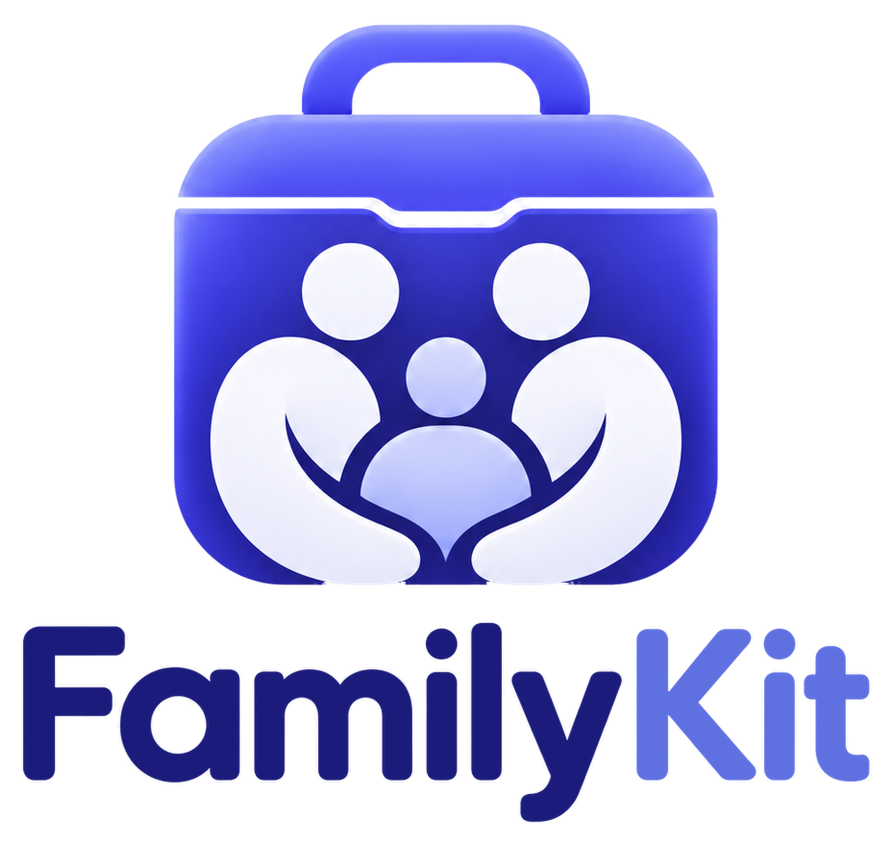

Brand Foundation
EVERYTHING IN PLACE.
Who we are, what we say, how we sound and how we look. One shared guide for the FamilyKit app and website.
VERSION | DATE | OWNER | PRODUCT
1.0 | Nov 2026 | Medhaara Innovations | FamilyKit

What's inside
01 | Who it's for | The whole family; app first
02 | Brand core | Promise, what it does, how it works
03 | Key messages | Hero heading, supporting line, three benefits
04 | Tone of voice | How we sound, including the Diary
05 | Colours | Brand purple, accents, neutrals, status colours
06 | Typography | Poppins and Mulish, app and website sizes
07 | Logo | Versions, app icon, favicon, rules
08 | Visual style | Icons, illustrations, photos
09 | Trust signals | Our six security and privacy promises
10 | To be decided | Open questions for the founder

How to use this guide. Every word, colour and rule in here was agreed with the founder. Use it as written. If something is not covered, or you want to change it, ask the founder first. Items still open are listed in section 10.

01 Who it's for
FamilyKit is for the whole family. The mobile app is the main product: a responsive web app (PWA). The website supports it. When in doubt, design for the phone first.
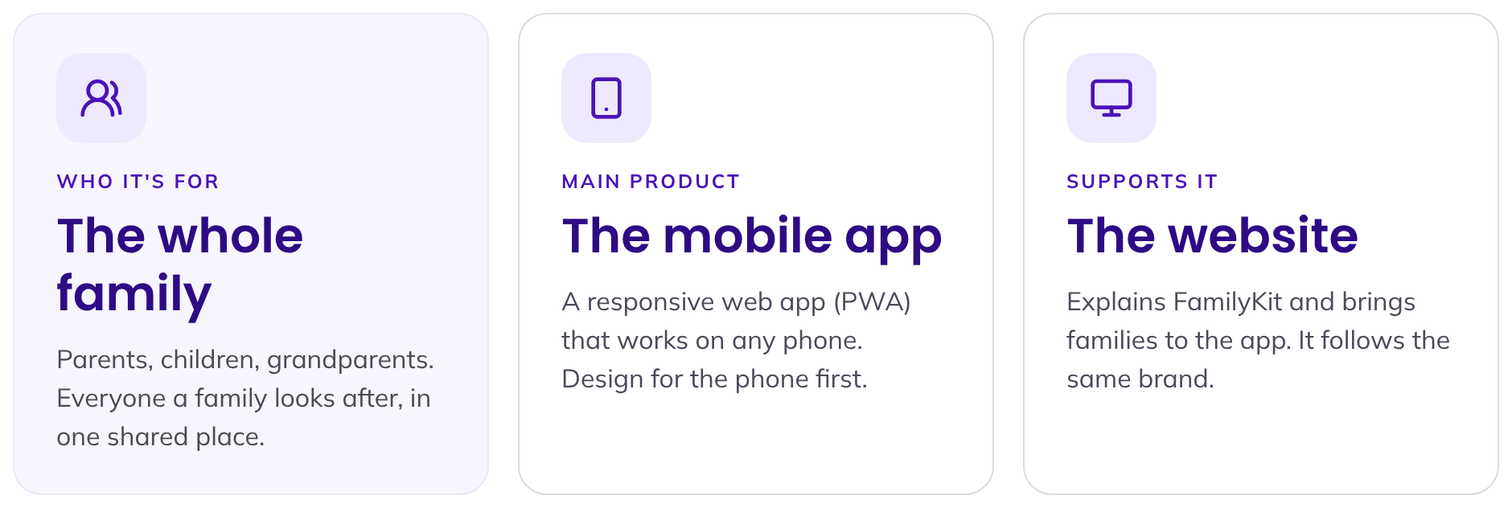

02 Brand core
The three lines everything else comes from. Use them word for word.
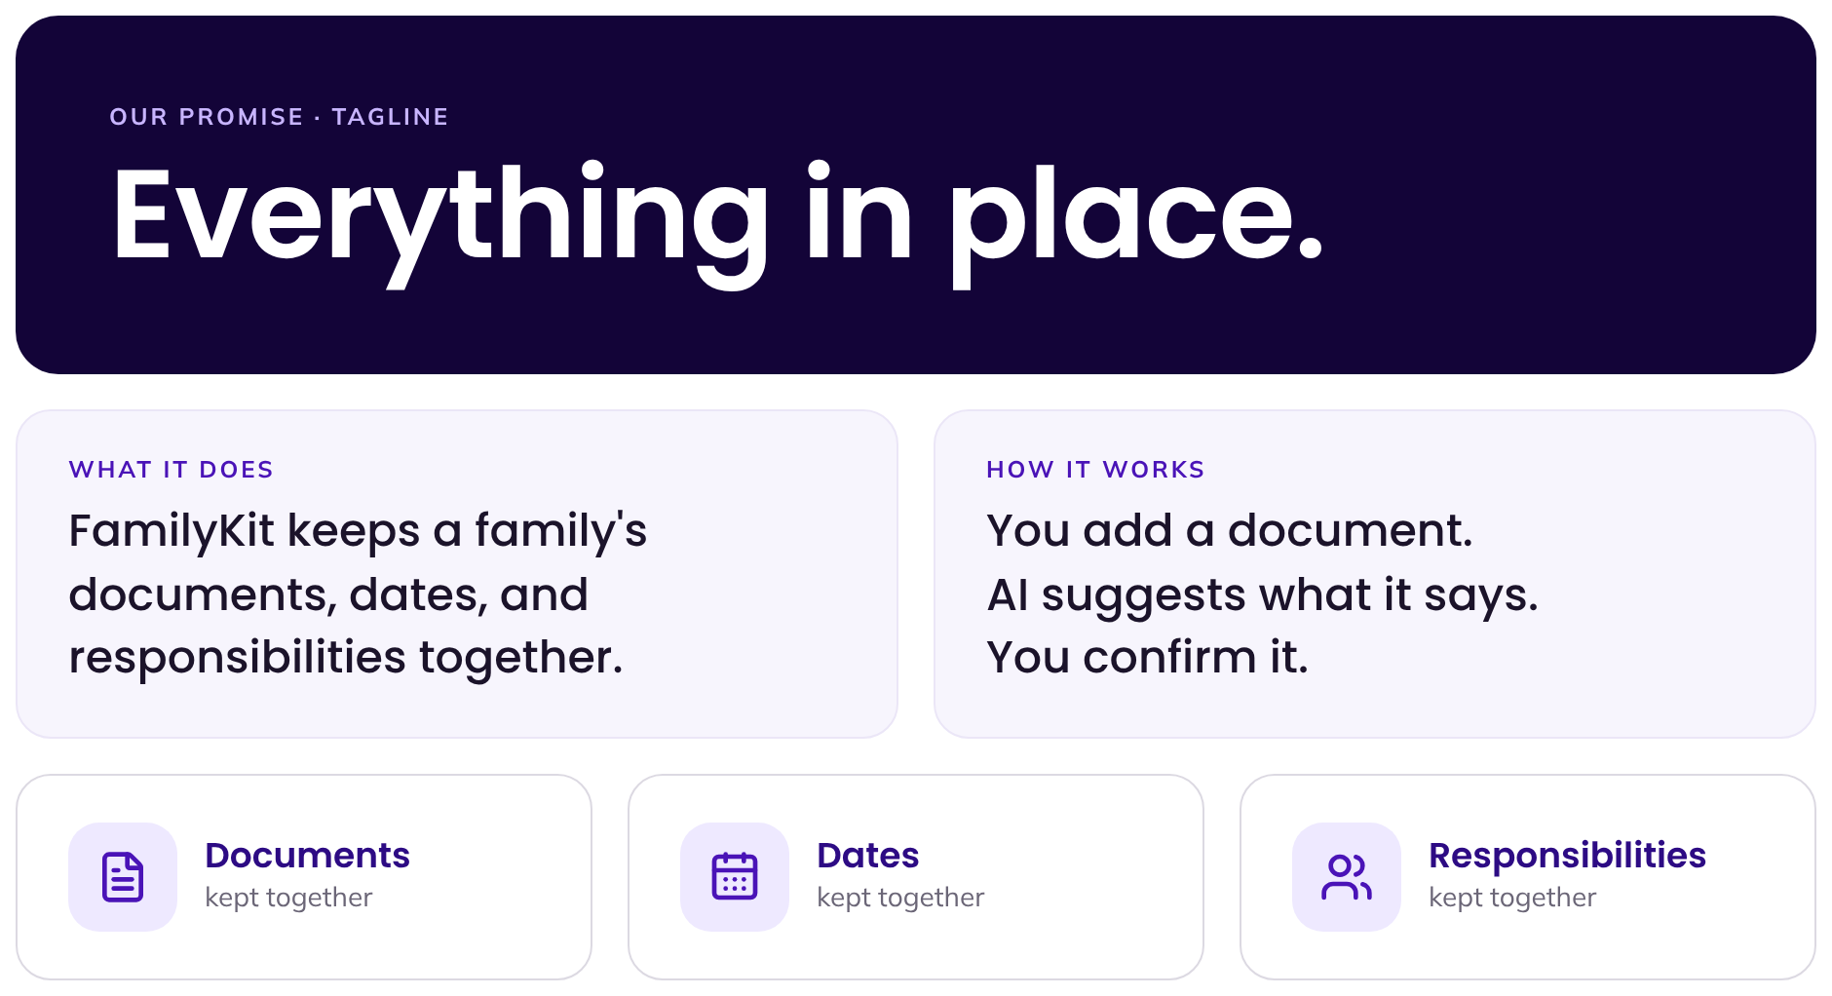
Part | Exact wording | Where to use it
Promise / tagline | Everything in place. | Logo lock-ups, app splash, browser tab, sign-offs
What it does | FamilyKit keeps a family's documents, dates, and responsibilities together. | About sections, app store, first-time intro
How it works | You add a document. AI suggests what it says. You confirm it. | Onboarding, "How it works" on the website

How it really works, step by step
This is the real flow in the app. AI never saves anything on its own: the person always checks and confirms.
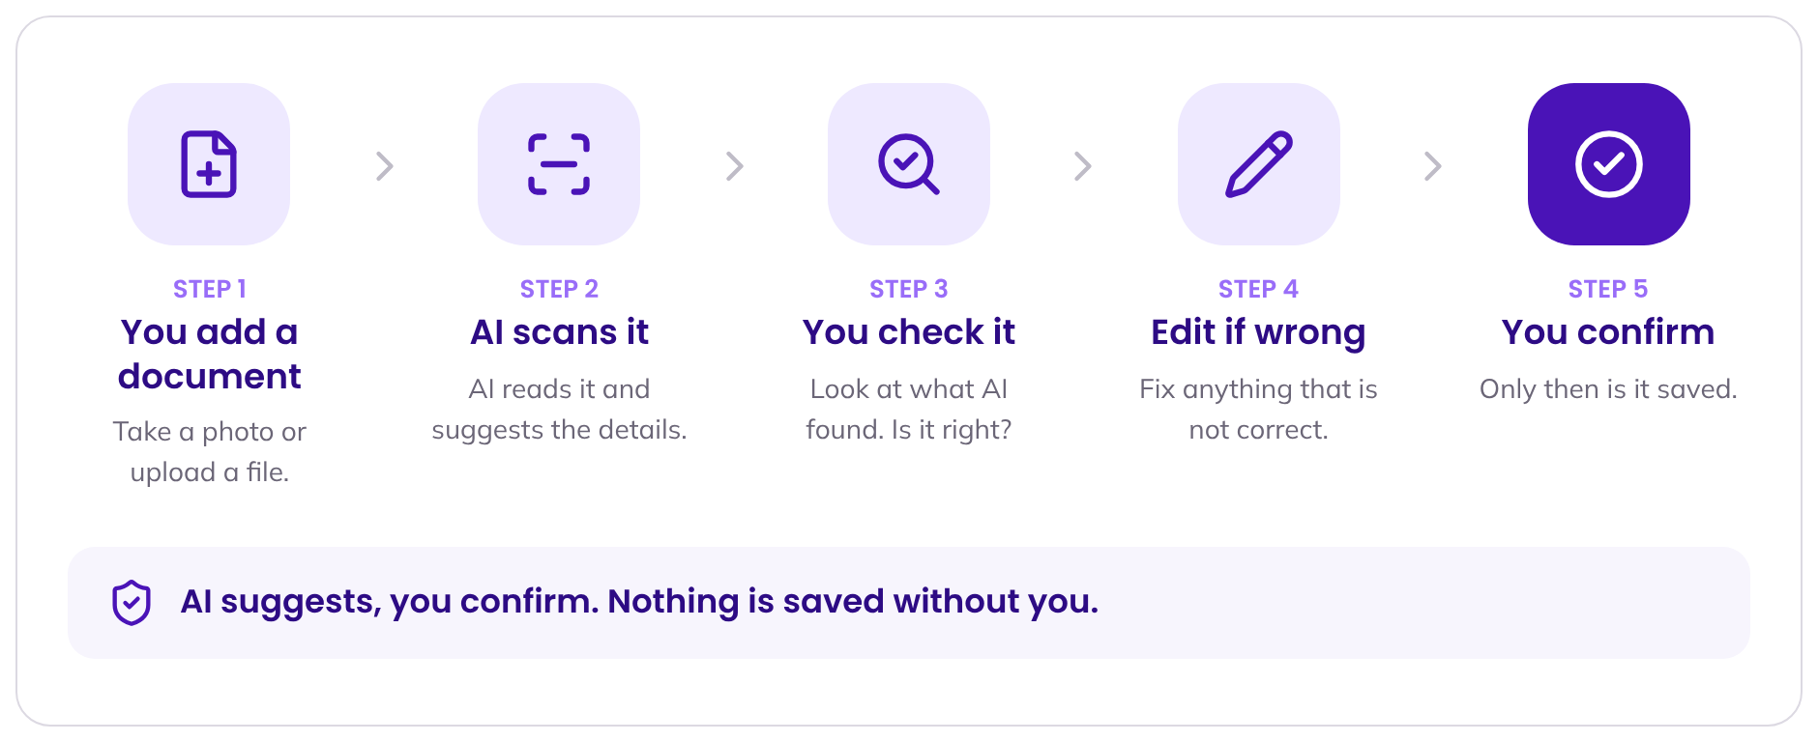

03 Key messages
The words at the top of the website and in the app introduction. Shown here as they would appear on the website.
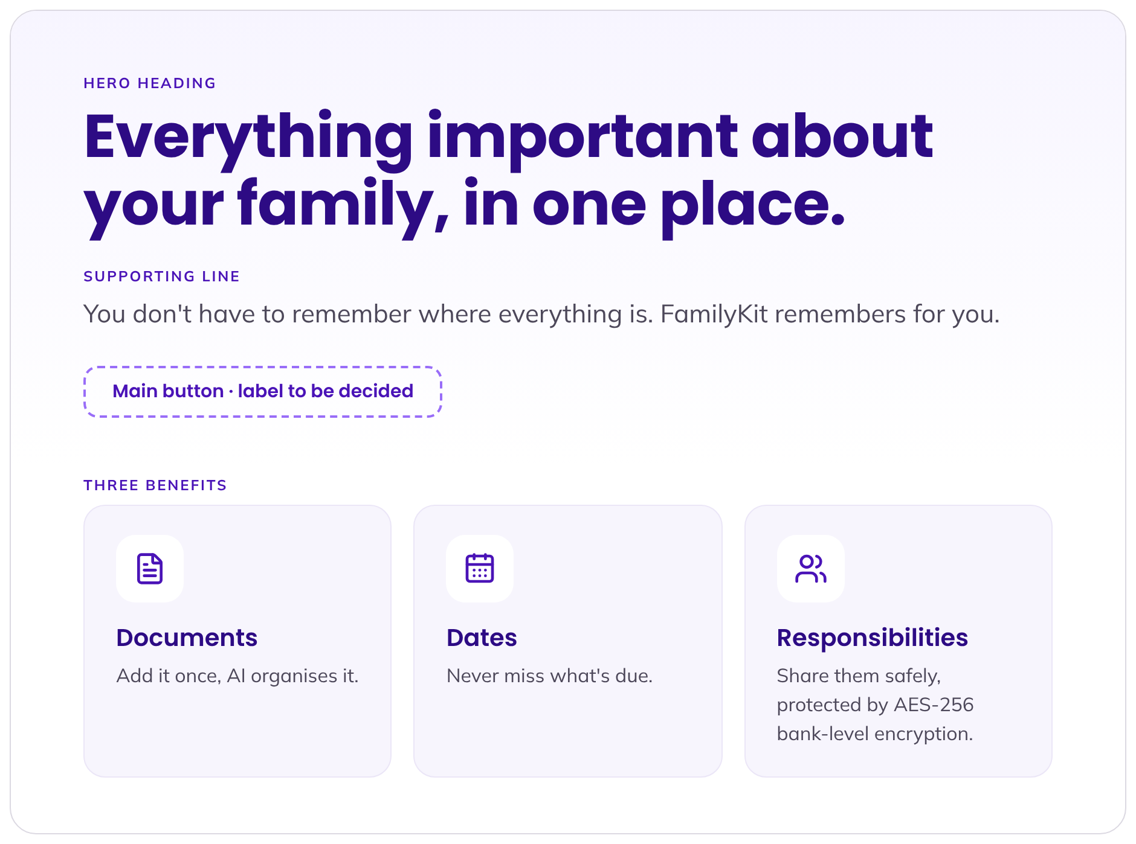
Message | Exact wording
Hero heading | Everything important about your family, in one place.
Supporting line | You don't have to remember where everything is. FamilyKit remembers for you.
Benefit 1: Documents | Add it once, AI organises it.
Benefit 2: Dates | Never miss what's due.
Benefit 3: Responsibilities | Share them safely, protected by AES-256 bank-level encryption.

The main button label is still to be decided (see section 10).

04 Tone of voice
How FamilyKit sounds everywhere: buttons, messages, emails and the website. Five traits, always together.
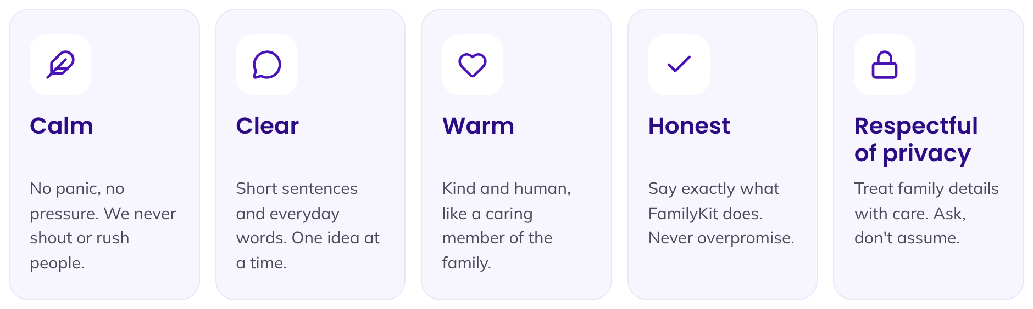

Say this, not that
SAY | DON'T SAY
"Your passport renews in 30 days." | "URGENT! Your passport is about to EXPIRE!"
"Check these details before you save." | "Please validate the extracted metadata."
"Something went wrong. Please try again." | "Error 500: request failed."
"Only the people you choose can see this." | "100% unhackable, totally secure."
"Who should be able to see this document?" | "Share with all your contacts?"
"Document saved." | "Awesome!!! You're crushing it! 🎉"

Writing rules
- Short and plain. Use everyday words. One idea per sentence.
- Talk to one person. Use "you" and "your family".
- Stay calm. No capitals for shouting, no exclamation marks in warnings, no countdown pressure.
- Be honest. Only promise what FamilyKit really does. Use the exact trust lines in section 09.
- Respect privacy. Ask before sharing. Never guess or show private details without a reason.

The Diary tone
The Diary uses the same calm voice, but softer and more personal. It never reminds, alerts or pushes. It only offers quiet, gentle prompts.
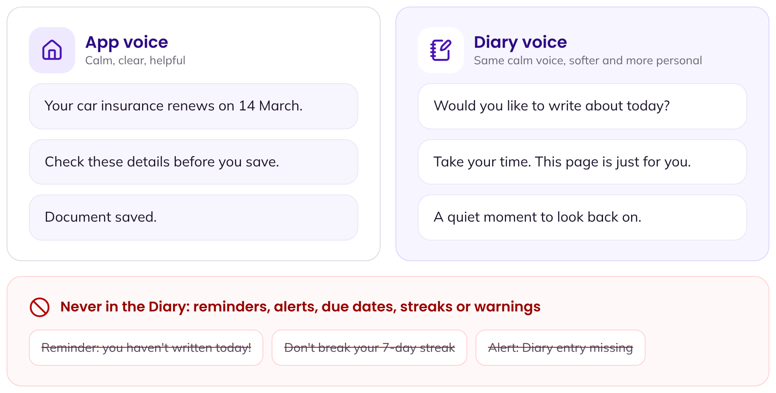
Instead of this (alert) | Write this (quiet prompt)
You haven't written in 3 days! | Would you like to write about today?
Reminder: add an entry now | Whenever you are ready, this page is here.
Entry saved successfully! | Saved. Thank you for sharing this moment.
Don't lose your streak | (Say nothing. No streaks in the Diary.)

The rest of the app may show reminders for dates and renewals, in the calm main voice. The Diary never does.

05 Colours
One deep purple for every main action, soft lavender and a bright lime for accents, purple-tinted neutrals and clear status colours. The full colour guide is the separate document "FamilyKit Brand Colours and Type".

The colours you will use most
Use | Colour | Hex | Rule
Button (rest) | Aa | #4A13B7 | The only main button colour. White text on it. One main button per screen.
Headings, button hover | Aa | #2D0B84 | All headings. Also the button colour on hover.
Button pressed | Aa | #21025E | When the button is being pressed.
Focus ring | Aa | #996DF8 | Lavender ring around anything selected by keyboard.
Soft lavender surface | Aa | #EEE9FF | Chips, soft panels and highlights.
Lime accent | Aa | #EFFF94 | Badges and highlights only. Always dark text #130438 on lime.
Dark sections | Aa | #130438 | Dark bands and footer, with white text.
Body text | Aa | #4D485A | Normal reading text.
Muted text | Aa | #6B6677 | Captions and helper text. The lightest text colour allowed.
Borders | Aa | #DCD9E2 | Dividers and card edges.
Page background | Aa | #F7F6FA | Soft alternate background; cards stay white.

Colour rules
DO | DON'T
Use one main button colour, #4A13B7, with #2D0B84 on hover and #21025E when pressed. | Don't add a second button colour (lavender, lime or another purple).
Put dark text #130438 on lime. | Never put white text on lime, and never use lime as text.
Use #6B6677 or darker for any text on white. | Never use light grey #9D99A6 or the bright status colours as text on white.
Always show a status with an icon and a word, not colour alone. | Don't rely on colour alone to show an error or success.
Keep bright accents rare: one lime and one lavender highlight per screen at most. | Don't place several bright fills side by side or behind long text.

Primary purple
Eleven even steps. Step 700 is the button, 800 the headings and hover, 900 pressed, 950 the dark bands.
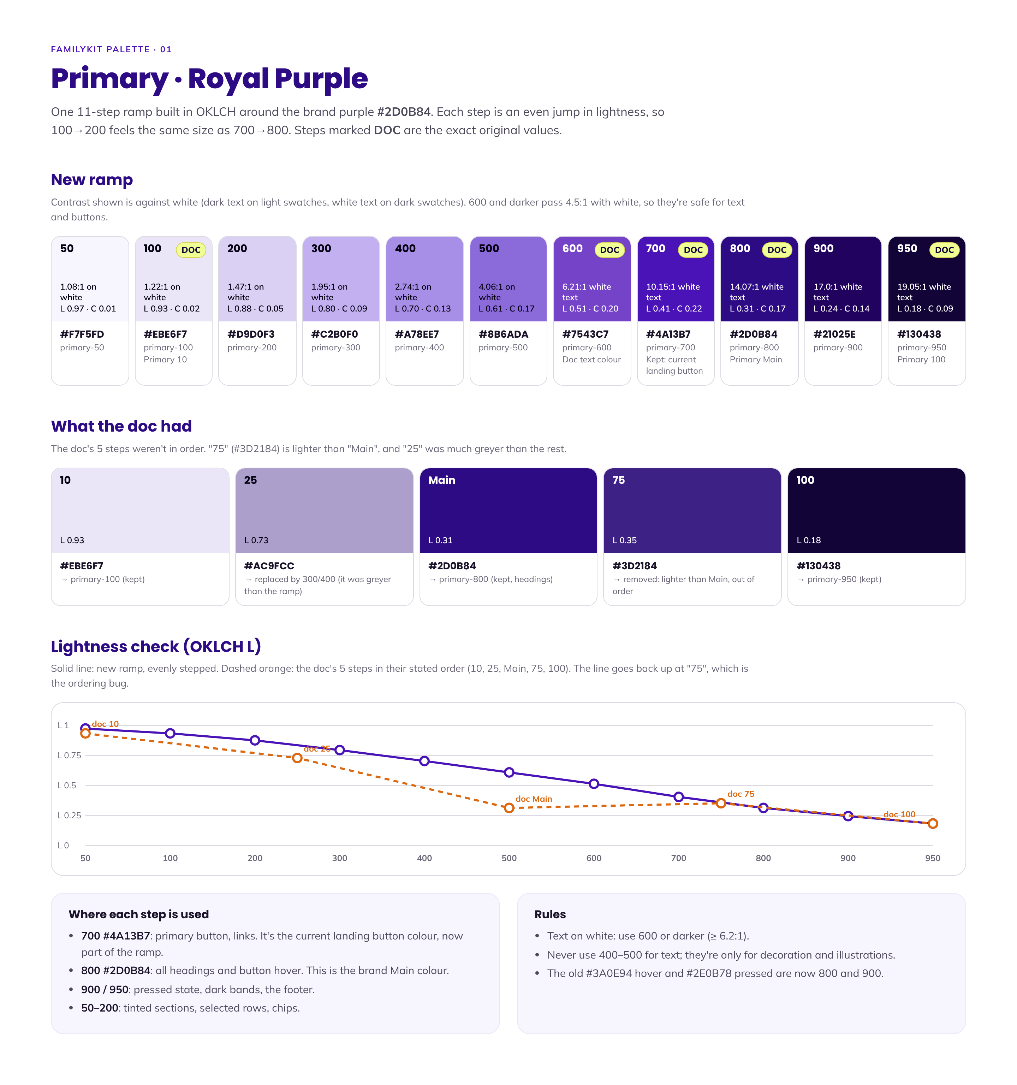

Accents: lavender and lime
Lavender is soft and calm (surfaces, avatars, focus ring). Lime is the bright highlight, used sparingly.
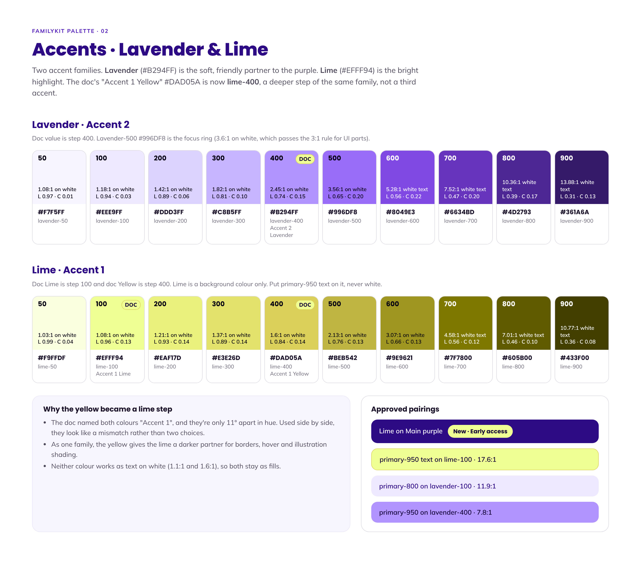

Neutrals
Purple-tinted greys for text, borders and backgrounds.
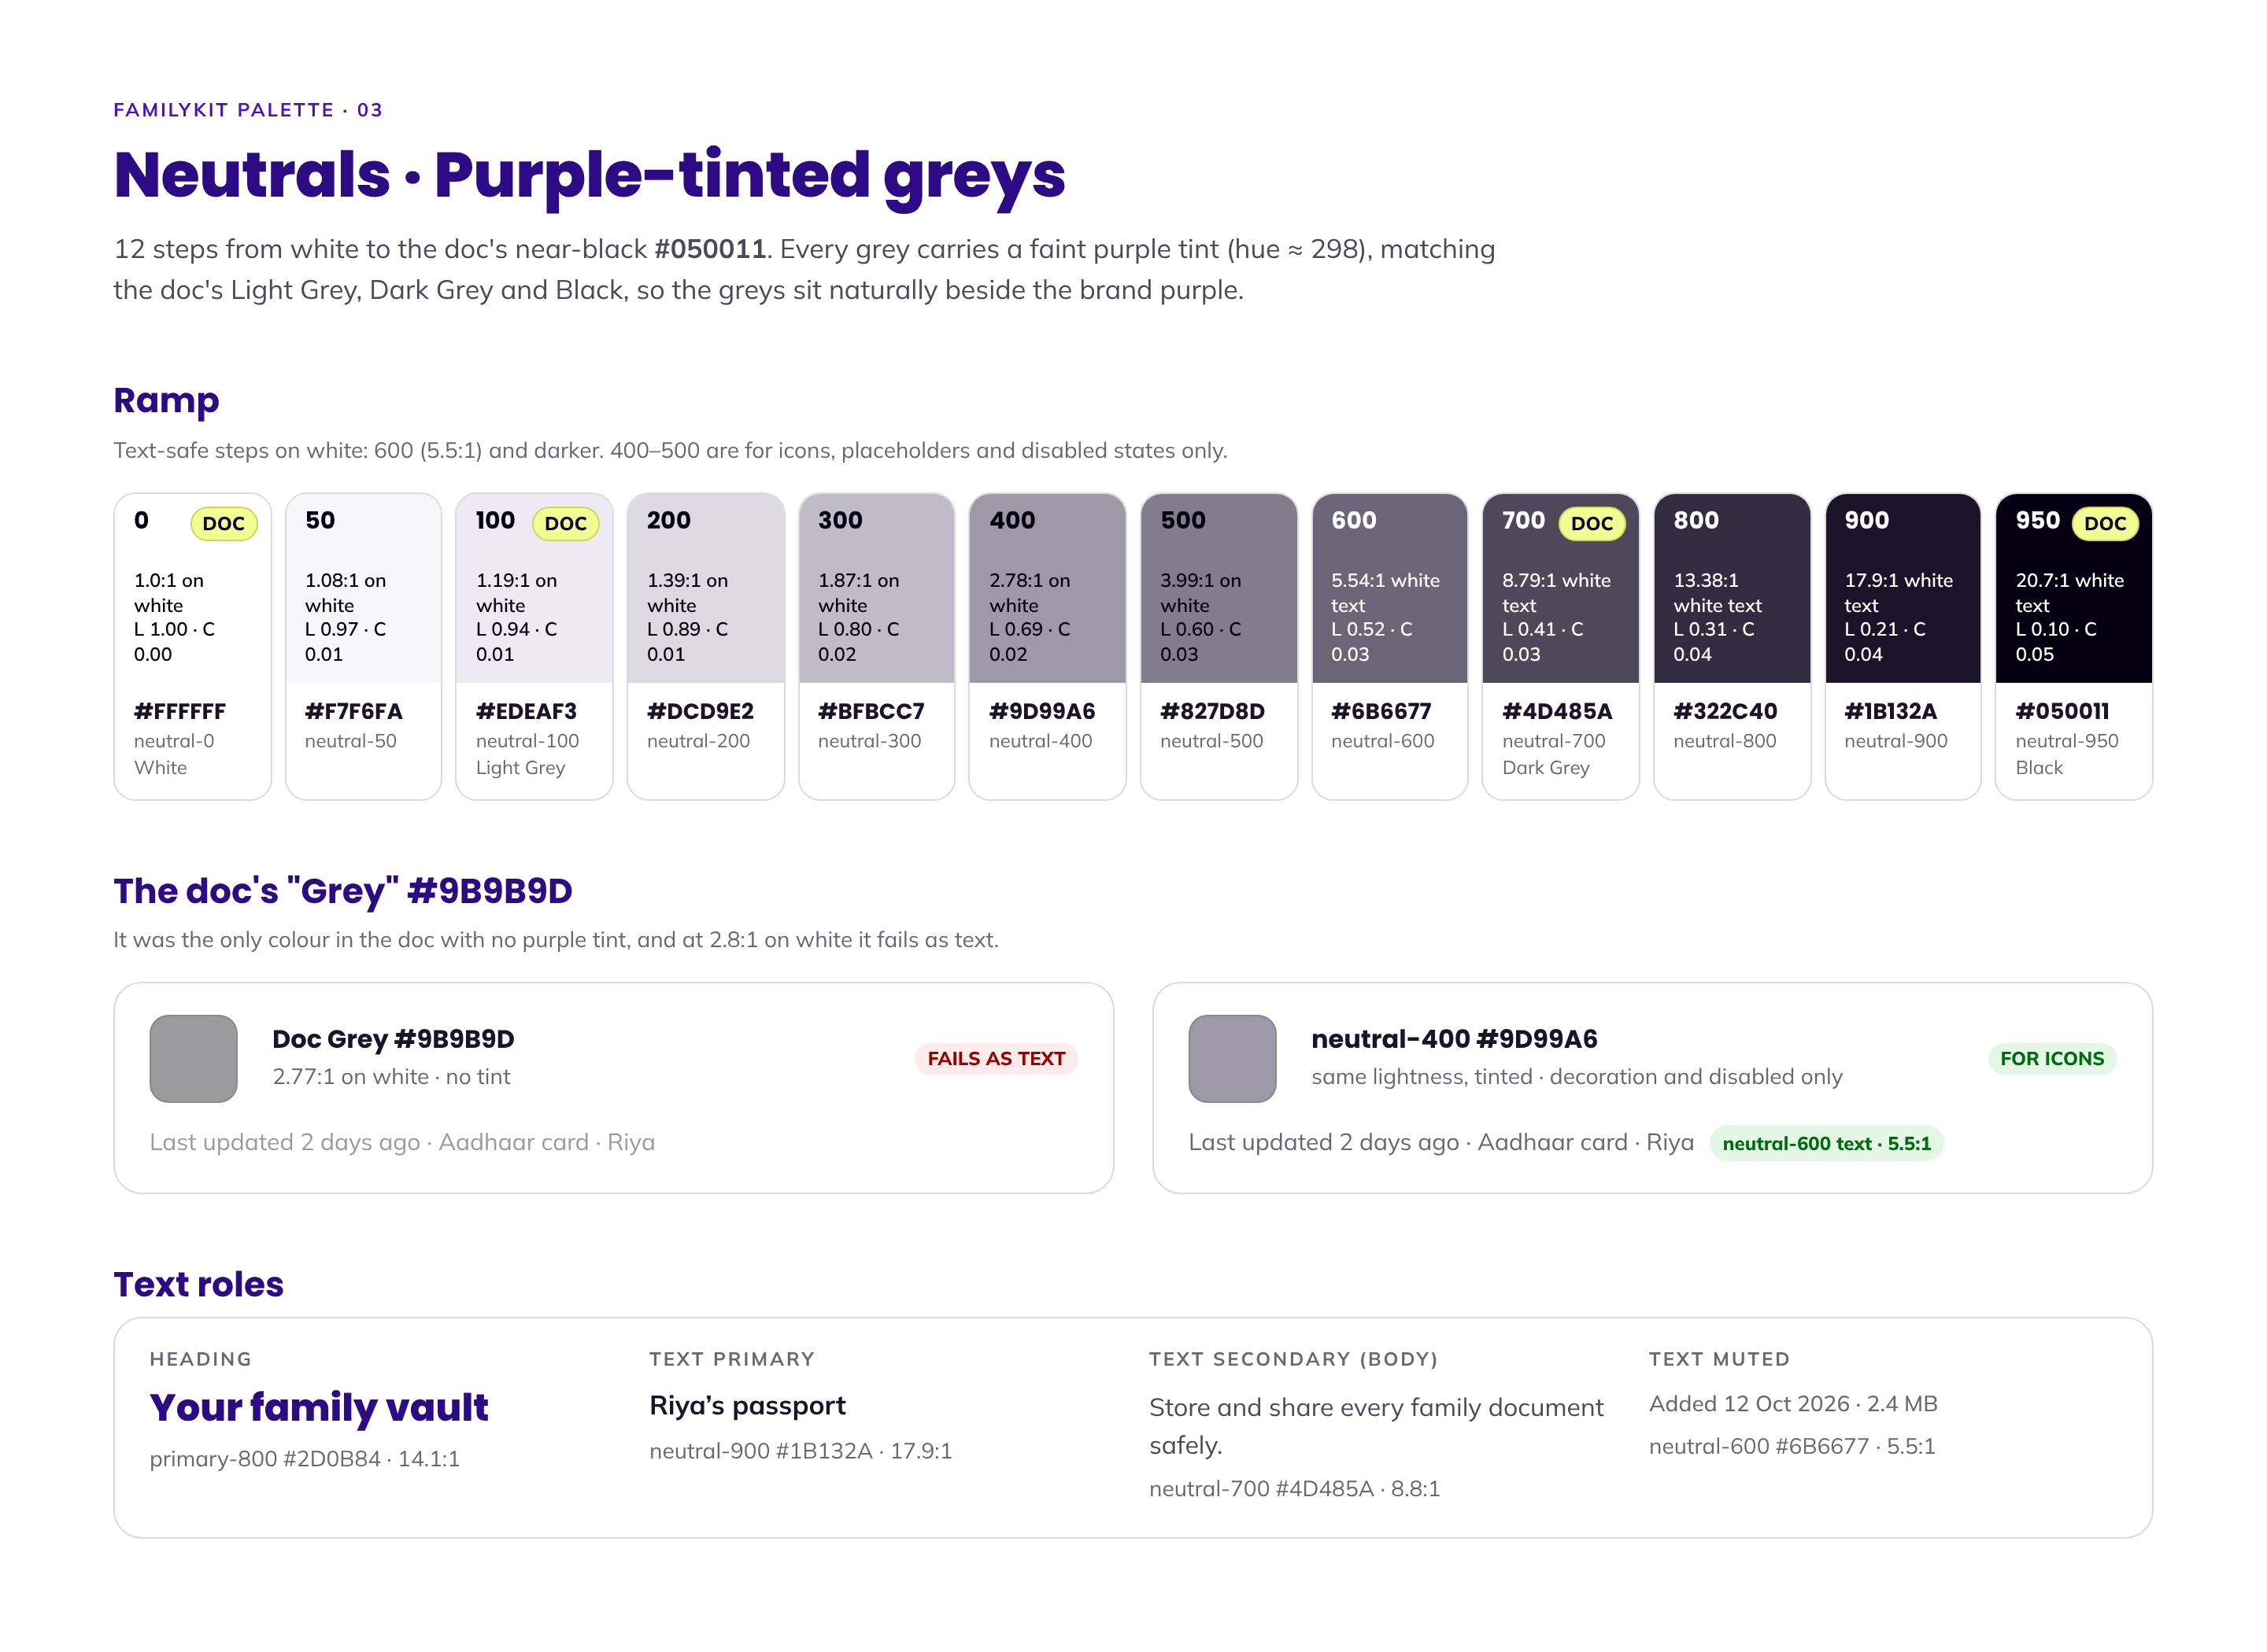

The palette in use
A sample screen built only from these colours.
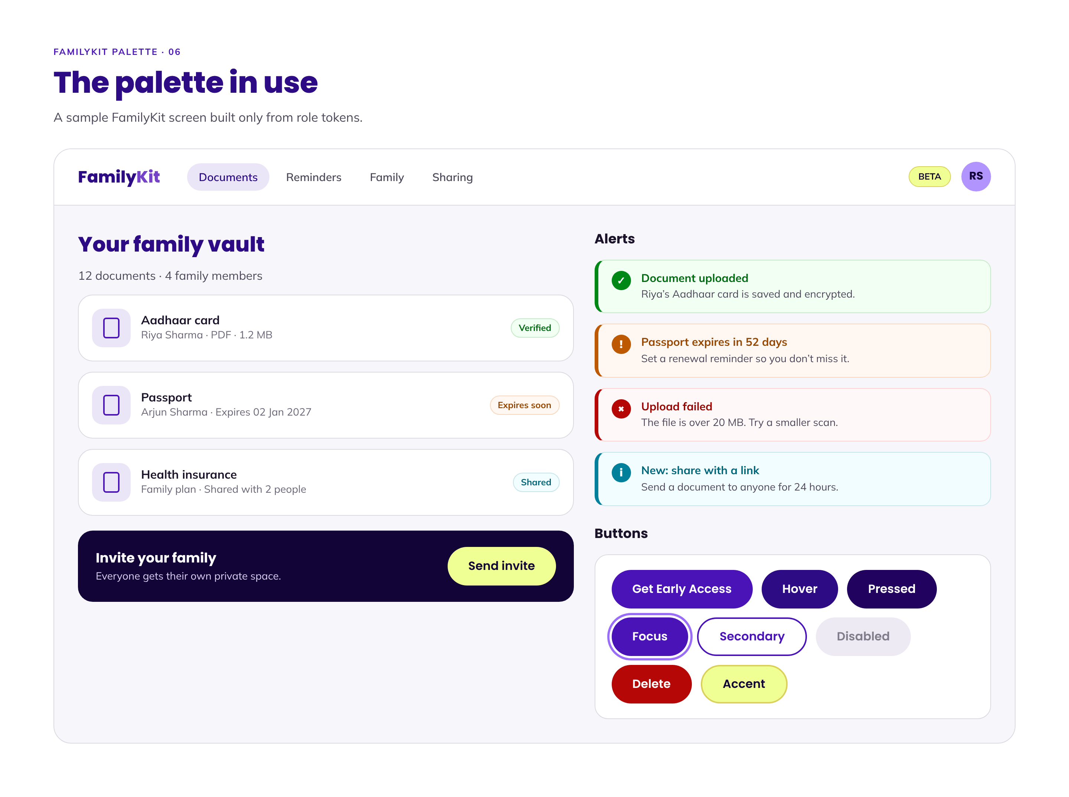

Status colours
Green for success, red for errors, orange for warnings, cyan for information. Each has a safe text colour and a soft background.
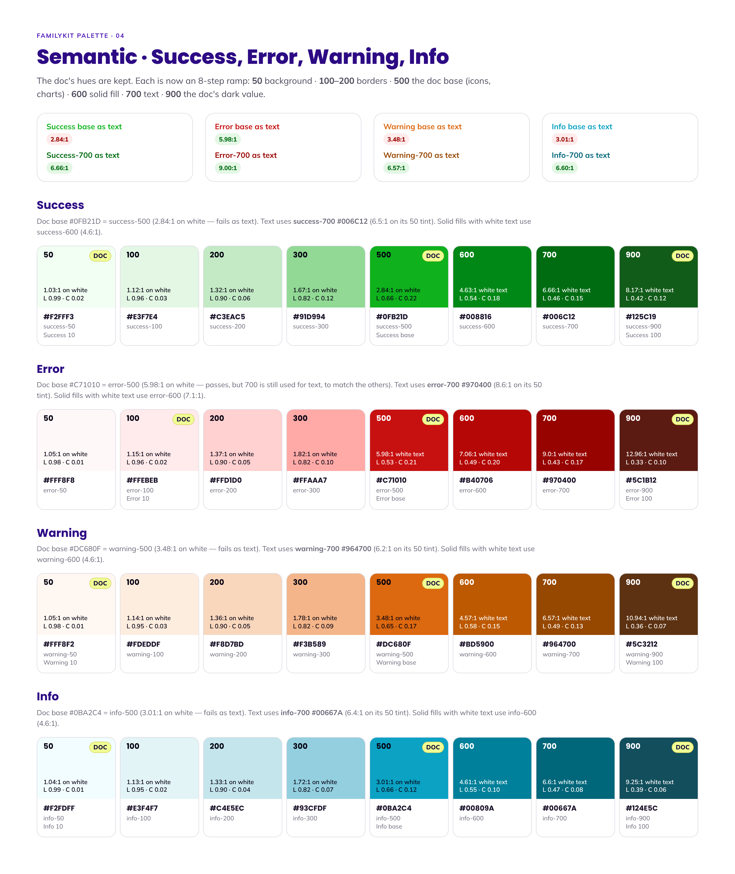

Roles and contrast
Which colour to use for each job, and how well each pair passes contrast checks.
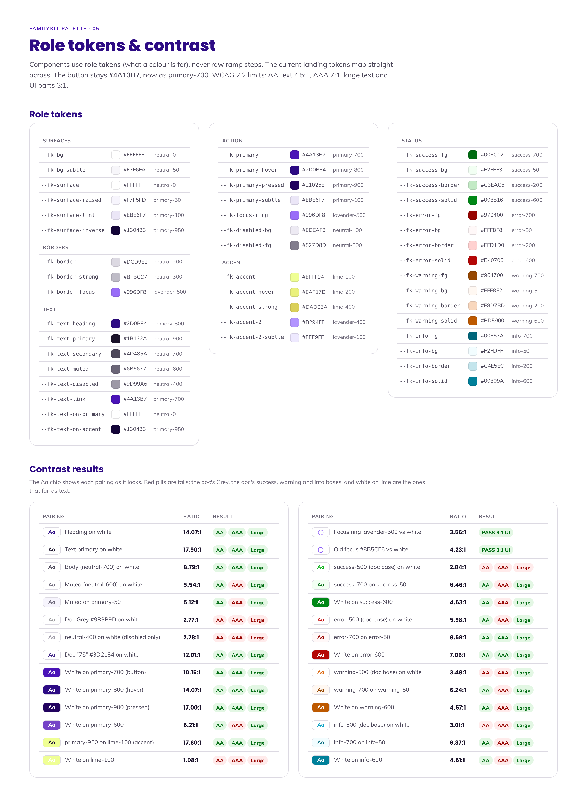
Contrast check (WCAG 2.2). Every text colour in this guide passes AA (4.5:1) on white, and most pass AAA (7:1). Examples: button white text on #4A13B7 is 10.15:1, headings #2D0B84 on white 14.07:1, body #4D485A 8.79:1, muted #6B6677 5.54:1. The focus ring #996DF8 is 3.56:1, which passes the 3:1 rule for non-text parts.

06 Typography
Two fonts only. The mobile app is the main product, so app sizes come first.
Aa  Poppins  HEADINGS · BUTTONS · AMOUNTS  Screen titles, headings, buttons, tabs, ₹ amounts, stats and dates. | Aa  Mulish  BODY TEXT · LABELS  Paragraphs, descriptions, form labels, captions and helper text.

App sizes (main product)
Role | Font and weight | Size (px)
Screen title | Poppins 600 | 24
Section heading (H2) | Poppins 600 | 20
Card / list title (H3) | Poppins 600 | 16–18
Body text | Mulish 400 | 15
Buttons | Poppins 500–600 | 14–15
Labels and captions | Mulish 600 | 12–13

Website sizes
Role | Desktop (px) | Mobile (px)
H1 (hero heading) | 56 | 32
H2 | 40 | 28
H3 | 22 | 18
Body text | 16 | 15

Amounts: Poppins numbers are not all the same width, so they do not line up in columns. Right-align amount columns for now. Using Mulish for amount columns is still to be decided (section 10). Smallest text anywhere: 12px.

Typography in use
The type scale on real app screens.
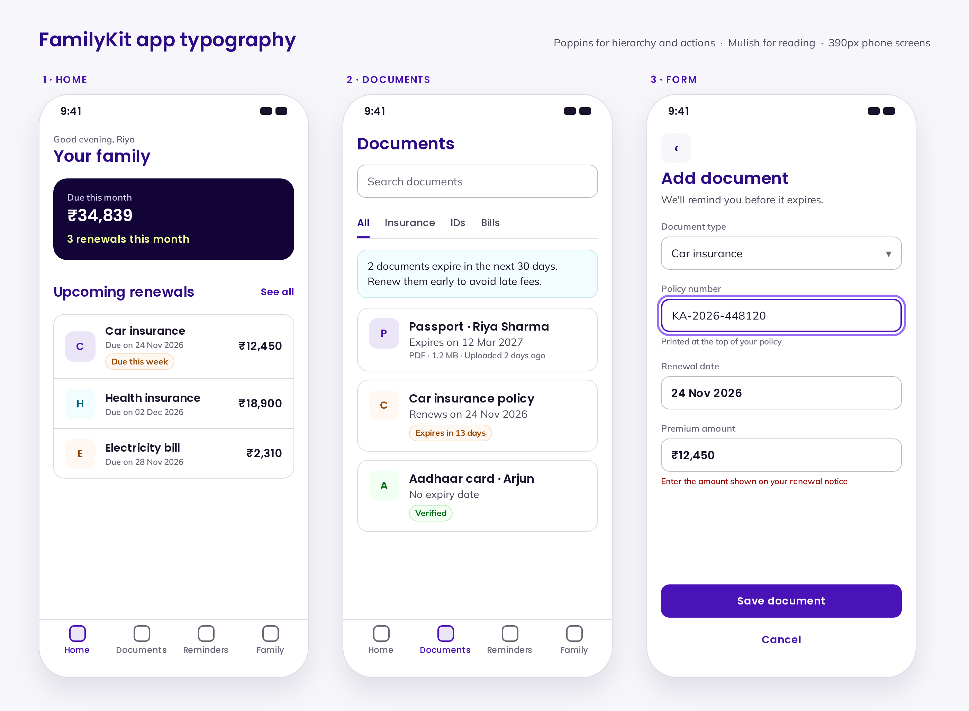

07 Logo
The FamilyKit logo is the founder's own design: a glossy indigo kit box with two parents cradling a child. Use the supplied files exactly as they are. Never redraw it.
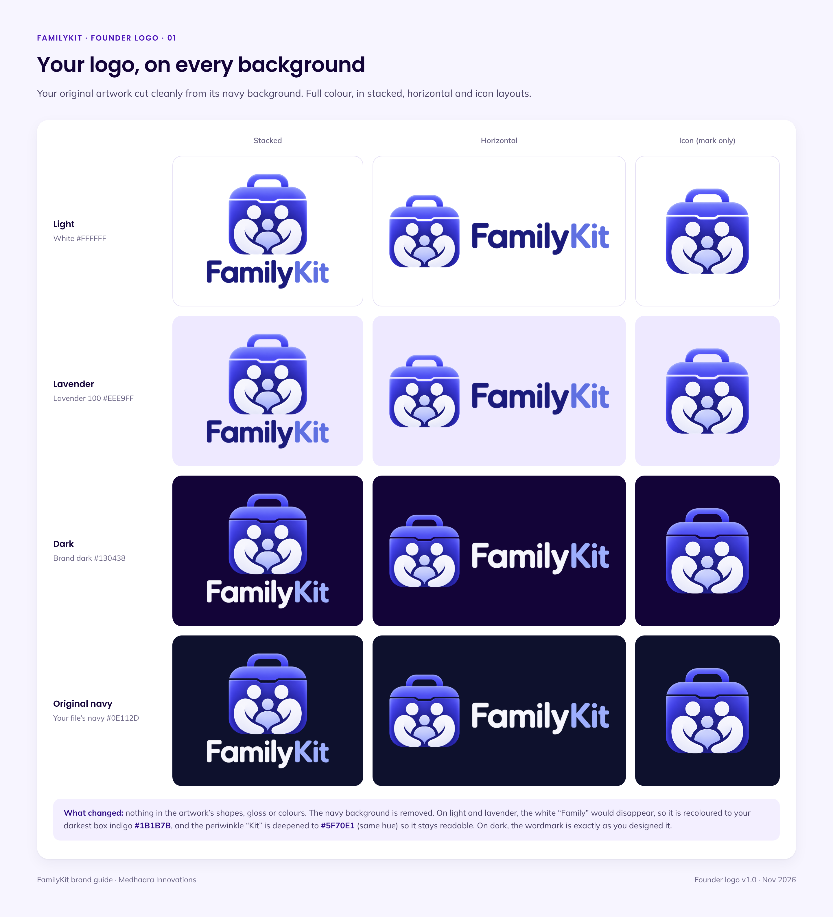
Light backgrounds: "Family" in #1B1B7B and "Kit" in #5F70E1, so the name stays readable. Dark backgrounds: the original colours, exactly as designed (white "Family", periwinkle "Kit").

One-colour versions
For stamps, embossing and single-colour print. The family figures are cut out so the paper shows through.
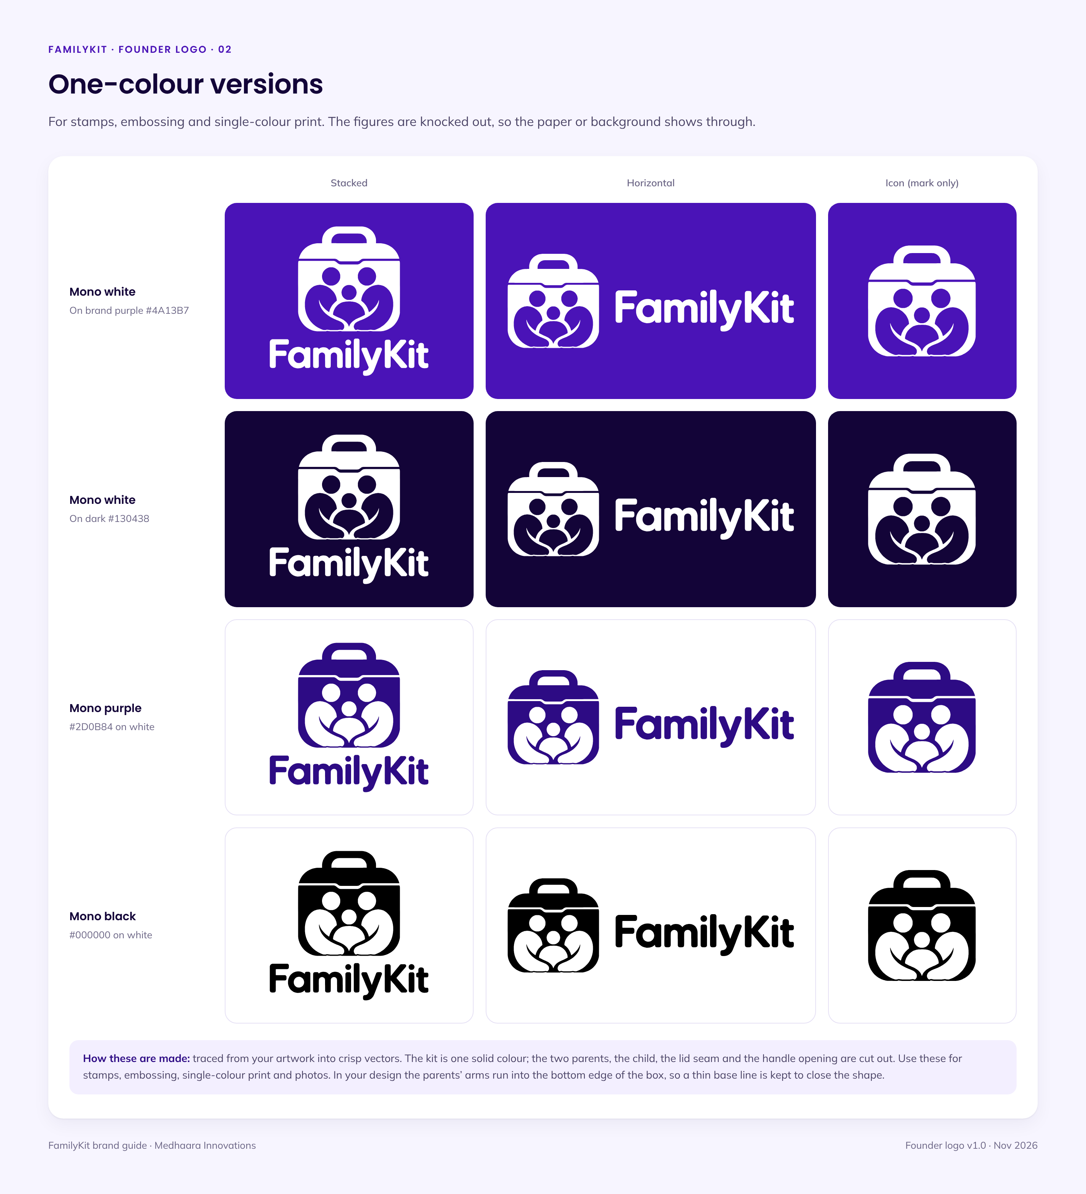

App icon and favicon
App icon: Option A, the glossy mark on brand dark #130438. It stands out on both light and dark phones. Favicon: at 16–32px the gloss turns blurry, so the browser-tab icon uses a simplified flat version of the logo at that size only.

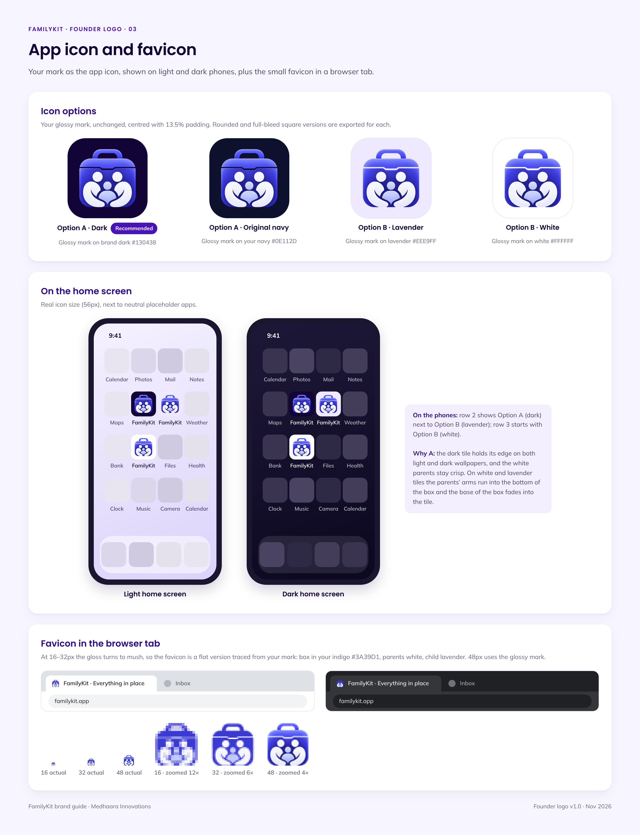

Logo rules
Clear space = the height of the kit's handle, on every side. Minimum sizes are shown on the sheet below. Six don'ts: never stretch, recolour, rotate, add effects or shadows, place it on busy backgrounds, or rearrange the parts.

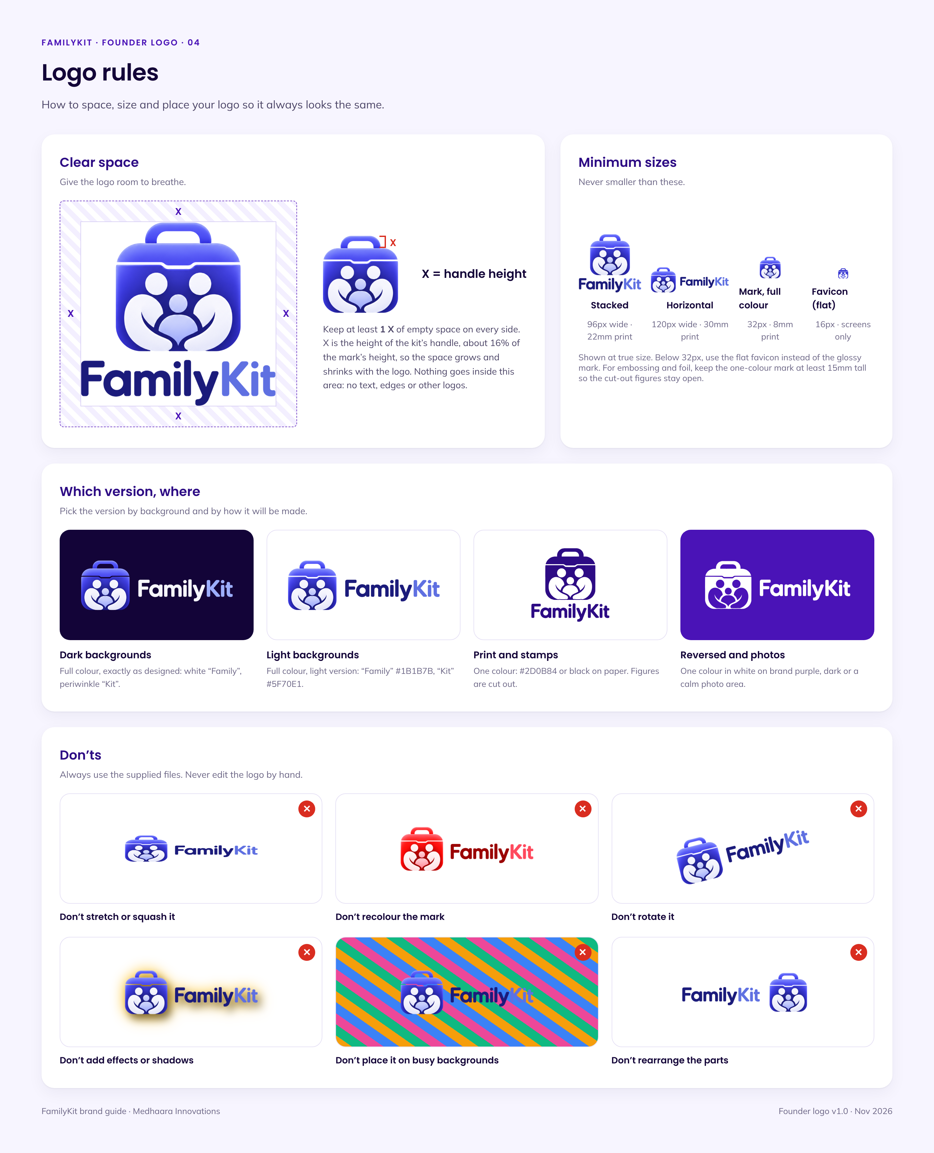

Logo files
All files are in the fk-logo/founder folder. Pick the file by where the logo will be used.
Folder | What is inside | Use it for
png/ | Full colour logo with a transparent background: mark, stacked, horizontal and wordmark, each in an on-light and an on-dark version (normal and @2x). | Website, app, presentations
png/flat/ | Logos placed on white, lavender #EEE9FF, dark #130438 and the original navy, plus one-colour versions on their backgrounds. | Quick use in documents and slides
png/mono/ | One-colour logos with transparent background: white, black and purple #2D0B84. | Stamps, embossing, single-colour print
svg/ | Vector one-colour logos (black, white, purple #2D0B84) for every layout. | Large print, signage, merchandise
png/app-icon/ | App icons on dark (Option A), navy, white and lavender: rounded, App Store, Apple touch and maskable sizes. | App stores, phone home screen (use dark)
png/favicon/ | favicon-16 and -32 (flat), favicon-48 (glossy), favicon.ico and favicon.svg. | Browser tab and bookmarks
review/ | The four review sheets shown in this section. | Reference only

Not for use: the earlier redrawn logos in fk-logo/svg, fk-logo/png and fk-logo/review were rejected. Use only the fk-logo/founder files.

08 Visual style
One look across icons, illustrations and photos: simple, calm and warm.

Icons: Lucide, outlined, rounded
All icons come from the free Lucide set. They are outlined, with rounded ends that match the soft shapes of the logo.
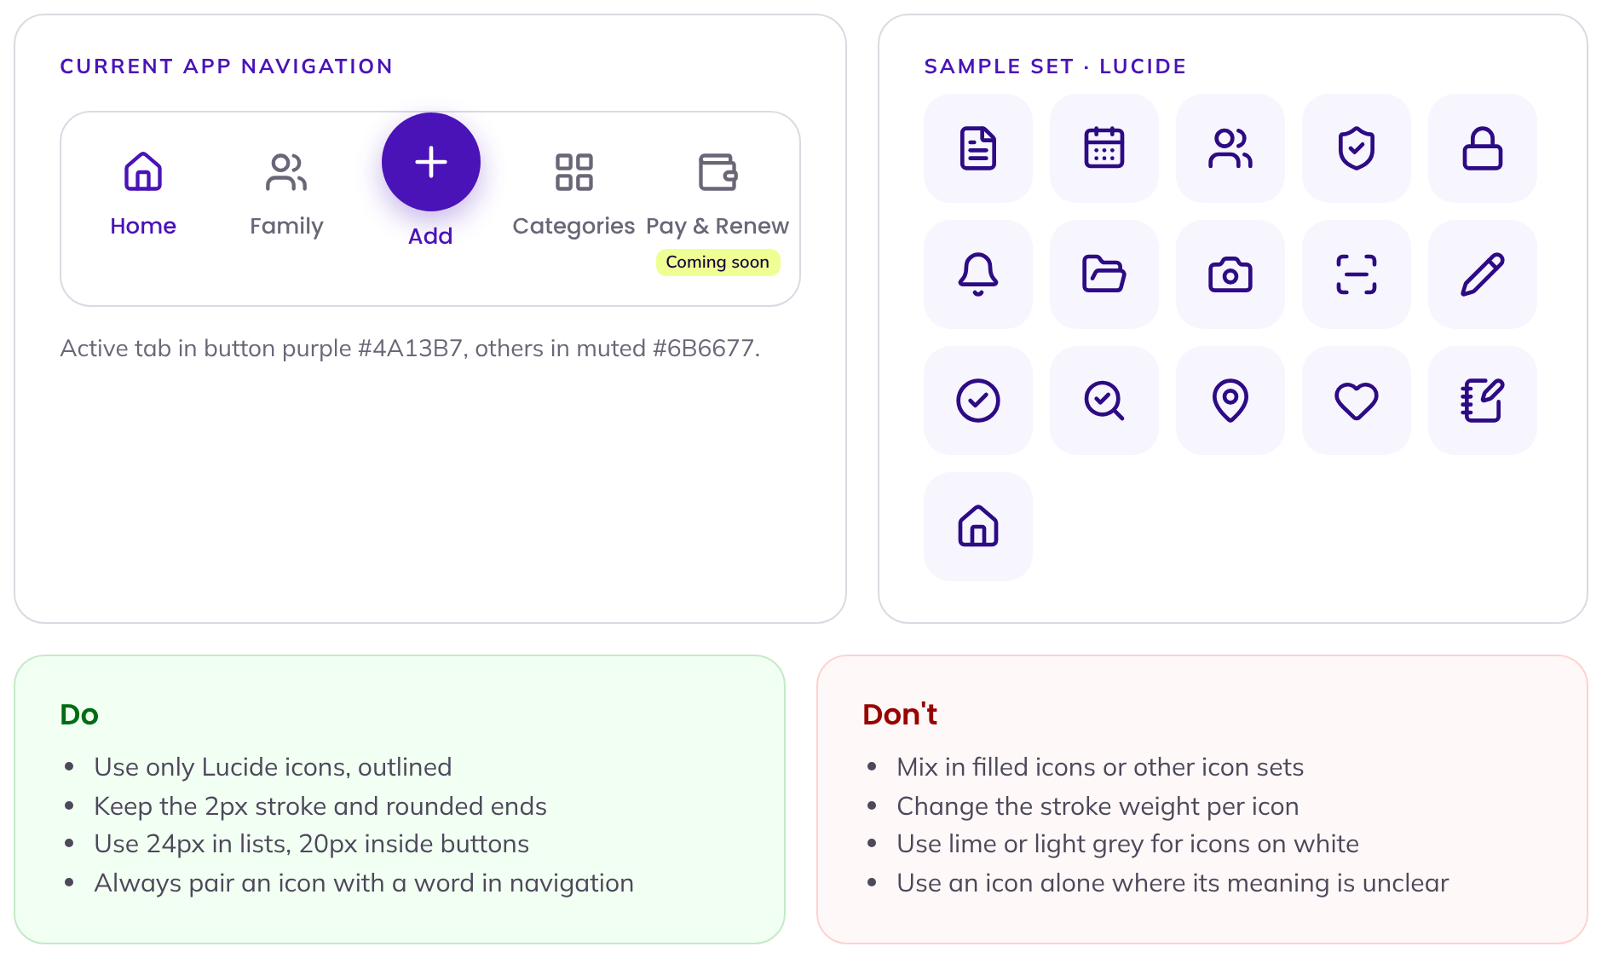

Illustrations: one simple flat style
Used only for empty screens and onboarding, in brand purples and lavender.
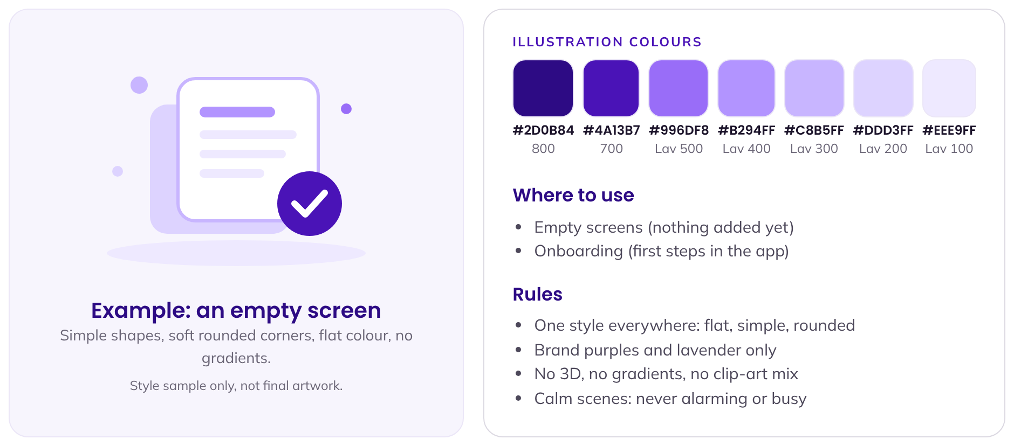

Photos: real families, at home
Real Indian families at home in natural light. Calm and warm, never a stock-office feel.
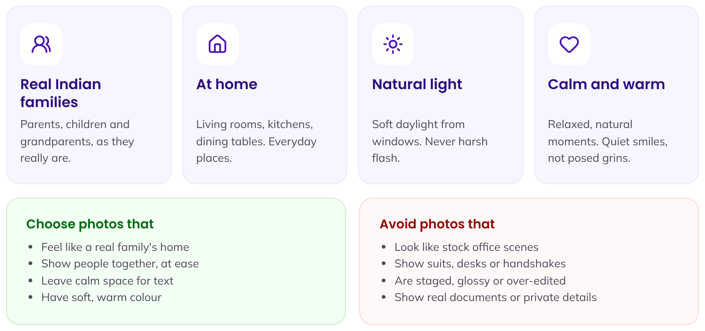
Where to find photos: choose real, natural-light photos of Indian families at home. Check that every photo has the right to be used, and that no real document, ID number or private detail is visible.

09 Trust signals
Six promises that help families feel safe. Use this exact wording. Do not shorten, combine or add to it.
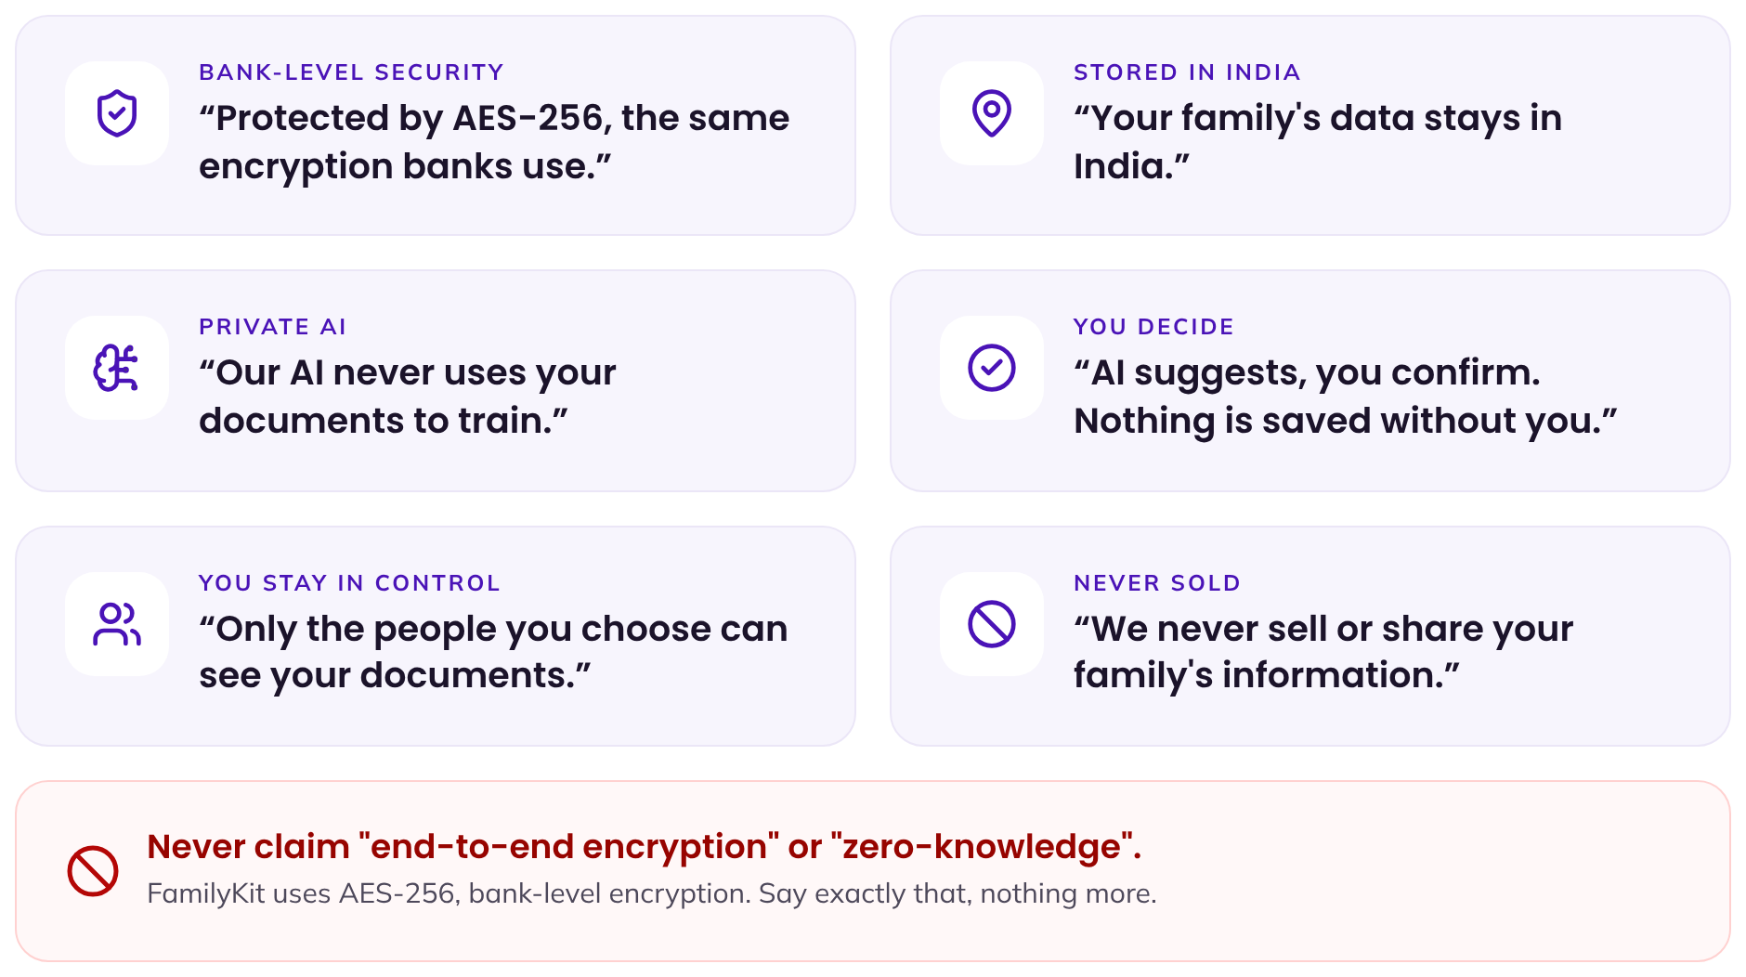
Promise | Exact wording
Bank-level security | Protected by AES-256, the same encryption banks use.
Stored in India | Your family's data stays in India.
Private AI | Our AI never uses your documents to train.
You decide | AI suggests, you confirm. Nothing is saved without you.
You stay in control | Only the people you choose can see your documents.
Never sold | We never sell or share your family's information.

10 To be decided
Three small questions are still open. Until the founder decides, the rest of this guide stays as written.
# | Question | Options | Why it matters
1 | Main button label | "Join waitlist" or "Get Early Access" | Appears on the website hero and every sign-up button.
2 | Pricing section on the website | Show a pricing section now, or not yet | Changes the website page layout.
3 | Font for amount columns | Use Mulish for amounts in columns, or keep Poppins right-aligned | Poppins has no same-width (tabular) numbers, so amounts in columns do not line up.

Decision log. Founder's answer and date:
1. ______________________________
2. ______________________________
3. ______________________________

