LAB PROGRAM 1- student details
Name: Medha M Chippalkatti USN:1BF25CS152 DATE: 01-10-2026
CODE:-
import java.util.Scanner;
class Student
{
String usn;
String name;
void accept(Scanner sc)
{
System.out.println("Enter USN:");
usn= sc.nextLine();
System.out.println("Enter Name:");
name=sc.nextLine();
}
void display()
{
System.out.println("USN is:"+usn);
System.out.println("Name is:"+name);
}
}
class StudentRun
{
public static void main(String arg[])
{
System.out.println("Name: MEDHA M CHIPPALKATTI LAB PROGRAM 1 USN:1BF25CS152");
Scanner sc = new Scanner(System.in);
System.out.println("Enter no. of Students");
int n = sc.nextInt();
sc.nextLine();
Student s[] = new Student[n];
for(int i = 0;i < n; i++)
{
s[i] = new Student();
s[i].accept(sc);
}
for(int i = 0;i < n; i++)
{
s[i].display();
}
}
}

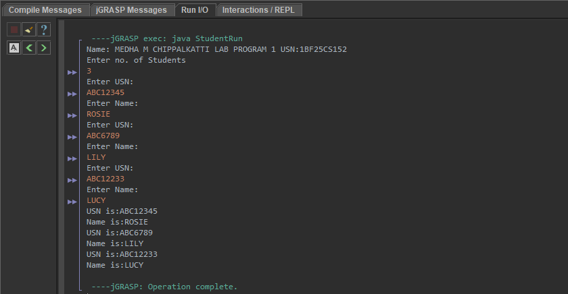
OUTPUT:-

