**Lab 4a by Samuel Peers (sampe354) and Medhanie Weldemariam (medwe277)**

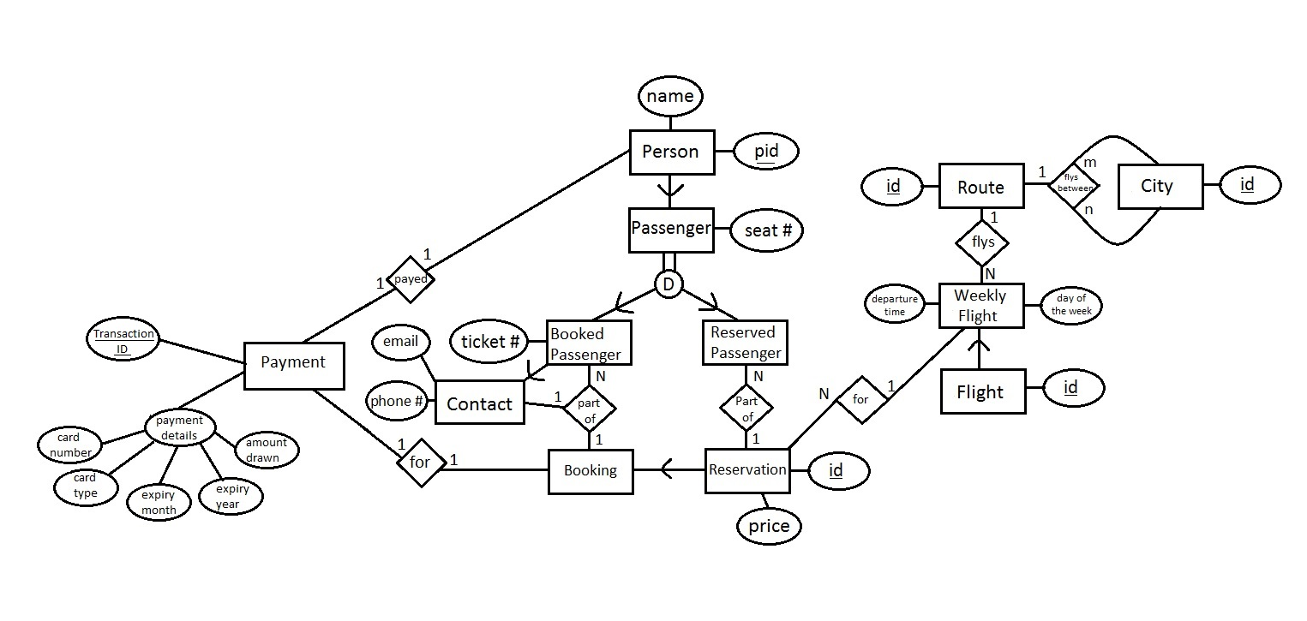

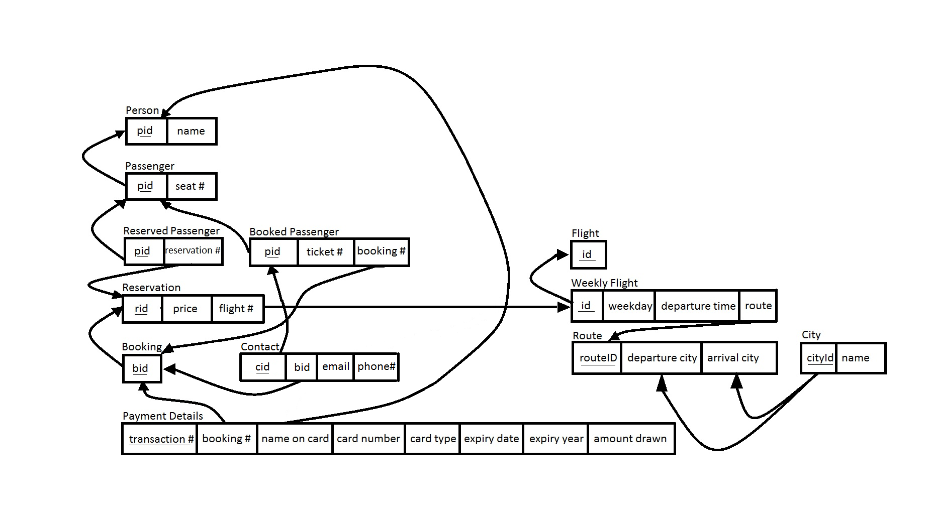2)

All the relations are in BCNF.

We feel that the fields in each relation are self explanatory.

We differentiated between "Reservation" and "Booking" by making them two separate entities, where "Booking" is a subclass of "Reservation". The way we see is that a booking is simply a reservation that has been payed for. So there is an "is a" relation between the two. "Booking" also has additional attributes that "Reservation" does not. Hence "Booking" as a subclass of "Reservation" is justified.