Lab 3 Samuel Peers (sampe354) and MedhanieAregawi

1. Given a relation R(A, B, C, D)
2. Supply a set of functional dependencies and a primary key such that R is in 1NF but not in 2NF.

Answer:

Primary Key: AB

FDs: AB 🡪 CD

B 🡪D

1. Supply a set of functional dependencies and a primary key such that R is in2NF but not in 3NF.

Answer:

Primary Key: AB

FDs: AB 🡪 CD

C 🡪 D

1. Supply a set of functional dependencies and a primary key such that R is in3NF but not in BCNF.

Answer:

Primary Key: AB

FDs: AB 🡪 CD

C 🡪 B

1. Given the universal relation R={A, B, C, D, E, F} and the set of functional dependencies F={{AB🡪C}; {A🡪D}; {D🡪AE}; {E🡪F}}
2. What is a primary key for R? Show how you arrive at your solution (applyingthe inference rules for functional dependencies).

Answer:

We determined the primary key for R by drawing a diagram:

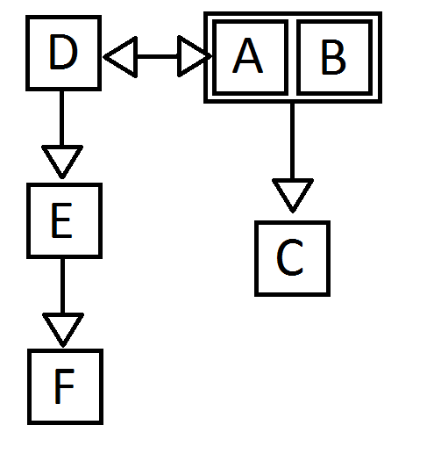

From this simple diagram, we can see that D,E, and F are functionally dependant on A and that C is functionally dependant on AB. Hence we should try and prove that AB is a candidate key.

1. AB 🡪 C //Given
2. A🡪D //Given
3. AB 🡪 CA //Augmentation on (1)
4. CA 🡪 DC //Augmentation on (2)
5. CA 🡪 D //Decomposition on (4)
6. AB 🡪 D //Transitive on (3) and (5)
7. AB 🡪 CD //Additive on (6) and (1)
8. D 🡪 AE //Given
9. D 🡪 E //Decomposition on (8)
10. CD 🡪 CE //Augmentation on (9)
11. CD 🡪 E //Decomposition on (10)
12. AB 🡪 E //Transitive on (7) and (11)
13. AB 🡪 CDE //Additive on (7) and (12)
14. E 🡪 F //Given
15. CDE 🡪 CDF //Augmentation on (14), added CD to both sides
16. CDE 🡪 F //Decomposition on (15)
17. AB 🡪 F //Transitive on (13) and (16)
18. AB 🡪 CDEF //Additive on (13) and (17)

So we have shown that AB 🡪 CDEF and thus AB is a candidate key.

Let us also try and prove that BD is a candidate key.

1. D 🡪 AE //Given
2. D 🡪 A //Decomposition on (19)
3. BD 🡪 AB //Augmentation on (20)
4. BD 🡪 A //Decomposition on (21)
5. BD 🡪 C //Transitive on (21) and (1)
6. BD 🡪 AC //Additive on (22) and (23)
7. D 🡪 E //Decomposition on (19)
8. BD 🡪 BE //Augmentation on (25)
9. BD 🡪 E //Decomposition on (26)
10. BD 🡪 ACE //Additive on (24) and (27)
11. D 🡪 F //Transitive on (25) and (14)
12. BD 🡪 BF //Augmentation on (29)
13. BD 🡪 F //Decomposition on (30)
14. BD 🡪 ACEF //Additive on (28) and (31)

So we have shown that BD is a candidate key.

Candidate Keys: AB and BD

Primary Key: AB

Prime attributes: A, B, D

Non-prime attributes: C, E, F

1. Decompose R in 2NF. Watch out for candidate keys.

Answer:

One of our FDs is D🡪 EF. This violates our rule that says no non-prime attribute may be functionally dependant of a part of a candidate key.

Before:

R(A, B, C, D, E, F)

After:

R1(A, B, C, D)

Candidate Keys: AB, BD

FDs: AB 🡪 C

BD 🡪 C

D 🡪 A

A 🡪 D

R2(D, E, F)

Candidate Key: D

FDs: D🡪 EF

E 🡪 F

1. Decompose R in 3NF. Watch out for candidate keys.

Answer:

One of our FDs is E 🡪 F (in R2). This violates the rule that says no non-prime attribute can be functionally dependant on a non-candidate key.

Before:

R2(D, E, F)

After:

R21(D, E)

Candidate Key: D

FD: D 🡪 E

R22(E, F)

Candidate Key: E

FD: E 🡪 F

1. Decompose R in BCNF.

Answer:

The FDs A 🡪 D and D 🡪 A (in R1) violate the rule that says every determinant must be a candidate key.

Before:

R1(A, B, C, D)

After:

R11(A, B, C)

Candidate Key: AB

FD: AB 🡪 C

R12(A, D)

Candidate Keys: A, D

FDs: A 🡪D

D 🡪A

1. Consider the following relation for published books:

BOOK(Title#, Title, Author#, BookType, Price, AuthorName, Publisher)

with the following additional dependencies:

Title# 🡪Title, BookType, Publisher

Author# 🡪AuthorName

BookType🡪Price

1. What is the normal form of BOOK?

1NF: BOOK is already in 1NF

2NF: The FDs

Title# 🡪 Title, BookType, Publisher, Price

Author# 🡪AuthorName

must be changed.

Before:

BOOK(Title#, Title, Author#, BookType, Price, AuthorName, Publisher)

After:

BOOK1(Author#, Title#)

Candidate Key: Author#Title#

BOOK2(Author#, AuthorName)

Candidate Key: Author#

FD: Author 🡪AuthorName

BOOK3(Title#, Title, BookType, Price, Publisher)

Candidate Key: Title#

FD: Title# 🡪 Title, BookType, Price, Publisher

BookType🡪 Price

3NF: The FD BookType🡪 Price in BOOK3 must be changed.

Before:

BOOK3(Title#, Title, BookType, Price, Publisher)

After:

BOOK31(Title#, BookType, Publisher)

Candidate Key: Title#

FD: Title# 🡪BookyType, Publisher

BOOK32(BookType, Price)

Candidate Key: BookType

FD: BookType🡪 Price

b) The relations are all already in BCNF.