Physics-Informed Neural Networks for District-Level COVID-19 Modelling in India
A SIRD Compartmental Approach: From a Two-Network Prototype to a Unified, Constraint-Respecting Architecture
Technical Report — IITG.AI COVID-19 Infection Rate Analysis Project — September 2026

Abstract
This report documents a Physics-Informed Neural Network (PINN) pipeline for modelling COVID-19 spread across Indian districts using a Susceptible–Infectious–Recovered–Deceased (SIRD) compartmental framework. Rather than fitting a classical ODE solver to noisy case data, the network is trained to satisfy the SIRD governing equations while fitting observed compartment fractions, letting it “back-calculate” hidden epidemiological parameters — transmission rate β, recovery rate γ, mortality rate μ — as functions of space, time and policy context, without ever being told when lockdowns occurred.
An earlier two-network design surfaced concrete problems — data leakage, a physically indefensible spatial-diffusion assumption, and forward-simulation instability patched with ad hoc hacks. The final Unified SIRD-PINN merges the two networks into one shared trunk with a softmax state head (structurally guaranteeing S+I+R+D=1), replaces the diffusion term with a mobility-weighted k-nearest-neighbour district-coupling term, and fixes a time-normalisation chain-rule bug that had inflated discovered rates by ~495×. Trained on 587,663 rows across 593 districts, it reaches a validation R² of 0.66 on the Infectious fraction, an Added Skill Score of +0.015 over a persistence baseline, and a state-closure error at floating-point precision (2.4×10⁻⁷). The report closes with an honest accounting of what still doesn't work — chiefly that forward (RK4) rollouts of the discovered parameters diverge even though direct predictions are accurate.

1. Introduction & the SIRD Model
Classical compartmental models (SIR, SEIR, SIRD) are usually fitted with fixed or piecewise-constant parameters, which breaks down across a country as heterogeneous as India, where 700+ districts saw staggered outbreaks, different lockdown timings, and different mobility/vaccination trajectories. Physics-Informed Neural Networks (PINNs) address this by training a network to minimise both a data-fitting loss and the residual of a governing ODE, evaluated via automatic differentiation. Because both losses share the same parameters, the network is forced to find state trajectories and rates that jointly explain the data and obey SIRD dynamics — an inverse problem, not a curve fit. This lets β, γ and μ vary with real covariates (stringency, mobility, vaccination) instead of being assumed constant.
The SIRD model partitions a population into four fractions — Susceptible (S), Infectious (I), Recovered (R), Deceased (D), with S+I+R+D=1 — governed by:
dS/dt = −βSI dI/dt = βSI − γI − μI dR/dt = γI dD/dt = μI
SIRD (rather than SEIR, used by a parallel teammate effort, Section 3.3) was chosen because the exposed period is not directly observable in the data and D is directly reported (deaths and recoveries are separate series in Google's COVID-19 Open Data), so no compartment needs to be inferred purely from the physics residual.
The dataset (india_processed_final.csv: Google's COVID-19 Open Data joined with Oxford stringency and mobility indices) covers 593 districts at daily granularity — 587,663 district-day rows after cleaning — with geographic coordinates (x, y), normalised time t, the four compartments, and context covariates (stringency, mobility, log population density, vaccination rate, 7-day infection lag).

2. Data Pipeline
The final pipeline performs, in order: (1) duplicate (district, t) rows (3,964 of 591,627) collapsed by averaging; (2) dropout-timestep repair — timesteps where the cross-district mean of I falls below 40% of a 9-step rolling median are treated as reporting gaps and linearly interpolated per district; (3) lag features (I_lag_7/14) regenerated from the cleaned series, not before repair; (4) an automated data-quality scan that flags zero-variance and non-finite columns — this caught two silent bugs: the column literally named stringency_index is constant at zero for every row (the real signal lives in stringency_index_alternate), and growth_rate contains inf values; (5) a leak-free split by district, not row (474 train / 119 validation districts, 469,734 / 117,929 rows), so validation districts are never seen in training — the single most important fix in the project's history (Section 3); (6) a k-nearest-neighbour (k=6) district graph used to compute a mobility-weighted “neighbour infectious pressure” feature, replacing the Laplacian term used earlier; (7) feature scaling fit on the training split only.

3. Development History: What the Earlier Approach Got Wrong
An earlier two-network prototype preceded the final Unified SIRD-PINN and is retained in the project's history because its failures directly motivate every design choice in Section 4.

3.1 Two-Network Model: Architecture and a Data-Leakage Bug
The original design used a TrackerNet mapping (x, y, t) to (S, I, R, D) through an independent sigmoid per compartment (no mechanism enforcing S+I+R+D=1), and a separate EnvironmentNet mapping coordinates plus context to (β, γ, D_diffusion, μ) through an unbounded exponential (positive, but with no ceiling). The two were coupled only through a physics loss containing a Laplacian diffusion term D·(I_xx+I_yy) — treating infection as diffusing through continuous space the way heat diffuses through a metal plate. This has no real epidemiological justification: district centroids (x, y) are unordered points, not a continuous medium, and a district's actual transmission pressure comes from human mobility to specific neighbours, not smooth geographic diffusion.
The first working version was also validated on a train/validation split built by shuffling all ~591k rows and slicing 50,000/15,000 — since consecutive days in the same district are highly autocorrelated, this let the model train on day t=0.40 of a district and be “tested” on day t=0.41 of the same district, a clear case of data leakage. Every accuracy number from this version was consequently unreliable for judging real generalisation.

3.2 Leak-Free Split and the Flat-Line / Blow-Up Problem
Re-splitting by district (all of a district's history falls entirely in train or validation) was carried forward into the final model (Section 2). Under this honest split, two new problems surfaced. First, the TrackerNet's plain sigmoid-MLP could not reproduce the sharp, multi-wave infection curve — national-aggregate predictions smoothed away both real epidemic waves almost entirely (Figure 1), a classic spectral-bias symptom for coordinate networks. Second, and more seriously, forward-integrating the discovered β, γ, μ with a numerical ODE solver was unstable: rollouts either collapsed I to zero or exploded every compartment to 1.0 within a few steps. This generation's notebooks worked around it with increasingly ad hoc patches — sub-stepping the integrator, clamping rates to hand-picked ranges, periodically re-injecting ground truth every 14–15 steps, and even an explicit “R₀-boost” multiplier to force an epidemic to occur. Needing this many manual interventions is itself evidence the discovered parameters were not yet mechanistically trustworthy.
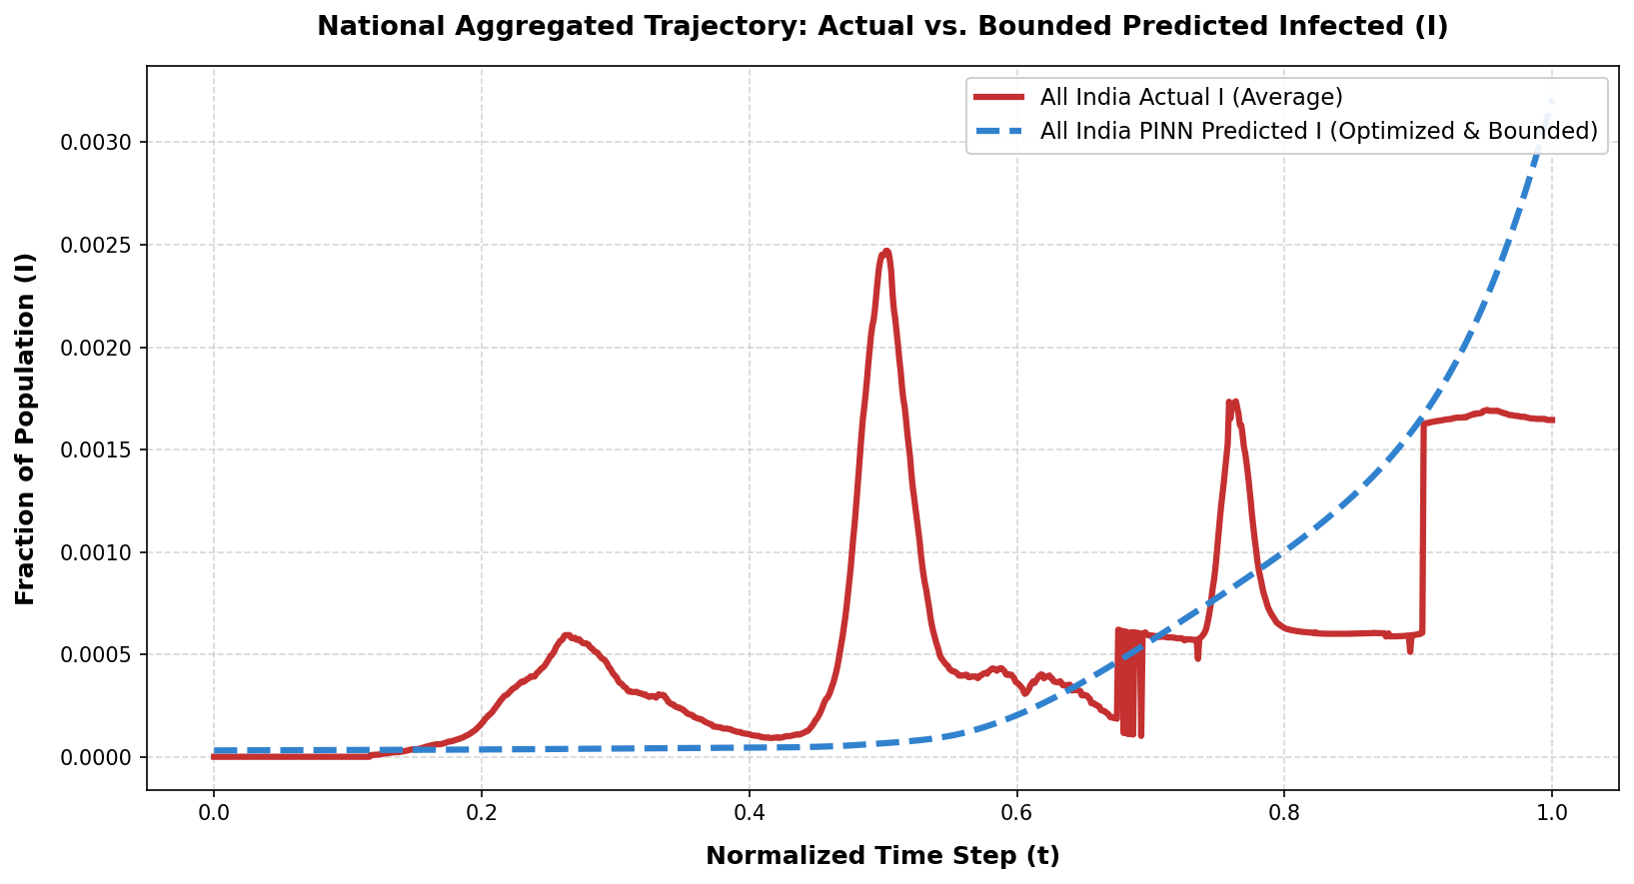
Figure 1. Earlier two-network model: national Infectious fraction, actual vs. predicted. Both real epidemic waves are missed almost entirely.

3.3 A Parallel Effort: SEIR-PINN
A teammate modelled the same problem with a SEIR formulation and a domain-decomposition strategy (separate networks per ~30-day window). That project independently hit the same time-scaling chain-rule bug fixed in Section 4.4, and the same saturating-activation problem fixed by the Softplus rate head in Section 4.2 — useful cross-project corroboration that these are generic PINN pitfalls, not notebook-specific mistakes.

4. Final Model: The Unified SIRD-PINN
The final model (Copy_of_Unified_SIRD_PINN_part3.ipynb) is a deliberate re-design motivated directly by Section 3's failures. It merges the two networks into one shared trunk (4 fully-connected layers, 128 units, SiLU, dropout 0.1) taking a 9-dimensional input — (x, y, t) plus six context features including the neighbour-pressure coupling feature — with two small heads: a state head (Linear→SiLU→Linear→Softmax) producing (S,I,R,D) that sum to exactly 1 by construction, and a rate head (Linear→Tanh→Linear→Softplus) producing (β,γ,μ) that are non-negative by construction and — unlike Sigmoid — have no zero-gradient saturation region.
The Laplacian is replaced by a k-nearest-neighbour (k=6), mobility-weighted “neighbour infectious pressure” feature; the physics loss adds diffusion_coupling×(neighbour_pressure − I), so infection pressure flows from sicker neighbours into a district and out toward healthier ones — a defensible mobility-based proxy, not an assumption of continuous spatial diffusion. The training objective combines an inverse-variance-weighted data loss across all four compartments (so the tiny I and D compartments aren't drowned out by S, which is close to 1 almost everywhere), the SIRD physics residual computed via true automatic differentiation, and a small redundant conservation penalty on |S+I+R+D−1| kept as a sanity check even though softmax already guarantees it.

Critical fix: the time-scaling chain rule
An early run produced physically impossible rates (γ up to ~11, μ up to ~4 — implying a recovery measured in hours). The cause: t is normalised to [0,1] over 991 real days and then rescaled again to [−1,1], so autograd returns dI/d(t_scaled), not dI/d(real day), while the residual compares this against βSI/γI/μI, which are per-real-day rates. Uncorrected, the network must inflate β,γ,μ by ~990/2≈495× to satisfy the residual. The fix multiplies every autograd time-derivative by 2/990≈0.00202 before it touches the rates, so discovered values come out as genuine, epidemiologically checkable per-day rates.

Training configuration
Hyperparameter | Value | Hyperparameter | Value
Optimizer | AdamW (wd 1e-5) | Epochs | 60 (full run)
Learning rate | 0.003, cosine-annealed | Gradient clip | max_norm = 1.0
Batch size | 4,096 | k (neighbour graph) | 6
Physics / coupling weight | 0.05 / 0.05 | Train / val districts | 474 / 119 (587,663 rows)

5. Results
Total loss fell from ~19,425 at epoch 1 to 0.146 by epoch 60 (Figure 2), with the physics term settling to a small, stable residual (~6.4×10⁻⁴) after the first few epochs. On the 119 held-out districts, direct (S,I,R,D) predictions (Figure 3) capture both real epidemic waves with recognisable shape and timing — in clear contrast to Figure 1 — though the model over-predicts the second-wave Infectious peak.
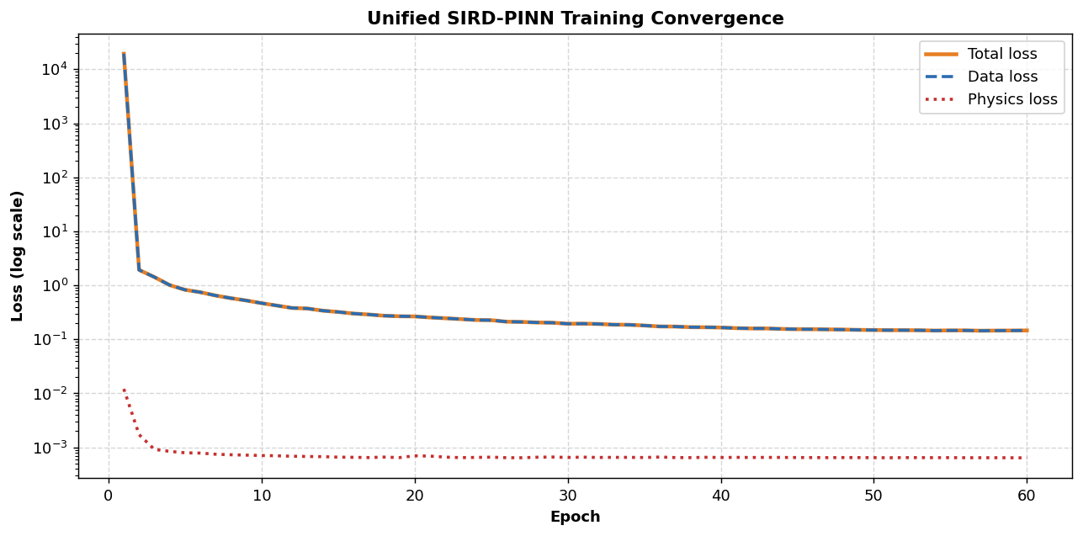
Figure 2. Training convergence (log scale).
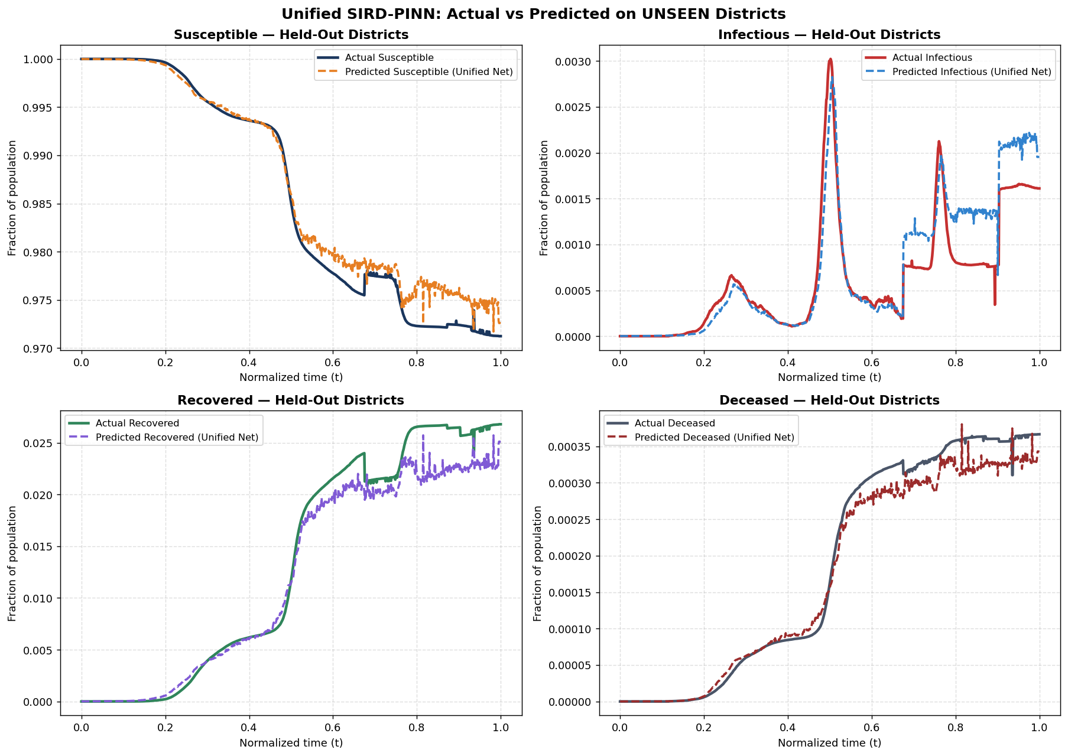
Figure 3. Actual vs. predicted S, I, R, D on held-out districts. Both epidemic waves are now visible, unlike Figure 1.

Forward (RK4) simulation: the key limitation
A stricter test discards the state head after the initial condition and integrates SIRD forward using only the discovered β(t), γ(t), μ(t) via RK4. This diverges almost immediately — S collapses to zero and I saturates to 1 within ~15% of the horizon (Figure 4). Direct state-head R² is +0.97/+0.79/+0.96/+0.98 for S/I/R/D, while ODE-simulated R² for the same compartments is −6,396 / −2,118,544 / −341 / −1,424,463 — orders of magnitude off. This is the project's single most important honest finding (Section 7).
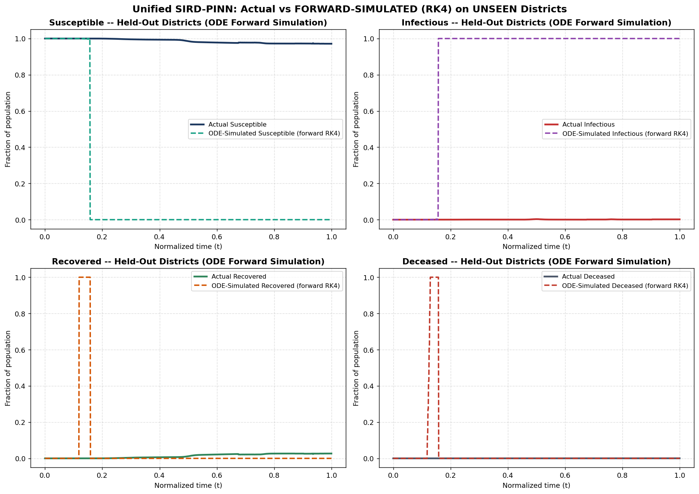
Figure 4. Forward RK4 rollout from the discovered rates alone diverges almost immediately, even though direct predictions (Figure 3) are accurate.

Multi-tier evaluation
A PINN's value lies as much in interpretable parameter discovery as raw accuracy, so the model is scored on three tiers: forecast skill vs. a persistence baseline (5-fold by district), physics-residual consistency, and β-vs-policy correlation (undefined at national aggregation — stringency collapses to near-zero variance once averaged nationally, even though district-level values range 36–74).
Metric | Earlier model | Unified SIRD-PINN
Validation R² (Infectious, direct) | not measured leak-free | 0.6622
Added Skill vs. persistence (5-fold) | not computed | +0.0147 (σ=0.0285; 3/5 folds positive)
MSPR, I / D (held-out) | not computed leak-free | 3.75×10⁻⁴ / 1.07×10⁻⁶
SIRD closure error | soft penalty only | 2.38×10⁻⁷ (softmax-guaranteed)

The Added Skill Score is reported honestly: only marginally positive on average and negative in two of five folds, meaning the model does not decisively beat naive persistence as a forecaster. Its value rests on the closure guarantee, low physics residual, and a directionally sensible β(t) — not forecast accuracy alone.

6. Why the Unified Model Improves on the Earlier Approach
- Exact closure instead of a soft penalty: softmax makes S+I+R+D=1 true by construction (2.4×10⁻⁷ error) rather than merely discouraged by a loss term.
- A defensible coupling mechanism: the k-nearest-neighbour, mobility-weighted term proxies an actual mechanism (inter-district mobility) instead of an unjustified continuous-diffusion assumption.
- Correctly scaled residuals: the chain-rule fix (Sec. 4) yields γ, μ of a magnitude that can be sanity-checked against real epidemiology, where earlier runs were inflated by ~2–3 orders of magnitude.
- No forward-simulation life support: the final model's RK4 divergence (Sec. 5) is reported as a measured, quantified limitation rather than concealed behind re-anchoring and R₀-boost hacks.
- A single shared trunk removes the risk of representational mismatch between two independently-optimised networks.

7. Limitations
- Forward-simulation instability: discovered rates reproduce training/validation data well when read directly, but diverge almost immediately under independent RK4 integration — not yet trustworthy as a standalone mechanistic simulator.
- Marginal forecast skill: Added Skill Score is small (+0.015 average) and negative in 2 of 5 folds — the model does not decisively beat naive persistence as a forecaster; its contribution is parameter discovery, not superior forecasting.
- National β-vs-stringency correlation is undefined, since national averaging washes out the real district-level variation (36–74) in stringency — a district- or state-level analysis is needed to actually test the model's policy-sensitivity claim.
- No cross-district parameter regularisation: nothing ties a district's discovered β/γ/μ to its neighbours' values, so adjacent similar districts could receive very different discovered rates.
- Single-run, CPU-bound evaluation: one 60-epoch run (~48 min, fixed seed); no repeated-seed variance estimates beyond the 5-fold Added Skill Score, and no GPU run was evaluated.

8. Conclusion and Future Work
The final Unified SIRD-PINN addresses the two structural problems (leakage, unjustified diffusion) and one procedural problem (unstructured output heads) surfaced by the earlier prototype, producing a state prediction that visibly captures both real epidemic waves on unseen districts with a near-machine-precision closure guarantee. The clearest next step is closing the forward-simulation gap in Section 5: adding an explicit rollout-consistency loss during training rather than checking it only post-hoc, replacing the k-NN coupling graph with real mobility-flow data, and regularising adjacent districts' discovered rates toward each other — analogous to the boundary-continuity constraint used in the parallel SEIR effort (Section 3.3). A district- or state-level recomputation of the β-vs-stringency correlation would also directly test the model's central epidemiological claim.

References
1. IITG.AI, “Project Proposal: Using PINNs to analyze infection rates of COVID-19 across India,” internal project document, April 2026.
2. Companion SEIR-PINN technical report (parallel teammate effort, Section 3.3), internal project document.
3. Domain-decomposition / ODE-normalisation techniques referenced in the SEIR companion report: https://doi.org/10.1371/journal.pone.0315762
4. Google Health COVID-19 Open Data, joined with Oxford stringency and Google/Apple mobility indices (source: india_processed_final.csv).
5. Notebooks: Copy_of_Unified_SIRD_PINN_part3.ipynb (final model); SIRD_medha_copy.ipynb and related notebooks (development history, Section 3).

