**DML**

//Inserts into mmr_customer table.

insert into mmr_customer (customer_id, customer_name, date_of_birth, customer_annual_income) values(100,'Medha Nangunoori','1995-08-05','115600');

insert into mmr_customer (customer_id, customer_name, date_of_birth, customer_annual_income) values(101,'Rohini Manepally','1994-06-03','85700');

insert into mmr_customer (customer_id, customer_name, date_of_birth, customer_annual_income) values(102,'Mounika Alluri','1993-03-25','95500');

insert into mmr_customer (customer_id, customer_name, date_of_birth, customer_annual_income) values(103,'Ravali Anthati','1992-04-15','75800');

insert into mmr_customer (customer_id, customer_name, date_of_birth, customer_annual_income) values(104,'Preethi NF','1993-09-13','100450');

insert into mmr_customer (customer_id, customer_name, date_of_birth, customer_annual_income) values(105,'Anusha Rudraraju','1991-12-08','84800');

insert into mmr_customer (customer_id, customer_name, date_of_birth, customer_annual_income) values(106,'Lakshmi Kumari','1990-08-19','96000');

insert into mmr_customer (customer_id, customer_name, date_of_birth, customer_annual_income) values(107,'Pratyusha Gutta','1993-04-05','114600');

insert into mmr_customer (customer_id, customer_name, date_of_birth, customer_annual_income) values(108,'Hema Malini','1992-11-07','95600');

insert into mmr_customer (customer_id, customer_name, date_of_birth, customer_annual_income) values(109,'Mounika Thota','1991-07-08','77600');

insert into mmr_customer (customer_id, customer_name, date_of_birth, customer_annual_income) values(110,'Preetham Viramally','1990-10-26','195600');

insert into mmr_customer (customer_id, customer_name, date_of_birth, customer_annual_income) values(111,'Sandeep Nemori','1990-11-17','77600');

insert into mmr_customer (customer_id, customer_name, date_of_birth, customer_annual_income) values(112,'Rishitha Gujja','1990-12-08','84800');

insert into mmr_customer (customer_id, customer_name, date_of_birth, customer_annual_income) values(113,'Padmini Damaraju','1989-08-19','96000');

insert into mmr_customer (customer_id, customer_name, date_of_birth, customer_annual_income) values(114,'Bhanu Bellamkonda','1992-04-05','114600');

insert into mmr_customer (customer_id, customer_name, date_of_birth, customer_annual_income) values(115,'Sharath Chandra','1991-11-07','95600');

insert into mmr_customer (customer_id, customer_name, date_of_birth, customer_annual_income) values(116,'Lohit Devana','1990-07-08','77600');

insert into mmr_customer (customer_id, customer_name, date_of_birth, customer_annual_income) values(117,'Tirupati Macherla','1988-10-26','195600');

insert into mmr_customer (customer_id, customer_name, date_of_birth, customer_annual_income) values(118,'Praveen Dandamudi','1986-11-17','77600');

COMMIT;

//Insert into mmr_supplier

insert into mmr_supplier (supplier_id,supplier_name, supplier_address) values(441, 'Rich Industries','Warrensburg,MO');

insert into mmr_supplier (supplier_id,supplier_name, supplier_address) values(442, 'Transtar Industries','Kansas City,MO');

insert into mmr_supplier (supplier_id,supplier_name, supplier_address) values(443, 'comptons automotive Industries','Kansas City,MO');

insert into mmr_supplier (supplier_id,supplier_name, supplier_address) values(444, 'keystone automotive','Charlotte,NC');

insert into mmr_supplier (supplier_id,supplier_name, supplier_address) values(445, 'National parts depot','Kansas City,MO');

COMMIT;

//Insert into mmr_parts

insert into mmr_parts( part_id,part_name, part_price) values(320,'Air Filter', '$21.99');

insert into mmr_parts( part_id,part_name, part_price) values(321,'Air Vent', '$31.99');

insert into mmr_parts( part_id,part_name, part_price) values(322,'Tire Guage', '$41.99');

insert into mmr_parts( part_id,part_name, part_price) values(323,'AC Filter', '$21.99');

insert into mmr_parts( part_id,part_name, part_price) values(324,'Radiator', '$15.99');

insert into mmr_parts( part_id,part_name, part_price) values(325,'Brake Pads', '$45.99');

insert into mmr_parts( part_id,part_name, part_price) values(326,'Oil filter', '$31.99');

insert into mmr_parts( part_id,part_name, part_price) values(327,'Jackey', '$55.49');

insert into mmr_parts( part_id,part_name, part_price) values(328,'Speedometer', '$130.99');

insert into mmr_parts( part_id,part_name, part_price) values(329,'mirror', '$41.99');

insert into mmr_parts( part_id,part_name, part_price) values(330,'Seat Belt', '$145.99');

insert into mmr_parts( part_id,part_name, part_price) values(331,'Steering Wheel','$109.45');

insert into mmr_parts( part_id,part_name, part_price) values(332,'Fuel Guage', '$24.59');

insert into mmr_parts( part_id,part_name, part_price) values(333,'Tachometer', '$55.89');

insert into mmr_parts( part_id,part_name, part_price) values(334,'Hand Brake', '$67.45');

insert into mmr_parts( part_id,part_name, part_price) values(335,'Gear Shift', '$123.45');

insert into mmr_parts( part_id,part_name, part_price) values(336,'Tail Lamp', '$25.99');

COMMIT;

//Insert into mmr_supplies

insert into mmr_supplies(supplier_id, part_id) values(441,320);

insert into mmr_supplies(supplier_id, part_id) values(441,321);

insert into mmr_supplies(supplier_id, part_id) values(441,322);

insert into mmr_supplies(supplier_id, part_id) values(441,323);

insert into mmr_supplies(supplier_id, part_id) values(441,324);

insert into mmr_supplies(supplier_id, part_id) values(442,325);

insert into mmr_supplies(supplier_id, part_id) values(442,326);

insert into mmr_supplies(supplier_id, part_id) values(442,327);

insert into mmr_supplies(supplier_id, part_id) values(442,328);

insert into mmr_supplies(supplier_id, part_id) values(442,329);

insert into mmr_supplies(supplier_id, part_id) values(443,330);

insert into mmr_supplies(supplier_id, part_id) values(443,331);

insert into mmr_supplies(supplier_id, part_id) values(443,332);

insert into mmr_supplies(supplier_id, part_id) values(444,333);

insert into mmr_supplies(supplier_id, part_id) values(444,334);

insert into mmr_supplies(supplier_id, part_id) values(445,335);

insert into mmr_supplies(supplier_id, part_id) values(445,336);

COMMIT;

//Inserts into mmr_brand table

insert into mmr_brand (brand_id, brand_name) values(1,'Ferrari');

insert into mmr_brand (brand_id, brand_name) values(2,'BMW');

insert into mmr_brand (brand_id, brand_name) values(3,'Toyota');

insert into mmr_brand (brand_id, brand_name) values(4,'Rolls Royce');

insert into mmr_brand (brand_id, brand_name) values(5,'Chevrolet');

insert into mmr_brand (brand_id, brand_name) values(6,'Hyundai');

insert into mmr_brand (brand_id, brand_name) values(7,'Honda');

insert into mmr_brand (brand_id, brand_name) values(8,'Mercedes');

insert into mmr_brand (brand_id, brand_name) values(9,'Ford');

insert into mmr_brand (brand_id, brand_name) values(10,'KIA');

COMMIT;

//Inserts into mmr_model

insert into mmr_model (model_id, brand_id, model_name) values(500,1,'Ferrari Daytona');

insert into mmr_model (model_id, brand_id, model_name) values(501,1,'Ferrari 275');

insert into mmr_model (model_id, brand_id, model_name) values(502,1,'Ferrari 250 GTO');

insert into mmr_model (model_id, brand_id, model_name) values(503,2,'BMW i8');

insert into mmr_model (model_id, brand_id, model_name) values(504,2,'BMW x5');

insert into mmr_model (model_id, brand_id, model_name) values(505,2,'BMW x3');

insert into mmr_model (model_id, brand_id, model_name) values(506,3,'Toyota Camry');

insert into mmr_model (model_id, brand_id, model_name) values(507,3,'Toyota Corolla');

insert into mmr_model (model_id, brand_id, model_name) values(508,4,'Rolls Royce Ghost');

insert into mmr_model (model_id, brand_id, model_name) values(509,4,'Rolls Royce Phantom');

insert into mmr_model (model_id, brand_id, model_name) values(510,4,'Rolls Royce Shadow');

insert into mmr_model (model_id, brand_id, model_name) values(511,4,'Rolls Royce Silver Phantom');

insert into mmr_model (model_id, brand_id, model_name) values(512,5,'Chevrolet corvette');

insert into mmr_model (model_id, brand_id, model_name) values(513,5,'Chevrolet Camaro');

insert into mmr_model (model_id, brand_id, model_name) values(514,6,'Hyundai Elantra');

insert into mmr_model (model_id, brand_id, model_name) values(515,6,'Hyundai Accent');

insert into mmr_model (model_id, brand_id, model_name) values(516,6,'Hyundai Veloster');

insert into mmr_model (model_id, brand_id, model_name) values(517,7,'Honda Civic');

insert into mmr_model (model_id, brand_id, model_name) values(518,7,'Honda Fit');

insert into mmr_model (model_id, brand_id, model_name) values(519,8,'Mercedes C Class');

insert into mmr_model (model_id, brand_id, model_name) values(520,8,'Mercedes E Class');

insert into mmr_model (model_id, brand_id, model_name) values(521,8,'Mercedes S Class');

insert into mmr_model (model_id, brand_id, model_name) values(522,9, 'Ford Fusion');

insert into mmr_model (model_id, brand_id, model_name) values(523,9, 'Ford Endevour');

insert into mmr_model (model_id, brand_id, model_name) values(524,9, 'Ford Mustang');

insert into mmr_model (model_id, brand_id, model_name) values(525,10, 'KIA Ria');

insert into mmr_model (model_id, brand_id, model_name) values(526,10, 'KIA Optima');

COMMIT;

//Inserts into mmr_model_of_parts

insert into mmr_model_of_parts (model_id,part_id) values(500,320);

insert into mmr_model_of_parts (model_id,part_id) values(501,321);

insert into mmr_model_of_parts (model_id,part_id) values(502,322);

insert into mmr_model_of_parts (model_id,part_id) values(503,323);

insert into mmr_model_of_parts (model_id,part_id) values(504,324);

insert into mmr_model_of_parts (model_id,part_id) values(505,325);

insert into mmr_model_of_parts (model_id,part_id) values(506,326);

insert into mmr_model_of_parts (model_id,part_id) values(507,327);

insert into mmr_model_of_parts (model_id,part_id) values(508,328);

insert into mmr_model_of_parts (model_id,part_id) values(509,329);

insert into mmr_model_of_parts (model_id,part_id) values(510,330);

insert into mmr_model_of_parts (model_id,part_id) values(511,331);

insert into mmr_model_of_parts (model_id,part_id) values(512,332);

insert into mmr_model_of_parts (model_id,part_id) values(513,333);

insert into mmr_model_of_parts (model_id,part_id) values(514,334);

insert into mmr_model_of_parts (model_id,part_id) values(515,335);

insert into mmr_model_of_parts (model_id,part_id) values(516,336);

insert into mmr_model_of_parts (model_id,part_id) values(517,321);

insert into mmr_model_of_parts (model_id,part_id) values(518,322);

insert into mmr_model_of_parts (model_id,part_id) values(519,323);

insert into mmr_model_of_parts (model_id,part_id) values(520,324);

insert into mmr_model_of_parts (model_id,part_id) values(521,325);

insert into mmr_model_of_parts (model_id,part_id) values(522,326);

insert into mmr_model_of_parts (model_id,part_id) values(523,327);

insert into mmr_model_of_parts (model_id,part_id) values(524,328);

insert into mmr_model_of_parts (model_id,part_id) values(525,329);

insert into mmr_model_of_parts (model_id,part_id) values(526,330);

COMMIT;

//Inserts into mmr_vehicle

insert into mmr_vehicle (vin, customer_id, model_id, color, bodystyle, engine, myear) values('WNACB82510B138801',100,501,'Black','Non Convertible','6-valve',2018);

insert into mmr_vehicle (vin, customer_id, model_id, color, bodystyle, engine, myear) values('WNACB82510B138802',100,502,'Red','Convertible','6-valve',2019);

insert into mmr_vehicle (vin, customer_id, model_id, color, bodystyle, engine, myear) values('WNACB82510B138803',101,503,'While','Convertible','6-valve',2018);

insert into mmr_vehicle (vin, customer_id, model_id, color, bodystyle, engine, myear) values('WNACB82510B138804',101,505,'Blue','Non Convertible','6-valve',2018);

insert into mmr_vehicle (vin, customer_id, model_id, color, bodystyle, engine, myear) values('WNACB82510B138805',102,506,'Red','Non Convertible','4-valve',2018);

insert into mmr_vehicle (vin, customer_id, model_id, color, bodystyle, engine, myear) values('WNACB82510B138806',103,507,'Gold','Non Convertible','4-valve',2019);

insert into mmr_vehicle (vin, customer_id, model_id, color, bodystyle, engine, myear) values('WNACB82510B138807',104,508,'Gray','Convertible','8-valve',2018);

insert into mmr_vehicle (vin, customer_id, model_id, color, bodystyle, engine, myear) values('WNACB82510B138808',105,509,'Blue','Non Convertible','6-valve',2019);

insert into mmr_vehicle (vin, customer_id, model_id, color, bodystyle, engine, myear) values('WNACB82510B138809',106,510,'White','Convertible','8-valve',2018);

insert into mmr_vehicle (vin, customer_id, model_id, color, bodystyle, engine, myear) values('WNACB82510B138810',107,511,'White','Convertible','6-valve',2018);

insert into mmr_vehicle (vin, customer_id, model_id, color, bodystyle, engine, myear) values('WNACB82510B138811',108,512,'Black','Non Convertible','6-valve',2017);

insert into mmr_vehicle (vin, customer_id, model_id, color, bodystyle, engine, myear) values('WNACB82510B138812',109,513,'White','Convertible','6-valve',2018);

insert into mmr_vehicle (vin, customer_id, model_id, color, bodystyle, engine, myear) values('WNACB82510B138813',110,514,'White','Non Convertible','4-valve',2019);

insert into mmr_vehicle (vin, customer_id, model_id, color, bodystyle, engine, myear) values('WNACB82510B138814',110,515,'Black','Non Convertible','4-valve',2019);

insert into mmr_vehicle (vin, customer_id, model_id, color, bodystyle, engine, myear) values('WNACB82510B138815',111,516,'White','Non Convertible','4-valve',2019);

insert into mmr_vehicle (vin, customer_id, model_id, color, bodystyle, engine, myear) values('WNACB82510B138816',112,517,'Gray','Convertible','8-valve',2019);

insert into mmr_vehicle (vin, customer_id, model_id, color, bodystyle, engine, myear) values('WNACB82510B138817',113,518,'Blue','Non Convertible','6-valve',2019);

insert into mmr_vehicle (vin, customer_id, model_id, color, bodystyle, engine, myear) values('WNACB82510B138818',114,519,'White','Convertible','8-valve',2019);

insert into mmr_vehicle (vin, customer_id, model_id, color, bodystyle, engine, myear) values('WNACB82510B138819',115,520,'White','Convertible','6-valve',2019);

insert into mmr_vehicle (vin, customer_id, model_id, color, bodystyle, engine, myear) values('WNACB82510B138820',116,521,'Black','Non Convertible','6-valve',2019);

insert into mmr_vehicle (vin, customer_id, model_id, color, bodystyle, engine, myear) values('WNACB82510B138821',117,522,'White','Convertible','6-valve',2019);

insert into mmr_vehicle (vin, customer_id, model_id, color, bodystyle, engine, myear) values('WNACB82510B138822',118,523,'White','Non Convertible','4-valve',2018);

insert into mmr_vehicle (vin, customer_id, model_id, color, bodystyle, engine, myear) values('WNACB82510B138823',110,524,'Black','Non Convertible','4-valve',2018);

insert into mmr_vehicle (vin, customer_id, model_id, color, bodystyle, engine, myear) values('WNACB82510B138824',103,525,'White','Non Convertible','4-valve',2018);

insert into mmr_vehicle (vin, customer_id, model_id, color, bodystyle, engine, myear) values('WNACB82510B138825',102,526,'White','Non Convertible','4-valve',2018);

insert into mmr_vehicle (vin, customer_id, model_id, color, bodystyle, engine, myear) values('WNACB82510B138826',100,500,'Red','Non Convertible','6-valve',2018);

COMMIT;

//Inserts into mmr_inventory1

insert into mmr_inventory1 (inventory_item_id,inv_location_id,inv_address) values(600,900,'Overland Park, KS, 66214');

insert into mmr_inventory1 (inventory_item_id,inv_location_id,inv_address) values(601,900,'Overland Park, KS, 66214');

insert into mmr_inventory1 (inventory_item_id,inv_location_id,inv_address) values(602,900,'Overland Park, KS, 66214');

insert into mmr_inventory1 (inventory_item_id,inv_location_id,inv_address) values(603,900,'Overland Park, KS, 66214');

insert into mmr_inventory1 (inventory_item_id,inv_location_id,inv_address) values(604,900,'Overland Park, KS, 66214');

insert into mmr_inventory1 (inventory_item_id,inv_location_id,inv_address) values(605,900,'Overland Park, KS, 66214');

insert into mmr_inventory1 (inventory_item_id,inv_location_id,inv_address) values(606,900,'Overland Park, KS, 66214');

insert into mmr_inventory1 (inventory_item_id,inv_location_id,inv_address) values(607,901,'Charlotte, NC, 28262');

insert into mmr_inventory1 (inventory_item_id,inv_location_id,inv_address) values(608,901,'Charlotte, NC, 28262');

insert into mmr_inventory1 (inventory_item_id,inv_location_id,inv_address) values(609,901,'Charlotte, NC, 28262');

insert into mmr_inventory1 (inventory_item_id,inv_location_id,inv_address) values(610,901,'Charlotte, NC, 28262');

insert into mmr_inventory1 (inventory_item_id,inv_location_id,inv_address) values(611,901,'Charlotte, NC, 28262');

insert into mmr_inventory1 (inventory_item_id,inv_location_id,inv_address) values(612,901,'Charlotte, NC, 28262');

insert into mmr_inventory1 (inventory_item_id,inv_location_id,inv_address) values(613,901,'Charlotte, NC, 28262');

insert into mmr_inventory1 (inventory_item_id,inv_location_id,inv_address) values(614,901,'Charlotte, NC, 28262');

insert into mmr_inventory1 (inventory_item_id,inv_location_id,inv_address) values(615,902,'Columbus, OH, 43215');

insert into mmr_inventory1 (inventory_item_id,inv_location_id,inv_address) values(616,902,'Columbus, OH, 43215');

insert into mmr_inventory1 (inventory_item_id,inv_location_id,inv_address) values(617,902,'Columbus, OH, 43215');

insert into mmr_inventory1 (inventory_item_id,inv_location_id,inv_address) values(618,902,'Columbus, OH, 43215');

insert into mmr_inventory1 (inventory_item_id,inv_location_id,inv_address) values(619,902,'Columbus, OH, 43215');

insert into mmr_inventory1 (inventory_item_id,inv_location_id,inv_address) values(620,902,'Columbus, OH, 43215');

insert into mmr_inventory1 (inventory_item_id,inv_location_id,inv_address) values(621,902,'Columbus, OH, 43215');

insert into mmr_inventory1 (inventory_item_id,inv_location_id,inv_address) values(622,902,'Columbus, OH, 43215');

insert into mmr_inventory1 (inventory_item_id,inv_location_id,inv_address) values(623,902,'Columbus, OH, 43215');

insert into mmr_inventory1 (inventory_item_id,inv_location_id,inv_address) values(624,902,'Columbus, OH, 43215');

insert into mmr_inventory1 (inventory_item_id,inv_location_id,inv_address) values(625,902,'Columbus, OH, 43215');

COMMIT;

//Inserts into mmr_goes_to

insert into mmr_goes_to (inventory_item_id, vin) values(600,'WNACB82510B138801');

insert into mmr_goes_to (inventory_item_id, vin) values(601,'WNACB82510B138802');

insert into mmr_goes_to (inventory_item_id, vin) values(602,'WNACB82510B138803');

insert into mmr_goes_to (inventory_item_id, vin) values(603,'WNACB82510B138804');

insert into mmr_goes_to (inventory_item_id, vin) values(604,'WNACB82510B138805');

insert into mmr_goes_to (inventory_item_id, vin) values(605,'WNACB82510B138806');

insert into mmr_goes_to (inventory_item_id, vin) values(606,'WNACB82510B138807');

insert into mmr_goes_to (inventory_item_id, vin) values(607,'WNACB82510B138808');

insert into mmr_goes_to (inventory_item_id, vin) values(608,'WNACB82510B138809');

insert into mmr_goes_to (inventory_item_id, vin) values(609,'WNACB82510B138810');

insert into mmr_goes_to (inventory_item_id, vin) values(610,'WNACB82510B138811');

insert into mmr_goes_to (inventory_item_id, vin) values(611,'WNACB82510B138812');

insert into mmr_goes_to (inventory_item_id, vin) values(612,'WNACB82510B138813');

insert into mmr_goes_to (inventory_item_id, vin) values(613,'WNACB82510B138814');

insert into mmr_goes_to (inventory_item_id, vin) values(614,'WNACB82510B138815');

insert into mmr_goes_to (inventory_item_id, vin) values(615,'WNACB82510B138816');

insert into mmr_goes_to (inventory_item_id, vin) values(616,'WNACB82510B138817');

insert into mmr_goes_to (inventory_item_id, vin) values(617,'WNACB82510B138818');

insert into mmr_goes_to (inventory_item_id, vin) values(618,'WNACB82510B138819');

insert into mmr_goes_to (inventory_item_id, vin) values(619,'WNACB82510B138820');

insert into mmr_goes_to (inventory_item_id, vin) values(620,'WNACB82510B138821');

insert into mmr_goes_to (inventory_item_id, vin) values(621,'WNACB82510B138822');

insert into mmr_goes_to (inventory_item_id, vin) values(622,'WNACB82510B138823');

insert into mmr_goes_to (inventory_item_id, vin) values(623,'WNACB82510B138824');

insert into mmr_goes_to (inventory_item_id, vin) values(624,'WNACB82510B138825');

insert into mmr_goes_to (inventory_item_id, vin) values(625,'WNACB82510B138826');

COMMIT;

//Inserts into mmr_dealer

insert into mmr_dealer (dealer_id, dealer_name, dealer_address, brand_id) values(800,'Hendrick BMW','Charlotte,NC,28262',2);

insert into mmr_dealer (dealer_id, dealer_name, dealer_address, brand_id) values(801,'United BMW','Lees summit,MO,66250',2);

insert into mmr_dealer (dealer_id, dealer_name, dealer_address, brand_id) values(802,'Germain Toyota','Easton,OH,43219',3);

insert into mmr_dealer (dealer_id, dealer_name, dealer_address, brand_id) values(803,'Germain Ferari','Easton,OH,43219',1);

insert into mmr_dealer (dealer_id, dealer_name, dealer_address, brand_id) values(804,'United Toyota','Shawnee,KS,66250',3);

insert into mmr_dealer (dealer_id, dealer_name, dealer_address, brand_id) values(805,'Penske Rolls Royce','Columbus,OH,43215',4);

insert into mmr_dealer (dealer_id, dealer_name, dealer_address, brand_id) values(806,'Penske Chevrolet','Atlanta,Ga,21765',5);

insert into mmr_dealer (dealer_id, dealer_name, dealer_address, brand_id) values(807,'Gwinette Hyundai','Atlanta,GA,21765',6);

insert into mmr_dealer (dealer_id, dealer_name, dealer_address, brand_id) values(808,'Larsen Honda','Charlotte,NC,28202',7);

insert into mmr_dealer (dealer_id, dealer_name, dealer_address, brand_id) values(809,'Mercedes of North Kansas','Overland Park,KS,66214',8);

insert into mmr_dealer (dealer_id, dealer_name, dealer_address, brand_id) values(810,'Raytown Ford','Raytown,MO,66214',9);

insert into mmr_dealer (dealer_id, dealer_name, dealer_address, brand_id) values(811 ,'Scott Clark KIA','Concrod,NC,28262',10);

COMMIT;

//Inserts into mmr_dealer_takes_from

insert into mmr_dealer_takes_from (dealer_id, inventory_item_id) values(800,602);

insert into mmr_dealer_takes_from (dealer_id, inventory_item_id) values(801,603);

insert into mmr_dealer_takes_from (dealer_id, inventory_item_id) values(802,604);

insert into mmr_dealer_takes_from (dealer_id, inventory_item_id) values(804,605);

insert into mmr_dealer_takes_from (dealer_id, inventory_item_id) values(803,600);

insert into mmr_dealer_takes_from (dealer_id, inventory_item_id) values(803,601);

insert into mmr_dealer_takes_from (dealer_id, inventory_item_id) values(803,625);

insert into mmr_dealer_takes_from (dealer_id, inventory_item_id) values(805,606);

insert into mmr_dealer_takes_from (dealer_id, inventory_item_id) values(805,607);

insert into mmr_dealer_takes_from (dealer_id, inventory_item_id) values(805,608);

insert into mmr_dealer_takes_from (dealer_id, inventory_item_id) values(805,609);

insert into mmr_dealer_takes_from (dealer_id, inventory_item_id) values(806,610);

insert into mmr_dealer_takes_from (dealer_id, inventory_item_id) values(806,611);

insert into mmr_dealer_takes_from (dealer_id, inventory_item_id) values(807,612);

insert into mmr_dealer_takes_from (dealer_id, inventory_item_id) values(807,613);

insert into mmr_dealer_takes_from (dealer_id, inventory_item_id) values(807,614);

insert into mmr_dealer_takes_from (dealer_id, inventory_item_id) values(808,615);

insert into mmr_dealer_takes_from (dealer_id, inventory_item_id) values(808,616);

insert into mmr_dealer_takes_from (dealer_id, inventory_item_id) values(809,617);

insert into mmr_dealer_takes_from (dealer_id, inventory_item_id) values(809,618);

insert into mmr_dealer_takes_from (dealer_id, inventory_item_id) values(809,619);

insert into mmr_dealer_takes_from (dealer_id, inventory_item_id) values(810,620);

insert into mmr_dealer_takes_from (dealer_id, inventory_item_id) values(810,621);

insert into mmr_dealer_takes_from (dealer_id, inventory_item_id) values(810,622);

insert into mmr_dealer_takes_from (dealer_id, inventory_item_id) values(811,623);

insert into mmr_dealer_takes_from (dealer_id, inventory_item_id) values(811,624);

insert into mmr_dealer_takes_from (dealer_id, inventory_item_id) values(804,625);

COMMIT;

//Inserts into mmr_dealer_sale_details

insert into mmr_dealer_sale_details (dealer_sale_id,price_of_vehicle,vin,customer_id,dealer_id)values(900,'35000','WNACB82510B138801',100,803);

insert into mmr_dealer_sale_details (dealer_sale_id,price_of_vehicle,vin,customer_id,dealer_id)values(901,'45000','WNACB82510B138802',100,803);

insert into mmr_dealer_sale_details (dealer_sale_id,price_of_vehicle,vin,customer_id,dealer_id)values(902,'37000','WNACB82510B138803',101,800);

insert into mmr_dealer_sale_details (dealer_sale_id,price_of_vehicle,vin,customer_id,dealer_id)values(903,'40000','WNACB82510B138804',101,801);

insert into mmr_dealer_sale_details (dealer_sale_id,price_of_vehicle,vin,customer_id,dealer_id)values(904,'50000','WNACB82510B138805',102,804);

insert into mmr_dealer_sale_details (dealer_sale_id,price_of_vehicle,vin,customer_id,dealer_id)values(905,'38000','WNACB82510B138806',103,802);

insert into mmr_dealer_sale_details (dealer_sale_id,price_of_vehicle,vin,customer_id,dealer_id)values(906,'37000','WNACB82510B138807',104,805);

insert into mmr_dealer_sale_details (dealer_sale_id,price_of_vehicle,vin,customer_id,dealer_id)values(907,'42000','WNACB82510B138808',105,805);

insert into mmr_dealer_sale_details (dealer_sale_id,price_of_vehicle,vin,customer_id,dealer_id)values(908,'43000','WNACB82510B138809',106,805);

insert into mmr_dealer_sale_details (dealer_sale_id,price_of_vehicle,vin,customer_id,dealer_id)values(909,'44000','WNACB82510B138810',107,805);

insert into mmr_dealer_sale_details (dealer_sale_id,price_of_vehicle,vin,customer_id,dealer_id)values(910,'51000','WNACB82510B138811',108,806);

insert into mmr_dealer_sale_details (dealer_sale_id,price_of_vehicle,vin,customer_id,dealer_id)values(911,'50000','WNACB82510B138812',109,806);

insert into mmr_dealer_sale_details (dealer_sale_id,price_of_vehicle,vin,customer_id,dealer_id)values(912,'39000','WNACB82510B138813',110,807);

insert into mmr_dealer_sale_details (dealer_sale_id,price_of_vehicle,vin,customer_id,dealer_id)values(913,'38800','WNACB82510B138814',110,807);

insert into mmr_dealer_sale_details (dealer_sale_id,price_of_vehicle,vin,customer_id,dealer_id)values(914,'35900','WNACB82510B138815',111,807);

insert into mmr_dealer_sale_details (dealer_sale_id,price_of_vehicle,vin,customer_id,dealer_id)values(915,'35090','WNACB82510B138816',112,808);

insert into mmr_dealer_sale_details (dealer_sale_id,price_of_vehicle,vin,customer_id,dealer_id)values(916,'35790','WNACB82510B138817',113,808);

insert into mmr_dealer_sale_details (dealer_sale_id,price_of_vehicle,vin,customer_id,dealer_id)values(917,'37980','WNACB82510B138818',114,809);

insert into mmr_dealer_sale_details (dealer_sale_id,price_of_vehicle,vin,customer_id,dealer_id)values(918,'41000','WNACB82510B138819',115,809);

insert into mmr_dealer_sale_details (dealer_sale_id,price_of_vehicle,vin,customer_id,dealer_id)values(919,'43000','WNACB82510B138820',116,809);

insert into mmr_dealer_sale_details (dealer_sale_id,price_of_vehicle,vin,customer_id,dealer_id)values(920,'41100','WNACB82510B138821',117,810);

insert into mmr_dealer_sale_details (dealer_sale_id,price_of_vehicle,vin,customer_id,dealer_id)values(921,'39970','WNACB82510B138822',118,810);

insert into mmr_dealer_sale_details (dealer_sale_id,price_of_vehicle,vin,customer_id,dealer_id)values(922,'35000','WNACB82510B138823',110,810);

insert into mmr_dealer_sale_details (dealer_sale_id,price_of_vehicle,vin,customer_id,dealer_id)values(923,'36000','WNACB82510B138824',103,811);

insert into mmr_dealer_sale_details (dealer_sale_id,price_of_vehicle,vin,customer_id,dealer_id)values(924,'39000','WNACB82510B138825',102,811);

insert into mmr_dealer_sale_details (dealer_sale_id,price_of_vehicle,vin,customer_id,dealer_id)values(925,'42000','WNACB82510B138826',100,803);

COMMIT;

**SQL Queries**

**Q1**. **To find vin, car model, year, cost of car AND dealer name of customer Preetham Viramally. Display all cars if customer has more than one car.**

SELECT mc.customer_name,mv.vin,mm.model_name,mv.myear,ms.price_of_vehicle

FROM mmr_vehicle mv, mmr_model mm, mmr_dealer_sale_details ms, mmr_customer mc, mmr_dealer mdWHERE mv.model_id = mm.model_id

AND mv.customer_id = mc.customer_id

AND ms.vin = mv.vin AND ms.dealer_id = md.dealer_id AND ms.customer_id = mc.customer_id AND mc.customer_name = 'Preetham Viramally';

Output:

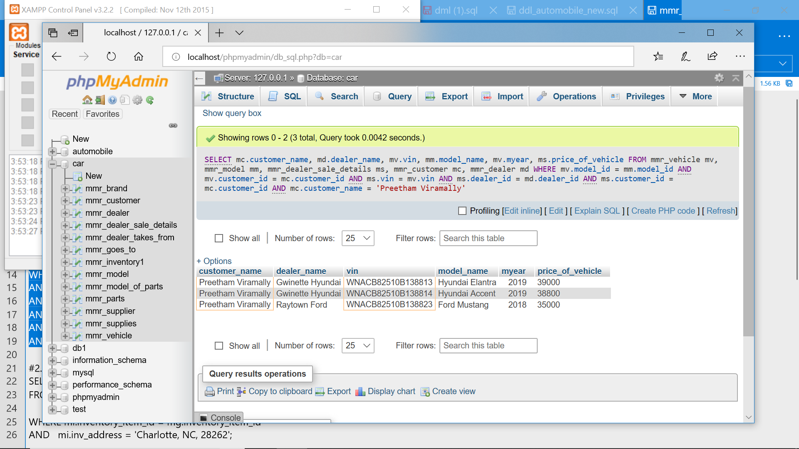

**Q2. To find number of vehicles at the inventory located at Charlotte area.**

SELECT count(mg.vin) FROM mmr_inventory1 mi, mmr_goes_to mg WHERE mi.inventory_item_id = mg.inventory_item_id AND mi.inv_address = 'Charlotte, NC, 28262';

Output:

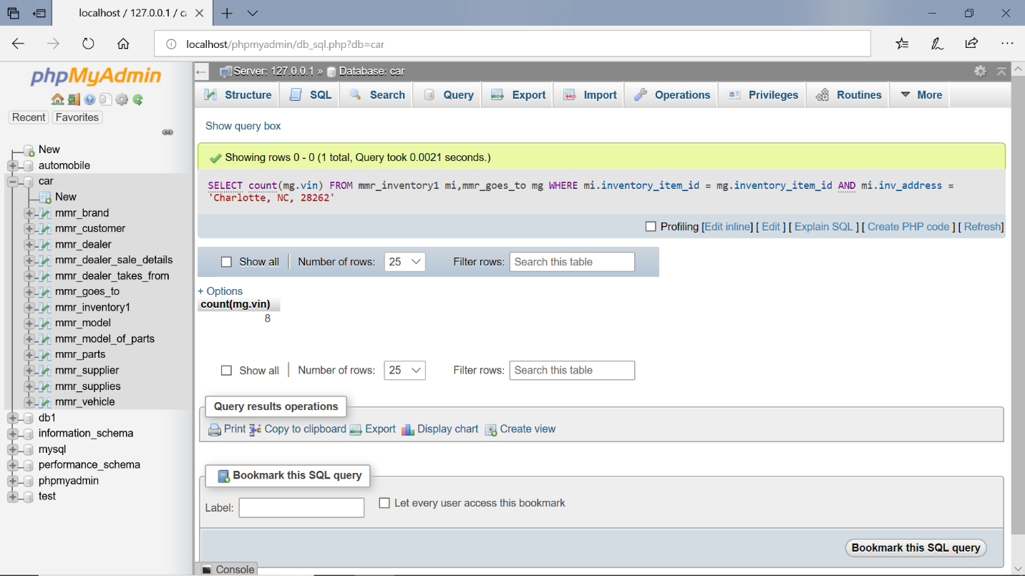

**Q3. To find the availability of BMW x3 at Charlotte inventory**

SELECT dealer_name, dealer_address

FROM mmr_dealer mdWHERE dealer_id in(SELECT distinct mt.dealer_id FROM mmr_model mm, mmr_dealer md, mmr_goes_to mg, mmr_dealer_takes_from mt, mmr_vehicle mv WHERE mm.model_id = mv.model_id

AND md.dealer_id = mt.dealer_id

AND mt.inventory_item_id = mg.inventory_item_id

AND mg.vin = mv.vin

AND mm.model_name ='BMW x3');

Output:

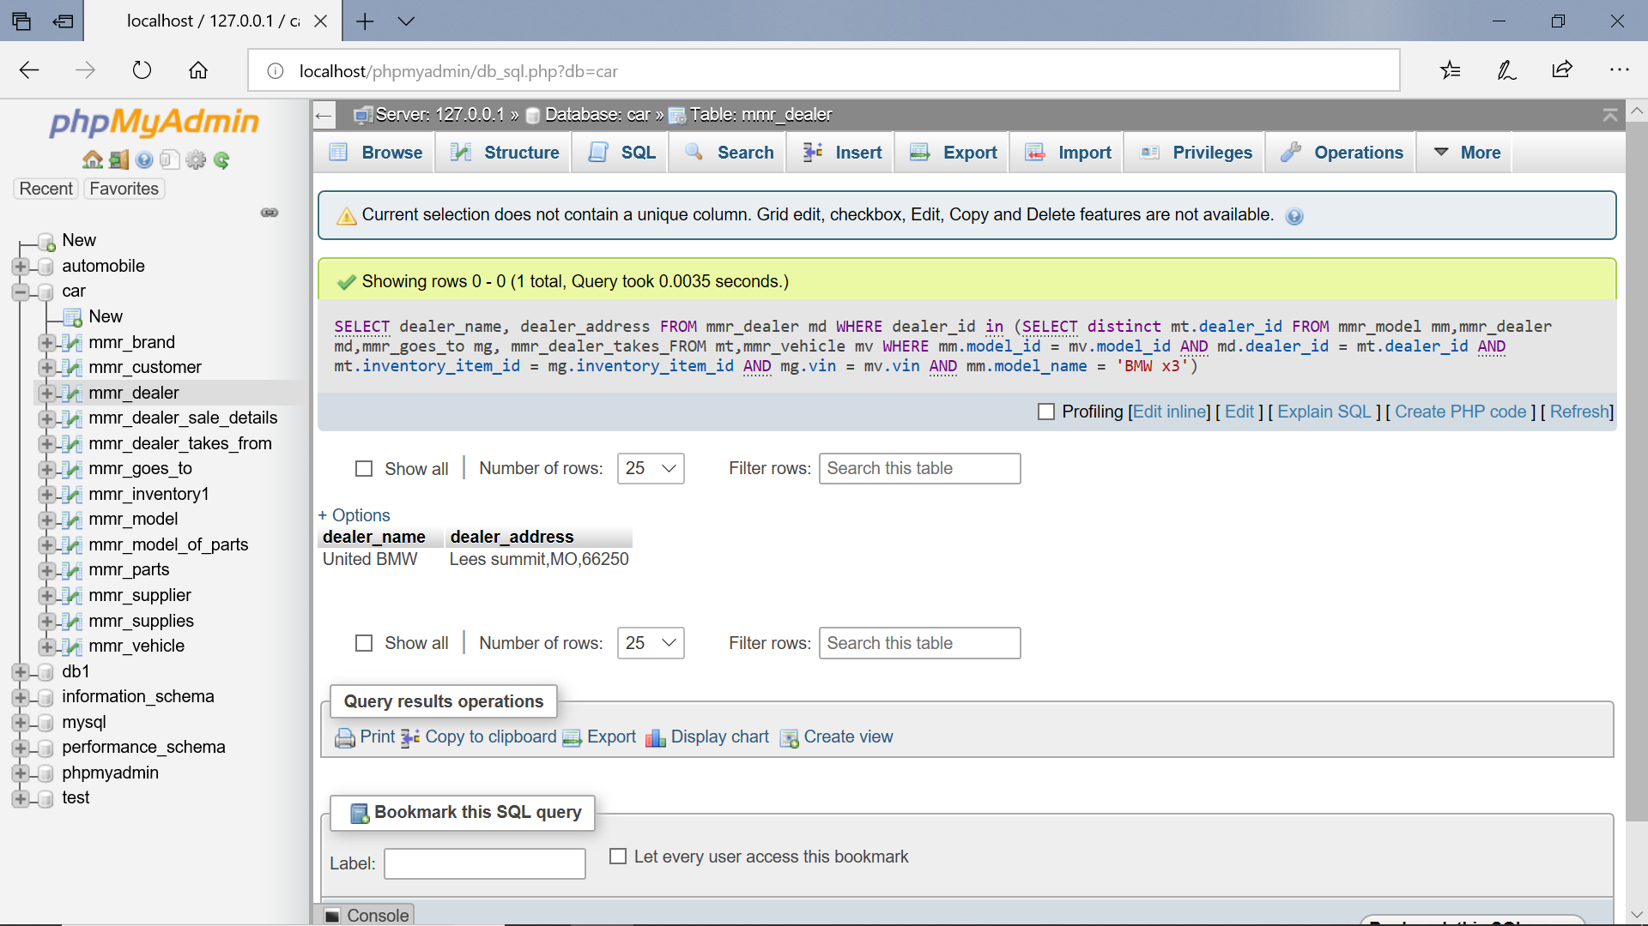

**Q4. To find all available models of Rolls Royce at Penske Rolls Royce dealer**

SELECT model_name,dealer_nameFROM mmr_dealer md ,mmr_model mmWHERE md.brand_id=mm.brand_id AND dealer_name='Penske Rolls Royce'

Output:

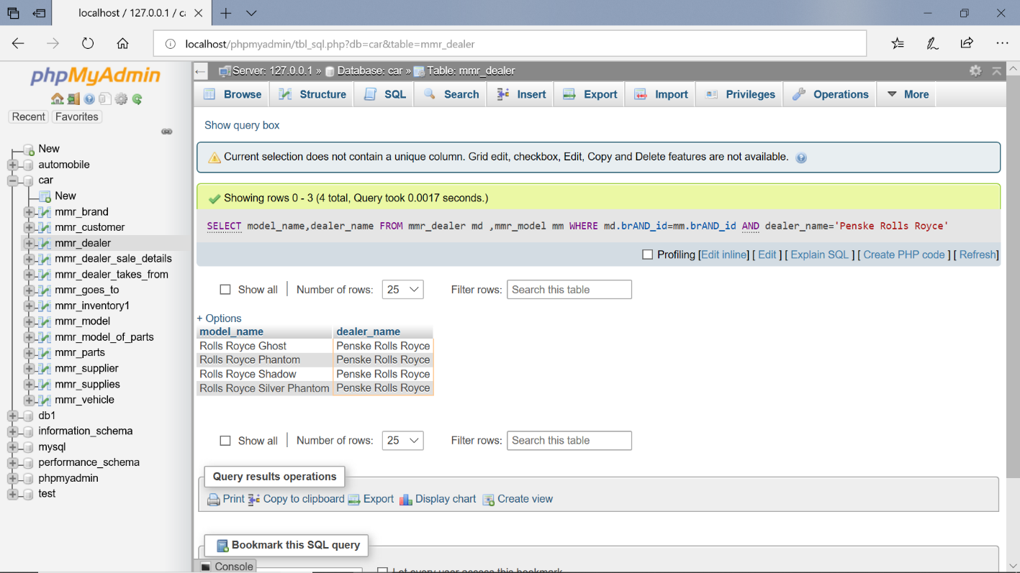

**Q5. Using order by and joining dealer_takes_from and mmr_goes_to**

SELECT t.dealer_id , t.inventory_item_id , g.vin

FROM mmr_dealer_takes_from t

INNER JOIN mmr_goes_to g

ON t.inventory_item_id = g.inventory_item_id

ORDER BY inventory_item_id

Output:

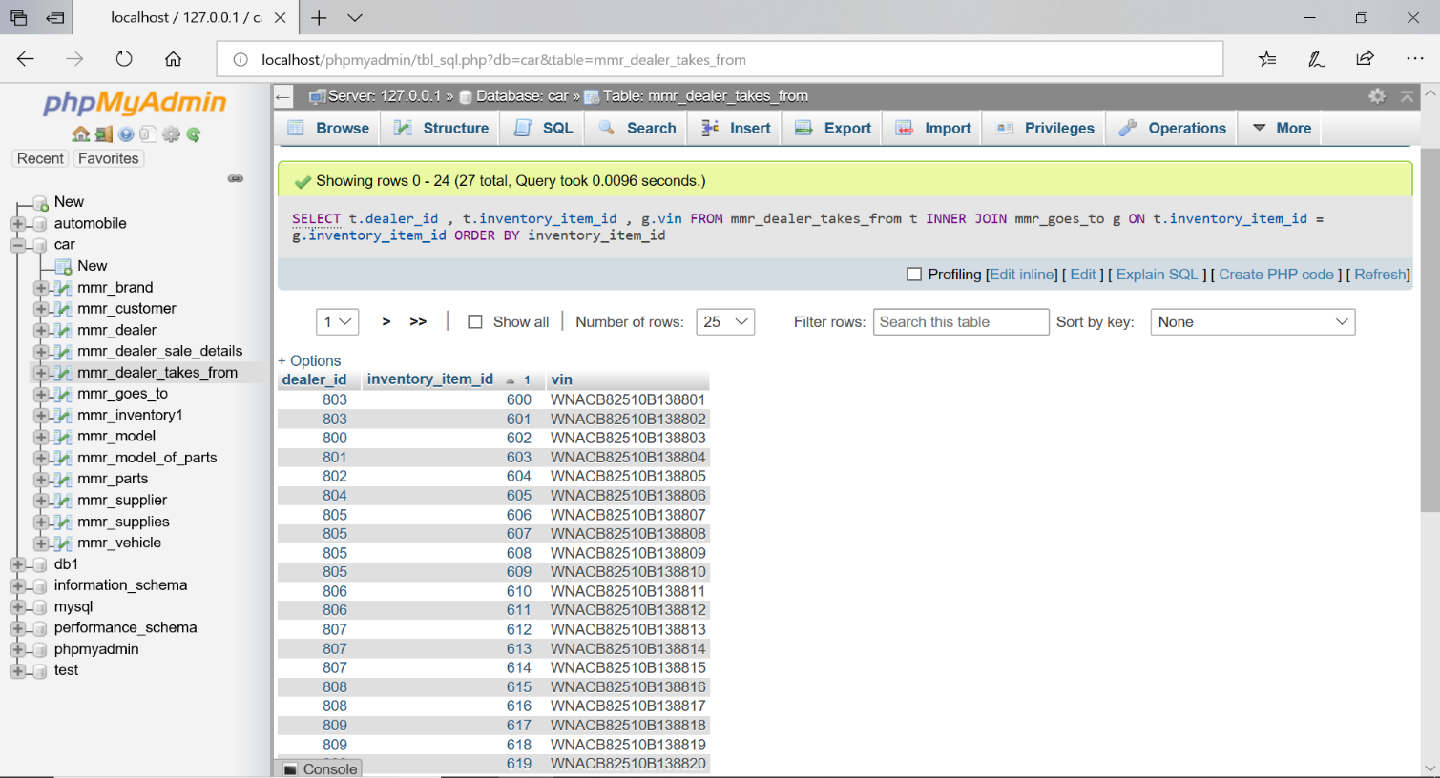

**Q6. Using inner Join**

SELECT d. dealer_id, d. dealer_name, d. dealer_address

From mmr_dealer d

INNER JOIN mmr_brand b

ON d. brand_id=b. brand_id;

Output:

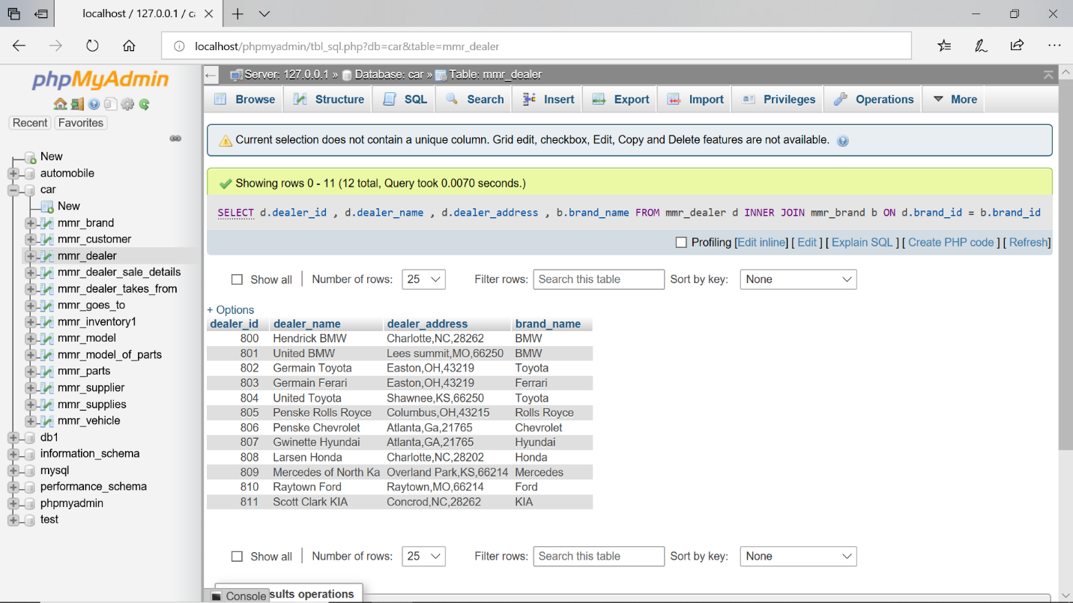

**Q7. Query using Sub Query**

SELECT *

FROM mmr_customer

WHERE customer_annual_income < (select AVG(customer_annual_income)

FROM mmr_customer);

Output:

