WebDriver

Why we need automation:

It saves time to execute regression test cases.

It simplifies cross browser testing.

We can do data driven testing.

Defects not found through manual testing and complex testcases can be automated.

Reusability and avoid redundancy.

When to automate and when not to automate?

when not to automate:

If UI of project is going to be changed – no need to automate.

Tight dead lines

Look and feel related components

when to automate:

when we know that project needs more and more regression.

It saves time to execute regression test cases.

when we need cross browser testing and data driven testing.

Defects not found through manual testing and complex testcases can be automated.

Reusability and avoid redundancy.

Automation:

UI/Web application/Browser automation – WebDriver, Nightwatch.js, Protractor etc

WebServices Automation- SOAP and REST – SoapUI, HttpCLient, RestAssured, Chakram

Mobile applications automation- Appium, UIAutomator ,UIAutomation, Perfecto, Calabash etc.

test frameworks – TestNG, JUnit, Chai.js etc..

UI/Web application/Browser automation :

Other automation tools – QTP, SilkTest etc were used earlier

Selenium – IDE, RC, WebDriver, Grid

Selenium WebDriver

IDE :

Record and playback tool- it is firefox plugin.

TestCase- description, teststeps, testdata, expected, actual , result

Command – Action perfomed in browser

Target – locating the element on which html element we are performing the action

Value- input to the element like text boxes..

Assert - if the actual and expected do not match- test wil not continue execution

verify – even if the actual and expected do not match- test wil still continue execution , we can see log statement that the verification failed.

Disadvantage of IDE:

We can execute tests only in firefox- it is only firefox plugin.

We cannot do continuous build and continuous integration.

data driven testing cannot be done.

**Selenium Remote Control** (RC) is a test tool that allows you to write automated web application UI tests in any programming language against any HTTP website using any mainstream JavaScript-enabled browser.

Selenium RC comes in two parts.

1. A server which automatically launches and kills browsers, and acts as a HTTP proxy for web requests from them.
2. Client libraries for your favorite computer language

Set of jars using which we can develop automation code.

RC supports different languages for automation like Java,Ruby, Python etc.

**package** **com.example.tests**;

**import** **com.thoughtworks.selenium.\***;

**import** **java.util.regex.Pattern**;

**public** **class** **NewTest** **extends** SeleneseTestCase {

**public** **void** **setUp**() **throws** Exception {

setUp("http://www.google.com/", "*firefox");

}

**public** **void** **testNew**() **throws** Exception {

selenium.open("/");

selenium.type("q", "selenium rc");

selenium.click("btnG");

selenium.waitForPageToLoad("30000");

assertTrue(selenium.isTextPresent("Results * for selenium rc"));

}

}

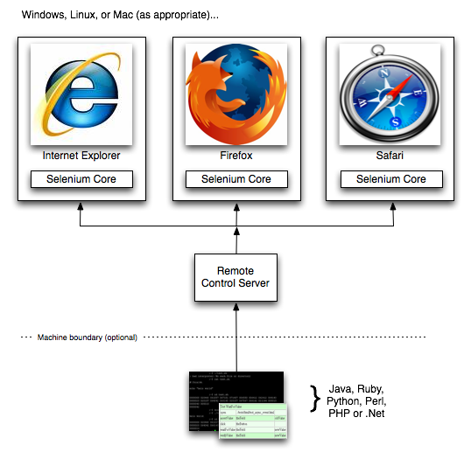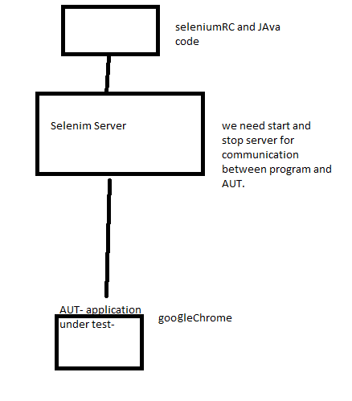

Disadvantage:

It is slower than WebDriver as we need to start/stop server

It injects javascript functions into the browser when the browser was loaded and then uses its javascript to drive the AUT within the browser **Grid.**

**Selenium-Grid** allows you run your tests on different machines against different browsers in parallel. That is, running multiple tests at the same time against different machines running different browsers and operating systems. Essentially, Selenium-Grid support distributed test execution. It allows for running your tests in a distributed test execution environment.

Two reasons why you might want to use Selenium-Grid.

* To run your tests against multiple browsers, multiple versions of browser, and browsers running on different operating systems.
* To reduce the time it takes for the test suite to complete a test pass.

**WebDriver:**

WebDriver is automation tool used for browser/ web applications automation.

WebDriver API provides many classes and interfaces to develop automation scripts.

WebDriver is an main interface in WebDriver API which has multiple implementation classes like FirefoxDriver,ChromeDriver,SafariDriver etc.

How Does WebDriver ‘Drive’ the Browser Compared to Selenium-RC?[¶](http://www.seleniumhq.org/docs/03_webdriver.jsp#how-does-webdriver-drive-the-browser-compared-to-selenium-rc)

Selenium-WebDriver makes direct calls to the browser using each browser’s native support for automation. How these direct calls are made, and the features they support depends on the browser you are using. Information on each ‘browser driver’ is provided later in this chapter.

For those familiar with Selenium-RC, this is quite different from what you are used to. Selenium-RC worked the same way for each supported browser. It ‘injected’ javascript functions into the browser when the browser was loaded and then used its javascript to drive the AUT within the browser. WebDriver does not use this technique. Again, it drives the browser directly using the browser’s built in support for automation.

**What we need for automation:**

Automation Tool – WebDriver

ProgrammingLanguage- Java

TestFramework- Creating TestSuites, assertions, test reports – TestNG

Maven – Build Tool

Git- code repository management

Jenkins- Continuous integration

**Automation script has 4 main parts:**

Load the browser with required URL.

Identify the element to automate – we use locators

perform the action on the element

assert for actual and expected.

<input id="gh-ac" class="gh-tb ui-autocomplete-input" size="50" maxlength="300" placeholder="Search..." name="_nkw" autocapitalize="off" autocorrect="off" spellcheck="false" autocomplete="off" aria-live="polite" role="status" aria-haspopup="false" type="text"/>

<span class="ui-helper-hidden-accessible" role="status" aria-live="polite"/>

<a..

<button..

Locating Elements:

By class: 8 static methods – using class name u can call the methods

id -

name

linkText

partialLinkText

css selectors

xpath

tagName

className