**Zomato Restaurant effectiveness analysis**

**Final report for the BDM capstone Project** Submitted by

Name: Medhaa Priya

Roll number: 21f3001271



IITM Online BS Degree Program,

Indian Institute of Technology, Madras, Chennai Tamil Nadu, India, 600036

**Contents**

1 Executive Summary and Title …………………………………………………………………………………………………………3

2 Proof of Originality………..……………………………………………………………………………………………………………….3

3 Meta Data and Descriptive Statistics……………………………………………………………………….…………………..4-9

4 Results and Findings………….…………………………………………….……………………………………………………………10

5 Problem Solving Approach……………………………………………………………………………………………………….11-16

6 Interpretation of Results…………………………………………………………………………………………………………..17-18

7 Recommendations………………………………………………………………………………………………………………………..19

8 Conclusion…………………………………………………………………………………………………………………………………….20

9 Appendix……………………………………………………………………………………………………………………………………….20

**1. Executive Summary and Title**

The project focuses on 900 restaurants listed on Zomato across 13 metropolitan cities of India. The business is B2C and deals in the segment of providing online food delivery and restaurant reservation services directly to end consumers.

The major business issues that the organization is facing are related to identifying customer preferences, restaurant preference evaluation across cities, market segmentation, targeting, and devising effective pricing strategies.

The issues will be addressed by analyzing the data via different analytical approaches to obtain a fruitful outcome. The approach is mainly in the form of Exploratory Data Analysis, which involves comprehensive data cleaning and preprocessing, statistical analysis on variables like ratings, reviews, cuisines, prices and location, and data visualization techniques like histogram, scatter plots, to identify patterns, trends and ay outliers in the data.

The expected outcome will help the organization optimize their business model, and have a better understanding of consumer preferences, along with the market dynamics, delivery logistics as well as marketing strategies.

**2. Proof of originality:**

The data has been gathered through a Secondary source, from a website named Kaggle. [The link to the dataset is attached here](https://www.kaggle.com/datasets/narsingraogoud/zomato-restaurants-dataset-for-metropolitan-areas), and the [csv version is attached here](https://drive.google.com/file/d/1ataXWyyM5x7B3GtW2nxba78CBInWLMVV/view?usp=drive_link). This dataset is carefully analyzed to assure its reliability.

Signature of Candidate: 

Name: Medhaa Priya

Date: 8.7.2024

**3. Meta Data and Descriptive Statistics**

**3.1 Metadata**

* About the dataset-

This dataset provides a comprehensive view of the restaurant scene in the 13 metropolitan areas of India( 900 restaurants) . Researchers, analysts, and food enthusiasts can use this dataset to gain insights into various aspects such as dining and delivery ratings, customer reviews and preferences, popular cuisines, best-selling items, and pricing information across different cities. It enables the exploration of dining patterns, the comparison of restaurants and cuisines between cities, and the identification of trends in the food industry. This dataset serves as a valuable resource for understanding the culinary landscape and making data-driven decisions related to the restaurant business, customer satisfaction, and food choices in these metropolitan areas of India. (to be reworded)

* Collaborator- Bagagouni NARSING RAO (Owner)
* Coverage- Temporal coverage start date, Temporal coverage end date, Geospatial coverage
* DOI Citation- 10.34740/kaggle/dsv/6110780
* APA Citation- B NARSING RAO. (2023). Zomato Restaurants Dataset for Metropolitan Areas [Data set]. Kaggle. <https://doi.org/10.34740/KAGGLE/DSV/6110780>
* Provenance

Sources- <https://www.zomato.com/>

Collection Methodology-

This dataset has been obtained through the process of web scraping, which involves extracting relevant data from web pages hosted on the Zomato website. The dataset includes various attributes of restaurants such as restaurant name, dining ratings, delivery ratings, dining votes, delivery votes, cuisine, place city name, item name, best seller status, votes for specific item, and prices for each item. This technique automates the extraction of data from Zomato website to gather information about restaurants situated in the metropolitan areas. The collected data provides some valuable insights into the dining preferences, ratings, and pricing patterns of these restaurants.

**3.2 Descriptive Statistics**

* Summary statistics

Data information

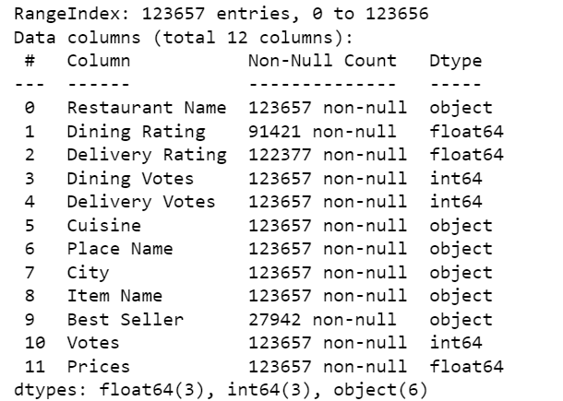

*Fig 3.2*

Data summary

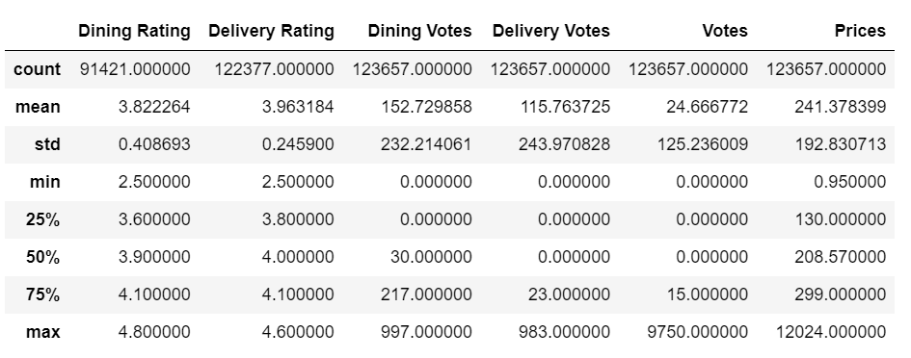

*Fig 3.3*

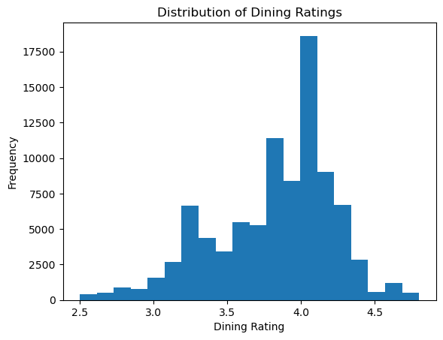

*Fig 3.4*

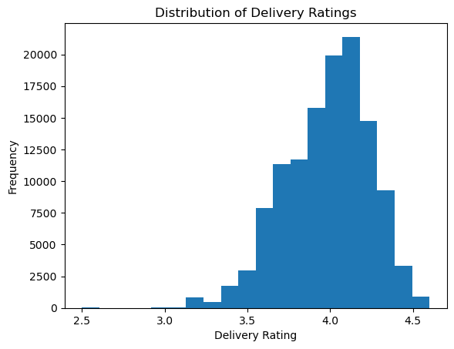

*Fig 3.5*

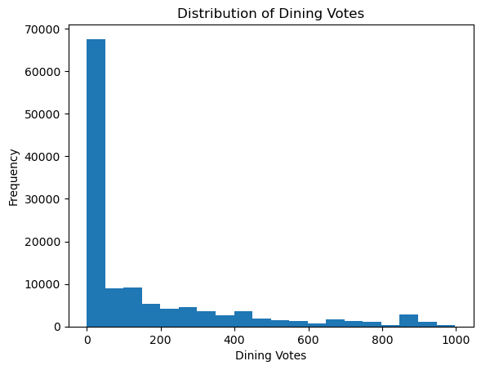

*Fig 3.6*

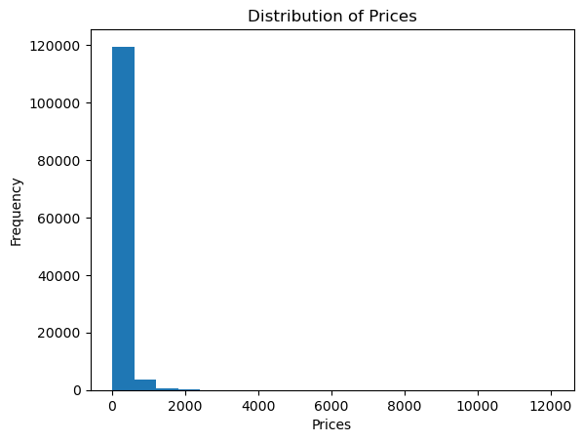

*Fig 3.7*

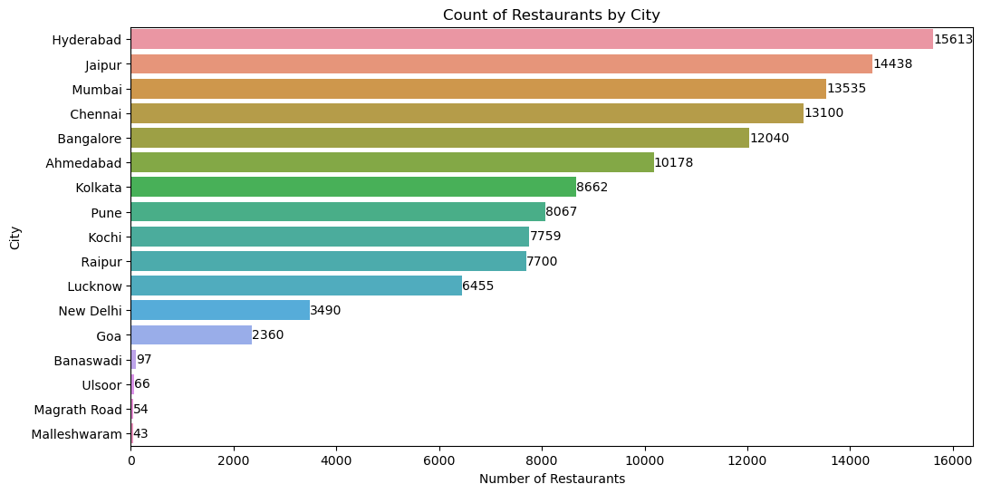

*Fig 3.8*

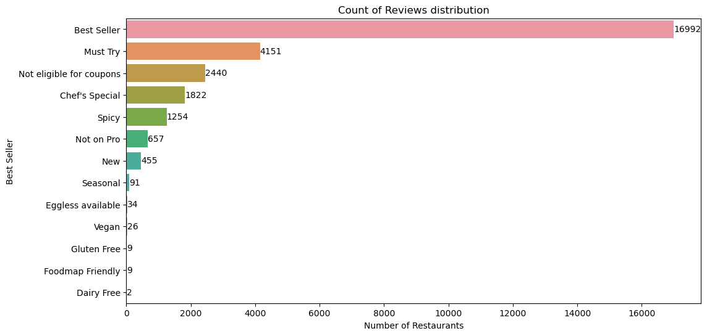

*Fig 3.9*

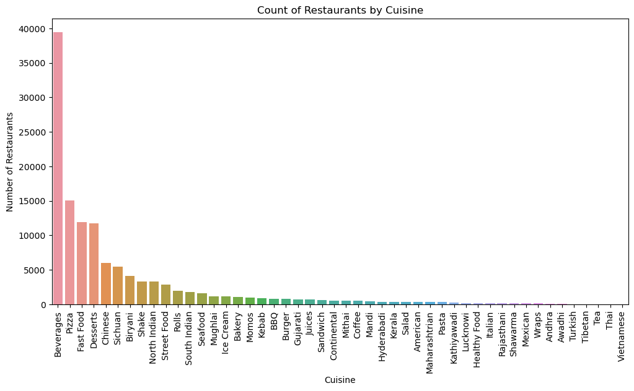

*Fig 3.10*

**4. Methodology**

To conduct an in-depth analysis of the performance of various restaurants across cities, under both dining and delivery categories, we use relevant metrics from the dataset such as ratings, item review, popularity, revenue and operational efficiency to benchmark restaurant performance across cities, identifying top performers and underperformers. This will aid conduct root cause analysis for understanding the factors contributing to underperformance and develop targeted strategies for improvement. Further methodological processes are explained below:

* **Data Cleaning-** After examining the dataset, we performed some preliminary data cleaning processes such as, identifying empty values and transforming them into NaN or 0 values for Categorical and Numerical variables respectively. Moreover, we also looked for any data duplicates in order to remove such occurrences. Finally, we identified inconsistent entries in categorical variables, and standardized their forms for a smoother analysis.
* **Exploratory Data Analysis-** This step is performed to understand the characteristics, patterns, and relationship among the data variables. Such explorations are projected through various statistical techniques like value count, mean, mode, median, quartiles, standard deviation, min & max values and frequency distributions. We also explore the breadth of cities covered within India, to reflect the tier-level diversity. The data.info() and data.describe() methods in python help us gauge the same. They are further visualized through histograms and bar charts, with the help of packages like matplotlib and seaborn.
* **Restaurant Performance Evaluation-** We then use relevant metrics from the dataset such as ratings, review, popularity, revenue and operational efficiency to benchmark restaurant performance across cities, identifying top performers and underperformers. This will aid conduct root cause analysis for understanding the factors contributing to underperformance and develop targeted strategies for improvement. Variables such as Dining Rating and Votes, and Delivery Ratings and Votes help us gauge the same. The One-word product reviews further help us understand the perceptions of the items among customers, across various cities. This helped us conduct a city-level analysis for their respective restaurants.
* **Strategy Development and Implementation-** Based on the insights gained from the analysis, we develop comprehensive strategies and action plans to address the identified business problems. These strategies may include recommendations for menu optimization, pricing adjustments, targeted marketing campaigns, operational process improvements, and resource allocation plans.

**5. Results and Findings**

This section presents the graphical representation of the relevant questions asked for the purpose of our analysis. These include:

* *What is the performance of dining and delivery services by the restaurants under Zomato?*
* *What are the high and Low performing restaurants under both dining and delivery services across all the cities as a whole?*
* *Is there cuisine variety among the most and the least preferred options across the cities?*
* *Is there any relations between the votes and their respective ratings among both dining and delivery services?*
* *Is there any relation between prices and the ways customers perceive the dining and delivery services across restaurants?*
* *How many cities are selling their items above average levels of their respective average city prices?*

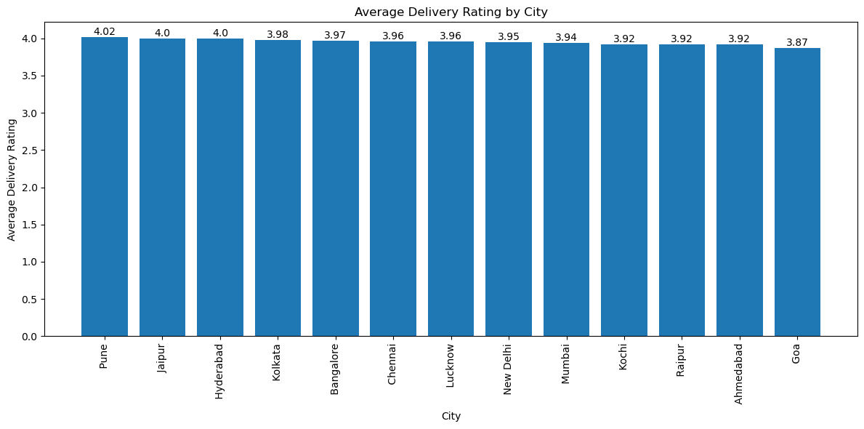

*Fig 5.1. Average Rating of eligible Items for Delivery across Cities*

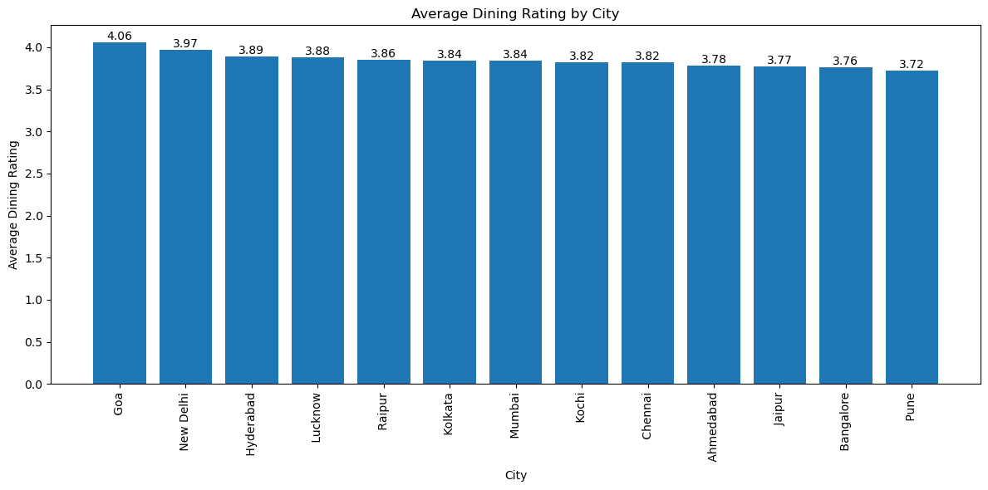

*Fig 5.2. Average Rating of eligible Items for Dining across Cities*

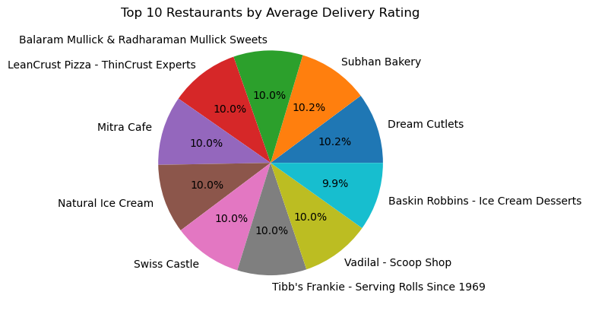 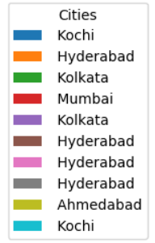

*Fig 5.3. Highest performing restaurant across cities as per Delivery experience*

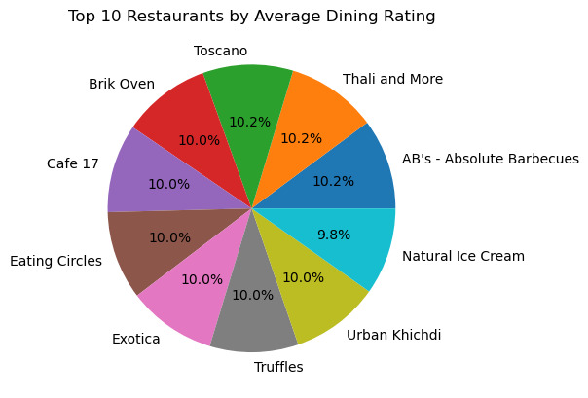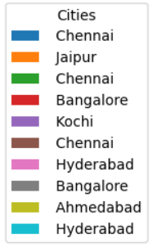

*Fig 5.4. Highest performing restaurant across cities as per Dining experience*

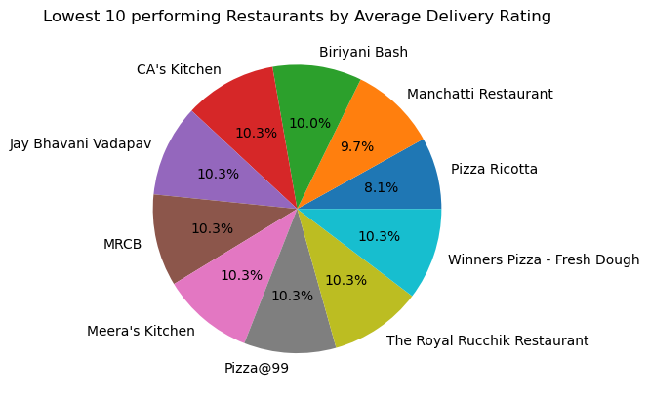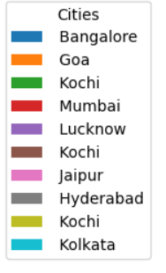

*Fig 5.5.*  *Lowest performing restaurant across cities as per Delivery experience*

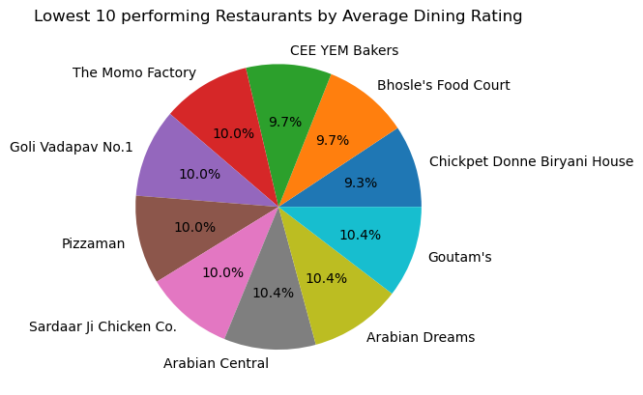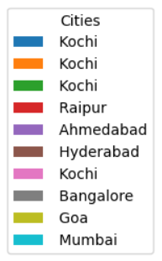

*Fig 5.6. Lowest performing restaurant across cities as per Dining experience*

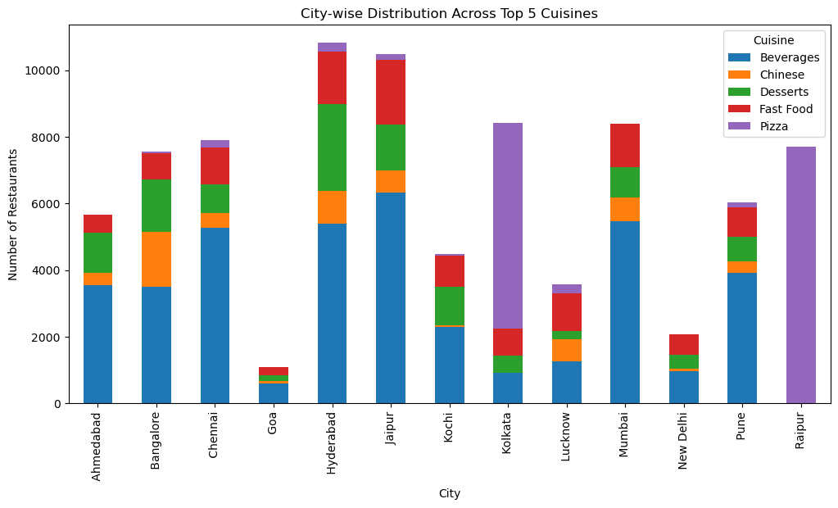

*Fig 5.7. Representation of most preferred cuisines across cities*

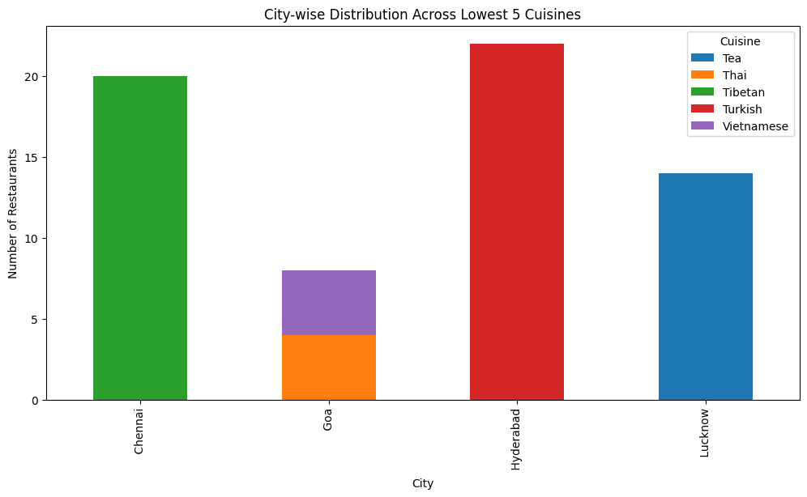

*Fig 5.8. Representation of least preferred cuisines across cities*

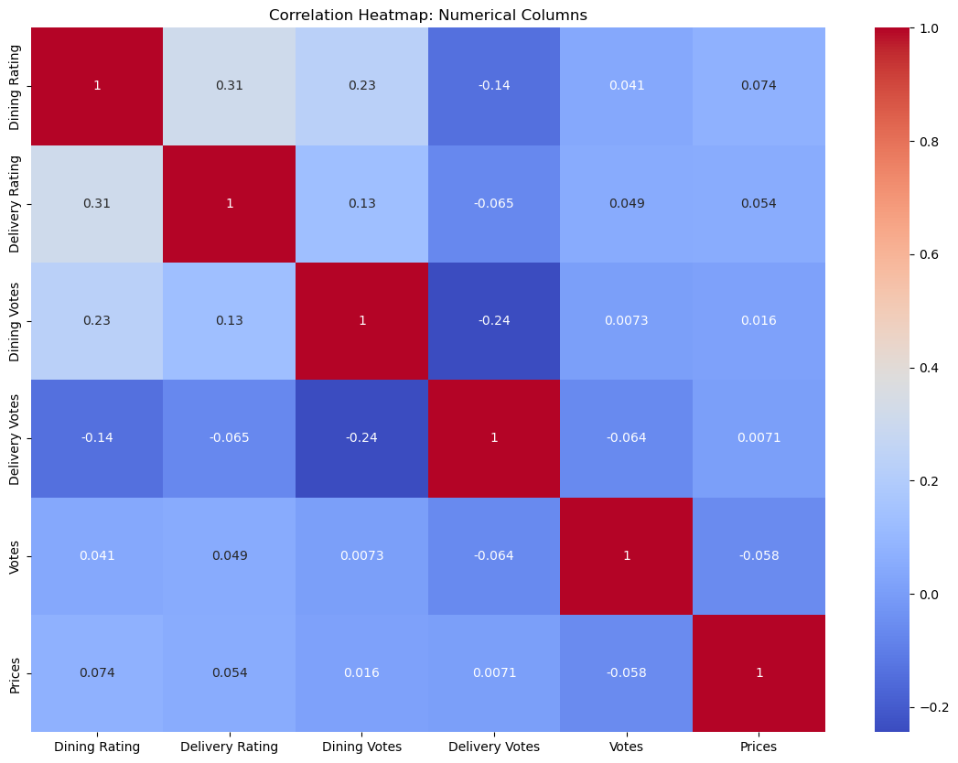

*Fig 5.9. Correlation matrix among the quantitative variables*

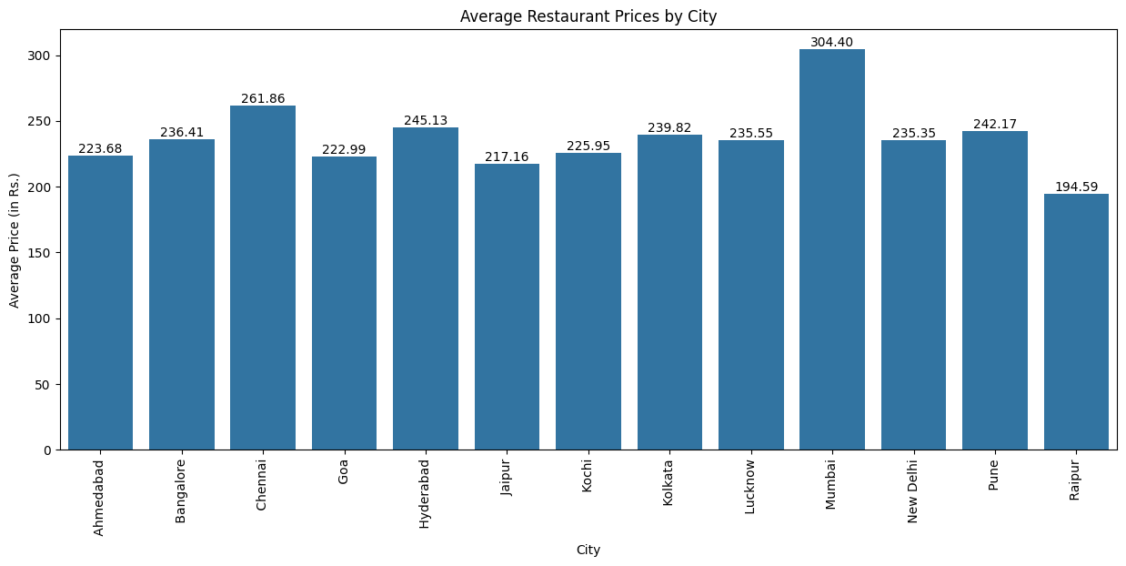

*Fig 5.10. City-wise representation of average prices of restaurants*

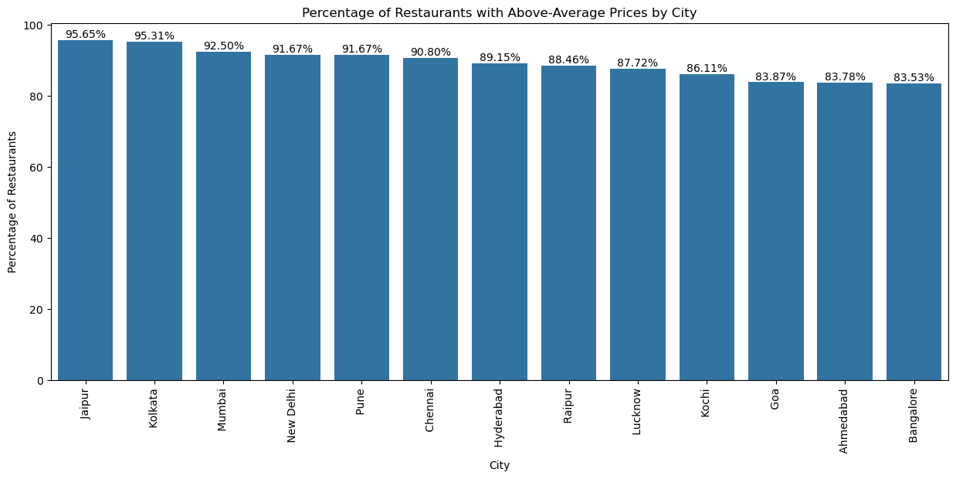

*Fig 5.11. City-wise analysis of the no. of items being sold at above average price levels*

**5. Interpretation of results**

* ***What is the performance of dining and delivery services by the restaurants under Zomato? (Refer Fig1. and Fig2.)***

According to the analysis, the delivery ratings for all cities fall between 3.5 and 4.0, indicating generally positive delivery experiences across the board. Pune, a tier 2 city has the highest average delivery rating at approximately 4.0. On the other hand, Magrath Road, a locality in Bangalore has the lowest average rating at around 3.7

On the other hand, the dining ratings for all cities fall between 3.5 and 4.0, indicating generally positive delivery experiences across the board. Goa, a tier 2 city has the highest average delivery rating at approximately 4.0. On the other hand, Magrath Road, a locality in Bangalore has the lowest average rating at around 3.5. Ulsoor, another locality in Bangalore

* ***What are the high and Low performing restaurants under both dining and delivery services across all the cities as a whole?***

***(Refer Fig 3., Fig4., Fig5., Fig6.)***

The above graphs give a representation of the highest and lowest performing restaurants within the dining and delivery categories of all the 13 cities. From our analysis it is noted that all the restaurants represent a diversity of city regions. The labels of restaurants along with their respective cities give us further understanding of the city and the restaurants corresponding to both delivery and dining experience.

Around 66.67% of the top performing restaurants in their delivery services belong to Hyderabad, with Kolkata second in number. On the other hand, there are a variety of cities performing well in their dining services. Around majority (30%) of the cities belong to Chennai, with Hyderabad second in number.

Among the lowest performing cities, with respect to delivery services, Kochi tops with a contribution of 30% of their restaurants to their list. Interestingly, Kochi also contributes to a majority of the share in the lowest performing dining services, amounting to 40% of the total number of cities.

* ***Is there cuisine variety among the most and the least preferred options across the cities? (Refer Fig 7. and Fig 8.)***

From the given dataset we identified the topmost 5 cuisines including Beverage, Chinese, Fast-Food, Desserts and Pizza. While all the 13 cities have a fairly healthy distribution of cuisine distribution throughout their restaurants, Kolkata and Raipur, are the two cities that have a majority of their restaurants catering to ‘Pizza’ joints. Such interpretations can further help us understand the dynamics of population within these cities, and the kind of food preferences that affect their eating-out habits and daily lifestyles. Overall, the fair representation of cuisines tell us that the cities are doing well, in identifying the dishes that are the most popular and provide high-revenue opportunities from their local customers.

On the other hand, the least preferred cuisines among the customers include Tea, Thai, Tibetan, Turkish and Vietnamese. With their least performance, it is also important to note that only 4 out of the 13 cities including Chennai, Goa, Hyderabad and Lucknow cater to such restaurants. This indicates that the restaurants are identifying well with respect to the consumer preferences, and customizing their menu accordingly.

* ***Is there any relations between the votes and their respective ratings among both dining and delivery services? (Refer Fig 9.)***

According to the correlation matrix that is generated, we can derive that there is a positive correlation of 0.23 between dining ratings and the dinding votes, which means the increased number of votes explains the high ratings for the restaurants by 23%.

However, we see a contradictory phenomenon when it comes to understanding the relationship between delivery ratings and its respective delivery services. They have a negative correlation of -0.065 indicating that with increase in the number of votes, leads to a decrease of 6.5% in the ratings. This may give us an understanding of how delivery services are perceived among the customers, indicating the issues associated with quality and logistics related to their services

* ***Is there any relation between prices and the ways customers perceive the dining and delivery services across restaurants? (Refer Fig 9.)***

There is a positive correlation of 0.074 between prices and the delivery ratings, indicating that higher the prices, tends to higher ratings for the restaurants respectively. Similarly there is a positive correlation of 0.054 between prices and the dining ratings, which means that increase in prices, also lead to increase in the ratings for a particular item. This tells us about the consumer behavior where they assign a higher value to items with higher prices. It could also indicate that the restaurants increase their prices for items with higher rating preferences, in order to optimize their profit maximization.

* ***How many cities are selling their items above average levels of their respective average city prices? (Refer Fig 10., Fig 11.)***

From Figure 10, we can easily interpret that Mumbai has the highest average prices at Rs. 304.40 among its restaurants, whereas, Raipur has the lowest average prices at Rs. 194.59. On delving deeper, we find in Fig 11. That more than 80% of the restaurants in the 13 cities sell their items at prices, above their average level prices.

**6. Recommendations**

To enhance its dining and delivery services, Zomato can implement several strategies based on the performance metrics and analysis of its restaurant network.

**6.1 Addressing delivery service performance-**

* Optimizing delivery logistics- This may involve enhancing the efficiency of delivery routes and reducing delivery times through better route planning and real-time traffic data integration.
* Improving partener quality restaurant- Ensuring that partener restaurants adhere to high standards and timely order preparation, which can reduce complain and enhance customer satisfaction
* The negative correlation between delivery ratings and votes indicates that the company may implement measures like i) Quality control checks- Introduce regular quality audits and customer feedback mechanisms to ensure that popular restaurants maintain high standards. ii) Encourage restaurants to improve- Offer incentives for restaurants that show consistent improvement in delivery ratings.

**6.2 Enhancing Dining Experiences-**

* Leveraging High-Rated cities- Highlighting restaurants in well performing cities like Goa and Pune as case studies for quality service, ambience, and customer engagement.

Expanding success models- Encouraging similar restaurant types and dining experiences in lower-rated areas based on successful models from high-rated cities.

* Addressing low-performing areas- This indicates the involvement of i)Localized strategies- understanding the unique challenges and customer preferences in citieslike Kochi. ii)Incentivizing improvement- Offering support and incentives to restaurants in such cities to enhance their serving and dining experience

**6.3 Diversifying Cuisine offerings-**

* Expanding Popular Cuisines- This can be done by promoting diverse cuisines through their menu offerings beyond popular options to cater to a broader range of tastes and preferences.
* Introduce New Cuisines- Promoting emerging cuisine trends and preferences in different cities to stimulate variety and attract a wider customer base
* Addressing Least preferred cuisines- This can be done by i)Evaluating customer preferences- Conducting market research to understand the low appeal of these cuisines, and explore any untapped segments within the existing cities. ii) Encouraging Niche offerings- Support restaurants that offer these cuisines to market themselves better or modify their offerings to better match the local preferences.

**6.4 Price and Perceptions**

* The positive correlation between price and ratings indicated that higher prices are associated with better perceived value. Zomato can further enhance this by i) Communicate Value- Help restaurants effectively communicate the value proposition of higher-priced items to justify their cost and attract customers. ii) Monitor pricing strategies- Endure that restaurants are not inflating prices unjustifiably which could deter customers.
* On the average price analysis, Zomato should promote transparency by advocating for transparent pricing and provide customers with clear information on price variations to maintain trust. It should also encourage competitive pricing by facilitating strategies among restaurants to ensure fair pricing and prevent price gouging.

**7. Conclusion**

The analysis of Zomato’s restaurant data across 13 Indian metropolitan cities reveals significant insights into the performance of dining and delivery services. The overall ratings for both delivery and dining services fall within a positive range of 3.5 to 4.0 out of 5.0, indicating a solid foundation for service quality. However, variations between cities highlight areas for improvement. Key findings suggest that while popular restaurants often face challenges in maintaining high ratings, there are actionable strategies to enhance the performance. Optimizing delivery logistics, improving partener restaurant quality, and addressing inconsistencies in service can elevate the delivery experience. For dining services, leveraging successful models from high-rated cities and addressing issues in lower performing areas can drive such improvements. Cuisine diversity analysis further shows a strong preference for certain types of cuisines, with less popular options having a limited appeal. Expanding cuisine offerings and promoting emerging trends could attract a broader customer base and enhance the satisfaction. Price perceptions indicate that higher prices are often associated with better ratings, reflecting customer expectations of value. Transparent pricing and competitive strategies are crucial in maintaining trust and fairness in the market.

By implementing these recommendations, Zomato can refine its business model, enhance customer satisfaction, and strengthen its market position. This comprehensive approach will enable Zomato to better meet consumer needs and navigate the competitive landscape effectively.

**8. Appendix**

[Link to Python code](https://colab.research.google.com/drive/11ZUR0Vh6jkvEEQyIskNPMg6Pxb6acom1?usp=drive_link)