

**CSE 3105/ CSE 3137**

**OBJECT ORIENTED ANALYSIS AND DESIGN**

**FALL 2020**

**COURSE PROJECT: Media Browser Application**

***System Design Document***

***Group 1***

*Utku ÇELEBİ – 170316059*

*Name2 Surname2 – ID2*

*Name3 Surname3 – ID3*

*Name4 Surname4 – ID4*

*26 December 2020*

Table of Contents

1 Introduction 1

1.1 Purpose of the System 1

1.2 Design goals 1

2 Current Software Architecture 1

3 Proposed Software Architecture 1

3.1 Subsystem decomposition 1

3.2 Hardware/software mapping 1

3.3 Persistent data management 1

3.4 Access control and security 1

3.5 Boundary conditions 1

4 Subsystem Services 2

5 Glossary 2

6 References 2

# Introduction

The purpose of the Introduction section is to provide a brief overview of the software architecture and the design goals. It also provides references to other documents and traceability information (e.g., related requirements analysis document, references to existing systems, constraints impacting the software architecture).

## Purpose of the System

## Design goals

The design goals represent the desired qualities of Bumpers and provide a consistent set of criteria that must be considered when making design decisions. The following design goals are identified.

* Using C#
* Usability
* Robustness
* Response time
* Customization

# Current Software Architecture

The second section, *Current software architecture*, describes the architecture of the system being replaced. If there is no previous system, this section can be replaced by a survey of current architectures for similar systems. The purpose of this section is to make explicit the background information that system architects used, their assumptions, and common issues the new system will address.

# Proposed Software Architecture

The third section, *Proposed Software Architecture*, documents the system design model of the new system. It is divided into seven subsections:

## Subsystem decomposition

The following UML class diagram gives an overview of the identified subsystems and their relations.

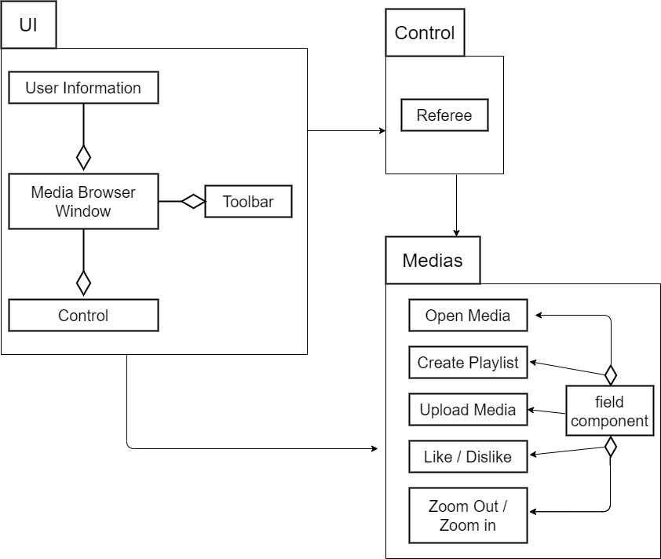

## Hardware/software mapping

*Hardware/software mapping* describes how subsystems are assigned to hardware and off-the-shelf components. It also lists the issues introduced by multiple nodes and software reuse.

## Persistent data management

*Persistent data management* describes the persistent data stored by the system and the data management infrastructure required for it. This section typically includes the description of data schemes, the selection of a database, and the description of the encapsulation of the database.

## Access control and security

*Access control and security* describes the user model of the system in terms of an access matrix. This section also describes security issues, such as the selection of an authentication mechanism, the use of encryption, and the management of keys.

## Boundary conditions

The starting, stopping and installing of the media browser application defines the boundary conditions. Here we must take care of the different operating systems medias is build for.

# Subsystem Services

The fourth section, *Subsystem Services*,describes the services provided by each subsystem. This section serves as a reference for teams for the boundaries between their subsystems. The interface of each subsystem is derived from this section and detailed in the Object Design Document.

# Glossary

Describe the definitions, acronyms, and abbreviations you used in your report.

# References

If you refer to other sources, list them here.