

**CSE 3105/ CSE 3137**

**OBJECT ORIENTED ANALYSIS AND DESIGN**

**FALL 2020**

**COURSE PROJECT: Media Browser Application**

***System Design Document***

***Group 1***

*Utku ÇELEBİ – 170316059*

*Tahsin ALTINTAŞ – 160315024*

*Mustafa Ahmet YILMAZ – 170316042*

*İbrahim UZUN – 160315035*

*17 January 2021*

Table of Contents

1 Introduction 1

1.1 Purpose of the System 1

1.2 Design goals 1

2 Current Software Architecture 1

3 Proposed Software Architecture 1

3.1 Subsystem decomposition 2

3.2 Hardware/software mapping 3

3.3 Persistent data management 4

3.4 Access control and security 4

3.5 Boundary conditions 4

4 Subsystem Services 4

5 Glossary 6

6 References 6

# Introduction

## Purpose of the System

Media applications, viewing, editing or sharing media applications is an important issue in information and file transfer today. The media browser application we designed, we wanted to develop a media application that allows users to watch videos within the main application, view pictures and listen to music by switching between tabs.

Users using this media app will be able to log into the media app and interact with other people using this media app, such as media like or dislike, creating playlists, viewing pictures, music, videos that are already in the app.

## Design goals

The design goals represent the desired qualities of Bumpers and provide a consistent set of criteria that must be considered when making design decisions. The following design goals are identified.

* Using C#
* Usability
* Robustness
* Response time
* Customization

# Current Software Architecture

Since the dependencies between subsystems in commonly used media applications are complex and excessive, there may be serious problems in communication between media files and media files properties, between playlists.By addressing this issue, it was aimed to prevent complexity by designing the subsystem layout as efficiently as possible.

# Proposed Software Architecture

Software architecture refers to the fundamental structures of a software system and the discipline of creating such structures and systems. It functions as a blueprint for the system and the developing project, laying out the tasks necessary to be executed by the design teams. The third section, *Proposed Software Architecture*, documents the system design model of the new system. It is divided into seven subsections.

## Subsystem decomposition

The following UML class diagram gives an overview of the identified subsystems and their relations.

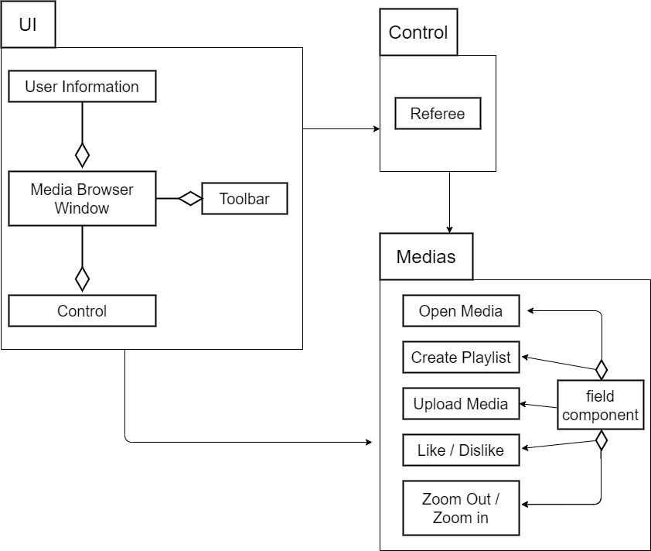

## Hardware/software mapping

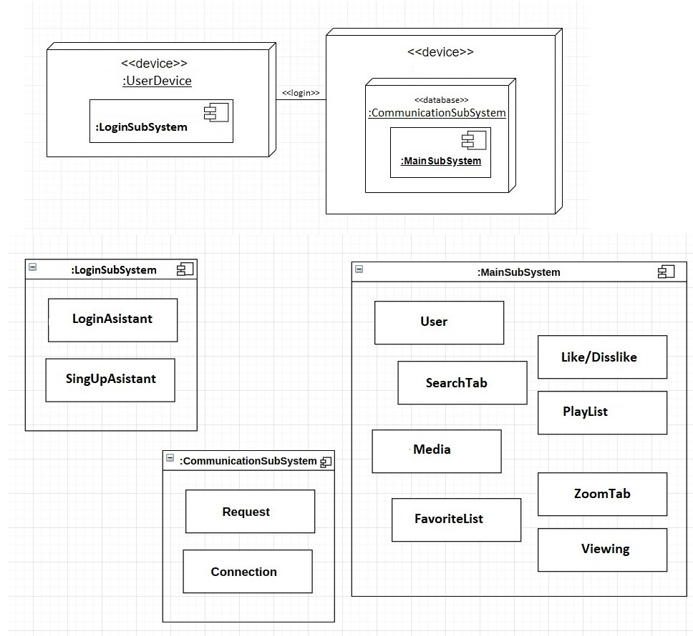

**CommunicationSubSystem:** The CommunicationSubSystem is reponsible for transporting object from MainSubSystem on the :LoginSubSystem.

## Persistent data management

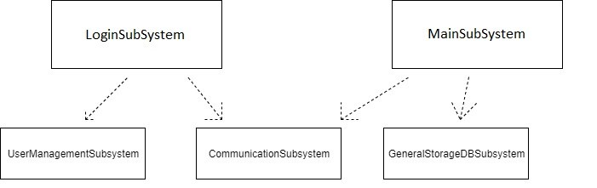

**UserManagementSubsystem:** The UserManagementSubsytsem is responsible for stroring user informations and manage the actions user does meanwhile using the applicaiton.

**LoginSubSystem :** The LoginSubSystem is responsible for all the login actions. Store all the informations that users provide.

## Access control and security

## Buffers do not support access control or security, as users are anonymous to buffers.

## Boundary conditions

The starting, stopping and installing of the media browser application defines the boundary conditions. Here we must take care of the different operating systems medias is build for.

# Subsystem Services

A subsystem is a single, predefined operating environment through which the system coordinates the work flow and resource use. The system can contain several subsystems, all operating independently of each other. Subsystems manage resources. Subsystems are essentially systems within systems. Because all systems are ordered hierarchically, it is inevitable that subsystems will develop within a larger system. An individual may be a part of multiple subsystems. Common subsystems include parents, siblings, and parent-child relationships. A system is a collection of organized things and combination of parts working together to accomplish a goal. Whereas a subsystem is derived from system and it is an integral part of a larger system.

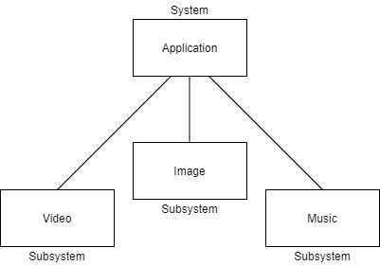

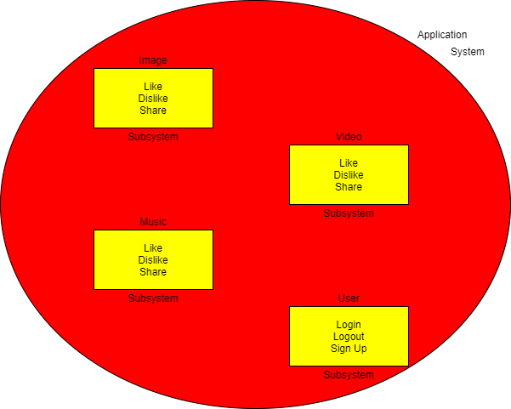

# Glossary

# References

**[1]** developer.android.com/guide/topics/media-apps/audio-app/building-a-mediabrowserservice

**[2]** developer.android.com/guide/topics/media-apps/audio-app/building-a-mediabrowser-client

**[3]** www.ibm.com/support/knowledgecenter/ssw_ibm_i_72/rzaks/rzaksaboutsbs.htm