Advanced Spatial Sound Sample

# *This sample is compatible with VS 2017 and the Windows 10 Creators Update Preview*

# Description

This sample demonstrates how use ISpatialAudioClient to playback both static and dynamic positional audio using Windows Sonic technologies in a Universal Windows Platform (UWP) app. The static bed plays on startup and dynamic sounds that follow random paths can be added and removed

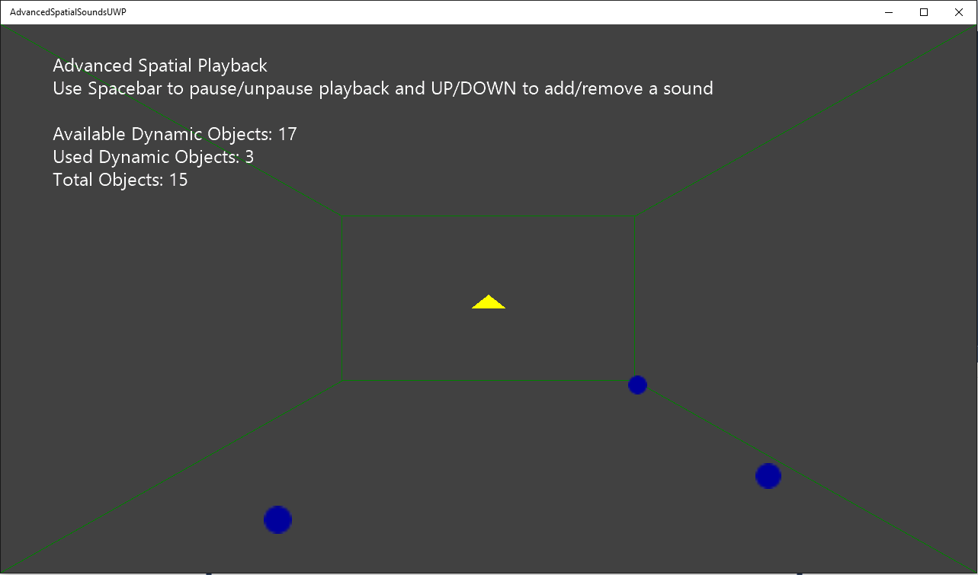

# Using the sample

|  |  |
| --- | --- |
| Action | Keyboard |
| Add a dynamic sound | Up |
| Remove a dynamic sound | Down |

# Implementation notes

This sample demonstrates how to use ISpatialAudioClient to play static and dynamic positional sound using spatial technologies. Once ISpatialAudioClient has been initialized and started, it uses the callback to request buffer frames.

# Update history

Initial release for VS2017 RC and the Windows 10 Creators Update Preview SDK (15021)