Simple Play 3D Spatial Sound Sample

*This sample is compatible with VS 2017 and the Windows 10 Creators Update Preview*

# Description

This sample demonstrates how use ISpatialAudioClient to playback positional audio using Windows Sonic technologies in a Universal Windows Platform (UWP) app. The listener is static (represented by the white triangle) and emitter (represented by the spinning black triangle) can be moved in 3D space, though the view is top down.

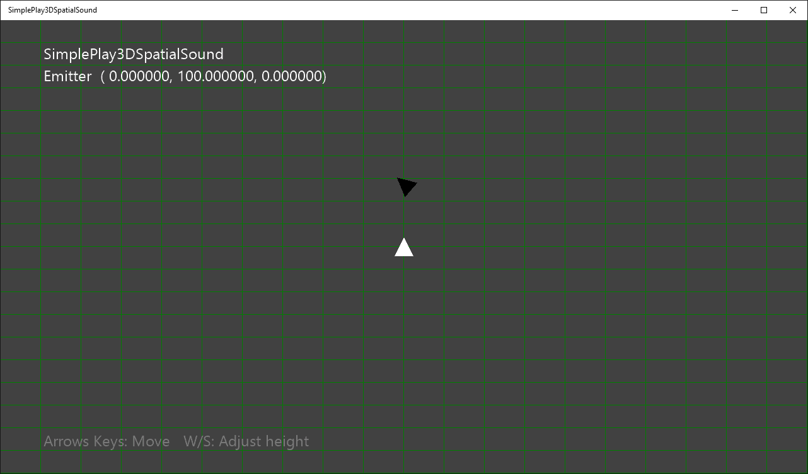

# Using the sample

|  |  |  |
| --- | --- | --- |
| Action | Gamepad | Keyboard |
| Move the emitter | Left thumbstick | Up/Down/Left/Right |
| Adjust emitter height | Left/Right shoulder buttons | W/S |
| Reset emitter location | Left/Right thumstick | Home |

# Implementation notes

This sample demonstrates how to use ISpatialAudioClient to play positional sound using spatial technologies. Once ISpatialAudioClient has been initialized and started, it uses the callback to request buffer frames. At that time, the sound is also positioned based on the location of the emitter triangle.

# Update history

Initial release for VS2017 RC and the Windows 10 Creators Update Preview SDK (105021)