**How to run the completed project**

**Prerequisites**

To run the completed project in this folder, you need the following:

* [Visual Studio](https://visualstudio.microsoft.com/vs/) installed on your development machine. If you do not have Visual Studio, visit the previous link for download options. (**Note:** This tutorial was written with Visual Studio 2019 version 16.5.0. The steps in this guide may work with other versions, but that has not been tested.)
* Either a personal Microsoft account with a mailbox on Outlook.com, or a Microsoft work or school account.

If you don't have a Microsoft account, there are a couple of options to get a free account:

* You can [sign up for a new personal Microsoft account](https://signup.live.com/signup?wa=wsignin1.0&rpsnv=12&ct=1454618383&rver=6.4.6456.0&wp=MBI_SSL_SHARED&wreply=https://mail.live.com/default.aspx&id=64855&cbcxt=mai&bk=1454618383&uiflavor=web&uaid=b213a65b4fdc484382b6622b3ecaa547&mkt=E-US&lc=1033&lic=1).
* You can [sign up for the Office 365 Developer Program](https://developer.microsoft.com/office/dev-program) to get a free Office 365 subscription.

**Register a native application with the Azure Active Directory admin center**

1. Open a browser and navigate to the [Azure Active Directory admin center](https://aad.portal.azure.com/) and login using a **personal account** (aka: Microsoft Account) or **Work or School Account**.
2. Select **Azure Active Directory** in the left-hand navigation, then select **App registrations** under **Manage**.

[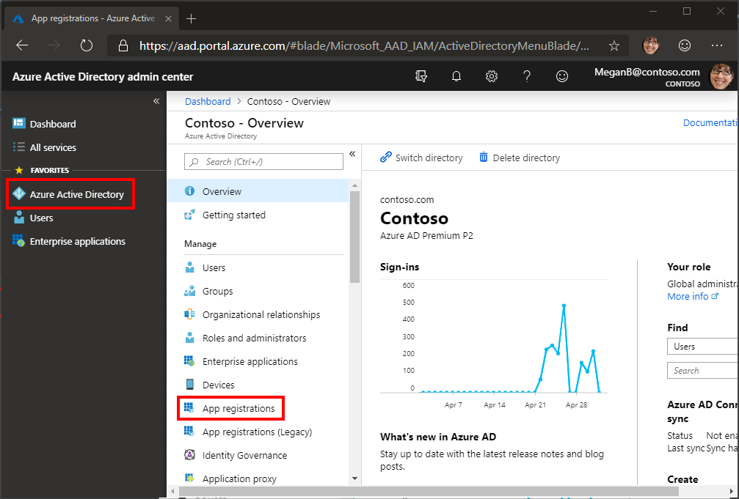](https://github.com/microsoftgraph/msgraph-training-uwp/blob/main/tutorial/images/aad-portal-app-registrations.png)

1. Select **New registration**. On the **Register an application** page, set the values as follows.
   * Set **Name** to UWP Graph Tutorial.
   * Set **Supported account types** to **Accounts in any organizational directory and personal Microsoft accounts**.
   * Under **Redirect URI**, change the dropdown to **Public client (mobile & desktop)**, and set the value to https://login.microsoftonline.com/common/oauth2/nativeclient.

[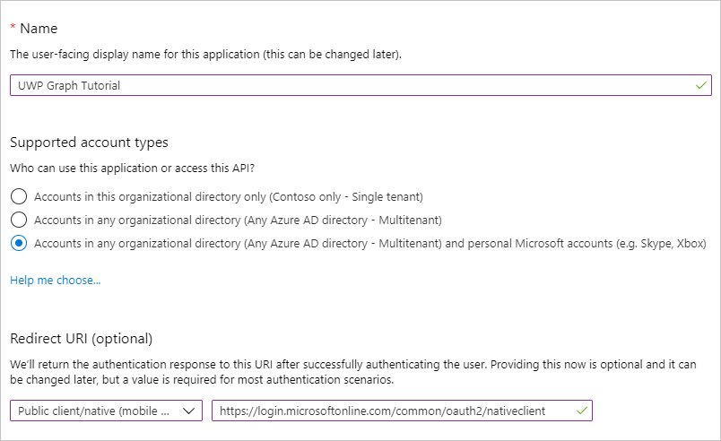](https://github.com/microsoftgraph/msgraph-training-uwp/blob/main/tutorial/images/aad-register-app.png)

1. Choose **Register**. On the **UWP Graph Tutorial** page, copy the value of the **Application (client) ID** and save it, you will need it in the next step.

[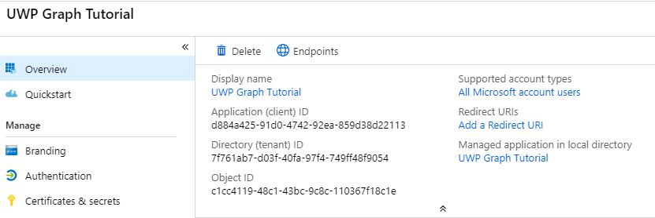](https://github.com/microsoftgraph/msgraph-training-uwp/blob/main/tutorial/images/aad-application-id.png)

**Configure the sample**

1. Rename the OAuth.resw.example file to OAuth.resw.
2. Open graph-tutorial.sln in Visual Studio.
3. Edit the OAuth.resw file in visual studio.Replace YOUR_APP_ID_HERE with the **Application Id** you got from the App Registration Portal.
4. In Solution Explorer, right-click the **graph-tutorial** solution and choose **Restore NuGet Packages**.

**Run the sample**

In Visual Studio, press **F5** or choose **Debug > Start Debugging**.