Restoration Workshop: step guide
One section per object. Each step has a picture of the object, the tool and one line on what the tool does. Use the Navigation pane (View > Navigation Pane) to jump between objects.

Rusty Padlock

Step 1: Chip Off the Rust Scale
Chip the rust lumps off the lock.
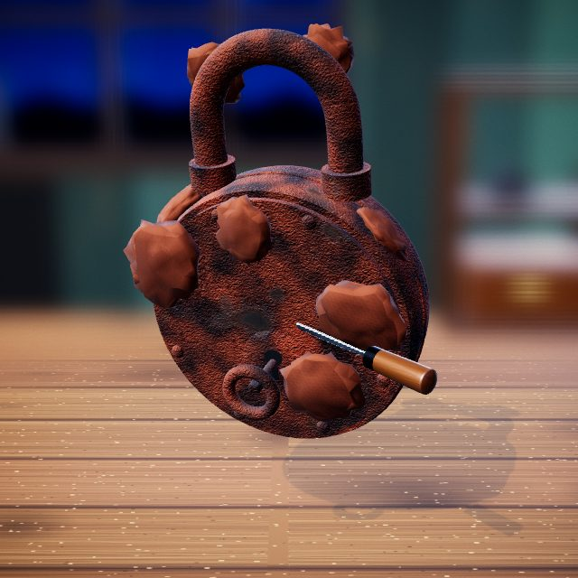 | 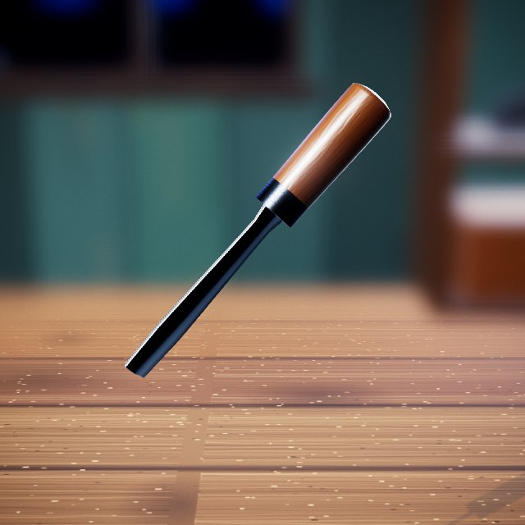  Chisel: knocks off crusty rust and splits seams.

Step 2: Electrolysis Bath
Electrolysis bath lifts the remaining rust.
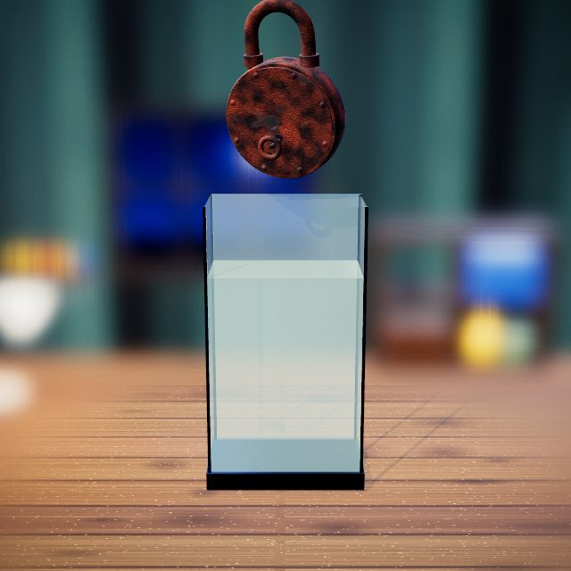 | Cleaning tank: the bath the object is lowered into.

Step 3: Free the Stuck Key
Heat the keyhole, then twist out the stuck key.
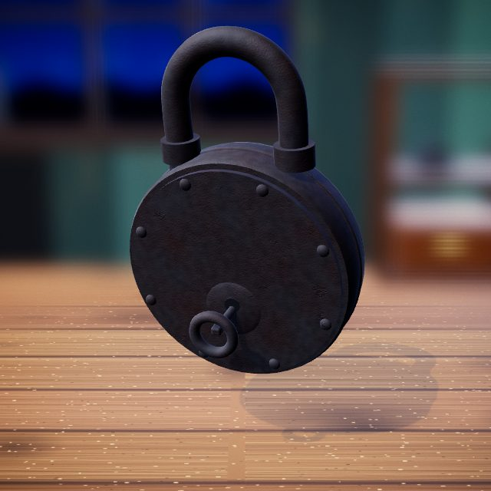 | 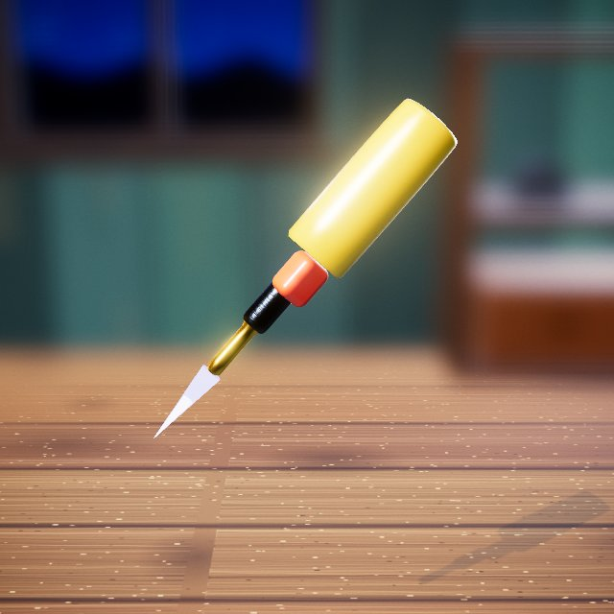  Butane torch: heats metal until it glows so it can be freed, bent or brazed.

Step 4: Split the Body Open
Split the lock body open along the seam.
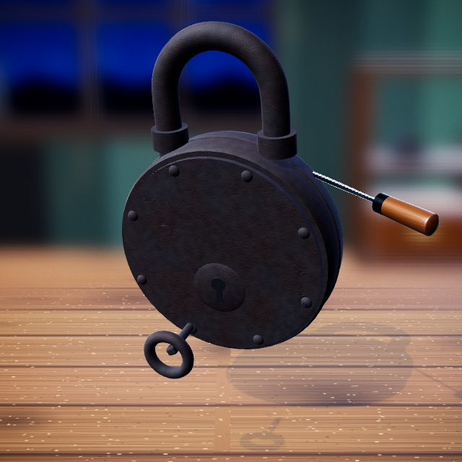 | Chisel: knocks off crusty rust and splits seams.

Step 5: Wire-Wheel to Bright Steel
Wire-wheel every part to bright steel.
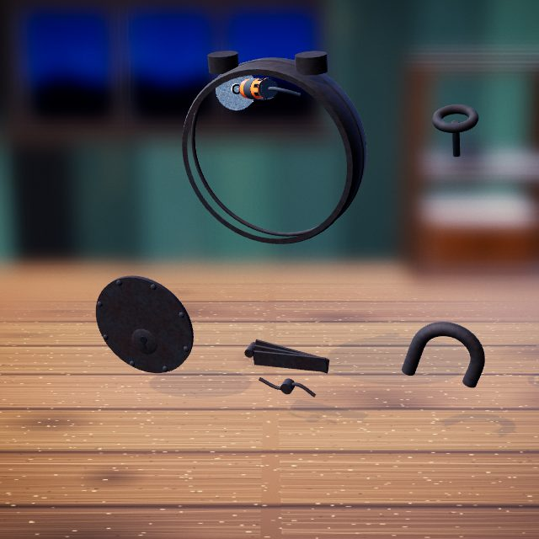 | 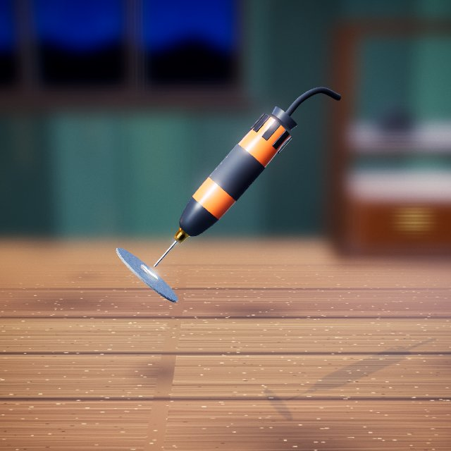  Rotary grinder: wire wheel, burr or sanding disc that takes metal back to bright steel.

Step 6: Cold-Blue the Iron
Brush on cold bluing for a blue-black finish.
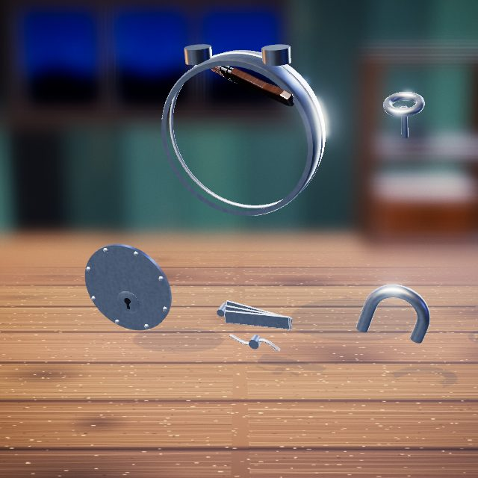 | 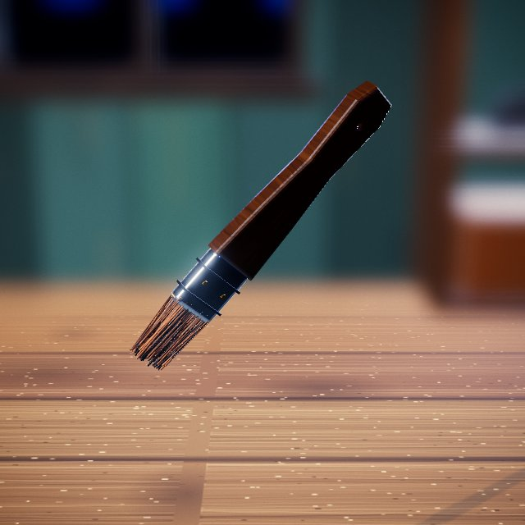  Stain brush: brushes on liquids such as bluing, oil, stain or stripper.

Step 7: Refit the Lock Parts
Put the levers, shackle and plate back.
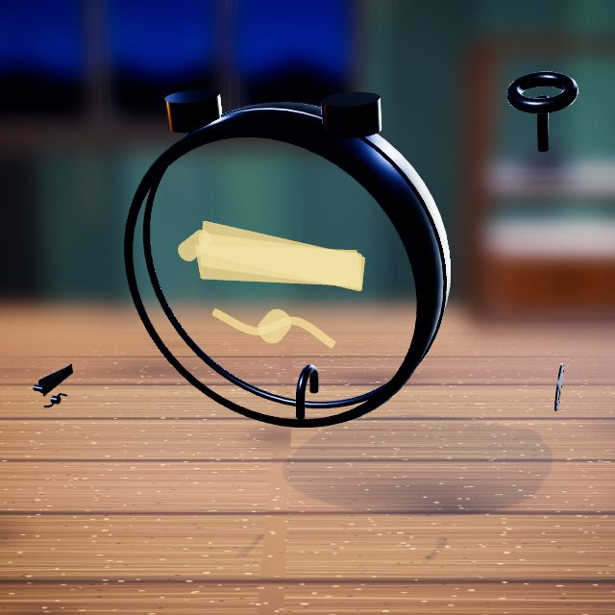 | Hands: drag, lift and fit parts by hand.

Step 8: Peen the Rivets
Tap each rivet to peen it shut.
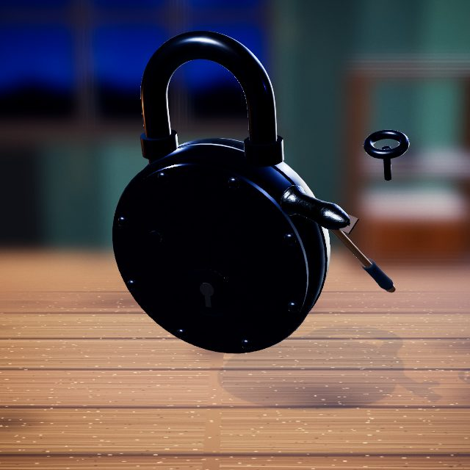 | 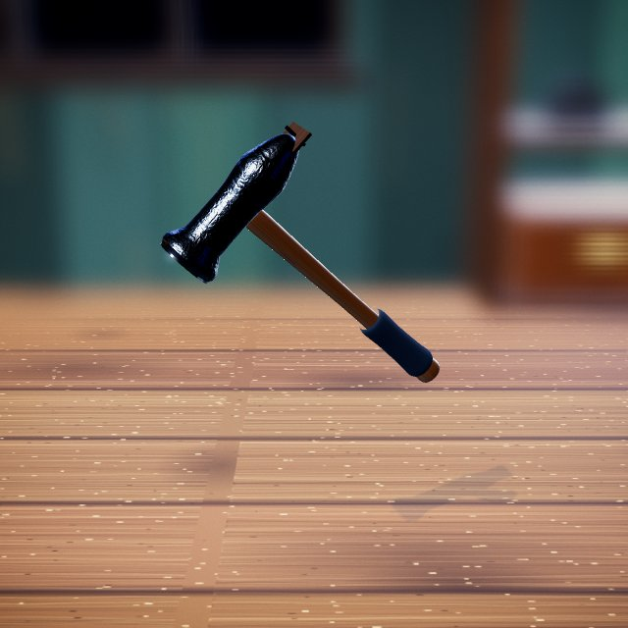  Hammer: drives out and peens rivets.

Step 9: Key Test
Turn the key; the shackle springs open.
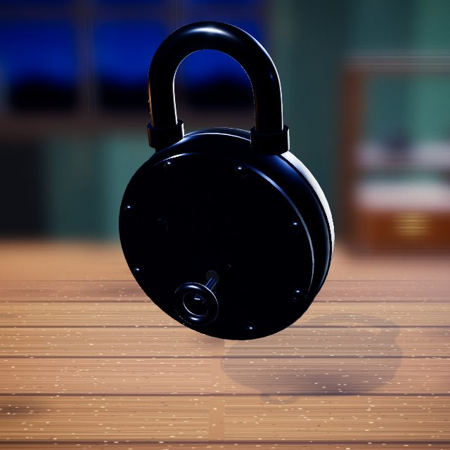 | Hands: drag, lift and fit parts by hand.

Step 10: Before and After
Before and after.
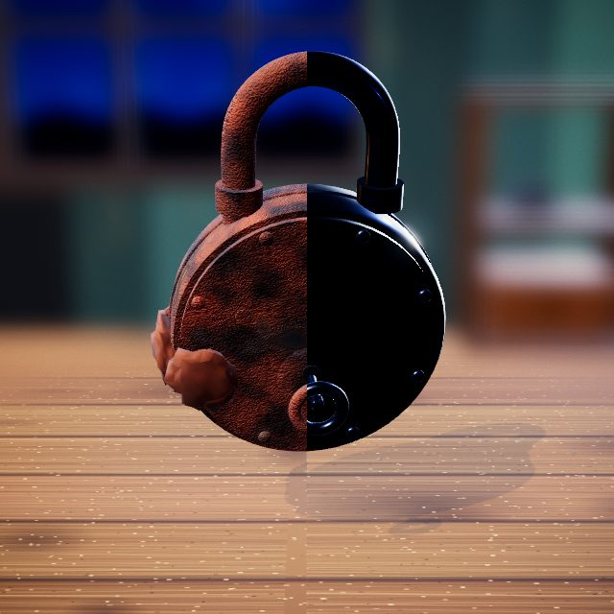 | Slider: drag it to compare before and after.

Pocket Knife

Step 1: Knock Off the Rust Crust
Knock the rust crust off the knife.
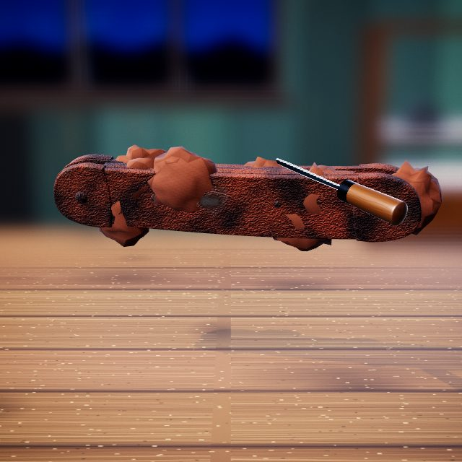 | Chisel: knocks off crusty rust and splits seams.

Step 2: Open the Seam
Cut open the seam between blade and handle.
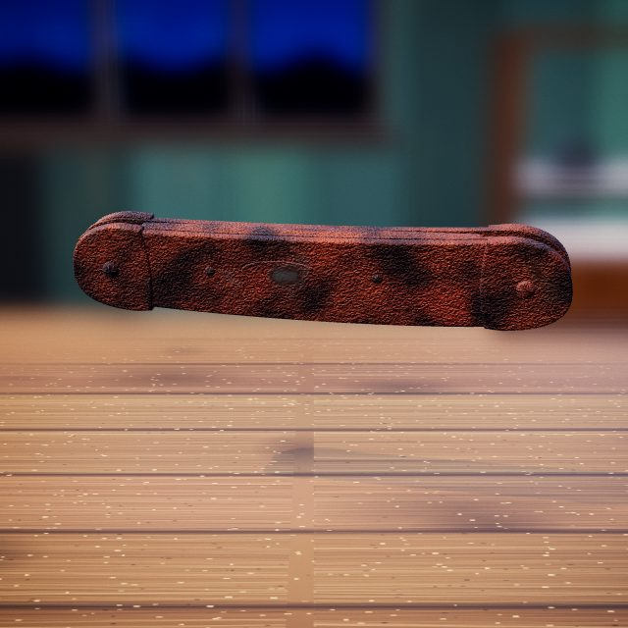 | Carbide Burr (rotary grinder): wire wheel, burr or sanding disc that takes metal back to bright steel.

Step 3: Electrolysis
Electrolysis jar loosens the rust.
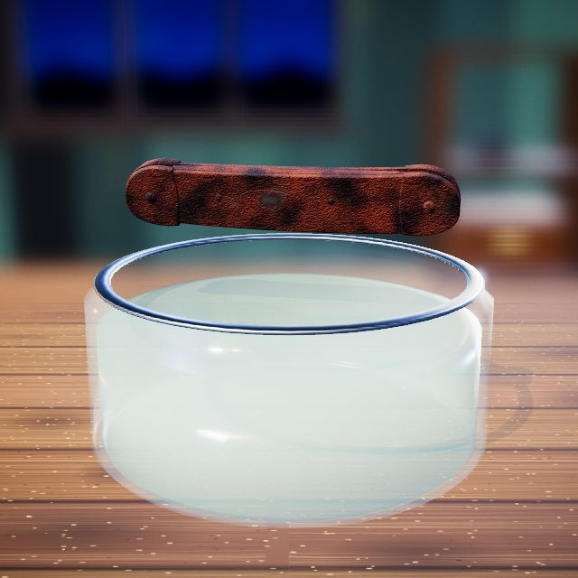 | Cleaning jar: the bath the parts are lowered into.

Step 4: Scrape the Black Scale
Scrape off the loosened black scale.
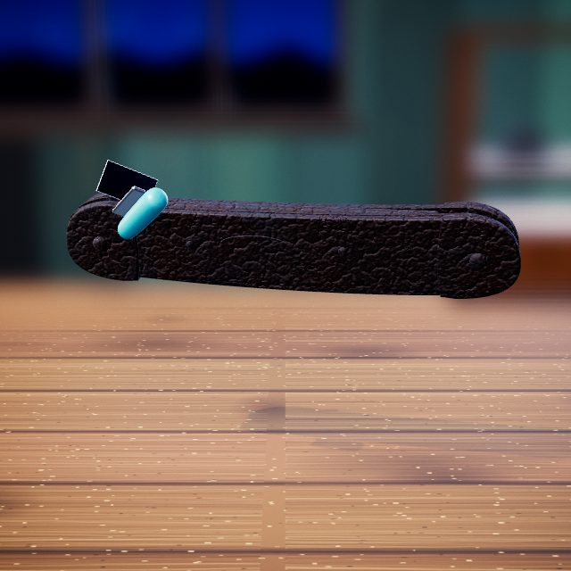 | 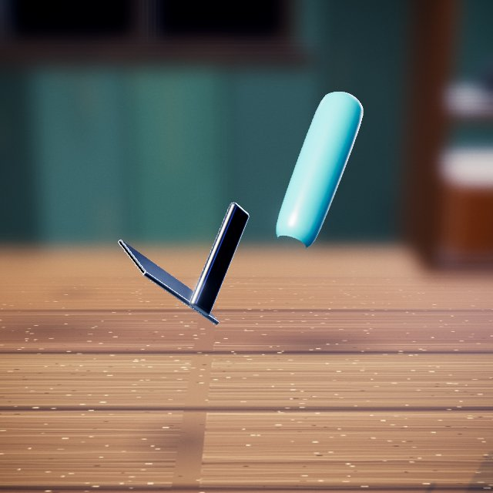  Paint scraper: lifts loose scale and old paint in strips.

Step 5: Wire-Wheel Reveal
Wire-wheel the knife to bright steel.
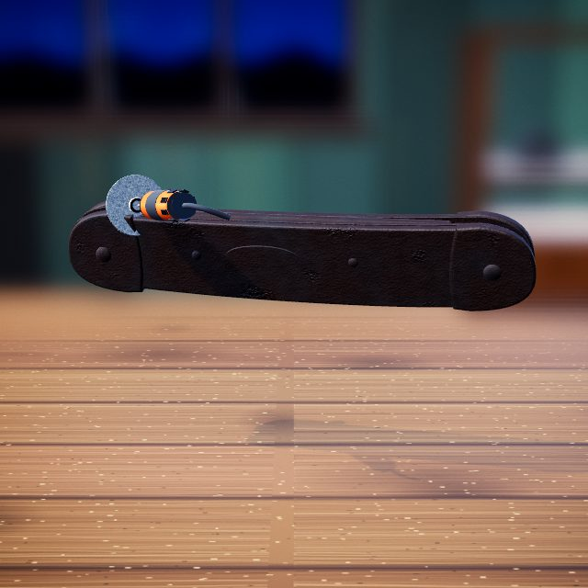 | Rotary grinder: wire wheel, burr or sanding disc that takes metal back to bright steel.

Step 6: Punch Out the Pins
Punch out the pins so the knife comes apart.
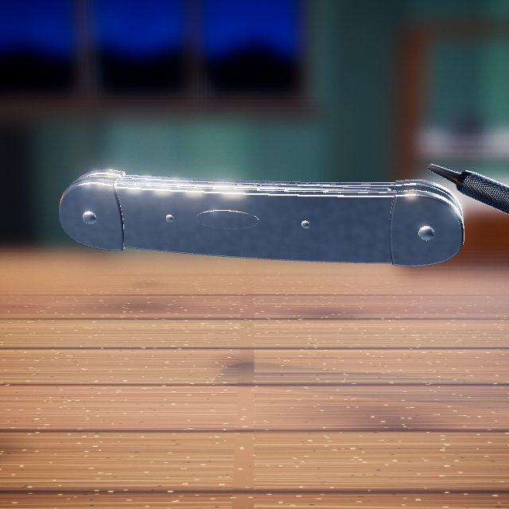 | 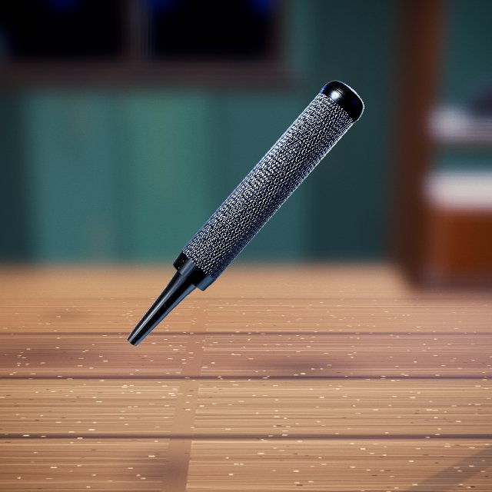  Pin punch: drives pins out with hammer taps.

Step 7: Sharpen the Blade
Long, slow strokes hone the edge.
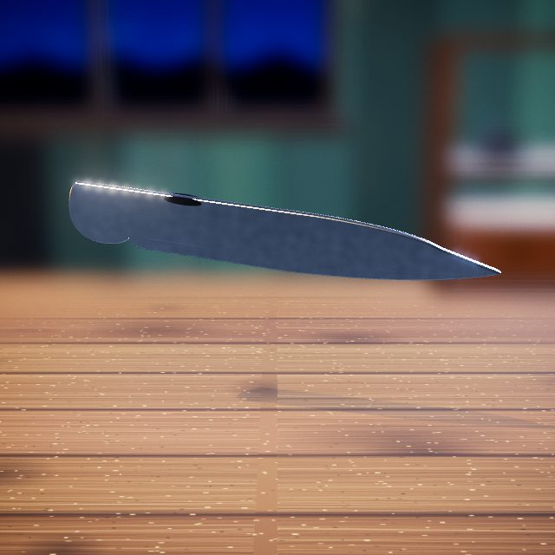 | 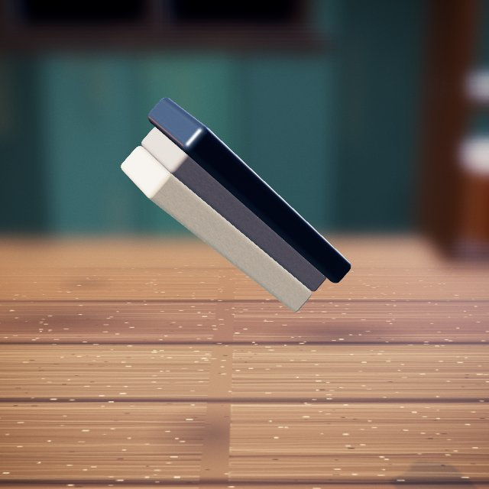  Whetstone: sharpens a blade edge.

Step 8: Forge a New Bail Ring
Heat the wire red-hot and bend a new bail ring.
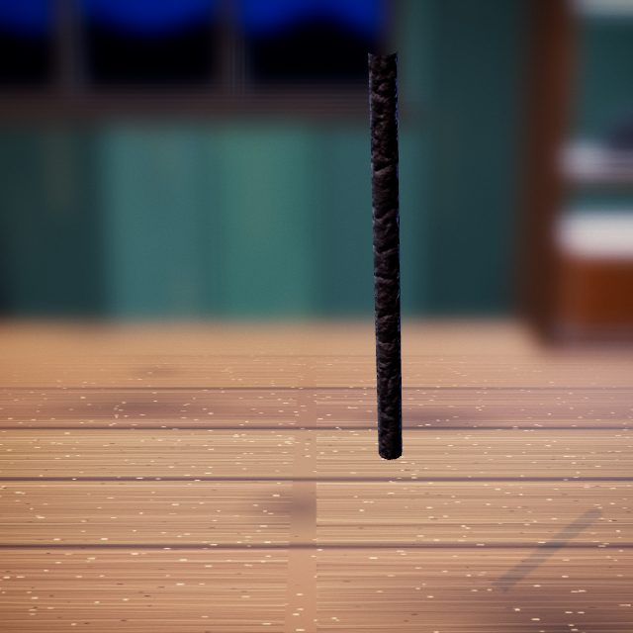 | Butane torch: heats metal until it glows so it can be freed, bent or brazed.

Step 9: Oil Finish & Rivet Together
Brush on oil; the knife is riveted back together.
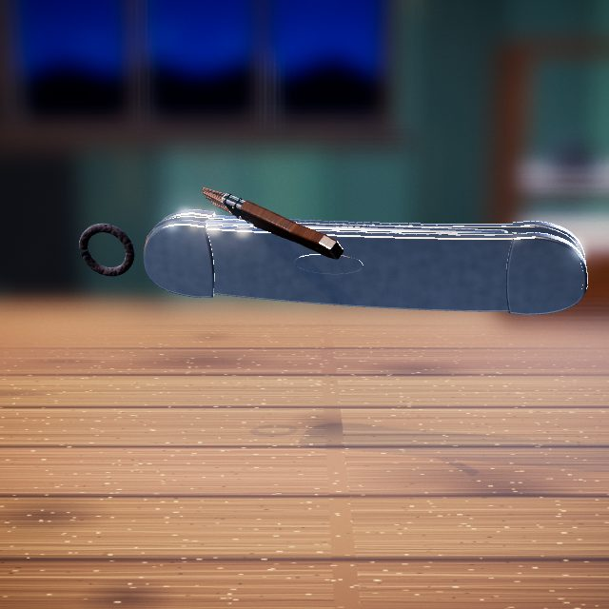 | Stain brush: brushes on liquids such as bluing, oil, stain or stripper.

Step 10: Flick It Open
Flick the blade open and shut.
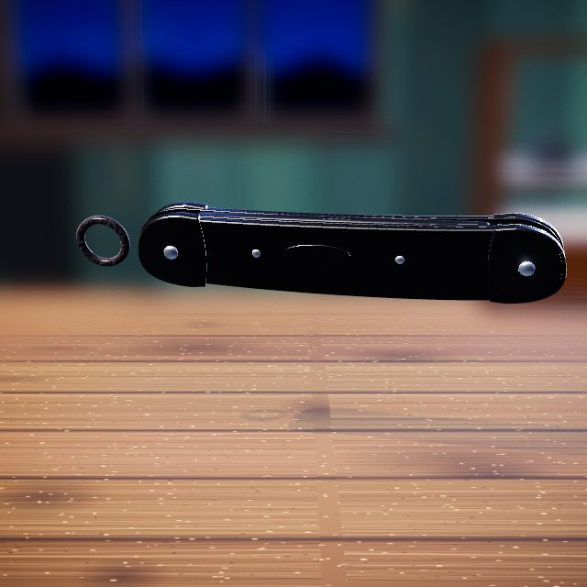 | Hands: drag, lift and fit parts by hand.

Step 11: Before and After
Before and after.
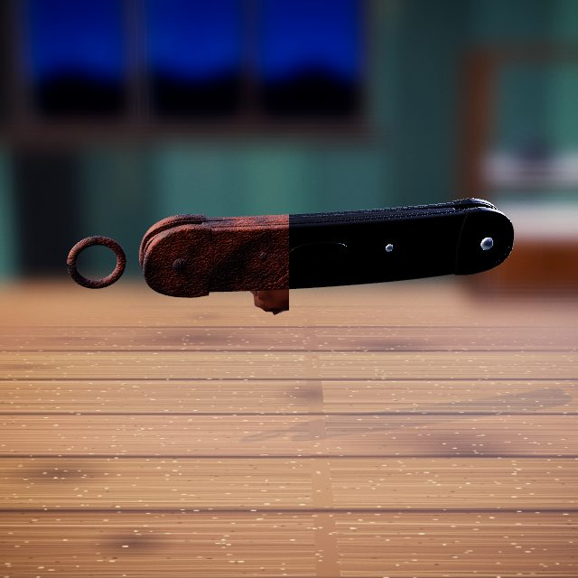 | Slider: drag it to compare before and after.

Rusty Longsword

Step 1: Knock Out the Rivets
Knock out the handle rivets.
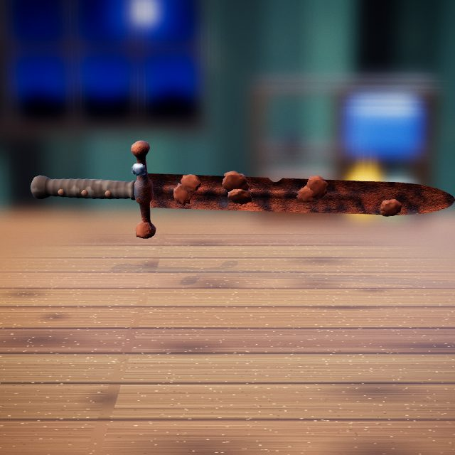 | Hammer: drives out and peens rivets.

Step 2: Pull Off the Handle
Slide the handle off the tang.
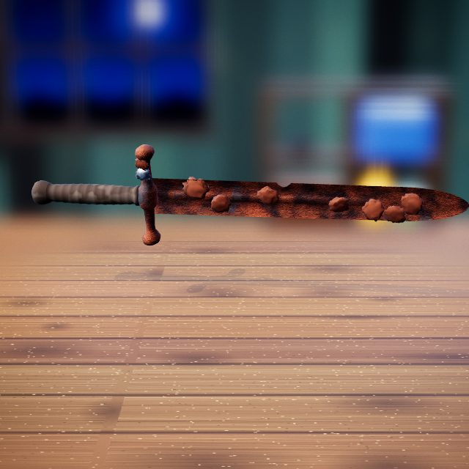 | Hands: drag, lift and fit parts by hand.

Step 3: Pick Off the Deep Rust
Pick off the deep rust.
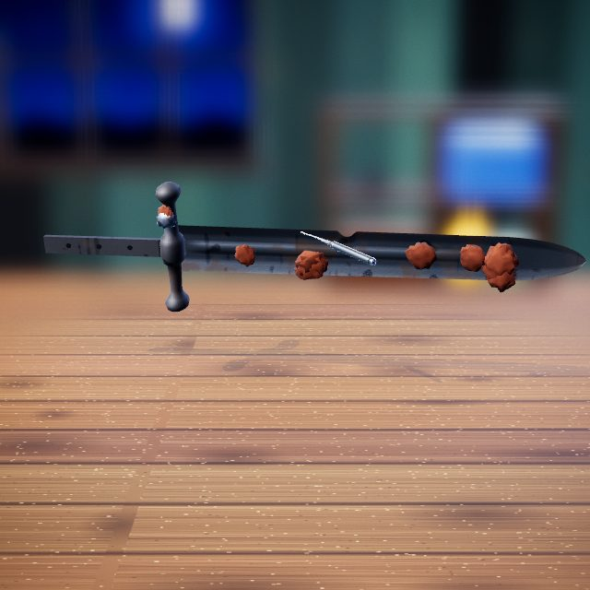 | 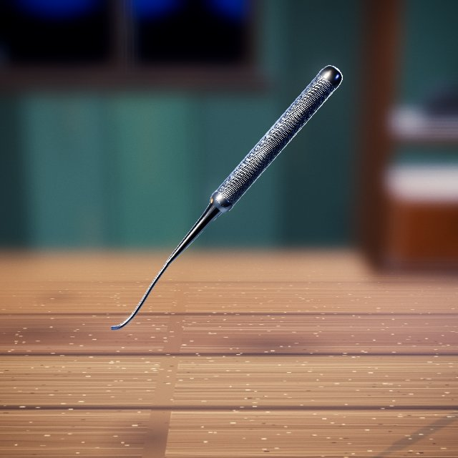  Metal pick: picks heavy rust crust off detailed areas.

Step 4: Wash Off the Residue
Wash off the black residue.
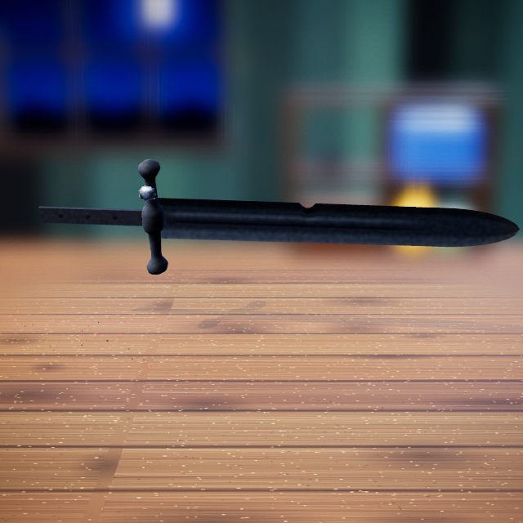 | 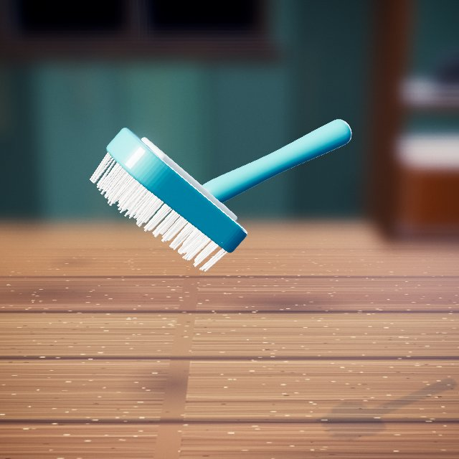  Soap brush: scrubs off grime and residue with soapy water.

Step 5: Grind Out the Flaws
Grind out pits and flaws.
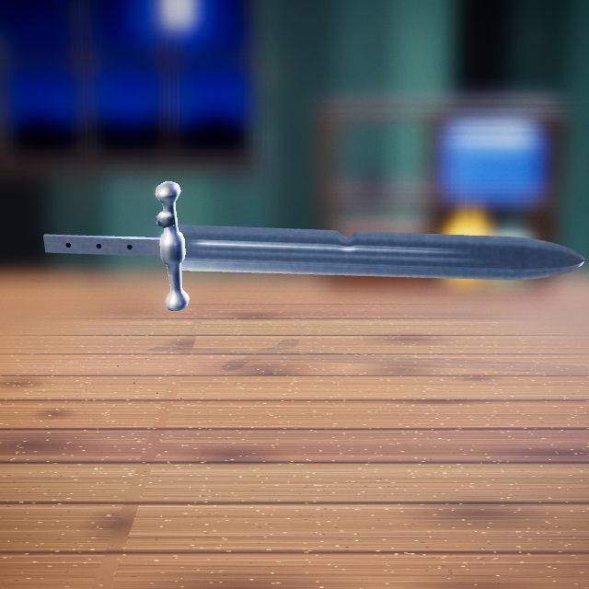 | Rotary grinder: wire wheel, burr or sanding disc that takes metal back to bright steel.

Step 6: File the Edges
File both edges straight.
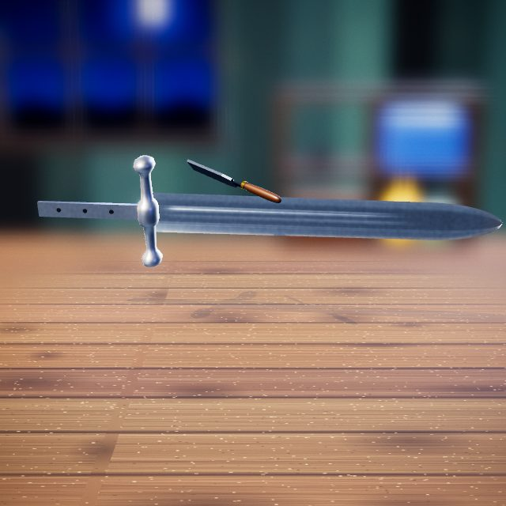 | 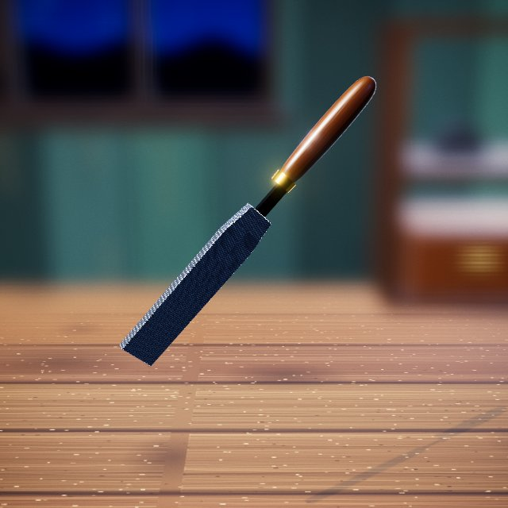  Metal file: straightens and evens edges.

Step 7: Polish the Blade
Polish the blade to a mirror.
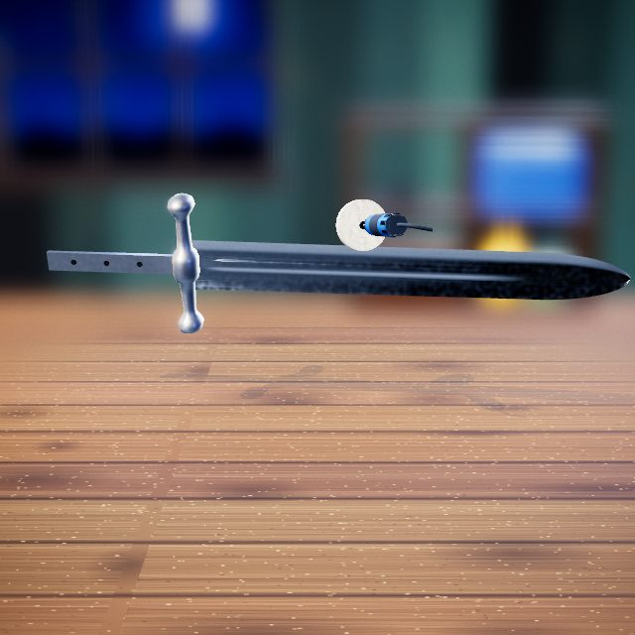 | 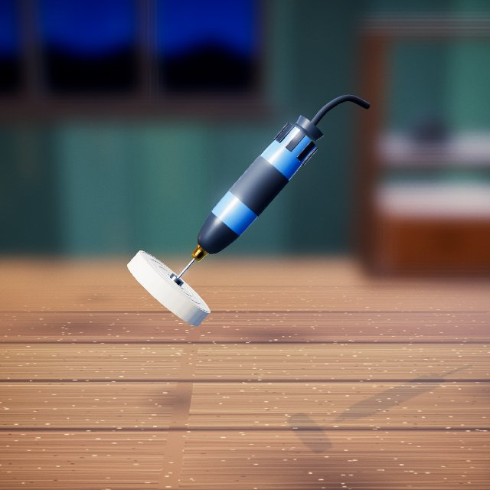  Buffing wheel: polishes metal, brass or plastic to a mirror shine.

Step 8: Restore the Handle
Stain the wooden grip.
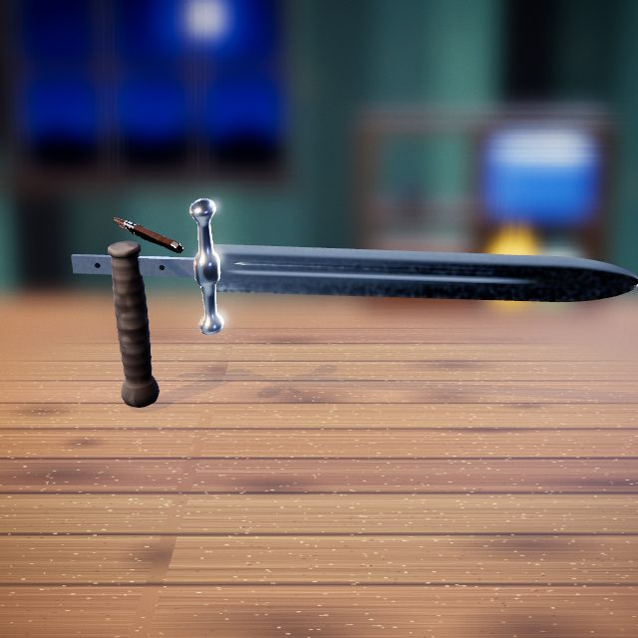 | Stain brush: brushes on liquids such as bluing, oil, stain or stripper.

Step 9: Reattach the Handle
Slide the grip back onto the tang.
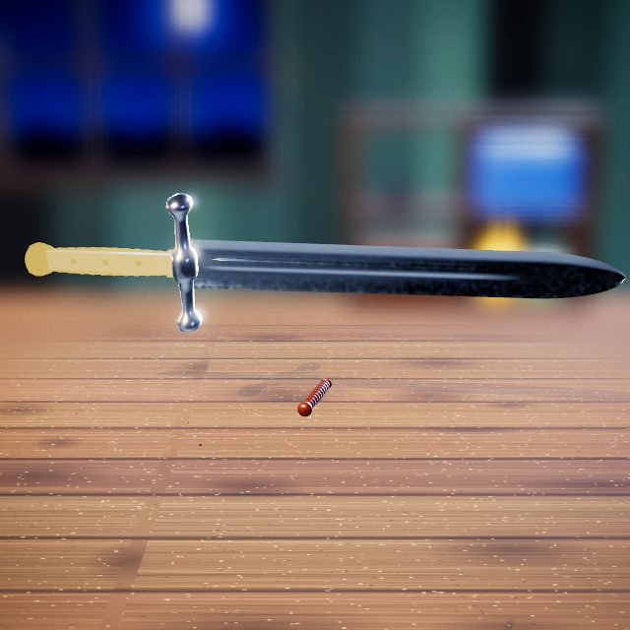 | Hands: drag, lift and fit parts by hand.

Step 10: Hammer the Rivets Home
Tap each brass rivet to hammer it flush.
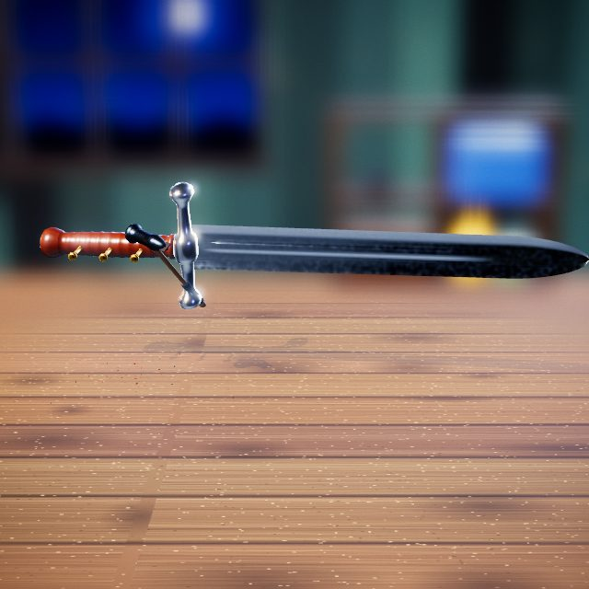 | Hammer: drives out and peens rivets.

Step 11: Before and After
Before and after.
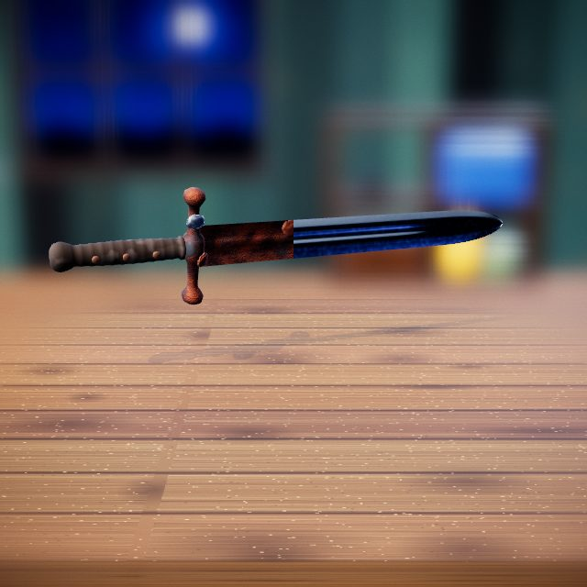 | Slider: drag it to compare before and after.

Vintage Lighter

Step 1: Remove the Outer Shell
Slide the case off the insert.
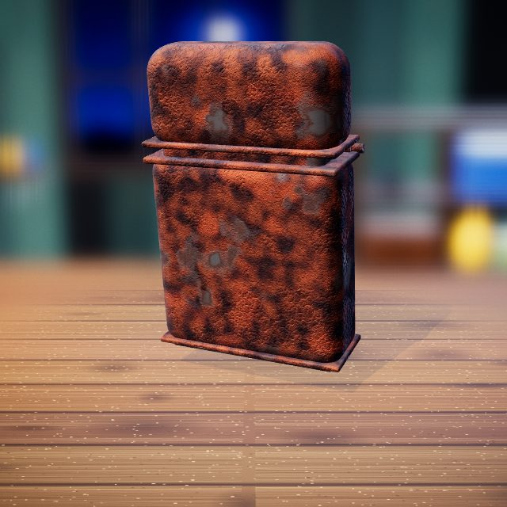 | Hands: drag, lift and fit parts by hand.

Step 2: Remove the Old Cotton
Pull out the old cotton.
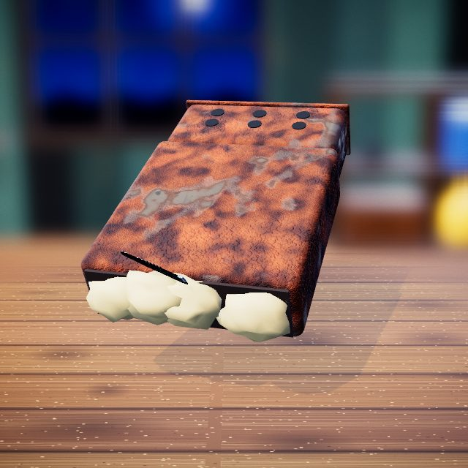 | 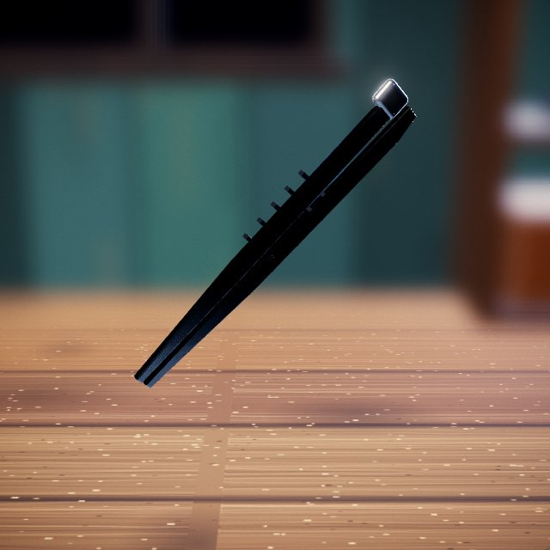  Tweezers: lifts out and places small parts.

Step 3: Remove the Hinge Pin
Punch out the hinge pin.
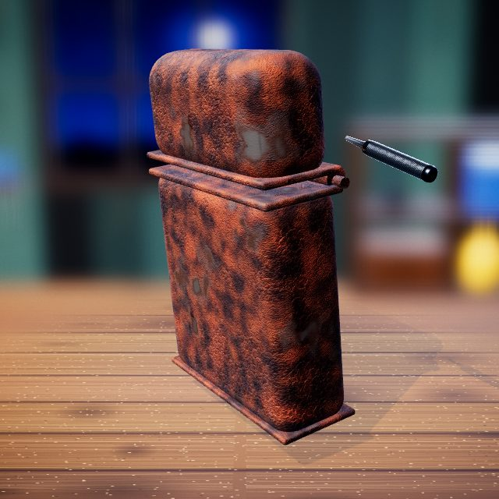 | Pin punch: drives pins out with hammer taps.

Step 4: Remove the Flint Wheel
Lift out the flint wheel.
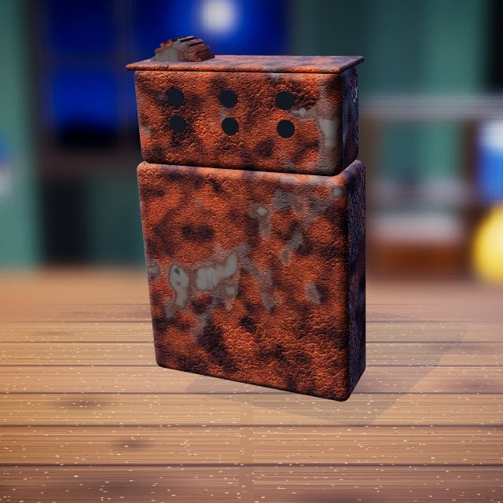 | 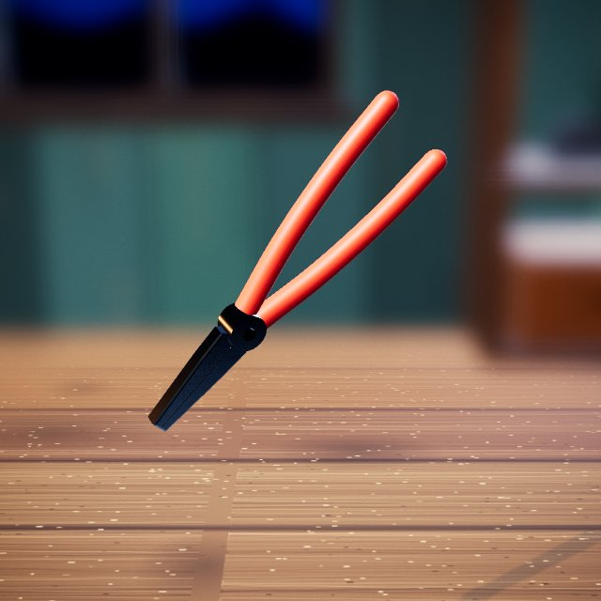  Pliers: grips and pulls small parts out.

Step 5: Sand the Damaged Spots
Sand the damaged spots.
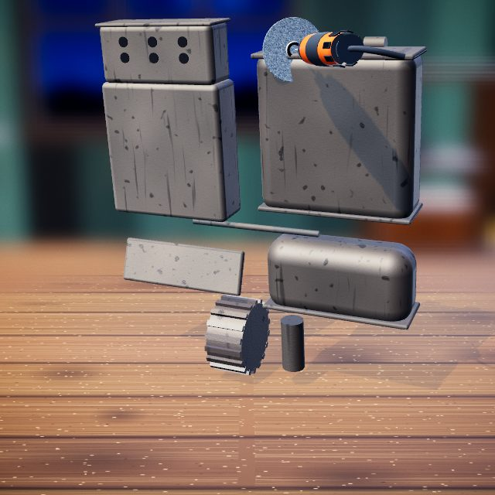 | Rotary grinder: wire wheel, burr or sanding disc that takes metal back to bright steel.

Step 6: Polish the Main Body
Polish the body until it gleams.
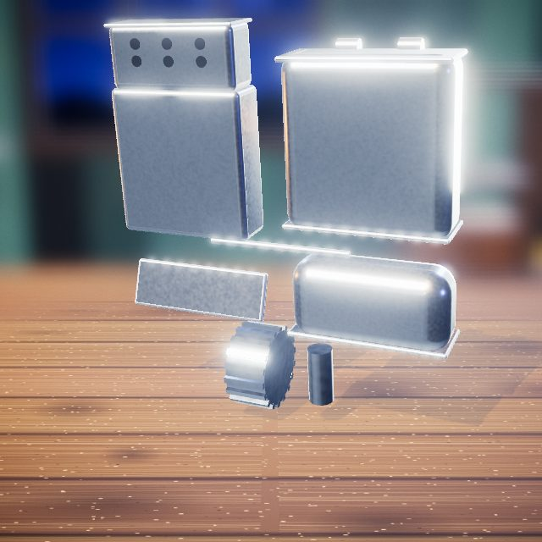 | Buffing wheel: polishes metal, brass or plastic to a mirror shine.

Step 7: Reassemble the Mechanism
Refit the flint wheel and shaft.
 | Hands: drag, lift and fit parts by hand.

Step 8: Install Fresh Cotton
Pack in fresh cotton.
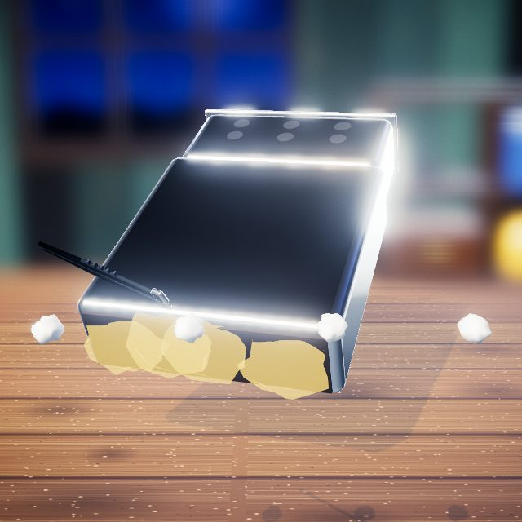 | Tweezers: lifts out and places small parts.

Step 9: Spray the GenZ Finish
Spray the new colour finish.
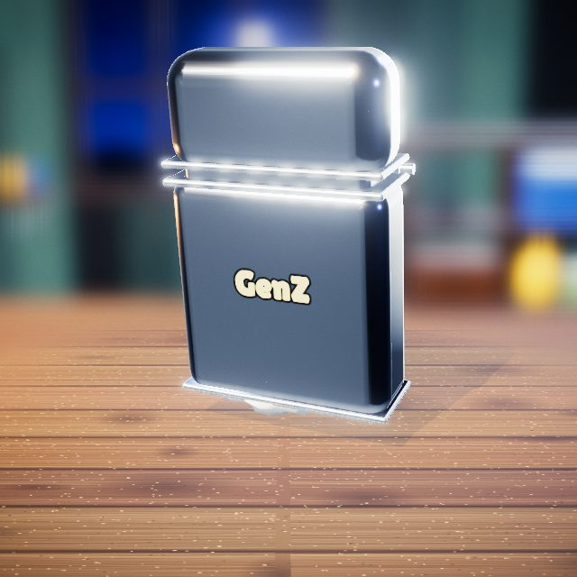 | 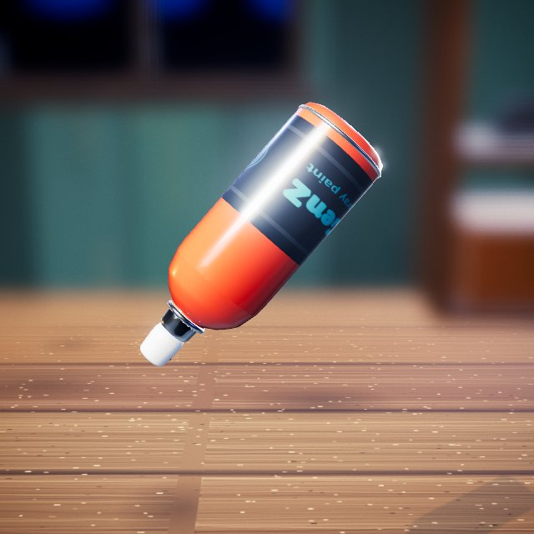  Spray paint: sprays an even colour coat.

Step 10: Lid Motion Check
Flip the lid open and shut.
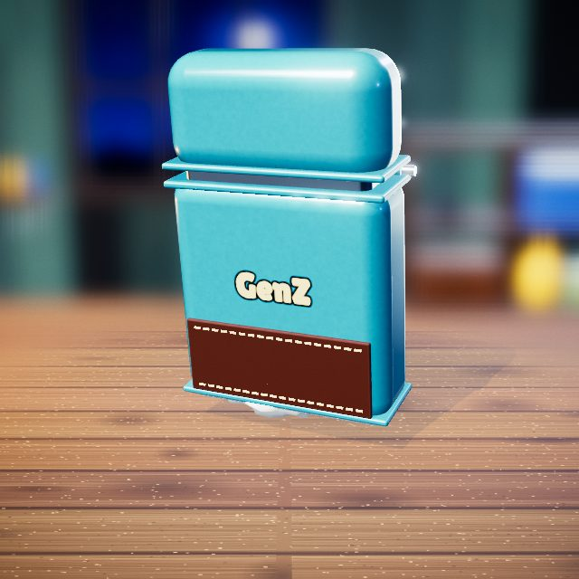 | Hands: drag, lift and fit parts by hand.

Step 11: Before and After
Before and after.
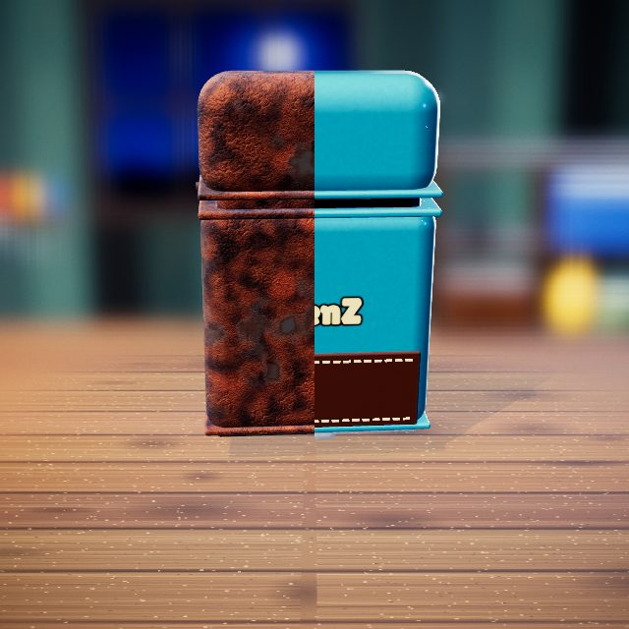 | Slider: drag it to compare before and after.

Wristwatch

Step 1: Remove the Damaged Crystal
Lift off the scratched crystal.
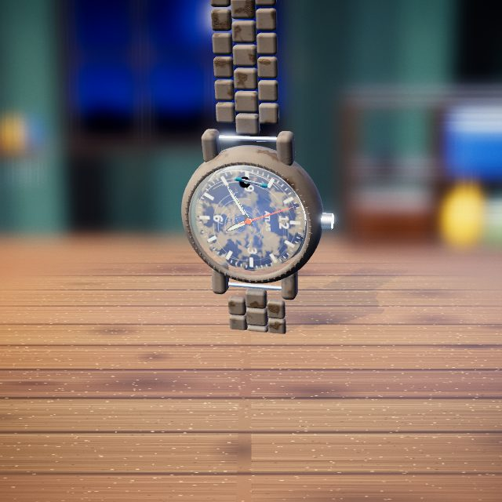 | 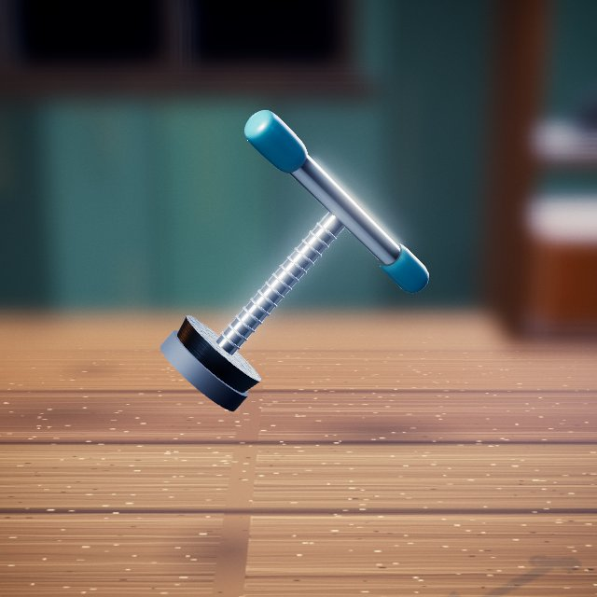  Press tool: presses parts in or out and straightens bends.

Step 2: Open the Back Cover
Unscrew the case back with the case wrench.
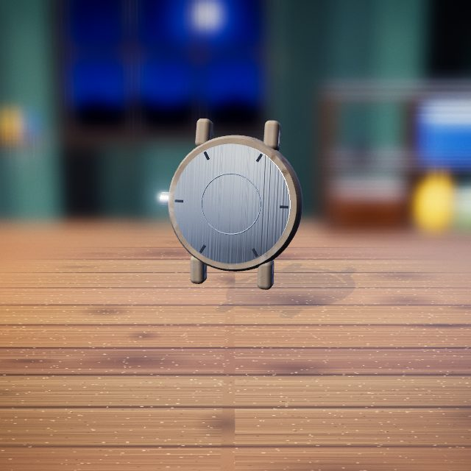 | Case wrench: unscrews the watch back.

Step 3: Remove the Movement
Lift out the movement.
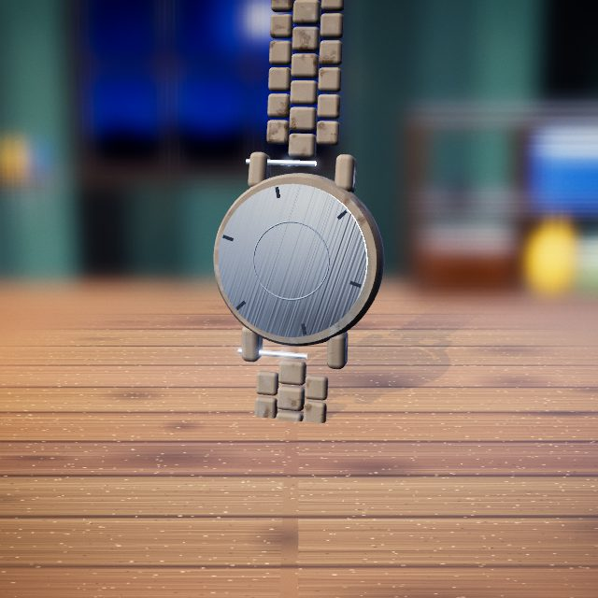 | Hands: drag, lift and fit parts by hand.

Step 4: Remove the Hands
Take the hands off the centre post.
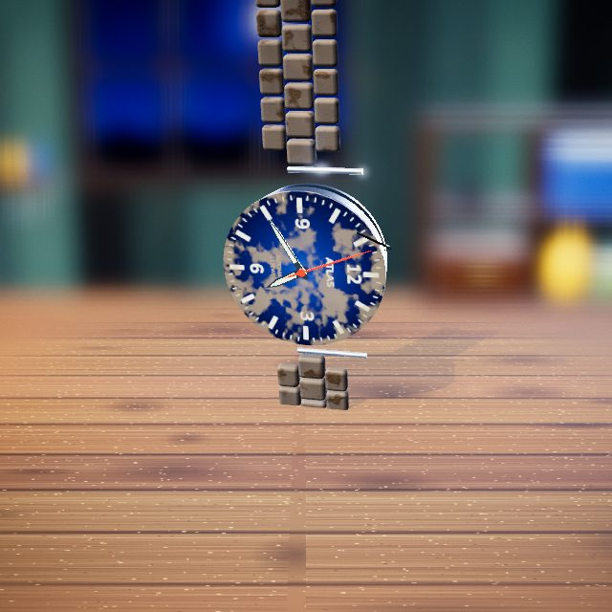 | Tweezers: lifts out and places small parts.

Step 5: Clean the Dial
Brush the dust off the dial.
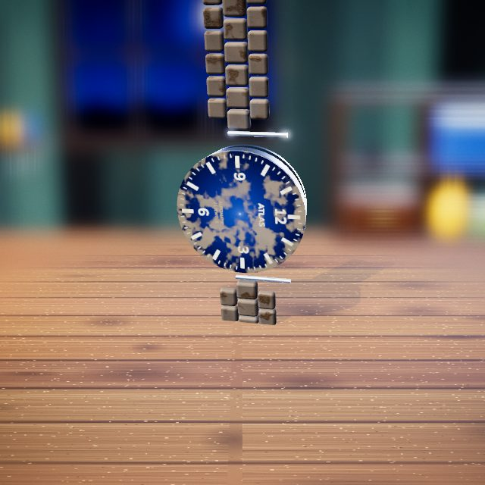 | 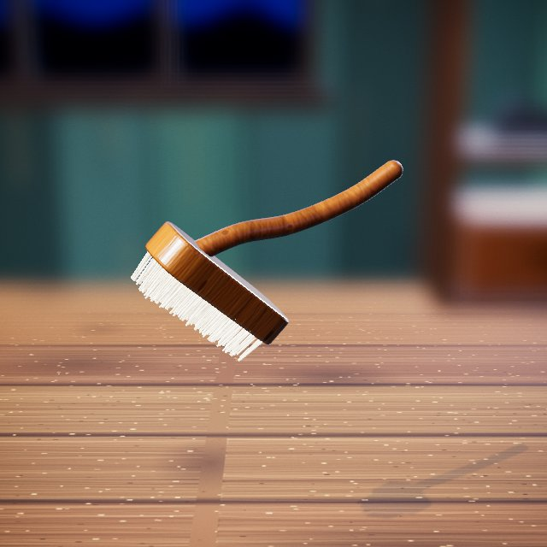  Soft brush: sweeps away dust and crumbs without scratching.

Step 6: Restore the Bracelet
Scrub the bracelet links clean.
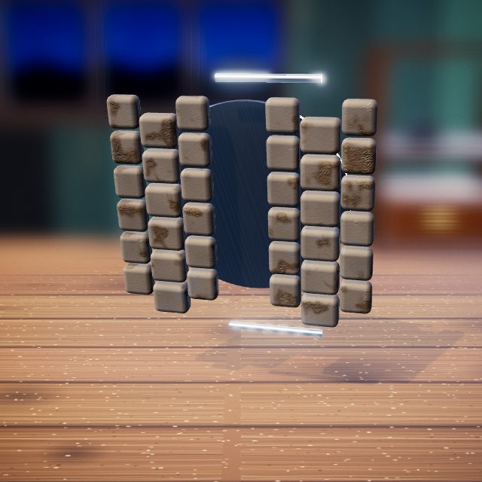 | Soap brush: scrubs off grime and residue with soapy water.

Step 7: Polish the Case
Polish the case.
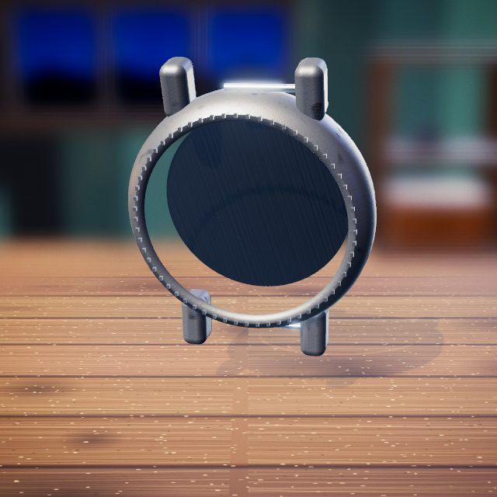 | 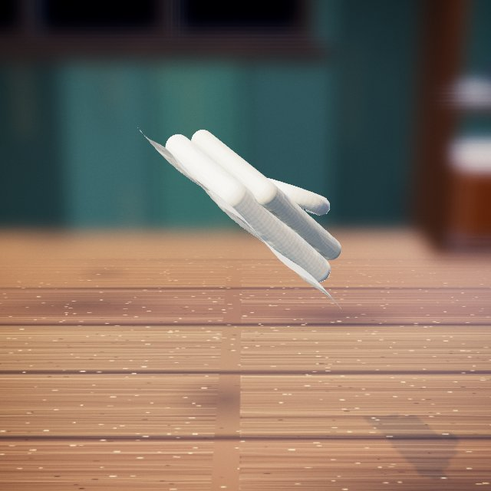  Polishing cloth: rubs metal to a soft shine.

Step 8: Install the Hands
Fit the hands back on.
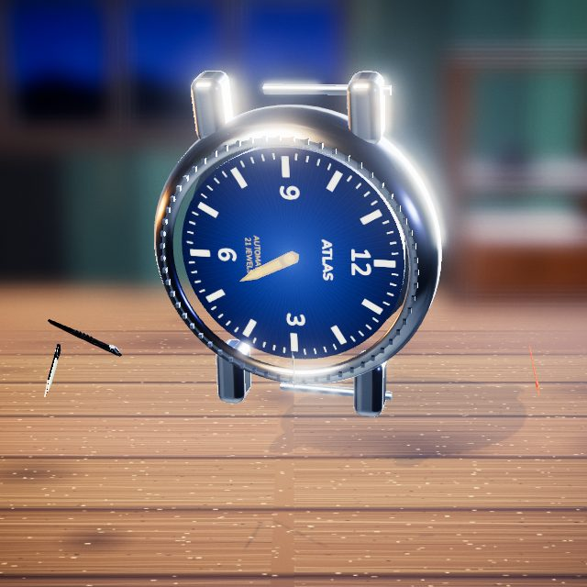 | Tweezers: lifts out and places small parts.

Step 9: Install the New Crystal
Press in a new crystal.
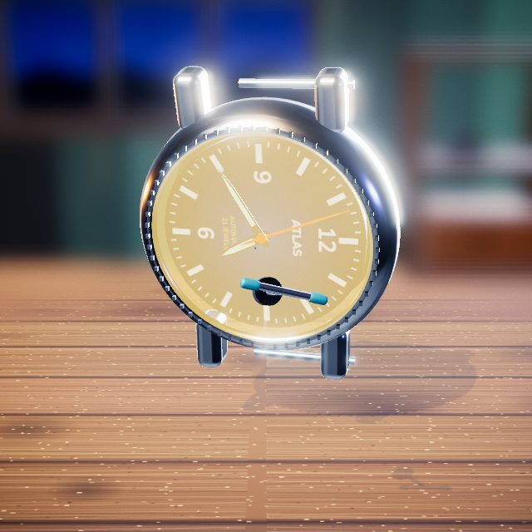 | Press tool: presses parts in or out and straightens bends.

Step 10: Final Time Check
Wind the crown; the hands move.
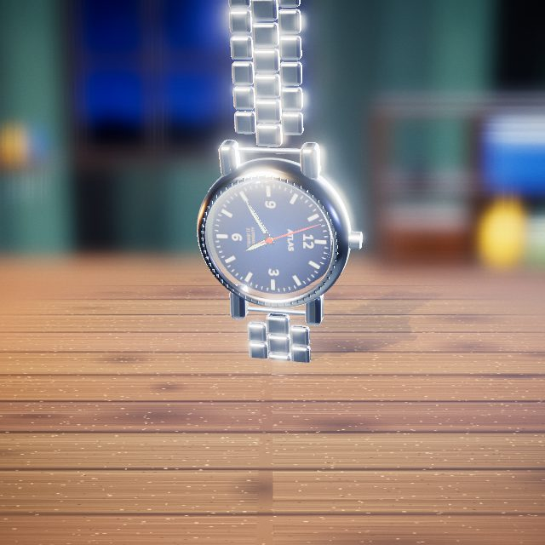 | Crown: the watch's winding knob.

Step 11: Before and After
Before and after.
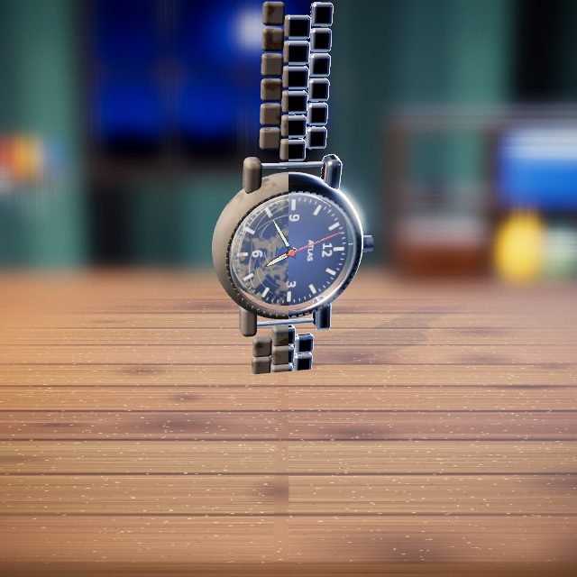 | Slider: drag it to compare before and after.

Old PC Keyboard

Step 1: Pop Off the Keycaps
Pop off the keycaps.
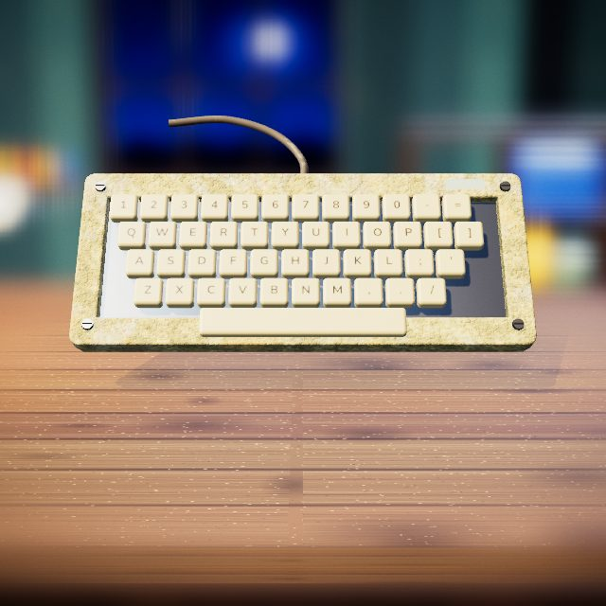 | 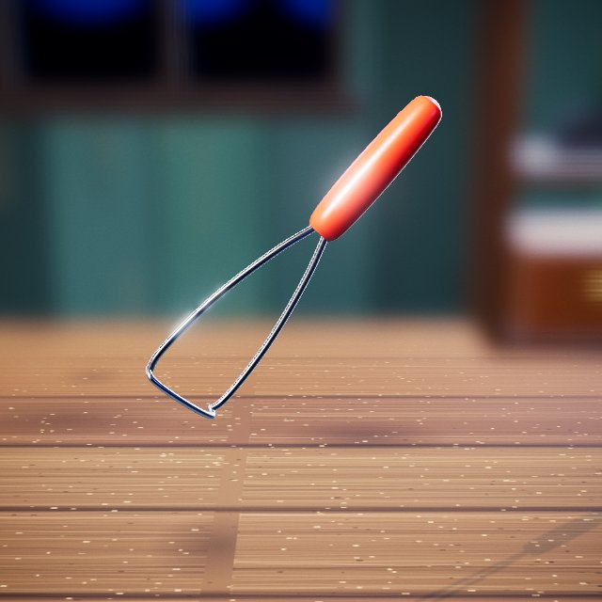  Keycap puller: pops keycaps off the keyboard.

Step 2: Brush Out the Hair & Crumbs
Brush out the hair and crumbs.
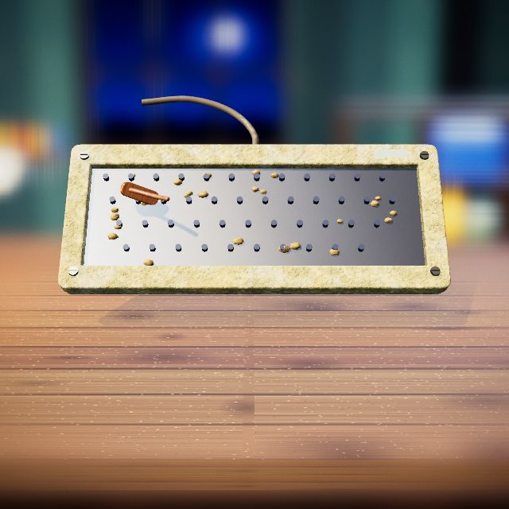 | Soft brush: sweeps away dust and crumbs without scratching.

Step 3: Singe the Last Hairs
Singe away the last stuck hairs.
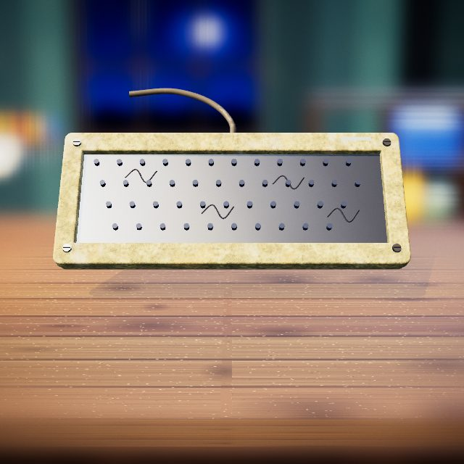 | 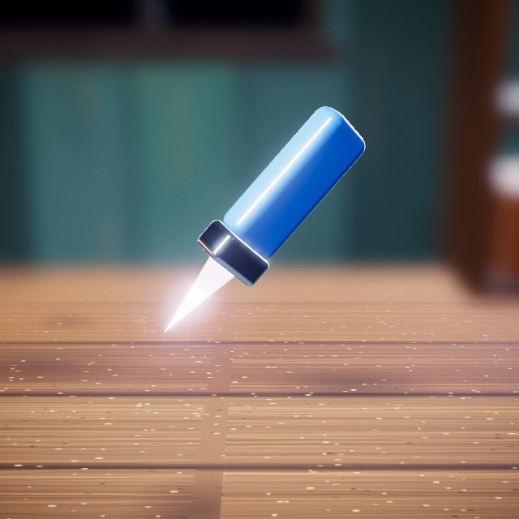  Lighter: a small flame that singes away hairs.

Step 4: Unscrew the Case
Unscrew the case.
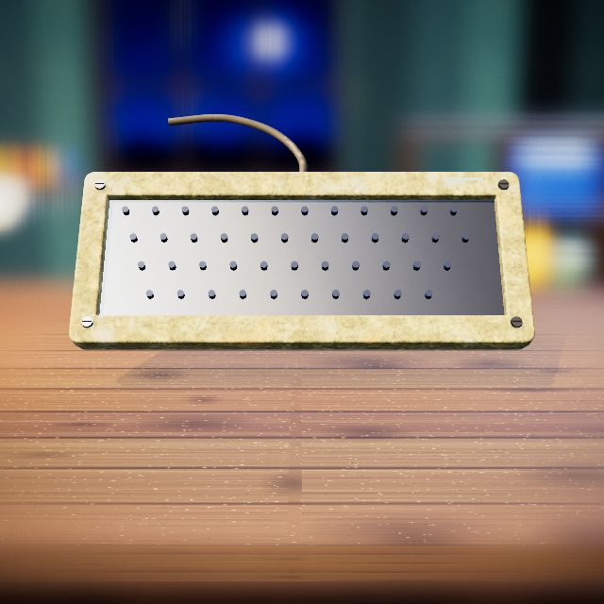 | 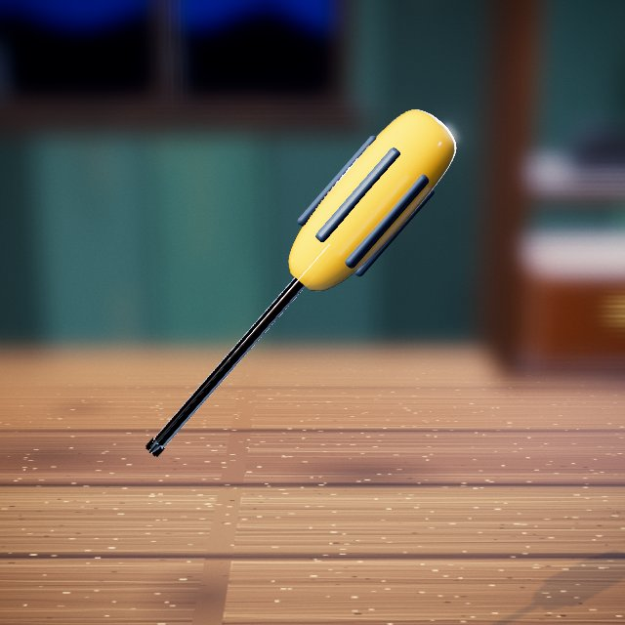  Screwdriver: removes the case screws.

Step 5: Run It Through the Dishwasher
Load the parts and run the dishwasher.
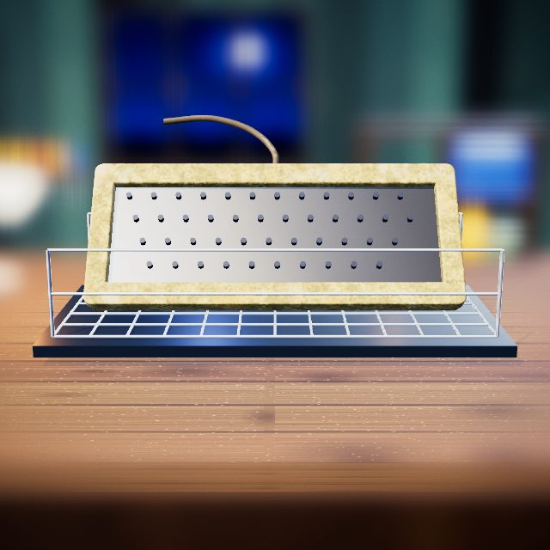 | Hands: drag, lift and fit parts by hand.

Step 6: Peroxide & UV Bath
A peroxide and UV bath whitens the yellowed plastic.
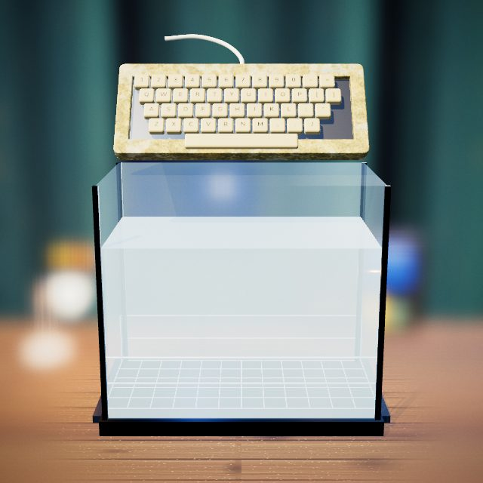 | Cleaning tank: the bath the object is lowered into.

Step 7: Polish the LED Window
Polish the hazy LED window clear.
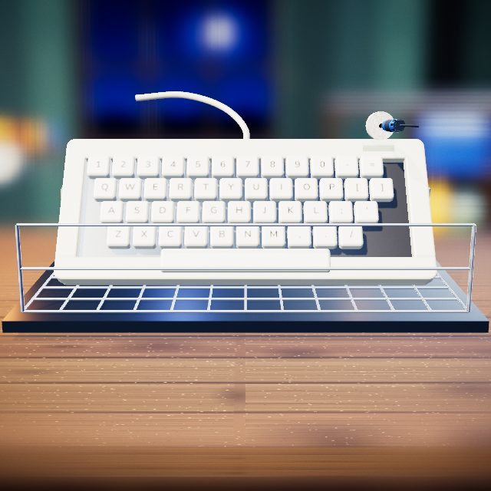 | Buffing wheel: polishes metal, brass or plastic to a mirror shine.

Step 8: Click the Keycaps Back On
Click the keycaps back on.
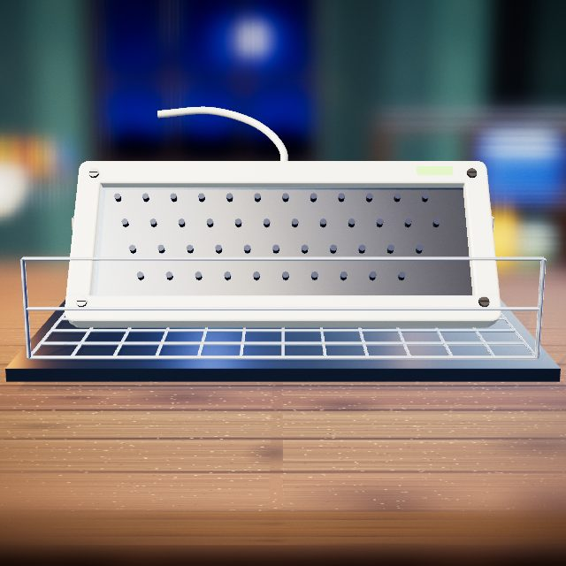 | Hands: drag, lift and fit parts by hand.

Step 9: Typing Test
Type a test word.
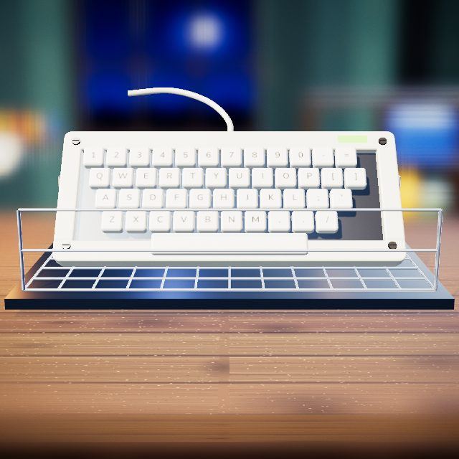 | Hands: drag, lift and fit parts by hand.

Step 10: Before and After
Before and after.
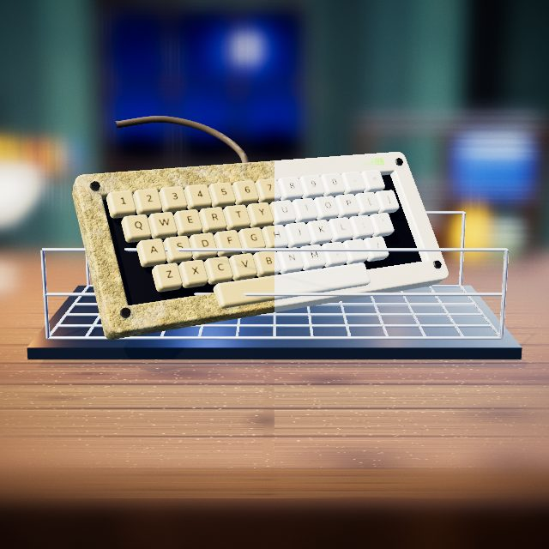 | Slider: drag it to compare before and after.

Twin-Bell Alarm Clock

Step 1: Pull Out the Movement
Pry the back off and pull out the movement.
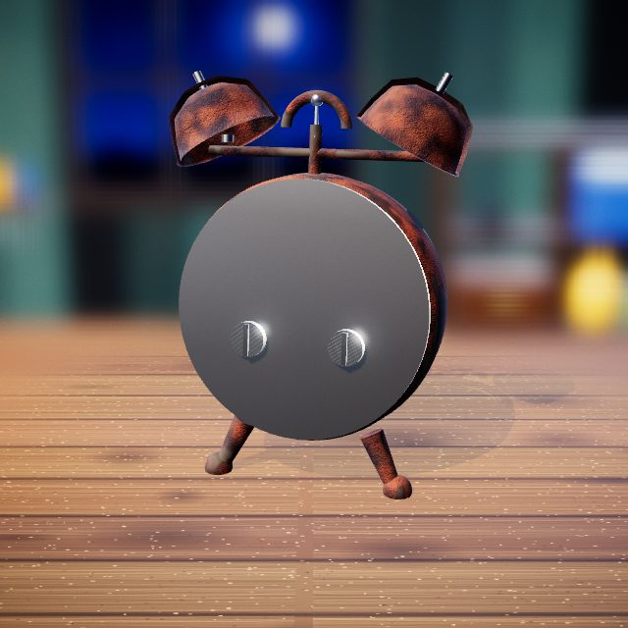 | 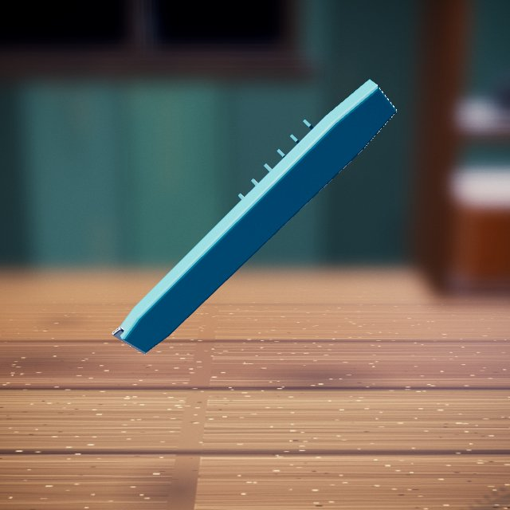  Pry tool: levers covers off.

Step 2: Tweeze Out the Gears
Tweeze out the gears.
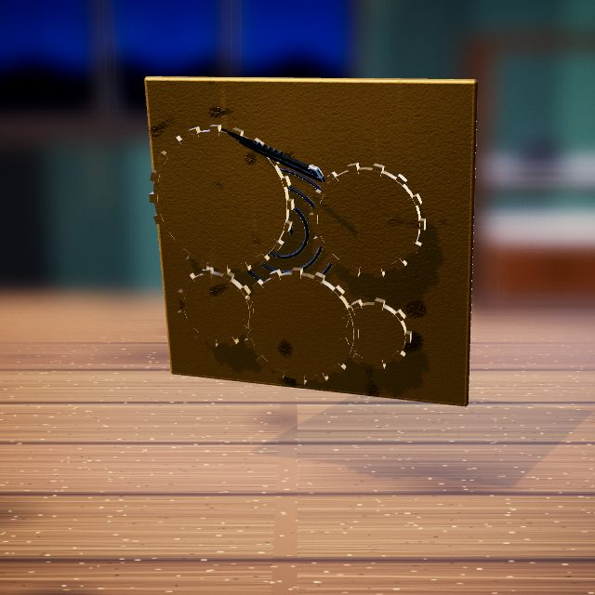 | Tweezers: lifts out and places small parts.

Step 3: Citric Acid Bath
A citric acid bath dissolves the rust.
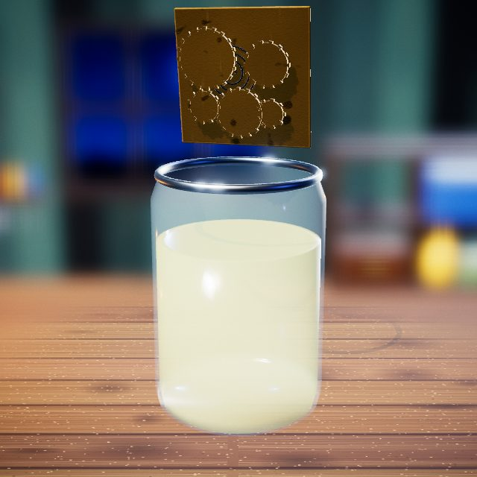 | Cleaning jar: the bath the parts are lowered into.

Step 4: Polish the Brass
Polish the brass plates and bells.
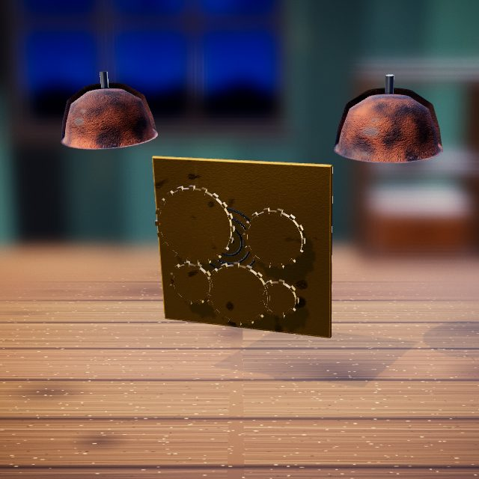 | Buffing wheel: polishes metal, brass or plastic to a mirror shine.

Step 5: Braze the Rust Holes
Braze the rust holes shut.
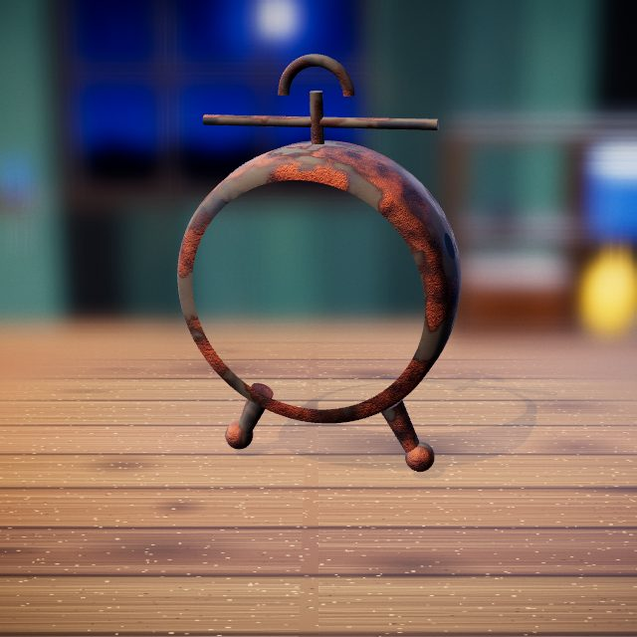 | Butane torch: heats metal until it glows so it can be freed, bent or brazed.

Step 6: Fill & Sand Smooth
Fill and sand the case smooth.
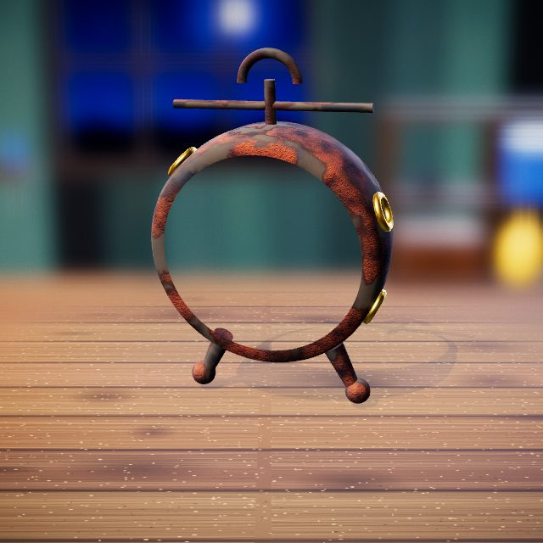 | 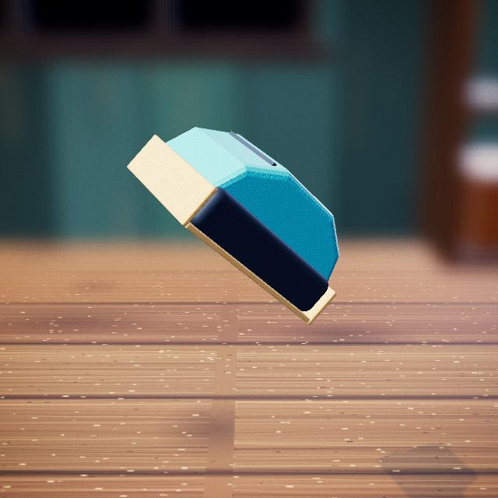  Sandpaper: smooths filler and wood.

Step 7: Spray Gloss Black
Spray the case gloss black.
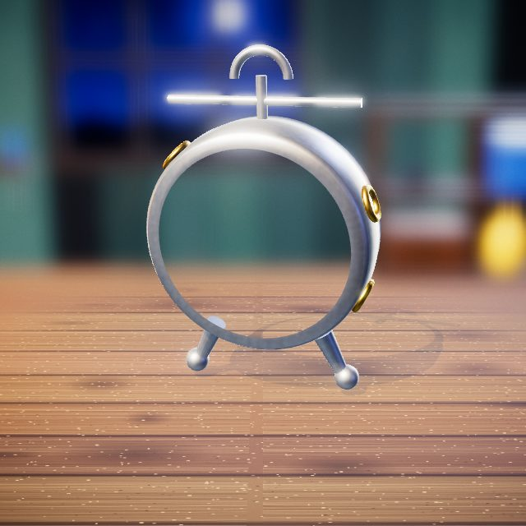 | Spray paint: sprays an even colour coat.

Step 8: Fit the New Dial & Hands
Fit the new dial, hands and glass.
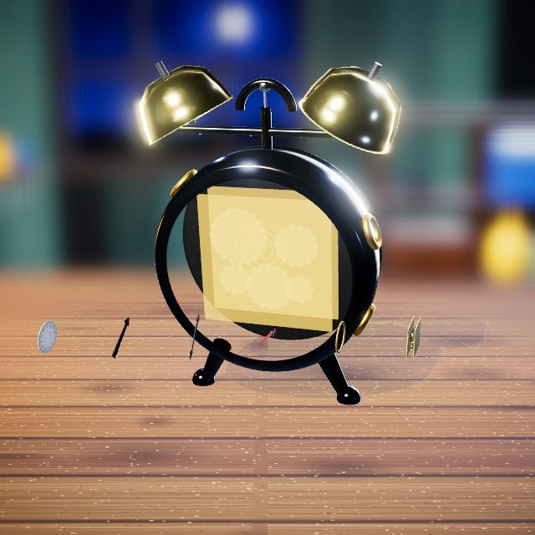 | Hands: drag, lift and fit parts by hand.

Step 9: Wind It & Ring It
Wind it up; it ticks and rings.
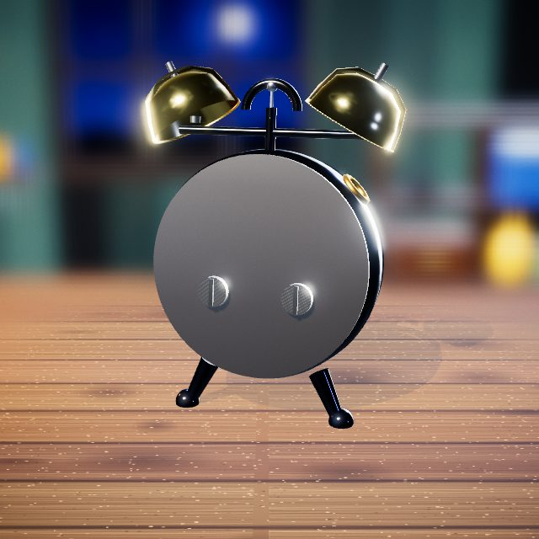 | Winding key: winds the clock spring.

Step 10: Before and After
Before and after.
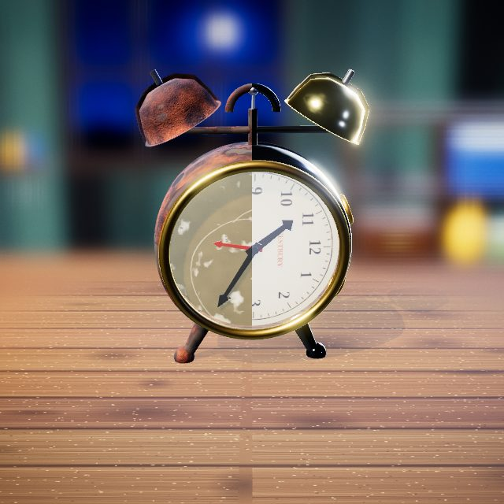 | Slider: drag it to compare before and after.

Stratocaster

Step 1: Snip the Rusty Strings
Snip the rusty strings.
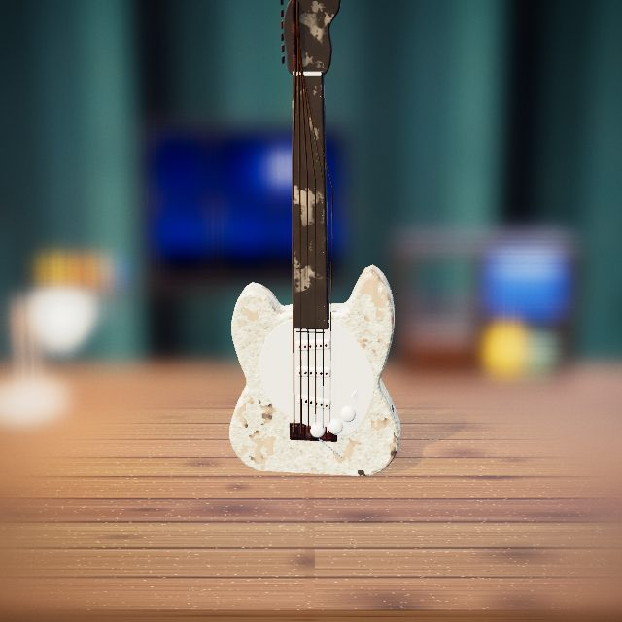 | 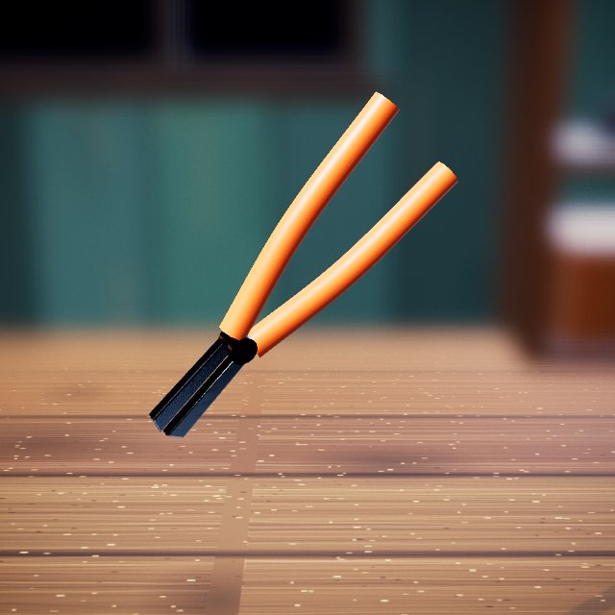  Wire snips: cut old strings and wire.

Step 2: Strip the Hardware
Pull off the pickguard, bridge and neck.
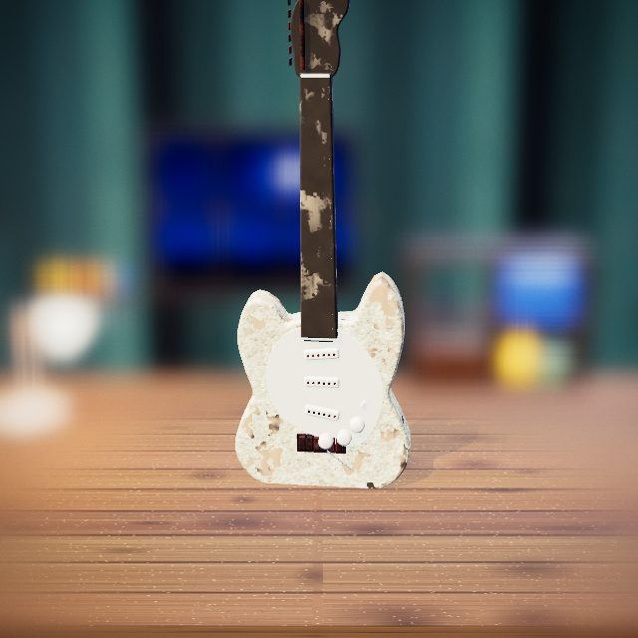 | Hands: drag, lift and fit parts by hand.

Step 3: Brush On Paint Stripper
Brush on paint stripper.
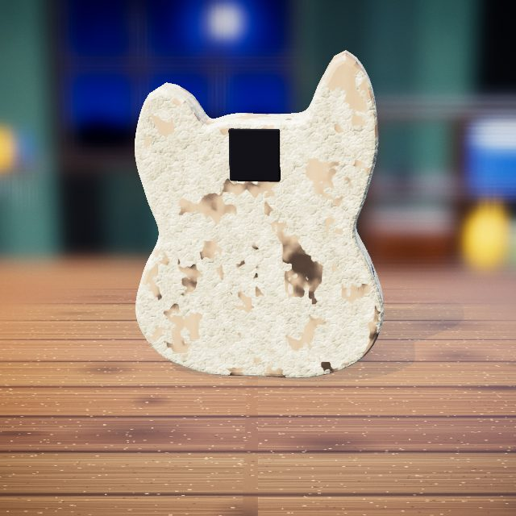 | Stain brush: brushes on liquids such as bluing, oil, stain or stripper.

Step 4: Scrape Off the Old Paint
Scrape off the old paint.
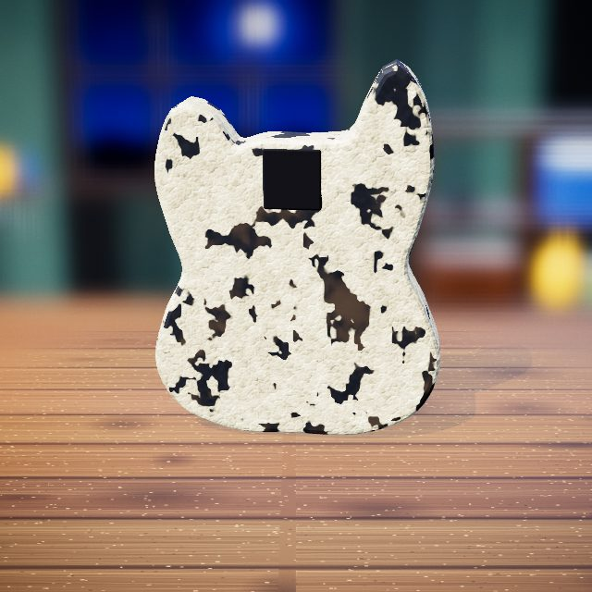 | Paint scraper: lifts loose scale and old paint in strips.

Step 5: Sand to Bare Wood
Sand down to bare wood.
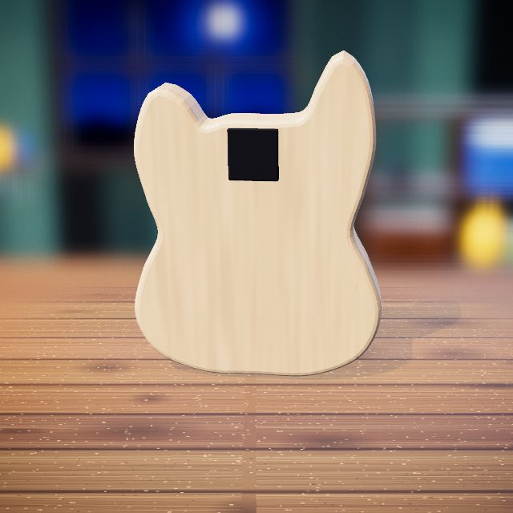 | Sandpaper: smooths filler and wood.

Step 6: Spray Metallic Red
Spray metallic red.
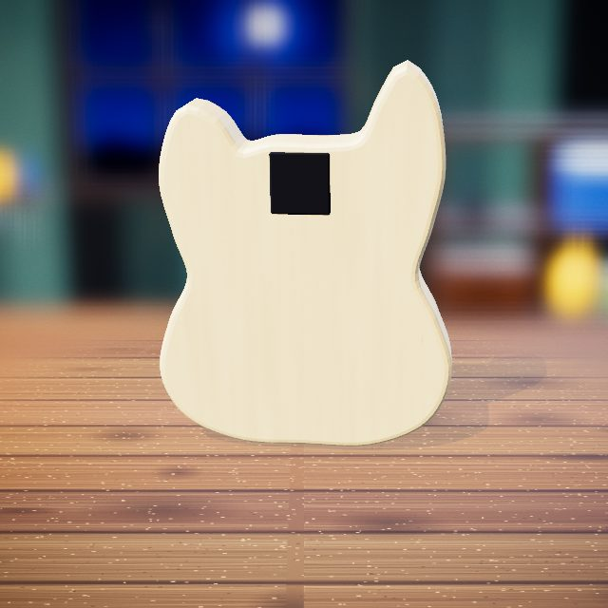 | Spray paint: sprays an even colour coat.

Step 7: Polish the Pickup Poles
Polish the rusty pickup poles to chrome.
 | Buffing wheel: polishes metal, brass or plastic to a mirror shine.

Step 8: Press In New Frets
Tap each slot to press in a new fret.
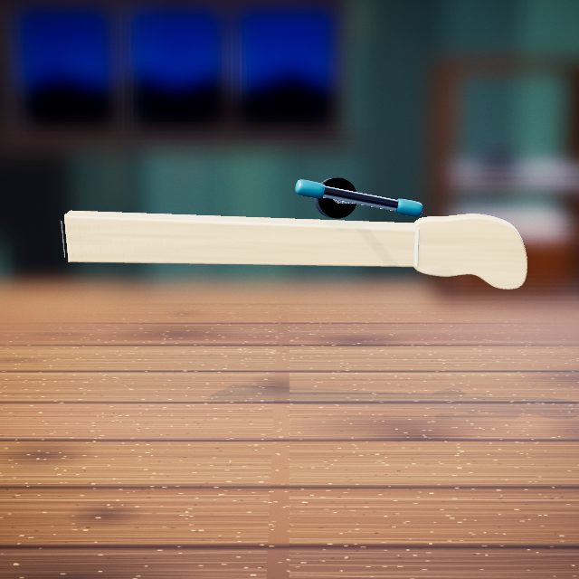 | Press tool: presses parts in or out and straightens bends.

Step 9: String Up & Tune
Circle each peg; the string glides into tune.
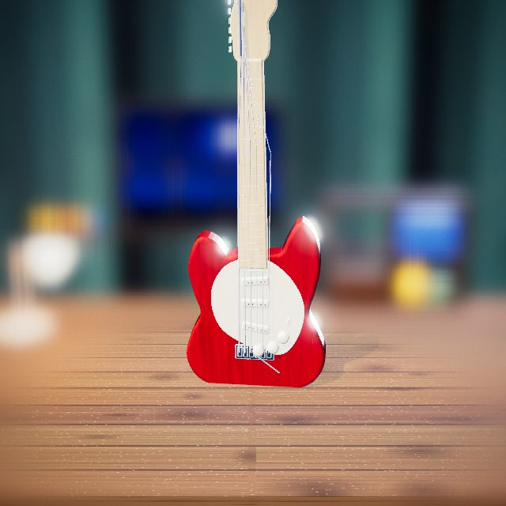 | Tuning pegs: tighten each string to pitch.

Step 10: Strum a Chord
Strum a chord.
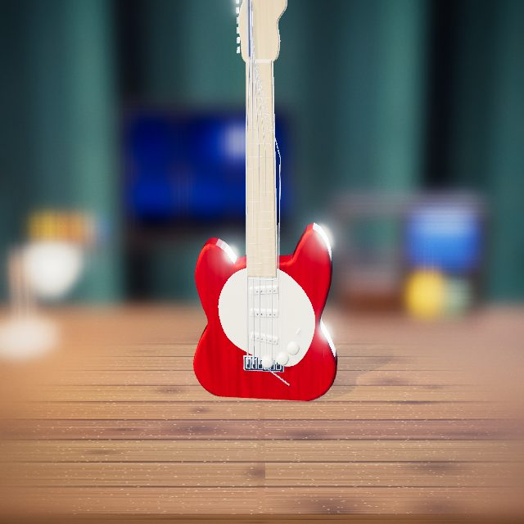 | Hand: strums the strings.

Step 11: Before and After
Before and after.
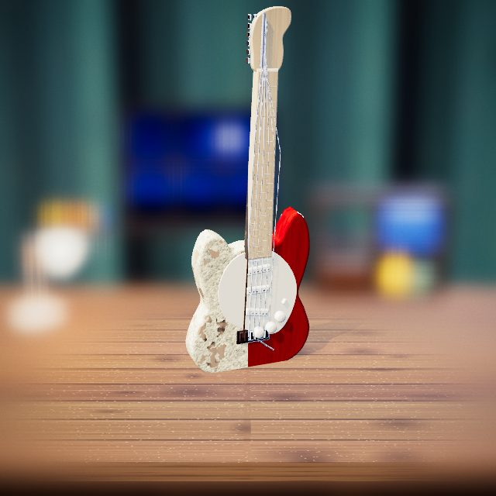 | Slider: drag it to compare before and after.

Typewriter

Step 1: Lift Off the Carriage
Lift off the carriage.
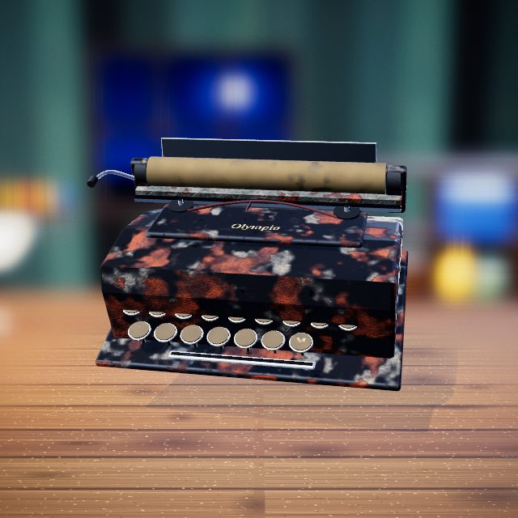 | Hands: drag, lift and fit parts by hand.

Step 2: Pull the Typebars
Pull out the typebars.
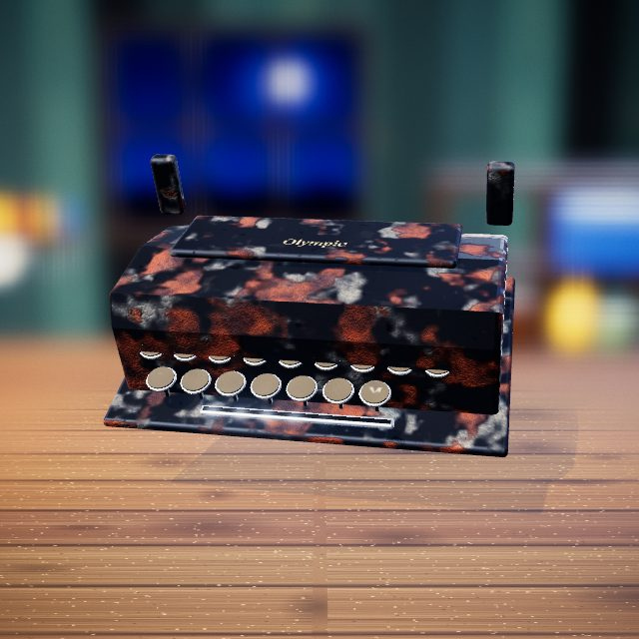 | Pliers: grips and pulls small parts out.

Step 3: Rust-Remover Jar
Rust-remover jar cleans the typebars.
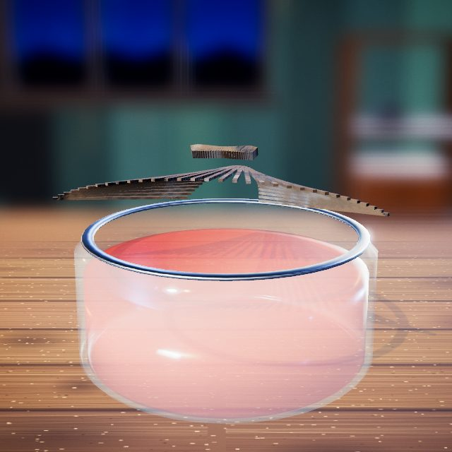 | Cleaning jar: the bath the parts are lowered into.

Step 4: Sandblast the Panels
Sandblast the panels to bare metal.
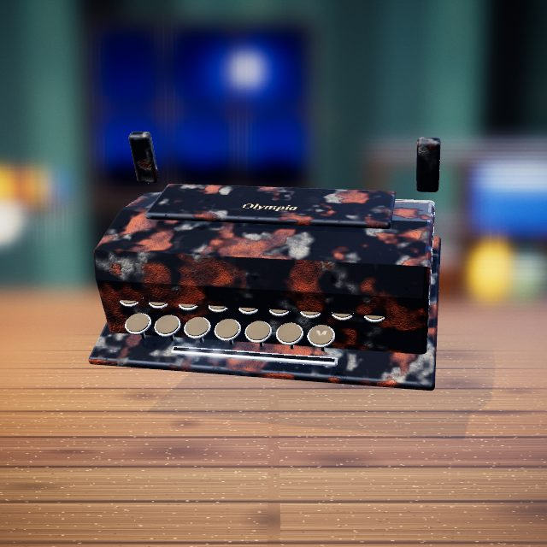 | 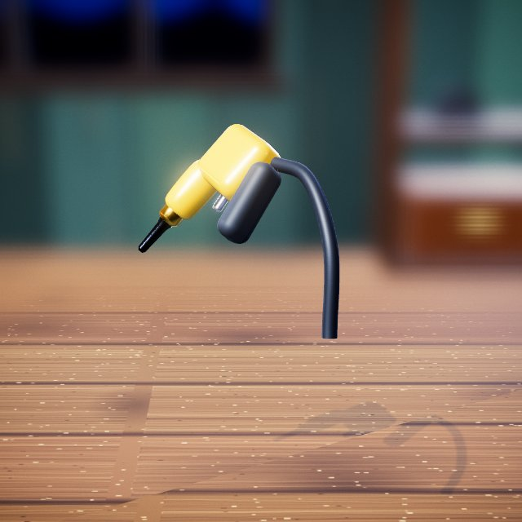  Sandblaster: blasts paint and rust down to bare metal.

Step 5: Spray Gloss Black
Spray gloss black.
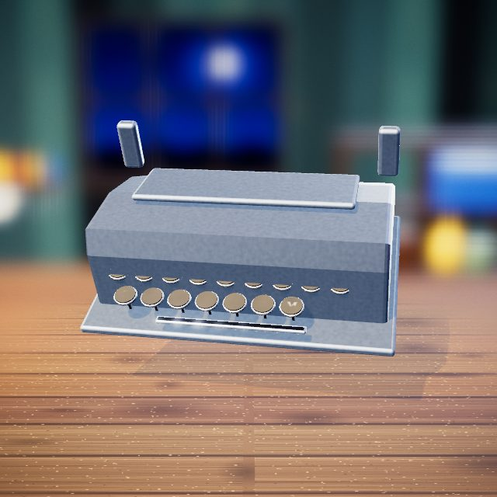 | Spray paint: sprays an even colour coat.

Step 6: Laser the Olympia Logo
Laser the Olympia logo back on.
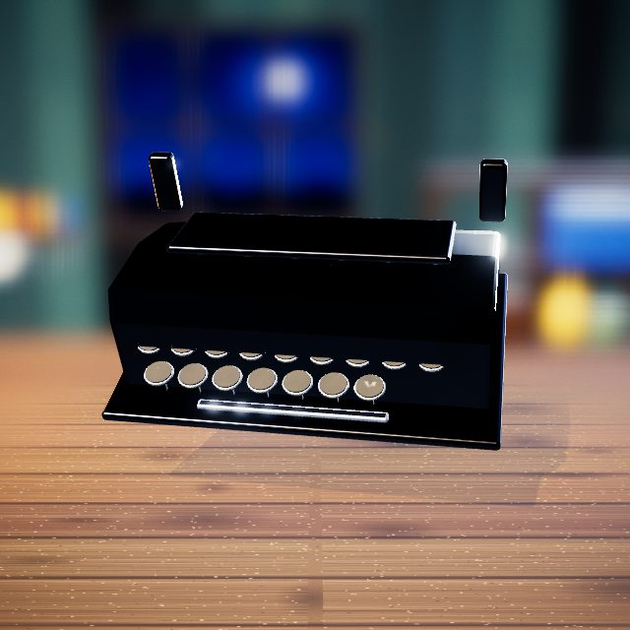 | 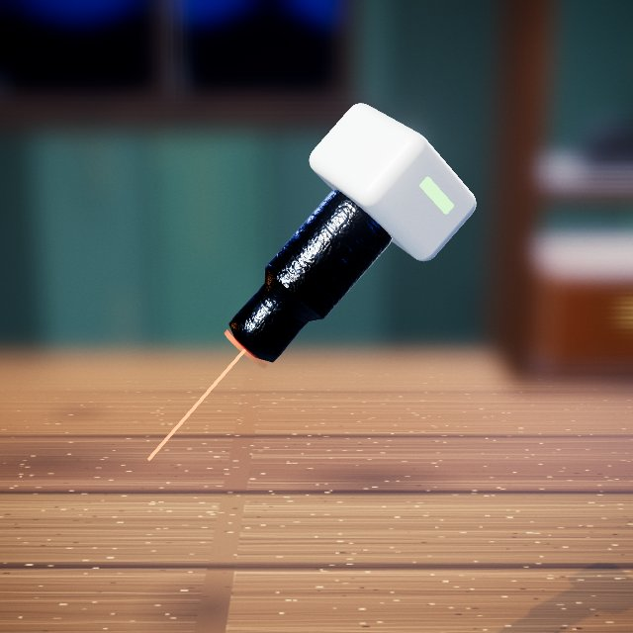  Laser engraver: burns logos and lettering in.

Step 7: Oil the Key Pivots
Oil each key pivot.
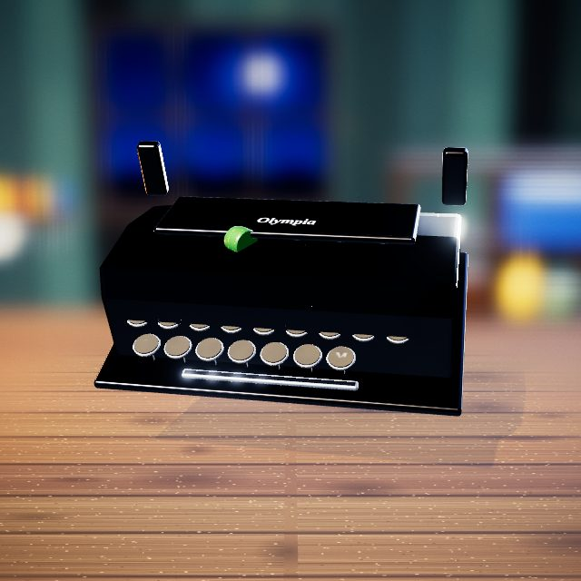 | 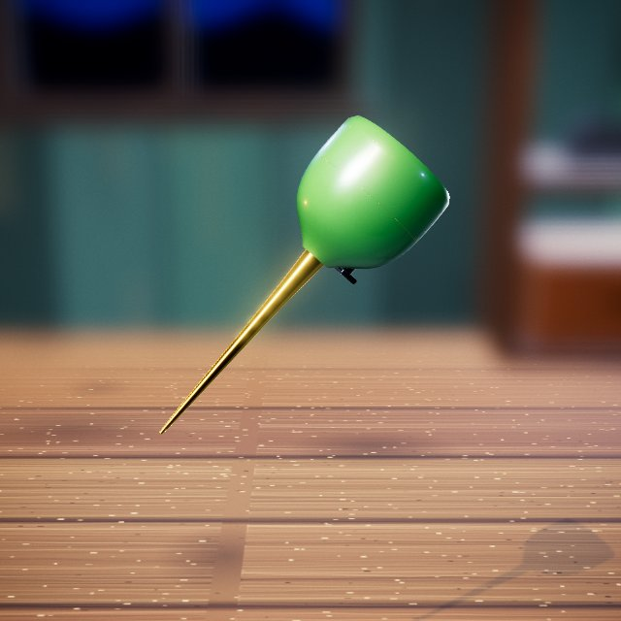  Oil can: puts a drop of oil on each moving joint.

Step 8: Refit the Carriage
Drop the carriage back on its rails.
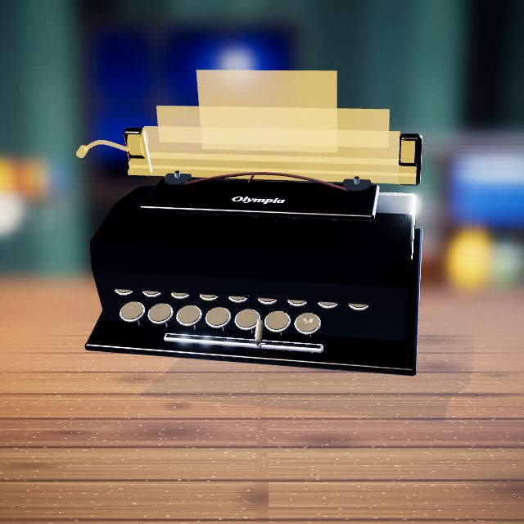 | Hands: drag, lift and fit parts by hand.

Step 9: Typing Test
Type a test line.
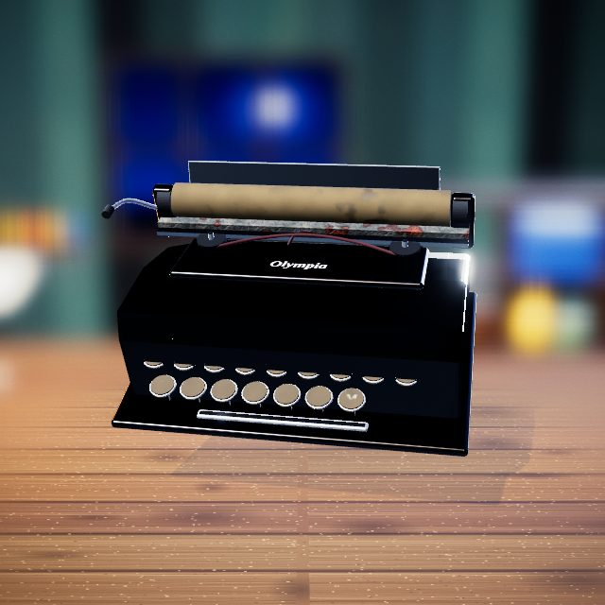 | Hands: drag, lift and fit parts by hand.

Step 10: Before and After
Before and after.
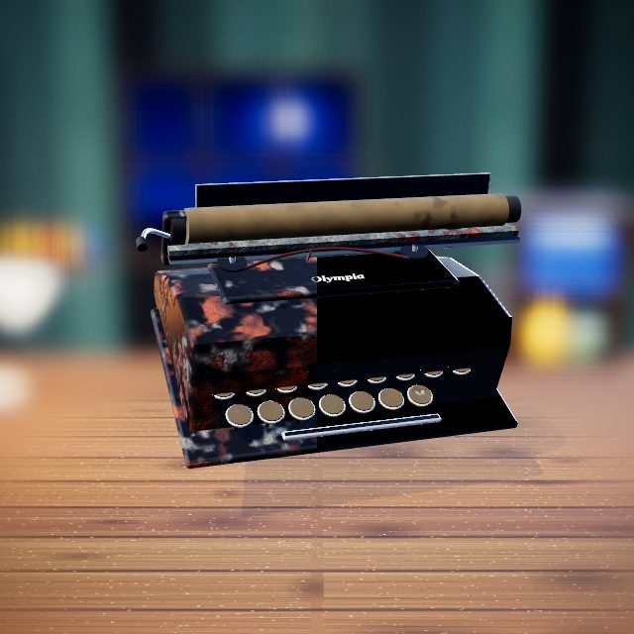 | Slider: drag it to compare before and after.

Antique Pistol

Step 1: Pick Off Heavy Corrosion
Pick off the heavy corrosion.
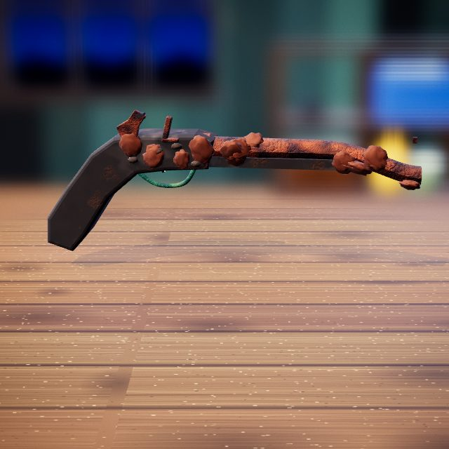 | Metal pick: picks heavy rust crust off detailed areas.

Step 2: Apply Cleaning Compound
Spread on cleaning compound.
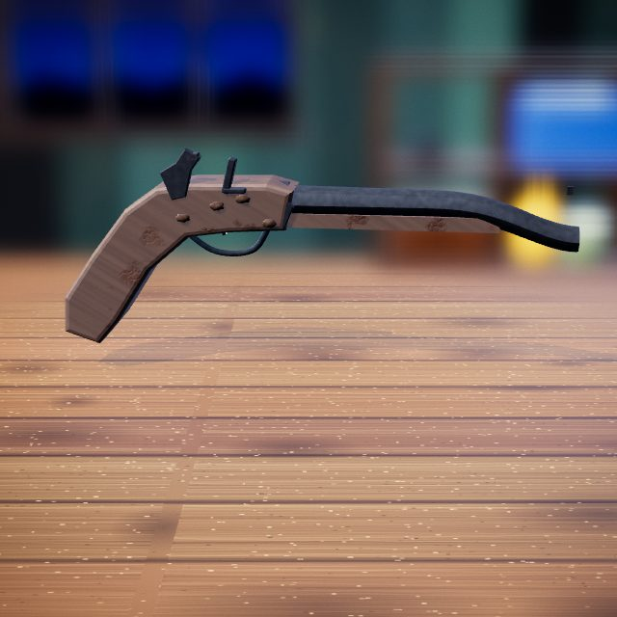 | 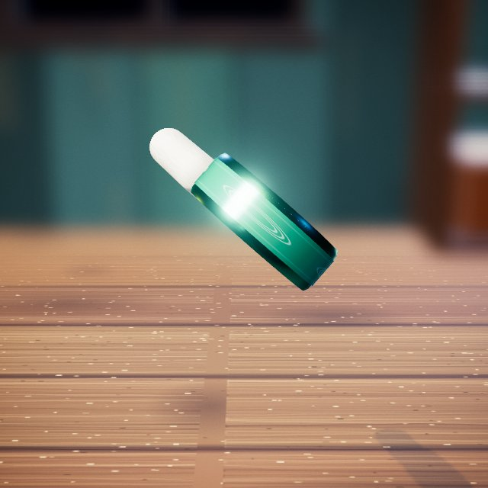  Cleaning compound: a paste that lifts tarnish and grime.

Step 3: Straighten the Exterior
Press out the bends.
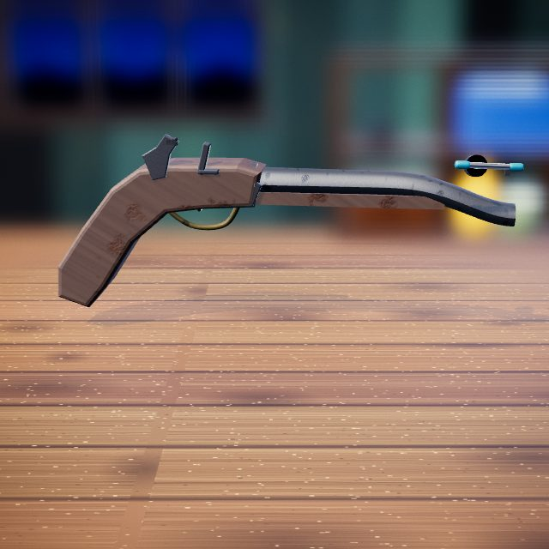 | Press tool: presses parts in or out and straightens bends.

Step 4: Repair the Exterior Cracks
Fill the cracks.
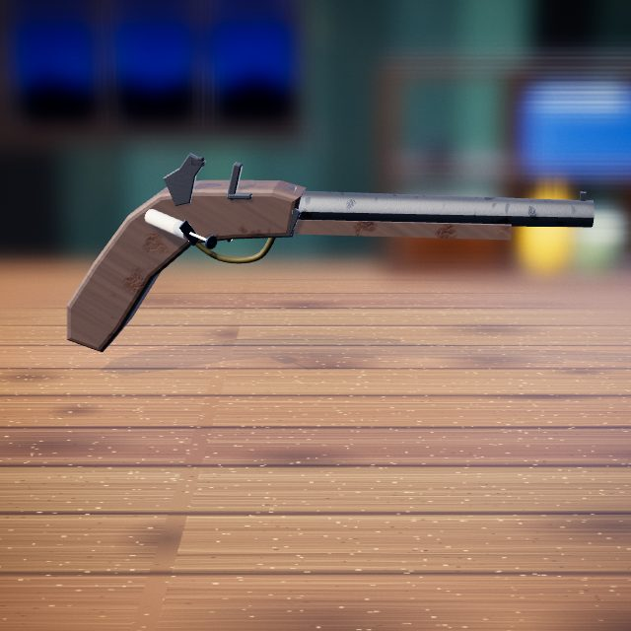 | 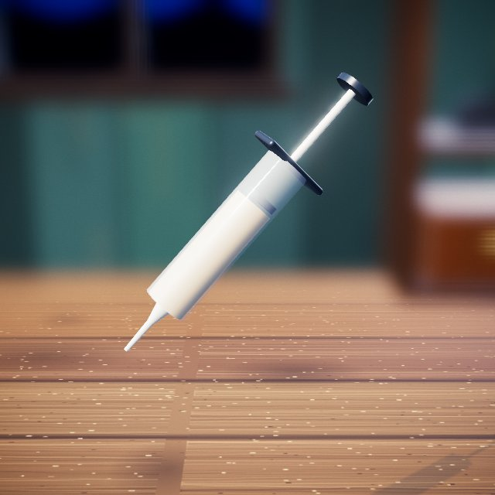  Repair filler: fills cracks and holes.

Step 5: Grind the Repair Marks
Grind the repairs flush.
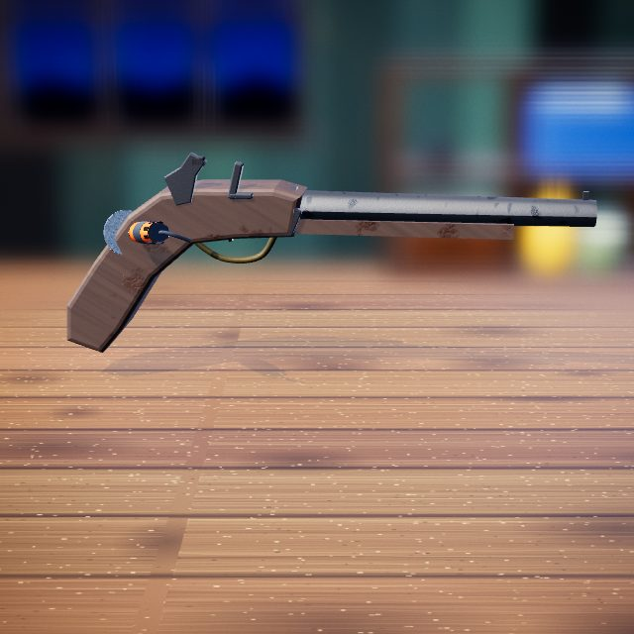 | Rotary grinder: wire wheel, burr or sanding disc that takes metal back to bright steel.

Step 6: Polish the Exterior Metal
Polish the metal.
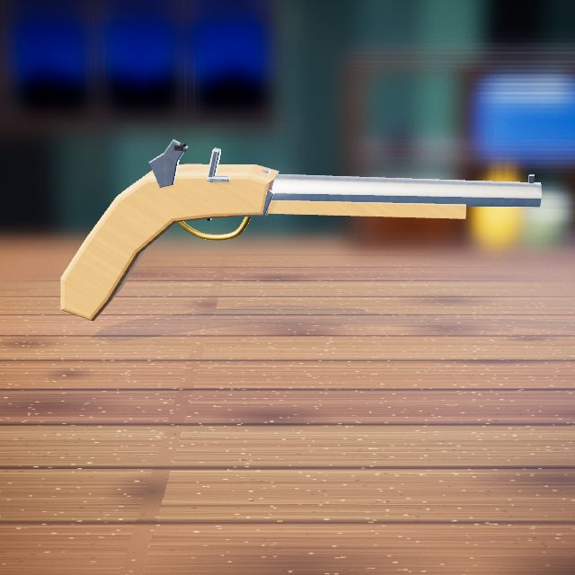 | Polishing cloth: rubs metal to a soft shine.

Step 7: Apply the Final Finish
Brush on the final finish.
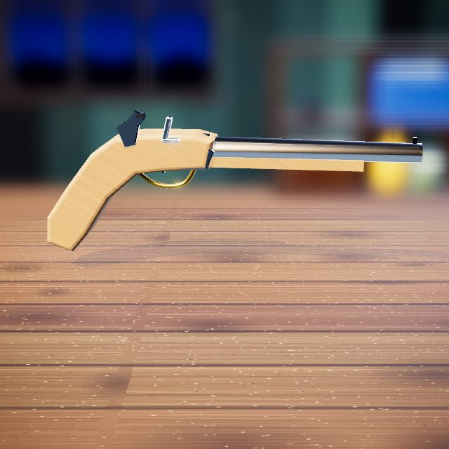 | 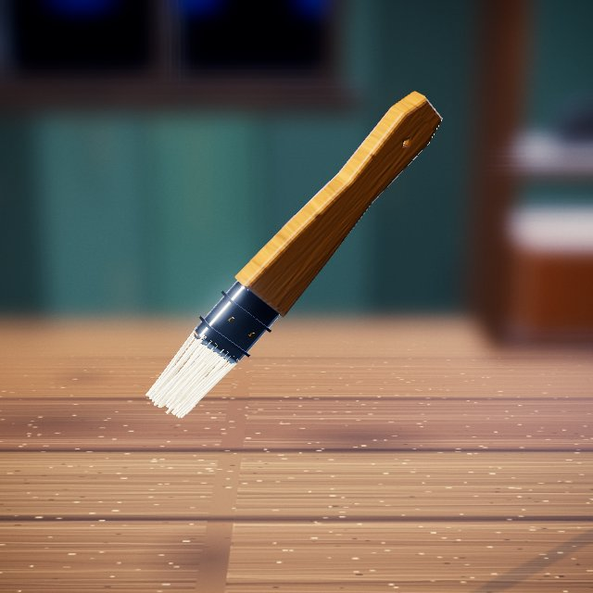  Finish brush: brushes on the protective top coat.

Step 8: Reassemble Cosmetic Parts
Fit the butt cap, ramrod and pins.
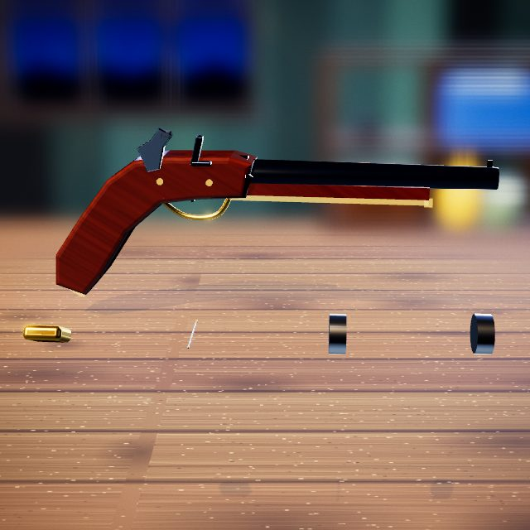 | Hands: drag, lift and fit parts by hand.

Step 9: Mechanical Presentation Check
Work the hammer and frizzen.
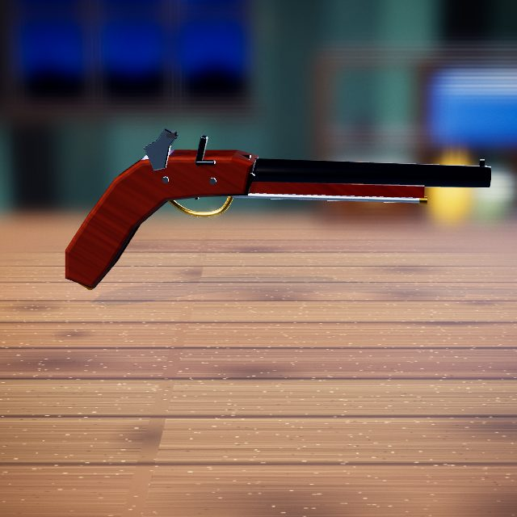 | Hands: drag, lift and fit parts by hand.

Step 10: Before / After Reveal
Before and after.
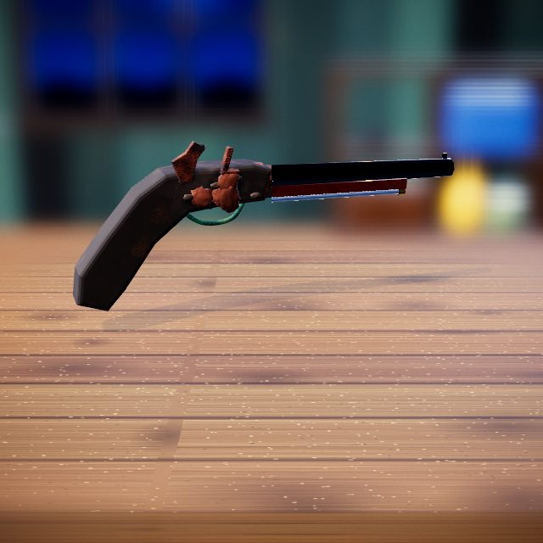 | Slider: drag it to compare before and after.

