**Help Me**

**CTQA-cp Version 0.3.1**

Webpage: http://code.google.com/p/ctqa-cp/

***Contents***

- Introduction

- Get Started

- Detailed information on analysis modules

***Introduction***

CTQA is a software package to aid in quality assurance of image quality for CT scanners. The software currently supports analysis of CT-images of the CatPhan600 and CatPhan504 phantoms. Other phantoms may be supported upon request to the author.

The purpose of CTQA-cp is twofold:

1) To handle and analyze image sets consisting of a few thousand images that are commonly obtained from image quality assurance protocols on CT scanners.

2) Easily provide results that can be copied to your favorite word or spreadsheet processor, or be saved to disk.

*Note: CTQA-cp starts several processes to speed up the analysis. This means that CTQA can be listed a couple of times in the task manager. Killing of any of these processes while CTQA-cp is running will make the application to misbehave.*

***Get started***

CTQA-cp can be installed on Windows by running the executable CTQA_cp-Version-win32.msi. No administrator privileges are required. Linux and OSX users may be able to run the source code if all dependencies are satisfied. If you need assistance or have questions, the developers e-mail address can be found on the webpage.

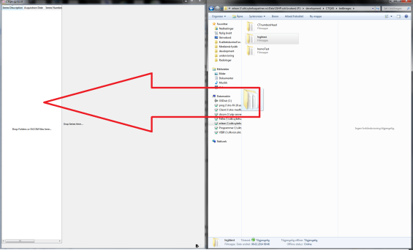

Import images by dragging folders/image files into the analysis tree (left white region in the main window). CTQA-cp will import all CT DiCOM files in the folders and subfolders. An import log can be displayed by pressing the black icon in the lower right corner. CTQA-cp will then automatically try to identify the location of the phantom and analyze relevant images.

The following analysis modules are implemented and are described more in detail later:

* 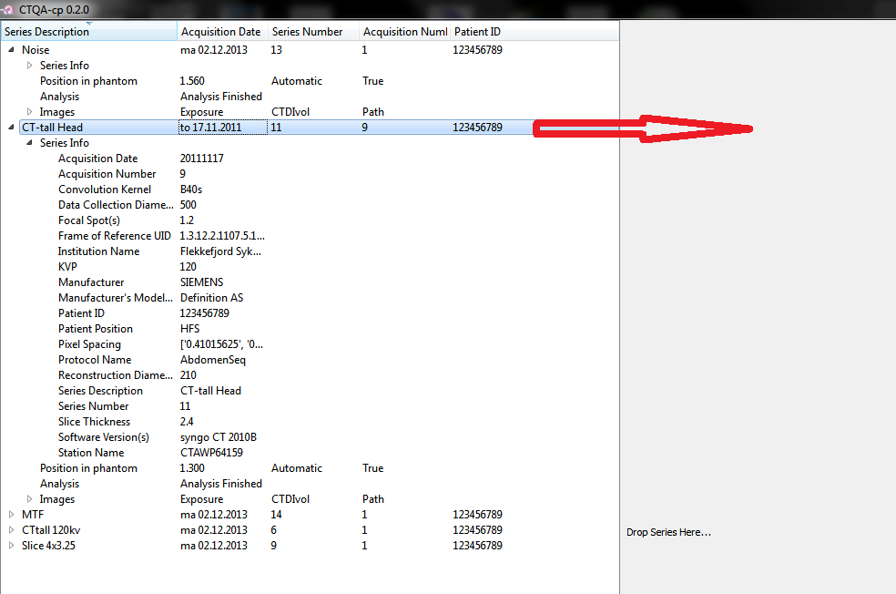CT-number linearity
* Slice thickness
* Pixel size
* High Resolution (MTF)
* Image noise
* Noise power spectra (NPS)
* Homogeneity
* Low contrast model observer (Experimental, currently unusable)

View available analysis for a series by dragging the series from the tree view to the window view (grey region to the right). Details for a series obtained from the DiCOM headers can be viewed by expanding the Series Info tab.

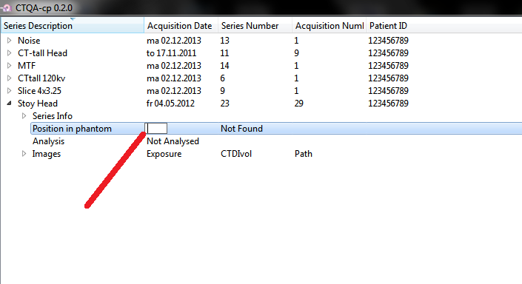***When the phantom is not localized***

If images from the CP404 phantom module are not present in any series from the same CT study, CTQA-cp is not capable to find the proper z-location of the phantom. “Not Found” will then be displayed for the series Phantom Position. To perform an analysis, double click on the tab illustrated in the figure and manual edit the location of the CP404 module center. This change will affect all series sharing the same coordinate frame of reference (i.e. the same study instance). Analysis of all affected series will be preformed after editing.

*Note: There may be issues in manually editing the CP404 location if the images are acquired in Feet First Supine (FFS) orientation.*

*General on the analysis window*

Image view to the right displays the primary image/images in the analysis. Window width and window center can be adjusted by moving the mouse while pressing the right mouse button. Location of the image is displayed below window center and window width. The mouse wheel can be used to scroll through multiple images if present. All images, plots and tables can be copied to a word processor by drag and drop. Other actions can be performed from the top left menu bar, such as copying plot data to clipboard for easily paste in a spreadsheet.

*Note: Left clicking anywhere on the analysis window will highlight the current series being displayed in the series tree.*

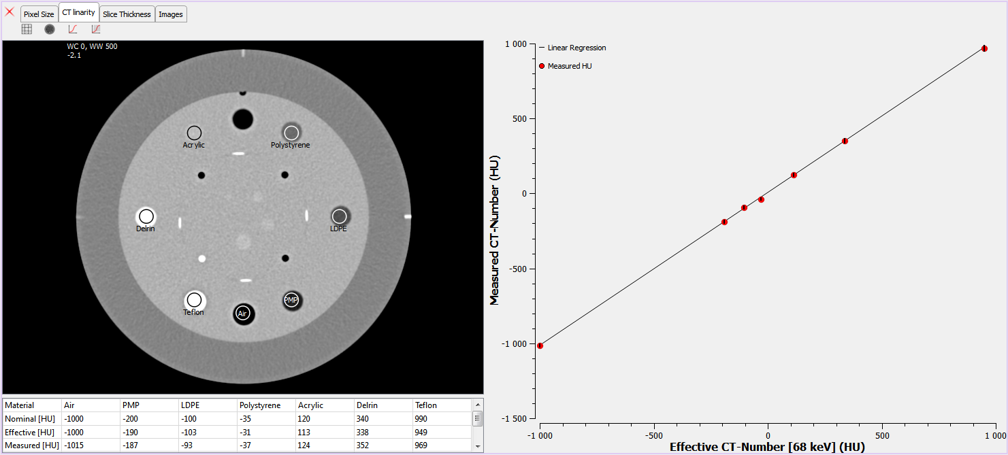

*Viewing Images*

Images or an image series can be viewed by dragging images from the tree structure or from the file manager to the window view region (grey region). This is only a simple viewer supporting basic operations such as adjusting window level and center and zooming while scrolling and holding the ctrl key.

*Exporting analyzed images*

Imported images that are used in any analysis can be exported by clicking P:\development\CTQA5\ctqa-cp\source\Icons\exportImages.png in the lower left corner. Images containing information to the analysis is copied to the selected folder and can be used to recreate the analysis later.

**Detailed information on the analysis modules:**

*Linearity*

This module identifies seven regions in the CP404 phantom module containing different materials. If the phantom supports a water insert, CPQA-cp will automatically detect the water vial. The image view displays the image used for this analysis with ROI’s for the different materials as overlay. This is to verify that the ROI placement was successful. The plot displays measured CT numbers vs. effective CT numbers with error bars for the respective materials. Effective CT values are calculated by estimating the effective energy of the beam and obtaining CT-numbers from the attenuation coefficients of the materials for a monochromatic beam with same energy. The table provides measured values in addition to estimated effective energy of the x-ray source and the regression coefficients for the linear least squares fit of measurements. In addition nominal CT-numbers are included in the table, these are obtained from the CatPhan600 manual and are comparable to a 120kVp filtered beam.

*Slice thickness*

Slice thickness is estimated by the four wolfram ramps by the method provided in the CatPhan600 manual. The four boxes in the image view shows the analysis region, make sure that no high density material other than the wolfram ramps are present in the boxes for a correct analysis. The table displays the analysis for the four ramps in addition to the nominal slice thickness obtained from the DiCOM header.

*Pixel size*

Pixel size is estimated by locating the three small air gaps and the wolfram rod in the CP404 module and counting the pixels between each gap/rod according to the CatPan 600 manual. The table displays the results in addition to the nominal pixel size obtained from the DiCOM header. Make sure the displayed lines properly align with the air gaps and the wolfram rod.

*MTF*

High resolution analysis is performed by MTF (Modulator Transfer Function) curves, by the methods of Bischof et. al. in the 1977 paper: Modulation Transfer Function of the EMI CT head scanner; Medical Physics, Vol 4, 1977. To increase the certainties of the MTF, radial profiles of the 2D Fourier transform of the ROI containing the wolfram bead are added. This makes the displayed MTF an average of the MTF for the x and y direction in the image. Estimates of line pair intensity at 50%, 10% and 2% MTF are given in the table. If the scanned region contains both wolfram beads, two analyses will be displayed. Make sure the displayed ROI contains the wolfram bead.

The MTF3D version in CTQA-cp is a slightly improved version that reduces noise in the MTF by including slices before and after the tungsten bead in the analysis.

*Noise*

The noise analysis uses all images available images from the CP486 CatPhan module. The image view displays the first image, center image and last image of the analysis overlaid with the analysis ROI. The plot shows the standard deviation for each ROI vs. image position, and the table shows mean and standard deviations for the corresponding images in the image.

*NPS*

Noise power spectra are calculated for all available images from the CP486 CatPhan module. Multiple ROIs are used to reduce noise in the NPS. The plot shows the corresponding NPS for the individual images in addition to the NPS obtained by averaging the NPS of all available images, i.e. all images analyzed in the noise module. An NPS is obtained by:

$$NPS\left(μ,υ\right)={\left|\frac{F\left[image\left(x,y\right)-background\right]}{XY}\right|}^{2}$$

Where X, Y is the size of the image, $F$ is the Fourier transform and background is the mean value in the image. The one dimensional NPS is obtained by radial profiles of the 2D NPS specter.

*Homogeneity*

Homogeneity module provides mean and standard deviations for five ROIs for the center image in the CP486 homogeneity module. The area of the ROI’s corresponds to the area of a circle with diameter 10% of the diameter of the homogeneous region in the CP486 module. For all off center ROI’s the deviation in CT numbers from the center ROI are provided in the table. In addition, the mean deviations of the peripheral ROIs from the center for all images in the CP486 module are also plotted. This may reveal if the homogeneity differ across detector rows.

*Low contrast model observer (experimental, unusable, use with care)*

Low contrast resolution module provides several discs of varying size and contrast in the CP515 module. This is an experimental method that uses a model observer to classify if a disc is detectable or not and returns the smallest visible disc size for 1%, 0.5% and 0.1% contrast. The method is based on the method by Hernandez-Giron et. Al. in their paper:

*Automated assessment of low contrast sensitivity for CT systems using a model observer*

*I. Hernandez-Giron, J. Geleijns, A. Calzado, and W. J. H. Veldkamp*

*Medical Physics 38, S25 (2011), doi: 10.1118/1.3577757*

This analysis is fairly dependent on noise, for best results I suggest to experiment with different mAs settings on the scanner to obtain results that can be compared to previous analysis. For very low or very high image noise, this model implementation will not extrapolate estimated low contrast resolution. For best results use images where the low contrast phantom inserts are barely visible.

Author

Erlend Andersen

Medical physicist

April 22, 2015