

**ENGINEERING** ​**FACULTY**​

**Department** ​ **of**​ ​ **Computer**​ ​ **Engineering**​

**SENIOR ​PROJECT​**

**REPORT**

**PHARMA**

31018108372 Gülşah Şahin

56866369638 Özgür Hasan Aytar

54388288130 Tuğba Öztürk

**Lect. Dr. Alper Kürşat UYSAL**

**April 2019**

Contents

**Page**

ABBREVIATIONS 1

1. ABSTRACT 2

2. INTRODUCTION 3

2.1. Project Title 3

2.2. Group Members 3

2.3. Project Motivation 3

2.4. Project Definition 3

2.5. Scope of Project 3

2.6. Project Milestone Chart 4

3. PLATFORM AND TECHNOLOGIES TO BE USED 5

4. DESIGN 6

4.1. Desktop App 6

4.2. Mobile App 9

5. CONCLUSIONS 12

6. REFERENCES 12

**List of Figures**

**Page**

Figure 2.1 Project Schedule 4

Figure 4.1 Users Login Page 6

Figure 4.2 Admin, Doctor and Pharmacist Login Page 6

Figure 4.3 Admin Page 7

Figure 4.4 Pharmacist Page 7

Figure 4.5 Doctor Page 8

Figure 4.6 Writing Prescription Page 8

Figure 4.7 User Login Page 9

Figure 4.8 Register Page 9

Figure 4.9 List of Doctor Page 10

Figure 4.10 Prescription Page 10

Figure 4.11 Medicine’s Detail Page 11

Figure 4.12 Profile Page 11

# ABBREVIATIONS

**T.C ID** Republic of Turkey Identification

**App** Application

**IoT** Internet of Things

**SQL** Structured Query Language

# ABSTRACT

Our project makes efficient bridge between doctor, patient and pharmacy. This project provides various benefits to people. The most important benefits of the project are that avoid using incorrect medicine.

Our main aim is to inform the patients about the medicines they will use. The patients will be able to access to usage range of medicine, usage way of medicine, usage dose of medicine and if any max usage period of medicine from own mobile App without the need doctor's and pharmacist's information. We have two App for this project. This project includes one desktop App and one mobile App.

In the desktop App we have three different login pages. Doctors, pharmacists and admins will be able to use to our desktop App. After doctors log into the desktop App, patients will scan own card then doctor will be able to see patient’s information like name, surname, age and extra information like allergy and chronic illness. And doctors will be able to prescribe to patients in this our desktop App. Pharmacists will be able to reach the medicine, prescribed by doctors after patients scan own card. Admins will be able to add a new patient’s information into the system. And admins can update patient’s information. According to the medicine period determined by the doctor goes to the patient notification from the mobile App. Patients can start this period at any time. The patients can see the medicine written by the doctors before, on a separate page. Also, patients can see own information on a separate page. We can take id of new T.C ID card. In this project, patients can use a new T.C ID card. In this way, patients do not need to provide new card.

With this project, how to use the medicine of patients, when to use it and how often to use it with the mobile App to provide easy way to reach.

Keywords: Doctor, Patient, Pharmacy, Health System, Card

# INTRODUCTION

## Project Title

**PHARMA**

## Group Members

Gülşah Şahin

Özgür Hasan Aytar

Tuğba Öztürk

## Project Motivation

Advancing technology has a positive impact on people’s lives day by day. Especially IoT is becoming an increasingly growing topic of conversation both in the workplace and outside of it. Therefore, our motivation is to integrate IoT into the health field. One of its benefits of the project is that doctors can transmit an electronic prescription to a pharmacy directly from IoT. Also, patients can reach own prescription.

## Project Definition

Our main aim is to inform the patients about the medicines they will use. The patients will be able to access to usage range of medicine, usage way of medicine, usage dose of medicine and if any max usage period of medicine from own mobile App without the need doctor's and pharmacist's information.

## Scope of Project

The purpose of this project is to enable patients to use medicine in a more informed manner. The other purpose of this project is to minimize the problems that may arise from unconsciously used medicine.

## Project Milestone Chart

This table shows planned deadlines of the design, programming and test steps. Project deadline is assumed end of 2018-2019 Spring term.

|  |  |  |  |  |
| --- | --- | --- | --- | --- |
|  | **February** | **March** | **April** | **May** |
| **Research** |  |  |  |  |
| **Design** |  |  |  |  |
| Desktop Design |  |  |  |  |
| Mobile Design |  |  |  |  |
| Database Design |  |  |  |  |
| Arduino Analysis |  |  |  |  |
| UI Analysis |  |  |  |  |
| Algorithm Analysis |  |  |  |  |
| **Programming** |  |  |  |  |
| Arduino Programming |  |  |  |  |
| Database Programming |  |  |  |  |
| UI Programming |  |  |  |  |
| Algorithm Programming |  |  |  |  |
| **Test** |  |  |  |  |
| **Deploy** |  |  |  |  |
| **Deadline** |  |  |  |  |

Figure 2.1 Project Schedule

# PLATFORM AND TECHNOLOGIES TO BE USED

**Arduino UNO:** is an open-source microcontroller board based on the Microchip ATmega328P microcontroller and developed by Arduino.cc. The board is equipped with sets of digital and analog input/output (I/O) pins that may be interfaced to various expansion boards (shields) and other circuits. The board has 14 Digital pins, 6 Analog pins, and programmable with the Arduino IDE (Integrated Development Environment) via a type B USB cable.

**Arduino IDE:** is a cross-platform App (for Windows, macOS, Linux) that is written in the programming language Java. It is used to write and upload programs to Arduino board.

**Microsoft Visual Studio**: is an integrated development environment (IDE) from Microsoft. It is used to develop computer programs, as well as websites, web apps, web services and mobile apps. It can produce both nativecode and managed code.

**Android Studio:** is the official integrated development environment (IDE) for Google's Android operating system, built on JetBrains' IntelliJ IDEA software and designed specifically for Android development. It is available for download on Windows, macOS and Linux based operating systems. It is a replacement for the Eclipse Android Development Tools (ADT) as the primary IDE for native Android App development.

**Microsoft Azure** is a growing collection of integrated cloud services that developers and IT professionals use to build, deploy and manage Apps through global network of datacenters. With Azure, user get the freedom to build and deploy wherever they want using the tools, Apps and frameworks of their choice.

**Microsoft SQL Server:** is a relational database management system developed by Microsoft. As a database server, it is a software product with the primary function of storing and retrieving data as requested by other software Apps—which may run either on the same computer or on another computer across a network (including the Internet).

# DESIGN

## Desktop App

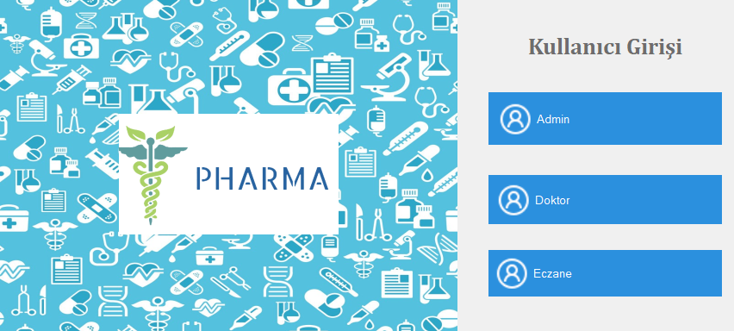

Figure 4.1 Users Login Page

The desktop App is available for three different users. These are admin, doctors and pharmacist.

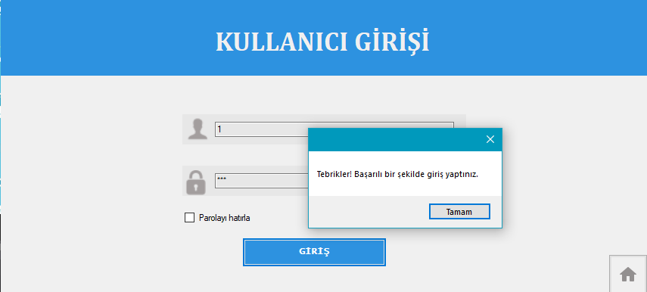

Figure 4.2 Admin, Doctor and Pharmacist Login Page

Each user logs in with own T.C ID number and the password own has set in advance.

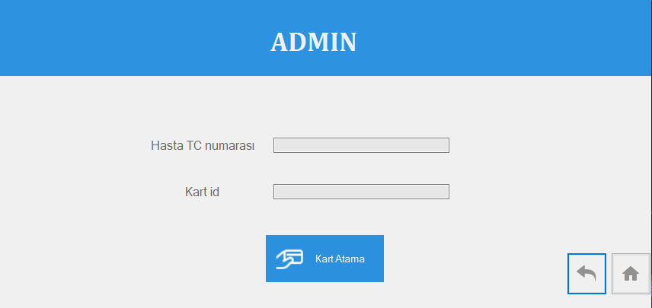

Figure 4.3 Admin Page

Admin identifies the card to the patients in the admin page.

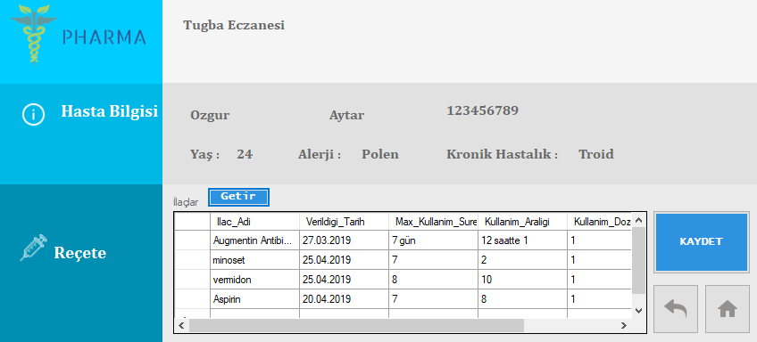

Figure 4.4 Pharmacist Page

On the pharmacist's page, after patient scan the T.C ID card, the pharmacist sees the patient's medication information and records the medications sold.

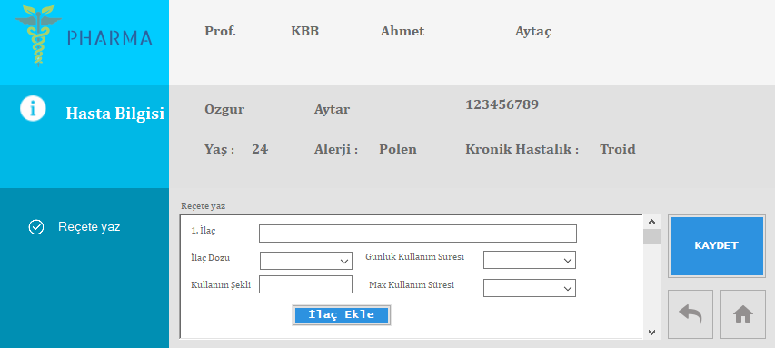

Figure 4.5 Doctor Page

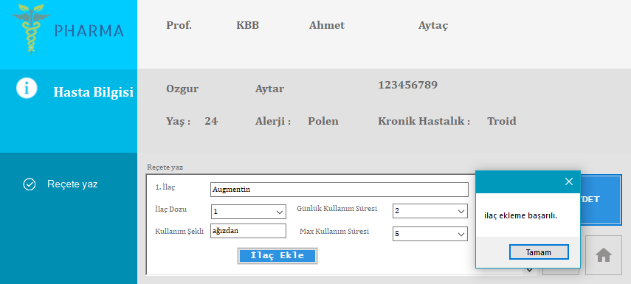

Figure 4.6 Writing Prescription Page

On the doctor's page, the doctor can see the patient's information and write the medication.

## Mobile App

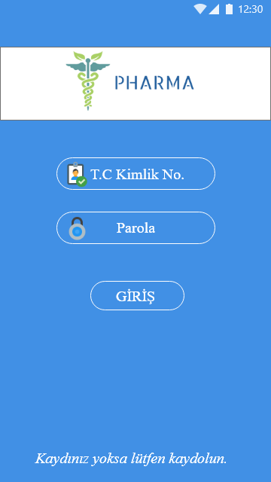

Figure 4.7 User Login Page

The user log into app with T.C ID number and password if s/he has an account.

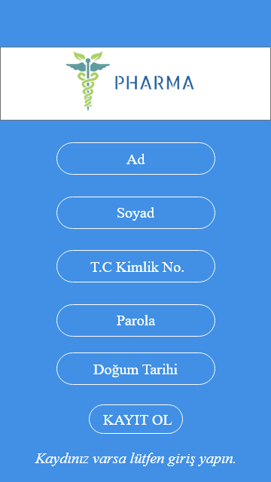

Figure 4.8 Register Page

The user fills up the form to register to system. The information required is the name, surname, T.C ID number, password and birthdate.

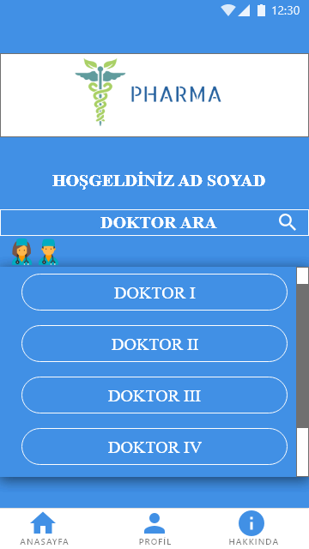

Figure 4.9 List of Doctor Page

In that page user sees the doctors who write prescribing and s/he can search by doctor’s name.

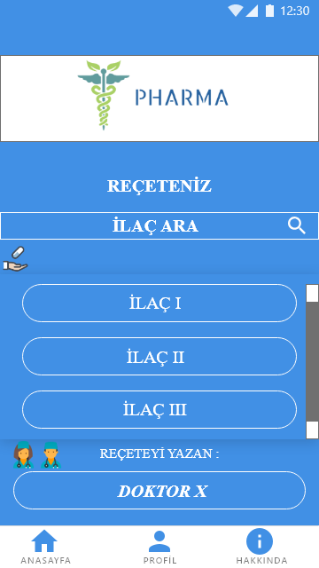

Figure 4.10 Prescription Page

After doctor clicks, app shows the medicines written by the doctor and s/he can search by medicine’s name.

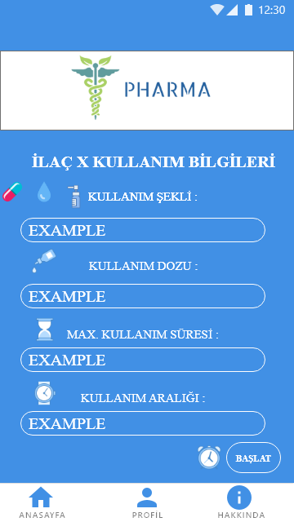

Figure 4.11 Medicine’s Detail Page

After selecting the medicine, user sees usage informations of medicine. These are usage range of medicine, usage way of medicine, usage dose of medicine and if any max usage period of medicine.

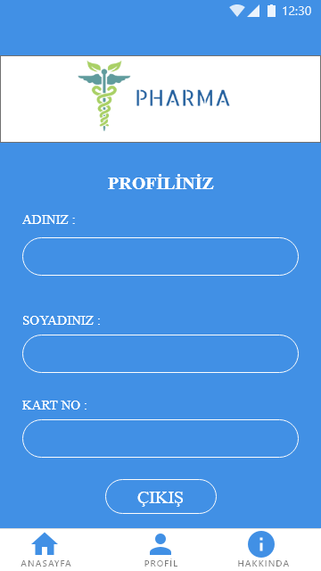

Figure 4.12 Profile Page

The user can log out in profile page and s/he can see name, surname and T.C ID number.

# CONCLUSIONS

At the end of the project, we were able to show to people how medicines are consumed consciously and writing prescription which make easier with IoT. With this project, how to use the medicine of patients, when to use it and how often to use it with the mobile App to provide easy way to reach. **Pharma** is a consumer-oriented project.

# REFERENCES

* <https://create.arduino.cc/projecthub/coderscafe/automated-simple-pendulum-7c5bc3>
* <https://iotbyhvm.ooo/arduino-ide/>
* <https://docs.microsoft.com/en-us/visualstudio/get-started/visual-studio-ide?view>
* <https://meterpreter.org/android-studio/>
* <https://www.reachengine.com/partners/microsoft-azure/>
* <https://itopsec.com/sql-server/>