

**ENGINEERING** ​**FACULTY**​

**Department** ​ **of**​ ​ **Computer**​ ​ **Engineering**​

**SENIOR ​PROJECT​**

**REPORT**

**PHARMA**

31018108372 Gülşah Şahin

56866369638 Özgür Hasan Aytar

54388288130 Tuğba Öztürk

**Dr. Lec. Üyesi Alper Kürşat UYSAL**

* Users Login



The desktop application is available for three different users.For admin, doctors and pharmacist.

* Admin,Docktor and Pharmacist Login Page

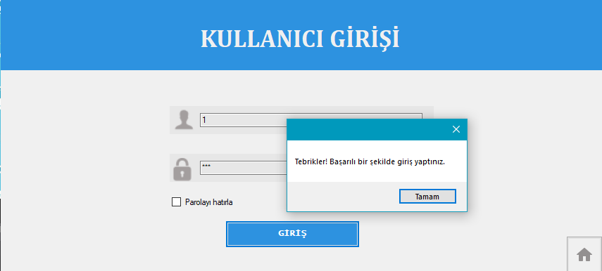

Each user logs in with own tc ID number and the password own has set in advance.

* Admin Page

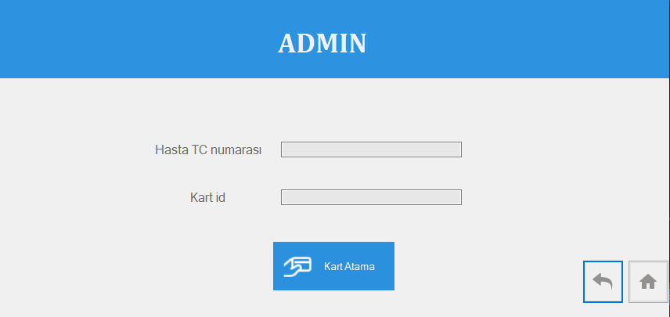

Admin identifies the card to the patients in the admin page.

* Pharmacist Page

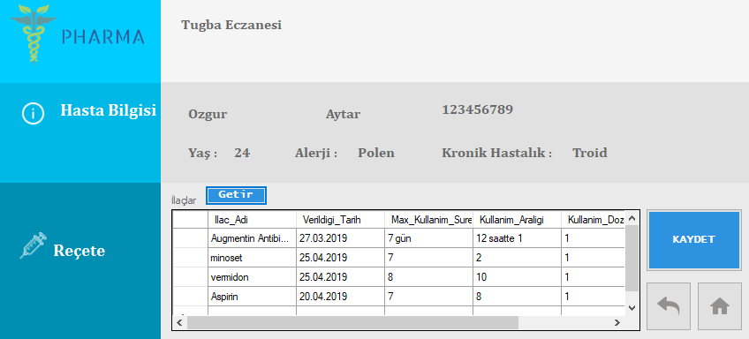

On the pharmacist's page, after patient scan the tc id card, the pharmacist sees the patient's medication information and records the medications sold.

* Doctor Page

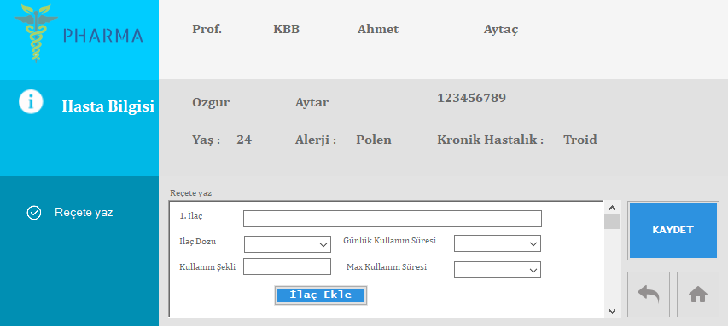

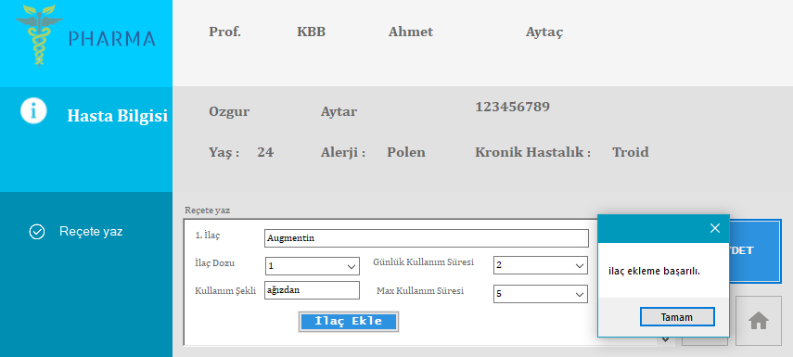

On the doctor's page, the doctor can see the patient's information and write the medication.

**Project Milestone Chart**

This table shows planned deadlines of the design, programming and test steps. Project deadline is assumed end of 2018-2019 Spring term.

|  |  |  |  |  |
| --- | --- | --- | --- | --- |
|  | **February** | **March** | **April** | **May** |
| **Research** |  |  |  |  |
| **Design** |  |  |  |  |
| Desktop Design |  |  |  |  |
| Mobile Design |  |  |  |  |
| Database Design |  |  |  |  |
| Arduino Analysis |  |  |  |  |
| UI Analysis |  |  |  |  |
| Algorithm Analysis |  |  |  |  |
| **Programming** |  |  |  |  |
| Arduino Programming |  |  |  |  |
| Database Programming |  |  |  |  |
| UI Programming |  |  |  |  |
| Algorithm Programming |  |  |  |  |
| **Test** |  |  |  |  |
| **Deploy** |  |  |  |  |
| **Deadline** |  |  |  |  |