

**ENGINEERING** ​**FACULTY**​

**Department** ​ **of**​ ​ **Computer**​ ​ **Engineering**​

**SENIOR ​PROJECT​**

**REPORT**

**PHARMA**

31018108372 Gülşah Şahin

56866369638 Özgür Hasan Aytar

54388288130 Tuğba Öztürk

**Dr. Lec. Üyesi Alper Kürşat UYSAL**

CONTENTS

1. **ABSTRACT1**
2. **PROJECT**​ ​**SUMMARY1**
   1. Motivation1
   2. Definition1
   3. Goal of Project1
   4. Scope​ ​of​ ​Project1
3. **REQUIREMENTS2**
   1. Project Requirements2
      1. Background​ ​Knowledge​ ​Technology​ Requirements2
   2. Functional​ ​Requirements​3
   3. Non-Functional Requirements3
      1. Performance3
      2. Scalability3
      3. Security3
      4. Maintainability4
      5. Usability4
      6. Availability4
      7. Data Integrity4
4. **RESPONSIBILITIES4**
5. **MANAGEMENT** **SUMMARY4**
   1. Planning4
   2. Project Milestone Chart5
6. **CONCEPTUAL** **DESIGN6**
   1. Mobile Application’s Design6
   2. Desktop Application’s Design9
7. **REFERENCES12**
8. **ABSTRACT**

Our project makes efficient bridge between doctor, patient and pharmacy. This project provides various benefits to people. The most important benefits of the project is that avoid to use incorrect medicine which is thesis of BIM437 Computer Engineering Design. Below the following titles there are details about the project, requirements, first conceptual design and management summary of the project.

1. **PROJECT** **SUMMARY**
   1. **Motivation**

Advancing technology has a positive impact on people’s lives day by day. Especially the internet of things (IoT) is becoming an increasingly growing topic of conversation both in the workplace and outside of it. Therefore our motivation is to integrate the Internet of Things (IoT) into the health field. One of its benefits of the project is that doctors can transmit an electronic prescription to a pharmacy directly from the internet of things (IoT). Also patients can reach own prescription.

* 1. **Definition**

Our main aim is to inform the patients about the medicines they will use. The patients will be able to access to usage range of medicine, usage way of medicine, usage dose of medicine and if any max usage period of medicine from own mobile application without the need doctor's and pharmacist's information.We have two application for this project. This project includes one desktop application and one mobile application. We will use Microsoft Visual Studio for desktop application. In the desktop application we have three different login page. Doctors , pharmacists and admins will be able to use to our desktop application. After doctors log into the desktop application , patients will scan own card then doctor will be able to see patients information like name, surname , age and also extra information like allergy and chronic illness. And doctors will be able to prescribe to patients in this our desktop application. Pharmacists will be able to reach the medicine, prescribed by doctors after patients scan own card.Admins will be able to add a new patients information into the system. And admins can update patients information. According to the medicine period determined by the doctor goes to the patient notification from the mobile application. Patients can start this period at any time. The patients can see the medicine written by the doctors before, on a separate page. Also patients can see own information on a seperate page. We can take id of new TC ID card. In this project, patients can use a new TC ID card. In this way, patients do not need to provide new card.

* 1. **Goal of Project**

With this project, how to use the medicine of patients, when to use it and how often to use it with the mobile application to provide easy way to reach.

* 1. **Scope of Project**

The purpose of this project is to enable patients to use medicine in a more informed manner. The other purpose of this project is to minimize the problems that may arise from unconsciously used medicine.

1. **REQUIREMENTS**
   1. **Project Requirements**
      1. ***Background Knowledge Technology Requirements***

**Arduino UNO :** is an open-source microcontroller board based on the Microchip ATmega328P microcontroller and developed by Arduino.cc. The board is equipped with sets of digital and analog input/output (I/O) pins that may be interfaced to various expansion boards (shields) and other circuits. The board has 14 Digital pins, 6 Analog pins, and programmable with the Arduino IDE (Integrated Development Environment) via a type B USB cable.

**Arduino IDE :** is a cross-platform application (for Windows, macOS, Linux) that is written in the programming language Java. It is used to write and upload programs to Arduino board.

**Microsoft Visual Studio** **:** is an integrated development environment (IDE) from Microsoft. It is used to develop computer programs, as well as websites, web apps, web services and mobile apps. It can produce both nativecode and managed code.

**Microsoft Azure SQL Database :** is a database that runs on a cloud computing platform, and access to it is provided as a service. Managed database services take care of scalability, backup, and high availability of the database. It includes built-in intelligence that learns app patterns and adapts to maximize performance, reliability, and data protection.

**Microsoft SQL Server :** is a relational database management system developed by Microsoft. As a database server, it is a software product with the primary function of storing and retrieving data as requested by other software applications—which may run either on the same computer or on another computer across a network (including the Internet).

**Android Studio :** is the official integrated development environment (IDE) for Google's Android operating system, built on JetBrains' IntelliJ IDEA software and designed specifically for Android development. It is available for download on Windows, macOS and Linux based operating systems. It is a replacement for the Eclipse Android Development Tools (ADT) as the primary IDE for native Android application development.

* 1. **Functional Requirements**
  + There are one desktop application and one mobile application.
  + Desktop application consist of three different login page. These are for admin, doctor and pharmacy.
  + Admin page consist of assign cards to patients and update patient’s informations
  + After scanning the card, doctor can write prescription with usage informations.
  + Doctor can see information of patient.
  + After scanning the card, pharmacist can reach prescription.
  + Pharmacist marks the medicine he/she gives his/her medicine.
  + Patients can login with his/her id number and password into the mobile application.
  + Patients can reach own prescription.
  + Patients can read usage informations of own medicines.
  + The application send notification to patients for information about own medicine.
  1. **Non-Functional Requirements**
     1. ***Performance***

1. The desktop application works by reading a card from Arduino, therefore there is definite time required to read the tag.
2. For the database, managing and tuning the performance of relational databases takes expertise and time. Query Performance Insight is a part of the Azure SQL Database intelligent performance product line. It helps you spend less time troubleshooting database performance.
3. For the mobile application Android Studio's Instant Run feature pushes code and resource changes to our running app. It intelligently understands the changes and often delivers them without restarting our app or rebuilding our APK, so we can see the effects immediately.
   * 1. ***Scalability***

Hospitals, pharmacies and the citizens will use our application. There is no limitation of user. That’s why, the scalability of the system will be high.

* + 1. ***Security***

Users's informations are one of the most important about security, therefore we will only use necessary permissions, and pay attention to permissions our libraries may use.

* + 1. ***Maintainability***

We will test how we can abstract the interaction using a pattern that enables us to write better maintainable code.

* + 1. ***Usability***

Easy-to-use and user-friendly logic will be used and icon selections will be for general understanding.

* + 1. ***Availability***

Our mobile application will be written for Android 4.0 or higher versions so users those want to use our application should have a smart phone that operates Android 4.0 or higher. Our desktop application supports Windows OS.

* + 1. ***Data Integrity***

Administrators create or remove cards and assign cards to users by accessing the database and updating the data. We provide data integrity during the update and deletion by successfully registering the data.

1. **RESPONSIBILITIES**

We plan to do our project together by using equal time and workforce in every step.

1. **MANAGEMENT SUMMARY**
   1. **Planning**

* We created a project idea and we scoped this project idea.
* We have researched about the technologies we will use.
* We created user diagram, class diagram and requirement list for this project.
* We started working on design. We have researched to make the design useful for user.
* We planned to programming language which we will use.
  1. **Project Milestone Chart**

This table shows planned deadlines of the design, programming and test steps. Project deadline is assumed end of 2018-2019 Spring term.

|  |  |  |  |  |
| --- | --- | --- | --- | --- |
|  | **February** | **March** | **April** | **May** |
| **Research** |  |  |  |  |
| **Design** |  |  |  |  |
| Desktop Design |  |  |  |  |
| Mobile Design |  |  |  |  |
| Database Design |  |  |  |  |
| Arduino Analysis |  |  |  |  |
| UI Analysis |  |  |  |  |
| Algorithm Analysis |  |  |  |  |
| **Programming** |  |  |  |  |
| Arduino Programming |  |  |  |  |
| Database Programming |  |  |  |  |
| UI Programming |  |  |  |  |
| Algorithm Programming |  |  |  |  |
| **Test** |  |  |  |  |
| **Deploy** |  |  |  |  |
| **Deadline** |  |  |  |  |

1. **CONCEPTUAL DESIGN** 
   1. **MOBILE APPLICATION’S DESIGN**

This screenshots belong to our mobile application in android studio.

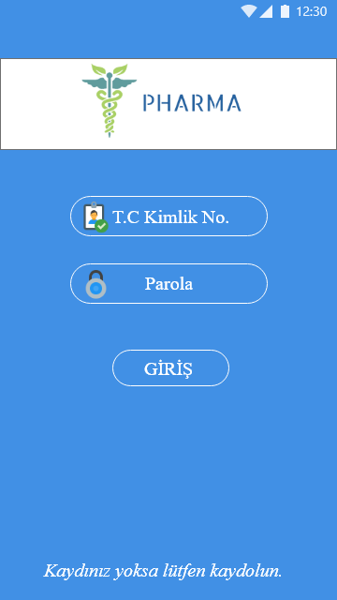

Figure 1. Login Page

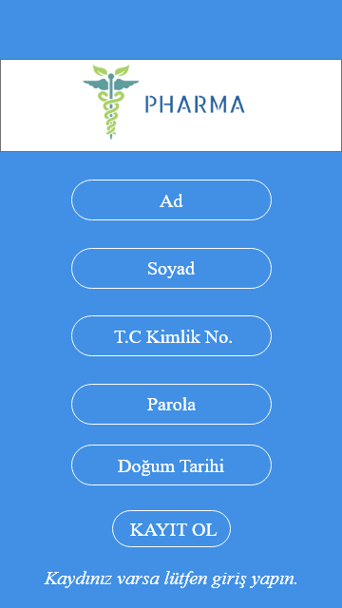

Figure 2. Sign Up Page

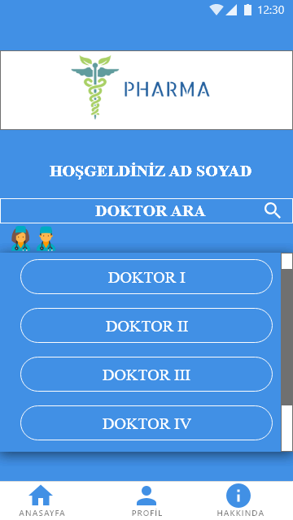

Figure 3. Main Page

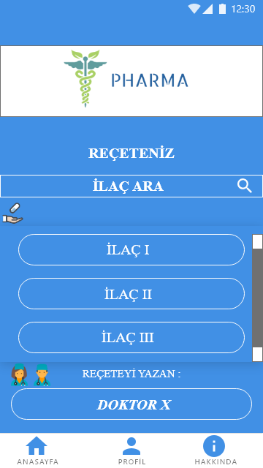

Figure 4. Prescription Page

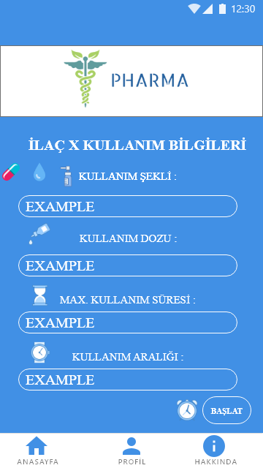

Figure 5. Medicine Info Page

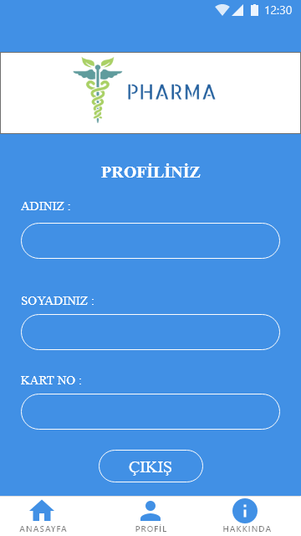

Figure 6. Profile Page

* 1. **DESKTOP APPLICATION’S DESIGN**

This screenshots belong to our desktop application in visual studio windows form.

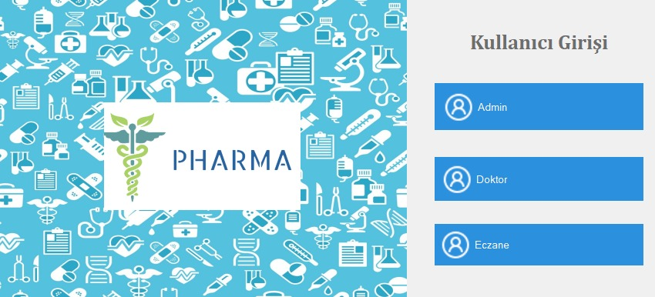

Figure 7. User Page

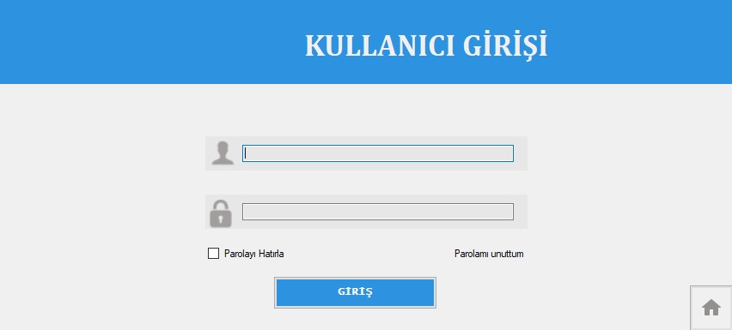

Figure 8. Login Page

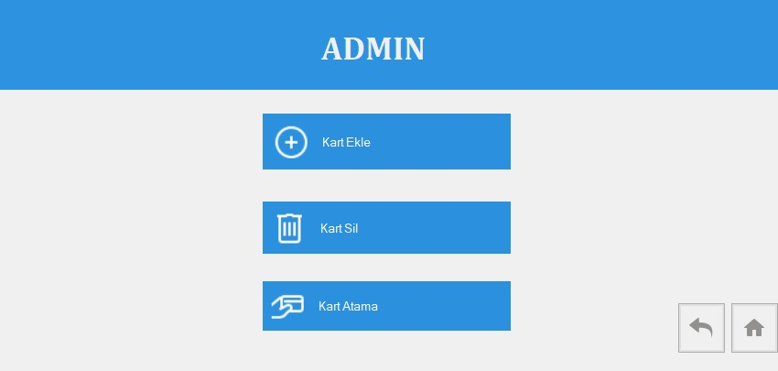

Figure 9. Admin Page

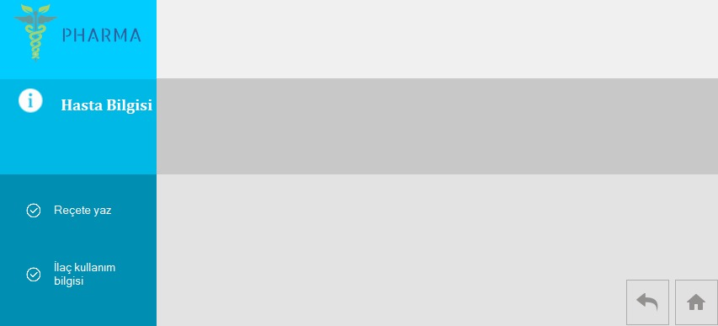

Figure 10. Doctor Page

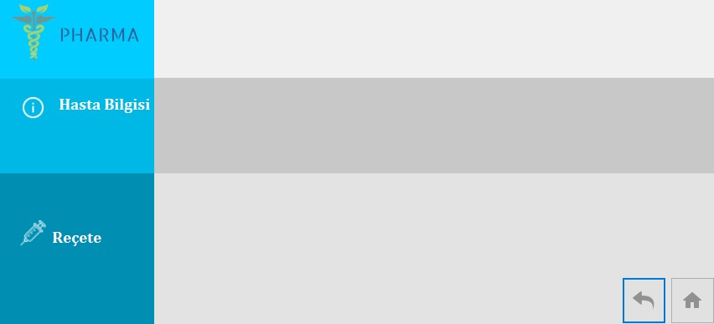

Figure 11. Prescribing Page

1. **REFERENCES**

* <https://developer.android.com/studio/features>
* <http://www.wikizeroo.net/>
* <https://fluentbytes.com/maintainable-test-automation-for-winforms-using-codedui/>
* <https://docs.microsoft.com/nb-no/azure/sql-database/sql-database-query-performance>
* <https://helpx.adobe.com/xd/tutorials.html>
* <https://maker.robotistan.com/arduino-dersleri-18-rc522-rfid-modul-kullanimi/>