ESKİSEHİR TECHICAL UNİVERSITY

FACULTY OF ENGINEERING



PHARMA

Özgür Hasan Aytar
Tuğba Öztürk
Gülşah Şahin

A Bachelor of Science Project

Department of Computer Engineering

May 2019
PHARMA

by
Özgür Hasan Aytar
(56866369638)

Tuğba Öztürk
(54388288130)

Gülşah Şahin
(31018108372)

Submitted in partial fulfillment of the requirements for the degree of Bachelor of Science in Computer Engineering is approved by the following scientific committee members.

Date of Approval : May 16, 2019

Member (Advisor) : Lect. Dr. Alper Kürşat Uysal

Member :Lect. Dr. Sevcan Yılmaz Gündüz

Member :Lect. Özgür Özşen

ABSTRACT

Our project makes efficient bridge between doctor, patient and pharmacy. This project provides various benefits to people. We aim to make the recipe system easier. This project enables patients to use the medicine more consciously. Minimizes the problems that may arise from unconsciously used medicine. The most important benefits of the project is that avoid to use incorrect medicine which is thesis of BIM437 Computer Engineering Design. Below the following titles there are details about the project, requirements, first conceptual design and management summary of the project..

Keywords: pharmacy, recipe, use correct medicine

ÖZET

Yanlış ilaç kullanımından dolayı her yıl bir çok insan ilaç direnci kazanmakta ve yaşamını kaybetmektedir. Bu proje ile Dünya Sağlık Örgütünün desteklediği akılcı ilaç kullanımına (AİK) teknolojik gelişmeler ile katkı sağlanmaktadır. Mobil uygulama sayesinde her hastaya ilaç kullanım bilgisi (ilaç saati, kullanım periyodu, ilaç dozu) belirlenen periyodlarla mobil uygulama üzerinden bildirim ile gönderilecektir. Hasta önceki hastalıkları, muayene olduğu doktorlar, kullandığı ilaçlar ve alerjileri hakkında bilgi sahibi olabilecektir.
Projenin diğer bir aşamasında IoT teknolojileri kullanılmıştır. Bir Internet of Things (IoT) ekosistemi, ortamlarından elde ettiği verileri toplamak, göndermek ve üzerinde işlem yapmak için yerleşik işlemcileri, sensörleri ve iletişim donanımlarını kullanan web özellikli akıllı cihazlardan oluşur. Arduino Uno ve Rfid kart okuyucu kullanılarak hasta, doktor, eczacı arasında köprü kurmak amaçlanmıştır. Her hasta sahip olduğu çipli kimlik kartları sayesinde. Doktora veya eczaneye gittiğinde kartını okutabilir. Doktor hastanın bilgilerine (ad, soyad, yaş, önceki hastalıklar, alerji, önceki ilaçlar…)erişebilir. Masaüstü uygulaması üzerinden yeni ilaç yazıp kullanım bilgisi girebilir. Eczacı ise masaüstü uygulamasını kullanarak hastaya yazılan ilaçları görebilir ve ilaç ekleme çıkarma yapabilir. Bu sayede reçete sistemi tek bir çatı altında toplanmış ve daha kolay, kullanışlı ve güvenilir hale gelmesi sağlanmıştır.

Anahtar Kelimeler: AİK, Internet of Things, Rfid, Arduino Uno

ACKNOWLEDGEMENT

We would first like to express our deepest gratitude to our advisor Lect. Dr. Alper Kürşat Uysal whose guidance, encouragement, great wisdom and support provided us to complete our thesis. The door to Instructor KÜRŞAT office was always open whenever we ran into a trouble spot or had a question about our thesis research.

Finally we must express our very profound gratitude to our parents for providing us with unfailing support and continuous encouragement throughout our years of study and through the process of researching and writing this thesis. This accomplishment would not have been possible without them, thank you.
Contents
ABSTRACT i
ÖZET ii
ACKNOWLEDGEMENT iii
Contents iv
ABBREVIATIONS vi
1. INTRODUCTION 1
1.1. Definition 1
1.2. Goal of Project 2
1.3. Scope of Project 2
2. TECHNOLOGIES 3
Arduino Uno 3
Arduino IDE 3
Microsoft Visual Studio 4
Microsoft Azure Sql Database 4
Microsoft Sql Server 5
Android Studio 5
3. CONCEPTUAL DESIGN 6
3.1. Arduino Design 6
3.2. Mobile Application’s Design 7
3.3. Desktop Application’s Design 11
4. REQUIREMENTS 15
4.1. Funtional Requirements 15
4.2. Non-Functional Requirements 15
5. CODE PARTS 16
5.1. Mobile Applications Codes 16
5.2. Desktop Applications Codes: 17
5.3. Arduino Codes 18
6. CONCLUSIONS 19
REFERENCES 20

LIST OF FIGURES
Figure 1.Arduino Uno 10
Figure 2.DB Diagram 5
Figure 3.MFRC522 RFID Reader with Arduino 6
Figure 4.Mobile Login Page 7
Figure 5.Mobile Register Page 7
Figure 6.Mobile Main Page 8
Figure 7.Mobile Prescription Page 8
Figure 8.Mobile Medicine Info Page 9
Figure 9.Mobile User Page 9
Figure 10.Mobile New Password Page 10
Figure 11.Mobile About Page 10
Figure 12.Desktop Users Page 11
Figure 13.Desktop Login Page 11
Figure 14.Desktop Admin Page 12
Figure 15.Desktop Assign Card Page 12
Figure 16.Desktop Doctor Page 13
Figure 17.Desktop Allergy Page 13
Figure 18.Desktop Pharmacy Page 14
Figure 19.Mobile DB Connection 16
Figure 20.Mobile Creating Dynamic Buttons 16
Figure 21.Mobile Push Notification 17
Figure 22.Desktop DB Connection 17
Figure 23.Desktop Serial Port Data Received 17
Figure 24.Arduino Reading RFID 18

ABBREVIATIONS

IoT | Internet of Things
App | Application
SQL | Structured Query Language
AİK | Akılcı İlaç Kullanımı
ADT | Android Development Tools
IDE | Integrated Development Environment

INTRODUCTION

Advancing technology has a positive impact on people’s lives day by day. Especially the internet of things (IoT) is becoming an increasingly growing topic of conversation both in the workplace and outside of it. Therefore our motivation is to integrate the Internet of Things (IoT) into the health field. One of its benefits of the project is that doctors can transmit an electronic prescription to a pharmacy directly from the internet of things (IoT). Also patients can reach own prescription

Definition
Our main aim is to inform the patients about the medicines they will use. The patients will be able to access to usage range of medicine, usage way of medicine, usage dose of medicine and if any max usage period of medicine from own mobile application without the need doctor's and pharmacist's information.We have two application for this project. This project includes one desktop application and one mobile application. We will use Microsoft Visual Studio for desktop application. In the desktop application we have three different login page. Doctors , pharmacists and admins will be able to use to our desktop application. After doctors log into the desktop application , patients will scan own card then doctor will be able to see patients information like name, surname , age and also extra information like allergy and chronic illness. And doctors will be able to prescribe to patients in this our desktop application. Pharmacists will be able to reach the medicine, prescribed by doctors after patients scan own card.Admins will be able to add a new patients information into the system. And admins can update patients information. According to the medicine period determined by the doctor goes to the patient notification from the mobile application. Patients can start this period at any time. The patients can see the medicine written by the doctors before, on a separate page. Also patients can see own information on a seperate page. We can take id of new TC ID card. In this project, patients can use a new TC ID card. In this way, patients do not need to provide new card.

Goal of Project

Our project has two main aim. Our first aim is to prevent the use of wrong medicines through notifications sent from the mobile application. Preventing medicine resistance. To eliminate the damage caused by unconscious medicine use.

Our other purpose is to create a prescription system that is easier and more usable by bringing the patient and the pharmacy together on the same system.

Scope of Project
The purpose of this project is to enable patients to use medicine in a more informed manner. The other purpose of this project is to minimize the problems that may arise from unconsciously used medicine.

TEchnologıes

Arduino Uno

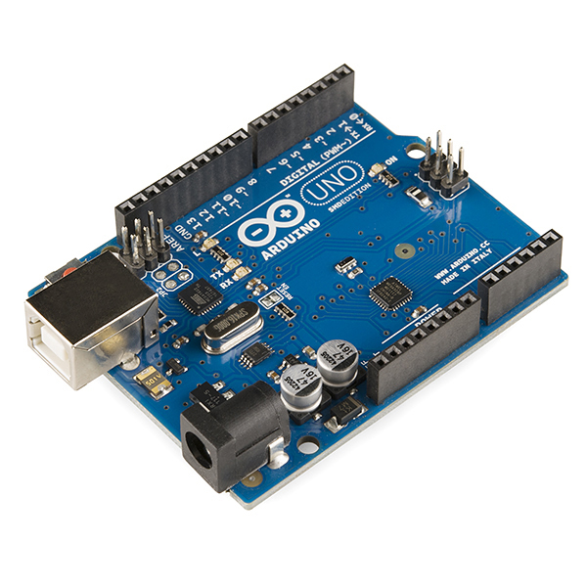
The Arduino UNO is an open-source microcontroller board based on the Microchip ATmega328P microcontroller and developed by Arduino.cc. The board is equipped with sets of digital and analog input/output (I/O) pins that may be interfaced to various expansion boards (shields) and other circuits.The board has 14 Digital pins, 6 Analog pins, and programmable with the Arduino IDE (Integrated Development Environment) via a type B USB cable. It can be powered by a USB cable or by an external 9 volt battery, though it accepts voltages between 7 and 20 volts.
Figure 1.Arduino Uno

Arduino IDE
The Arduino integrated development environment (IDE) is a cross-platform application (for Windows, macOS, Linux) that is written in the programming language Java. It is used to write and upload programs to Arduino compatible boards, but also, with the help of 3rd party cores, other vendor development boards.

The Arduino IDE supports the languages C and C++ using special rules of code structuring. The Arduino IDE supplies a software library from the Wiring project, which provides many common input and output procedures.

Microsoft Visual Studio
Microsoft Visual Studio is an integrated development environment (IDE) from Microsoft. It is used to develop computer programs, as well as websites, web apps, web services and mobile apps. Visual Studio uses Microsoft software development platforms such as Windows API, Windows Forms, Windows Presentation Foundation, Windows Store and Microsoft Silverlight. It can produce both native code and managed code.

Microsoft Azure Sql Database
Microsoft Azure SQL Database [1] is a managed cloud database (SaaS) provided as part of Microsoft Azure.

A cloud database is a database that runs on a cloud computing platform, and access to it is provided as a service. Managed database services take care of scalability, backup, and high availability of the database. Azure SQL Database is a managed database service which is different from AWS RDS which is a container service.

Microsoft Azure SQL Database includes built-in intelligence that learns app patterns and adapts to maximize performance, reliability, and data protection.

Microsoft Sql Server
Microsoft SQL Server is a relational database management system developed by Microsoft. As a database server, it is a software product with the primary function of storing and retrieving data as requested by other software applications—which may run either on the same computer or on another computer across a network.

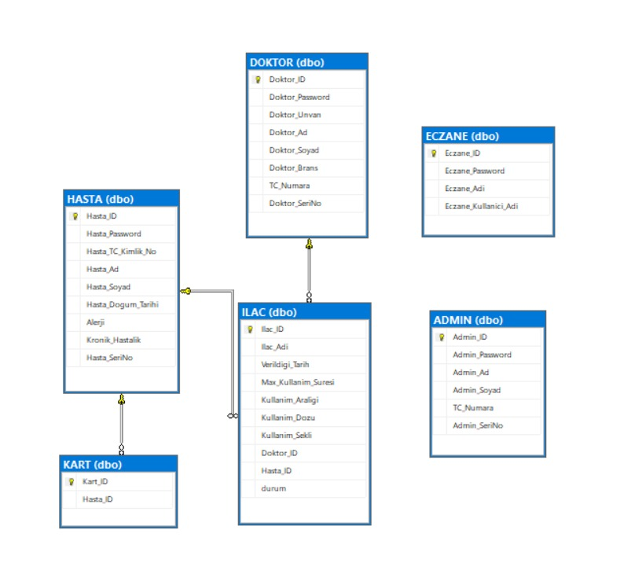

Figure 2.DB Diagram

Android Studio

Android Studio is the official integrated development environment (IDE) for Google's Android operating system, built on JetBrains' IntelliJ IDEA software and designed specifically for Android development. It is available for download on Windows, macOS and Linux based operating systems. It is a replacement for the Eclipse Android Development Tools (ADT) as the primary IDE for native Android application development.

CONCEPTUAL DESIGN

Arduino Design
RFID means radio-frequency identification. RFID uses electromagnetic fields to transfer data over short distances. RFID is useful to identify people, to make transactions, etc…

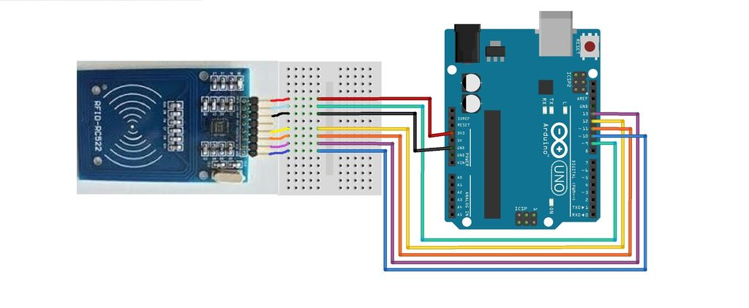
Figure 3.MFRC522 RFID Reader with Arduino

Mobile Application’s Design
This screenshots belong to our mobile application in android studio.
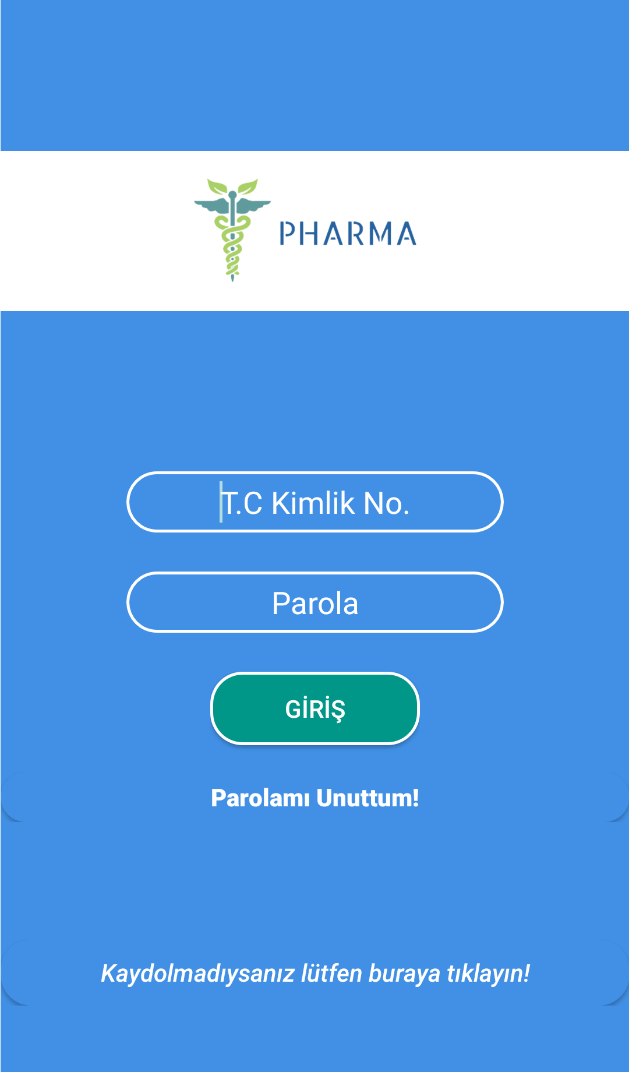
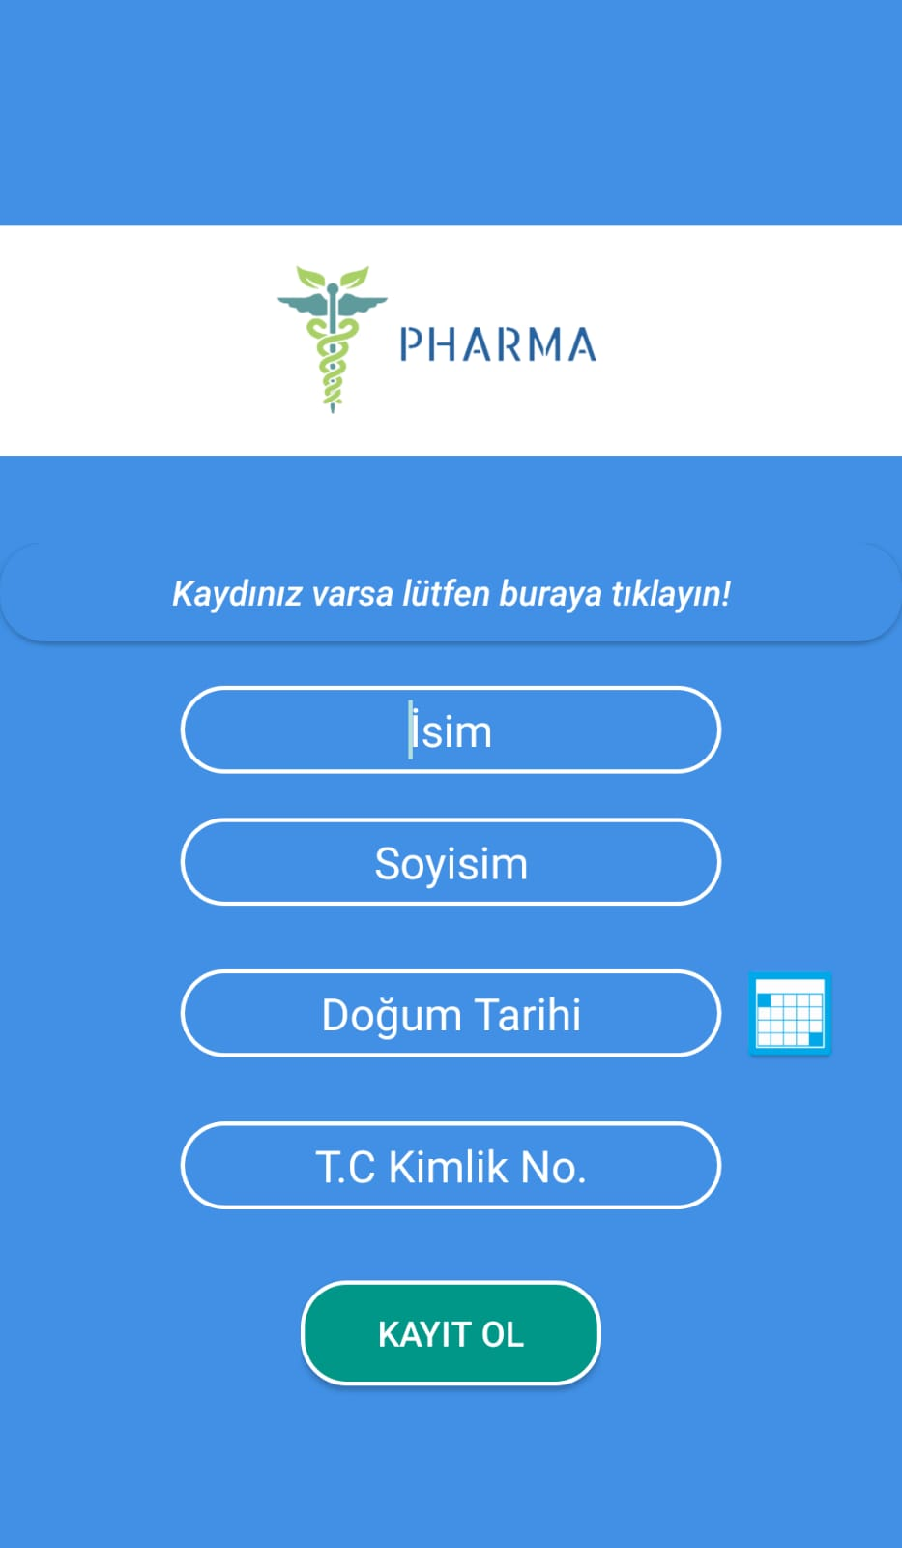

Figure 4.Mobile Login Page
Figure 5.Mobile Register Page

Figure 3.1 Login Page:
The patient who has previously registered the system can enter the system with his / her ID number and password.

Figure 3.1.2 Sign up Page:
Patient name, surname, birth date, ID number can be registered with the system information.

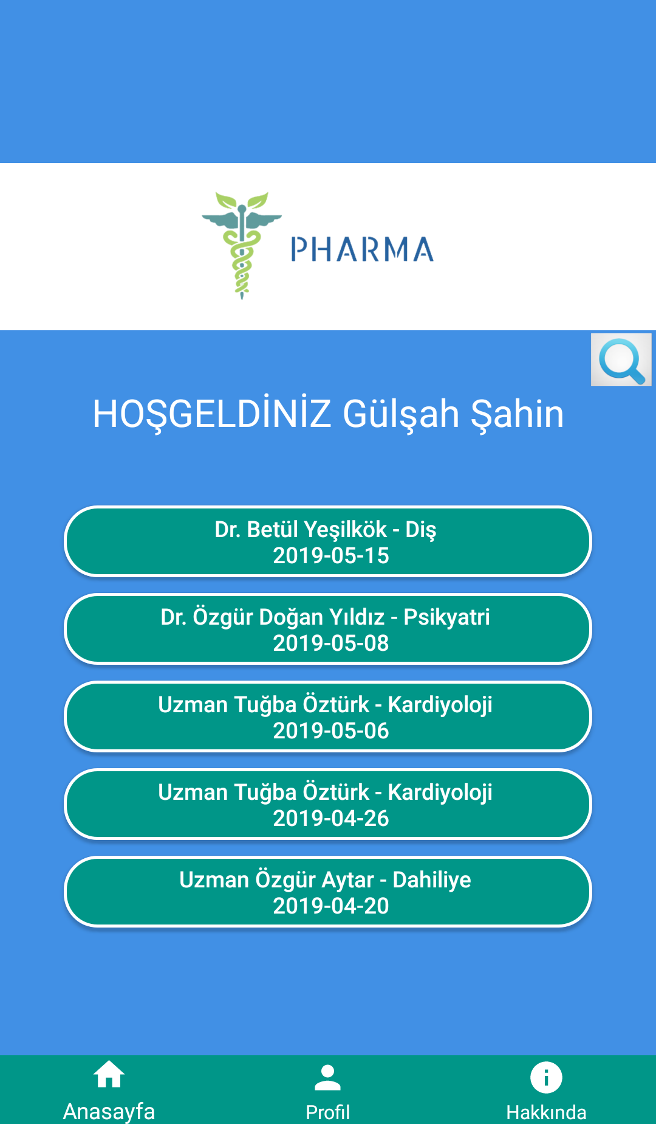
Figure 6.Mobile Main Page
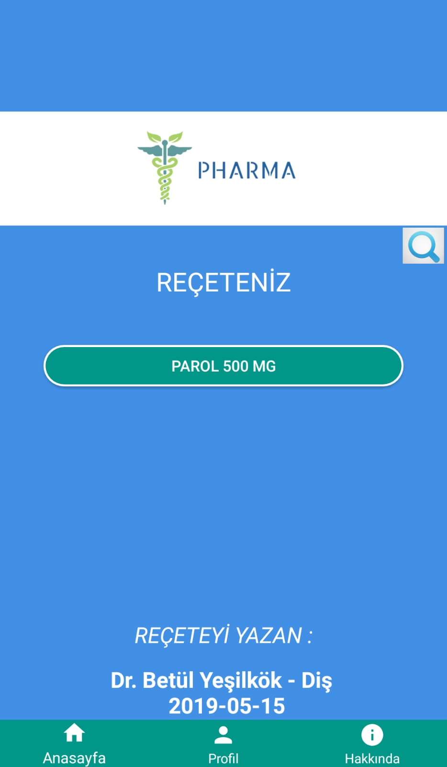
Figure 7.Mobile Prescription Page

Figure 8.Mobile Main Page:
The patient can see the doctors who have been inspectioned before.

Figure 9.Mobile Prescription Page:
The patient can see the medications written by the doctor he chooses on this page.

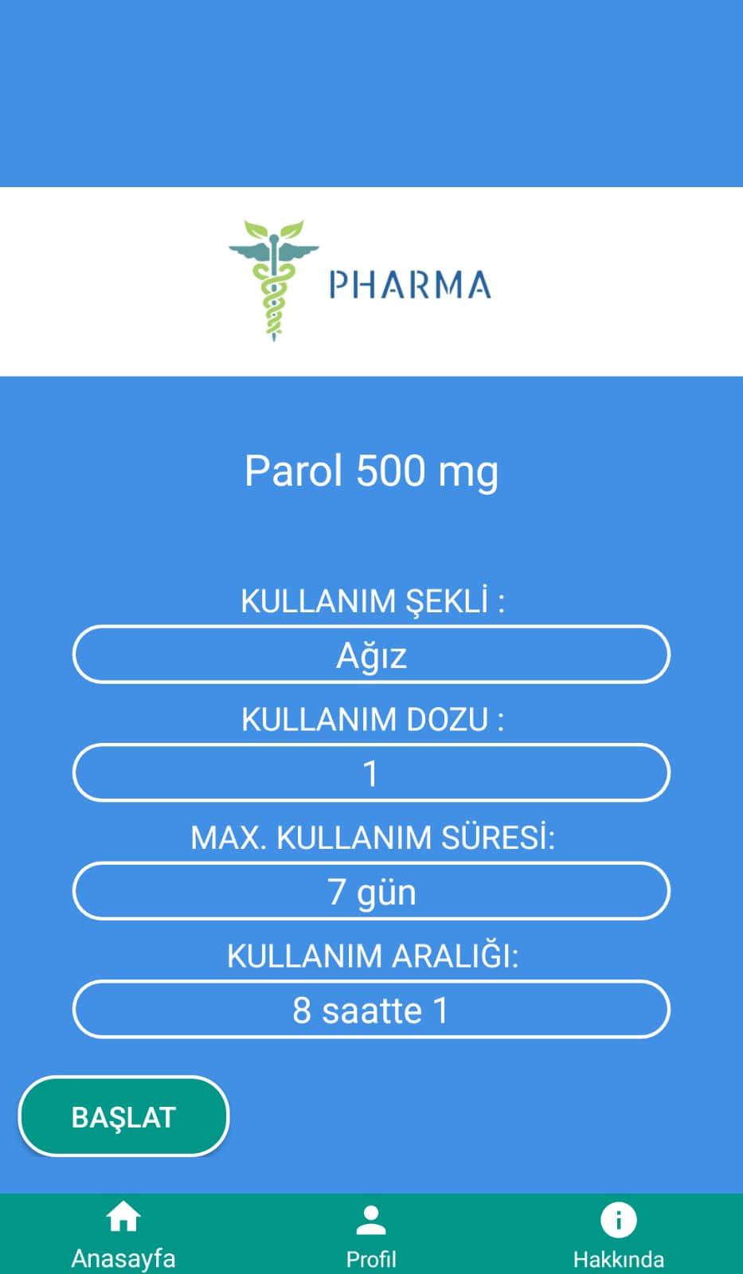
Figure 10.Mobile Medicine Info Page
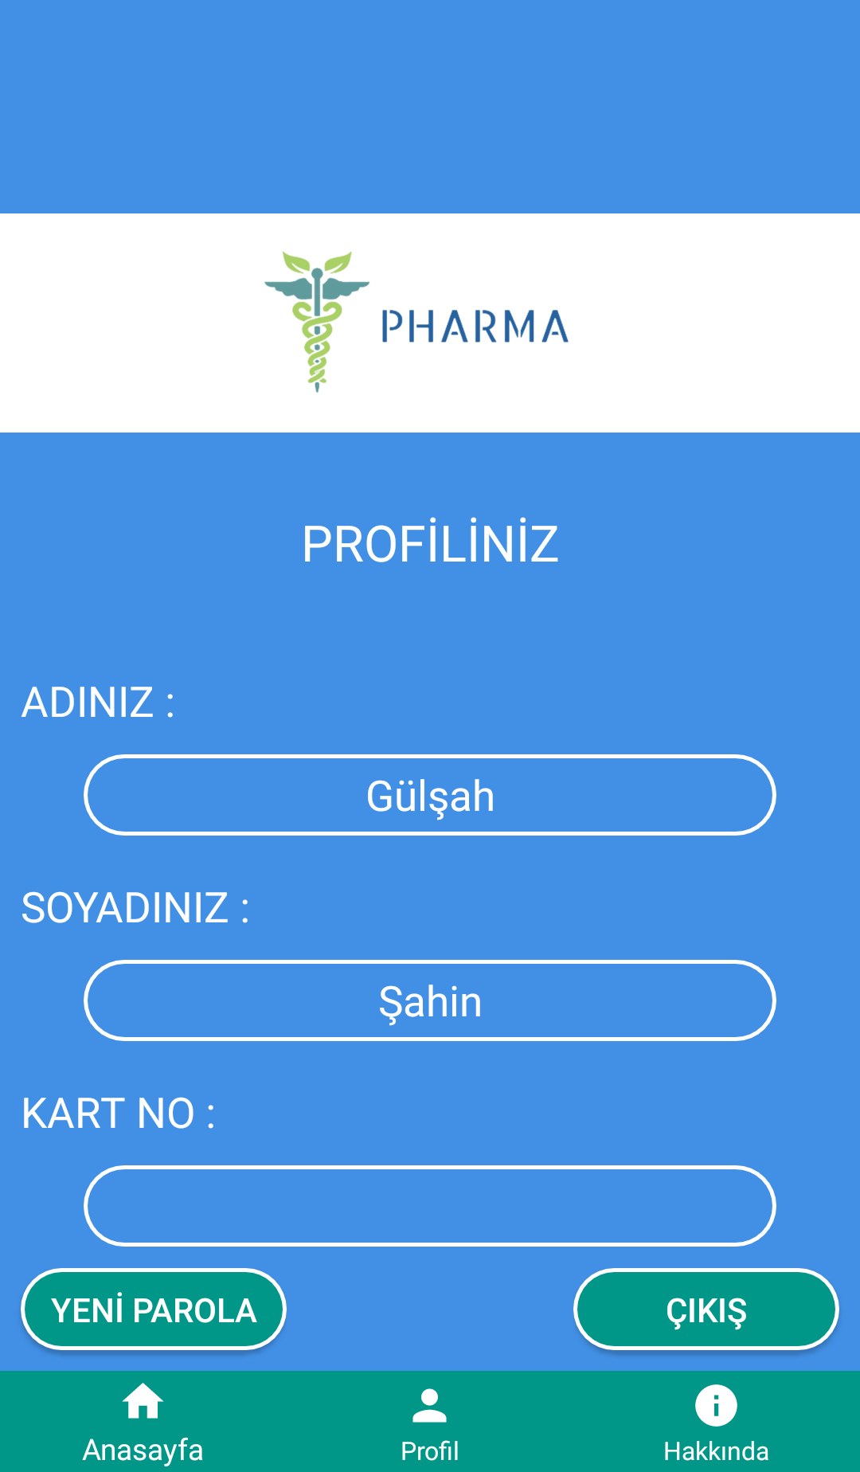
Figure 11.Mobile User Page

Figure 12.Mobile Medicine Info Page:
On this page, the patient can learn the usage dose, usage type, maximum usage time and usage interval of the medicine he / she chooses. It can initiate the notification stopwatch when the medicine starts.

Figure 13.Mobile User Page:
The patient can see their personal information on this page.

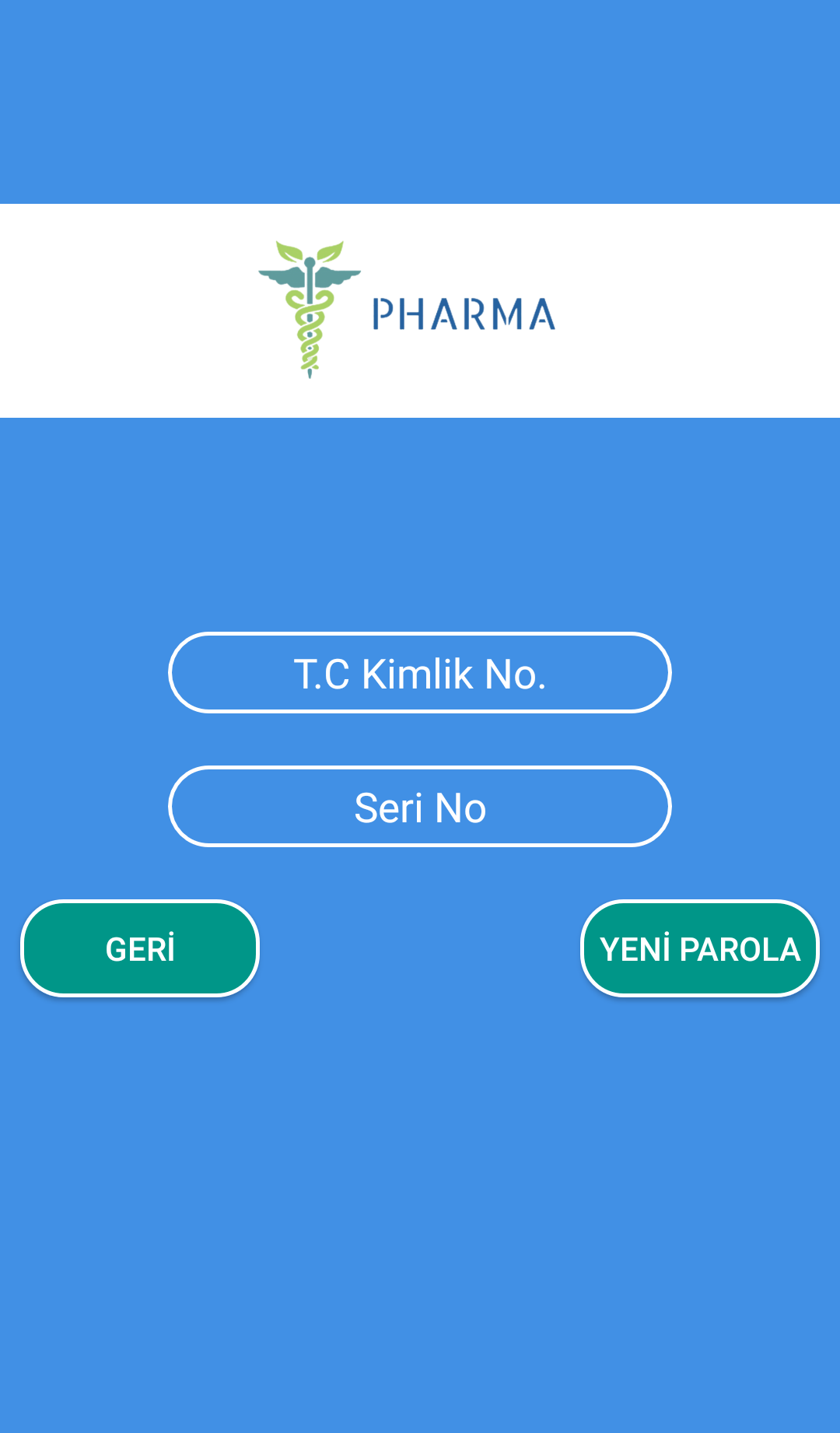
Figure 14.Mobile New Password Page
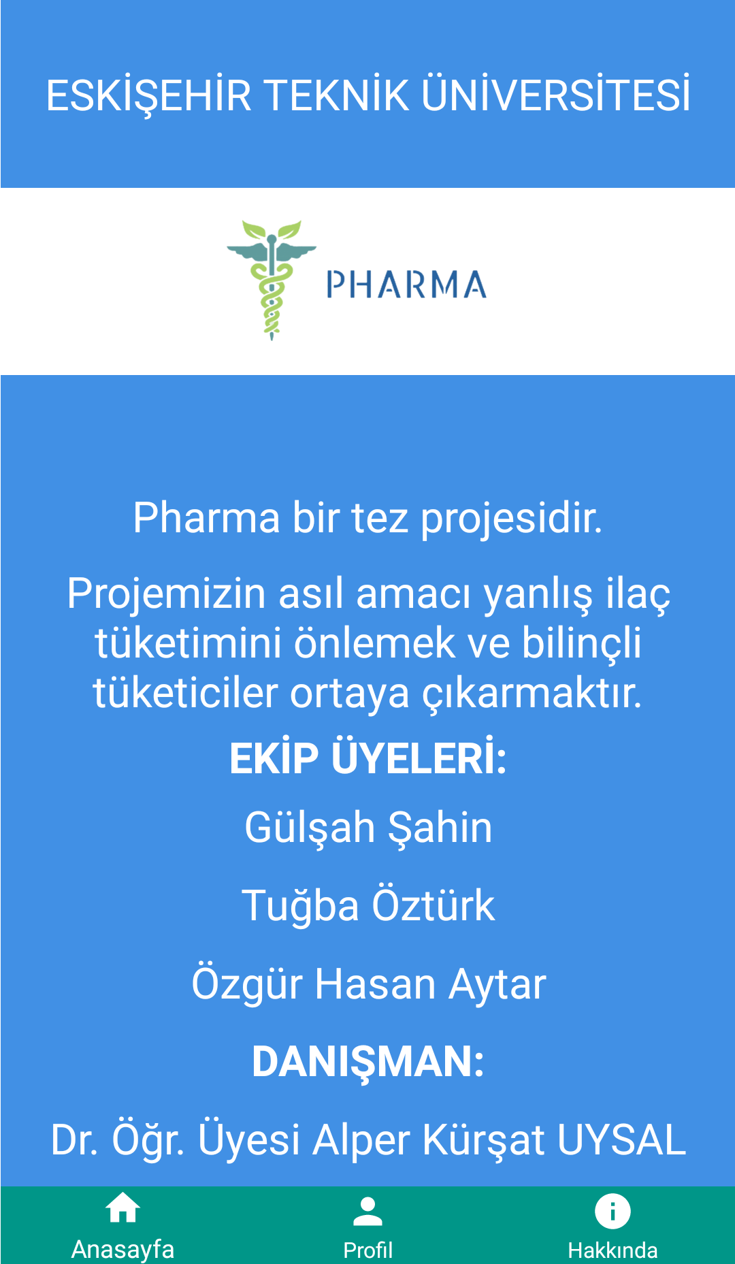
Figure 15.Mobile About Page

Figure 16.Mobile New Password Page:
If the patient forgets the password, you can re-enter the password by entering the serial number and new password.

Desktop Application’s Design

This screenshots belong to our desktop application in visual studio windows form.
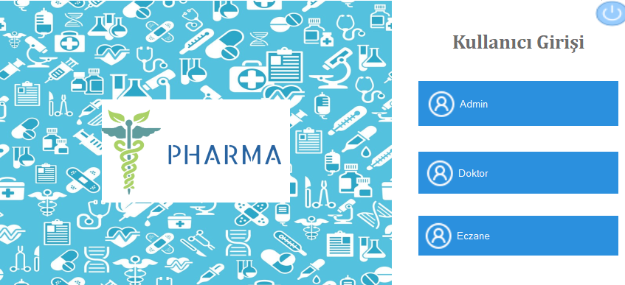
Figure 17.Desktop Users Page

The desktop App is available for three different users. These are admin, doctors and pharmacist.

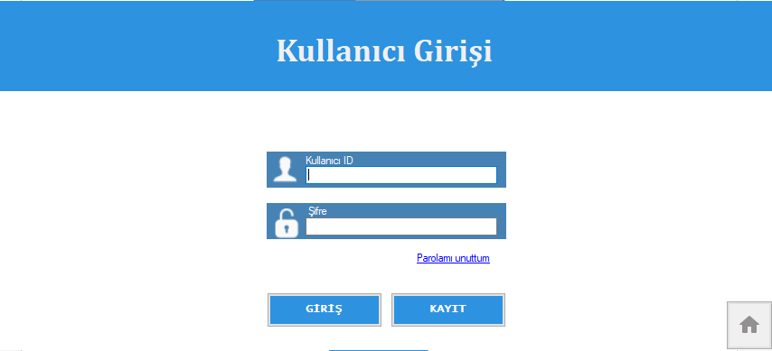
Figure 18.Desktop Login Page

Figure 19.Desktop Login Page:
Each user logs in with own T.C ID number and the password own has set in advance.
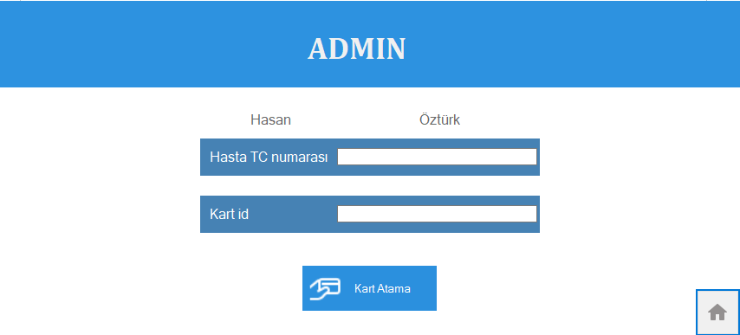
Figure 20.Desktop Admin Page

Figure 21.Desktop Admin Page:
Admin identifies the card to the patients in the admin page.

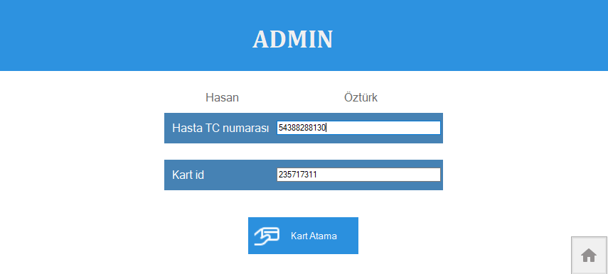
Figure 22.Desktop Assign Card Page

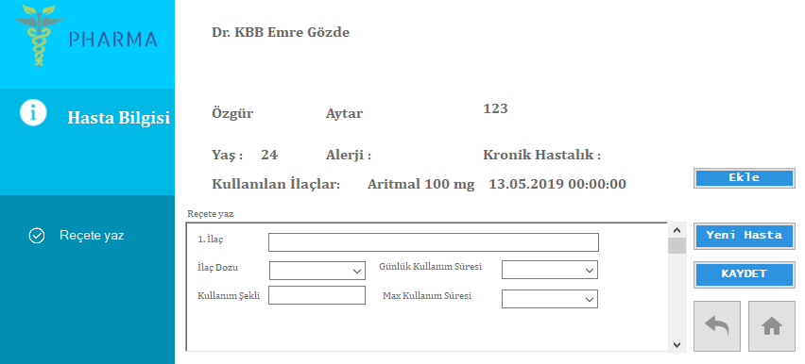
Figure 23.Desktop Doctor Page

On the doctor's page, the doctor can see the patient's information and write the medication.

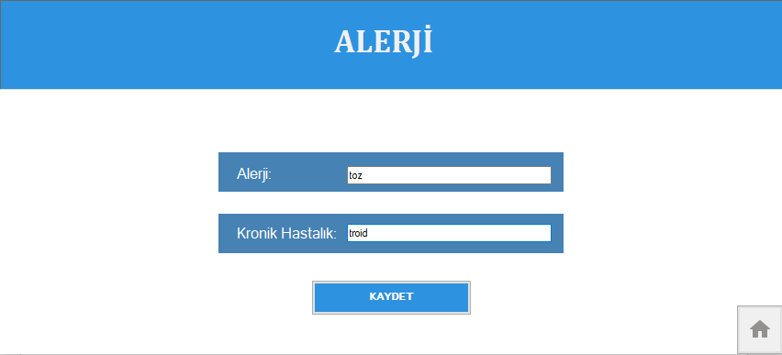
Figure 24.Desktop Allergy Page

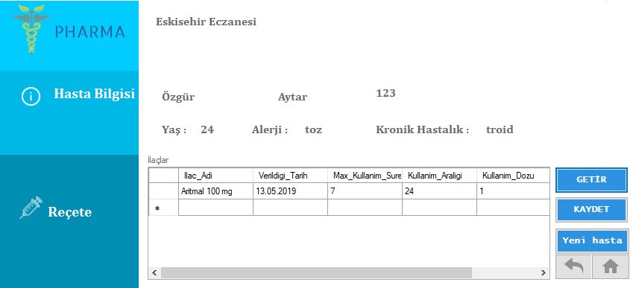
Figure 25.Desktop Pharmacy Page

Figure 26.Desktop Pharmacy Page:
On the pharmacist's page, after patient scan the T.C ID card, the pharmacist sees the patient's medication information and records the medications sold.

REQUIREMENTS

Funtional Requirements
  - There are one desktop application and one mobile application.
  - Desktop application consist of three different login page. These are for admin, doctor and pharmacy.
  - Admin page consist of assign cards to patients and update patient’s informations
  - After scanning the card, doctor can write prescription with usage informations.
  - Doctor can see information of patient.
  - After scanning the card, pharmacist can reach prescription.
  - Pharmacist marks the medicine he/she gives his/her medicine.
  - Patients can login with his/her id number and password into the mobile application.
  - Patients can reach own prescription.
  - Patients can read usage informations of own medicines.
  - The application send notification to patients for information about own medicine.

Non-Functional Requirements
- The desktop application works by reading a card from Arduino, therefore there is definite time required to read the tag.
- For the database, managing and tuning the performance of relational databases takes expertise and time. Query Performance Insight is a part of the Azure SQL Database intelligent performance product line. It helps you spend less time troubleshooting database performance.
- For the mobile application Android Studio's Instant Run feature pushes code and resource changes to our running app. It intelligently understands the changes and often delivers them without restarting our app or rebuilding our APK, so we can see the effects immediately.

CODE PARTS

Mobile Applications Codes

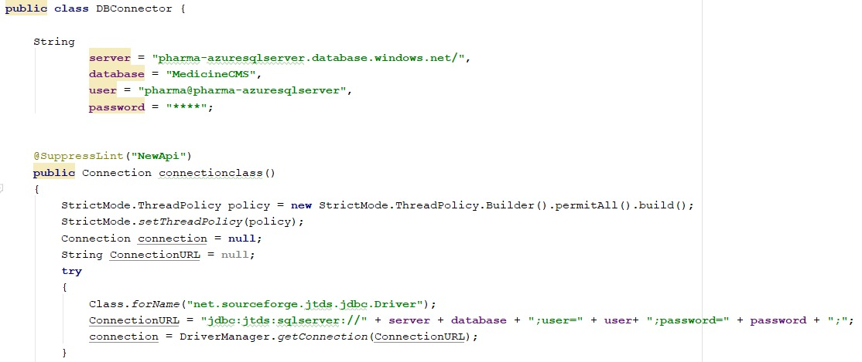
Figure 27.Mobile DB Connection

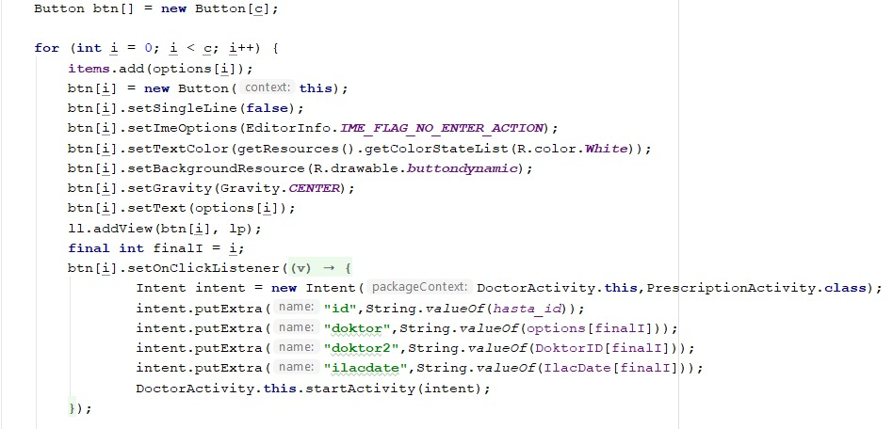
Figure 28.Mobile Creating Dynamic Buttons

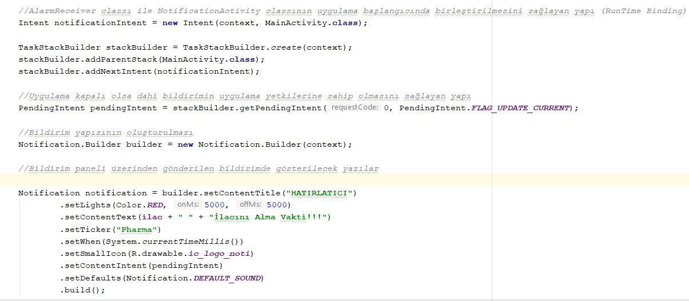
Figure 29.Mobile Push Notification

Desktop Applications Codes:

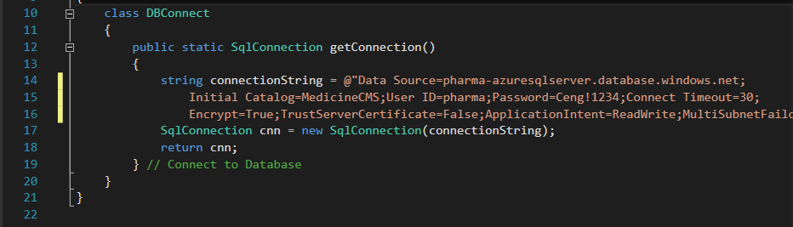
Figure 30.Desktop DB Connection

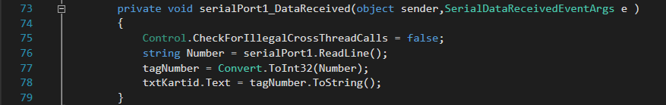
Figure 31.Desktop Serial Port Data Received

Arduino Codes

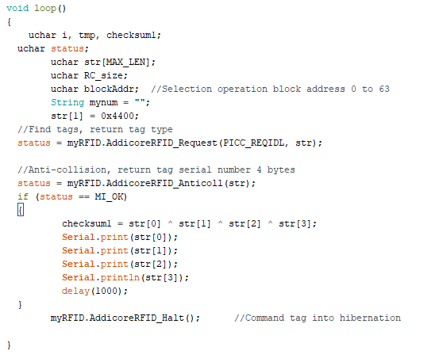
Figure 32.Arduino Reading RFID

CONCLUSIONS

The Pharma project has been shown to make the recipe system more useful. Doctor, patient and pharmacy has been collected in a single system. Even if the patients forget the recipe numbers on the paper, they could get rid of the prescription system by their chip cards.
In this project, the use of false medicines was prevented by notifications sent from the mobile application. Prevented medicine resistance, deaths and diseases caused by incorrect medicine.

REFERENCES

- https://developer.android.com/studio/features
- http://www.wikizeroo.net/
- https://fluentbytes.com/maintainable-test-automation-for-winforms-using-codedui/
- https://docs.microsoft.com/nb-no/azure/sql-database/sql-database-query-performance
- https://helpx.adobe.com/xd/tutorials.html
- https://maker.robotistan.com/arduino-dersleri-18-rc522-rfid-modul-kullanimi/
- https://play.google.com/store/apps/

