VISOKA ŠKOLA STRUKOVNIH STUDIJA

ZA INFORMACIONE I KOMUNIKACIONE TEHNOLOGIJE

INTERNET TEHNOLOGIJE

**DIGITALNA GALERIJA FOTOGRAFIJA u LARAVEL-U**

Z a v r š n i r a d

Mentor: Student:

Dr Nenad Kojić, dipl. inž. Miloš Medić 130/14

Beograd, 2018.

VISOKA ŠKOLA STRUKOVNIH STUDIJA

ZA INFORMACIONE I KOMUNIKACIONE TEHNOLOGIJE

INTERNET TEHNOLOGIJE

Predmet: Web programiranje-PHP2

Tema: **DIGITALNA GALERIJA FOTOGRAFIJA U LARAVEL-U**

Ocena ___ ( )

Članovi komisije:

1. ______________________
2. ______________________
3. ______________________

**SADRŽAJ**

1. UVOD 6

2. RADNO OKRUŽENJE 7

3. ORGANIZACIJA 8

3.1 Organizaciona šema 8

3.2 Stranice 9

3.2.1 “Početna” stranica 9

3.2.2 “Prijava” stranica 10

3.2.3 “Registracija” stranica 11

3.2.4 “Kako učestvovati“ stranica 12

3.2.5 “Pobednici” stranica 13

3.2.6 “Galerija” stranica 14

3.2.7 “Prijavi rad” stranica 15

3.2.8 “Prijavi rad” stranica – prvi deo 16

3.2.9 “Prijavi rad” stranica – drugi deo 17

3.2.10 “Prijavi rad” stranica – treći deo 18

3.2.11 “Pojedinačni prikaz slike” stranica 19

3.2.12 “Admin – početna” stranica 20

3.2.13 “Admin - ciklusi” stranica 21

3.2.14 “Admin - korisnici” stranica 22

3.2.15 “Admin - galerija” stranica 23

4. KODOVI 24

4.1 Kontroleri 24

4.1.1 HomeController.php 24

4.1.2 GalleryShareController.php 25

4.1.3 GalleryApi.php 26

4.1.4.1 CyclesController.php 28

4.1.4.2 GalleryController.php 31

4.1.4.3 IndexController.php 33

4.1.4.4 UserController.php 34

4.2 Modeli 37

4.2.1 Cycle 37

4.2.2 GalleryItem 37

4.2.3 GalleryItemData 39

4.2.3 GalleryItemLike 39

4.2.3 GalleryWinner 40

4.2.3 Role 40

4.2.3 UserData 41

4.2.3 UserInputModel 41

4.2.3 User 42

4.3 Helperi 43

4.3.1 Helpers.php 43

4.4 Traits 44

4.4.1 FileUploadTrait.php 44

4.4.2 Likeable.php 45

4.4.3 StubLikeableTrait.php 47

4.5 Rute 47

4.5.1 api.php 47

4.5.2 web.php 48

4.6 Views 49

4.6.1 layouts.app.php 49

4.6.2 layouts.admin.php 50

4.6.3 awards.php 51

4.6.4 header.php 52

4.6.5 home.php 53

4.6.6 hvala.php 53

4.6.7 index.php 54

4.6.8 landingpage.php 54

4.6.9 participate.php 55

4.6.10 registration.php 55

4.6.10 shareLayout.php 55

4.6.11 show.php 56

4.6.12 winners.php 57

4.6.13 login.php 58

4.6.14 register.php 60

4.6.15.1 index.php 61

4.6.15.2 header.php 62

4.6.15.3 index.php 62

4.6.15.4 index.php 65

4.6.15.5 indsert.php 66

4.6.15.6 update.php 68

4.6.15.7 index.php 69

4.6.15.8 insert.php 70

4.6.15.9 update.php 72

4.7 Vue.js 74

4.7.1 app.js 74

4.7.2 GalleryItems.vue 76

4.7.3 FinishModifyingScreen.vue 78

4.7.4 Modal.vue 79

4.7.5 ModifyImage.vue 80

4.7.6 Participate.vue 84

4.7.7 RegistrationForm.vue 86

4.7.8 Winners.vue 87

4.7 Composer.json 88

4.8 Package.json 89

4.9 Main.css 89

5. DIZAJN BAZE 107

5.1 Struktura baze 107

Users – Sadrži sve korisnike aplikacije 107

User_data – Sadrži dodatne informacije o korisnicima 107

Roles – Sadrži korisničke uloge 107

Role_users – Spaja korisnike sa ulogama 107

Gallery_items – Sadrži sve slike 107

Gallery_item_data – Sadrži dodatne informacije o slikama iz galerije 107

Gallery_winners – Sadrži informacije o pobednicima 107

Gallery_likes – Sadrži informacije o slikama za koje je korisnik glasao 107

Cycles – Sadrži informacije o ciklusima 107

Migrations – Tabela koju *laravel* kreira, koristi se za migracije 107

6. ZAKLJUČAK 108

7. LITERATURA 109

[1] https://laravel.com/docs 109

[2] https://vuejs.org/v2/guide/ 109

[3] http://stackoverflow.com/ 109

1. UVOD

Ideja ovog rada je realizacija digitalne galerije fotografija namenjena raznim kompanijama, pošto je to trenutno popularno rešenje za digitalne aktivacije brendova, kao I podizanje svesti o postojanju brenda.

Zamisao je da korisnik može pristupiti web aplikaciji preko dekstop računara ili mobilnog uređaja gde je potrebno da se registruje ukoliko pristupa prvi put i tu ostavi podatke koji se kasnije mogu koristi za internu analizu od strane kompanije. Uzećemo za primer da se radi o aktivaciji za neki osvežavajući napitak gde je tema aktivacije da se korisnik fotografiše sa napritkom gde je prikazano kako korisnik uživa. Nakon pristupa aplikaciji korisnik može dodati fotografiju a zatim može preko nje dodati predefinisane stikere po izboru kompanije. Na primer korisnik je na plaži i može dodati stiker - "suncobran",  zatim stiker - "sunce" itd. Nakon dodavanja stikera korisnik šalje fotografiju i dobija poruku da će se fotografija pojaviti u galeriji nakon odobrenja od strane administratora aplikacije. Ukoliko korisnik ne želi da postavi fotografiju, može pristupiti direktno galeriji gde može da pregleda fotografije ostalih korisnika i može im dati glas ili podeliti link na društvenu mrežu. Pošto je ova aktivacija takmičarskog karakera postojala bi i stranica gde administrator na nedeljnom nivou proglašava pobednika na osnovu broja glasova korisnika.

Administraciju cele aplikacije, što podrazumeva dodavanje/izmena/brisanje korisnika zatim dodavanje/izmena/brisanje ciklusa aktivacije kao i odobravanje fotografija/proglašavanje pobednika, vrše administratori.

2. RADNO OKRUŽENJE

U toku izrade web aplikacije korišćeno je razvojno okruženje:

* PhpStorm

Programski jezici / Tehnologije:

* HTML5
* CSS3
* JS framework Vue.js
* PHP framework Laravel

Baza podataka:

* MySql

Biblioteke korišćene za izradu sajta:

* Bootstrap
* font-awesome
* jquery

Verzionisanje koda:

* Git

3. ORGANIZACIJA

3.1 Organizaciona šema

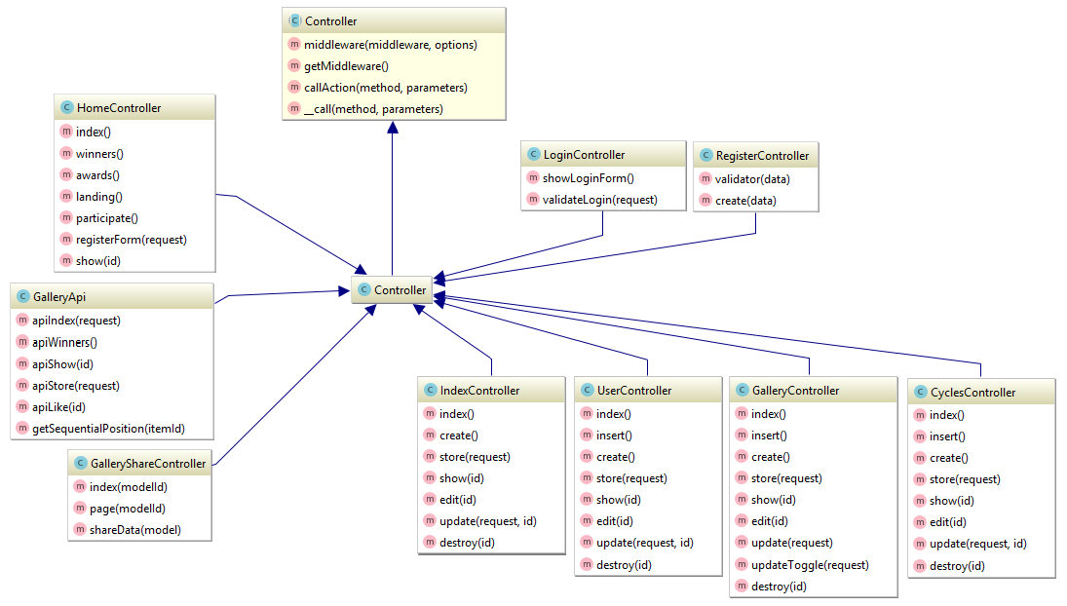

Slika 3.1.1 *Organizaciona šema*

3.2 Stranice

3.2.1 “Početna” stranica

“Početna” stranica, u vrhu imamo meni čiji elemnti se menjaju u zavisnosti od nivoa pristupa korisnika. Klikom na odabrani link iz menija korisnik se redirektuje na odabranu stranicu. Slike koje predstavljaju sadržaj ove stranice su linkovane radi boljeg korisničkog iskustva.

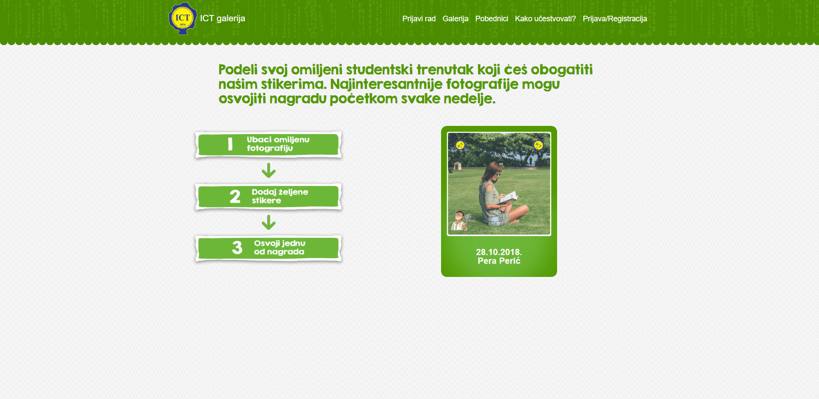

Slika 3.2.1 *Izgled “Početna” stranice*

3.2.2 “Prijava” stranica

“Prijava“ stranica, korisnik može da izvrši autorizaciju pomoću email-a i lozinke.

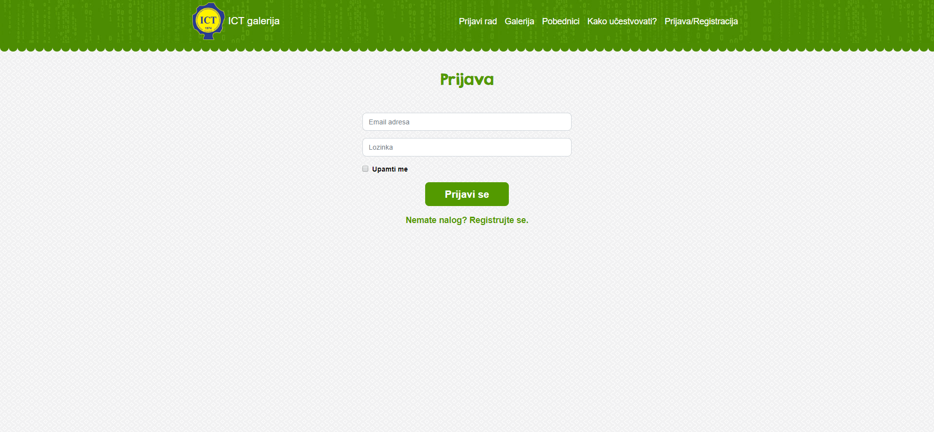

Slika 3.2.2 *Izgled “Prijava“ stranice*

3.2.3 “Registracija” stranica

“Registracija” stranica – korisniku se pruža mogućnost da napravi nalog za pristup aplikaciji, kako bi nakon prijave na aplikaciju imao dodatne mogućnosti pri korišćenju aplikacije.

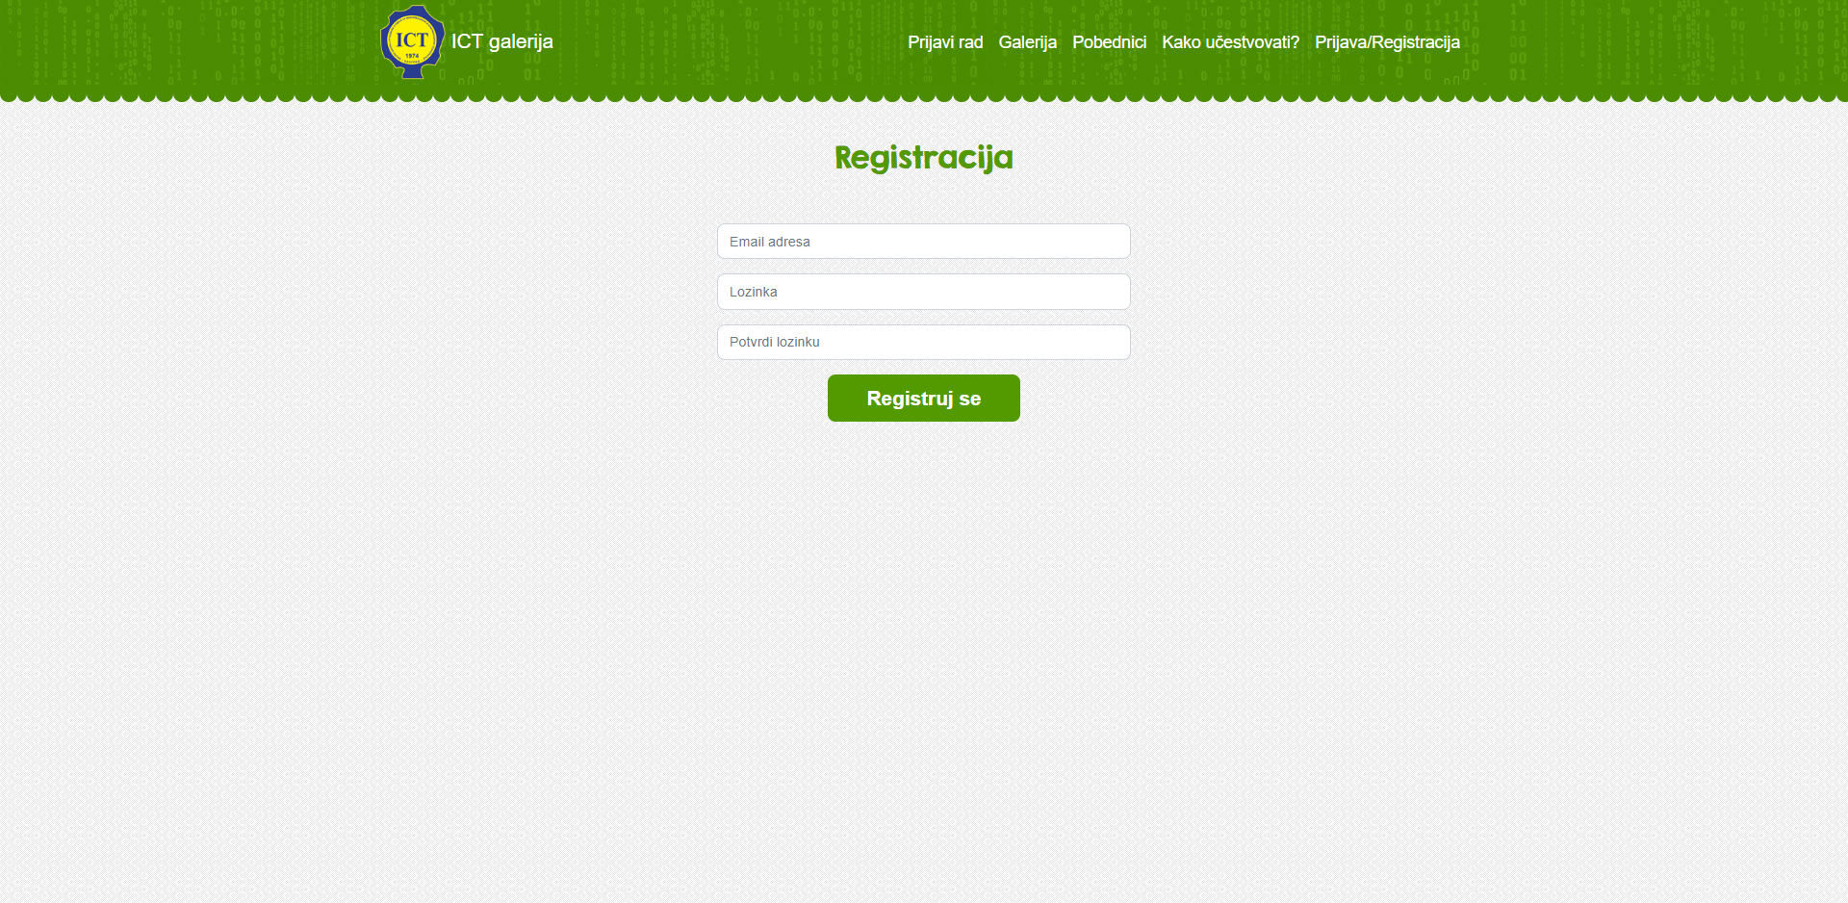

Slika 3.2.3 *Izgled “Registracija” stranice*

3.2.4 “Kako učestvovati“ stranica

“Kako učestvovati” stranica – kratko objašnjenje cilja aplikacije kao i prikaz nagrada.

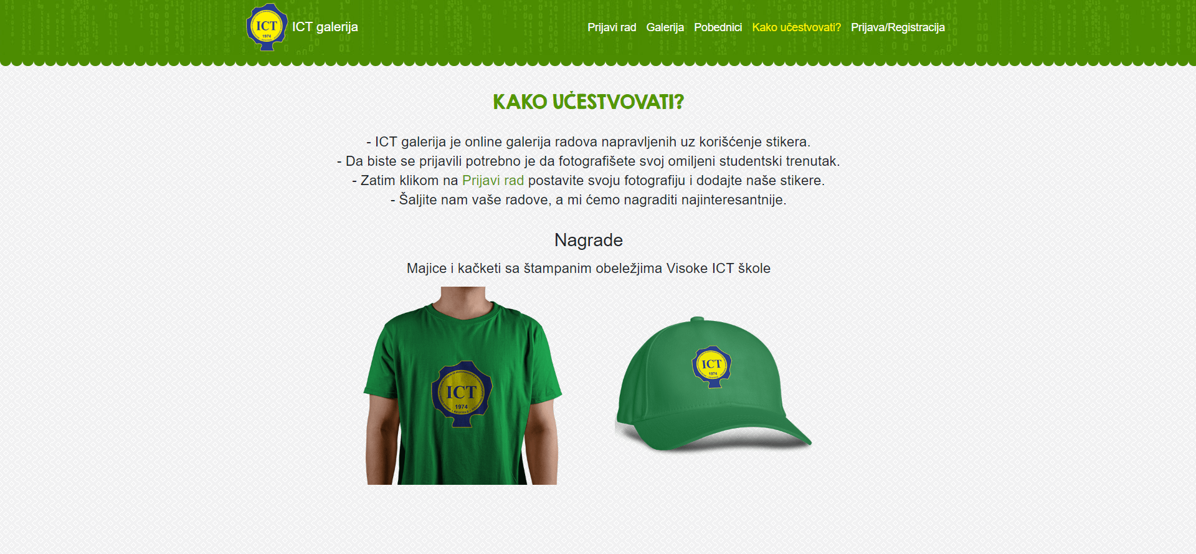

Slika 3.2.4 *Izgled “Kako učestvovati” stranice*

3.2.5 “Pobednici” stranica

“Kako učestvovati” stranica – korisnik može da vidi dobitnike nagrada.



Slika 3.2.5 *Izgled “Pobednici” stranice*

3.2.6 “Galerija” stranica

“Galerija” stranica – Korisnicima je pružen prikaz svih slika u galeriji sa datumom, nazivom I brojem glasova. Galerija je realizovana sa *infinite* skrolovanjem. Ne autorizovani korisnik može da podeli link slike na facebook-u. Autorizovani korisnik može da glasa za sliku I to samo jednom u 24 sata za istu sliku I takođe može da podeli sliku.

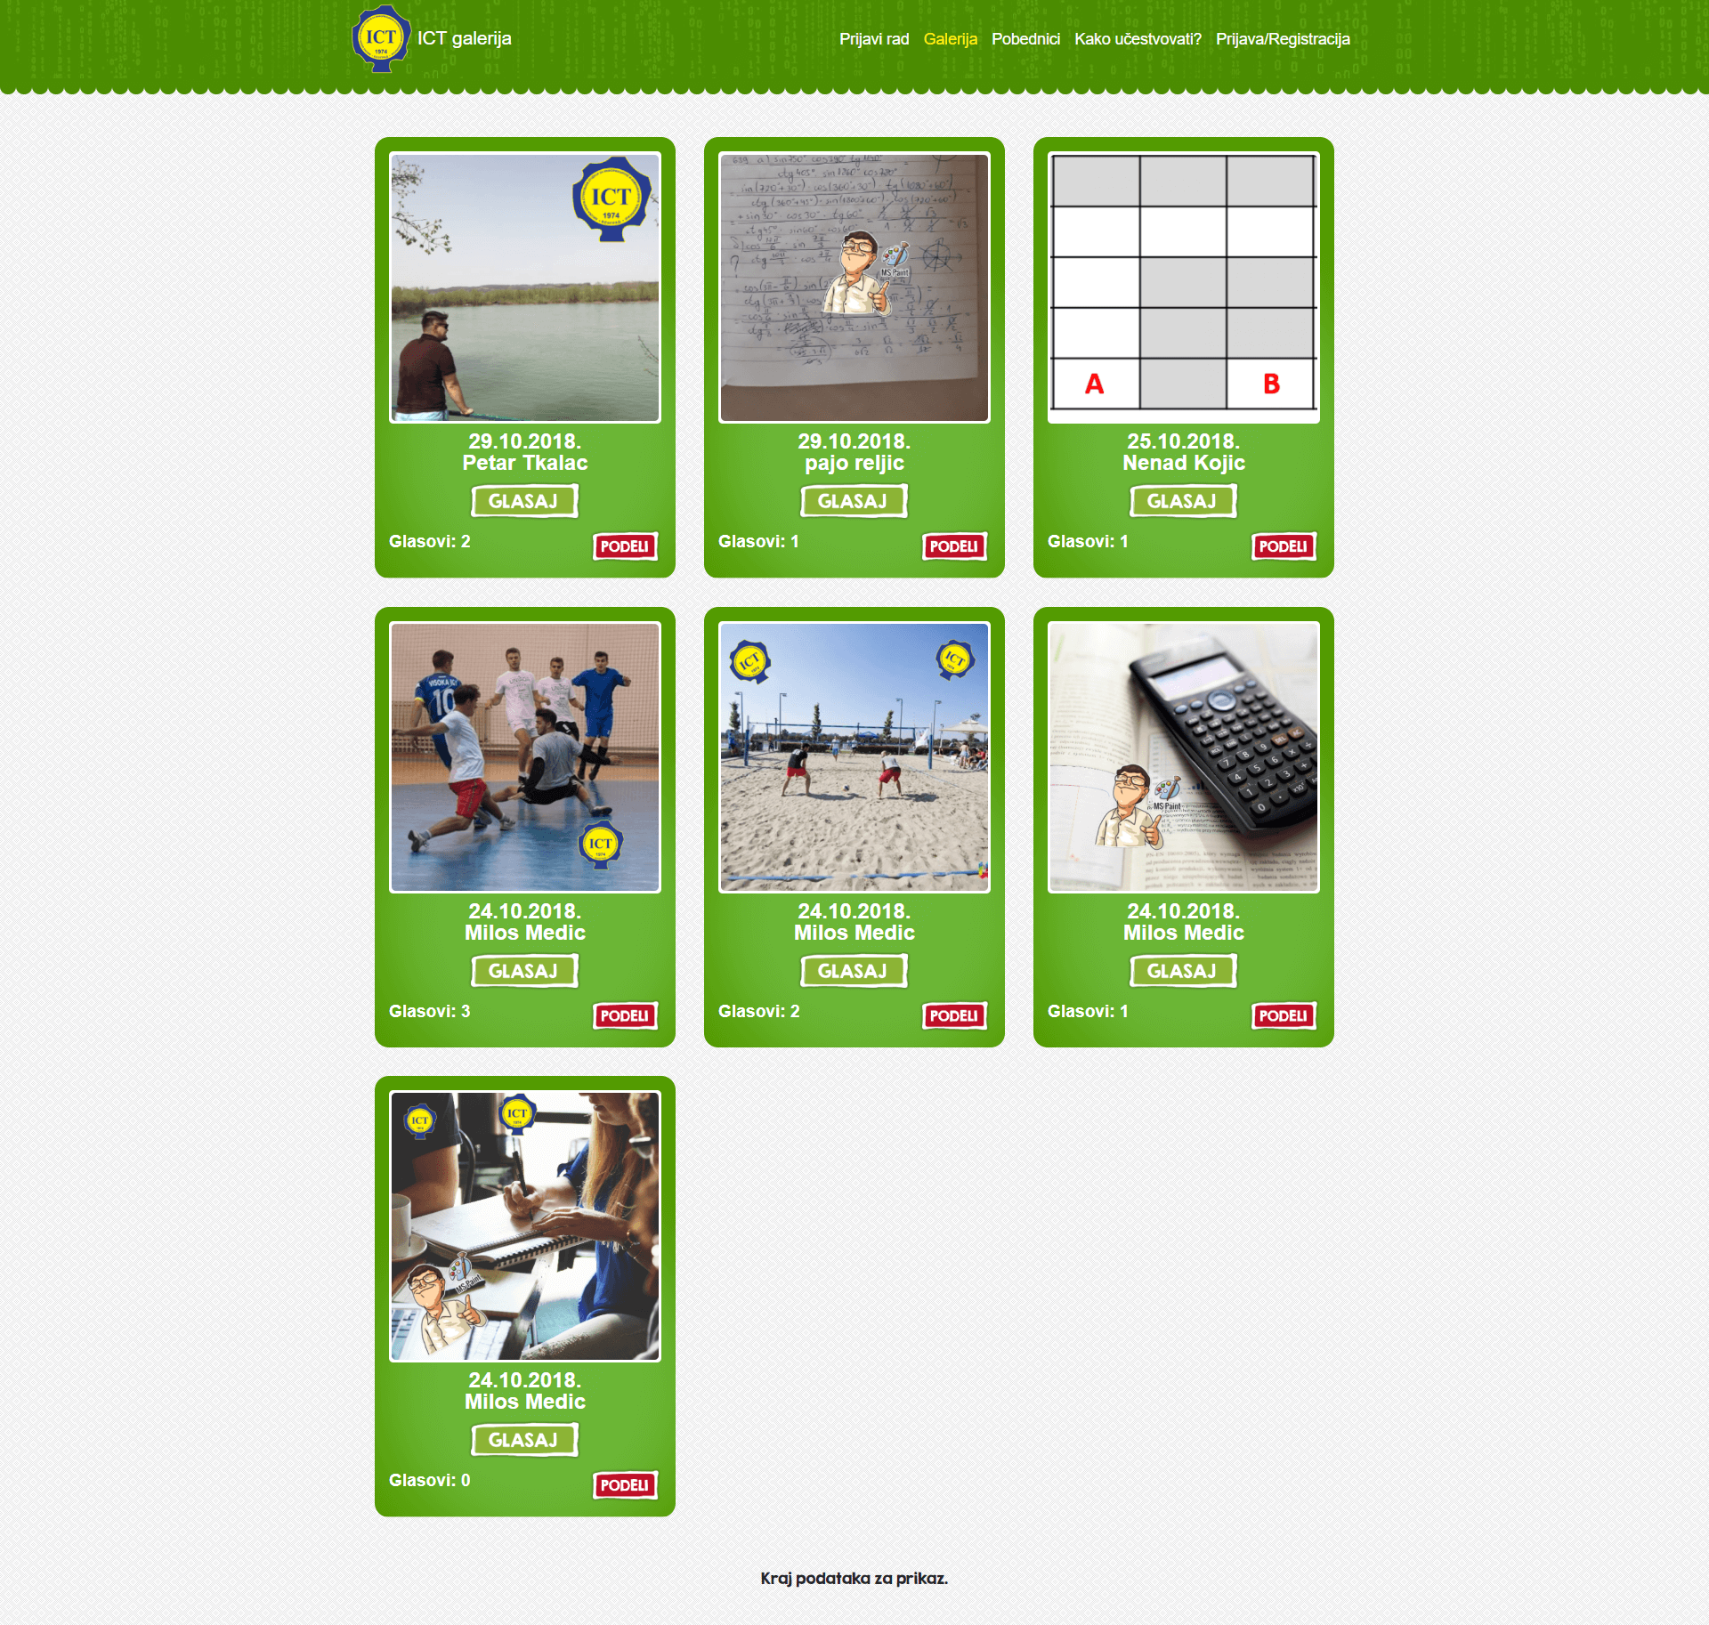

Slika 3.2.6 *Izgled “Galerija” stranice*

3.2.7 “Prijavi rad” stranica

“Prijavi rad” – stranica – Nakon registracije ukoliko korisnik želi da postavi fotografiju u galeriju, prvo mora da popuni dodatne podatke koji se koriste za identifikaciju korisnika kao i pri slanju nagrade, ukoliko je korisnik osvoji.

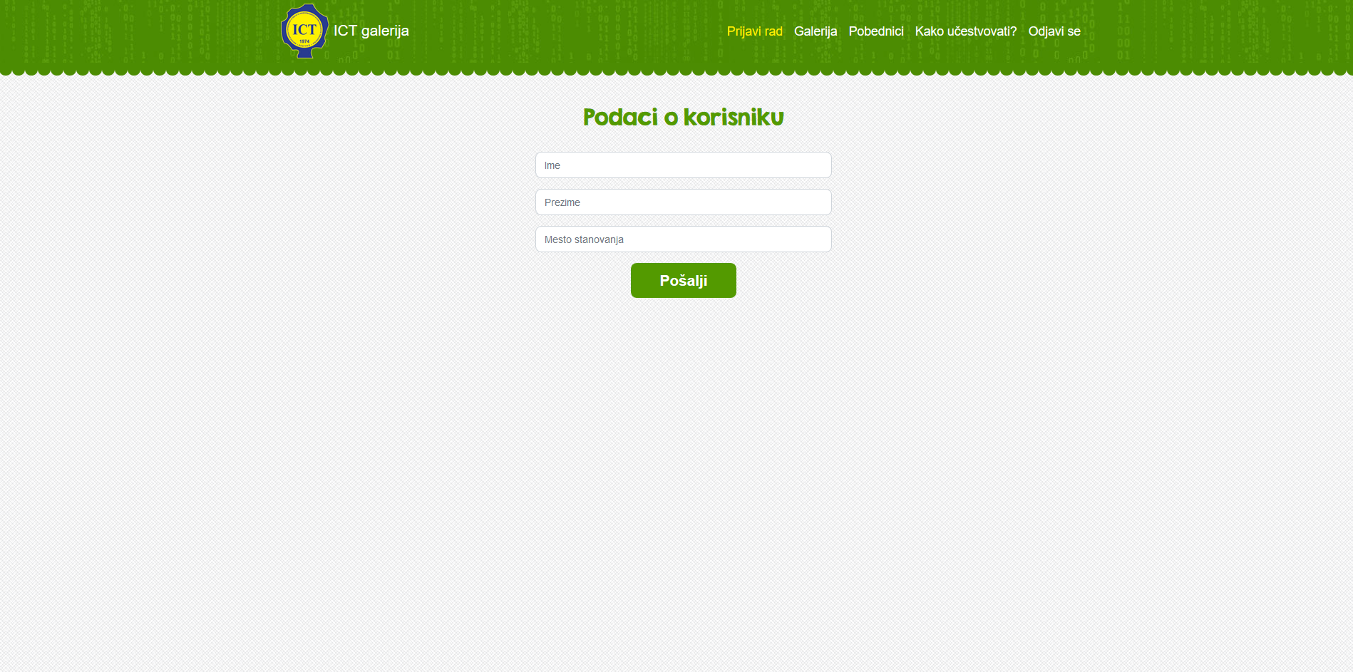

Slika 3.2.7 *Izgled “Prijavi rad” stranice*

3.2.8 “Prijavi rad” stranica – prvi deo

“Prijavi rad” – prvi deo stranica – Nakon popunjavanja dodatnih podataka korisnik dobija mogućnost da doda fotografiju.

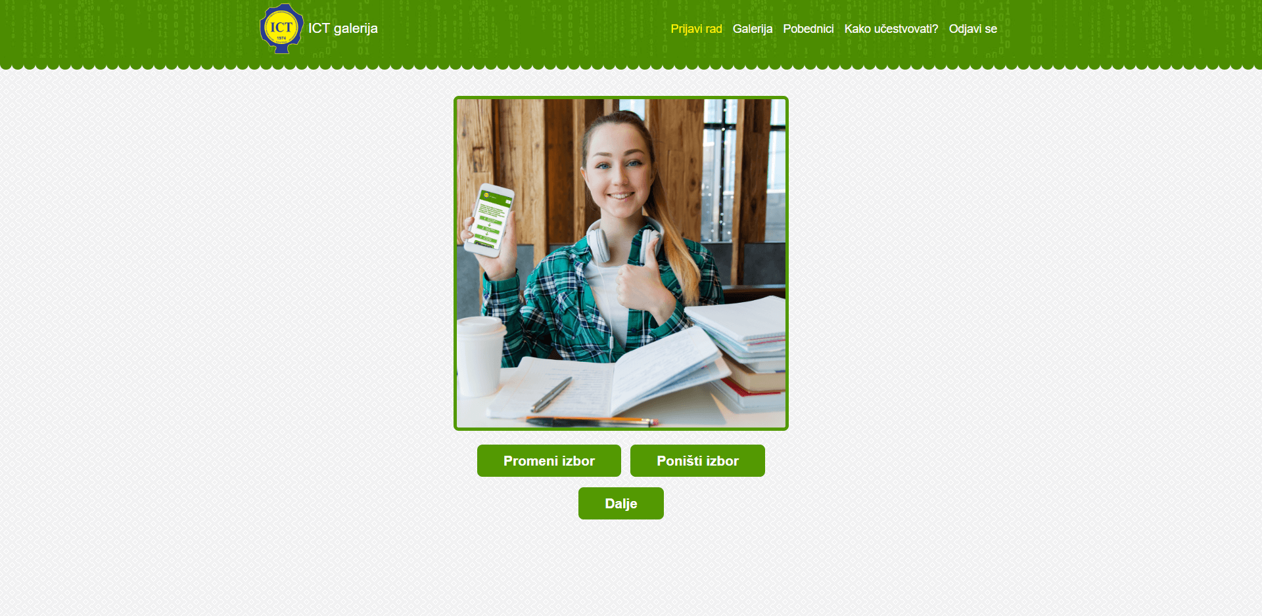

Slika 3.2.8 *Izgled “Prijavi rad” – prvi deo stranice*

3.2.9 “Prijavi rad” stranica – drugi deo

“Prijavi rad” – drugi deo stranica – Nakon dodavanja fotografije korisnik ima mogućnost da ukrasi fotografiju sa predefinisanim stikerima. Korisnik nije u obavezi da ukrasi svoju fotografiju.

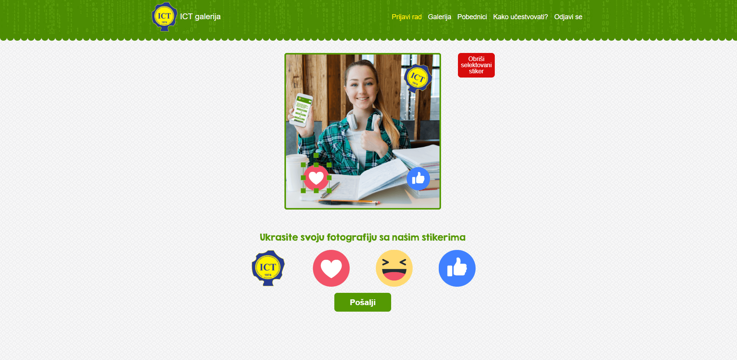

Slika 3.2.9 *Izgled “Prijavi rad” – drugi deo stranice*

3.2.10 “Prijavi rad” stranica – treći deo

“Prijavi rad” – treći deo stranica – Nakon slanja fotografije korisnik dobija obaveštenje gde se navodi da će se fotografija naći u galeriji nakon odobrenja od strane administrator aplikacije.

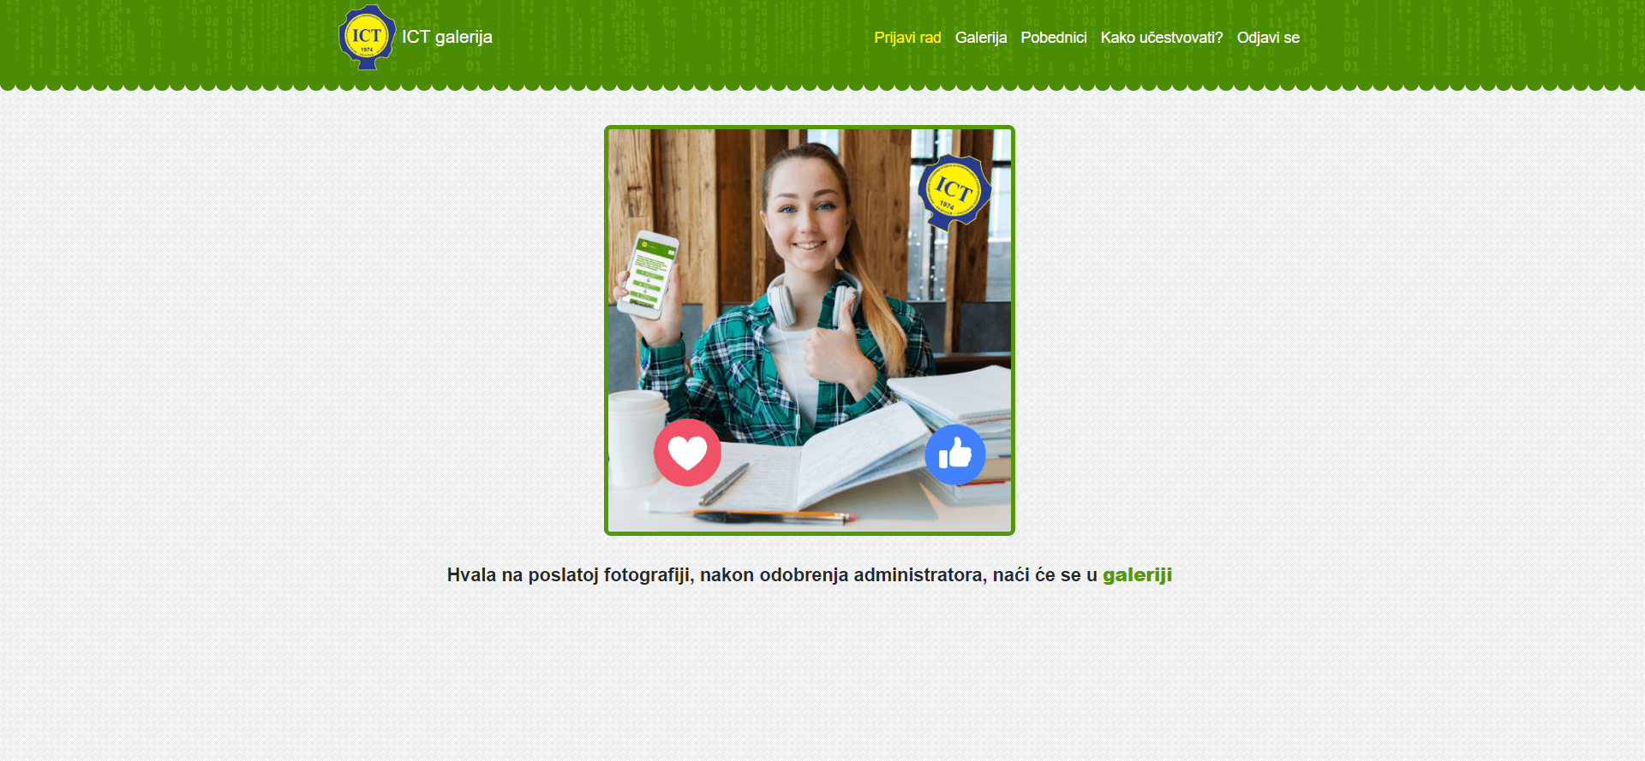

Slika 3.2.10 *Izgled “Prijavi rad” – treći deo stranice*

3.2.11 “Pojedinačni prikaz slike” stranica

“Pojedinačni prikaz slike” stranica – Nakon klika na fotografiju iz galerije, prikazuje se pojedinačna fotografija sa istim opcijama koje sadrži I u galeriji.

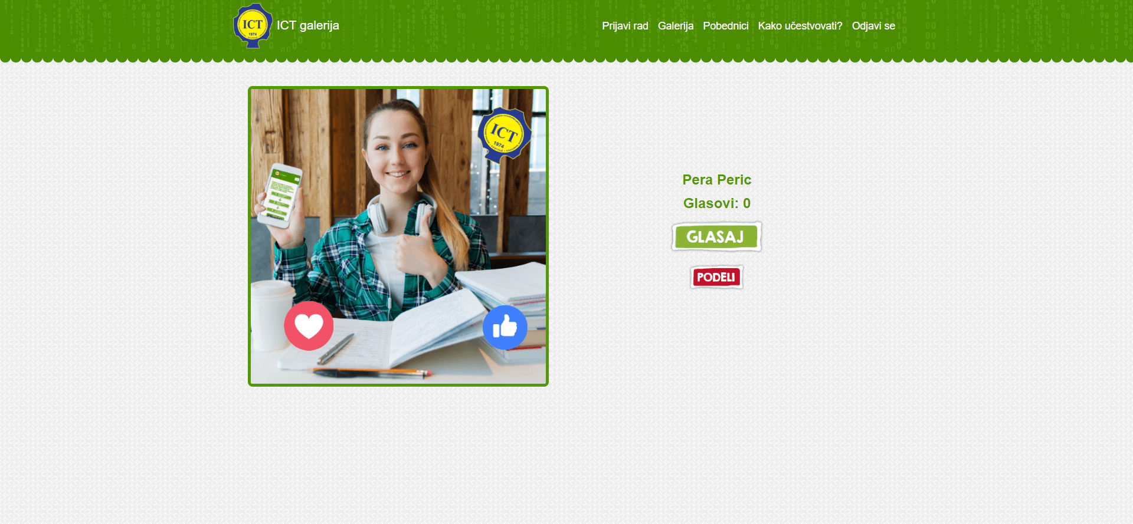

Slika 3.2.11 *Izgled “Pojedinačni prikaz slike” stranice*

3.2.12 “Admin – početna” stranica

“Admin – početna” stranica – Osnovni prikaz statistike. Može se videti broj registrovanih korisnika, broj korisnika sa dodatnim informacijama kao I broj poslatih fotografija. Pristup admin panelu imaju samo *Super admin*-i I *Administrator*-i

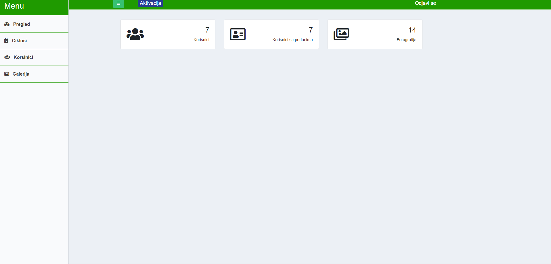

Slika 3.2.12 Izgled “Admin – početna” stranice

3.2.13 “Admin - ciklusi” stranica

“Admin – ciklusi” stranica – Super admin/Administrator može dodati/izmeniti/obrisati ciklus. Ciklus olakšava administraciju aplikacije tako što ne dozvoljava unos fotografija izvan trajanja trenutnog ciklusa, kao I ne dozvoljava prikaz fotografija u galeriji za istekle cikluse.

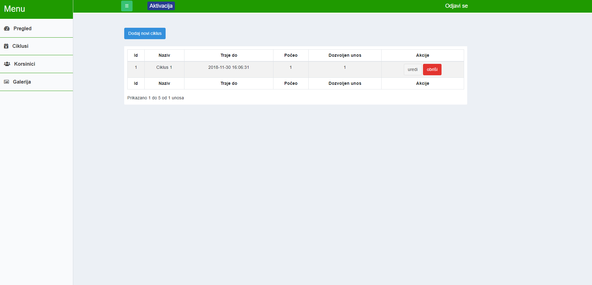

Slika 3.2.13 Izgled “Admin – ciklusi” stranice

3.2.14 “Admin - korisnici” stranica

“Admin – korisnici” stranica – Super admin može dodati/izmeniti/obrisati korisnika, dok administratoru ta opcija nije dozvoljena.

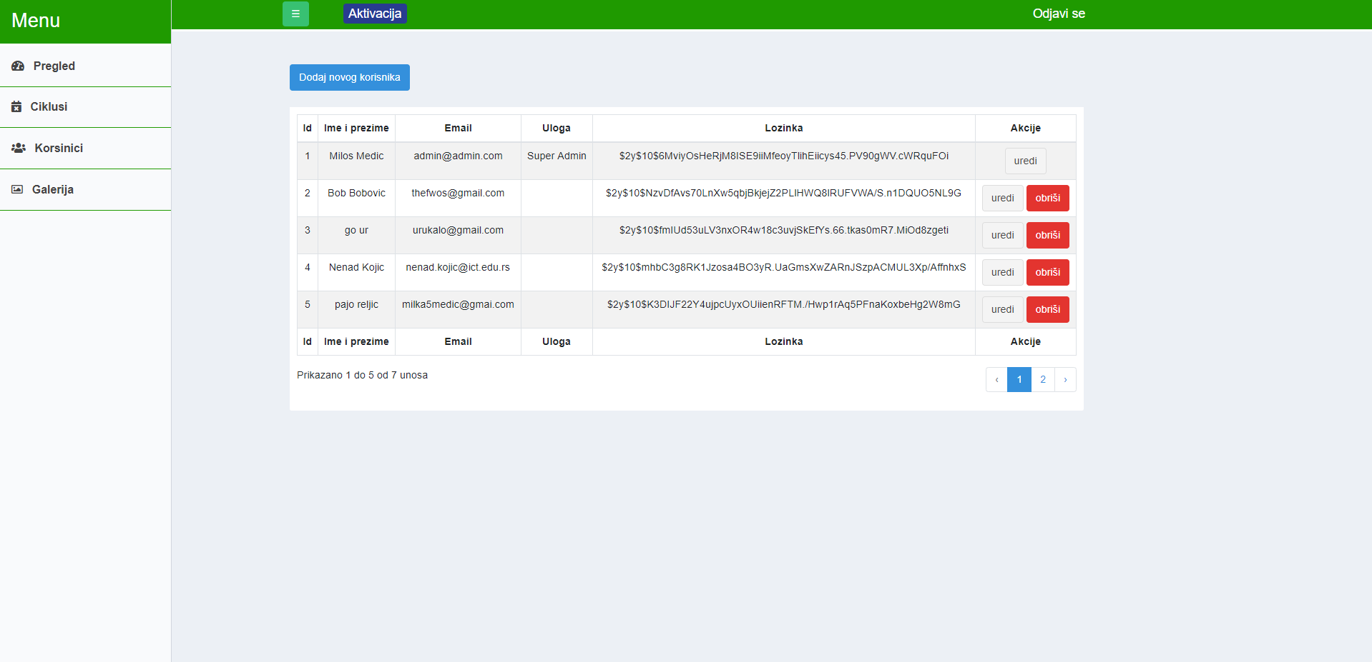

Slika 3.2.14 Izgled “Admin – korisnici” stranice

3.2.15 “Admin - galerija” stranica

“Admin – galerija” stranica - Super admin/Administrator može dodati obrisati/odobriti fotografiju/proglasiti pobednika.

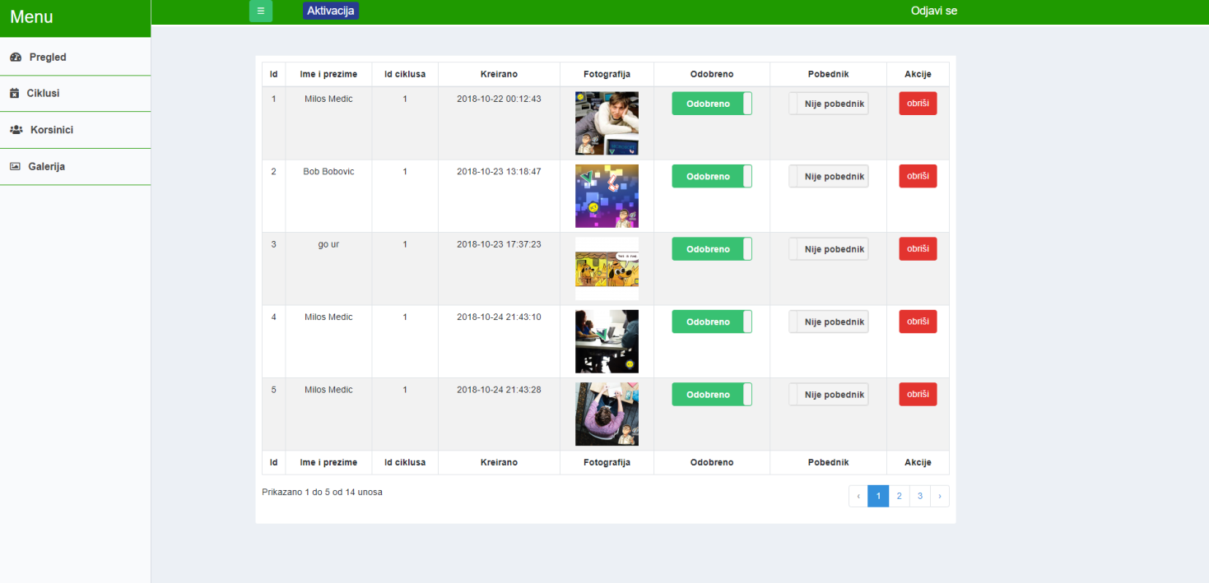

Slika 3.2.15 Izgled “Admin – galerija” stranice

1. KODOVI

4.1 Kontroleri

4.1.1 HomeController.php

**<?php  
  
namespace** App\Http\Controllers;  
  
**use** Illuminate\Http\Request;  
**use** App\Models\UserData;  
**use** App\Models\GalleryItem;  
  
**class** HomeController **extends** Controller  
{  
 */**  
 * Create a new controller instance.  
 *  
 \** ***@return*** *void  
 */* **public function** __construct()  
 {  
 *//$this->middleware('auth');* $this->middleware(**'auth'**, [**'only'** => [  
 **'participate'** ]]);  
 }  
  
 */**  
 * Show the application dashboard.  
 *  
 \** ***@return*** *\Illuminate\Http\Response  
 */* **public function** index()  
 {  
 **return** view(**'index'**);  
 }  
  
 **public function** winners()  
 {  
 **return** view(**'winners'**);  
 }  
  
 **public function** awards()  
 {  
 **return** view(**'awards'**);  
 }  
  
 **public function** landing()  
 {  
 **return** view(**'landingpage'**);  
 }  
  
 **public function** participate()  
 {  
 $user = auth()->user();  
 $userData = $user->**userData**;  
  
 **if** ($userData && $userData->**completed** == 1) {  
 **return** view(**'participate'**);  
 } **else** {  
 **return** view(**'registration'**);  
 }  
  
 }  
  
 **public function** registerForm(Request $request)  
 {  
 $this->validate($request, [  
 **'livingPlace'** => **'required|string|min:2|max:191'**,  
 **'firstName'** => **'required|string|min:2|max:191'**,  
 **'lastName'** => **'required|string|min:2|max:191'**,  
 ]);  
  
 $name = $request->**firstName** . **" "** . $request->**lastName**;  
  
 $user = auth()->user();  
 **if** (!$user) abort(400);  
  
 $user->**name** = $name;  
 $user->save();  
  
 $userData = **new** UserData();  
 $userData->**user_id** = $user->**id**;  
 $userData->**completed** = 1;  
 $userData->**livingPlace** = $request->post(**'livingPlace'**);  
 $userData->save();  
  
 **return** redirect(route(**'participate'**));  
 }  
  
 **public function** show($id)  
 {  
 $galleryItem = GalleryItem::*query*()->findOrFail($id);  
 **return** view(**'show'**)->with([**'galleryItem'** => $galleryItem->toArray()]);  
 }  
}

4.1.2 GalleryShareController.php

**<?php***/**  
 * Created by PhpStorm.  
 * User: milos  
 * Date: 10/20/2018  
 * Time: 10:42 PM  
 */***namespace** App\Http\Controllers;  
  
**use** App\Http\Controllers\Controller;  
**use** Illuminate\Support\Facades\View;  
**use** Jenssegers\Agent\Facades\Agent;  
**use** App\Models\GalleryItem;  
  
**class** GalleryShareController **extends** Controller  
{  
 **public function** index($modelId = **null**)  
 {  
 **if** (Agent::*isRobot*()) {  
 **return** $this->page($modelId);  
 } **else** {  
 **return** redirect(**"https://diplomski.milosmedic.com/public/gallery/item/show/**$modelId**"**);  
 }  
 }  
  
 **public function** page($modelId)  
 {  
 **if** ($modelId != **null**) {  
 $model = GalleryItem::*find*($modelId);  
 **return** view(**'shareLayout'**)->with($this->shareData($model));  
 } **else** {  
 **return** view(**'shareLayout'**)->with($this->shareData(**null**));  
 }  
 }  
  
 **protected function** shareData($model)  
 {  
 **if** ($model != **null**) {  
 **return** [  
 **'og_image'** => url(**'storage/gallery/uploads/'** . $model->**item_data**->**photo**),  
 **'og_url'** => url(**'gallery/item/show/'** . $model->**id**)  
 ];  
 } **else** {  
 **return** [];  
 }  
 }  
}

4.1.3 GalleryApi.php

**<?php***/**  
 * Created by PhpStorm.  
 * User: milos  
 * Date: 9/25/2018  
 * Time: 10:04 PM  
 */***namespace** App\Http\Controllers;  
  
**use** App\Http\Controllers\Controller;  
**use** Illuminate\Http\Request;  
**use** Illuminate\Routing\Route;  
**use** Illuminate\Support\Facades\DB;  
**use** Illuminate\Support\Facades\Log;  
**use** Illuminate\Support\Facades\View;  
**use** App\Models\Cycle;  
**use** App\Models\GalleryItem;  
**use** App\Models\GalleryItemData;  
**use** App\Models\GalleryWinner;  
**use** App\Models\UserData;  
**use** App\Http\Traits\FileUploadTrait;  
**use** App\Http\Helpers **as** Helper;  
**use** Illuminate\Support\Facades\Auth;  
  
  
**class** GalleryApi **extends** Controller  
{  
 **protected $serviceName**;  
  
 **use** FileUploadTrait;  
  
 **protected $disabled** = **false**;  
  
 **public function** apiIndex(Request $request)  
 {  
 **if** (**isset**($request->**itemLimit**)) {  
 $limit = $request->**itemLimit**;  
 } **else** {  
 $limit = 20;  
 }  
 **if** (**isset**($request->**itemOffsetId**) && $request->**itemOffsetId** != -1) {  
 $offset = $this->getSequentialPosition($request->**itemOffsetId**);  
 } **else** {  
 $offset = 0;  
 }  
 **if** (**isset**($request->**itemLimitId**) && $request->**itemLimitId** != -1) {  
 $limit = $this->getSequentialPosition($request->**itemLimitId**);  
 $limit--;  
 **if** ($limit > 20) {  
 $offset = $limit - 20;  
 }  
 }  
 $items = GalleryItem::*query*()->where(**'cycle_id'**, Helper::*getCurrentCycleId*())->where(**'approved'**, 1)->take($limit)->offset($offset)->orderBy(**'created_at'**, **'desc'**)->orderBy(**'id'**, **'desc'**)->get();  
 **return** response()->json($items, 200);  
 }  
  
 **public function** apiWinners()  
 {  
 **return** GalleryWinner::*query*()->where(**'approved'**, **'='**, 1)->orderBy(**'gallery_winners.created_at'**, **'desc'**)->join(**'gallery_item_data'**, **'gallery_item_data.item_id'**, **'='**, **'gallery_winners.item_id'**)->get();  
 }  
  
 **public function** apiShow($id)  
 {  
 $galleryItem = GalleryItem::*query*()->findOrFail($id);  
 **return** view(**'show'**)->with([**'galleryItem'** => $galleryItem->toArray()]);  
 }  
  
 **public function** apiStore(Request $request)  
 {  
 $galleryItem = **null**;  
 $status = 0;  
 $response = **null**;  
 **try** {  
 **if** ($this->**disabled**) {  
 $response = response()->json([**'message'** => **'Konkurs je zavrsen.'**], $status = 403);  
 **throw new** \Exception();  
 }  
  
 $this->validate($request, [  
 **'photo'** => **'required|image|mimes:jpeg,png,jpg|max:10000'** ]);  
  
 $request->**request**->add([**'photo_max_width'** => 1440, **'photo_max_height'** => 1440]);  
 $request = $this->saveFiles($request);  
  
 $galleryItem = GalleryItem::*create*();  
  
 $user = Auth::*user*();  
  
 $itemData = [  
 **'item_id'** => $galleryItem->**id**,  
 **'photo'** => $request->**photo**,  
 **'name'** => *explode*(**' '**, $user->**name**)[0] . **" "** . *explode*(**' '**, $user->**name**, 2)[1]  
 ];  
  
 GalleryItemData::*insert*($itemData);  
  
 $response = response()->json($galleryItem, $status = 200);  
 } **catch** (\Exception $e) {  
 **throw** $e;  
 } **finally** {  
 **if** (!$response) {  
 $response = response()->json([**'message'** => **'Aktivacija nije aktivna.'**], 403);  
 }  
 **return** $response;  
 }  
 }  
  
 **public function** apiLike($id)  
 {  
 **if** (!auth()->user())  
 **return** response()->json([**'message'** => **'Morate biti prijavljeni kako biste glasali.'**], 403);  
 $galleryItem = GalleryItem::*findOrFail*($id);  
 **if** ($galleryItem) {  
  
 **if** ($like = $galleryItem->addLike()) {  
 **return** response()->json($like, 200);  
 }  
 **return** response()->json([**'message'** => **'Operacija nije dozvoljena.'**], 403);  
 }  
 **return** response()->json([**'message'** => **'Trazena stavka nije pronadjena.'**], 404);  
 }  
  
  
 **protected function** getSequentialPosition($itemId)  
 {  
 **return** DB::*select*(  
 DB::*raw*(**'SELECT x.position  
 FROM  
 (  
 SELECT t.id,@rownum := @rownum + 1 AS position  
 FROM gallery_items t  
 JOIN (SELECT @rownum := 0) r  
 WHERE t.approved = 1  
 ORDER BY t.created_at DESC, t.id DESC  
 ) x  
 WHERE x.id = :item_id'**),  
 [**'item_id'** => $itemId]  
 )[0]->**position**;  
 }  
}

4.1.4.1 CyclesController.php

**<?php  
  
namespace** App\Http\Controllers\Admin;  
  
**use** Illuminate\Http\Request;  
**use** App\Http\Controllers\Controller;  
**use** App\Models\Cycle;  
**use** App\Models\GalleryItem;  
**use** Illuminate\Support\Carbon;  
**use** Prologue\Alerts\Facades\Alert;  
**use** Illuminate\Support\Facades\DB;  
**use** App\Http\Helpers **as** Helper;  
**use** Session;  
  
**class** CyclesController **extends** Controller  
{  
 */**  
 * Display a listing of the resource.  
 *  
 \** ***@return*** *\Illuminate\Http\Response  
 */* **public function** index()  
 {  
 $items = Cycle::*paginate*(5);  
  
  
 **return** view(**"admin.cycles.index"**, *compact*(**'items'**));  
 }  
  
 */**  
 * Show the form for creating a new resource.  
 *  
 \** ***@return*** *\Illuminate\Http\Response  
 */* **public function** insert()  
 {  
 **return** view(**"admin.cycles.insert"**);  
 }  
  
 **public function** create()  
 {  
 *//* }  
  
 */**  
 * Store a newly created resource in storage.  
 *  
 \** ***@param*** *\Illuminate\Http\Request $request  
 \** ***@return*** *\Illuminate\Http\Response  
 */* **public function** store(Request $request)  
 {  
 $this->validate($request, [  
 **'name'** => **'required|max:30'**,  
 **'lasts_until'** => **'required'**,  
 **'begun'** => **'required|max:1'**,  
 **'allow_input'** => **'required|max:1'** ]);  
  
 *//check if last_until is after now()* $tz = **new** \DateTime($request->**lasts_until**);  
 $tz = $tz->getTimezone();  
 $time = \Carbon\Carbon::*instance*(**new** \DateTime($request->**lasts_until**));  
  
 **if** (Carbon::*now*($tz)->gte($time)) {  
 Session::*flash*(**'message'**, **'Traje do vrednost '** . $time . **' mora biti veća od trenutnog vremena '** . Carbon::*now*($tz) . **'.'**);  
 **return** redirect()->back();  
 }  
  
 *//check if new cycle is slicing current cycle* $currentCycleId = Helper::*getCurrentCycleId*();  
 $currentCycle = Cycle::*find*($currentCycleId);  
 **if** ($currentCycle) {  
 $requestTime = Carbon::*createFromTimestamp*(*strtotime*($request->**lasts_until**));  
 $currentCycleTime = Carbon::*createFromTimestamp*(*strtotime*($currentCycle->**lasts_until**));  
  
 **if** ($currentCycleTime->gte($requestTime)) {  
 **if** ($currentCycle->**begun** == 1) {  
 Session::*flash*(**'message'**, **'Vremenski raspon za ovaj ciklus se preseca sa još jednim ciklusom koji je već započeo.'**);  
  
 **return** redirect()->back();  
 }  
 }  
 }  
  
 Cycle::*create*($request->all());  
  
 **return** redirect(**'admin/cycle/index'**);  
 }  
  
 */**  
 * Display the specified resource.  
 *  
 \** ***@param*** *int $id  
 \** ***@return*** *\Illuminate\Http\Response  
 */* **public function** show($id)  
 {  
 *//* }  
  
 */**  
 * Show the form for editing the specified resource.  
 *  
 \** ***@param*** *int $id  
 \** ***@return*** *\Illuminate\Http\Response  
 */* **public function** edit($id)  
 {  
 $cycle = DB::**table**(**"cycles"**)->where(**'id'**, $id)->first();  
 **return** view(**'admin.cycles.update'**, *compact*(**'cycle'**));  
 }  
  
 */**  
 * Update the specified resource in storage.  
 *  
 \** ***@param*** *\Illuminate\Http\Request $request  
 \** ***@param*** *int $id  
 \** ***@return*** *\Illuminate\Http\Response  
 */* **public function** update(Request $request, $id)  
 {  
 *//check if new cycle is slicing current cycle* $currentCycleId = Helper::*getCurrentCycleId*();  
 $currentCycle = Cycle::*find*($currentCycleId);  
  
 **if** (**isset**($currentCycle)) {  
 **if** ($request->**lasts_until** > $currentCycle->**lasts_until**) {  
 **if** ($currentCycle->**begun** == 1) {  
 Session::*flash*(**'message'**, **'Vremenski raspon za ovaj ciklus se preseca sa još jednim ciklusom koji je već započeo.'**);  
  
 **return** redirect()->back();  
 }  
 }  
 }  
  
 $cycle = Cycle::*findOrFail*($id);  
 $cycle->update($request->all());  
  
 **return** redirect(**'admin/cycle/index'**);  
 }  
  
 */**  
 * Remove the specified resource from storage.  
 *  
 \** ***@param*** *int $id  
 \** ***@return*** *\Illuminate\Http\Response  
 */* **public function** destroy($id)  
 {  
 $cycle = Cycle::*findOrFail*($id);  
 $cycle->cycleItems()->delete();  
 $cycle->delete();  
 **return** redirect(**'admin/cycle/index'**);  
  
  
  
 }  
}

4.1.4.2 GalleryController.php

**<?php  
  
namespace** App\Http\Controllers\Admin;  
  
**use** App\Models\GalleryItemData;  
**use** App\Models\GalleryItem;  
**use** App\Models\GalleryWinner;  
**use** App\User;  
**use** Illuminate\Http\Request;  
**use** App\Http\Controllers\Controller;  
**use** Illuminate\Support\Facades\DB;  
**use** App\Http\Helpers **as** Helper;  
  
**class** GalleryController **extends** Controller  
{  
 */**  
 * Display a listing of the resource.  
 *  
 \** ***@return*** *\Illuminate\Http\Response  
 */* **public function** index()  
 {  
  
 $items = GalleryItem::*with*(**'item_data'**)->paginate(5);  
  
  
 *//dd($items->all());* **return** view(**"admin.gallery.index"**, *compact*(**'items'**));  
 }  
  
 */**  
 * Show the form for creating a new resource.  
 *  
 \** ***@return*** *\Illuminate\Http\Response  
 */* **public function** insert()  
 {  
 *//* }  
  
 **public function** create()  
 {  
 *//* }  
  
 */**  
 * Store a newly created resource in storage.  
 *  
 \** ***@param*** *\Illuminate\Http\Request $request  
 \** ***@return*** *\Illuminate\Http\Response  
 */* **public function** store(Request $request)  
 {  
 *//* }  
  
 */**  
 * Display the specified resource.  
 *  
 \** ***@param*** *int $id  
 \** ***@return*** *\Illuminate\Http\Response  
 */* **public function** show($id)  
 {  
 *//* }  
  
 */**  
 * Show the form for editing the specified resource.  
 *  
 \** ***@param*** *int $id  
 \** ***@return*** *\Illuminate\Http\Response  
 */* **public function** edit($id)  
 {  
 *//* }  
  
 */**  
 * Update the specified resource in storage.  
 *  
 \** ***@param*** *\Illuminate\Http\Request $request  
 \** ***@param*** *int $id  
 \** ***@return*** *\Illuminate\Http\Response  
 */* **public function** update(Request $request)  
 {  
 $item = GalleryItem::*findOrFail*($request[**"data"**][0]);  
 $item->**approved** = $request[**"data"**][1];  
 $item->save();  
  
 **return** redirect()->back();  
 }  
  
 **public function** updateToggle(Request $request)  
 {  
 $value = (int)$request->post(**'value'**);  
 $type = $request->post(**'type'**);  
 **if** (!*is_numeric*($value) || ($value != 0 && $value != 1)) abort(403);  
 $id = (int)$request->post(**'id'**);  
 **if** (!*is_numeric*($id)) abort(403);  
 $galleryItem = GalleryItem::*findOrFail*($id);  
  
 **switch** ($type) {  
 **case 'winner'** :  
 {  
 $galleryWinner = GalleryWinner::*where*(**'item_id'**, $galleryItem->**id**)->first();  
 **if** (!$galleryWinner) {  
 $galleryWinner = **new** GalleryWinner();  
 $galleryWinner->**user_id** = $galleryItem->**user_id**;  
 $galleryWinner->**item_id** = $galleryItem->**id**;  
 $galleryWinner->**cycle_id** = $galleryItem->**cycle_id**;  
 }  
 $galleryWinner->**approved** = $value;  
 $galleryWinner->save();  
 **break**;  
 }  
 **case 'approve'** :  
 **default** :  
 {  
 $galleryItem->**approved** = $value;  
 $galleryItem->save();  
 **break**;  
 }  
 }  
  
  
 }  
  
 */**  
 * Remove the specified resource from storage.  
 *  
 \** ***@param*** *int $id  
 \** ***@return*** *\Illuminate\Http\Response  
 */* **public function** destroy($id)  
 {  
 $item = GalleryItem::*findOrFail*($id);  
 $item->delete();  
 **return** redirect(**'admin/gallery/index'**);  
 }  
}

4.1.4.3 IndexController.php

**<?php  
  
namespace** App\Http\Controllers\Admin;  
  
**use** App\Models\UserData;  
**use** Illuminate\Http\Request;  
**use** App\Models\GalleryItemData;  
**use** App\Models\GalleryItem;  
**use** App\Models\GalleryWinner;  
**use** App\User;  
**use** App\Http\Controllers\Controller;  
**use** Illuminate\Support\Facades\DB;  
**use** App\Http\Helpers **as** Helper;  
  
**class** IndexController **extends** Controller  
{  
 */**  
 * Display a listing of the resource.  
 *  
 \** ***@return*** *\Illuminate\Http\Response  
 */* **public function** index()  
 {  
 $users = User::*count*();  
 $usersInfo = UserData::*count*();  
 $images = GalleryItem::*count*();  
  
 **return** view(**"admin.index"**, *compact*(**'users'**, **'usersInfo'**, **'images'**));  
 }  
  
 */**  
 * Show the form for creating a new resource.  
 *  
 \** ***@return*** *\Illuminate\Http\Response  
 */* **public function** create()  
 {  
 *//* }  
  
 */**  
 * Store a newly created resource in storage.  
 *  
 \** ***@param*** *\Illuminate\Http\Request $request  
 \** ***@return*** *\Illuminate\Http\Response  
 */* **public function** store(Request $request)  
 {  
 *//* }  
  
 */**  
 * Display the specified resource.  
 *  
 \** ***@param*** *int $id  
 \** ***@return*** *\Illuminate\Http\Response  
 */* **public function** show($id)  
 {  
 *//* }  
  
 */**  
 * Show the form for editing the specified resource.  
 *  
 \** ***@param*** *int $id  
 \** ***@return*** *\Illuminate\Http\Response  
 */* **public function** edit($id)  
 {  
 *//* }  
  
 */**  
 * Update the specified resource in storage.  
 *  
 \** ***@param*** *\Illuminate\Http\Request $request  
 \** ***@param*** *int $id  
 \** ***@return*** *\Illuminate\Http\Response  
 */* **public function** update(Request $request, $id)  
 {  
 *//* }  
  
 */**  
 * Remove the specified resource from storage.  
 *  
 \** ***@param*** *int $id  
 \** ***@return*** *\Illuminate\Http\Response  
 */* **public function** destroy($id)  
 {  
 *//* }  
}

4.1.4.4 UserController.php

**<?php  
  
namespace** App\Http\Controllers\Admin;  
  
**use** App\Models\Role;  
**use** App\Models\UserData;  
**use** App\User;  
**use** Illuminate\Http\Request;  
**use** App\Http\Controllers\Controller;  
**use** Illuminate\Support\Facades\DB;  
  
**class** UserController **extends** Controller  
{  
 */**  
 * Display a listing of the resource.  
 *  
 \** ***@return*** *\Illuminate\Http\Response  
 */* **public function** index()  
 {  
 $users = User::*with*(**'roles'**)->paginate(5);  
 *//dd($users->all());* **return** view(**"admin.user.index"**, *compact*(**'users'**));  
 }  
  
 */**  
 * Show the form for creating a new resource.  
 *  
 \** ***@return*** *\Illuminate\Http\Response  
 */* **public function** insert()  
 {  
 **return** view(**"admin.user.insert"**);  
 }  
  
 **public function** create()  
 {  
 *//* }  
  
 */**  
 * Store a newly created resource in storage.  
 *  
 \** ***@param*** *\Illuminate\Http\Request $request  
 \** ***@return*** *\Illuminate\Http\Response  
 */* **public function** store(Request $request)  
 {  
 $this->validate($request, [  
 **'name'** => **'required|max:45'**,  
 **'email'** => **'required|email|max:65'**,  
 **'password'** => **'required|max:35'**,  
 ]);  
  
 $password = bcrypt($request[**'password'**]);  
 $request[**'password'**] = $password;  
  
 $user = User::*create*($request->all());  
  
 **if** (!**empty**($request->**role**)) {  
 DB::**table**(**'role_users'**)->insert(  
 [**'role_id'** => $request->**role**, **'user_id'** => $user->**id**]  
 );  
 }  
  
  
 **return** redirect(**'admin/user/index'**);  
  
 }  
  
 */**  
 * Display the specified resource.  
 *  
 \** ***@param*** *int $id  
 \** ***@return*** *\Illuminate\Http\Response  
 */* **public function** show($id)  
 {  
 *//* }  
  
 */**  
 * Show the form for editing the specified resource.  
 *  
 \** ***@param*** *int $id  
 \** ***@return*** *\Illuminate\Http\Response  
 */* **public function** edit($id)  
 {  
 $user = User::*with*(**'roles'**)->where(**'id'**, $id)->first();  
 **return** view(**'admin.user.update'**, *compact*(**'user'**));  
 }  
  
 */**  
 * Update the specified resource in storage.  
 *  
 \** ***@param*** *\Illuminate\Http\Request $request  
 \** ***@param*** *int $id  
 \** ***@return*** *\Illuminate\Http\Response  
 */* **public function** update(Request $request, $id)  
 {  
 $userRole = DB::*table*(**'role_users'**)->where(**'user_id'**, $id)->first();  
  
 **if** ($userRole) {  
 **if** (**empty**($request->**role**)) {  
 DB::**table**(**'role_users'**)->where(**'user_id'**, **'='**, $id)->delete();  
 } **else** {  
 DB::**table**(**'role_users'**)  
 ->where(**'user_id'**, $id)  
 ->update([**'role_id'** => $request->**role**]);  
 }  
 } **else** {  
 DB::*table*(**'role_users'**)->insert(  
 [**'role_id'** => $request->**role**, **'user_id'** => $id]  
 );  
 }  
  
 $user = User::*findOrFail*($id);  
 $user->update($request->all());  
  
 **return** redirect(**'admin/user/index'**);  
 }  
  
 */**  
 * Remove the specified resource from storage.  
 *  
 \** ***@param*** *int $id  
 \** ***@return*** *\Illuminate\Http\Response  
 */* **public function** destroy($id)  
 {  
 $user = User::*findOrFail*($id);  
  
 $user->userGalleryItems()->delete();  
 $user->userData()->delete();  
 $user->delete();  
 **return** redirect(**'admin/user/index'**);  
 }  
}

4.2 Modeli

4.2.1 Cycle

**<?php***/**  
 * Created by PhpStorm.  
 * User: milos  
 * Date: 9/25/2018  
 * Time: 10:38 PM  
 */***namespace** App\Models;  
  
**use** Jenssegers\Date\Date;  
**use** Illuminate\Database\Eloquent\Model;  
  
**class** Cycle **extends** Model  
{  
 **protected $table** = **'cycles'**;  
 **protected $guarded** = [**'id'**];  
  
 **public function** getLastsUntilAttribute()  
 {  
 **return** Date::*parse*($this->**attributes**[**'lasts_until'**]);  
 }  
  
 **public function** setLastsUntilAttribute($value)  
 {  
 $this->**attributes**[**'lasts_until'**] = Date::*parse*($value)->timezone(**'UTC'**);  
 }  
  
 **public function** cycleItems()  
 {  
 **return** $this->hasMany(**'App\Models\GalleryItem'**, **'cycle_id'**, **'id'**);  
 }  
}

4.2.2 GalleryItem

**<?php***/**  
 * Created by PhpStorm.  
 * User: milos  
 * Date: 9/25/2018  
 * Time: 10:11 PM  
 */***namespace** App\Models;  
  
**use** Illuminate\Support\Traits\Macroable;  
**use** PHPUnit\Framework\MockObject\Stub;  
**use** App\Models\UserInputModel;  
**use** App\Http\Traits\Likeable;  
  
  
**class** GalleryItem **extends** UserInputModel  
{  
 */**  
 \** ***@var*** *Likeable  
 */* **public function** __construct(**array** $attributes = [])  
 {  
 **parent**::*__construct*($attributes);  
 }  
  
 **protected $table** = **'gallery_items'**;  
  
  
 **use** Likeable;  
  
 **protected $fillable** = [  
 **'user_id'**,  
 **'cycle_id'**,  
 **'approved'** ];  
  
 **protected $appends** = [**'canLike'**, **'likeCount'**, **'imageUrl'**];  
 **public $timestamps** = **true**;  
 **protected $guarded** = [**'id'**];  
  
 **public function** likes()  
 {  
 **return** $this->hasMany(**'App\Models\GalleryItemLike'**, **'item_id'**, **'id'**);  
 }  
  
 **public function** item_data()  
 {  
 **return** $this->hasOne(**'App\Models\GalleryItemData'**, **'item_id'**, **'id'**);  
 }  
  
 **public function** cycle()  
 {  
 **return** $this->hasOne(**'App\Models\Cycle'**, **'id'**, **'cycle_id'**);  
 }  
  
 **public function** user()  
 {  
 **return** $this->hasOne(**'App\User'**, **'id'**, **'user_id'**);  
 }  
  
 **public function** getImageUrlAttribute()  
 {  
 **return** [  
 **'upload'** => url(**'storage/gallery/uploads/'** . optional($this->**item_data**)->**photo**),  
 **'preview'** => url(**'storage/gallery/preview/'** . optional($this->**item_data**)->**photo**),  
 **'thumb'** => url(**'storage/gallery/thumbs/'** . optional($this->**item_data**)->**photo**),  
 ];  
 }  
  
 **public function** getIsWinnerAttribute()  
 {  
 **return** GalleryWinner::*where*(**'item_id'**, $this->**id**)->where(**'approved'**, 1)->first() ? **true** : **false**;  
 }  
}

4.2.3 GalleryItemData

**<?php***/**  
 * Created by PhpStorm.  
 * User: milos  
 * Date: 9/25/2018  
 * Time: 10:45 PM  
 */***namespace** App\Models;  
  
**use** Illuminate\Database\Eloquent\Model;  
  
**class** GalleryItemData **extends** Model  
{  
 **protected $table** = **'gallery_item_data'**;  
  
 **protected $guarded** = [**'id'**];  
  
 **protected $primaryKey** = **'item_id'**;  
  
 **public $timestamps** = **true**;  
  
 **public function** item()  
 {  
 **return** $this->belongsTo(**'App\Models\GalleryItem'**, **'item_id'**, **'id'**);  
 }  
}

4.2.3 GalleryItemLike

**<?php***/**  
 * Created by PhpStorm.  
 * User: milos  
 * Date: 9/25/2018  
 * Time: 10:47 PM  
 */***namespace** App\Models;  
  
**use** Illuminate\Database\Eloquent\Model;  
  
**class** GalleryItemLike **extends** Model  
{  
 **protected $table** = **'gallery_likes'**;  
 **protected $primaryKey** = **"post_id"**;  
  
 **public function** item()  
 {  
 **return** $this->belongsTo(**'App\Models\GalleryItem'**);  
 }  
}

4.2.3 GalleryWinner

**<?php***/**  
 * Created by PhpStorm.  
 * User: milos  
 * Date: 9/25/2018  
 * Time: 10:48 PM  
 */***namespace** App\Models;  
  
  
**use** Illuminate\Database\Eloquent\Model;  
  
**class** GalleryWinner **extends** Model  
{  
 **protected $table** = **'gallery_winners'**;  
  
 **public function** getCreatedAtAttribute(){  
 $galleryItem = GalleryItem::*find*($this->**item_id**);  
 **if**($galleryItem){  
 **return** $galleryItem->**created_at**;  
 }  
 **return** $this->**created_at**;  
 }  
}

4.2.3 Role

**<?php***/**  
 * Created by PhpStorm.  
 * User: milos  
 * Date: 10/9/2018  
 * Time: 4:51 PM  
 */***namespace** App\Models;  
  
**use** Illuminate\Database\Eloquent\Model;  
  
**class** Role **extends** Model  
{  
  
 **protected $fillable** = [  
 **'name'** ];  
  
 **public $timestamps** = **true**;  
  
 */**  
 * A role can have many users.  
 *  
 \** ***@return*** *\Illuminate\Database\Eloquent\Relations\BelongsToMany  
 */* **public function** users()  
 {  
  
 **return** $this->belongsToMany(**'App\User'**, **'users'**);  
 }  
}

4.2.3 UserData

**<?php***/**  
 * Created by PhpStorm.  
 * User: milos  
 * Date: 9/25/2018  
 * Time: 10:38 PM  
 */***namespace** App\Models;  
  
**use** Illuminate\Database\Eloquent\Model;  
  
**class** UserData **extends** Model  
  
{  
 **protected $table** = **'user_data'**;  
  
 **protected $appends** = [**'name'**, **'email'**];  
  
 **public $timestamps** = **true**;  
  
 **public function** user()  
 {  
 **return** $this->belongsTo(**'App\User'**);  
 }  
  
 **public function** getEmailAttribute()  
 {  
 **return** $this->user()->**email**;  
 }  
  
 **public function** getNameAttribute()  
 {  
 **return** $this->user()->**name**;  
 }  
}

4.2.3 UserInputModel

**<?php***/**  
 * Created by PhpStorm.  
 * User: milos  
 * Date: 9/25/2018  
 * Time: 10:19 PM  
 */***namespace** App\Models;  
  
**use** Illuminate\Support\Facades\Auth;  
**use** Illuminate\Support\Facades\Schema;  
**use** Jenssegers\Date\Date;  
**use** App\Http\Helpers **as** Helper;  
**use** Illuminate\Database\Eloquent\Model;  
  
**class** UserInputModel **extends** Model  
{  
  
 **public static function** boot()  
 {  
 **parent**::*boot*();  
 **self**::*creating*(**function** ($model) {  
  
 $model->**user_id** = Auth::*user*()->**id**;  
 $model->**cycle_id** = Helper::*getCurrentCycleId*();  
 **if** ($model->**cycle_id** == -1) {  
 abort(500, **'Došlo je do greške.'**);  
 }  
 **if** (Schema::*hasColumn*($model->getTable(), **'approved'**)) {  
 $model->**approved** = 0;  
 }  
 $cycle = Cycle::*find*(Helper::*getCurrentCycleId*());  
 **if** ($cycle && $cycle->**allow_input** == 0) {  
 abort(403, **'Aktivacija je završena.'**);  
 }  
 **if** ($cycle && $cycle->**begun** == 0) {  
 $cycle->**begun** = 1;  
 $cycle->save();  
 }  
 });  
 }  
  
 **public function** user()  
 {  
 **return** $this->hasOne(**'App\User'**, **'id'**, **'user_id'**);  
 }  
  
 **public function** cycle()  
 {  
 **return** $this->hasOne(**'App\Models\Cycle'**, **'id'**, **'cycle_id'**);  
 }  
}

4.2.3 User

**<?php  
  
namespace** App;  
  
**use** Illuminate\Notifications\Notifiable;  
**use** Illuminate\Contracts\Auth\MustVerifyEmail;  
**use** Illuminate\Foundation\Auth\User **as** Authenticatable;  
  
**class** User **extends** Authenticatable  
{  
 **use** Notifiable;  
  
 */**  
 * The attributes that are mass assignable.  
 *  
 \** ***@var*** *array  
 */* **protected $fillable** = [  
 **'name'**, **'email'**, **'password'**,  
 ];  
  
 */**  
 * The attributes that should be hidden for arrays.  
 *  
 \** ***@var*** *array  
 */* **protected $hidden** = [  
 **'password'**, **'remember_token'**,  
 ];  
  
 **public function** userData()  
 {  
 **return** $this->hasOne(**'App\Models\UserData'**);  
 }  
 **public function** userGalleryItems()  
 {  
 **return** $this->hasMany(**'App\Models\GalleryItem'**);  
 }  
  
 **public function** roles()  
 {  
 **return** $this->belongsToMany(**'App\Models\Role'**, **'role_users'**, **'user_id'**);  
 }  
  
 **public function** isAdmin()  
 {  
 **foreach** ($this->roles()->get() **as** $role) {  
 **if** ($role->**name** == **'Super Admin'** || $role->**name** == **'Administrator'**) {  
 **return true**;  
 }  
 }  
  
 **return false**;  
 }  
}

4.3 Helperi

4.3.1 Helpers.php

**<?php***/**  
 * Created by PhpStorm.  
 * User: milos  
 * Date: 9/27/2018  
 * Time: 4:20 PM  
 */***namespace** App\Http;  
  
  
**class** Helpers  
{  
 **static function** getCurrentCycleId()  
 {  
*// if ($cycleId = SessionHandler::get('cycleId')) {  
// return $cycleId;  
// }* $query = \Illuminate\Support\Facades\DB::*select*(\Illuminate\Support\Facades\DB::**raw**(**'SELECT id as cycleId FROM cycles WHERE** *CURRENT_TIMESTAMP* **< lasts_until ORDER BY lasts_until asc LIMIT 1'**));  
 **if** (**isset**($query[0])) {  
 $cycleId = $query[0]->**cycleId**;  
 SessionHandler::*set*(**'cycleId'**, $cycleId);  
 **return** $cycleId;  
 }  
  
 **return** -1;  
 }  
}

4.4 Traits

4.4.1 FileUploadTrait.php

**<?php***/**  
 * Created by PhpStorm.  
 * User: milos  
 * Date: 9/25/2018  
 * Time: 11:58 PM  
 */***namespace** App\Http\Traits;  
  
**use** Illuminate\Http\Request;  
**use** Intervention\Image\Facades\Image;  
  
  
**trait** FileUploadTrait  
{  
 */**  
 * File upload trait used in controllers to upload files  
 */* **public function** saveFiles(Request $request)  
 {  
  
 $uploadPath = **"storage/gallery/uploads"**;  
 $thumbPath = **"storage/gallery/thumbs"**;  
 $previewPath = **"storage/gallery/preview"**;  
 **if** (!*file_exists*($uploadPath)) {  
 *mkdir*($uploadPath, 0775, **true**);  
 *mkdir*($thumbPath, 0775, **true**);  
 }  
  
 $finalRequest = $request;  
  
 **foreach** ($request->all() **as** $key => $value) {  
 **if** ($request->hasFile($key)) {  
 **if** ($request->has($key . **'_max_width'**) && $request->has($key . **'_max_height'**)) {  
 *// Check file width* $filename = *time*() . **'-'** . $request->file($key)->getClientOriginalName();  
  
 $ext = $request->file($key)->clientExtension();  
 **if**(!*strpos*($filename, **'.'**)) {  
 $filename .= **'.'** . $ext;  
 }  
 $file = $request->file($key);  
 $image = Image::*make*($file);  
 **if** (!*file_exists*($thumbPath)) {  
 *mkdir*($thumbPath, 0775, **true**);  
 }  
 **if** (!*file_exists*($previewPath)) {  
 *mkdir*($previewPath, 0775, **true**);  
 }  
 Image::*make*($file)->resize(100, 100)->save($thumbPath . **'/'** . $filename);  
 Image::*make*($file)->resize(480, 480)->save($previewPath . **'/'** . $filename);  
 $width = $image->width();  
 $height = $image->height();  
 **if** ($width > $request->{$key . **'_max_width'**} && $height > $request->{$key . **'_max_height'**}) {  
 $image->resize($request->{$key . **'_max_width'**}, $request->{$key . **'_max_height'**});  
 } **elseif** ($width > $request->{$key . **'_max_width'**}) {  
 $image->resize($request->{$key . **'_max_width'**}, **null**, **function** ($constraint) {  
 $constraint->aspectRatio();  
 });  
 } **elseif** ($height > $request->{$key . **'_max_width'**}) {  
 $image->resize(**null**, $request->{$key . **'_max_height'**}, **function** ($constraint) {  
 $constraint->aspectRatio();  
 });  
 }  
 $image->save($uploadPath . **'/'** . $filename, 75);  
 $finalRequest = **new** Request(*array_merge*($finalRequest->all(), [$key => $filename]));  
 } **else** {  
 $file = $request->file($key);  
 **if** (!*file_exists*($thumbPath)) {  
 *mkdir*($thumbPath, 0775, **true**);  
 }  
 $filename = *time*() . **'-'** . config(**'photo'**);  
  
 Image::*make*($file)->resize(150, 150)->save($thumbPath . **'/'** . $filename);  
 $request->file($key)->move($uploadPath, $filename);  
 $finalRequest = **new** Request(*array_merge*($finalRequest->all(), [$key => $filename]));  
 }  
 }  
 }  
  
 **return** $finalRequest;  
 }  
}

4.4.2 Likeable.php

**<?php***/**  
 * Created by PhpStorm.  
 * User: milos  
 * Date: 9/28/2018  
 * Time: 1:23 PM  
 */***namespace** App\Http\Traits;  
  
**use** Illuminate\Support\Facades\DB;  
**use** Jenssegers\Date\Date;  
**use** App\Models\GalleryItemLike;  
**use** App\Http\Traits\StubLikeableTrait;  
**use** App\Models\GalleryItem;  
  
**trait** Likeable  
{  
 **use** StubLikeableTrait;  
  
 */**  
 * Likeable constructor.  
 */* **public function** __construct()  
 {  
 $this->setAppends(*array_merge*($this->**appends**, [**'userLikeCount'**]));  
 }  
  
  
 **public function** checkCycle()  
 {  
 **return true**;  
 }  
  
 **public function** getUniqueId()  
 {  
 $uniqueId = session(**'unique_id'**);  
 **if** (!$uniqueId) {  
 $uniqueId = *uniqid*();  
 session([**'unique_id'** => $uniqueId]);  
 }  
 **return** $uniqueId;  
 }  
  
 **public function** addLike()  
 {  
 **if**(!$this->checkCycle()) **return** [];  
 **try** {  
 $ip = $_SERVER[**'REMOTE_ADDR'**];  
 $like = **new** GalleryItemLike();  
 $like->**unique_id** = $this->getUniqueId();  
 $like->**item_id** = $this->id;  
 $like->**ip_address** = $ip;  
 $like->**date_liked** = *date*(**'Y-m-d'**);  
  
 **if** ($like->save()) {  
 **return** $like;  
 } **else** {  
 **return** [];  
 }  
 } **catch** (\Exception $e){  
 **return** [];  
 }  
 }  
  
 **public function** getCanLikeAttribute()  
 {  
 $ip = $_SERVER[**'REMOTE_ADDR'**];  
 $uniqueId = $this->getUniqueId();  
 $itemId = $this->id;  
 $dateLiked = Date::*parse*(*date*(**'Y-m-d'**));  
  
 $query = DB::*select*(DB::*raw*(**"SELECT** *COUNT***(***\****) as like_count FROM "** . $this->**likesTable** . **" WHERE (item_id = ? AND date_liked = ? AND unique_id = ?) OR (item_id = ? AND date_liked = ? AND ip_address = ?)"**),  
 [$itemId, $dateLiked, $uniqueId, $itemId, $dateLiked, $ip]  
 );  
 $count = $query[0]->**like_count**;  
 **return** $count == 0 ? **true** : **false**;  
 }  
  
 **public function** getUserLikeCountAttribute()  
 {  
 $itemId = $this->id;  
 $dateLiked = Date::*parse*(*date*(**'Y-m-d'**));  
 $ip = $_SERVER[**'REMOTE_ADDR'**];  
 $uniqueId = $this->getUniqueId();  
 $query = DB::**select**(DB::**raw**(**"SELECT** *COUNT***(***\****) as like_count FROM "** . $this->**likesTable** . **" WHERE (item_id = ? AND date_liked = ? AND unique_id = ?) OR (item_id = ? AND date_liked = ? AND ip_address = ?)"**), [$itemId, $dateLiked, $uniqueId, $itemId, $dateLiked, $ip]);  
 $count = $query[0]->**like_count**;  
 **return** $count == 0 ? **true** : **false**;  
 }  
  
 **public function** getLikeCountAttribute()  
 {  
 $itemId = $this->id;  
 $query = DB::**select**(DB::**raw**(**"SELECT** *COUNT***(***\****) as like_count FROM "** . $this->**likesTable** . **" WHERE item_id = ?"**), [$itemId]);  
 $count = $query[0]->**like_count**;  
 **return** $count;  
 }  
}

4.4.3 StubLikeableTrait.php

**<?php***/**  
 * Created by PhpStorm.  
 * User: milos  
 * Date: 9/28/2018  
 * Time: 1:15 PM  
 */***namespace** App\Http\Traits;  
  
  
**trait** StubLikeableTrait  
{  
 **protected $likesTable** = **'gallery_likes'**;  
  
 **public function** checkCycle() : bool { **return false**;}  
  
 **public function** addLike() : **array** { **return** []; }  
  
 **public function** getCanLikeAttribute() : bool { **return false**; }  
  
 **public function** getLikeCountAttribute() : int { **return** 0; }  
}

4.5 Rute

4.5.1 api.php

**<?php  
  
use** Illuminate\Http\Request;  
  
*/*  
|--------------------------------------------------------------------------  
| API Routes  
|--------------------------------------------------------------------------  
|  
| Here is where you can register API routes for your application. These  
| routes are loaded by the RouteServiceProvider within a group which  
| is assigned the "api" middleware group. Enjoy building your API!  
|  
*/*Route::*middleware*(**'auth:api'**)->get(**'/user'**, **function** (Request $request) {  
 **return** $request->user();  
});  
  
Route::*group*([**'prefix'** => **'/v1/gallery/'**], **function** () {  
 Route::*get*(**'index'**, **'GalleryApi@apiIndex'**)->name(**'gallery.index'**);  
 Route::*get*(**'show/{id}'**, **'GalleryApi@apiShow'**);  
 Route::*get*(**'winners'**, **'GalleryApi@apiWinners'**);  
});  
  
Route::*group*([**'prefix'** => **'/gallery/'**], **function** () {  
 Route::*get*(**'item/show/{id}'**, **'GalleryApi@apiShow'**);  
});

4.5.2 web.php

**<?php***/*  
|--------------------------------------------------------------------------  
| Web Routes  
|--------------------------------------------------------------------------  
|  
| Here is where you can register web routes for your application. These  
| routes are loaded by the RouteServiceProvider within a group which  
| contains the "web" middleware group. Now create something great!  
|  
*/*Auth::*routes*();  
  
Route::*get*(**'/logout'**, **'\App\Http\Controllers\Auth\LoginController@logout'**);  
  
Route::*get*(**'/home'**, **'HomeController@landing'**)->name(**'home'**);  
Route::*get*(**'/'**, **'HomeController@landing'**);  
Route::*post*(**'/'**, **'HomeController@landing'**);  
  
Route::*group*([**'middleware'** => **'web'**, **'prefix'** => **'/gallery'**], **function** () {  
 Route::*get*(**'index'**, **'HomeController@index'**)->name(**'galleryindex'**);  
 Route::*get*(**'/'**, **'HomeController@index'**)->name(**'galleryindex'**);  
 Route::*get*(**'/participate'**, **'HomeController@participate'**)->name(**'participate'**);  
 Route::*get*(**'/winners'**, **'HomeController@winners'**)->name(**'winners'**);  
 Route::*get*(**'/awards'**, **'HomeController@awards'**)->name(**'awards'**);  
 Route::*post*(**'participate'**, **'HomeController@registerForm'**);  
 Route::*get*(**'item/show/{id}'**, **'HomeController@show'**);  
  
});  
  
Route::*group*([**'middleware'** => **'web'**, **'prefix'** => **'/api/v1/gallery'**], **function** () {  
 Route::*post*(**'store'**, **'GalleryApi@apiStore'**);  
 Route::*post*(**'like/{id}'**, **'GalleryApi@apiLike'**);  
});  
  
  
*//admin*Route::*group*([**'middleware'** => **'admin'**, **'namespace'** => **'Admin'**, **'prefix'** => **'admin'**], **function** () {  
 Route::*get*(**'user'**, **'UserController@index'**);  
 Route::*get*(**'user/index'**, **'UserController@index'**);  
 Route::*get*(**'user/insert'**, **'UserController@insert'**);  
 Route::*get*(**'user/update/{id}'**, **'UserController@edit'**);  
 Route::*post*(**'user/store'**, **'UserController@store'**);  
 Route::*patch*(**'user/edit/{id}'**, **'UserController@update'**);  
 Route::*get*(**'user/delete/{id}'**, **'UserController@destroy'**);  
  
 Route::*get*(**'cycle'**, **'CyclesController@index'**);  
 Route::*get*(**'cycle/index'**, **'CyclesController@index'**);  
 Route::*get*(**'cycle/insert'**, **'CyclesController@insert'**);  
 Route::*get*(**'cycle/update/{id}'**, **'CyclesController@edit'**);  
 Route::*post*(**'cycle/store'**, **'CyclesController@store'**);  
 Route::*patch*(**'cycle/edit/{id}'**, **'CyclesController@update'**);  
 Route::*get*(**'cycle/delete/{id}'**, **'CyclesController@destroy'**);  
  
 Route::*get*(**''**, **'IndexController@index'**);  
 Route::*get*(**'index'**, **'IndexController@index'**);  
  
 Route::*get*(**'gallery'**, **'GalleryController@index'**);  
 Route::*get*(**'gallery/index'**, **'GalleryController@index'**);  
 Route::*post*(**'gallery/update'**, **'GalleryController@update'**);  
 Route::*post*(**'gallery/updateToggle'**, **'GalleryController@updateToggle'**);  
 Route::*get*(**'gallery/delete/{id}'**, **'GalleryController@destroy'**);  
});  
  
  
*//share route*Route::*group*([**'middleware'** => **'web'**, **'prefix'** => **'/gallery/share'**], **function** () {  
 Route::*get*(**'/{modelId}'**, **'GalleryShareController@index'**);  
});

4.6 Views

4.6.1 layouts.app.php

<!DOCTYPE **html**>  
<**html lang="**{{ app()->getLocale() }}**"**>  
<**head**>  
 *<!-- Global site tag (gtag.js) - Google Analytics -->* <**script async src="https://www.googletagmanager.com/gtag/js?id=UA-127964720-1"**></**script**>  
 <**script**>  
 ***window***.**dataLayer** = ***window***.**dataLayer** || [];  
 **function** *gtag*(){**dataLayer**.push(***arguments***);}  
 *gtag*(**'js'**, **new *Date***());  
  
 *gtag*(**'config'**, **'UA-127964720-1'**);  
 </**script**>  
 <**meta charset="utf-8"**>  
 <**meta http-equiv="X-UA-Compatible" content="IE=edge"**>  
 <**meta name="viewport" content="width=device-width, initial-scale=1"**>  
 <**meta property="og:title" content="ICT galerija"**/>  
 <**meta property="og:description" content="Podeli svoj omiljeni studentski trenutak"**/>  
 **@stack('og')** <**link rel="shortcut icon" href="**{{ asset(**'images/favicon.ico'**) }}**"**/>  
 *<!-- CSRF Token -->* <**meta name="csrf-token" content="**{{ csrf_token() }}**"**>  
 <**title**>**@yield('title_text')**</**title**>  
 <**link href="**{{ asset(**'css/app.css'**) }}**" rel="stylesheet"**>  
 <**link href="**{{ asset(**'css/main.css?v=6'**) }}**" rel="stylesheet"**>  
 <**script**>  
 **let *baseUrl*** = **'<?php echo** url(**'/'**); **?>'**;  
 </**script**>  
</**head**>  
<**body**>  
<**div id="app"**>  
 **@include('header')  
 @yield('content')**</**div**>  
  
<**script src="**{{ asset(**'js/jquery-3.3.1.js'**) }}**"**></**script**>  
<**script src="**{{ asset(**'js/bootstrap.bundle.min.js'**) }}**"**></**script**>  
<**script src="**{{ asset(**'js/fabric.min.js'**) }}**"**></**script**>  
**@stack('scripts')**</**body**>  
</**html**>

4.6.2 layouts.admin.php

<!DOCTYPE **html**>  
<**html lang="**{{ app()->getLocale() }}**"**>  
<**head**>  
 <**meta charset="utf-8"**>  
 <**meta http-equiv="X-UA-Compatible" content="IE=edge"**>  
 <**meta name="viewport" content="width=device-width, initial-scale=1"**>  
 <**link rel="shortcut icon" href="**{{ asset(**'images/favicon.ico'**) }}**"**/>  
 *<!-- CSRF Token -->* <**meta name="csrf-token" content="**{{ csrf_token() }}**"**>  
 <**title**>**@yield('title_text')**</**title**>  
  
 <**link rel="stylesheet" href="https://use.fontawesome.com/releases/v5.3.1/css/all.css"**>  
 <**link href="**{{ asset(**'css/bootstrap-toggle.min.css'**) }}**" rel="stylesheet"**>  
 <**link href="**{{ asset(**'css/dataTables.bootstrap4.min.css'**) }}**" rel="stylesheet"**>  
 **@stack('css')** <**link href="**{{ asset(**'css/main.css?v=3'**) }}**" rel="stylesheet"**>  
 <**script**>  
 **let *baseUrl*** = **'<?php echo** url(**'/'**); **?>'**;  
 </**script**>  
</**head**>  
<**body class="admin cbp-spmenu-push"**>  
<**nav class="cbp-spmenu cbp-spmenu-vertical cbp-spmenu-left" id="cbp-spmenu-s1"**>  
 <**h3**>Menu</**h3**>  
 <**a href="**{{url(**"admin/index"**)}}**"**><**i class="fas fa-tachometer-alt"**></**i**>**&nbsp;&nbsp;** Pregled</**a**>  
 <**a href="**{{url(**"admin/cycle/index"**)}}**"**><**i class="fa fa-calendar-times"**></**i**>**&nbsp;&nbsp;** Ciklusi</**a**>  
 **@foreach(**Auth::*user*()->**roles as** $role**)  
 @php (**$userRole = $role->**name)  
 @endforeach  
 @if(**$userRole === **"Super Admin")** <**a href="**{{url(**"admin/user/index"**)}}**"**><**i class="fas fa-users"**></**i**>**&nbsp;&nbsp;** Korsinici</**a**>  
 **@endif** <**a href="**{{url(**"admin/gallery/index"**)}}**"**><**i class="far fa-image"**></**i**>**&nbsp;&nbsp;** Galerija</**a**>  
</**nav**>  
<**div class="admin-wrap"**>  
 **@include('admin.header')  
 @yield('content')**</**div**>  
  
<**script src="**{{ asset(**'js/jquery-3.3.1.js'**) }}**"**></**script**>  
<**script src="**{{ asset(**'js/bootstrap.bundle.min.js'**) }}**"**></**script**>  
  
<**script src="**{{ asset(**'js/classie.js'**) }}**"**></**script**>  
  
<**script**>  
 **$**(***document***).ready(**function** () {  
 **let** menuLeft = ***document***.getElementById(**'cbp-spmenu-s1'**);  
 **let** showLeftPush = ***document***.getElementById(**'showLeftPush'**);  
 **let** body = ***document***.**body**;  
  
 **$**(**function** () {  
 **classie**.*toggle*(showLeftPush, **'active'**);  
 **classie**.*toggle*(body, **'cbp-spmenu-push-toright'**);  
 **classie**.*toggle*(menuLeft, **'cbp-spmenu-open'**);  
 });  
  
 showLeftPush.**onclick** = **function** () {  
 **classie**.*toggle*(**this**, **'active'**);  
 **classie**.*toggle*(body, **'cbp-spmenu-push-toright'**);  
 **classie**.*toggle*(menuLeft, **'cbp-spmenu-open'**);  
 **$**(**".admin-wrap"**).toggleClass(**"admin-wrap-toggle"**);  
  
 };  
 });  
  
  
</**script**>  
**@stack('scripts')**</**body**>  
</**html**>

4.6.3 awards.php

**@extends('layouts.app')  
  
@section('content')** <**div class="container awards"**>  
 <**div class="col-lg-12 row"**>  
 <**div class="col-lg-12 middle-block"**>  
 <**div class="col-lg-12"**>  
 <**div class="container user_manual" id="app" style="text-align**: **center"**>  
 <**h1**>KAKO UČESTVOVATI?</**h1**>  
 <**p**>  
 - ICT galerija je online galerija radova napravljenih uz korišćenje stikera.<**br**>  
  
 </**p**>  
 <**p**>  
 - Da biste se prijavili potrebno je da fotografišete svoj omiljeni studentski trenutak.  
 </**p**>  
 <**p**>  
 - Zatim klikom na <**a href="<?php echo** url(**'/'**); **?>/gallery/participate"**>Prijavi rad</**a**> postavite svoju fotografiju i dodajte naše stikere.  
 </**p**>  
 <**p**>  
 - Šaljite nam vaše radove, a mi ćemo nagraditi najinteresantnije.  
 </**p**>  
  
 </**div**>  
 </**div**>  
 <**div class="col-lg-12 awards-imgs"**>  
 <**h1**>Nagrade</**h1**>  
 <**h2**>Majice i kačketi sa štampanim obeležjima Visoke ICT škole</**h2**>  
 <**img class="awards-shirt" src="**{{asset(**"images/shirt.png"**)}}**"**>  
 <**img class="awards-cap" src="**{{asset(**"images/cap.png"**)}}**"**>  
  
 </**div**>  
  
 </**div**>  
 </**div**>  
 </**div**>  
**@endsection  
@section('title_text')** Nagrade | ICT galerija  
**@endsection**

4.6.4 header.php

<**div class="header-wrap"**>  
 <**div class="container header"**>  
 <**div class="col-lg-12"**>  
 <**nav class="navbar navbar-expand-lg navbar-light bg-light"**>  
 <**a class="navbar-brand" href="<?php echo** url(**'/'**); **?>"**><**img  
 src="**{{asset(**"images/logo_visoka_ict_skola.png"**)}}**"**> ICT galerija</**a**>  
 <**button class="navbar-toggler" type="button" data-toggle="collapse" data-target="#navbarNav"  
 aria-controls="navbarNav" aria-expanded="false" aria-label="Toggle navigation"**>  
 <**span class="navbar-toggler-icon"**></**span**>  
 </**button**>  
 <**div class="collapse navbar-collapse" id="navbarNav"**>  
 <**ul class="navbar-nav"**>  
  
 <**li class="nav-item"**>  
 **@if(**Auth::*user*()**)  
 @foreach(**Auth::*user*()->**roles as** $role**)  
 @php (**$userRole = $role->**name)  
 @endforeach  
 @if(isset**($userRole)**)  
 @if(**$userRole === **"Super Admin"** || $userRole === **"Administrator")** <**a href="**{{url(**"/admin"**)}}**"  
 class="nav-link" target="_blank"**>  
 <**button class="btn btn-primary panel-button"**>Admin  
 panel  
 </**button**>  
 </**a**>  
 **@endif  
 @endif  
 @endif** </**li**>  
 <**li class="nav-item** {{ ((\Request::*route*()->getName() == **'participate'**)) ? **'active'** : **''** }}**"**>  
 <**a class="nav-link" href="<?php echo** url(**'/'**); **?>/gallery/participate"**>Prijavi rad</**a**>  
 </**li**>  
 <**li class="nav-item** {{ ((\Request::*route*()->getName() == **'galleryindex'**)) ? **'active'** : **''** }}**"**>  
 <**a class="nav-link" href="<?php echo** url(**'/'**); **?>/gallery/index"**>Galerija</**a**>  
 </**li**>  
 <**li class="nav-item** {{ ((\Request::*route*()->getName() == **'winners'**)) ? **'active'** : **''** }}**"**>  
 <**a class="nav-link" href="<?php echo** url(**'/'**); **?>/gallery/winners"**>Pobednici</**a**>  
 </**li**>  
 <**li class="nav-item** {{ ((\Request::*route*()->getName() == **'awards'**)) ? **'active'** : **''** }}**"**>  
 <**a class="nav-link" href="<?php echo** url(**'/'**); **?>/gallery/awards"**>Kako učestvovati?</**a**>  
 </**li**>  
 <**li class="nav-item"**>  
 **@if (**Auth::*check*()**)** <**a class="nav-link" href="**{{ url(**'/logout'**) }}**"**>Odjavi se</**a**>  
 **@else** <**a class="nav-link" href="**{{ url(**'/login'**) }}**"**>Prijava/Registracija</**a**>  
 **@endif** </**li**>  
 </**ul**>  
 </**div**>  
 </**nav**>  
 </**div**>  
 </**div**>  
</**div**>

4.6.5 home.php

**@extends('layouts.app')  
@section('content')  
@endsection**

4.6.6 hvala.php

**@extends('layouts.app')  
@section('content')** <**div class="col-lg-12 show-item-page"**>  
 <**div class="container"**>  
 <**div class="row"**>  
 <**div class="col-lg-6"**>  
 <**div class="col-sm-2 col-xs-2 show-on-mob"**>  
 **&nbsp;** </**div**>  
 <**div class="col-sm-10 col-xs-10"**>  
 <**a href="<?php echo** url(**'/'**); **?>/gallery/landing"**>  
 <**div class="logo-wrapper"**>  
 </**div**>  
 </**a**>  
 </**div**>  
 </**div**>  
 </**div**>  
 <**div class="bottom-wrapper col-lg-12"**>  
 **<?php if**(**isset**($galleryItem)){ **?>** <**div class="item-wrapper show-bottom-wrap col-lg-6 col-md-6 col-sm-12 col-xs-12"**>  
  
 <**div class="rotate-wrapper"**>  
 <**div class="gallery-img-wrapper"**>  
 <**img class="gallery-item-image" src="**{{$galleryItem[**'imageUrl'**][**'upload'**]}}**"**>  
 </**div**>  
 </**div**>  
 </**div**>  
 <**div class="col-lg-6 col-md-6 col-sm-12 sub-description"**>  
 <**p class="thanks-message"**>Hvala na poslatoj fotografiji, nakon autorizacije će se naći u  
 galeriji</**p**>  
 <**p**><**a href="<?php echo** url(**'/'**); **?>/gallery/index"**>  
 <**img class=" show-imgt img-responsive" style="margin**: 0 **auto**;**"  
 src="**{{ asset(**'images/btn_galerija.png'**) }}**"**>  
 </**a**>  
 </**p**>  
 </**div**>  
 **<?php** }**else**{ **?>** <**p class="username"**> Please insert a photo id in the url.</**p**>  
 **<?php** } **?>** </**div**>  
 </**div**>  
 </**div**>  
**@endsection  
@section('title_text')** Hvala | ICT galerija  
**@endsection**

4.6.7 index.php

**@extends('layouts.app')  
@section('content')** <**div class="container" id="app"**>  
 <**gallery-items**></**gallery-items**>  
 </**div**>  
**@endsection  
@push('scripts')** <**script src="**{{ asset(**'js/app.js'**) }}**"**></**script**>  
**@endpush  
@section('title_text')** Galerija | ICT galerija  
**@endsection**

4.6.8 landingpage.php

**@extends('layouts.app')  
  
@section('content')** <**div class="container landing"**>  
 <**div class="title col-xs-12 col-lg-10 row col-center"**>  
 <**p**>Podeli svoj omiljeni studentski trenutak koji ćeš obogatiti našim stikerima. Najinteresantnije fotografije  
 mogu osvojiti nagradu početkom svake nedelje.  
 </**p**>  
 </**div**>  
 <**div class="col-lg-12 row landing-bottom"**>  
 <**div class="col-lg-5 col-center home-imgs"**>  
 <**a class="home-manual-img" href="<?php echo** url(**'/'**); **?>/gallery/participate"**><**img  
 src="**{{asset(**"images/1.png"**)}}**"**></**a**><**br**>  
 <**img class="downArrow" src="**{{asset(**"images/arrow_down.png"**)}}**"**><**br**>  
 <**a class="home-manual-img" href="<?php echo** url(**'/'**); **?>/gallery/participate"**><**img  
 src="**{{asset(**"images/2.png"**)}}**"**></**a**><**br**>  
 <**img class="downArrow" src="**{{asset(**"images/arrow_down.png"**)}}**"**><**br**>  
 <**a class="home-manual-img" href="<?php echo** url(**'/'**); **?>/gallery/awards"**><**img  
 src="**{{asset(**"images/3.png"**)}}**"**></**a**>  
 </**div**>  
 <**div class="col-lg-7 home-imgs-main"**>  
 <**a href="<?php echo** url(**'/'**); **?>/gallery/index"**><**img class="col-center"  
 src="**{{asset(**"images/example.png"**)}}**"**></**a**>  
 </**div**>  
 </**div**>  
 </**div**>  
**@endsection  
  
@section('title_text')** Početna | ICT galerija  
**@endsection**

4.6.9 participate.php

**@extends('layouts.app')  
@section('content')** <**div class="container app-wrapper" id="app"**>  
 <**participate class="participate-display" style="padding-top**: 2.5**rem"**></**participate**>  
 <**modifyimage class="modifyimage-display"**></**modifyimage**>  
 <**finishmodifyingimage class="finishmodifyingimage-display"**></**finishmodifyingimage**>  
  
 </**div**>  
**@endsection  
@push('scripts')** <**script src="**{{ asset(**'js/app.js'**) }}**"**></**script**>  
**@endpush  
@section('title_text')** Prijavi rad | ICT galerija  
**@endsection**

4.6.10 registration.php

**@extends('layouts.app')  
@section('content')** <**div class="col-lg-12"**>  
 <**div class="container app-wrapper" id="app"**>  
 **@php** $a=2; **@endphp** <**registration :nameold="'**{!! old(**'firstName'**) !!}**'" :lastnameold="'**{!! old(**'lastName'**) !!}**'" :placeold="'**{!! old(**'livingPlace'**) !!}**'"**></**registration**>  
 <**div class="col-lg-6 col-center"**>  
 **@if(**$errors->all()**)** <**ul class="alert alert-danger"**>  
 **@foreach(**$errors->all() **as** $error**)** <**li**>{{$error}}</**li**>  
 **@endforeach** </**ul**>  
 **@endif** </**div**>  
 </**div**>  
 </**div**>  
**@endsection  
@push('scripts')** <**script src="**{{ asset(**'js/app.js'**) }}**"**></**script**>  
**@endpush  
@section('title_text')** Popuni podatke | ICT galerija  
**@endsection**

4.6.10 shareLayout.php

**@extends('layouts.app')  
@push('og')** <**meta property="og:url" content="**{{$og_url ?? url()->full()}}**"**/>  
 <**meta property="og:type" content="**{{$og_website ?? **'website'**}}**"**/>  
 <**meta property="og:site_name" content="ICT galerija"**/>  
 <**meta property="og:image" content="**{{$og_image ?? url(**'/images/og.png'**)}}**"**/>  
**@endpush**

4.6.11 show.php

**@extends('layouts.app')  
@section('content')** <**div class="container show-page"**>  
 <**div class="col-lg-12 row"**>  
 <**div class="item-wrap col-lg-6 col-md-6 col-sm-12 col-xs-12"**>  
 <**img class="" src="**{{$galleryItem[**'imageUrl'**][**'upload'**]}}**"**>  
 </**div**>  
 <**div class="outter-content col-lg-6 col-md-6 col-sm-12"**>  
 <**div class="inner-content"**>  
 <**p class=""**>{{$galleryItem[**'item_data'**][**'name'**]}}</**p**>  
 <**p class=""**>Glasovi: <**span  
 class="show-like-count"**>{{$galleryItem[**'likeCount'**]}}</**span**></**p**>  
 **@if(**$galleryItem[**'canLike'**]**)** <**p class="show-like show-like-img"**><**img  
 src="**{{asset(**"images/btn_glasaj.png"**)}}**"**></**p**>  
 **@else** <**p class="show-like-img"**><**img style="opacity**: 0.5**"  
 src="**{{asset(**"images/btn_glasaj.png"**)}}**"**></**p**>  
 **@endif** <**p class="show-like-after show-like-img"**><**img style="opacity**: 0.5**"  
 src="**{{asset(**"images/btn_glasaj.png"**)}}**"**></**p**>  
 <**p onclick="***fbShare*({{$galleryItem[**'id'**]}})**"**><**img class="item-share"  
 src="**{{asset(**"images/btn_share.png"**)}}**"**></**p**>  
 </**div**>  
 </**div**>  
 </**div**>  
 </**div**>  
 *<!-- Modal -->* <**div class="modal fade" id="exampleModalCenter" tabindex="-1" role="dialog"  
 aria-labelledby="exampleModalCenterTitle" aria-hidden="true"**>  
 <**div class="modal-dialog modal-dialog-centered" role="document"**>  
 <**div class="modal-content"**>  
 <**div class="modal-header"**>  
 <**h5 class="modal-title" id="exampleModalLongTitle"**>Greška!</**h5**>  
 <**button type="button" class="modal-default-button close" data-dismiss="modal" aria-label="Close"**>  
 <**span aria-hidden="true"**>**&times;**</**span**>  
 </**button**>  
 </**div**>  
 <**div class="modal-body"**>  
 </**div**>  
 </**div**>  
 </**div**>  
 </**div**>  
**@endsection  
@push('scripts')** <**script**>  
 **$**(***document***).ready(**function** () {  
 **let** canLike = **"<?php** print_r($galleryItem[**'canLike'**]); **?>"**;  
  
 **if** (!canLike)  
 **$**(**".show-like"**).css(**"opacity"**, **"0.5"**);  
  
 **$**(**".show-like-after"**).hide();  
  
 });  
  
 $(**".show-like"**).on(**"click"**, **function** () {  
 **let** id = **"<?php** print_r($galleryItem[**'id'**]); **?>"**;  
 **let** baseUrl = **"<?php echo** url(**'/'**); **?>"**;  
  
 $.ajax({  
 url: baseUrl + **'/api/v1/gallery/like/'** + id,  
 data: **null**,  
 type: **'post'**,  
 headers: {  
 **'X-CSRF-TOKEN'**: $(**'meta[name="csrf-token"]'**).attr(**'content'**)  
 },  
 success: **function** (output) {  
 **let** newVal = parseInt($(**".show-like-count"**).html()) + +1;  
 $(**".show-like-count"**).html(newVal);  
 $(**".show-like"**).css(**"opacity"**, **"0.5"**);  
 $(**".show-like"**).hide();  
 $(**".show-like-after"**).show();  
 },  
 error: **function** (e) {  
 $(**".modal"**).modal(**'show'**);  
 $(**".modal-body"**).html(**"Morate biti prijavljeni kako biste glasali."**);  
 },  
 });  
 });  
  
 **function** fbShare(id) {  
 **let** url = baseUrl + **"/gallery/share/"** + id;  
 **let** fbpopup = window.open(**"https://www.facebook.com/sharer/sharer.php?u="** + url, **"pop"**, **"width=600, height=400, scrollbars=no"**);  
 **return false**;  
 }  
 </**script**>  
**@endpush  
@section('title_text')** Rad | ICT galerija  
**@endsection**

4.6.12 winners.php

**@extends('layouts.app')  
@section('content')** <**div class="container winners"**>  
 <**div class="col-lg-12 row"**>  
 <**div class="container user_manual" id="app" style="text-align**: **center"**>  
 <**h1**>Pobednici</**h1**>  
 <**p**>  
 Molimo autore dole izabranih fotografija, koje je izabrao žiri na osnovu najviše lajkovanih radova,  
 da nas kontaktiraju na mail <**span class="red-font"**><**a  
 href="mailto:contact@milosmedic.com"**>contact@milosmedic.com</**a**></**span**> kako  
 bismo dogovorili sve detalje oko preuzimanja nagrade po vašem izboru.  
 </**p**>  
 </**div**>  
 <**winners**></**winners**>  
 </**div**>  
 </**div**>  
**@endsection  
@push('scripts')** <**script src="**{{ asset(**'js/app.js'**) }}**"**></**script**>  
**@endpush  
@section('title_text')** Pobednici | ICT galerija  
**@endsection**

4.6.13 login.php

**@extends('layouts.app')  
  
@section('content')** <**div class="container login"**>  
 <**div class="row justify-content-center"**>  
 <**div class="col-md-8"**>  
 <**p class="page-title"**>Prijava</**p**>  
 <**div class="card"**>  
  
 <**div class="card-body"**>  
 <**form method="POST" class="loginForm" action="**{{ route(**'login'**) }}**"**>  
 **@csrf** <**div class="form-group"**>  
  
 <**div class="col-md-8 col-center"**>  
 <**div class="input-wrapper"**>  
 <**input id="email" type="email"  
 class="form-control**{{ $errors->has(**'email'**) ? **' is-invalid'** : **''** }}**"  
 name="email" value="**{{ old(**'email'**) }}**" placeholder="Email adresa"  
  
 autofocus**>  
 </**div**>  
 **@if (**$errors->has(**'email'**)**)** <**span class="invalid-feedback" role="alert"**>  
 <**strong**>{{ $errors->first(**'email'**) }}</**strong**>  
 </**span**>  
 **@endif** </**div**>  
 </**div**>  
  
 <**div class="form-group"**>  
  
 <**div class="col-md-8 col-center"**>  
 <**div class="input-wrapper"**>  
 <**input id="password" type="password"  
 class="form-control**{{ $errors->has(**'password'**) ? **' is-invalid'** : **''** }}**"  
 name="password" placeholder="Lozinka"** >  
 </**div**>  
 **@if (**$errors->has(**'password'**)**)** <**span class="invalid-feedback" role="alert"**>  
 <**strong**>{{ $errors->first(**'password'**) }}</**strong**>  
 </**span**>  
 **@endif** </**div**>  
 </**div**>  
  
 <**div class="form-group"**>  
 <**div class="col-md-8 col-center"**>  
 <**div class="form-check"**>  
 <**input class="form-check-input" type="checkbox" name="remember"  
 id="remember"** {{ old(**'remember'**) ? **'checked'** : **''** }}>  
  
 <**label class="form-check-label" for="remember"**>  
 Upamti me  
 </**label**>  
 </**div**>  
 </**div**>  
 </**div**>  
  
 <**div class="form-group"**>  
 <**div class="col-md-8 col-center"**>  
 <**button type="submit"**>  
 Prijavi se  
 </**button**>  
 </**div**>  
 </**div**>  
 *{{--<div class="form-group">--}}  
 {{--<div class="col-md-8 col-center">--}}  
 {{--<a class="btn btn-link" href="{{ route('password.request') }}">--}}  
 {{--Zaboravljena lozinka?--}}  
 {{--</a>--}}  
 {{--</div>--}}  
 {{--</div>--}}* <**div class="form-group"**>  
 <**div class="col-md-8 col-center"**>  
 <**a class="reg-link" href="<?php echo** url(**'/'**); **?>/register"**>  
 Nemate nalog? Registrujte se.  
 </**a**>  
 </**div**>  
 </**div**>  
 </**form**>  
 **@if(**$errors->all()**)** <**ul class="alert alert-danger"**>  
 **@foreach(**$errors->all() **as** $error**)** <**li**>{{$error}}</**li**>  
 **@endforeach** </**ul**>  
 **@endif** </**div**>  
 </**div**>  
 </**div**>  
 </**div**>  
 </**div**>  
**@endsection  
@push('scripts')** <**script**>  
 **$**(***document***).ready(**function** () {  
 **$**(**".loginForm"**).click(**function** () {  
 */*  
 var fname = document.getElementById('fname').value;  
 var lname = document.getElementById('lname').value;  
 var age = document.getElementById('age').value;  
  
 if (fname.length == 0) {  
 alert("Please input a first name");  
 } else if (lname.length == 0) {  
 alert("Please input a last name");  
 } else if (age.length == 0) {  
 alert("Please input an age");  
 }  
 */* });  
 });  
 </**script**>  
**@endpush  
@section('title_text')** Prijava | ICT galerija  
**@endsection**

4.6.14 register.php

**@extends('layouts.app')  
  
@section('content')** <**div class="container login register"**>  
 <**div class="row justify-content-center"**>  
 <**div class="col-md-8"**>  
 <**p class="page-title"**>Registracija</**p**>  
 <**div class="card"**>  
  
 <**div class="card-body"**>  
 <**form method="POST" action="**{{ route(**'register'**) }}**"**>  
 **@csrf** <**div class="form-group"**>  
  
 <**div class="col-md-8 col-center"**>  
 <**div class="input-wrapper"**>  
 <**input id="email" type="email"  
 class="form-control**{{ $errors->has(**'email'**) ? **' is-invalid'** : **''** }}**"  
 name="email" value="**{{ old(**'email'**) }}**" placeholder="Email adresa"** >  
 </**div**>  
 **@if (**$errors->has(**'email'**)**)** <**span class="invalid-feedback" role="alert"**>  
 <**strong**>{{ $errors->first(**'email'**) }}</**strong**>  
 </**span**>  
 **@endif** </**div**>  
 </**div**>  
  
 <**div class="form-group"**>  
 <**div class="col-md-8 col-center"**>  
 <**div class="input-wrapper"**>  
 <**input id="password" type="password"  
 class="form-control**{{ $errors->has(**'password'**) ? **' is-invalid'** : **''** }}**"  
 name="password" placeholder="Lozinka"** >  
 </**div**>  
 **@if (**$errors->has(**'password'**)**)** <**span class="invalid-feedback" role="alert"**>  
 <**strong**>{{ $errors->first(**'password'**) }}</**strong**>  
 </**span**>  
 **@endif** </**div**>  
 </**div**>  
  
 <**div class="form-group"**>  
 <**div class="col-md-8 col-center"**>  
 <**div class="input-wrapper"**>  
 <**input id="password-confirm" type="password" class="form-control"  
 name="password_confirmation" placeholder="Potvrdi lozinku"** >  
 </**div**>  
 **@if (**$errors->has(**'password_confirmation'**)**)** <**span class="invalid-feedback" role="alert"**>  
 <**strong**>{{ $errors->first(**'password_confirmation'**) }}</**strong**>  
 </**span**>  
 **@endif** </**div**>  
 </**div**>  
  
 <**div class="form-group"**>  
 <**div class="col-md-8 col-center"**>  
 <**button type="submit" class=""**>  
 Registruj se  
 </**button**>  
 </**div**>  
 </**div**>  
 </**form**>  
 **@if(**$errors->all()**)** <**ul class="alert alert-danger"**>  
 **@foreach(**$errors->all() **as** $error**)** <**li**>{{$error}}</**li**>  
 **@endforeach** </**ul**>  
 **@endif** </**div**>  
 </**div**>  
 </**div**>  
 </**div**>  
 </**div**>  
**@endsection  
@section('title_text')** Registracija | ICT galerija  
**@endsection**

4.6.15.1 index.php

**@extends('layouts.admin')  
@push('css')** <**link href="**{{ asset(**'css/app.css'**) }}**" rel="stylesheet"**>  
**@endpush  
@section('content')** <**div class="container"**>  
 <**div class="col-lg-12 row admin-dash"**>  
 <**div class="col-lg-4"**>  
 <**div class="card"**>  
 <**div class="card-content"**>  
 <**div class="card-body"**>  
 <**div class="media d-flex"**>  
 <**div class="align-self-center"**>  
 <**i class="fas fa-users"**></**i**>  
 </**div**>  
 <**div class="media-body text-right"**>  
 <**h3**>{{$users}}</**h3**>  
 <**span**>Korisnici</**span**>  
 </**div**>  
 </**div**>  
 </**div**>  
 </**div**>  
 </**div**>  
 </**div**>  
 <**div class="col-lg-4"**>  
 <**div class="card"**>  
 <**div class="card-content"**>  
 <**div class="card-body"**>  
 <**div class="media d-flex"**>  
 <**div class="align-self-center"**>  
 <**i class="far fa-address-card"**></**i**>  
 </**div**>  
 <**div class="media-body text-right"**>  
 <**h3**>{{$usersInfo}}</**h3**>  
 <**span**>Korisnici sa podacima</**span**>  
 </**div**>  
 </**div**>  
 </**div**>  
 </**div**>  
 </**div**>  
 </**div**>  
 <**div class="col-lg-4"**>  
 <**div class="card"**>  
 <**div class="card-content"**>  
 <**div class="card-body"**>  
 <**div class="media d-flex"**>  
 <**div class="align-self-center"**>  
 <**i class="far fa-images"**></**i**>  
 </**div**>  
 <**div class="media-body text-right"**>  
 <**h3**>{{$images}}</**h3**>  
 <**span**>Fotografije</**span**>  
 </**div**>  
 </**div**>  
 </**div**>  
 </**div**>  
 </**div**>  
 </**div**>  
  
 </**div**>  
 </**div**>  
**@endsection  
  
@section('title_text')** Dodaj korisnika | ICT galerija  
**@endsection**

4.6.15.2 header.php

<**div class="admin-header"**>  
 <**div class="container header"**>  
 <**div class="col-lg-12"**>  
 <**nav class="navbar navbar-expand-lg navbar-light bg-light"**>  
  
 <**button id="showLeftPush" class="btn btn-primary"**>**&#9776;**</**button**>  
 <**a target="_blank" class="btn btn-primary panel-button" href="**{{ url(**'/'**) }}**"**>Aktivacija</**a**>  
  
 <**div class="navbar-collapse" id="navbarNav"**>  
 <**ul class="navbar-nav"**>  
 <**li class="nav-item"**>  
 **@if (**Auth::*check*()**)** <**a class="nav-link" href="**{{ url(**'/logout'**) }}**"**>Odjavi se</**a**>  
 **@else** <**a class="nav-link" href="**{{ url(**'/login'**) }}**"**>Prijava/Registracija</**a**>  
 **@endif** </**li**>  
 </**ul**>  
 </**div**>  
 </**nav**>  
 </**div**>  
 </**div**>  
</**div**>

4.6.15.3 index.php

**@extends('layouts.admin')  
@push('css')** <**link href="**{{ asset(**'css/app.css'**) }}**" rel="stylesheet"**>  
**@endpush  
@section('content')** <**style**>  
 **table**, **th**, **tr**, **td** {  
 **border**: 1**px solid #000000**;  
 **border-collapse**: **collapse**;  
 **padding**: 5**px**;  
 }  
  
 </**style**>  
 <**div class="container"**>  
 <**br**>  
 <**br**>  
 <**div class="table-wrapper"**>  
  
  
 <**table class="table table-striped table-bordered" style="width**:100%**"**>  
 <**thead**>  
 <**tr**>  
 <**th**>Id</**th**>  
 <**th**>Ime i prezime</**th**>  
 <**th**>Id ciklusa</**th**>  
 <**th**>Kreirano</**th**>  
 <**th**>Fotografija</**th**>  
 <**th**>Odobreno</**th**>  
 <**th**>Pobednik</**th**>  
 <**th**>Akcije</**th**>  
 </**tr**>  
 </**thead**>  
 <**tbody**>  
 **@php** $counter = 1  
 **@endphp  
 @foreach(**$items **as** $item**)** <**tr**>  
 <**td**>{{$counter}}</**td**>  
 <**td**>{{$item->**item_data**->**name**}}</**td**>  
 <**td**>{{$item->**cycle_id**}}</**td**>  
 <**td**>{{$item->**created_at**}}</**td**>  
 <**td**>  
 <**a href="**{{asset(**"storage/gallery/uploads/"**.$item->**item_data**->**photo**)}}**" target="_blank"**>  
 <**img src="**{{asset(**"storage/gallery/thumbs/"**.$item->**item_data**->**photo**)}}**"**>  
 </**a**>  
 </**td**>  
 <**td**>  
  
  
 <**input type="checkbox"  
 class="toggle-switch"  
 @if(**$item->**approved) checked @endif  
 data-id="**{{$item->**id**}}**"  
 value="**{{$item->**id**}}**"  
 data-type="approve"  
 data-toggle="toggle"  
 data-on="Odobreno"  
 data-off="Nije odobreno"  
 data-onstyle="success"  
 data-offstyle="default"** >  
 </**td**>  
  
  
 <**td**>  
 <**input type="checkbox"  
 class="toggle-switch"  
 @if(**$item->getIsWinnerAttribute()**) checked @endif  
 value="**{{$item->**id**}}**"  
 data-id="**{{$item->**id**}}**"  
 data-type="winner"  
 data-toggle="toggle"  
 data-on="Pobednik"  
 data-off="Nije pobednik"  
 data-onstyle="success"  
 data-offstyle="default"** >  
 </**td**>  
 <**td**><**a class="btn btn-xs btn btn-danger" onclick="return** *confirm*(**'Da li ste sigurni?'**)**"  
 href="delete/**{{$item->**id**}}**"**>obriši</**a**>  
  
  
 </**td**>  
  
 </**tr**>  
 **@php** $counter++  
 **@endphp  
 @endforeach** </**tbody**>  
 <**tfoot**>  
 <**tr**>  
 <**th**>Id</**th**>  
 <**th**>Ime i prezime</**th**>  
 <**th**>Id ciklusa</**th**>  
 <**th**>Kreirano</**th**>  
 <**th**>Fotografija</**th**>  
 <**th**>Odobreno</**th**>  
 <**th**>Pobednik</**th**>  
 <**th**>Akcije</**th**>  
 </**tr**>  
 </**tfoot**>  
 </**table**>  
 <**div class="row"**>  
 <**div class="col-sm-5"**>  
 <**div class="dataTables_info" id="crudTable_info" role="status" aria-live="polite"**>  
 Prikazano {{($items->currentpage()-1)*$items->perpage()+1}}  
 do {{$items->currentpage()*$items->perpage()}}  
 od {{$items->total()}} unosa  
  
 </**div**>  
 </**div**>  
 <**div class="col-sm-2"**></**div**>  
 <**div class="col-sm-5 hidden-print"**>  
 <**div class="dataTables_paginate paging_simple_numbers" id="crudTable_paginate"**>  
 {{ $items->links() }}  
 </**div**>  
 </**div**>  
 </**div**>  
 </**div**>  
 </**div**>  
**@endsection  
@push('scripts')** <**script src="https://gitcdn.github.io/bootstrap-toggle/2.2.2/js/bootstrap-toggle.min.js"**></**script**>  
  
 <**script**>  
 **$**(**".toggle-switch"**).change(**function** () {  
 **let** id = **$**(**this**).attr(**'data-id'**);  
 **let** value = **$**(**this**).prop(**'checked'**) === **true** ? 1 : 0;  
 **let** type = **$**(**this**).attr(**'data-type'**);  
  
 **$**.ajax({  
 **type**: **'POST'**,  
 **url**: **'updateToggle'**,  
 **headers**: {  
 **'X-CSRF-TOKEN'**: **$**(**'meta[name="csrf-token"]'**).attr(**'content'**)  
 },  
 **data**: {**id**: id, **value**: value, **type**: type},  
 success: **function** (data) {  
 },  
 error: **function** (e) {  
 ***console***.log(e);  
 }  
 });  
 });  
 </**script**>  
**@endpush  
  
@section('title_text')** Pregled fotografija | ICT galerija  
**@endsection**

4.6.15.4 index.php

**@extends('layouts.admin')  
@push('css')** <**link href="**{{ asset(**'css/app.css'**) }}**" rel="stylesheet"**>  
**@endpush  
@section('content')** <**style**>  
 **table**, **th**, **tr**, **td** {  
 **border**: 1**px solid #000000**;  
 **border-collapse**: **collapse**;  
 **padding**: 5**px**;  
 }  
 </**style**>  
 <**div class="container"**>  
 <**br**>  
 <**br**>  
 <**a href="**{{url(**"admin/user/insert"**)}}**"**>  
 <**button type="button" class="btn btn-primary"**>Dodaj novog korisnika</**button**>  
 </**a**>  
 <**br**>  
 <**br**>  
 <**div class="table-wrapper"**>  
 <**table class="table table-striped table-bordered" style="width**:100%**"**>  
 <**thead**>  
 <**tr**>  
 <**th**>Id</**th**>  
 <**th**>Ime i prezime</**th**>  
 <**th**>Email</**th**>  
 <**th**>Uloga</**th**>  
 <**th**>Lozinka</**th**>  
 <**th**>Akcije</**th**>  
 </**tr**>  
 </**thead**>  
 <**tbody**>  
 **@php** $counter = 1  
 **@endphp  
 @foreach(**$users **as** $user**)** <**tr**>  
 <**td**>{{$counter}}</**td**>  
 <**td**>{{$user->**name**}}</**td**>  
 <**td**>{{$user->**email**}}</**td**>  
 <**td**>  
 **@foreach(**$user->**roles as** $role**)** {{$role->**name**}}  
 **@endforeach** </**td**>  
 <**td class="password-admin"**>{{$user->**password**}}</**td**>  
 <**td**>  
  
 <**a class="btn btn-xs btn btn-default" href="update/**{{$user->**id**}}**"**>uredi</**a**>  
 **@if(**Auth::*user*()->**id** != $user->**id)** <**a  
 class="btn btn-xs btn btn-danger"  
 onclick="return** *confirm*(**'Da li ste sigurni? Brisanjem korisnika, obrisaćete i sve njegove fotografije!'**)**"  
 href="delete/**{{$user->**id**}}**"**>obriši</**a**>  
 **@endif** </**td**>  
 </**tr**>  
 **@php** $counter++  
 **@endphp  
 @endforeach** </**tbody**>  
 <**tfoot**>  
 <**tr**>  
 <**th**>Id</**th**>  
 <**th**>Ime i prezime</**th**>  
 <**th**>Email</**th**>  
 <**th**>Uloga</**th**>  
 <**th**>Lozinka</**th**>  
 <**th**>Akcije</**th**>  
 </**tr**>  
 </**tfoot**>  
 </**table**>  
 <**div class="row"**>  
 <**div class="col-sm-5"**>  
 <**div class="dataTables_info" id="crudTable_info" role="status" aria-live="polite"**>  
 Prikazano {{($users->currentpage()-1)*$users->perpage()+1}}  
 do {{$users->currentpage()*$users->perpage()}}  
 od {{$users->total()}} unosa  
  
 </**div**>  
 </**div**>  
 <**div class="col-sm-2"**></**div**>  
 <**div class="col-sm-5 hidden-print"**>  
 <**div class="dataTables_paginate paging_simple_numbers" id="crudTable_paginate"**>  
 {{ $users->links() }}  
 </**div**>  
 </**div**>  
 </**div**>  
 </**div**>  
 </**div**>  
**@endsection  
@section('title_text')** Pregled korisnika | ICT galerija  
**@endsection**

4.6.15.5 indsert.php

**@extends('layouts.admin')  
@push('css')** <**link href="**{{ asset(**'css/app.css'**) }}**" rel="stylesheet"**>  
  
**@endpush  
@section('content')** <**div class="container"**>  
 <**div class="container"**>  
 <**div class="box col-lg-6 col-center"**>  
 <**div class="box-header with-border"**>  
 <**h3 class="box-title"**>Dodaj novog korisnika</**h3**>  
 </**div**>  
 <**div class="box-body row display-flex-wrap" style="display**: **flex**; **flex-wrap**: **wrap**;**"**>  
  
 <**form action="store" method="post"**>  
 <**input type="hidden" name="_token" value="**{{csrf_token()}}**"**>  
  
  
 <**div class="form-group col-xs-12"**>  
 <**label for="name"**>Ime i prezime</**label**>  
 <**input type="text" name="name" class="form-control" value="" id="name" maxlength="45" minlength="2" pattern="^[A-z0-9\s]*$" required**>  
 </**div**>  
 <**div class="form-group col-xs-12"**>  
 <**label for="email"**>Email</**label**>  
 <**input type="email" name="email" class="form-control" value="" id="email" maxlength="65" minlength="2" required**>  
 </**div**>  
  
 <**div class="form-group col-xs-12"**>  
 <**label for="email"**>Uloge</**label**><**br**>  
 <**input type="radio" name="role" value="1"**> Super Admin<**br**>  
 <**input type="radio" name="role" value="2"**> Administrator<**br**>  
 <**button class="btn btn-default disableRoles" type="button"**>Bez uloge</**button**>  
 </**div**>  
 <**div class="form-group col-xs-12"**>  
 <**label for="password"**>Lozinka</**label**>  
 <**input type="password" name="password" class="form-control" value="" id="password" maxlength="35" minlength="4" required**>  
 </**div**>  
  
 <**div id="saveActions" class="form-group"**>  
 <**div class="btn-group"**>  
 <**button type="submit" class="btn btn-success"**>  
 <**span class="fa fa-save" role="presentation" aria-hidden="true"**></**span**> **&nbsp;** <**span data-value="save_and_back"**>Sačuvaj</**span**>  
 </**button**>  
 </**div**>  
 <**a href="javascript:*history*.back()" class="btn btn-default"**><**span  
 class="fa fa-ban"**></**span**> **&nbsp;**Poništi</**a**>  
 </**div**>  
 </**form**>  
 </**div**>  
 </**div**>  
 </**div**>  
 </**div**>  
**@endsection  
@push('scripts')** <**script**>  
 **$**(**".disableRoles"**).click(**function** () {  
 ***document***.getElementById(**"sub1"**).**checked** = **false**;  
 ***document***.getElementById(**"sub2"**).**checked** = **false**;  
 });  
 </**script**>  
**@endpush  
@section('title_text')** Dodaj korisnika | ICT galerija  
**@endsection**

4.6.15.6 update.php

**@extends('layouts.admin')  
@push('css')** <**link href="**{{ asset(**'css/app.css'**) }}**" rel="stylesheet"**>  
**@endpush  
@section('content')** <**div class="container"**>  
 <**div class="box col-lg-6 col-center"**>  
 <**div class="box-header with-border"**>  
 <**h3 class="box-title"**>Dodaj novog korisnika</**h3**>  
 </**div**>  
 <**div class="box-body row display-flex-wrap" style="display**: **flex**; **flex-wrap**: **wrap**;**"**>  
  
 <**form action="**{{url(**"admin/user/edit/**$user->**id"**)}}**" method="post"**>  
  
 <**input type="hidden" name="_token" value="**{{csrf_token()}}**"**>  
 {{method_field(**'patch'**)}}  
  
 <**div class="form-group col-xs-12"**>  
 <**label for="name"**>Ime i prezime</**label**>  
 <**input type="text" name="name" class="form-control" value="**{{$user->**name**}}**" id="name" maxlength="45" minlength="2" pattern="^[A-z0-9\s]*$" required**>  
 </**div**>  
 <**div class="form-group col-xs-12"**>  
 <**label for="email"**>Email</**label**>  
 <**input type="email" name="email" class="form-control" value="**{{$user->**email**}}**" id="email" maxlength="65" minlength="2" required**>  
 </**div**>  
 <**div class="form-group col-xs-12"**>  
 <**label for="email"**>Uloge</**label**><**br**>  
  
 **@foreach(**$user->**roles as** $role**)  
 @php (**$userRole = $role->**name)  
 @endforeach  
 @if(isset**($userRole)**)** <**input type="radio" id="sub1" name="role" value="1"  
 @if(**$userRole === **"Super Admin") checked @endif**> Super Admin<**br**>  
 <**input type="radio" id="sub2" name="role" value="2"  
 @if(**$userRole === **"Administrator") checked @endif**> Administrator<**br**>  
 **@else** <**input type="radio" id="sub1" name="role" value="1"**> Super Admin  
 <**input type="radio" id="sub2" name="role" value="2"**> Administrator  
 **@endif** <**button class="btn btn-default disableRoles" type="button"**>Bez uloge</**button**>  
 </**div**>  
 <**div class="form-group col-xs-12"**>  
 <**label for="password"**>Lozinka</**label**>  
 <**input type="password" name="password" class="form-control" value="**{{$user->**password**}}**"  
 id="password" maxlength="45" minlength="4" required**>  
 </**div**>  
  
 <**div id="saveActions" class="form-group"**>  
 <**div class="btn-group"**>  
 <**button type="submit" class="btn btn-success"**>  
 <**span class="fa fa-save" role="presentation" aria-hidden="true"**></**span**> **&nbsp;** <**span data-value="save_and_back"**>Sačuvaj</**span**>  
 </**button**>  
 </**div**>  
 <**a href="javascript:*history*.back()" class="btn btn-default"**><**span  
 class="fa fa-ban"**></**span**> **&nbsp;**Poništi</**a**>  
 </**div**>  
 </**form**>  
 </**div**>  
 </**div**>  
 </**div**>  
**@endsection  
@push('scripts')** <**script**>  
 **$**(**".disableRoles"**).click(**function** () {  
 ***document***.getElementById(**"sub1"**).**checked** = **false**;  
 ***document***.getElementById(**"sub2"**).**checked** = **false**;  
 });  
 </**script**>  
**@endpush  
  
@section('title_text')** Izmeni korisnika | ICT galerija  
**@endsection**

4.6.15.7 index.php

**@extends('layouts.admin')  
@push('css')** <**link href="**{{ asset(**'css/app.css'**) }}**" rel="stylesheet"**>  
**@endpush  
@section('content')** <**style**>  
 **table**, **th**, **tr**, **td** {  
 **border**: 1**px solid #000000**;  
 **border-collapse**: **collapse**;  
 **padding**: 5**px**;  
 }  
  
 </**style**>  
 <**div class="container"**>  
 <**br**>  
 <**br**>  
 <**a href="**{{url(**"admin/cycle/insert"**)}}**"**>  
 <**button type="button" class="btn btn-primary"**>Dodaj novi ciklus</**button**>  
 </**a**>  
  
 <**br**>  
 <**br**>  
  
 <**div class="table-wrapper"**>  
  
  
 <**table class="table table-striped table-bordered" style="width**:100%**"**>  
 <**thead**>  
 <**tr**>  
 <**th**>Id</**th**>  
 <**th**>Naziv</**th**>  
 <**th**>Traje do</**th**>  
 <**th**>Počeo</**th**>  
 <**th**>Dozvoljen unos</**th**>  
 <**th**>Akcije</**th**>  
 </**tr**>  
 </**thead**>  
 <**tbody**>  
 **@php** $counter = 1  
 **@endphp  
 @foreach(**$items **as** $item**)** <**tr**>  
 <**td**>{{$counter}}</**td**>  
 <**td**>{{$item->**name**}}</**td**>  
 <**td**>{{$item->**lasts_until**}}</**td**>  
 <**td**>{{$item->**begun**}}</**td**>  
 <**td**>{{$item->**allow_input**}}</**td**>  
 <**td**><**a class="btn btn-xs btn btn-default" href="update/**{{$item->**id**}}**"**>uredi</**a**> <**a  
 class="btn btn-xs btn btn-danger" onclick="return** *confirm*(**'Da li ste sigurni?'**)**"  
 href="delete/**{{$item->**id**}}**"**>obriši</**a**></**td**>  
  
 </**tr**>  
 **@php** $counter++  
 **@endphp  
 @endforeach** </**tbody**>  
 <**tfoot**>  
 <**tr**>  
 <**th**>Id</**th**>  
 <**th**>Naziv</**th**>  
 <**th**>Traje do</**th**>  
 <**th**>Počeo</**th**>  
 <**th**>Dozvoljen unos</**th**>  
 <**th**>Akcije</**th**>  
 </**tr**>  
 </**tfoot**>  
 </**table**>  
 <**div class="row"**>  
 <**div class="col-sm-5"**>  
 <**div class="dataTables_info" id="crudTable_info" role="status" aria-live="polite"**>  
 Prikazano {{($items->currentpage()-1)*$items->perpage()+1}}  
 do {{$items->currentpage()*$items->perpage()}}  
 od {{$items->total()}} unosa  
  
 </**div**>  
 </**div**>  
 <**div class="col-sm-2"**></**div**>  
 <**div class="col-sm-5 hidden-print"**>  
 <**div class="dataTables_paginate paging_simple_numbers" id="crudTable_paginate"**>  
 {{ $items->links() }}  
 </**div**>  
 </**div**>  
 </**div**>  
 </**div**>  
 </**div**>  
**@endsection  
@section('title_text')** Pregled ciklusa | ICT galerija  
**@endsection**

4.6.15.8 insert.php

**@extends('layouts.admin')  
@push('css')** <**link href="//netdna.bootstrapcdn.com/twitter-bootstrap/2.2.2/css/bootstrap-combined.min.css" rel="stylesheet"**>  
 <**link href="**{{ asset(**'css/bootstrap-datetimepicker.min.css'**) }}**" rel="stylesheet"**>  
 <**style**>  
 .**admin** .**navbar-collapse** {  
 **padding**: 0.5**rem**;  
 }  
  
 .**admin** .**navbar** {  
 **margin-top**: 1**rem**;  
 }  
 </**style**>  
**@endpush  
@section('content')** <**div class="container"**>  
 **@if(**Session::*has*(**'message'**)**)** <**p class="alert** {{ Session::*get*(**'alert-class'**, **'alert-warning'**) }}**"**>{{ Session::*get*(**'message'**) }}</**p**>  
 **@endif** <**div class="box col-lg-6 col-center"**>  
  
 <**div class="box-header with-border"**>  
 <**h3 class="box-title"**>Dodaj novi ciklus</**h3**>  
 </**div**>  
 <**div class="box-body row display-flex-wrap" style="display**: **flex**; **flex-wrap**: **wrap**;**"**>  
  
  
 <**form action="store" method="post"**>  
  
 <**input type="hidden" name="_token" value="**{{csrf_token()}}**"**>  
 <**div class="form-group col-xs-12"**>  
 <**label for="name"**>Naziv</**label**>  
 <**input type="text" name="name" class="form-control" value="" id="name" maxlength="30" minlength="2" pattern="^[A-z0-9\s\-\/]*$" required**>  
 </**div**>  
 <**div class="form-group col-xs-12"**>  
 <**label for="email"**>Traje do</**label**>  
  
 <**div id="datetimepicker1" class="col-lg-4 input-append date"**>  
 <**input name="lasts_until" class="form-control" type="text" required**>  
 <**span class="add-on"**>  
 <**i data-time-icon="icon-time" data-date-icon="icon-calendar"**>  
 </**i**>  
 </**span**>  
 </**div**>  
 </**div**>  
 <**div class="form-group col-xs-12"**>  
 <**label for="password"**>Počeo</**label**>  
 <**input type="text" name="begun" class="form-control" value="0" id="" maxlength="1" minlength="1" pattern="^[0|1]$" required**>  
 </**div**>  
 <**div class="form-group col-xs-12"**>  
 <**label for="password"**>Dozvoli unos</**label**>  
 <**input type="text" name="allow_input" class="form-control" value="0" id="" maxlength="1" minlength="1" pattern="^[0|1]$" required**>  
 </**div**>  
  
  
 <**div id="saveActions" class="form-group"**>  
 <**div class="btn-group"**>  
 <**button type="submit" class="btn btn-success"**>  
 <**span class="fa fa-save" role="presentation" aria-hidden="true"**></**span**> **&nbsp;** <**span data-value="save_and_back"**>Sačuvaj</**span**>  
 </**button**>  
 </**div**>  
 <**a href="javascript:*history*.back()" class="btn btn-default"**><**span  
 class="fa fa-ban"**></**span**> **&nbsp;**Poništi</**a**>  
 </**div**>  
 </**form**>  
  
 </**div**>  
  
 </**div**>  
  
  
 </**div**>  
**@endsection  
@push('scripts')** <**script src="**{{ asset(**'js/bootstrap-datetimepicker.min.js'**) }}**"**></**script**>  
 <**script type="text/javascript"**>  
 **$**(**function** () {  
 **$**(**'#datetimepicker1'**).datetimepicker({  
 **format**: **'yyyy-MM-dd hh:mm:ss'**,  
 **todayHighlight**: **'TRUE'** });  
 });  
  
 </**script**>  
**@endpush  
@section('title_text')** Dodaj ciklus | ICT galerija  
**@endsection**

4.6.15.9 update.php

**@extends('layouts.admin')  
@push('css')** <**link href="//netdna.bootstrapcdn.com/twitter-bootstrap/2.2.2/css/bootstrap-combined.min.css" rel="stylesheet"**>  
 <**link href="**{{ asset(**'css/bootstrap-datetimepicker.min.css'**) }}**" rel="stylesheet"**>  
 <**style**>  
 .**admin** .**navbar-collapse** {  
 **padding**: 0.5**rem**;  
 }  
  
 .**admin** .**navbar** {  
 **margin-top**: 1**rem**;  
 }  
 </**style**>  
**@endpush  
@section('content')** <**div class="container"**>  
 **@if(**Session::*has*(**'message'**)**)** <**p class="alert** {{ Session::*get*(**'alert-class'**, **'alert-warning'**) }}**"**>{{ Session::*get*(**'message'**) }}</**p**>  
 **@endif** <**div class="box col-lg-6 col-center"**>  
  
 <**div class="box-header with-border"**>  
 <**h3 class="box-title"**>Izmeni ciklus</**h3**>  
 </**div**>  
 <**div class="box-body row display-flex-wrap" style="display**: **flex**; **flex-wrap**: **wrap**;**"**>  
  
  
 <**form action="**{{url(**"admin/cycle/edit/**$cycle->**id"**)}}**" method="post"**>  
 <**input type="hidden" name="_token" value="**{{csrf_token()}}**"**>  
 {{method_field(**'patch'**)}}  
  
 <**div class="form-group col-xs-12"**>  
 <**label for="name"**>Naziv</**label**>  
 <**input type="text" name="name" class="form-control" value="**{{$cycle->**name**}}**" id="name" maxlength="30" minlength="2" pattern="^[A-z0-9\s\-\/]*$" required**>  
 </**div**>  
 <**div class="form-group col-xs-12"**>  
 <**label for="email"**>Traje do</**label**>  
  
 <**div id="datetimepicker1" class="col-lg-4 input-append date"**>  
 <**input name="lasts_until" class="form-control" value="**{{$cycle->**lasts_until**}}**" type="text" required**>  
 <**span class="add-on"**>  
 <**i data-time-icon="icon-time" data-date-icon="icon-calendar"**>  
 </**i**>  
 </**span**>  
 </**div**>  
 </**div**>  
 <**div class="form-group col-xs-12"**>  
 <**label for="password"**>Počeo</**label**>  
 <**input type="text" name="begun" class="form-control" value="**{{$cycle->**begun**}}**" id="password" maxlength="1" minlength="1" pattern="^[0|1]$" required**>  
 </**div**>  
 <**div class="form-group col-xs-12"**>  
 <**label for="password"**>Dozvoli unos</**label**>  
 <**input type="text" name="allow_input" class="form-control" value="**{{$cycle->**allow_input**}}**" id="password" maxlength="1" minlength="1" pattern="^[0|1]$" required**>  
 </**div**>  
  
  
 <**div id="saveActions" class="form-group"**>  
 <**div class="btn-group"**>  
 <**button type="submit" class="btn btn-success"**>  
 <**span class="fa fa-save" role="presentation" aria-hidden="true"**></**span**> **&nbsp;** <**span data-value="save_and_back"**>Sačuvaj</**span**>  
 </**button**>  
 </**div**>  
 <**a href="javascript:*history*.back()" class="btn btn-default"**><**span  
 class="fa fa-ban"**></**span**> **&nbsp;**Poništi</**a**>  
 </**div**>  
 </**form**>  
  
 </**div**>  
  
 </**div**>  
  
  
 </**div**>  
**@endsection  
@push('scripts')** <**script src="**{{ asset(**'js/bootstrap-datetimepicker.min.js'**) }}**"**></**script**>  
 <**script type="text/javascript"**>  
 **$**(**function** () {  
 **$**(**'#datetimepicker1'**).datetimepicker({  
 **format**: **'yyyy-MM-dd hh:mm:ss'**,  
 **todayHighlight**: **'TRUE'** });  
 });  
  
 </**script**>  
**@endpush  
@section('title_text')** Izmeni ciklus | ICT galerija  
**@endsection**

4.7 Vue.js

4.7.1 app.js

**let** Vue = require(**'vue'**);  
***window***.Vue = Vue;  
  
**let** axios = require(**'axios'**);  
**let** VueAxios = require(**'vue-axios'**);  
  
**import** Vuex **from 'vuex'**;  
**import** galleryItems **from './components/GalleryItems.vue'**;  
**import** participate **from './components/Participate.vue'**;  
**import** modifyimage **from './components/ModifyImage.vue'**;  
**import** registration **from './components/RegistrationForm.vue'**;  
**import** finishmodifyingimage **from './components/FinishModifyingScreen.vue'**;  
**import** winners **from './components/Winners.vue'**;  
  
Vue.use(VueAxios, axios);  
  
**const** store = **new** Vuex.**Store**();  
  
Vue.config.**debug** = **true**;  
  
  
Vue.component(**'modal'**,  
 require(**'./components/Modal.vue'**)  
);  
  
  
**new** Vue({  
 store,  
 **el**: **'#app'**,  
 **data**: {  
 **appItems**: [],  
 **items**: [],  
 **currentOffset**: -1,  
 **startingOffset**: -1,  
 **limit**: 7,  
 **moreItems**: 1,  
 **loadingData**: 0,  
 **baseUrl**: ***baseUrl***,  
 **endPoint**: **''**,  
 **apiUrl**: ***baseUrl*** + **'/api/v1/'**,  
 **pItemUrl**: ***baseUrl*** + **"/storage/gallery/preview/"** },  
 **components**: {  
 galleryItems,  
 participate,  
 modifyimage,  
 finishmodifyingimage,  
 registration,  
 winners,  
 },  
 **methods**: {  
 likeItem: **function** (id, success, fail) {  
 ***console***.log(**'Gallery - like item '** + id);  
 **let** apiEndpoint = **this**.**apiUrl** + **'gallery/like/'** + id;  
 **this**.post(apiEndpoint, **null**, success, fail);  
 },  
 updateFrontEndLike: **function** (id) {  
 **for** (**let** i = 0; i < **this**.**appItems**.**length**; i++) {  
 **if** (**this**.**appItems**[i].item_data.item_id === id) {  
 **this**.**appItems**[i].**likeCount** = *parseInt*(**this**.**appItems**[i].**likeCount**) + +1;  
 **this**.**appItems**[i].**canLike** = **false**;  
 **break**;  
 }  
 }  
 },  
 shareItem: **function** (id, success, fail) {  
 ***console***.log(**'Gallery - share item '** + id);  
 **let** apiEndpoint = **this**.**apiUrl** + **'gallery/share/'** + id;  
 **this**.post(apiEndpoint, **null**, success, fail);  
 },  
 insertMoreDataToList: **function** () {  
 ***console***.log(**'Gallery - insertMoreDataToList'**);  
  
 **let** self = **this**;  
 **if** (**this**.**moreItems** === 1 && **this**.**loadingData** === 0) {  
 **if** (**this**.**loadingData** === 0) {  
 **this**.**loadingData** = 1;  
  
 **this**.loadMoreData(  
 **function** (errorText) {  
 self.**loadingData** = 0;  
 });  
 }  
 }  
 },  
  
 loadMoreData: **function** (success, error) {  
 ***console***.log(**'Gallery - loadMoreData'**);  
 **let** offset_id = **this**.**currentOffset**;  
 **let** limit = **this**.**limit**;  
  
 **let** queryString = **"?itemOffsetId="** + offset_id + **"&itemLimit="** + limit;  
  
 **let** self = **this**;  
 **this**.loadData(queryString, **function** (json) {  
 **if** (json.**length** > 0) {  
 self.**currentOffset** = json[json.**length** - 1].**id**; *//set last id* **if** (self.**startingOffset** === -1) {  
 self.**startingOffset** = json[0].**id**; *//set first id (only first call)* }  
 self.**items** = self.**items**.concat(json);  
 success(json);  
 } **else** {  
 self.**moreItems** = 0;  
 *setTimeout*(**function** () {  
 self.**moreItems** = 1;  
 }, 1000 * 10);  
 self.**loadingData** = 0;  
 }  
 }, **function** (json, xhr, status) {  
 error(xhr);  
 })  
  
 },  
  
 loadData: **function** (queryString, success, error, refresh) {  
 ***console***.log(**'Gallery - loadData'**);  
 **if** (queryString === **null** || queryString === **undefined** || queryString === **''**) {  
 **return false**;  
 }  
 **let** apiUrl = **this**.**apiUrl** + **"gallery/"** + **this**.**endPoint**;  
  
  
 **let** url = apiUrl + queryString;  
 **this**.get(url, **null**, success, error, refresh);  
 },  
 get: **function** (url, data, success, error, refresh) {  
 **let** self = **this**;  
 axios.get(url)  
 .then(response => {  
 *// JSON responses are automatically parsed.* **if** (success != **null**) {  
 **let** json = response.**data**;  
 success(json, ***status***);  
 }  
 **if** (refresh != **null**) {  
 **if** (response.**data**.**length** !== 0) {  
 self.**appItems** = response.**data**.concat(self.**appItems**);  
 }  
 } **else** {  
 self.**appItems** = self.**appItems**.concat(response.**data**);  
 }  
 })  
 .catch(e => {  
 ***console***.log(e);  
 })  
 },  
  
 post: **function** (url, data, success, error) {  
 axios.post(url)  
 .then(response => {  
 *// JSON responses are automatically parsed.* **if** (success != **null**) {  
 **let** json = response.**data**;  
 success(json, ***status***);  
 }  
 **return** response.**data**;  
 })  
 .catch(e => {  
 **let** endStatus = **true**;  
 error(endStatus, ***status***);  
 })  
 },  
 alert: **function** (message) {  
 *alert*(message);  
 }  
 }  
});

4.7.2 GalleryItems.vue

<**template**>  
 <**div class="col-lg-12 gallery row"**>  
 <**div class="item-wrapper col-lg-4 col-md-4 col-sm-6 col-xs-12" v-for="*item*** in **$parent**.**appItems"**>  
 <**div class="item-inner-wrapper"**>  
 <**div class="item-outter-wrapper"**>  
 <**a v-bind:href="$parent**.**baseUrl**+'/gallery/item/show/'+***item***.**id"**>  
 <**img :src="$parent**.**pItemUrl**+***item***.item_data.photo**"**>  
 </**a**>  
 </**div**>  
 <**div class=""**>  
 <**div class="middle-block"**>  
 <**div class="date"**>  
 <**span class="item-date"**>{{modifyDateTime(***item***.created_at)}}</**span**>  
 </**div**>  
 <**div class="name"**>  
 <**span :title="*item***.item_data.**name" class="item-username"**>{{***item***.item_data.**name**}}</**span**>  
 </**div**>  
 </**div**>  
 <**div class="bottom-block"**>  
 <**div class="vote"**>  
 <**span class="item-like" v-if="*item***.**canLike"**>  
 <**span class="vote-button"  
 v-on:click="**processLike(***item***.item_data.item_id)**"**><**img  
 :src="$parent**.**baseUrl**+'/images/btn_glasaj.png'**"**></**span**>  
 </**span**>  
 <**span class="item-like" v-else**>  
 <**span class="vote-button" style="opacity:0.5"**><**img  
 :src="$parent**.**baseUrl**+'/images/btn_glasaj.png'**"**></**span**>  
 </**span**>  
 </**div**>  
 <**div class="share"**>  
 <**span :id="*item***.item_data.item_id**"**>  
 Glasovi: {{***item***.**likeCount**}}  
 </**span**>  
 <**span class="item-share" v-on:click="**fbShare(***item***.**id**)**"**><**img  
 :src="$parent**.**baseUrl**+'/images/btn_share.png'**"**></**span**>  
 <**div class="clear"**></**div**>  
 </**div**>  
 </**div**>  
 </**div**>  
 </**div**>  
 </**div**>  
  
 <**mugen-scroll class="col-lg-12" :handler="**fetchData**" :should-handle="**!**loading"**>  
 <**div v-if="**this.**$parent**.**moreItems** === 1 && this.**$parent**.**appItems**.**length** > 6**"**>  
 <**img style="max-width: 2.5rem" :src="$parent**.**baseUrl**+'/images/loading.gif'**"**>  
 </**div**>  
 <**div v-else**>  
 Kraj podataka za prikaz.  
 </**div**>  
 </**mugen-scroll**>  
 <**modal v-if="**this.**modalOpen" id="testmodal" @close="**showModal**"**>  
 <**div class="modal-head" slot="header"**>  
 <**button class="modal-default-button" @click="**showModal**"**>X</**button**>  
 <**div style="clear: both;"**></**div**>  
 <**div**>{{**modalData**.**type**}}</**div**>  
 </**div**>  
 <**div slot='body'**>  
 <**span v-html="modalData**.**msg"**></**span**>  
 </**div**>  
 <**div slot="footer"**>  
 </**div**>  
 </**modal**>  
 </**div**>  
</**template**>  
<**script**>  
 **import** MugenScroll **from 'vue-mugen-scroll'  
  
 export default** {  
 **name**: **'appPagination'**,  
 created() {  
 **this**.**$parent**.**endPoint** = **'index'**;  
 },  
 **components**: {  
 MugenScroll  
 },  
 data() {  
 **return** {  
 **modalData**: 0,  
 **modalOpen**: **false**,  
 **loading**: **false**,  
 **initDataFetch**: **true**,  
 **likedItemId**: 0  
 }  
 },  
 **methods**: {  
 showModal(msg) {  
 **this**.**modalData** = msg;  
 **this**.**modalOpen** = !**this**.**modalOpen**;  
 },  
 processLike(item) {  
 **this**.**$parent**.likeItem(item, **this**.likeSuccess, **this**.likeError);  
 **this**.**likedItemId** = item;  
 },  
 likeError: **function** (e) {  
 **if** (e) {  
 **let** array = {  
 **'type'**: **'Greška!'**,  
 **'msg'**: **"Morate biti prijavljeni kako biste glasali."** };  
 **this**.showModal(array);  
 }  
 },  
 likeSuccess: **function** (id) {  
 **if** (**typeof** id.item_id !== **'undefined'**) {  
 **this**.**$parent**.updateFrontEndLike(**this**.**likedItemId**);  
 } **else** {  
 **this**.**$parent**.updateFrontEndLike(id);  
 **let** array = {  
 **'type'**: **'Greška!'**,  
 **'msg'**: **"Operacija nije dozvoljena."** };  
 **this**.showModal(array);  
 }  
 },  
 fbShare(id) {  
 **let** url = ***baseUrl*** + **"/gallery/share/"** + id;  
 **let** fbpopup = ***window***.open(**"https://www.facebook.com/sharer/sharer.php?u="** + url, **"pop"**, **"width=600, height=400, scrollbars=no"**);  
 **this**.**$parent**.shareItem(id);  
 },  
 fetchData() {  
 **this**.**$parent**.insertMoreDataToList();  
 **this**.**initDataFetch** = **false**;  
 },  
 modifyDateTime(dateTime) {  
 **let dateFormat** = require(**'dateformat'**);  
 **let** input = **new *Date***(dateTime);  
 **return dateFormat**(input, **"dd.mm.yyyy."**);  
 }  
 }  
 }  
</**script**>

4.7.3 FinishModifyingScreen.vue

<**template**>  
 <**div class="col-lg-12 row modify-image-finish"**>  
 <**div class="container"**>  
 <**div class="bottom-wrapper col-lg-12"**>  
 <**div class="col-center col-lg-6 col-md-6 col-sm-12 col-xs-12"**>  
 <**img class="gallery-item-image" v-bind:src="image"**>  
 </**div**>  
 <**div class="col-lg-12 col-md-12 col-sm-12"**>  
 <**p class="thanks-message"**>Hvala na poslatoj fotografiji, nakon odobrenja administratora, naći će se  
 u <**a v-bind:href="$parent**.**baseUrl**+'/gallery/index'**"**>galeriji</**a**></**p**>  
 </**div**>  
 </**div**>  
 </**div**>  
 </**div**>  
</**template**>  
<**script**>  
 **export default** {  
 **name**: **'app'**,  
 data() {  
 **return** {  
 **image**: **""** }  
 },  
 mounted() {  
 **$**(**".finishmodifyingimage-display"**).hide();  
  
 **this**.**$parent**.$on(**'successUpload'**, (image) => {  
 **$**(**".modifyimage-display"**).hide();  
 **$**(**".finishmodifyingimage-display"**).show();  
 **this**.**image** = ***URL***.*createObjectURL*(image);  
 });  
 }  
 }  
</**script**>

4.7.4 Modal.vue

<**template name="modal"**>  
 <**transition name="modal"**>  
 <**div class="modal-mask"**>  
 <**div class="modal-wrapper"**>  
 <**div class="modal-container"**>  
 <**div class="modal-header"**>  
 <**slot name="header"**></**slot**>  
 </**div**>  
  
 <**div class="modal-body"**>  
 <**slot name="body"**></**slot**>  
 </**div**>  
 <**div class="modal-footer"**>  
 <**slot name="footer"**></**slot**>  
 </**div**>  
 </**div**>  
 </**div**>  
 </**div**>  
 </**transition**>  
</**template**>  
  
<**style scoped**>  
 .**modal-mask** {  
 **position**: **fixed**;  
 **z-index**: 9998;  
 **top**: 0;  
 **left**: 0;  
 **width**: 100%;  
 **height**: 100%;  
 **background-color**: **rgba**(0, 0, 0, .5);  
 **display**: **table**;  
 **transition**: **opacity** .3**s ease**;  
 }  
  
 .**modal-wrapper** {  
 **display**: **table-cell**;  
 **vertical-align**: **middle**;  
 }  
  
 .**modal-container** {  
 **width**: 300**px**;  
 **margin**: 0**px auto**;  
 **padding**: 20**px** 30**px**;  
 **background-color**: **#fff**;  
 **border-radius**: 2**px**;  
 **box-shadow**: 0 2**px** 8**px rgba**(0, 0, 0, .33);  
 **transition**: **all** .3**s ease**;  
 **font-family**: **Helvetica**, **Arial**, **sans-serif**;  
 }  
  
 .**modal-header h3** {  
 **margin-top**: 0;  
 **color**: **#42b983**;  
 }  
  
 .**modal-body** {  
 **margin**: 20**px** 0;  
 }  
  
 .**modal-default-button** {  
 **float**: **right**;  
 }  
  
 .**modal-enter** {  
 **opacity**: 0;  
 }  
  
 .**modal-leave-active** {  
 **opacity**: 0;  
 }  
  
 .**modal-enter** .**modal-container**,  
 .**modal-leave-active** .**modal-container** {  
 **-webkit-transform**: **scale**(1.1);  
 **transform**: **scale**(1.1);  
 }  
</**style**>

4.7.5 ModifyImage.vue

<**template**>  
 <**div class="col-lg-12 row modify-image"**>  
 <**div class="col-lg-12 col-center"**>  
 <**div class="col-lg-8 col-md-8 col-sm-12 col-center modify-wrap"**>  
 <**div class="canvas-wrapper aligner"**>  
 <**canvas id="canvasMain"**></**canvas**>  
 </**div**>  
 </**div**>  
 <**div class="col-lg-4 col-centered col-sm-12 col-md-4 col-xs-12 remove-sticker"**>  
 <**button @click="**removeSticker**" class="delete"**>Obriši selektovani stiker</**button**>  
 </**div**>  
 <**div class="col-lg-12 col-md-12 col-sm-12 manual-sticker"**>  
 <**p**>  
 Ukrasite svoju fotografiju sa našim stikerima  
 </**p**>  
 </**div**>  
 <**div class="col-lg-12 col-md-12 col-sm-12 choose-sticker"**>  
 <**img class="img-responsive" @click="**selectSticker(**$parent**.**baseUrl** + '/images/stickers/logo.png')**"  
 v-bind:src="$parent**.**baseUrl** + '/images/stickers/logo.png'**"**/>  
 <**img class="img-responsive" @click="**selectSticker(**$parent**.**baseUrl** + '/images/stickers/love.png')**"  
 v-bind:src="$parent**.**baseUrl** + '/images/stickers/love.png'**"**/>  
 <**img class="img-responsive" @click="**selectSticker(**$parent**.**baseUrl** + '/images/stickers/lol.png')**"  
 v-bind:src="$parent**.**baseUrl** + '/images/stickers/lol.png'**"**/>  
 <**img class="img-responsive" @click="**selectSticker(**$parent**.**baseUrl** + '/images/stickers/like.png')**"  
 v-bind:src="$parent**.**baseUrl** + '/images/stickers/like.png'**"**/>  
 </**div**>  
 <**div class="col-sm-12 modify-buttons-wrapper"**>  
 <**button :disabled="isDisabled" class="button-upload save" @click="**uploadModitiedImage**"**>  
 Pošalji  
 </**button**>  
 </**div**>  
 </**div**>  
  
 <**modal v-if="**this.**modalOpen" @close="**showModal**"**>  
 <**div class="modal-head" slot="header"**>  
 <**button class="modal-default-button" @click="**showModal**"**>X</**button**>  
 <**div**>{{**modalData**.**type**}}</**div**>  
 </**div**>  
 <**div slot='body'**>  
 <**span v-html="modalData**.**msg"**></**span**>  
 </**div**>  
 <**div slot="footer"**>  
 </**div**>  
 </**modal**>  
 </**div**>  
</**template**>  
<**script**>  
 **import** PictureInput **from 'vue-picture-input'  
 import** axios **from 'axios'**;  
  
 **export default** {  
 **name**: **'app'**,  
 **components**: {  
 PictureInput,  
 axios  
 },  
 data() {  
 **return** {  
 **modalData**: 0,  
 **modalOpen**: **false**,  
 **baseUrl**: ***baseUrl***,  
 **canvas**: **""**,  
 **firstName**: **""**,  
 **lastName**: **""**,  
 **email**: **""**,  
 **livingPlace**: **""**,  
 **image**: **""**,  
 **isDisabled**: **false** }  
 },  
 mounted() {  
 **$**(**".modifyimage-display"**).hide();  
 $(**".delete"**).hide();  
 **const** self = **this**;  
 **this**.$parent.$on(**'loadImageToCanvas'**, (image) => {  
 $(**".modifyimage-display"**).show();  
  
 **let** uploadedImage = image;  
 **const** containerWidth = $(**".canvas-wrapper"**).width();  
 **const** containerHeight = $(**".canvas-wrapper"**).height();  
  
 self.canvas = **new** fabric.Canvas(**'canvasMain'**, {  
 preserveObjectStacking: **true** });  
 self.canvas.renderAll();  
  
 fabric.Image.fromURL(uploadedImage, **function** (img) {  
 img.id = **"user_image"**;  
 img.selectable = **false**;  
 img.globalCompositeOperation = **'destination-over'**;  
 self.canvas.setHeight(img.height);  
 self.canvas.setWidth(img.width);  
  
 **const** scaleW = containerWidth / img.width;  
 **const** scaleH = containerHeight / img.height;  
 **let** scale = 0;  
  
 **if** (scaleW > scaleH)  
 scale = scaleH;  
 **else** scale = scaleW;  
  
 **if** ($(window).width() > 768) {  
 $(**".canvas-container"**).css(**"transform"**, **"scale("** + scale * 0.85 + **")"**);  
 $(**".canvas-wrapper"**).css(**'width'**, parseInt(img.width * scale * 0.85) + **'px'**);  
 $(**".canvas-wrapper"**).css(**'height'**, parseInt(img.height * scale * 0.85) + **'px'**);  
 } **else** {  
 $(**".canvas-container"**).css(**"transform"**, **"scale("** + scale + **")"**);  
 $(**".canvas-wrapper"**).css(**'width'**, parseInt(img.width * scale) + **'px'**);  
 $(**".canvas-wrapper"**).css(**'height'**, parseInt(img.height * scale) + **'px'**);  
 }  
  
 self.canvas.forEachObject(**function** (obj) {  
 **let** setCoords = obj.setCoords.bind(obj);  
 obj.on({  
 moving: setCoords,  
 scaling: setCoords,  
 rotating: setCoords  
 });  
 });  
 self.canvas.add(img);  
  
 **let** cornerSize = 15;  
 cornerSize /= scale;  
  
 fabric.Object.prototype.set({  
 borderColor: **'#43740b'**,  
 cornerColor: **'#539a00'**,  
 cornerSize: cornerSize,  
 rotatingPointOffset: cornerSize * 2,  
 transparentCorners: **false** });  
  
 self.canvas.on(**'selection:created'**, **function** () {  
 $(**".delete"**).show();  
 });  
  
 self.canvas.on(**'selection:cleared'**, **function** () {  
 $(**".delete"**).hide();  
 });  
 });  
 });  
 },  
 methods: {  
 showModal(msg) {  
 **this**.modalData = msg;  
 **this**.modalOpen = !**this**.modalOpen;  
 },  
 selectSticker(myImg) {  
 **const** self = **this**;  
  
 self.canvas.getObjects().forEach(**function** (o) {  
 **if** (o.id === **"user_image"**) {  
 o.selectable = **false**;  
 }  
 });  
  
 fabric.Image.fromURL(myImg, **function** (oImg) {  
 **const** l = 20;  
 **const** t = 20;  
 oImg.scale(self.canvas.getWidth() / oImg.width / 3);  
 oImg.set({**'left'**: l});  
 oImg.set({**'top'**: t});  
 self.canvas.add(oImg);  
 self.canvas.moveTo(oImg, 3);  
 self.canvas.setActiveObject(oImg, 3);  
 });  
 self.canvas.on(**"after:render"**, **function** () {  
 self.canvas.calcOffset()  
 });  
 },  
 removeSticker() {  
 **const** self = **this**;  
 **if** (self.canvas.getActiveObject().id !== **"user_image"**) {  
 **let** activeObject = self.canvas.getActiveObject();  
 self.canvas.remove(activeObject);  
 }  
 },  
 uploadModitiedImage() {  
 **const** self = **this**;  
  
 **this**.isDisabled = **true**;  
 $(**'.save'**).css(**"opacity"**, **"0.5"**);  
  
 **function** dataURItoBlob(dataURI) {  
 *// convert base64/URLEncoded data component to raw binary data held in a string* **let** byteString;  
 **if** (dataURI.split(**','**)[0].indexOf(**'base64'**) >= 0)  
 byteString = atob(dataURI.split(**','**)[1]);  
 **else** byteString = unescape(dataURI.split(**','**)[1]);  
  
 *// separate out the mime component* **let** mimeString = dataURI.split(**','**)[0].split(**':'**)[1].split(**';'**)[0];  
  
 *// write the bytes of the string to a typed array* **let** ia = **new** Uint8Array(byteString.length);  
 **for** (**let** i = 0; i < byteString.length; i++) {  
 ia[i] = byteString.charCodeAt(i);  
 }  
  
 **return new** Blob([ia], {type: mimeString});  
 }  
  
 **let** dataURL = self.canvas.toDataURL(**"image/png"**);  
 **let** blob = dataURItoBlob(dataURL);  
  
 **const** config = {  
 headers: {  
 **'Content-Type'**: **'multipart/form-data'**,  
 **'X-CSRF-TOKEN'**: $(**'meta[name="csrf-token"]'**).attr(**'content'**),  
 **"Access-Control-Allow-Origin"**: **"*"** }  
 };  
  
 **let** formData = **new** FormData();  
 formData.append(**'photo'**, blob);  
  
 console.log(blob);  
 console.log(formData);  
  
 axios.post(**this**.$parent.apiUrl + **'gallery/store'**, formData, config)  
 .then(response => {  
 **this**.button = **'Upload'**;  
 **this**.image = **''**;  
 **this**.$parent.$emit(**'successUpload'**, blob);  
 **this**.isDisabled = **false**;  
 $(**'.save'**).css(**"opacity"**, **"1"**);  
 })  
 .catch(e => {  
 **this**.isDisabled = **false**;  
 $(**'.save'**).css(**"opacity"**, **"1"**);  
 **let** array = {  
 **'type'**: **'Greška!'**,  
 **'msg'**: e.response.data.message  
 };  
 **this**.showModal(array);  
 })  
 }  
 }  
 }  
</**script**>

4.7.6 Participate.vue

<**template**>  
 <**div class="col-lg-12 row participate"**>  
 <**div class="col-lg-6 col-md-8 col-center"**>  
 <**picture-input  
 ref="pictureInput"  
 @change="**onChanged**"  
 @remove="**onRemoved**"  
 @error="**error**"  
 :crop="**true**"  
 :removable="**true**"  
 removeButtonClass="ui red button"  
 accept="image/jpg, image/jpeg, image/png"  
 buttonClass="ui button primary"  
 :zIndex=**9800  
 **:size=**10  
 **:alertOnError="**false**"  
 :customStrings="**{  
 'upload' : '<p>Vaš uređaj ne podržava dodavanje slika.</p>',  
 'drag' : 'Prevucite sliku ili kliknite ovde da biste je izabrali',  
 'change' : 'Promeni izbor',  
 'remove' : 'Poništi izbor',  
 'select' : 'Izaberite sliku',  
 'tap': 'Pritisnite ovde da izaberete sliku <br>iz vaše galerije',  
 'selected': '<p>Slika je uspešno izabrana!</p>',  
 'fileSize': 'Veličina fajla prelazi dozvoljeni limit.',  
 'fileType': 'Tip fajla nije podržan.'  
 }**"** >  
 </**picture-input**>  
  
  
 <**button class="button-submit" @click="**submitForm()**"**>Dalje</**button**>  
 </**div**>  
 <**modal v-if="**this.**modalOpen" @close="**showModal**"**>  
 <**div class="modal-head" slot="header"**>  
 <**button class="modal-default-button" @click="**showModal**"**>X</**button**>  
 <**div style="clear: both;"**></**div**>  
 <**div**>{{**modalData**.**type**}}</**div**>  
 </**div**>  
 <**div slot='body'**>  
 <**span v-html="modalData**.**msg"**></**span**>  
 </**div**>  
 <**div slot="footer"**>  
 </**div**>  
 </**modal**>  
 </**div**>  
</**template**>  
<**script**>  
 **import** PictureInput **from 'vue-picture-input'  
 import** axios **from 'axios'**;  
  
 **export default** {  
 **name**: **'app'**,  
 **components**: {  
 PictureInput,  
 axios  
 },  
 **props**: [**'firstname'**, **'lastname'**, **'email'**, **'livingplace'**],  
 data() {  
 **return** {  
 **modalData**: 0,  
 **modalOpen**: **false**,  
 **url**: **''**,  
 **image**: **''**,  
 **button**: **'Upload'**,  
 **disable**: **''**,  
 **baseUrl**: ***baseUrl***,  
 }  
 },  
 **methods**: {  
 showModal(msg) {  
 **this**.**modalData** = msg;  
 **this**.**modalOpen** = !**this**.**modalOpen**;  
 },  
 onChanged() {  
 **if** (**this**.**$refs**.pictureInput.**file**) {  
 **this**.**image** = **this**.**$refs**.pictureInput.**file**;  
 **$**(**".image-check"**).removeClass(**"image-check-show"**);  
 } **else** {  
 ***console***.log(**"Old browser. No support for Filereader API"**);  
 }  
 },  
 onRemoved() {  
 **this**.**image** = **''**;  
 },  
 submitForm() {  
 **if** (**this**.**image** !== **""**) {  
 **let** canvas1 = **$**(**".picture-preview"**);  
 **this**.**$parent**.$emit(**'loadImageToCanvas'**, canvas1[0].toDataURL(**"image/png"**));  
 **$**(**".participate-display"**).hide();  
 } **else** {  
 **let** array = {  
 **'type'**: **'Upozorenje'**,  
 **'msg'**: **'Morate dodati sliku da biste nastavili dalje.'** };  
 **this**.showModal(array);  
 }  
 },  
 error: **function** (e) {  
 **let** array = {  
 **'type'**: **'Greška!'**,  
 **'msg'**: **"Pogrešan format fajla ili je fajl prevelik (podržani formati slike: jpg, jpeg, png i maksimalna veličina: 10mb)."** };  
 **this**.showModal(array);  
 }  
 }  
 }  
</**script**>

4.7.7 RegistrationForm.vue

<**template**>  
 <**div class="col-lg-12 show-item-page"**>  
 <**div class="container login"**>  
 <**div class="col-lg-8 col-center"**>  
 <**p class="page-title"**>Podaci o korisniku</**p**>  
 <**form id="userForm" v-on:submit.prevent="**formValidateBeforeSubmit**" method="POST"  
 class="participate-form"**>  
 <**input type="hidden" name="_token" :value="csrf"**>  
 <**div class="form-group"**>  
 <**div class="col-md-8 col-center"**>  
 <**div class="input-wrapper"**>  
 <**input class="form-control form-input firstName" name="firstName" type="text"  
 :value="**nameold**"  
 placeholder="Ime"**>  
 </**div**>  
 </**div**>  
 </**div**>  
 <**div class="form-group"**>  
 <**div class="col-md-8 col-center"**>  
 <**div class="input-wrapper"**>  
 <**input class="form-control form-input lastName" name="lastName" type="text"  
 :value="**lastnameold**"  
 placeholder="Prezime"**>  
 </**div**>  
 </**div**>  
 </**div**>  
 <**div class="form-group"**>  
 <**div class="col-md-8 col-center"**>  
 <**div class="input-wrapper"**>  
 <**input class="form-control form-input address" name="livingPlace" type="text"  
 :value="**placeold**"  
 placeholder="Mesto stanovanja"**>  
 </**div**>  
 </**div**>  
 </**div**>  
 <**div class="form-group"**>  
 <**div class="col-md-8 col-center"**>  
 <**div class="button-row"**>  
 <**button type="submit" class="save scroll-top-button" id="show-modal"**>Pošalji  
 </**button**>  
 </**div**>  
 </**div**>  
 </**div**>  
 </**form**>  
 </**div**>  
 </**div**>  
 </**div**>  
</**template**>  
<**script**>  
 **import** axios **from 'axios'**;  
  
 **export default** {  
 **name**: **'app'**,  
 **props**: [**'nameold'**, **'lastnameold'**, **'placeold'**],  
 **components**: {  
 axios  
 },  
 created() {  
 ***console***.log(**this**.nameold);  
 },  
 data: () => ({  
 **csrf**: ***document***.querySelector(**'meta[name="csrf-token"]'**).getAttribute(**'content'**),  
 }),  
 **methods**:  
 {  
 formValidateBeforeSubmit: **function** formValidateBeforeSubmit() {  
 ***document***.querySelector(**'#userForm'**).submit();  
 }  
 }  
 }  
</**script**>

4.7.8 Winners.vue

<**template**>  
 <**div class="col-lg-12 gallery row"**>  
 <**div class="item-wrapper col-lg-4 col-md-4 col-sm-6 col-xs-12" v-for="*item*** in **$parent**.**appItems"**>  
 <**div class="item-inner-wrapper"**>  
 <**div class="item-outter-wrapper"**>  
 <**a v-bind:href="$parent**.**pItemUrl**+***item***.photo**" target="_blank"**>  
 <**img :src="$parent**.**pItemUrl**+***item***.photo**"**>  
 </**a**>  
 </**div**>  
 <**div class="middle-block"**>  
 <**div**>{{modifyDateTime(***item***.created_at.**date**)}}</**div**>  
 <**div class="itemTitleName"**>{{***item***.**name**}}</**div**>  
 </**div**>  
 </**div**>  
 </**div**>  
 </**div**>  
</**template**>  
<**script**>  
  
 **export default** {  
 **name**: **'winners'**,  
 created() {  
 **this**.**$parent**.**endPoint** = **'winners'**;  
 **this**.fetchData();  
 },  
 **methods**: {  
 fetchData() {  
 **this**.**$parent**.insertMoreDataToList();  
 },  
 modifyDateTime(dateTime) {  
 **let dateFormat** = require(**'dateformat'**);  
 **let** input = **new *Date***(dateTime);  
 **let** output = **dateFormat**(input, **"dd.mm.yyyy."**);  
 **return** output;  
 }  
 }  
 }  
</**script**>

4.7 Composer.json

{  
 **"name"**: **"laravel/laravel"**,  
 **"description"**: **"The Laravel Framework."**,  
 **"keywords"**: [**"framework"**, **"laravel"**],  
 **"license"**: **"MIT"**,  
 **"type"**: **"project"**,  
 **"require"**: {  
 **"php"**: **"^7.1.3"**,  
 **"doctrine/dbal"**: **"^2.8"**,  
 **"fideloper/proxy"**: **"^4.0"**,  
 **"intervention/image"**: **"^2.4"**,  
 **"jenssegers/agent"**: **"^2.6"**,  
 **"jenssegers/date"**: **"^3.4"**,  
 **"laravel/framework"**: **"5.7.*"**,  
 **"laravel/tinker"**: **"^1.0"**,  
 **"prologue/alerts"**: **"^0.4.2"** },  
 **"require-dev"**: {  
 **"beyondcode/laravel-dump-server"**: **"^1.0"**,  
 **"filp/whoops"**: **"^2.0"**,  
 **"fzaninotto/faker"**: **"^1.4"**,  
 **"mockery/mockery"**: **"^1.0"**,  
 **"nunomaduro/collision"**: **"^2.0"**,  
 **"phpunit/phpunit"**: **"^7.0"** },  
 **"autoload"**: {  
 **"classmap"**: [  
 **"database/seeds"**,  
 **"database/factories"** ],  
 **"psr-4"**: {  
 **"App\\"**: **"app/"** }  
 },  
 **"autoload-dev"**: {  
 **"psr-4"**: {  
 **"Tests\\"**: **"tests/"** }  
 },  
 **"extra"**: {  
 **"laravel"**: {  
 **"dont-discover"**: [  
 ]  
 }  
 },  
 **"scripts"**: {  
 **"post-root-package-install"**: [  
 **"@php -r \"file_exists('.env') || copy('.env.example', '.env');\""** ],  
 **"post-create-project-cmd"**: [  
 **"@php artisan key:generate --ansi"** ],  
 **"post-autoload-dump"**: [  
 **"Illuminate\\Foundation\\ComposerScripts::postAutoloadDump"**,  
 **"@php artisan package:discover --ansi"** ]  
 },  
 **"config"**: {  
 **"preferred-install"**: **"dist"**,  
 **"sort-packages"**: **true**,  
 **"optimize-autoloader"**: **true** },  
 **"minimum-stability"**: **"dev"**,  
 **"prefer-stable"**: **true**}

4.8 Package.json

{  
 **"private"**: **true**,  
 **"scripts"**: {  
 **"dev"**: **"npm run development"**,  
 **"development"**: **"cross-env NODE_ENV=development node_modules/webpack/bin/webpack.js --progress --hide-modules --config=node_modules/laravel-mix/setup/webpack.config.js"**,  
 **"watch"**: **"npm run development -- --watch"**,  
 **"watch-poll"**: **"npm run watch -- --watch-poll"**,  
 **"hot"**: **"cross-env NODE_ENV=development node_modules/webpack-dev-server/bin/webpack-dev-server.js --inline --hot --config=node_modules/laravel-mix/setup/webpack.config.js"**,  
 **"prod"**: **"npm run production"**,  
 **"production"**: **"cross-env NODE_ENV=production node_modules/webpack/bin/webpack.js --no-progress --hide-modules --config=node_modules/laravel-mix/setup/webpack.config.js"** },  
 **"devDependencies"**: {  
 **"axios"**: **"^0.18.0"**,  
 **"bootstrap"**: **"^4.0.0"**,  
 **"cross-env"**: **"^5.1"**,  
 **"jquery"**: **"^3.2"**,  
 **"laravel-mix"**: **"^2.0"**,  
 **"lodash"**: **"^4.17.5"**,  
 **"popper.js"**: **"^1.12"**,  
 **"vue"**: **"^2.5.7"** },  
 **"dependencies"**: {  
 **"dateformat"**: **"^3.0.3"**,  
 **"vee-validate"**: **"^2.1.0-beta.9"**,  
 **"vue-axios"**: **"^2.1.3"**,  
 **"vue-mugen-scroll"**: **"^0.2.5"**,  
 **"vue-picture-input"**: **"^2.1.6"**,  
 **"vuex"**: **"^3.0.1"**,  
 **"vuex-i18n"**: **"^1.10.5"** }  
}

4.9 Main.css

body {

font-family:'Montserrat',sans-serif;

font-weight:300;

background:url(../images/back_pattern.png);

background-size:unset;

background-repeat:repeat

}

* {

margin:0;

padding:0

}

.col-center {

float:none;

display:block;

margin:0 auto

}

.clear {

clear:both

}

img {

max-width:100%

}

:focus {

outline:none

}

@font-face {

font-family:'FontAwesome';

src:url(../fonts/FontAwesome.otf)

}

.container.header {

max-width:1190px

}

.admin-wrap {

position:relative;

left:-15rem

}

.admin-wrap-toggle {

position:relative;

left:0

}

@font-face {

font-family:KGSecondChancesSolid;

src:url(../fonts/KGSecondChancesSolid.ttf)

}

.pull-down-header {

background-color:transparent!important

}

.bubble-item {

background:#d5d5d5!important

}

.mugen-scroll {

text-align:center!important

}

.modal-mask {

display:block!important

}

.modal-wrapper {

margin:0 auto;

position:absolute!important;

top:50%;

left:50%;

transform:translate(-50%,-50%)

}

.modal-open .modal {

background-color:rgba(0,0,0,0.8)

}

.header-wrap {

background:url(../images/ictheader-bg-big.jpg);

background-repeat:repeat-x

}

.header .navbar {

background-color:transparent!important

}

.header .navbar .nav-item.active a,.header .navbar .nav-item a:hover,.header .navbar-brand:hover {

color:#fff000

}

.header .navbar .nav-item a,.header .navbar-brand {

color:#fff;

font-size:1.1rem

}

.header .navbar-brand {

font-size:1.3rem

}

.header .navbar-nav {

margin-left:auto;

order:2

}

.landing p {

font-family:KGSecondChancesSolid;

font-size:1.8rem;

color:#539a00;

line-height:1.2

}

.gallery .item-wrapper .item-inner-wrapper {

background-image:url(../images/frame_bg.png);

border-radius:1rem;

padding:1rem;

background-repeat:no-repeat;

background-size:cover

}

.gallery .item-wrapper .item-outter-wrapper {

background-color:#fff;

padding:.2rem;

border-radius:.3rem

}

.gallery .item-wrapper {

padding:1rem

}

.gallery .item-wrapper .item-inner-wrapper {

color:#fff;

font-size:1rem

}

.gallery .middle-block {

text-align:center;

line-height:1;

padding-top:.5rem;

font-size:1.5rem;

font-weight:700

}

.gallery .bottom-block {

font-size:1.2rem;

font-weight:700

}

.gallery .bottom-block .item-share img {

max-width:5rem;

cursor:pointer

}

.gallery .bottom-block .vote-button img {

max-width:8rem;

cursor:pointer

}

.gallery .bottom-block {

padding-top:.5rem

}

.gallery .bottom-block .vote {

text-align:center;

margin-bottom:.5rem

}

.gallery .bottom-block .share span {

float:left

}

.gallery .bottom-block .share .item-share {

float:right

}

.mugen-scroll {

font-family:KGSecondChancesSolid;

font-size:1rem

}

.home-manual-img img {

max-width:23rem

}

.home-imgs-main img {

max-width:17rem

}

.participate .preview-container {

border:5px solid #539a00;

border-radius:.5rem!important

}

.participate .picture-inner .picture-inner-text {

font-size:1.8rem!important;

font-weight:700;

line-height:1.2!important

}

button {

background-color:#539a00;

color:#fff;

font-weight:700;

border:none;

border-radius:.5rem;

padding:.5rem 2.5rem;

font-family:Arial,'Helvetica Neue',Helvetica,sans-serif;

font-size:1.3rem;

cursor:pointer

}

.participate {

text-align:center

}

.participate .button-submit {

margin-top:1rem

}

.modify-image .choose-sticker img {

display:inline-block;

max-width:6rem;

margin:2rem;

cursor:pointer

}

.modify-image {

text-align:center;

padding-top:2rem;

padding-bottom:1rem

}

.modify-image .canvas-container canvas {

border:5px solid #539a00;

border-radius:.5rem

}

.canvas-wrapper {

min-height:30rem;

margin:0 auto;

margin-bottom:3rem

}

.modify-image-wrapper {

padding:0

}

.canvas-container {

-moz-transform-origin:top left;

-o-transform-origin:top left;

-webkit-transform-origin:top left;

-ms-transform-origin:top left;

transform-origin:top left

}

.canvas-wrapper {

margin:0 auto

}

@media only screen and (max-width: 991px) {

.header .navbar-nav {

text-align:center;

background-color:#4b8a00;

margin-top:4rem;

width:100%

}

.navbar-toggler {

background:#fff

}

}

@media only screen and (max-width: 478px) {

button {

font-size:.8rem

}

}

@media only screen and (max-width: 412px) {

.canvas-wrapper {

min-height:17rem

}

}

.modify-image-finish .thanks-message {

text-align:center;

font-size:1.5em;

line-height:1.2;

font-weight:700;

margin-top:2rem

}

.modify-image-finish .thanks-message a {

color:#539a00;

font-weight:bolder

}

.modify-image-finish .gallery-item-image {

border:5px solid #539a00;

border-radius:.5rem

}

.modify-image-finish {

padding-top:2.5rem

}

.show-page {

padding-top:2.5rem

}

.show-page .item-wrap img {

border:5px solid #539a00;

border-radius:.5rem

}

.show-page {

font-size:1.5rem;

font-weight:700;

color:#539a00;

text-align:center;

line-height:1

}

.show-page .show-like-img img {

max-width:10rem;

cursor:pointer

}

.show-page .item-share {

max-width:6rem;

cursor:pointer

}

.show-page .outter-content {

position:relative

}

.winners h1 {

margin-bottom:2rem;

margin-top:2.5rem

}

.show-page .inner-content {

position:absolute;

top:50%;

left:50%;

margin-right:-50%;

transform:translate(-50%,-50%)

}

.landing .title {

margin-bottom:3rem

}

.login {

text-align:center

}

.login .form-check {

text-align:left

}

.login .page-title,.winners .page-title {

font-size:2rem;

font-weight:700;

text-align:center;

padding-top:2.5rem;

margin:0 auto

}

.login .page-title {

font-family:KGSecondChancesSolid;

font-size:1.8rem;

color:#539a00;

line-height:1.2;

margin-bottom:2rem;

font-weight:400

}

.login .card {

background:none;

border:none

}

.login .form-control {

border-radius:.5rem

}

.form-control:focus {

box-shadow:none

}

.login .form-group {

color:#000;

font-weight:700

}

.login .reg-link {

color:#539a00;

font-size:1.1rem

}

.mugen-scroll div {

padding:2.5rem

}

.winners .middle-block p {

text-align:center;

font-size:1rem

}

.winners .middle-block p a {

color:#539a00;

font-weight:700

}

.winners .middle-block {

padding-top:2rem;

padding-bottom:1rem

}

.toggle-handle {

background-color:#fff

}

.btn-default {

background-color:#f4f4f4;

color:#444;

border-color:#ddd

}

.btn-default:hover {

color:#333;

background-color:#d4d4d4;

border-color:#8c8c8c

}

table > tbody > tr:hover {

background-color:#f5f5f5

}

.table-wrapper {

border-top-left-radius:0;

border-top-right-radius:0;

border-bottom-right-radius:3px;

border-bottom-left-radius:3px;

padding:10px;

background:#fff

}

.pagination {

float:right

}

.cbp-spmenu {

background:#47a3da;

position:fixed

}

.cbp-spmenu h3 {

color:#afdefa;

font-size:1.9em;

padding:20px;

margin:0;

font-weight:300;

background:#0d77b6

}

.cbp-spmenu a {

display:block;

color:#fff;

font-size:1.1em;

font-weight:300

}

.cbp-spmenu a:hover {

background:#258ecd

}

.cbp-spmenu a:active {

background:#afdefa;

color:#47a3da

}

.cbp-spmenu-vertical {

width:240px;

height:100%;

top:0;

z-index:1000

}

.cbp-spmenu-vertical a {

border-bottom:1px solid #258ecd;

padding:1em

}

.cbp-spmenu-horizontal {

width:100%;

height:150px;

left:0;

z-index:1000;

overflow:hidden

}

.cbp-spmenu-horizontal h3 {

height:100%;

width:20%;

float:left

}

.cbp-spmenu-horizontal a {

float:left;

width:20%;

padding:.8em;

border-left:1px solid #258ecd

}

.cbp-spmenu-left {

left:-240px

}

.cbp-spmenu-right {

right:-240px

}

.cbp-spmenu-left.cbp-spmenu-open {

left:0

}

.cbp-spmenu-right.cbp-spmenu-open {

right:0

}

.cbp-spmenu-top {

top:-150px

}

.cbp-spmenu-bottom {

bottom:-150px

}

.cbp-spmenu-top.cbp-spmenu-open {

top:0

}

.cbp-spmenu-bottom.cbp-spmenu-open {

bottom:0

}

.cbp-spmenu-push {

overflow-x:hidden;

position:relative;

left:0

}

.cbp-spmenu-push-toright {

left:240px

}

.cbp-spmenu-push-toleft {

left:-240px

}

.cbp-spmenu,.cbp-spmenu-push {

-webkit-transition:all .3s ease;

-moz-transition:all .3s ease;

transition:all .3s ease

}

@media screen and (max-width: 55.1875em) {

.cbp-spmenu-horizontal {

font-size:75%;

height:110px

}

.cbp-spmenu-top {

top:-110px

}

.cbp-spmenu-bottom {

bottom:-110px

}

}

@media screen and (max-height: 26.375em) {

.cbp-spmenu-vertical {

font-size:90%;

width:190px

}

.cbp-spmenu-left,.cbp-spmenu-push-toleft {

left:-190px

}

.cbp-spmenu-right {

right:-190px

}

.cbp-spmenu-push-toright {

left:190px

}

}

.admin-header {

border-bottom:3px solid #fff;

background-color:#1F9A00

}

.admin {

background:none;

background-color:#ecf0f5

}

.admin .cbp-spmenu h3 {

color:#fff;

font-size:1.9em;

padding:16px;

border-bottom:3px solid #fff

}

.admin .cbp-spmenu {

border-right:1px solid #d2d6de;

background-color:#f9fafc

}

.admin .cbp-spmenu a {

font-weight:600;

color:#444

}

.cbp-spmenu h3 {

background:#1F9A00

}

.cbp-spmenu a:hover {

background:#ecf0f5;

text-decoration:none

}

.cbp-spmenu-vertical a {

border-bottom:1px solid #1F9A00

}

.admin-dash .far,.admin-dash .fas,.admin-dash .fa {

font-size:3rem

}

.admin-dash {

padding-top:2rem

}

#showLeftPush {

margin-right:3rem;

background:#38c172;

border:none

}

.timepicker-picker div {

display:block!important

}

.collapse.show {

height:100%

}

.box {

border-radius:0;

border-top:1px solid #d2d6de;

position:relative;

border-radius:3px;

background:#fff;

border-top:1px solid #d2d6de;

margin-bottom:20px;

width:100%;

padding:2rem

}

.box-header.with-border {

border-bottom:1px solid #f4f4f4

}

.box-header {

color:#444;

display:block;

padding:10px;

position:relative

}

.box-body {

display:flex;

flex-wrap:wrap;

border-top-left-radius:0;

border-top-right-radius:0;

border-bottom-right-radius:3px;

border-bottom-left-radius:3px;

padding:10px

}

.form-group {

margin-bottom:15px

}

.admin .col-xs-12 {

width:100%;

float:left;

position:relative;

min-height:1px;

padding-right:15px;

padding-left:15px

}

.admin label {

display:inline-block;

max-width:100%;

font-weight:700

}

.admin .form-control {

border-radius:0;

box-shadow:none;

border-color:#d2d6de;

display:block;

width:100%;

font-size:14px;

line-height:1.42857143;

color:#555;

background-color:#fff;

background-image:none;

border:1px solid #ccc

}

.admin .col-lg-6 {

flex:0 0 50%;

max-width:50%

}

.admin .col-center {

float:none;

display:block;

margin:0 auto

}

.admin #saveActions {

text-align:center

}

.admin .navbar-collapse {

float:right

}

.admin ul {

list-style:none

}

.table th,.table td {

padding:.45rem;

text-align:center

}

.modal-head {

width:100%

}

.modal-head button {

float:right;

padding:0;

margin:0;

width:30px

}

.modal-head div {

float:left

}

.modal-open .modal {

background-color:rgba(0,0,0,0.5)

}

@media screen and (max-width: 768px) {

.landing p {

font-size:1.25rem;

margin-top:2rem;

margin-bottom:0

}

.home-imgs img {

max-width:80%

}

.home-imgs .downArrow {

max-width:2rem!important

}

.home-imgs-main {

padding:1rem 0

}

.home-imgs-main img {

max-width:70%

}

.header .navbar-nav {

margin-top:2rem

}

.header .navbar-brand {

font-size:1.2rem

}

.modify-image-finish,.modify-image,.row.participate,.container.show-page > .row,.container.winners > div,.container.winners .gallery.row,.gallery.row {

float:none;

display:block;

margin:0 auto

}

.modify-image-finish {

padding-top:2rem

}

.mugen-scroll div {

padding:1rem

}

.input-wrapper {

min-width:19rem;

min-height:2.4rem;

padding-top:0

}

.show-page {

padding-top:2rem

}

.show-page .inner-content {

position:relative;

top:unset;

left:unset;

margin-right:unset;

transform:unset;

margin-top:2rem;

margin-bottom:2rem

}

.row.participate {

padding-bottom:4rem

}

.participate .picture-inner .picture-inner-text {

font-size:1.4rem!important

}

.modify-image .choose-sticker img {

margin:.5rem

}

.choose-sticker {

padding:2rem 0

}

.landing p {

font-size:1rem!important;

margin-top:0;

margin-bottom:-1rem

}

}

@media screen and (max-width: 375px) {

.input-wrapper {

min-width:16rem

}

}

@media screen and (max-width: 320px) {

.input-wrapper {

min-width:13rem

}

}

@media screen and (max-width: 1866px) {

.container,.container.header {

max-width:1000px

}

}

@media screen and (max-width: 1439px) {

.container,.container.header {

max-width:790px

}

.table td.password-admin {

word-break:break-all

}

}

.header .navbar {

padding:0

}

.navbar-brand img {

max-width:4.25rem

}

.landing {

padding-top:2.5rem

}

.panel-button {

background-color:#283c90;

border-color:#283c90;

font-family:'Montserrat',sans-serif;

font-weight:300;

padding:0 .4rem;

line-height:1.5;

font-size:1.1rem;

vertical-align:bottom

}

.panel-button:hover {

background-color:#283c90

}

.item-outter-wrapper img {

border-radius:.3rem

}

.delete {

width:6rem;

padding:.5rem;

line-height:1;

font-size:1rem;

font-weight:400

}

.modify-wrap {

position:relative

}

.remove-sticker {

position:absolute;

top:0;

right:0

}

.manual-sticker p {

font-family:KGSecondChancesSolid;

font-size:1.4rem;

color:#539a00;

line-height:.045

}

@media screen and (min-width: 1820px) {

.remove-sticker {

right:4rem

}

}

@media screen and (max-width: 1440px) {

.canvas-wrapper {

min-height:25rem

}

.header .navbar .nav-item a,.header .navbar-brand {

font-size:.9rem

}

.winners .middle-block {

padding-bottom:0

}

.landing .title {

margin-bottom:2rem

}

.home-imgs-main {

max-width:16rem

}

.landing p {

font-size:1.5rem

}

.participate button {

padding:.5rem .7rem

}

.home-manual-img img {

max-width:100%

}

.home-imgs-main img {

max-width:14rem

}

.awards .user_manual p {

font-size:1.1rem;

line-height:1.6;

margin-bottom:0

}

.awards .middle-block .awards-imgs h2 {

font-size:1.1rem

}

.awards .awards-shirt,.awards .awards-cap {

max-width:14rem

}

.awards .middle-block .awards-imgs {

margin-top:1rem

}

.awards .user_manual h1 {

margin-bottom:1rem

}

}

@media screen and (min-width: 768px) {

.modify-image .choose-sticker img {

margin:1rem 2rem

}

.participate button {

margin-bottom:0!important

}

}

@media screen and (max-width: 480px) {

.landing-bottom,.home-imgs-main,.awards-imgs,.container.awards div {

float:none;

display:block;

margin:0 auto

}

.canvas-wrapper {

min-height:20rem

}

.choose-sticker {

padding:0

}

.remove-sticker {

position:relative;

top:unset;

right:unset;

margin-top:-2rem;

margin-bottom:1rem

}

.awards .awards-imgs .awards-shirt {

margin-right:0

}

.delete {

width:12rem

}

.user_manual p {

font-size:1rem!important

}

}

.gallery {

padding-top:2rem

}

.winners .gallery {

padding-top:0

}

.preview-container .picture-inner {

border-radius:1rem!important

}

.downArrow {

max-width:2rem;

margin:0 auto

}

.home-imgs {

text-align:center

}

.awards {

padding-top:2.5rem

}

.gallery.row {

padding-left:0;

padding-right:0;

margin-left:0;

margin-right:0

}

.alert-danger {

list-style:none

}

.awards-shirt,.awards-cap {

max-width:20rem

}

.user_manual h1 {

font-family:KGSecondChancesSolid;

font-size:1.8rem;

color:#539a00;

line-height:1.2;

margin-bottom:2rem

}

.user_manual p {

font-size:1.4rem;

line-height:1.4;

margin-bottom:0

}

.user_manual p a {

color:#5e961d

}

.awards .awards-imgs {

margin-top:2rem;

text-align:center

}

.awards .awards-imgs h1 {

margin-bottom:1rem;

font-size:1.8rem

}

.awards .awards-imgs h2 {

margin-bottom:1rem;

font-size:1.4rem

}

.awards .awards-imgs .awards-shirt {

margin-right:5rem

}

@media only screen and (max-width: 768px) {

.manual-sticker p {

line-height:1

}

}

.delete {

background-color:#d70c0c

}

5. DIZAJN BAZE

Aplikacija koristi MySQL bazu podataka. Na datoj šemi se može videti struktura tabela i njihova povezanost.

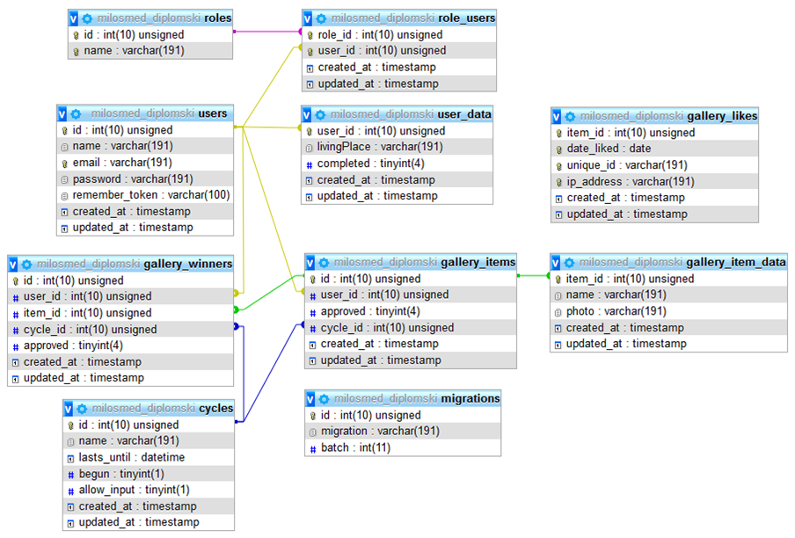

Slika 5.1. *Struktura baze*

5.1 Struktura baze

Users – Sadrži sve korisnike aplikacije

User_data – Sadrži dodatne informacije o korisnicima

Roles – Sadrži korisničke uloge

Role_users – Spaja korisnike sa ulogama

Gallery_items – Sadrži sve slike

Gallery_item_data – Sadrži dodatne informacije o slikama iz galerije

Gallery_winners – Sadrži informacije o pobednicima

Gallery_likes – Sadrži informacije o slikama za koje je korisnik glasao

Cycles – Sadrži informacije o ciklusima

Migrations – Tabela koju *laravel* kreira, koristi se za migracije

6. ZAKLJUČAK

U ovom radu realizovana je web aplikacija sa velikim brojem funkcionalnosti u cilju poboljšanja kvaliteta proizvoda i/ili usluga kompanija. Takođe im može omogućiti da dođu do informacija od strane svojih klijenata koje im mogu biti korisne za buduće poslovanje, kako bi na najbolji način odgovorili na zahteve tržišta, sve u cilju uspeha i razvoja svog biznisa.

Prijavljivanje korisnika se vrši kroz proveru identiteta korisnika preko email-a i lozinke. Korisniku, na osnovu uloge koja mu pripada, biva odobren pristup delovima sajta. Poseban deo Web sajta čini strana za pravljenje upitnika (*survey-a*), gde korisnici sa korisničkom ulogom “company” mogu na veoma lak način dodavat i brisati pitanja i odgovore.

Aplikacija ima dobru osnovu za dalji razvoj, uz unapređenja navedena u narednim pasusima.

Najveći fokus bi bio na samom izgedu i dizajnu sajta. Takođe bi trebalo napraviti „premium“ naloge za kompanije, koji će ima omogućiti neke od dodatnih funkcionalnosti, u vidu dodavanja neograničenog broja upitnika, a besplatne naloge ograničiti, i sistem za naplatu tih naloga.

Podeliti korisnike po grupama, tako da kompanije mogu tačno da biraju ciljnu grupu po godinama, zanimanju i ostalim ključnim indikatorima.

Trebalo bi unaprediti interakciju korisnika sa ulogom „user“, i takaođe im omogućiti nagrade posle uspešnog završetka određenog broja upitinka.

7. LITERATURA

[1] <https://laravel.com/docs>

[2] <https://vuejs.org/v2/guide/>

[3] <http://stackoverflow.com/>