Isaiah Medina

Professor Eastwood

SOAN 266: Neighborhoods, Culture and Poverty

April 11, 2020

Los Angeles: The City of Disadvantaged Angels

**Introduction:**

Mayor Schwarzenegger, my name is Isaiah Medina and I was assigned to the Committee for Socioeconomic Equality in California by your predecessor. Los Angeles County, and the United States at large, are facing an inequality issue with marginalized communities being the ones who feel the implications the most. In this paper we will establish three key topics for you to consider: racial segregation, concentrated disadvantage, and higher educational obtainment. Los Angeles County is well known for its previous racial discrimination and treatment of marginalized communities which could have contributed to the key topics that will be discussed. This paper will also conclude with a summary of the analysis done as well as suggestions on what could be done in Los Angeles County. Being the most populous county in the state, me and my team figured that any changes done here that work will be done in other counties that see our success. We hope you find this paper useful for future decisions you make in this county.

**Historical Background:**

In order to understand what is happening in Los Angeles County, a brief history of the city might be important. Los Angeles’ history goes back all the way to the era of exploration. The earliest record of Los Angeles is a reference to a Native village known as Yung Na which stood in the current location of the city.[1] From that point onward, not much activity happened in the area except in terms of Spanish exploration. Although the official date is contested, many scholars agree that the city was officially established on September 4, 1781.[2] Under the order of Governor Felipe de Neve, a proclamation was issued founding the Pueblo de Nuestra Señora de Los Angeles.[3] The goal was to attract forty-four settlers to cultivate the town into a farming community. These settlers became known as The Pobladores, or The Settlers. Within a couple of years, Neve’s goal of a farming community was becoming a reality. Living conditions were not the most favorable as with any civilization starting out. Supplies were scarce but, regardless of this, by the 1800s “there were seventy families, the white population had grown from one hundred and forty to three hundred and fifteen…a larger number than in any other California community”.[4] In 1818, the first American, Joseph Chapman, arrived in Los Angeles beginning an influx of foreigners throughout the next couple of decades, especially of Americans.[5] In 1822, California seceded from Spain and became part of the newly declared Mexican Empire with Los Angeles as the capitol of Alta California.[6] This empire fell once Agustín Iturbide was removed from his position of authority and Mexico became a republic with Alta California as an important state in the republic. The newly formed empire did not last long though as around this time the idea of Manifest Destiny permeated American thoughts throughout the 1830s and 40s. With a large population of white Americans already in California, as well as many that were still migrating there, the belief went around that “English-speaking America would do a better job of running the lands than the Native Americans or Spanish-speaking Catholic Mexicans”.[7] This sentiment grew as Texas sought independence from Mexico and led to the Mexican-American War. The war lasted two years and ended with the Treaty of Guadalupe Hidalgo on February 2, 1848, handing over California and Los Angeles into American hands.[8]

In 1850, California became a part of the United States and, in April of that same year, Los Angeles became incorporated as a city.[9] Once a part of the United States, a new era of growth occurred in the city with everything from new economic to infrastructure opportunities. Railroads were built from 1870-1880 with the most important railroads erected being the San Pedro, Santa Fe and Southern Pacific railroad systems.[10] These railroads allowed not only more people to move to Los Angeles but also allowed for the communication to improve as well as for economic exchange to occur. Los Angeles was originally an agricultural village and to this point has still remained as one. The railroad though allowed the City of Angels to easily transport goods to the East Coast, accessing a larger economy and become a hub for agricultural trade. Los Angeles eventually moved away from the agricultural sector throughout the 20th century with the advancement of technology and the expansion of city limits. Movie making became the new staple of the city’s economy with the formation of Hollywood. In 1908, movie production began as producers saw Los Angeles as a place where production costs could be cut.[11] By the 1920s, Hollywood had made Los Angeles the world’s film capital.[12] To this day, the film industry is still a large component of Los Angeles’ economy, generating “3.7 cents out of every dollar of income produced in Los Angeles – a figure twelve times that for the US economy as a whole”.[13] Los Angeles, because of other technological advances, industrialized to become a source of manufacturing for Southern California and the United States. During the early 1900s “many ordinances…were enacted in response to the growing number, expanding scale and greater variety of manufactories”.[14] One of the more important manufacturing industries that arose was the aerospace industry due to plane demands during World War II. To this day it has still remained one of the more important manufacturing industries in Los Angeles. Much like the film industry, manufacturing has also remained a vital component of the city’s economy. Approximately 22% of the jobs in Los Angeles belong to this sector to this day.[15] Apparel manufacturing is the most predominant form of manufacturing in Los Angeles, being so predominant that it goes as far as generating “10% of US income produced by the apparel industry”.[16] Other manufacturing for construction, mining, and oil industries contributes significantly as well to the local economy.[17] Agriculture still plays a role in the economy of the city as does tourism.

Los Angeles’ economic activity throughout the 20th and 21st century was enough to attract newcomers to the area. As previously stated, Los Angeles had originally been a Spaniard-Mexican town. Because of this, Los Angeles since its inception has had a large Hispanic population that today makes up 49% of Los Angeles’ population.[18] Some of this population resulted in family generations choosing to remain in Los Angeles while many others immigrated throughout the late 1900s and early 2000s due to economic opportunities. Blacks, like Hispanics, also had a previous history of exposure to the area. Of the forty-four original settlers that were moved to the area during the Spanish occupation, some were of black descent.[19] Blacks did not move in mass numbers to Los Angeles until the Second Great Migration. In a desperate attempt to escape poor economic conditions and Jim Crow segregation, blacks moved to the North and now to the west. “Eight million [Black] Americans moved west of the Mississippi after 1940, half of them to the Pacific Coast. There were 171,000 African Americans in the West in 1940, but 620,000 by 1945”.[20] This continued all throughout the mid to late 1900s with large waves of blacks settling in neighborhoods such as Compton and Watts in the south to Inglewood and Crenshaw in the north, drawn mostly by cheap inner city housing.[21] Today blacks make up about 9% of Los Angeles’ population.[22] Asians are the last major group to make a significant portion of the city’s population. Asians, similar to Hispanics, have previously immigrated to Los Angeles in small quantities since the mid 1600s.[23] Due to political and economic instability, large numbers of Koreans, Chinese and Japanese, among other nationalities, moved to Los Angeles to take advantage of the economic activity and its proximity to these people’s homeland.[24] Asians now form around 12% of the demographics in the area.[25]

Yet all this diversity came after years of racial discrimination against the non-white population. One result of this racial discrimination was the practice of redlining and housing discrimination in Los Angeles, which most likely led to the concentrated disadvantaged neighborhoods we see today, one example of which is Compton. Two key government mechanisms are responsible for enabling the practice of redlining, the Home-Owners Loan Corporation (HOLC) and the Federal Housing Administration (FHA) which was a subset of the National Housing Act of 1934. The HOLC was created by Hoover to “establish a system of banks and to provide credit reserves for mortgage lending institutions comparable to the Federal Reserve System that served commercial banks”.[26] In short, it was a way to refinance mortgages as a way to stop homeowners from foreclosing. The FHA’s primary responsibility was to authorize a mortgage insurance program to revolutionize the market.[27] Both of these organizations though did not give out loans to whoever wanted them though. Instead they had specific guidelines for who could receive a loan and after surveying different communities, they created a lettering system for which neighborhood would most likely repay a loan and be a good investment. A letter A is reported to have been a sound investment for both organizations while a D represented a neighborhood where the banks would not make back on their loan.[28] The criteria that was used to determine whether or not a loan would be profitable was said to be objective, yet based on historical records, it is clear to see how racism played a role in these standards. Neighborhoods that were “black or perceived to be in danger of becoming black” were redlined and not allowed to receive credit.[29]

Several examples of this type of treatment can be seen in Los Angeles County. A primary example of this would be Boyle Heights in the eastern part of the county. Boyle Heights during this time was a melting pot for various ethnicities and races such as Russians, Polish Jews and Mexican Americans to name a few.[30] Because of this mixing of ethnicities, and because of the lack of white residents, Boyle Heights received the lowest rating possible on the scale. Hollywood was another neighborhood which experienced redlining and received low ratings. This was also due to the lack of whites in the neighborhood which were thought to bring stability to an area. Banks and appraisers figured that if “not for a scattering of Japanese and Filipino residents [Hollywood] would be entitled to a higher grade”.[31] This trend was seen all over Los Angeles County in neighborhoods such as West Adams, West Jefferson Park, South Gate and many others. Two things prevented this from continuing, *Shelly v. Kraemer* in 1948 and the Fair Housing Act of 1968. In 1968 the Fair Housing Act was established which “outlawed the refusal to rent or sell to someone because of race”.[32] Although this was a step in the right direction, there were loopholes that allowed the practice to still happen. Eventually though housing opened up for minorities and, because of cheaper inner-city housing, ethnic or racial neighborhoods formed. Some of these neighborhoods were previously all white or multiethnic neighborhoods who now were no longer so because of white flight. These neighborhoods seemed to struggle as time passed on as they were areas of concentrated disadvantage who were not funded for services such as traffic safety, sanitation and street maintenance to name a few.[33] Another problem faced by these neighborhoods included the relaxing of zoning ordinances such that gentrification could take place.[34] Minority neighborhoods such as Chavez Ravine serve as prime example of this. Chavez Ravine was cleared in a “fifty-year effort to being affluent Angelenos ‘downtown’.[35] One of the projects that was to make this neighborhood more comforting for affluent Angelenos was Dodgers Stadium.[36]

**Racial Segregation and Dissimilarity:**

Although redlining is now a social construct which has been legally dismantled, one cannot say that the results of such practices, along with income disparity and concentrated disadvantage (which will be discussed in more detail later), have not caused there to be a racial segregation throughout Los Angeles County. As discussed in the historical section of this paper, several groups make up the demographics of Los Angeles County: white, blacks, Hispanics and Asians. Most research in other large metropolitan areas focuses exclusively on the black vs. white dialogue and history. Due to the precedence of this, segregation was studied between black and whites in Los Angeles County. In order to show the segregation levels in Los Angeles between these two groups, a dissimilarity index was calculated. A dissimilarity index is a demographic measure to show distribution of two groups across a given area. I first calculated black and white dissimilarity for 2018 and then for 2010. The dissimilarity index value given between the black and white population for Los Angeles County was 0.163 for 2018 and 0.171 for 2010. From extensive literature review, we know that across the United States the dissimilarity index has decreased over time. Different mechanisms could explain this pattern such as the availability of affordable housing in privileged neighborhoods or a change density zoning laws. These measures are not comprehensive but provide an idea of factors which help shrink dissimilarity among both groups. In order to observe if this trend is consistent with the national average, we decided to take census data from 1970 to 1990 and calculate dissimilarity indices for each decade. We then plotted it to see if there was a downward trend for dissimilarity in Los Angeles County. 1970 had a dissimilarity value of 0.106, 1980 had one of 0.160, and 1990 had 0.194. The values were plotted to give the following trend chart:

Two different issues arise from this specific analysis of white and black dissimilarity in Los Angeles County. The first issue that arises is the value of dissimilarity given for each of the decades plotted as well as 2010 and 2018. The values themselves are too small which is unusual for a large metropolitan area like Los Angeles which has experienced a large amount of racial segregation and redlining practices. The trend also does not follow the national average which questions the legitimacy of the dissimilarity analysis. One reason for which there may be a reverse trend and low dissimilarity indices could be because the black population in Los Angeles County is small. Blacks currently make up 9% of the population which is below the 13% national average size. For this reason, as well as the low dissimilarity indices, we decided to instead measure these values for Hispanics and non-Hispanics. Hispanics have long been a well-represented population in Los Angeles which provides enough data to see a dissimilarity between other races. A quick note about this analysis is that Hispanics are considered racially white under the census which is the reason Hispanic vs. non-Hispanic was studied instead. Similar to the previous analysis, dissimilarity indices were calculated for 1970-1990, 2010 and 2018. The dissimilarity indices for 1970-1990 were then plotted to see if there had been a decrease in racial segregation over time. The dissimilarity index for 2018 was 0.644 while for 2010 it was 0.669. 1970’s index value was 0.361 while for 1980 and 1990 it was 0.368 and 0.311, respectively. When plotted, the trend appears similar to what has been seen historically across other large metropolitan areas:

There appears to be an increase in dissimilarity index from 1970 to 1980, yet this could possibly come as a result of switching to census tract level measurements which were not present in 1970’s Los Angeles County. It is encouraging to see that racial segregation between the large Hispanic population and the non-Hispanic population. Multiple factors could once again explain this. The increase in Asian immigrants moving into previously all Hispanic neighborhoods could be one reason for this. Another reason for why segregation decreased might be due to Hispanics’ upward mobility and moving into previously all white neighborhoods. Blacks and Hispanics might also share neighborhoods, which could lead to a decrease in segregation, although this was already the case pre-1970. These mechanisms, although just theories, are ways in which segregation has decreased over time.

**Concentrated Disadvantage:**

The practices of redlining and segregation have had more profound effects than simply separating neighborhoods according to race. Many minorities were placed in poor living conditions such as subsidized housing, also sometimes referred to as “The Projects”. Along with these poor living conditions came other problems such as high levels of unemployment, public assistance, poverty and high crime rate. These were compounded the longer these communities were marginalized and a sort of feedback loop between the neighborhood these people lived in and the subpar living conditions they faced. Sociologists noticed this phenomenon and coined a term for it known as concentrated disadvantage. Concentrated disadvantage does not have a particular definition as it is very fluid and changed depending on which sociologist you ask. For this report, concentrated disadvantage will be defined as so: an index used to measure how socioeconomic and physical environment negatively impact a person’s well being. Concentrated disadvantage is also a synergistic effect, meaning that the sum total of the parts that make up the index for concentrated disadvantage have a greater effect on a person than if all the parts were measured individually. Some of the factors included in our concentrated disadvantage index measurement include percentage of residents unemployed, percentage of residents on public assistance, percentage of residents in poverty, percentage of single parents and percentage of residents under the age of 18. All factors chosen are known to compound and or lead to concentrated disadvantage.[37] The first observable characteristic that will be easy to show will be median household income. It is obvious that areas with lower income will be more impoverished than areas with higher income. Los Angeles County is also known for having well-off neighborhoods such as Calabasas, as well as disadvantaged communities such as Compton and Inglewood. We decided to plot the median household income at the census tract level for 2010 to note the distribution of income disparity throughout the county. The follow map showing household median income was produced:

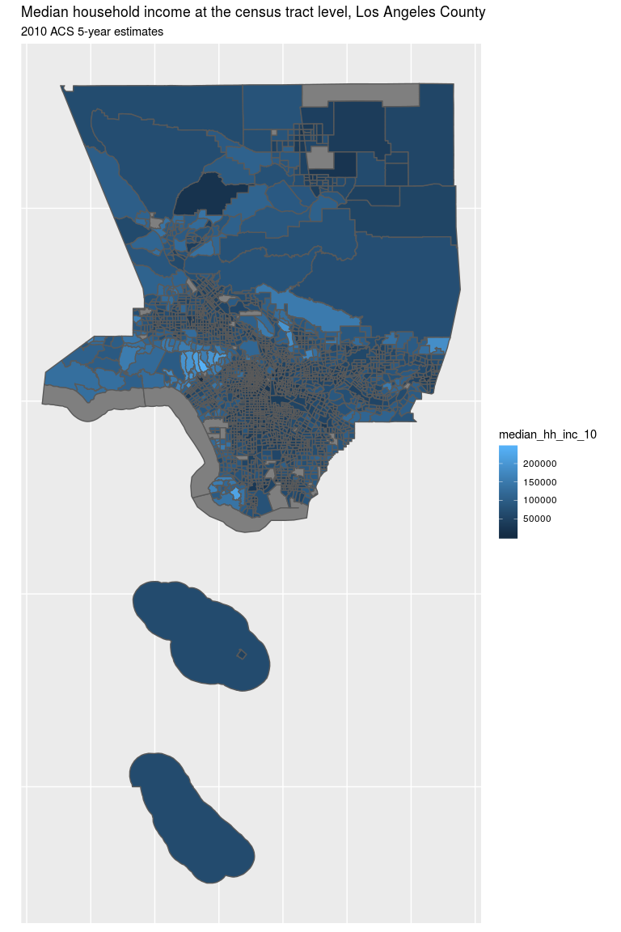

Worth noting in this map is that the median household income tends to be lower in areas previously redlined or segregated for minorites. Cities with higher income tend to have white residents such as the Calabasas region on the western most half of the map. One could speculate and say that this is a result of redlining and segregation, which is what I am speculating. But one could also say that there have been major strides to change the economic landscape of Los Angeles County and that every major city experiences this. I decided to counter this argument by showing the median household income at the census tract level for 2018. When the same map is created for 2018, the following is produced:

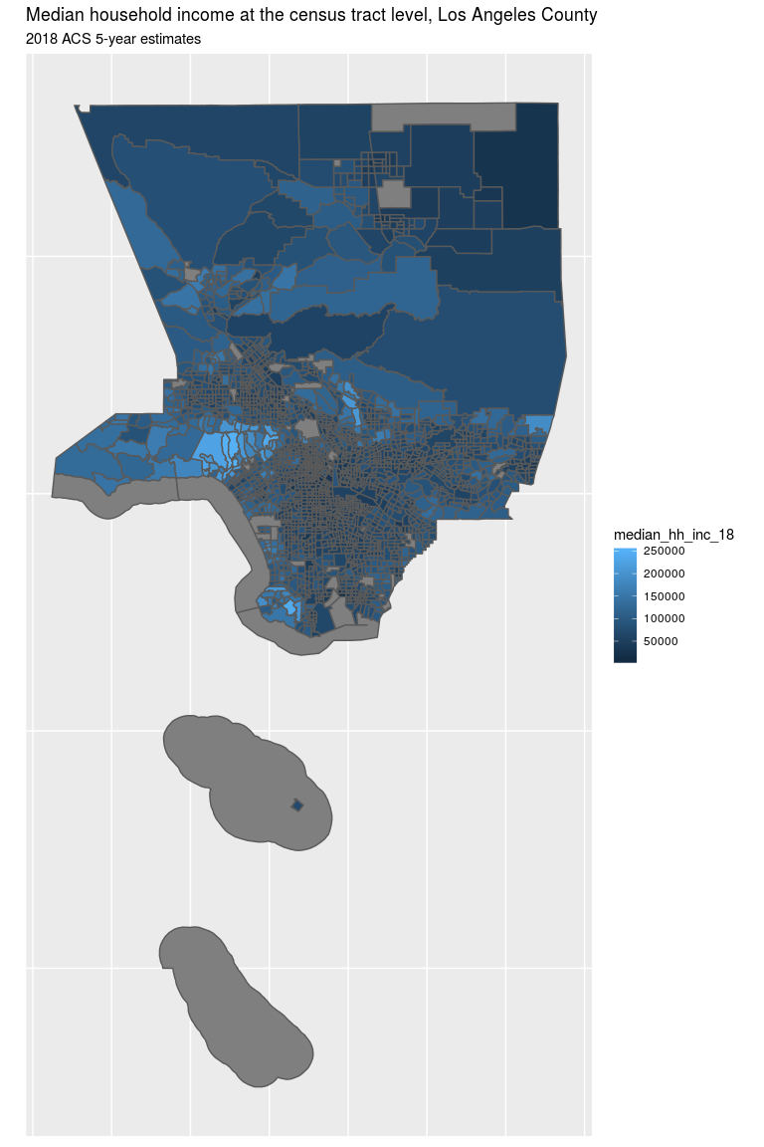

One could say the same graph was replicated, but it was not. If one were to inspect this closely, one could see that there has been some improvement in median household income throughout the county and a decrease in other areas. Census tracts in the northern part of the county seemed to have decreased in median household income for which the reason is not clearly known. Possible decline in local economy might be a reason for the decline in some census tract’s median household income. To further emphasize the point that median household income has stayed the same we regressed median household income for 2010 on 2018 which produced:

This was followed by a map chart showing residual change in median household income from 2010-2018.

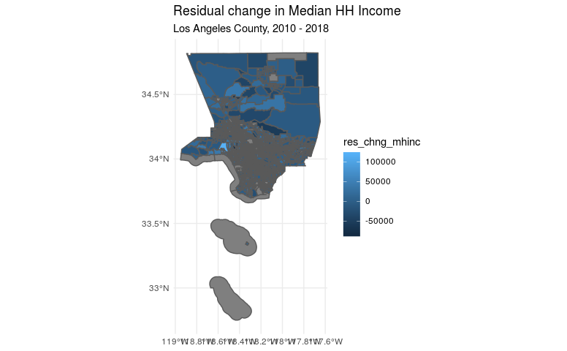

Both show that not much has changed in terms of median household income from 2010 to 2018. There is a bit of variance from the regression line and future studies of Los Angeles County should examine census tract level mechanisms for this slight variance.

How does this relate to concentrated disadvantage? Areas with lower income are more at risk of being in poverty which is one of the factors calculated in concentrated disadvantage. Those with lower median household incomes might also have a higher percentage of receiving household income, although this is only a speculation. There is also another interesting pattern to note between median household income and concentrated disadvantage. To see it, I created a histogram showing concentrated disadvantage throughout Los Angeles County for 2018 which produced the following chart:

The chart shows concentrated disadvantage distribution throughout Los Angeles County as well as concentrated advantage. As seen in the histogram, most of the concentrated disadvantage is centered around zero (the mean) with the graph skewing to the right. In the graph one can notice that there are some census tracts that are about 4 to 4.5 standard deviations to the right of the mean showing that those census tracts experience more concentrated disadvantage than what is average in Los Angeles County. In the graph there are also points to the left of zero. This data comes to show concentrated advantage, areas where residents experience very low to none of the factors listed in our concentrated disadvantage.[38] These might be more well-off communities in the county that experience little to none of the factors calculated in concentrated disadvantage. This data for the histogram was then used to produce a map of concentrated disadvantage spread at the census tract level throughout Los Angeles County for 2018. The following graph is what was produced:

One thing to note about the distribution of concentrated disadvantage is how it in some ways seems in tune with median household income. Areas that experienced higher median household income levels are almost the same areas that have little to no concentrated disadvantage. Some areas show concentrated advantage such as those in the western half of the county. To show how much has changed in terms of concentrated disadvantage, the same was done for 2018.

The histogram still shows a right skew and similar appearance. One census tract is still approximately 4.5 standard deviations away from the average, yet there is only one compared to two that we saw in 2018. When concentrated disadvantage is mapped onto Los Angeles County for 2010, once again the graphs look almost identical as the two maps did for household income:

All seems the same with the exception of a census tract in the middle of the county experiencing a high degree of concentrated disadvantage in 2018 compared to 2010. Both histograms also confirm this addition. The reason as to why this county experienced such a large jump in concentrated disadvantage is unknown. The main point that is being made is that areas with higher median income still in 2010 experience little to no concentrated disadvantage. This is by no means a correlative assumption. The recognition of a pattern is all that is being made and future sociologist studying Los Angeles County should see if there is a correlation between both cases. The other point being made is that not much has changed in terms of concentrated disadvantage in Los Angeles County. To show this, we regressed concentrated disadvantage for 2010 onto 2018:

The above graphs go to show how concentrated disadvantage is distributed throughout Los Angeles County. Areas of concentrated disadvantage seem to be in census tracts toward the southern center part of the county. The census tracts are very small which is why they may not seem as visible in both map depictions; however, they do exist. Even more alarming from this analysis is how not much has been done to decrease concentrated disadvantage in Los Angeles County. As seen in the regression chart of, concentrated disadvantage in 2010 did a decently in mapping concentrated disadvantage in 2018. There is variance in that regression chart which could be due to multiple factors. Factors such as a decrease in poverty, public assistance or higher employment could also be reasons as to why the data does not line accordingly to the regression line. However, the distribution is not extraneous enough to disregard the conclusion drawn. Future studies, as mentioned, should attempt to find correlation between median household income and concentrated disadvantage. The distribution of data points in the regression graph for disadvantage in 2010 and 2018 should also be analyzed in order to find an explanation as to what caused the points to not line up with the regression line.

**Educational Attainment:**

Concentrated disadvantage is known to affect marginalized communities more than white communities. This goes back to the history of racial segregation and redlining previously discussed in this paper. One aspect we wanted to examine in this paper was educational attainment of marginalized communities. Specifically, in this study we examined the percentage of black individuals whose highest educational obtainment was a bachelor’s degree. Black individuals were chosen for this analysis as the discussion in the United States regarding educational obtainment is often times in terms of black individuals and white individuals. For this analysis, a regression analysis was done. We took the percentage of black individuals in Los Angeles County and regressed against the bachelor obtainment for those over 25. Over 25 was a benchmark chosen on the speculation that many people start to settle down after 25, hence ending their educational journey. The regression was done and plotted, giving this chart:

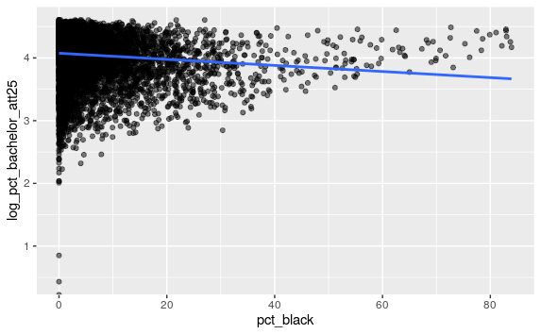

This graph could be interpreted as follows: as percentage of blacks in Los Angeles County increases, the percentage of those whose highest educational obtainment is a bachelor’s degree by 25, decreases. A line of best fit was added to the regression model to show the trend observed. Although the data points show a general trailing off after 30%, the line of best fit confirms our hypothesis of a negative relationship occurring between the two variables. The same regression was done on percentage of whites whose highest educational obtainment was a bachelor’s by 25 with the following graph being produced:

This regression chart states that as percentage of whites in Los Angeles County increases, so too does the percentage of those whose highest educational obtainment is a bachelor’s degree by 25. Likewise to the previous regression chart, a line of best fit was added to the chart to show that there is a positive relationship between both variables. There is a clear difference between both charts with a higher percentage of whites obtaining bachelor’s degrees by age 25 than black citizens do. This could be due to the lingering effects of institutionalized racism and segregation that occurred in Los Angeles throughout the 1900s. As institutionalized racism persisted throughout the 1990s, the effects of concentrated disadvantage compounded in marginalized communities. Although today institutionalized racism is claimed to have ended, the effects are still felt by, for example, the black community. These effects can be shown in regressions such as the two shown.

Different factors seen in concentrated disadvantaged neighborhoods could explain such trends. Their seemed to be a pattern between concentrated disadvantage and median household income, as discussed in the previous section. Lower median household income could be an obstacle to many young marginalized people which prevents them from obtaining higher education. High poverty levels may also be another contributing factor for low bachelor’s degree attainment in disadvantaged neighborhoods. Crime rate also tends to be higher in neighborhoods where there is concentrated disadvantage. Several studies have shown how crime rate plays a role in standardized test scores as well as interrupt vital brain activities for higher thinking.[39] Other factors could also be reasons for these trends. Universities might not be as likely to advertise or recruit black high schoolers from disadvantaged neighborhoods as they are white high schoolers from advantaged neighborhoods. Black residents of disadvantaged neighborhoods may also be unaware of resources that could help them pursue a college education. All these mechanisms could contribute to the disparity in educational attainment between black and white residents in Los Angeles County. Future studies could focus on mechanisms which contribute to this disparity. It would also be useful to find the disparity in educational attainment among all groups and not just exclusively within the black population. Ethnicities should also be the focus of said study as Hispanics are counted as white in the U.S. Census which could contribute to the variance in data points scattered outside of the regression line.

**Conclusions:**

From the analysis done throughout the paper Mayor Schwarzenegger, it can be said that redlining and other racist practices contributed to many of the problems seen today. Dissimilarity indices of Los Angeles County have shown that we have done a phenomenal job of reducing segregation in the county, yet it also shows that we could do more. One suggestion could be to eliminate single-family zoning that, historically speaking, only white residents could afford. By doing this, the dissimilarity and segregation of the county could decrease. This has worked in Minneapolis which shows that this has potential to work in a large city. Zoning with affordable housing in the conversation could be another way to decrease the dissimilarity index.[40] As for how concentrated disadvantage could decrease, there is no clear answer for that. One possible way to decrease concentrated disadvantage would be to invest in disadvantaged communities with the hope that this will combat the disadvantage.[41] Another possible way to combat concentrated disadvantage would be to create more accessible jobs to such communities in order to increase median household incomes and rise above the poverty line. Educational obtainment was also found to be significantly lower in Los Angeles’ black population compared to their white population. Combating this would mean exposing high school graduates to the resources available to them that could help them obtain higher education. Scholarships could also be held by your office to give deserving graduates that can be used for any educational expense. We could also convince colleges to do more recruiting where black populations are prevalent. It is important to know that while a bachelor’s degree has been shown to lead to a higher income, that it not the only avenue we should focus on. Possible trade schools could also be an option for many graduates. Future studies have been discussed in each individual section in detail. I sincerely hope you use this analysis for the benefit of underprivileged and marginalized communities in Los Angeles County. Only after studies such as this, can government officials see the disparity found in many communities and make the necessary changes to improve these situations.

1. Layne, J. “Annals of Los Angeles: Part I. From the Founding of the Pueblo to the American Occupation.” *California Historical Society Quarterly* 13, no. 3 (September 1, 1934). http://search.proquest.com/docview/13013
2. Ibid.
3. Ibid.
4. Ibid.
5. Ibid.
6. Layne, J. “Annals of Los Angeles (Concluded) Part II. From the American Conquest to the Civil War.” *California Historical Society Quarterly* 13, no. 3 (September 1, 1934). http://search.proquest.com/docview/13013
7. University of Michigan, “History of the War,” University of Michigan, accessed February 23, 2020, https://umich.edu/~ac213/student_projects06/magsylje/history.html
8. University of Nebraska Lincoln, “Encyclopedia of the Great Plains | GUADALUPE HIDALGO, TREATY OF,” Plains Humanities Alliance | Center for Great Plains Studies | Nebraska, accessed February 23, 2020, https://plainshumanities.unl.edu/encyclopedia/doc/egp.ha.017.xml.
9. Layne, J. “Annals of Los Angeles (Concluded) Part II
10. California State University, “Impact of Railroad: the Iron Horse and Octopus,” California State University , Northridge, accessed February 23, 2020, https://www.csun.edu/~sg4002/courses/417/readings/rail.pdf
11. University of Houston, “Digital History of Hollywood,” UH – Digital History, accessed February 23, 2020, https://www.digitalhistory.uh.edu/topic_display.cfm?tcid=124
12. Ibid.
13. Miles Finney, “The Los Angeles economy,” *Cities* 15, no. 3 (1998), doi:10.1016/s0264-2751(98)00002-x.
14. HISE, GREG. “Industry, Political Alliances and the Regulation of Urban Space in Los Angeles.” *Urban History* 36, no. 3 (2009): 473-97.
15. Finney, “The Los Angeles economy,”
16. Ibid.
17. Gale eBooks, “Los Angeles Economy,” accessed February 23, 2020, https://go.gale.com/ps/i.do?p=GVRL&u=vic_wlu&id=GALE%7CCX3441800793&v=2.1&it=r&sid=exlibris
18. U.S. Census, Census.gov, Los Angeles
19. Layne, J. “Annals of Los Angeles: Part I.
20. California State University, Monterrey Bay, “The Movement and Culture of African Americans in California,” Digital Commons at CSUMB, accessed February 23, 2020, https://digitalcommons.csumb.edu/cgi/viewcontent.cgi?article=1466&context=caps_thes_all
21. University of Southern California, “Inglewood Today: The History of South Central Los Angeles and its Struggle with Gentrification,” Lusk Center for Real Estate, last modified January 13, 2016, https://lusk.usc.edu/news/inglewood-todaythe-history-south-central-los-angeles-and-its-struggle-gentrification
22. U.S. Census, Census.gov, Los Angeles
23. California Polytechnical State Univeristy, “Geographical Spread of Asians in California,” DigitalCommons@CalPoly| California Polytechnical State University, San Luis Obispo Research, accessed February 23, 2020, https://digitalcommons.calpoly.edu/cgi/viewcontent.cgi?referer=https://www.google.com/&httpsredir=1&article=1126&context=socssp
24. Ibid.
25. U.S. Census, Census.gov, Los Angeles
26. University of Pennsylvania, “Who Received Loans? Home Owners’ Loan Corporation Lending and Discrimination in Philadelphia in the 1930, University of Pennsylvania Scholarly Commons, accessed February 23, 2020, https://repository.upenn.edu/cgi/viewcontent.cgi?article=1007&context=cplan_papers
27. Massey, Douglas S. “The Legacy of the 1968 Fair Housing Act.” *Sociological Forum* 30, no. S1 (2015): 571-88. Accessed February 23, 2020. www.jstor/stable/43654407
28. University of Richmond, “Mapping Inequality,” Digital Scholarship Lab, accessed February 23, 2020, https://dsl.richmond.edu/panorama/redlining/#loc=9/33.728/-118.32&city=los-angeles-ca&adimage=1/40/-216.35
29. Massey, Douglas S. “The Legacy of the 1968 Fair Housing Act.”
30. Ibid.
31. Brooks, *Alien Neighbors, Foreign Friends*, 117
32. Massey, Douglas S. “The Legacy of the 1968 Fair Housing Act.”
33. “How Prop 14 Shaped California’s Racial Covenants,” KCET, last modified June 6, 2019, https://www.kcet.org/shows/city-rising/how-prop-14-shaped-californias-racial-covenants
34. Ibid.
35. Greg Hise, “Border City: Race and Social Distance in Los Angeles”, *American Quarterly*, Vol. 56 No. 3, (Sept. 2004): 552.
36. Hise, “Border City”, 554.
37. Jonathan Eastwood, Open Office Hours, April 20, 2020.
38. Jonathan Eastwood, Open Office Hours, April 18, 2020.
39. Patrick Sharkey et al., "High Stakes in the Classroom, High Stakes on the Street: The Effects of Community Violence on Student’s Standardized Test Performance," Sociological Science 1 (2014), doi:10.15195/v1.a14.

    AND Jennifer A. Heissel et al., "Violence and Vigilance: The Acute Effects of Community Violent Crime on Sleep and Cortisol," Child Development 89, no. 4 (2017), doi:10.1111/cdev.12889.
40. Ann Owens, "Building Inequality: Housing Segregation and Income Segregation," Sociological Science 6 (2019), doi:10.15195/v6.a19.
41. Robert J. Sampson, "Neighbourhood effects and beyond: Explaining the paradoxes of inequality in the changing American metropolis," Urban Studies 56, no. 1 (2018), doi:10.1177/0042098018795363.