REACH User Guide
Version 1
Medinat Akindele
7/22/2025
Introduction
This guide provides stepwise instructions for setting up a new REACH domain, preparing model inputs, and running REACH to predict ambient PM2.5 concentrations and marginal social costs.

Outline of steps to prepare and run REACH for a new region
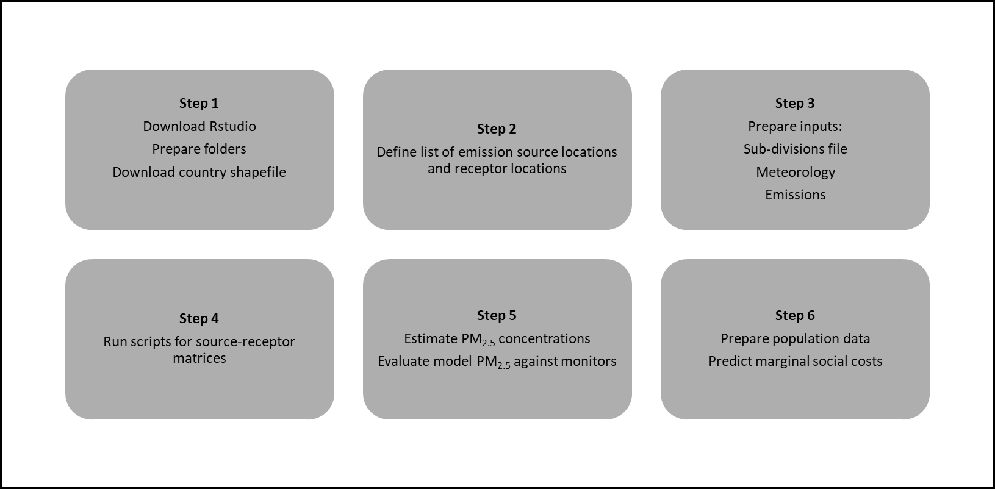

Step 1: Getting started
  - Download R and Rstudio
https://posit.co/products/open-source/rstudio/
  - Prepare directory
This section outlines the folders needed for REACH. Example folder locations are listed as ~.
- Create a folder called ‘Project’
~/Users/Project/
- Copy the folder called ‘REACH_NewRegion’, rename, and add to Project folder
~/Users/Project/REACH_NewRegion/
- Copy the folder REACH_Main from Github to the Project folder
~/Users/ Project/REACH_Main
- Create an R project folder in your REACH directory
- In Rstudio, select File New Project, name R project directory (e.g. Project_Name.Rproj)
- Save to REACH directory
~/Users/Project/REACH_NewRegion/Project_Name.Rproj

  - Download country shapefile(s)
Find shapefiles for the country(s) or region that is modelled and add to inputs folder.
~/Users/Project/REACH_NewRegion/inputs/

Step 2: Define list of emission source locations and receptor locations
A source location is defined as an emissions site. A receptor location is defined as a location impacted by emission sources upwind.
Option 1: Define list of sources and receptors as the same locations
Create a csv file with the centroids of each location (e.g. districts, municipalities) in the region. Ensure that the location_id is a unique identifier. If the location id is not provided in the shapefiles, you can create a unique identifier for each location in the region. In this example option, the emissions for each pollutant are aggregated to the grid/specified geography level.
location_id | country | lat | lon

For an example file format, see ~/REACH_SA/inputs/southern_africa.csv
Option 2: Define sources and receptors as different locations
In this case, you may want to model emissions at different coordinates other than the receptor locations (for example, additionally at the power plant or industry level). The receptors can be defined in the same way as option 1 with their centroid coordinates. The emission sources are defined differently with additional identifiers (e.g. facility name). For area sources, emissions can be aggregated to the grid/specified geography level instead of running the code for individual sources to save computational time.
location_id | facility_name | country | lat | lon
 | plant X

For an example file format, see ~/REACH_US/inputs/emissions/

Step 3: Prepare inputs
The 'Inputs' folder contains scripts to prepare emissions and meteorology data for REACH. The scripts were prepared for global EDGAR emissions and ERA5 meteorology datasets as the default option. These datasets can be used when local emissions and meteorology data are unavailable. For the entire directory with input and output files, download 'Inputs.zip' at the Zenodo link. There are also scripts for DACCIWA emissions and can be made available upon reasonable request.
  - Sub-divisions file
See Inputs folder on Zenodo. Prepare file from 06_subgrids.R.
Link to Zenodo for additional files: https://zenodo.org/records/20546830
  - Meteorology
Dataset: ERA5 hourly data on single levels from 1940 to present https://cds.climate.copernicus.eu/datasets/reanalysis-era5-single-levels?tab=download
1. Download the ERA5 reanalysis data
Step 1: Select the following variables:
- 10m u-component of wind
- 10m v-component of wind
- 2m dewpoint temperature
- 2m temperature
- Surface solar radiation downwards
- Total cloud cover
- Surface pressure
Step 2: Select year of interest, all days and times
Step 3: Select geographical region of interest
Step 4: Download ERA5 nc file
2. Prepare meteorology files for REACH
Run 05_meteorology.R

  - Emissions
3.31 EDGAR emissions inventory
Dataset: EDGAR v8.1 Global Air Pollutant Emissions
https://edgar.jrc.ec.europa.eu/dataset_ap81

Adjust the script (01_download_emissions.R) accordingly when downloading data from a more recent dataset.

The following scripts are used to prepare the EDGAR emissions data for the REACH model. Input information from the Southern Africa domain is applied to illustrate the use of the scripts. Replace the inputs accordingly for the domain of interest.

01_download_emissions.R

This script downloads EDGARv6.1 annual emissions for all sectors from the online website. There is a function to unzip the folders and extract the emissions in nc format.
02_process_emissions.R

This script maps EDGAR sector emissions from 0.1 degrees x 0.1 degrees spatial resolution into administrative geography resolution. The annual emission fluxes are converted into units of tonnes/year.

03_aggregate_edgar.R

This script consolidates the EDGAR sector emissions for each location and pollutant. EDGAR doesn’t provide detailed information about the stack heights of emission sources at elevated heights. For that reason, certain sectors were assumed to have all emissions at the ground-level or at an elevated height. These assumptions are documented in a file called edgar_sectors.csv, which can be adjusted based on knowledge of your domain. If using the newer version of EDGAR, please check the pollutant and sector list on the website and edit edgar_sectors.csv if needed.

The EDGAR sector emissions are then aggregated for each location and pollutant according to the assumption on whether the sector comprises of entirely ground-level or elevated sources. For ground-level sources, an effective stack height of 10 m was assumed. For elevated sources in Southern Africa, an effective stack height of 220 m was assumed based on information from South African power plants. In the script, adjust the stack information for your domain accordingly.

3.32 GFED biomass burning emissions
- Scripts located in biomass folder
- See GFED_preparation.docx for instructions

Step 4: Source-receptor matrices
  - Edit domain_info.R and specify:
- sub_divisions
- emission source locations
- receptor locations
- identifier name for receptor locations

  - Run scripts from Version A or Version B
- Version A is suitable for emission inventories where stack information for point sources is available.
- Version B is suitable for regions with less detailed emission inventories

Step 5: Estimate and evaluate PM_{2.5}
5.1 Baseline PM2.5 concentrations
- Open the REACH_US.Rproj folder in Rstudio
- Edit and run the 01_concentration.R script
- Edit and run the 02_partition.R script
- Adjust inputs as necessary for the domain of interest

Step 6: Marginal social costs
Process of estimating marginal social costs
REACH marginal social costs are estimated using the GBD methodology of predicting ambient PM2.5-attributed mortalities. Input data for the REACH-Southern Africa domain is provided as an example.
6.1 Data needed
- Population by age group (under age 5 yr and above age 25 yr) and location
This site has age-specific population data for many countries. Check to see if the countries in your modeling region are covered.
https://www.census.gov/geographies/mapping-files/time-series/demo/international-programs/subnationalpopulation.html

- Download GBD country-specific mortality rates by cause of disease:
https://vizhub.healthdata.org/gbd-results/
- Age groups 25 yr + (see image on left below)
- ischemic heart disease (IHD)
- stroke
- chronic obstructive pulmonary disease (COPD)
- lung cancer (LC)
- type II diabetes (DM)
Rename file to IHME-GBD_2021_DATA_mortality_rates.csv and add to GBD_mortality/inputs folder
- Age groups under 5 yr and above 25 yr (see image on right below)
- lower respiratory infections (LRI)
Rename file to IHME-GBD_2021_DATA_LRI_under5.csv and add to GBD_mortality/inputs folder

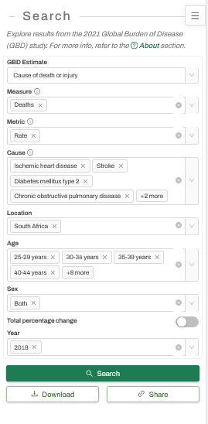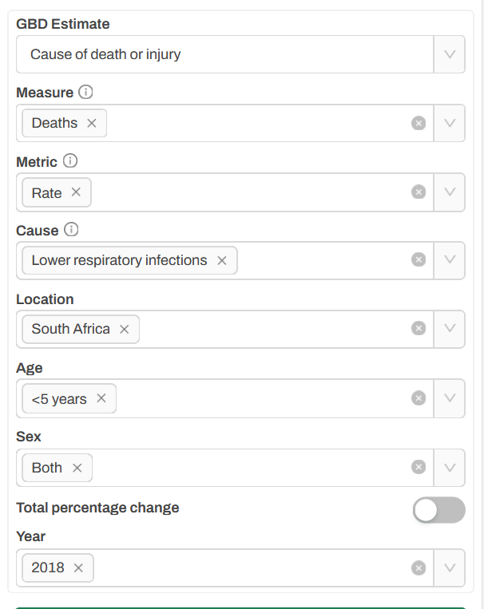
6.2 Steps
- Prepare a file with population by age group and location
- See script 00_popbyage.R for example
- Compute baseline mortalities
- Edit and run 01_mortality_bycause.R
- Adjust country names and year for coexposure factors
- Edit domain_inputs.R
- Calculate baseline PM2.5 attributable mortalities:
- Edit and run 02_basePM25_deaths.R
- Marginal social costs
- new_mort.R: Calculate new PM2.5 mortalities based on 1 tonne addition of a PM2.5 precursor to a source location. The difference in mortalities resulting from this addition and the baseline is the marginal social cost (mortalities/tonne)
- GBD_relative_risk.R: script with GBD concentration-response by cause of disease and interpolates RR for REACH PM2.5 estimates
Edit and run the following scripts for the marginal social costs
- PM_damage.R: primary PM2.5 marginal social costs
- NH3_damage.R: NH3 marginal social costs
- NOX_damage.R: NOX marginal social costs
- SO2_damage.R: SO2 marginal social costs
- VOC_damage.R: VOC marginal social costs

Note about calculating total PM2.5-attributed deaths. Estimate from script (02_basePM25_deaths.R) and not from multiplying emissions by the marginal social costs. The marginal social cost approach assumes a linear relationship between emissions and mortality, whereas the concentration-response functions are non-linear.

References
GBD PM2.5 attributable mortality method:
McDuffie, Erin E., Randall V. Martin, Joseph V. Spadaro, Richard Burnett, Steven J. Smith, Patrick O’Rourke, Melanie S. Hammer, et al. 2021. “Source Sector and Fuel Contributions to Ambient PM2.5 and Attributable Mortality across Multiple Spatial Scales.” Nature Communications 12 (1):3594. https://doi.org/10.1038/s41467-021-23853-y.
GBD relative risk is obtained from:
McDuffie, E., Brauer, M., Martin, R., Spadaro, J., Burnett, R., Hammer, M., & van Donkelaar, A. (2021). GBD-MAPS-Global: Analysis Input Dataset [Data set]. Zenodo. https://doi.org/10.5281/zenodo.4642700

Step 7: Citing REACH work
Note: Please check back shortly for the updated citation.
Akindele, Medinat, Peter J. Adams, Nicholas Z. Muller. "REACH: an accessible and globally portable air quality model for policy and health impact assessment." In preparation.

Appendix 1: Developing calibration coefficients
This section outlines the steps to determine calibration coefficients for primary
PM2.5, sulfate, nitrate, ammonium, and secondary organic carbon.
A.1 Inorganic PM2.5 calibration
Follow this order: calibrate sulfate first, then nitrate, and lastly ammonium
1. Assume an initial guess for the sulfate calibration and multiply the model predictions by this value. Calculate the mean bias between the model predictions and measured sulfate. Adjust the sulfate calibration until the mean bias is close to 0.
2. After finalizing the sulfate calibration, determine the nitrate calibration. Assume an initial guess for the total nitrate calibration and multiply the model predictions by this value. Estimate particulate nitrate with the regression in the 01_parition.R script. Calculate the mean bias between the model predictions and measured particulate nitrate. Adjust the nitrate calibration until the mean bias is close to 0.

3. Lastly, determine the ammonium calibration. Assume an initial guess for the total ammonium calibration and multiply the model predictions of total ammonium by this value. Estimate particulate ammonium with the equations in 01_partition.R script. Calculate the mean bias between the model predictions and measured particulate ammonium. Adjust the ammonium calibration until the mean bias is close enough to 0. Because of the non-linear interactions between sulfate, nitrate and ammonium, and the assumptions in estimating particulate ammonium, the mean bias will likely be larger than the sulfate and nitrate mean biases against observations.
A.2 Primary PM2.5 calibration
If there are quality measurements of primary PM2.5 or sub-components OC and BC, then compare the model predictions of primary PM2.5 to observations of primary PM2.5 and minimize the mean bias to be close to 0.
Otherwise if observations are unreliable or unavailable, then follow the same process as REACH-US. For REACH-US, the national emission-weighted marginal social cost for primary PM2.5 was calculated. This was compared to the average primary PM2.5 marginal social costs for APEEP, InMAP and EASIUR reduced-complexity models. The REACH national average primary PM2.5 marginal social cost was then scaled to fall within the range of the other models. Similar comparisons for other regions can be made given marginal social costs for other models are available. If data to conduct either of the above is unavailable, then the REACH-US primary PM2.5 calibration can be assumed for another region.
A.3 Secondary organic carbon (SOA) calibration
This section outlines the process to estimate the SOA calibration. For the Unites States, measurements of total (primary and secondary) OA are available and not available for secondary OA. Because of this reason, total OA in the model is calibrated to measured total OA and the resulting calibration coefficient is used to tune secondary OA.

The process is summarized in the following steps:
Step 1: Apply PM2.5 calibration to OA primary
OA_primary_cal = OA_primary * PM25_cal
Step 2: Set an initial guess for the SOA calibration
Step 3: Multiply the SOA calibration in step 2 by secondary OC
OA_secondary_cal = OC_secondary * SOA_cal
Step 4: Add total organic aerosols
OA_tot_cal = OA_primary_cal + OA_secondary_cal
Step 5: Compare modelled total OA (OA_tot_cal) to measurements of total OA and calculate mean bias
Step 6: If the mean bias is not close to 0, adjust initial guess for SOA calibration and repeat steps 2-6

NOTE: If speciated observations are not available to develop region-specific calibrations, use REACH-United States calibrations for your domain and note assumption. The REACH-United States calibrations have been shown to work reasonably well for REACH-Southern Africa based on SO2 and NOx evaluations.

Questions Asked
- Can I create a domain with regular-sized grids or some other type of grid size?
Yes. It doesn’t matter if your grids are regular (equal spaced) or irregular sized (e.g. districts/municipalities). With REACH, you only need to specify the coordinates (lat, lon) of the locations you’re modeling.

- How does the calibration work? Do I have to develop calibration-coefficients?
Please see the REACH model paper or send an email if there are further questions.

- Can I use the PM2.5 source-receptor matrix for BC?
Yes, BC is a sub-species of primary PM2.5, so the primary PM2.5 source-receptor matrix can be applied to BC emissions.

- Do we consider wet deposition processes in REACH?
Yes, but a constant timescale is used for wet deposition. It is possible to account for variable wet deposition, but the model scripts would have to be edited.

