WEEK-3
MongoDB
BookFlow_DB
Task-1:
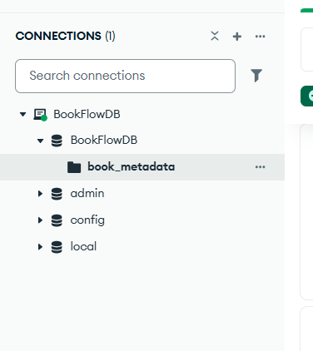
Task2:
{"avgRating": { "$gt": 4 }}
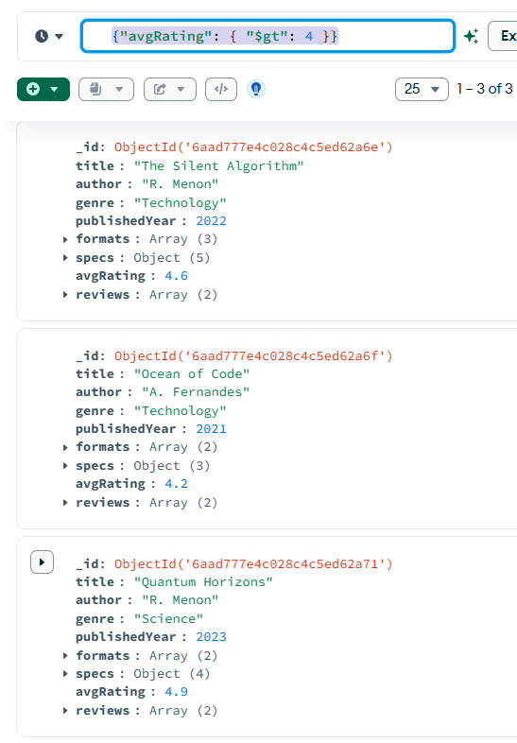
2. { "formats": { "$in": ["Digital", "Audiobook"] } }
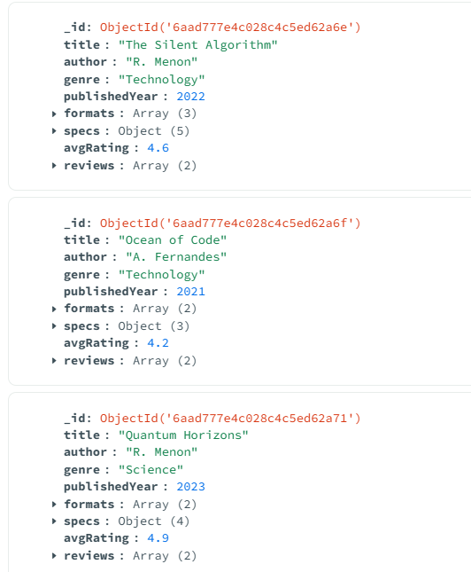
3. { "formats": { "$regex": "Digital", "$options": "i" } }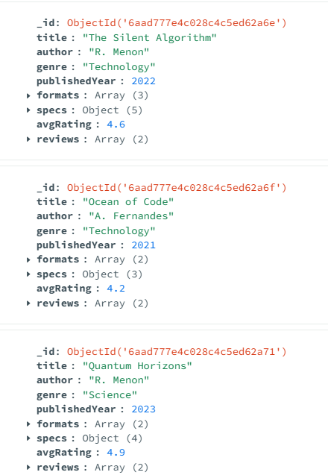
4. { "reviews.comment": { "$regex": "Digital", "$options": "i" } }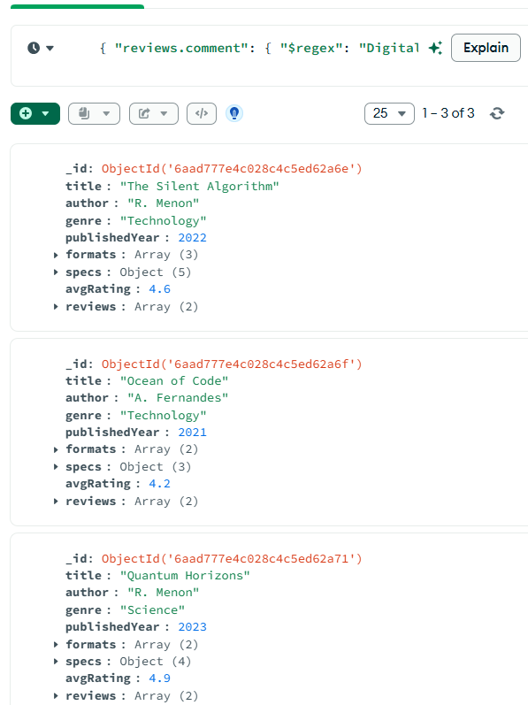
Task3:
{ "publishedYear": { "$gt": 2020 } }
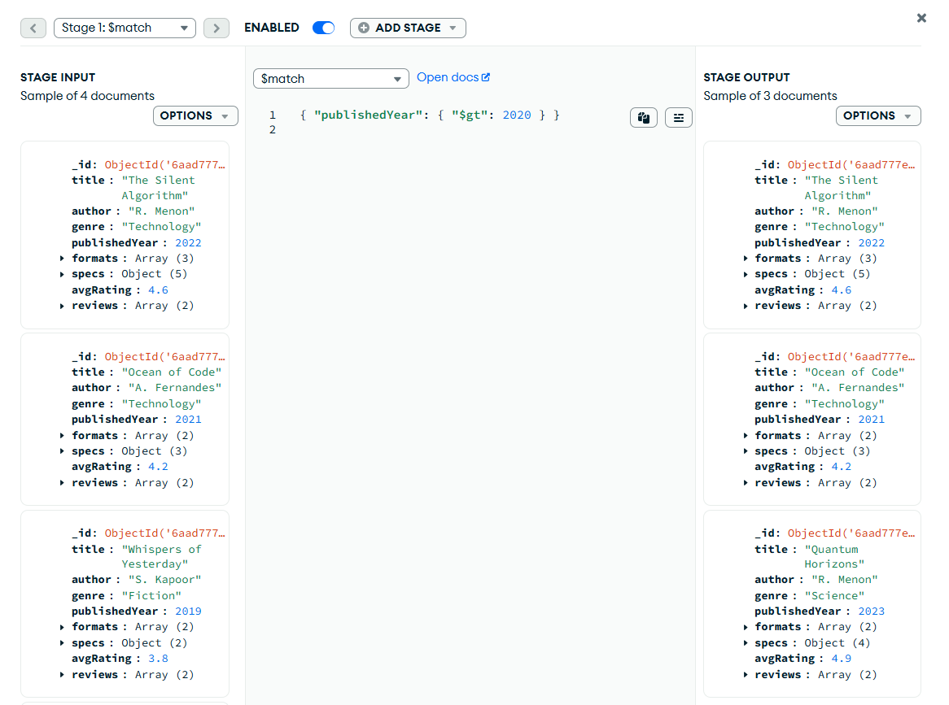
2."$reviews"
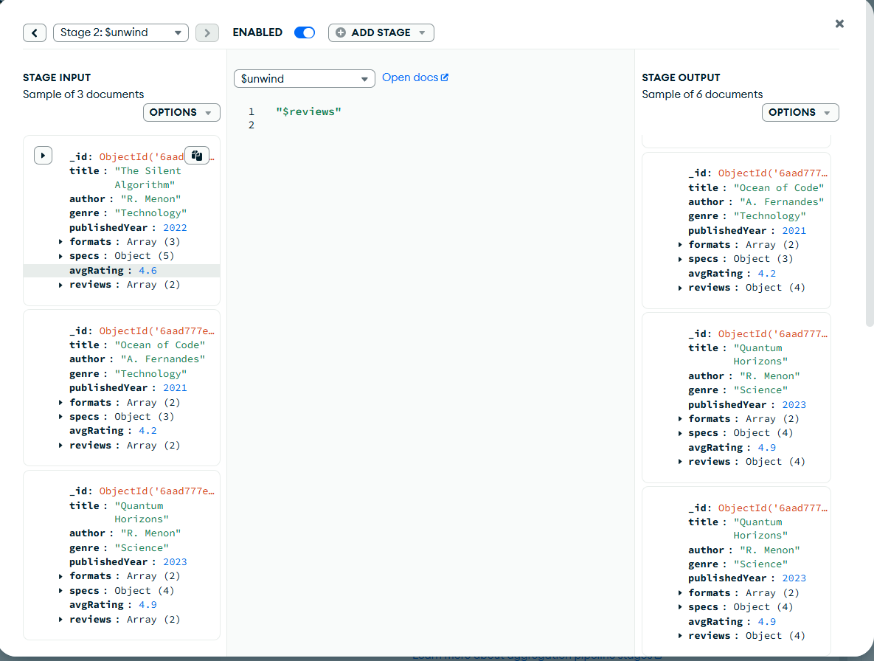
3. {
"_id": "$title",
"avgReviewRating": { "$avg": "$reviews.rating" },
"totalReviews": { "$sum": 1 },
"author": { "$first": "$author" }
}
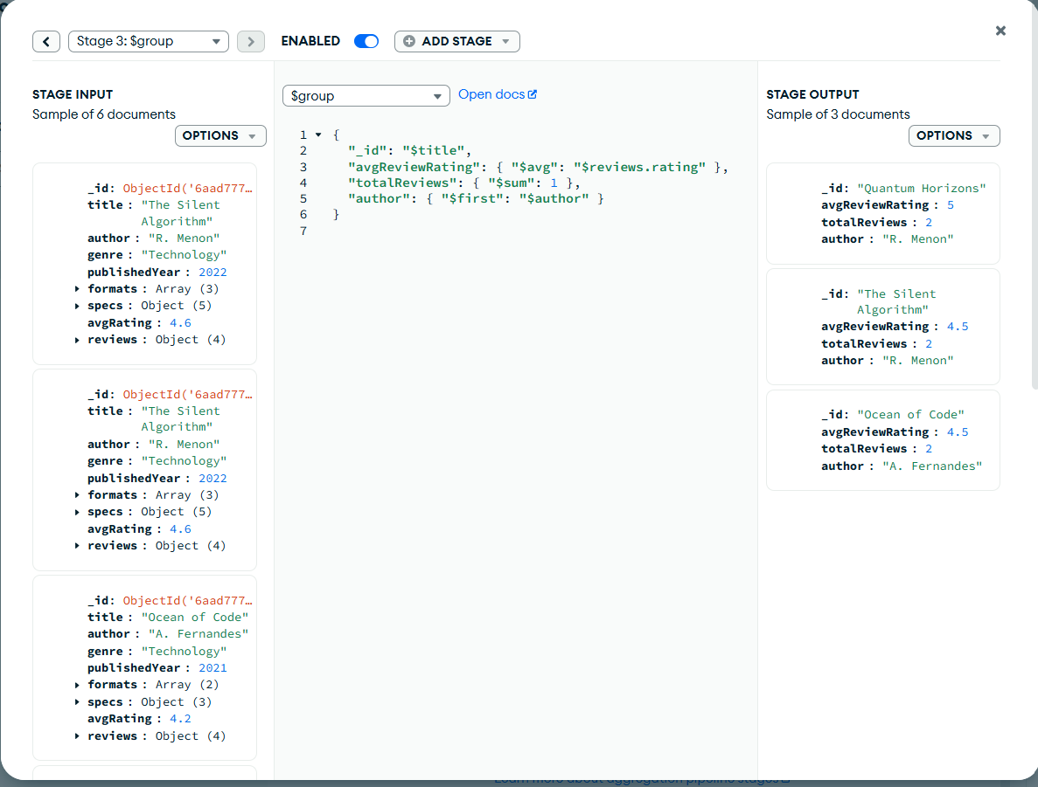
4. { "avgReviewRating": -1 }
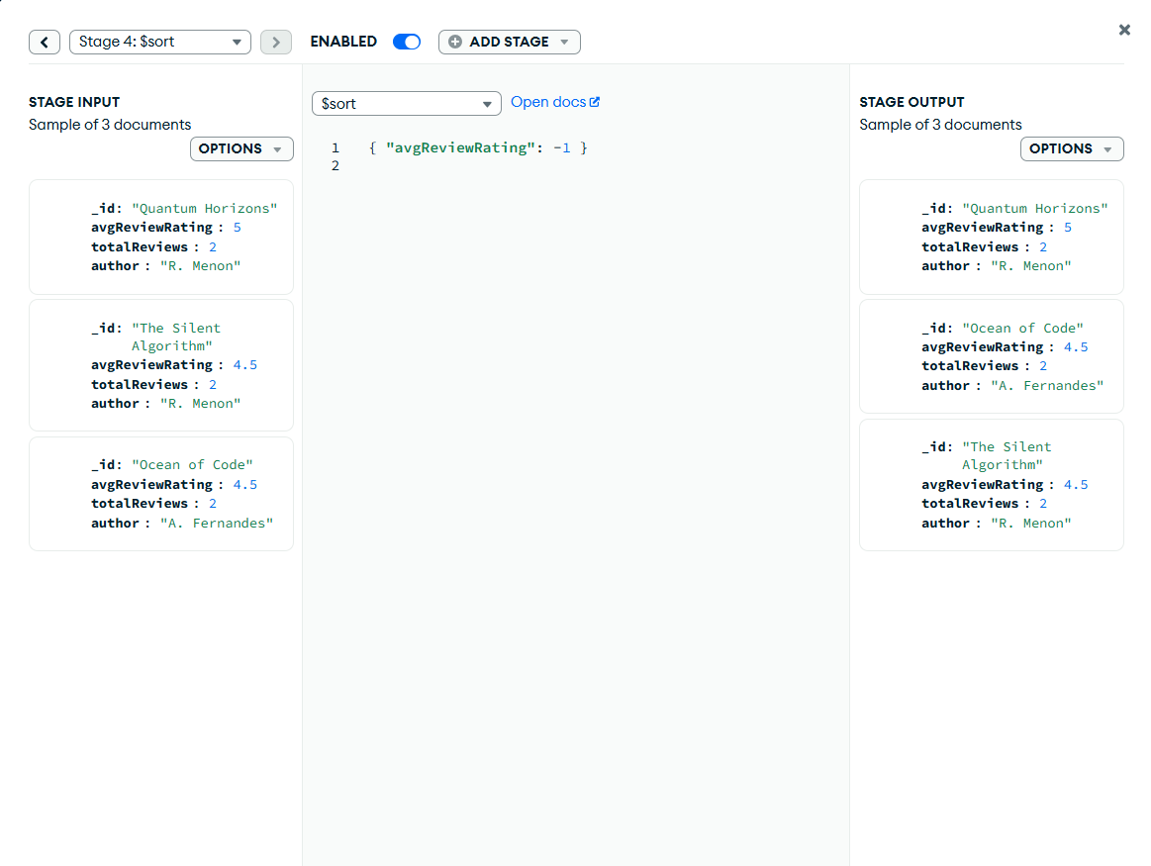
5. {
"_id": 0,
"title": "$_id",
"author": 1,
"avgReviewRating": { "$round": ["$avgReviewRating", 2] },
"totalReviews": 1
}
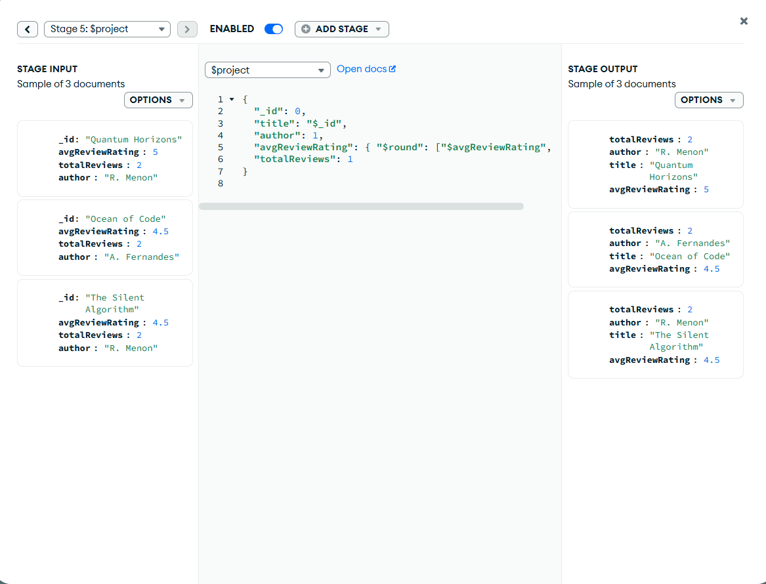

Task 4: Indexing for Speed
