EXAMPLE 1: NO PARAMETERS
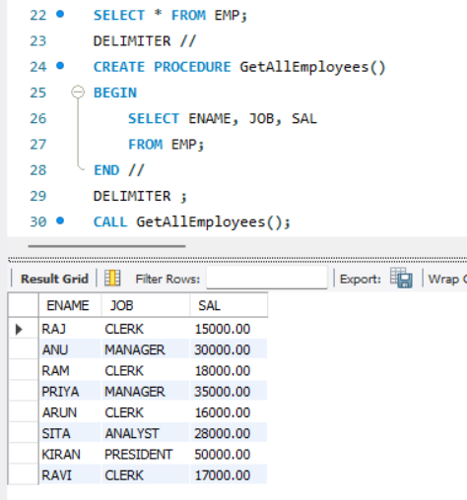
EXAMPLE 2: IN PARAMETERS
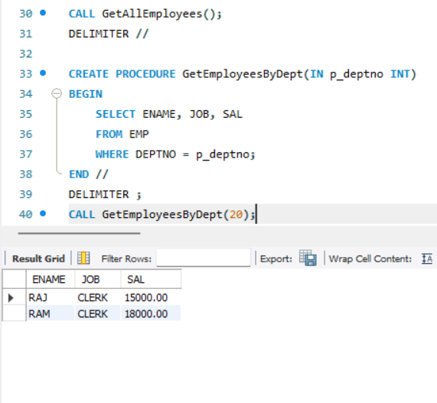
OUT PARAMETER:
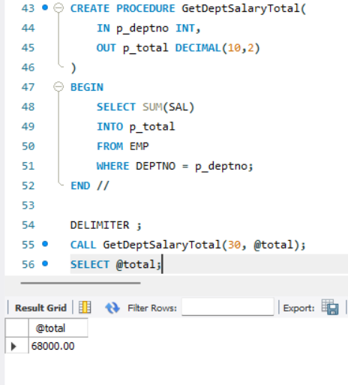
WITH LOGIC IF STATEMENT:
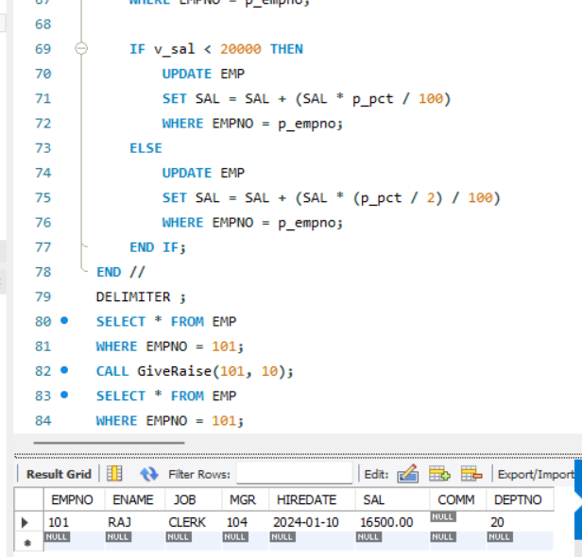
TRIGGERS:
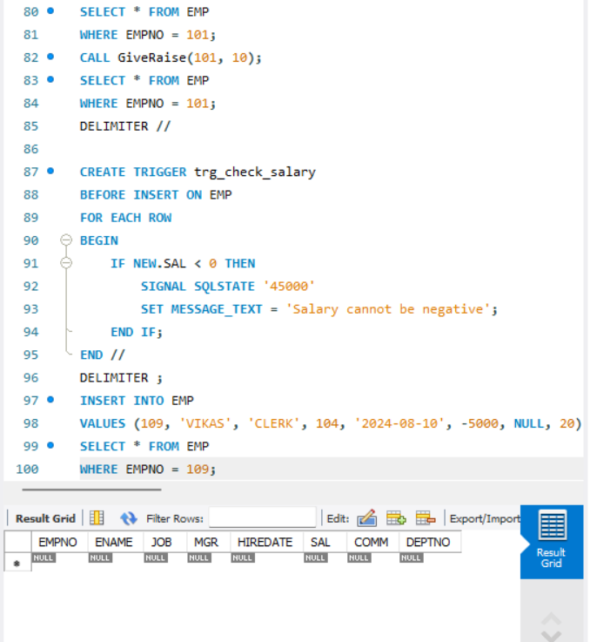
EXAMPLE 2: AUDIT LOG
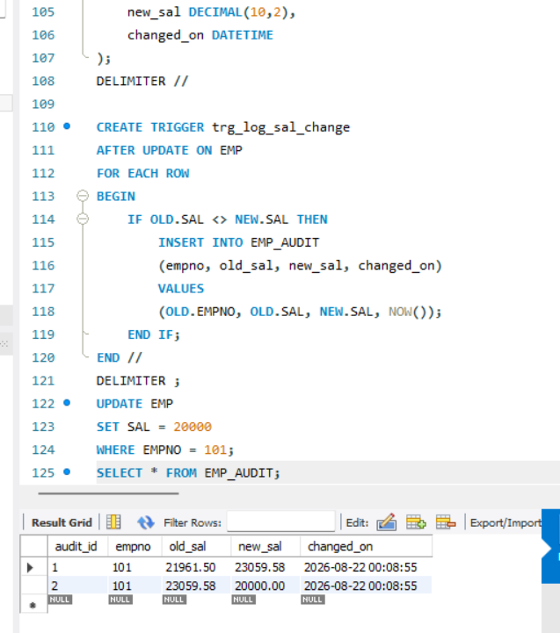
EXAMPLE 3: Prevent Deletion
