Disease Drug Prediction using ML

INTRODUCTION Since the arrival of advanced computing, the doctors’ still requires the technology in various possible ways like surgical representation process and x-ray photography, but the technology perceptually stayed behind. The method still requires the doctor’s information and experience due to alternative factors starting from medical records to weather conditions, atmosphere, blood pressure and numerous alternative factors. The huge numbers of variables are consider as entire variables that are required to understand the complete working process itself, however no model has analyzed successfully. To tackle this drawback, Medical decision support systems must be used. This system is able to assist the doctors to make the correct decision. Medical decision support system refers to both the process of attempting to determine or identify possible diseases or disorder and the opinion reached by this process. The diagnostic opinion in the sense, it indicates either degree of abnormality on a continuum or a kind of abnormality in a classification. It’s influenced by non medical factors such as power ethics and financial incentives for patient or doctor. It can be a brief summation or an extensive formulation, even taking the form of story or metaphor. It might be a means of communication such as computer code through which it triggers payment, prescription, notification, information or advice. Indication of medical diagnostic includes knowledge of what is normal and measuring of patient’s current condition. Automated decision support systems are rule based systems that are automatically providing solutions to repetitive management problems.

Medical decision could be extremely specialized and difficult job due to alternative factors or incase of rare diseases. The alternative factors include stress; tired misdiagnosis might vary from ignorance of doctors and incomplete information. Standard algorithm may go through the entire variables like prevailing conditions history of medical records, history of family records and various factors relating to the patient records, sheer magnitude of obtainable hidden factors. Differential diagnosis methods can be used to identify the presence of an entity where multiple alternatives are possible and also refers to include the candidate alternatives. This method is needs a process of elimination or obtaining information that shrinks the probability of candidate conditions to negligible levels. It contains four steps: 1) The doctor gather all information about the patients and create a symptoms list.2) The doctor should make a list of all possible causes of symptoms.3) The doctor should prioritize the list by which is the most dangerous possible cause of symptoms put in the top of the list. 4) The doctor should rule out or treat the possible causes beginning with the most urgently dangerous conditions.”Rule Out” in the sense to use the test method or other scientific method. If there will be no such diagnosis means removing the diagnosis from the list and using tests that should have distinct results, depends on which diagnosis is correct. This can be done based on the doctor’s knowledge and experience. This method is very easy to implement.
To reduce the large number of variables and find the most probable diseases by using the K-Means algorithm. This algorithm is more suitable to cluster the more number of diseases. K-Mean is one of the unsupervised learning algorithms which are used to solve the clustering problem. The main idea is to determine the k centroids, one for each cluster. Different tests performed on the patients will served as a attributes for clustering. By using this algorithm it reduce the number of iterations, boundries of clusters are well define without overlapping, to produce the accurate result for each and every diagnosis. This system uses Service oriented architecture (SOA), anyone can access with internet connections and LAMSTAR Network can be used to calculate the weight, to increase the accuracy of algorithm, overall speed test and produce the better result.

Dataset:
itching,
skin_rash
nodal_skin_eruptions
continuous_sneezing
shivering
chills
joint_pain
stomach_pain
acidity
ulcers_on_tongue
muscle_wasting
vomiting
burning_micturition
spotting_ urination
fatigue
weight_gain
anxiety
cold_hands_and_feets
mood_swings
weight_loss
restlessness
lethargy
patches_in_throat
irregular_sugar_level
cough
high_fever
sunken_eyes
breathlessness
sweating
dehydration
indigestion
headache
yellowish_skin
dark_urine
nausea
loss_of_appetite
pain_behind_the_eyes
back_pain
constipation
abdominal_pain
diarrhoea
mild_fever
yellow_urine
yellowing_of_eyes
acute_liver_failure
fluid_overload
swelling_of_stomach
swelled_lymph_nodes
malaise
blurred_and_distorted_vision
phlegm
throat_irritation
redness_of_eyes
sinus_pressure
runny_nose
congestion
chest_pain
weakness_in_limbs
fast_heart_rate
pain_during_bowel_movements
pain_in_anal_region
bloody_stool
irritation_in_anus
neck_pain
dizziness
cramps
bruising
obesity
swollen_legs
swollen_blood_vessels
puffy_face_and_eyes
enlarged_thyroid
brittle_nails
swollen_extremeties
excessive_hunger
extra_marital_contacts
drying_and_tingling_lips
slurred_speech
knee_pain
hip_joint_pain
muscle_weakness
stiff_neck
swelling_joints
movement_stiffness
spinning_movements
loss_of_balance
unsteadiness
weakness_of_one_body_side
loss_of_smell
bladder_discomfort
foul_smell_of urine
continuous_feel_of_urine
passage_of_gases
internal_itching
toxic_look_(typhos)
depression
irritability
muscle_pain
altered_sensorium
red_spots_over_body

We will predict the disease with the dataset and we have implemented to suggest medicine for diabetes and Hypertension problems.
Execution:
Click on run.bat file in your project directory
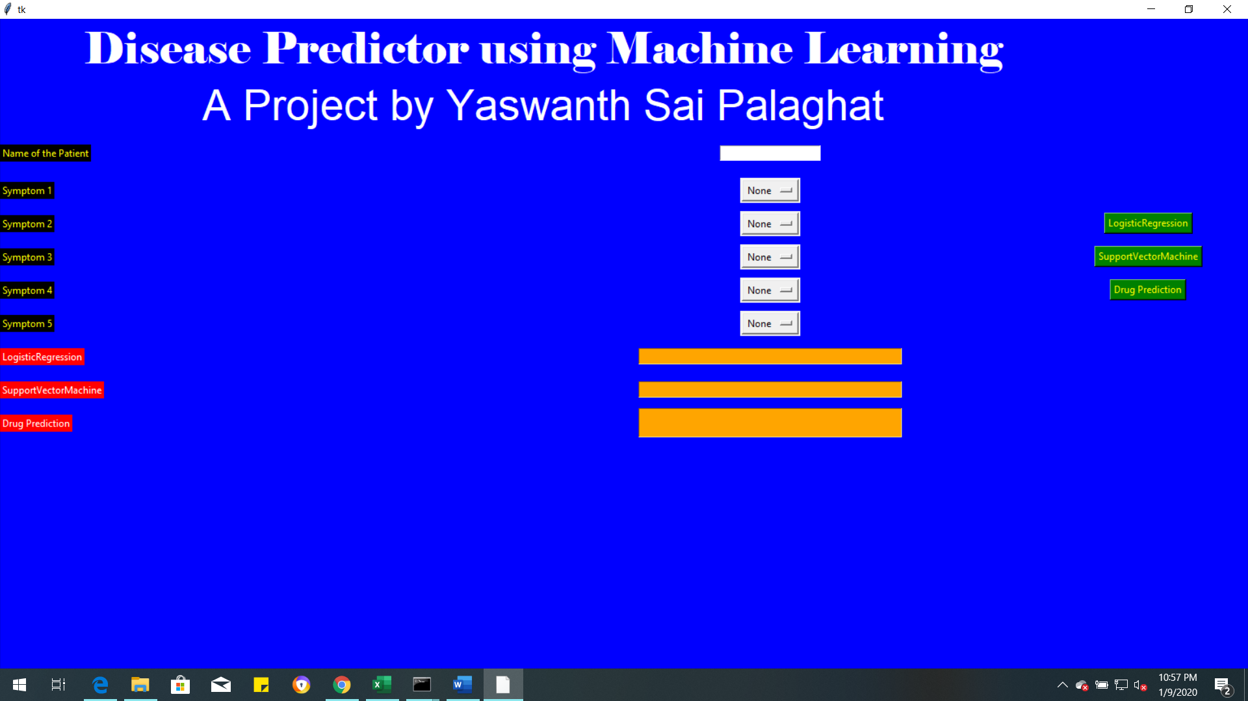
Enter the Name of patient and enter the symptoms of the patient to prediction the disease. And then click on algorithm from which you want to predict.
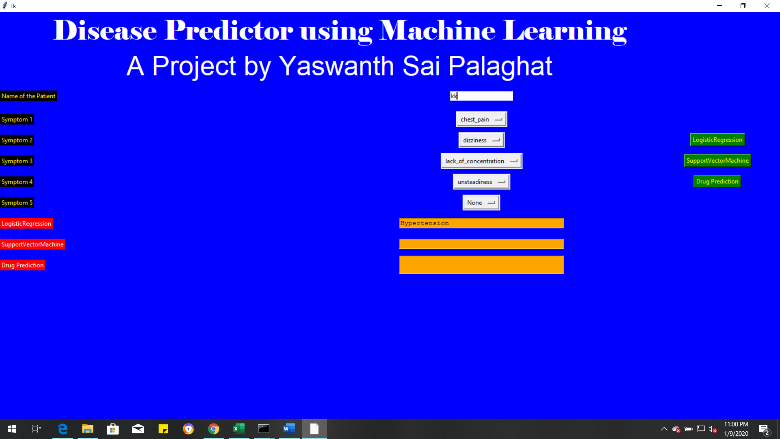

From the above figure for given symptoms it predicted Hypertensio by using Logistic regression
Now test for SVM also.

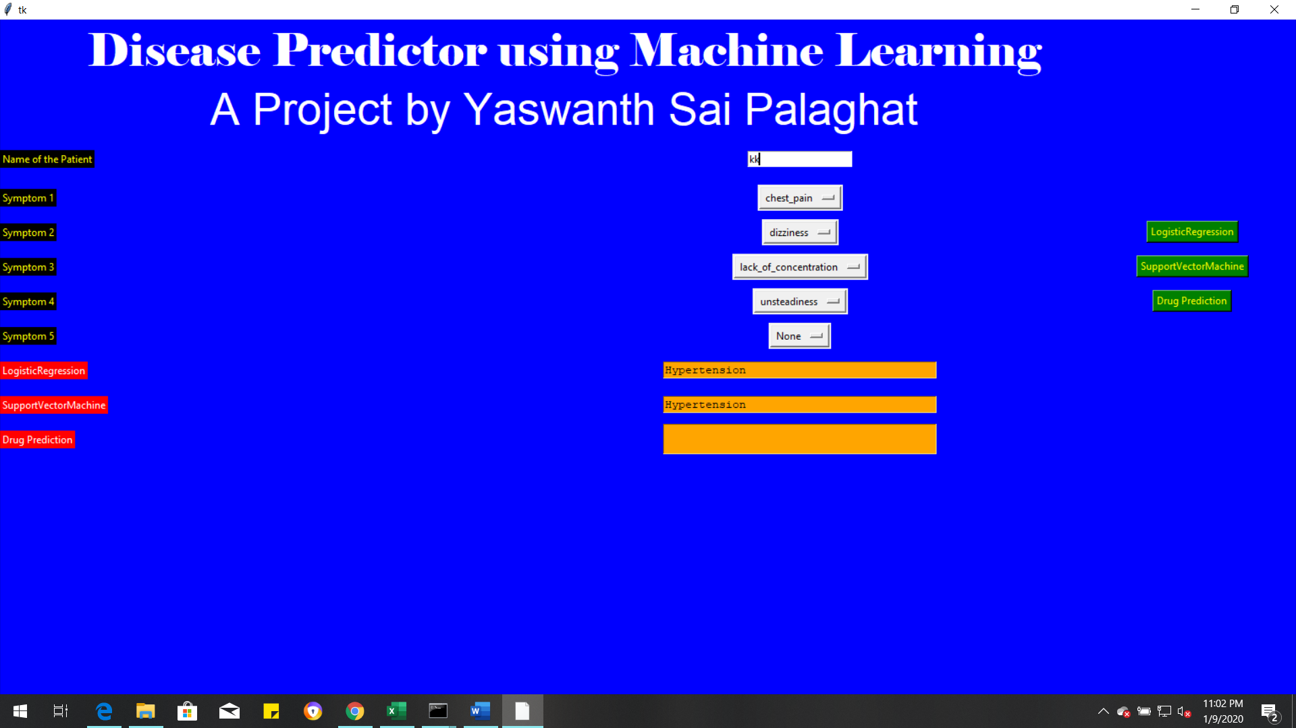
For SVM also for the given symptoms it predicted Hypertension. Now predict the Drug for the disease.
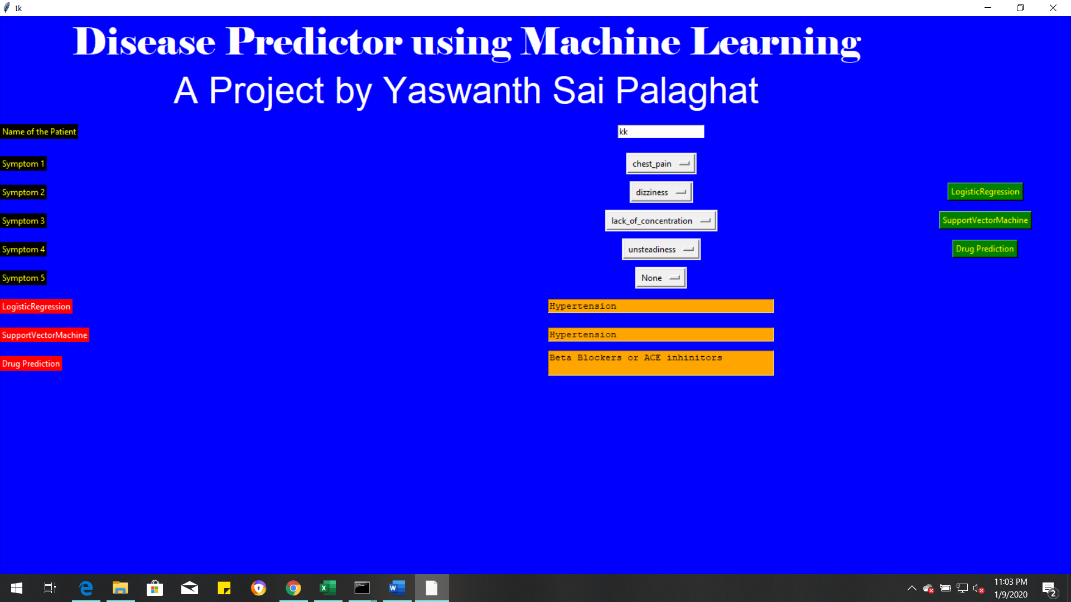
For Hypertension it suggest 2 drugs for relieve the pain

Symptoms for Diabetes:
Blurred & Distored Vision,
Obesity,
Excessive hunger
Polyuria
Increased appetite
Symptoms for Hypertension:
Lack of concentration, Unsteadiness,
Diziness, chest pain,

