A Hybrid Network Analysis and Machine Learning Model for Enhanced Financial Distress Prediction
SCREEN SHOTS
To run project double click on ‘run.bat’ file to get below screen
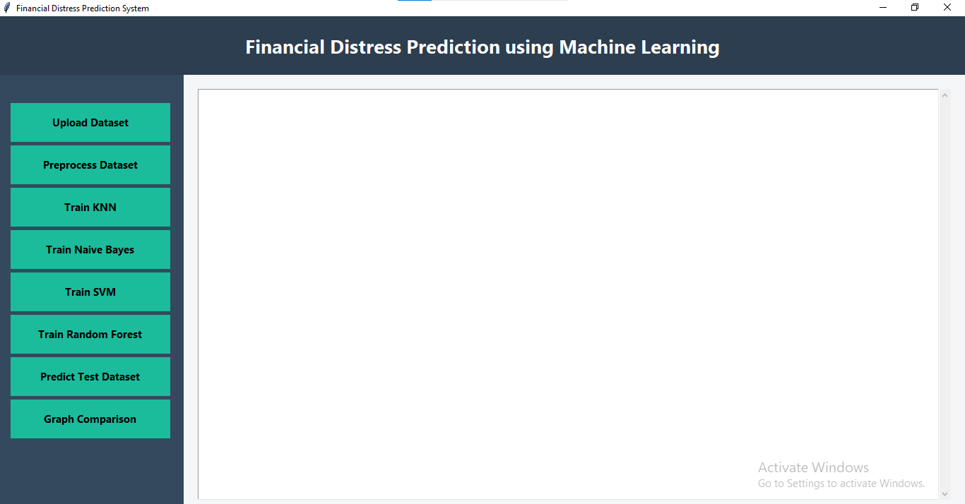
In above screen, click on upload button
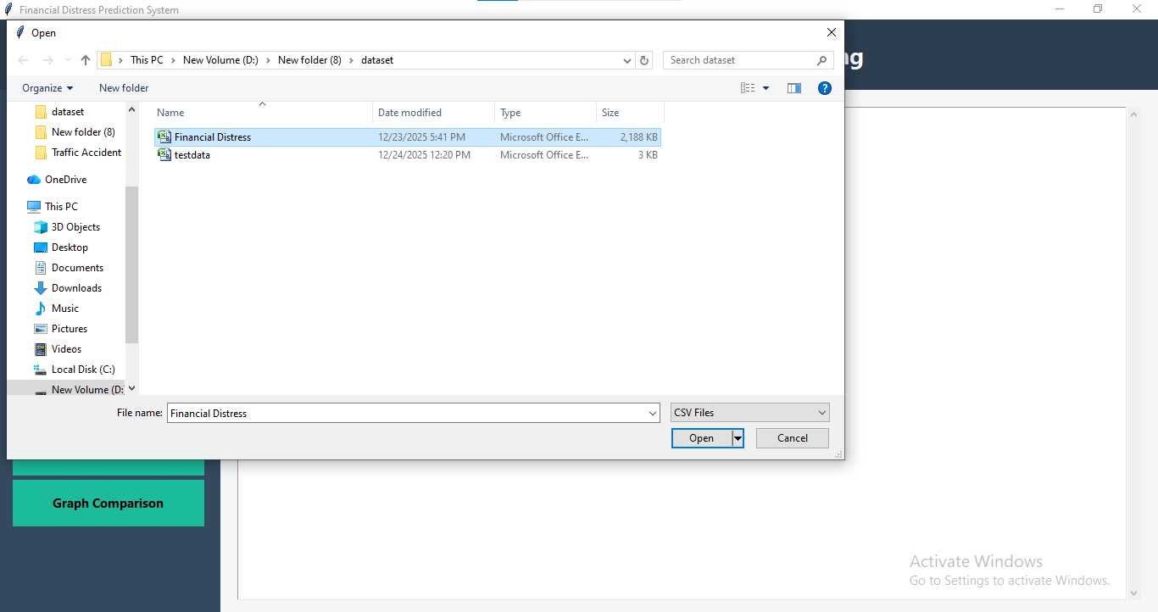
In above screen, upload Brain_Data_Organised dataset
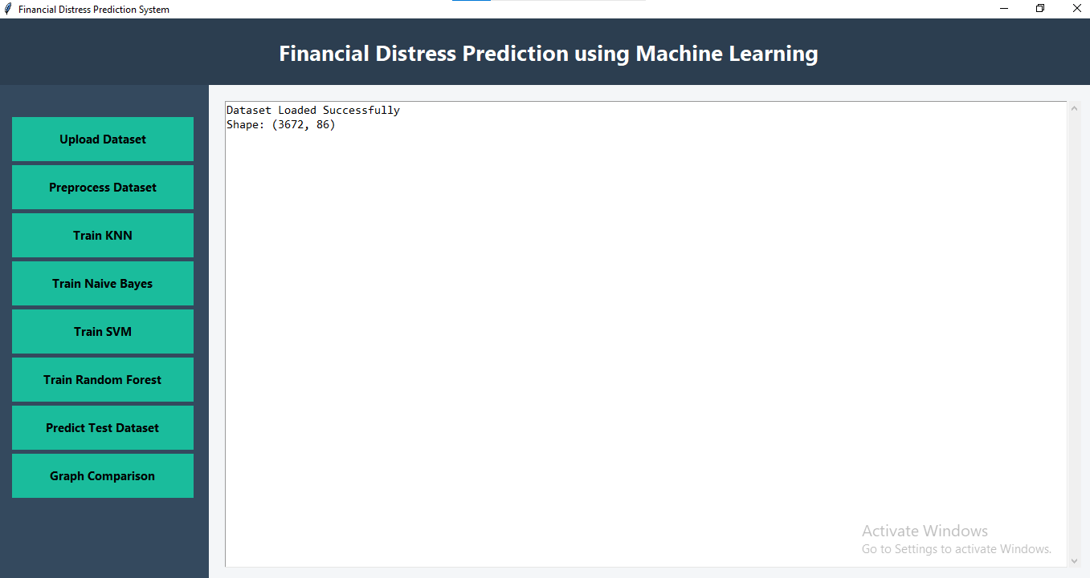
In above screen dataset is uploaded, Now click ‘Preprocess Dataset’ Button
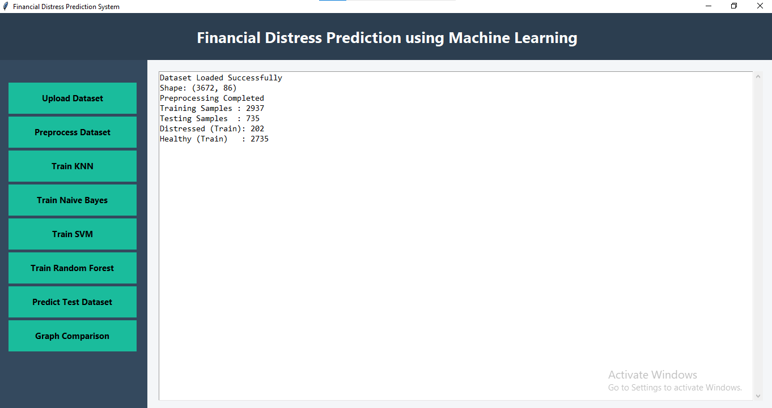
In above screen, we preprocess the dataset and splitting the dataset, 80% for training and 20% for testing, now click on Train KNN button.
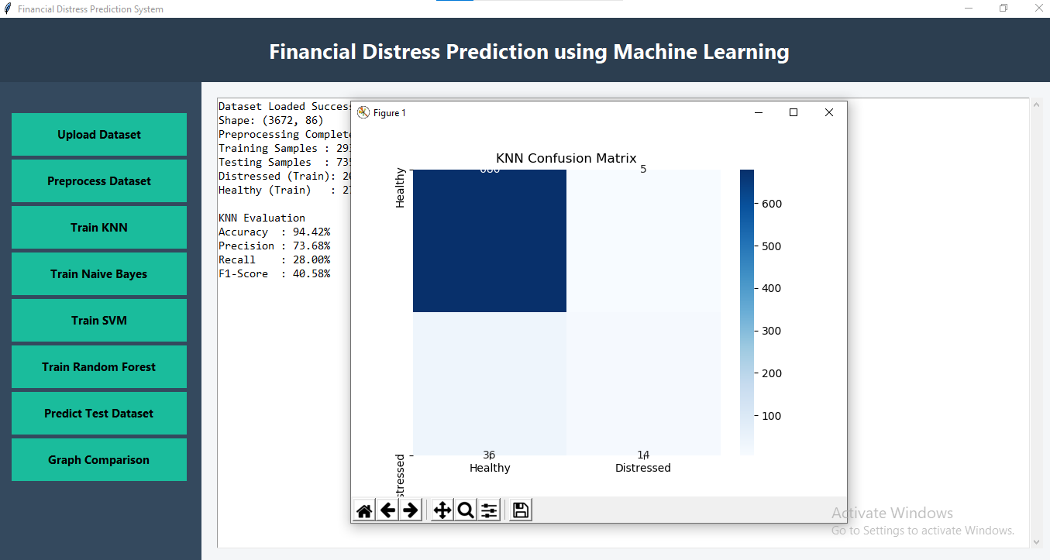
In above screen, after clicking the Train KNN button, to train KNN and got 94.42% accuracy. In confusion matrix graph x-axis represents Predicted Labels and y-axis represents True Labels, now click on Train Naive Bayes Button.
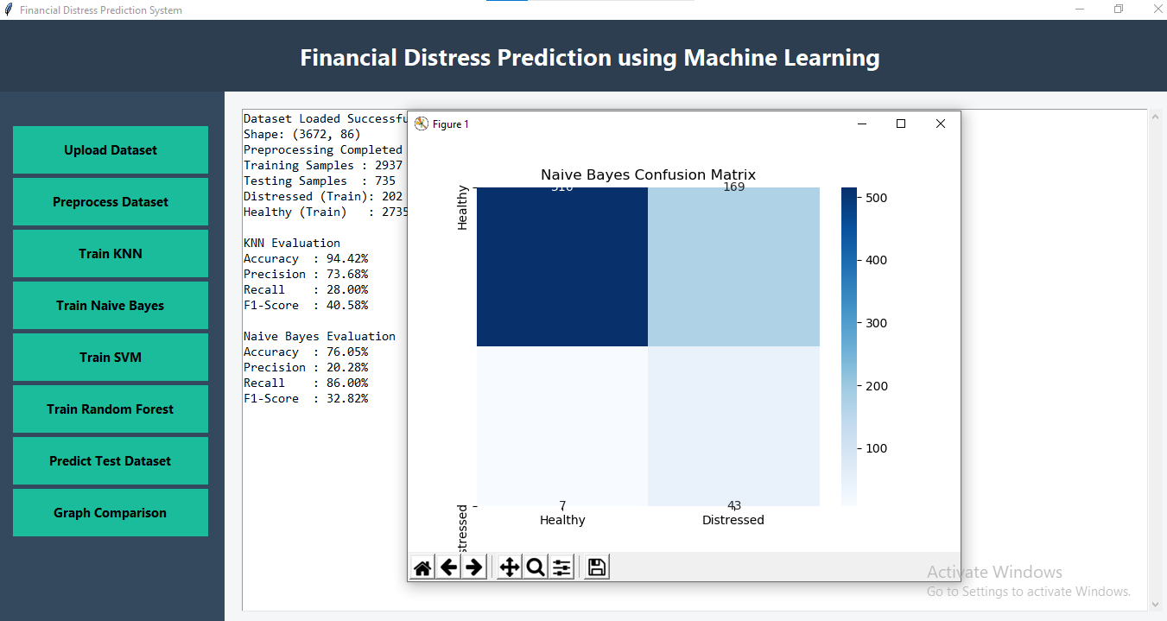

In above screen, after clicking the Train Naive Bayes button, to train Naive Bayes and got 76% accuracy. In confusion matrix graph x-axis represents Predicted Labels and y-axis represents True Labels, now click on Train SVM button.
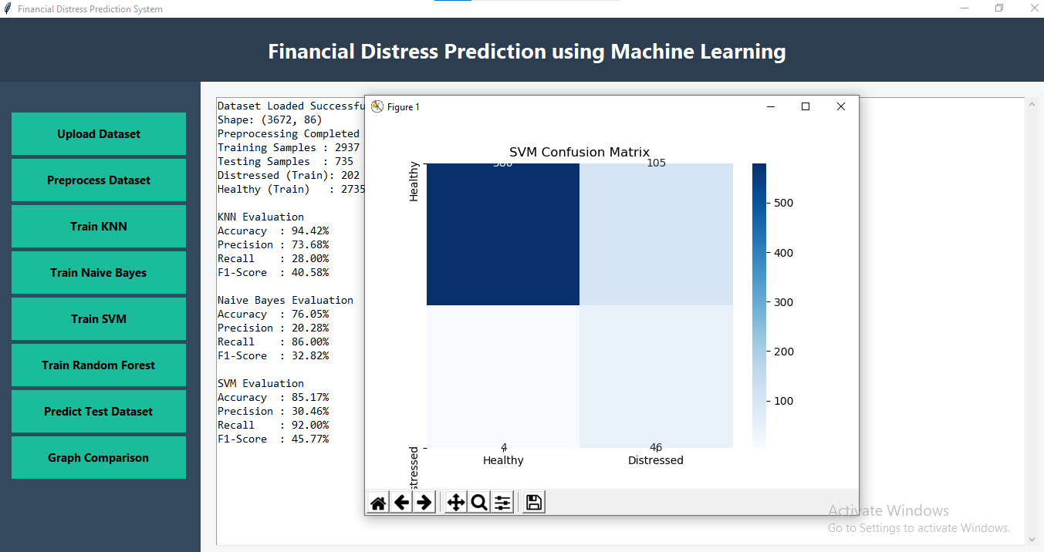
In above screen, after clicking the Train SVM button, to train SVM and got 85% accuracy. In confusion matrix graph x-axis represents Predicted Labels and y-axis represents True Labels, now click on Train Random Forest button.
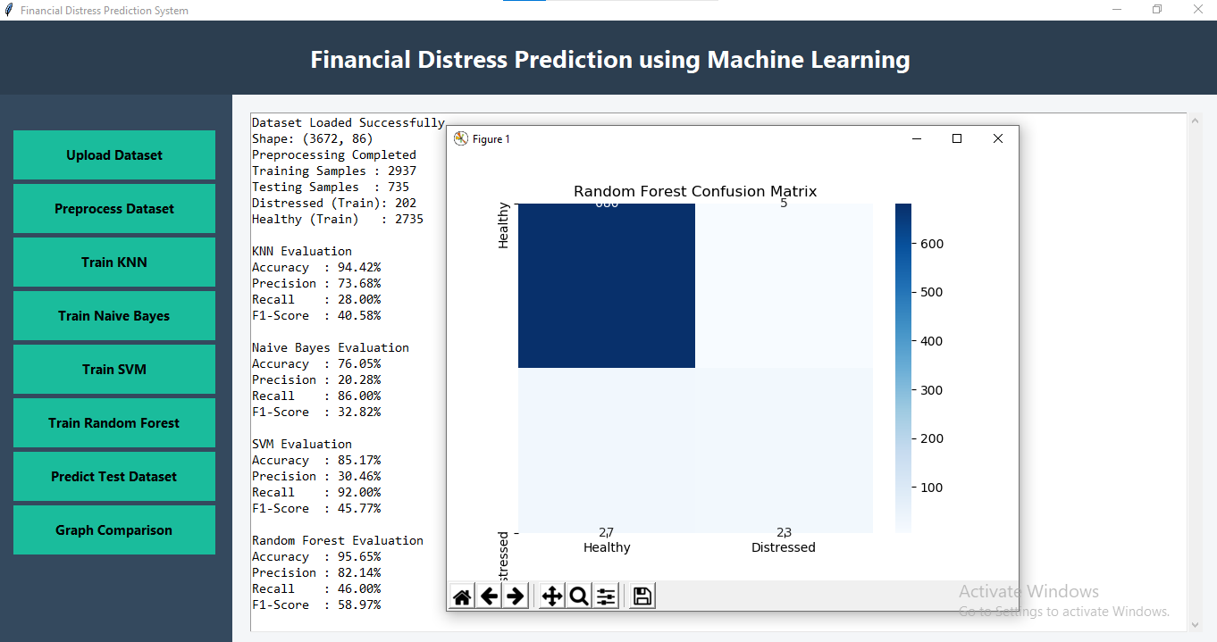
In above screen, after clicking the Train Random Forest button, to train Random Forest and got 96.65% accuracy. In confusion matrix graph x-axis represents Predicted Labels and y-axis represents True Labels, now click on Predict Test Dataset.
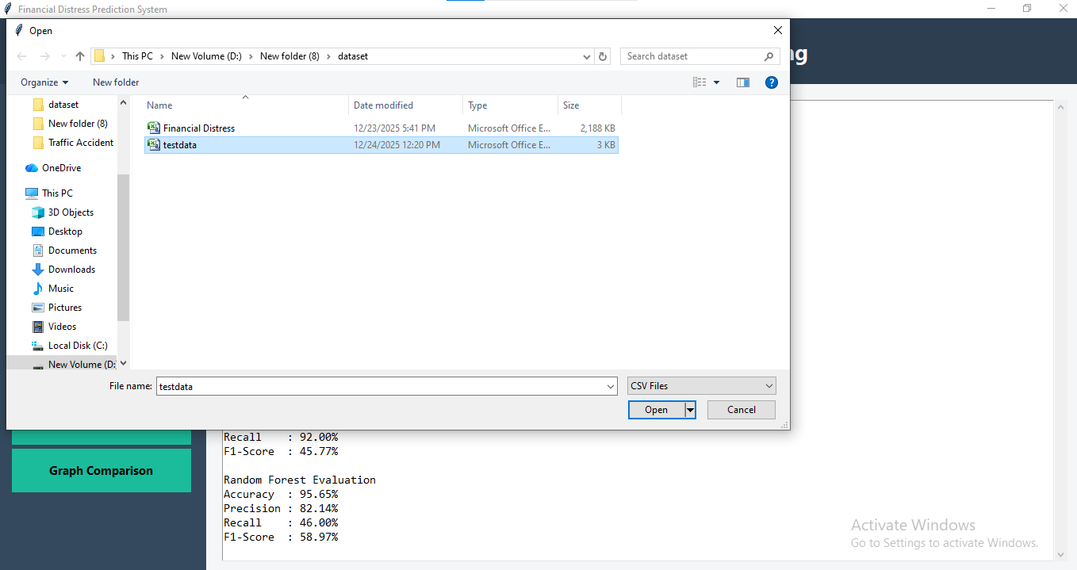
In above screen, click on predict from test data button, upload test data to predict whether data relates to Healthy or Distressed.
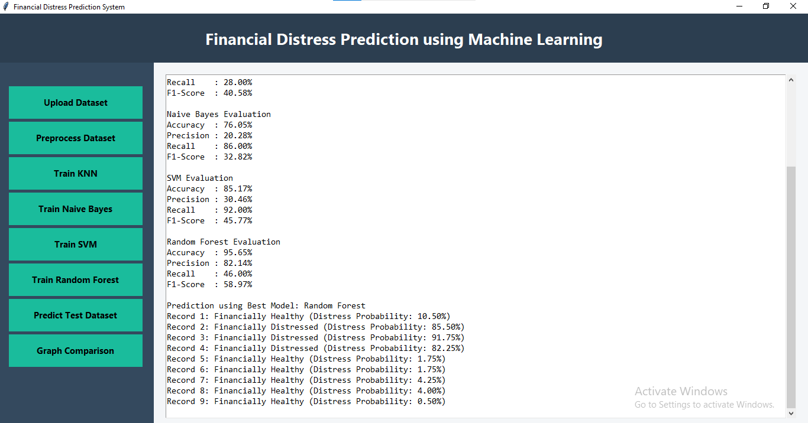
In above screen model predict from test data like Healthy or Distressed, click on comparison graph button, to compare all algorithms performance with four different parameters.
