Project Report

|  |
| --- |
| TABLE OF CONTENT |
| Data Source |
| Libraries Used |
| Data Preprocessing Steps |
| Models Used |
| Polynomial Regression |
| LSTM |

Data Source :

* Kaggle ([click here](https://www.kaggle.com/datasets/rohanrao/nifty50-stock-market-data?select=BHARTIARTL.csv))
* Dataset Contains Stock prices from 2002-02-18 to 2021-04-30
* 15 Features in Dataset :

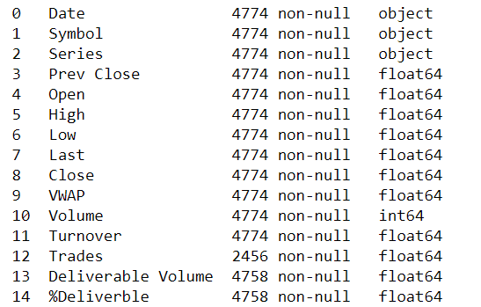

Libraries Used :

* Numpy
* Pandas
* Matplotlib
* Plotly
* Sklearn
* Keras

Data Preprocessing:

1. Changed Datatypes : date column to pandas datetime64
2. Dataset of parent company Airtel contains data of two sub companies 'BHARTI' and 'BHARTIARTL'
   * ‘Symbol’ contains 'BHARTI' and 'BHARTIARTL'
3. Extracted ‘BHARTI DF’ in variable ‘bharti_telecom’
4. Now all data processing is done on ‘bharti_telecom DF’
5. Missing Values
6. Outliers : User defined functions to remove outliers
7. Feature Selection and Scaling

Model Used :

1. Polynomial Regression:

* Reason( Why? ) : I have used this model because it can capture nonlinear relationships between variables. In the case of stock price prediction, it is often the case that the relationship between the predictors and the response variable is not linear. By using a polynomial regression, you can fit a curve to the data that better captures the underlying relationship, potentially improving the accuracy of your predictions.

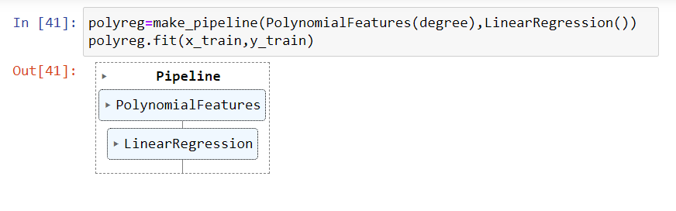

* Accuracy :

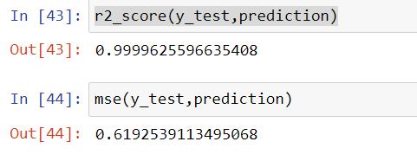

1. LSTM :
   * Reason( Why? ): I have used LSTM because LSTM is well-suited for time-series data analysis and prediction. LSTM networks have the ability to remember past information for long periods of time and selectively forget information that is no longer relevant, making them particularly effective for analyzing sequences of data with complex dependencies. For stock price prediction, LSTM can be used to analyze historical data and identify patterns that may be indicative of future trends in the stock market. By training the network on a dataset of past stock prices and associated market conditions, the LSTM can learn to recognize patterns and make predictions about future stock prices.
2. LSTM for single variable 'Closing Stock Price':
   * Data Preparation for the model
   * User defined function to extract input and output feature for LSTM
   * User defined function to split the test train data
   * Model:

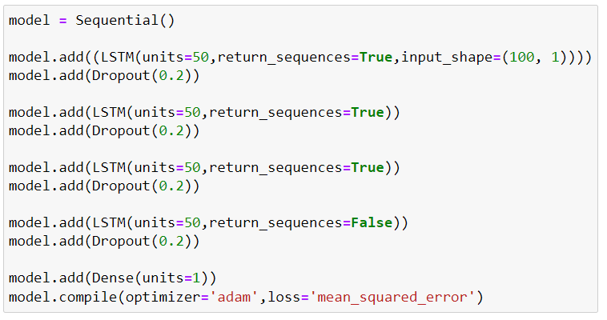

* Loss function:

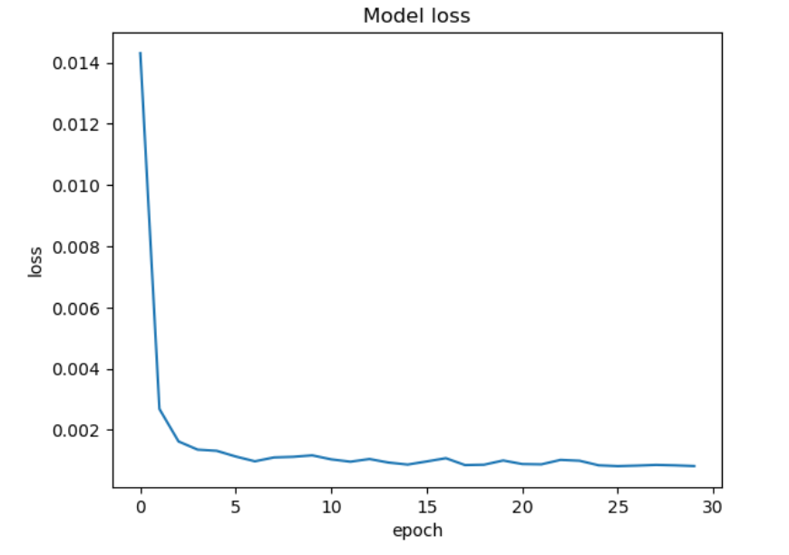

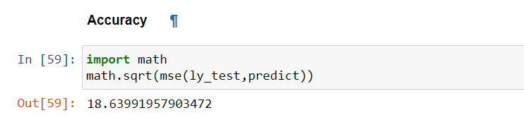

* Prediction:

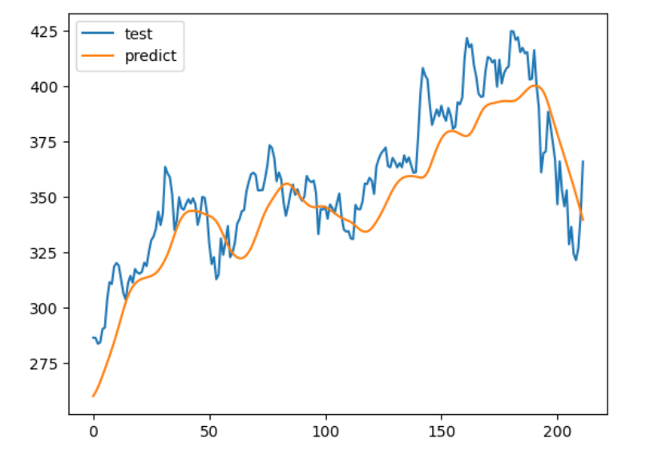

1. LSTM for multiple(11) features and 'closing stock price' as output feature :
   * Data Preparation for the model
   * User defined function to extract input and output feature for LSTM
   * User defined function to split the test train data
   * Model:

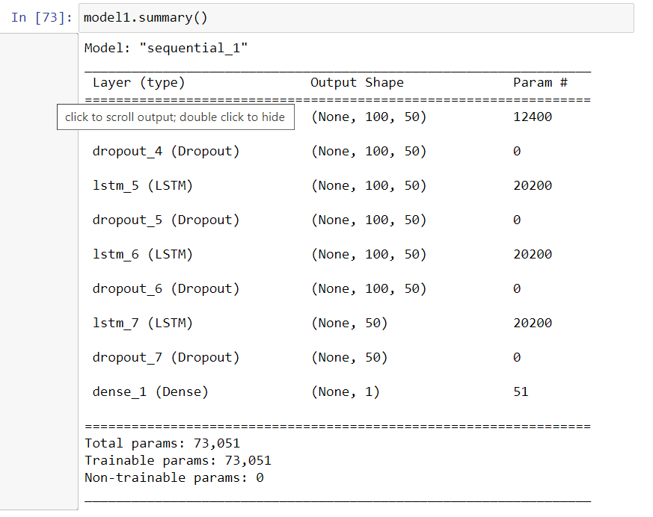

* Model Loss:

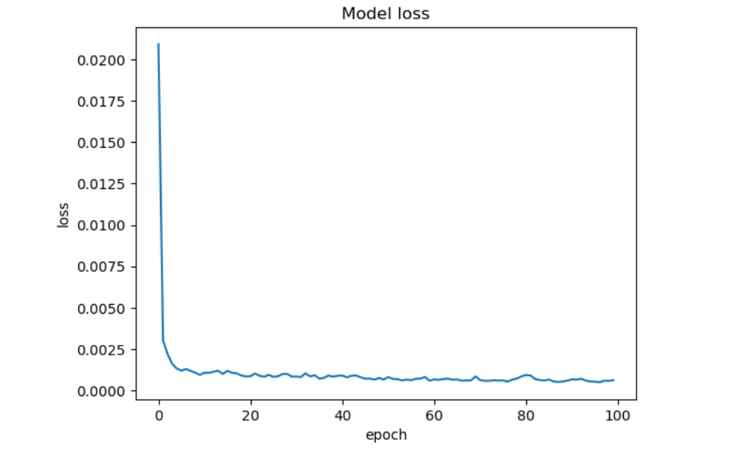

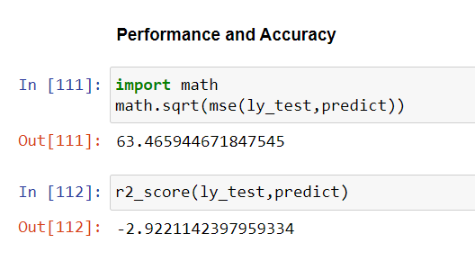

* Prediction:

