**Step 1 – Get inside AWS and create new EC2 instance for Jenkins:**

Click on launch instance:

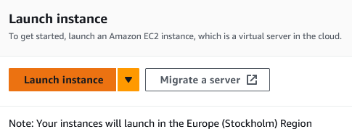

And select those options:

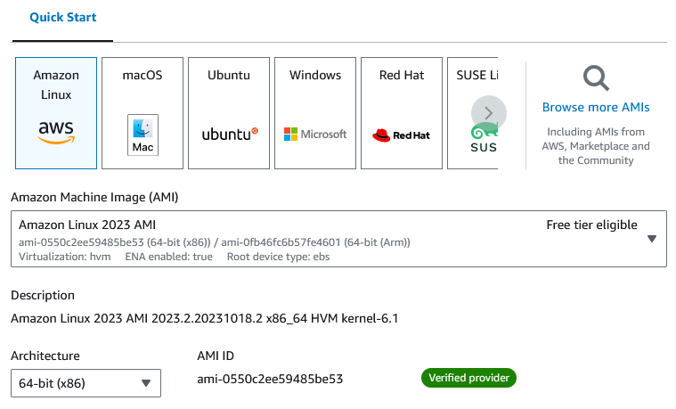

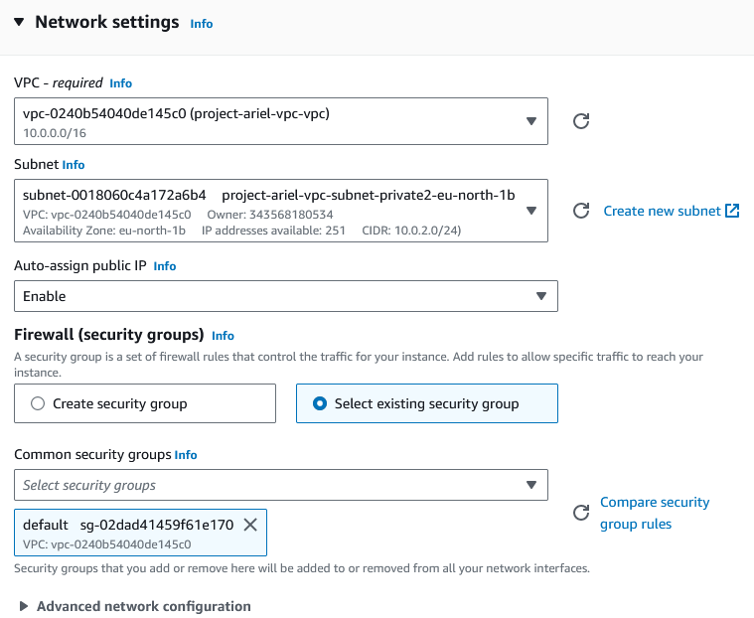

Note: its important to choose allowed region (before starting instance configuration).

Note: Enable the auto-assign public IP, its important also.

And launch instance.

**Step 2 – SSH connection:**

Now we need to move the “.*pem”* file of the key to a destined folder, then right click there and open git bash. Then go back to AWS and navigate to our instance, press connect and follow the SSH guide.

Open the gitbash in the destined folder and type:



Switch to root user:



**Step 3 – Install Jenkins server:**

Follow those steps:

Note: this guide begins via installing the 8th version of Java, and shows how to troubleshoot and change to version 11 for Jenkins. Also, my advice is to use “tab” button for auto-completion of commands because path varies from each instance to instance.

1. Install java software:



1. Once java JDK install completed we need to verify the version:



1. Lets find the java home path:

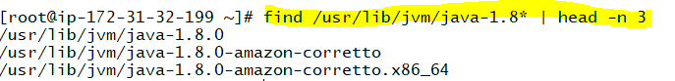

We need to copy-paste the last path (as JAVA_HOME variable) into the bash_profile root file. Then export the variable and store under PATH:

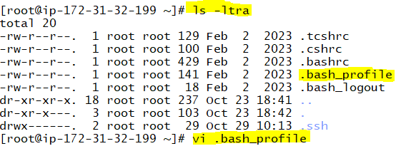

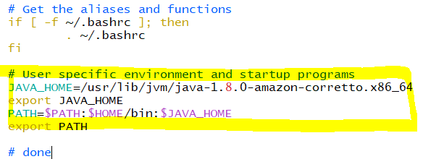

Don’t forget **“:wq”**.

1. Now execute the source command for the changes to take effect:



1. Check if the wget command enabled or not:

**wget**

If not then we need to download it from the repo:

**Wget -O /etc/yum.repos.d/Jenkins.repo https://pkg.jenkins.io/redhat-stable/jenkins.repo**

Note: This repo has been downloaded and placed under the “/etc/yum.repos.d/jenkins.repo”

1. Thus we can use the URL found in that directory and import a key:



Note: we need to run the “…/redhat-stable/Jenkins.io.key” but this one also should work.

1. And run the yum install for Jenkins:



1. Now enable the jenkins:



If we run **systemctl status Jenkins** we will get an error and the root of this error is that we installed java version 8, while Jenkins only can work with java versio 11+.

1. To fix this, we need to install **firewalld** service:







And check the status.

1. Add port:



And reload the service:



1. Now we need to locate the “Jenkins.war” file and force Jenkins connection via the new port:

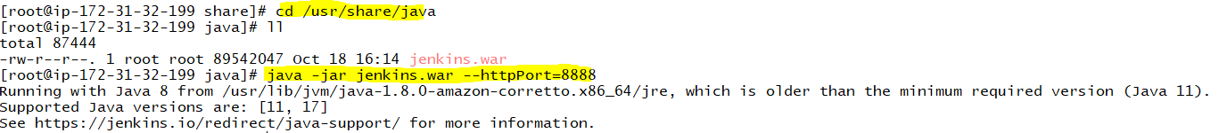

Which is the proof that we need a better version. Here we end our troubleshooting procedure and move on to the fix.

1. To fix this issue we need to download the zip file of jdk 11:

**curl -LO** [**https://corretto.aws/downloads/latest/amazon-corretto-11-x64-linux-jdk.tar.gz**](https://corretto.aws/downloads/latest/amazon-corretto-11-x64-linux-jdk.tar.gz)

And extract it to the java folder:

**tar -xvzf amazon-corretto-11-x64-linux-jdk.tar.gz -C /usr/share/java/**

Note: my Jenkins war file was located in /usr/share/java on the EC2 instance. It may different from VM to VM.

Then get inside the java folder and enter the bin folder of the amazon new jdk 11:

**cd /usr/share/java/amazon-corretto-*-linux-x64/bin**

Here we need to run this generic one line script:

**for i in java javac jfr; do path=$(find `pwd`/$i -type f); echo $path; sudo alternatives --install /usr/bin/$i $i $path 20000 ; sudo update-alternatives --config $i ; done**

And now we can choose the second branch (which is jdk 11):

**update-alternatives --config java**

Press “2” and press enter.

Now check java version:

**java -version**

And if its 11 we can rerun the Jenkins command:

**cd /usr/share/java**

**java -jar Jenkins.war - -httpPort=8888**

Success.

1. Now we can start Jenkins and allow it to be always on:

**service jenkins start**

This is the end of file that I got when I installed the Jenkins server:

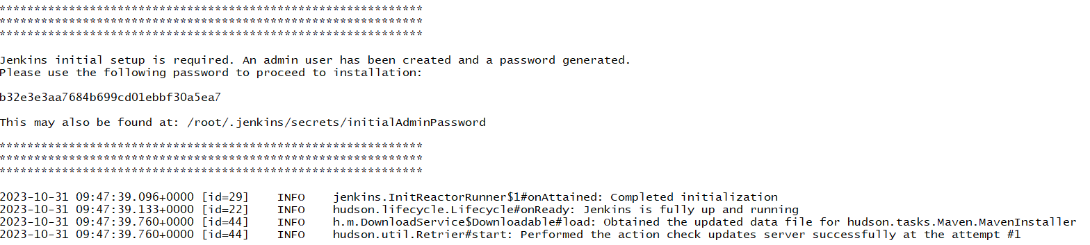

By the time Im writing this guide I will paste here the initial password that I will use later:

b32e3e3aa7684b699cd01ebbf30a5ea7

1. Now that we are done we can “ctrl+C” to disconnect from Jenkins node and start the service via *systemd*:



The second command will turn the service ON permanently.

1. And start the jenkins.service via *system*:



1. Access the Jenkins server:

We will access the Jenkins server via public IP but first lets check ports that are in LISTEN status:

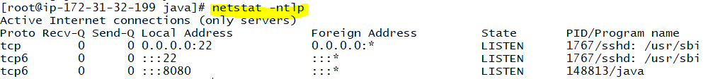

Note: I see that my Jenkins java uses the 8080 which is wrong, because our Jenkins node is down rightnow, and was configured on port 8888. Once we run previous command with port 8888, it will be up and in LISTEN.

Configure AWS security instance for port 8080:

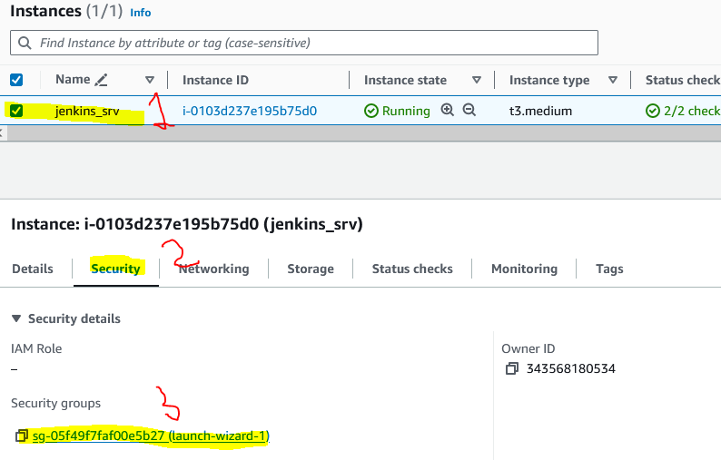

Click the security group and add new inbound rule for port 8888:

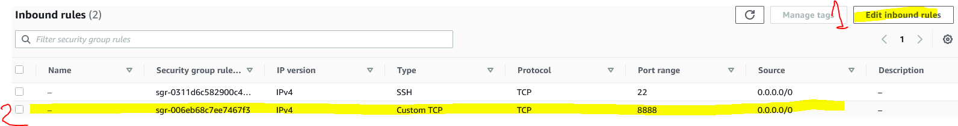

Save the rule.

Now we can access the Jenkins via the instance public IP and port 8888. First go to the VM and run the previous command to start the Jenkins executable:

**java -jar Jenkins.war - -httpPort=8888**

And once its up we can go to EC2 instance and copy the public IP with the port number:



Once done, we will see this:

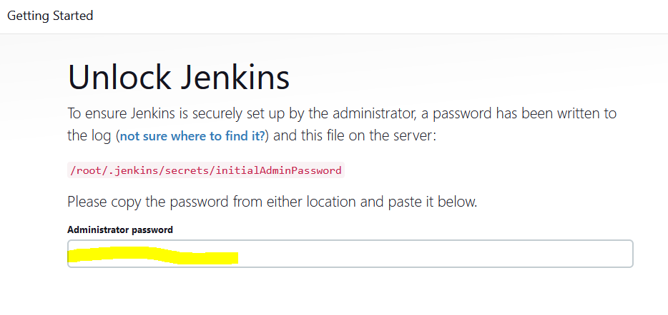

We need to copy the previous “initial password” here and continue configuration.

1. I continued to configuration is follows:

* Install suggested plugins
* Fill credentials
* Save URL
* Start using Jenkins!

Good Luck!