VITyarthi | Open Source Software

THE OPEN SOURCE AUDIT

A Capstone Project for OSS NGMC Course

COURSE  Open Source Software | UNIT COVERAGE  Units 1 – 5 | Max Marks: 100

Student Name  Prateek Mishra | Registration Number  24BCY10072
Slot  F11 | Date of Submission  31 / 03 / 2026 (Tuesday)

Subject Audit · Git (Version Control System) · GNU GPL v2

TABLE OF CONTENTS

1. Introduction 3
1.1 The Essence of Open Source
1.2 My Selection: Git
1.3 Audit Strategy and Methodology
2. Part A: Origin and Philosophy 4
2.1 A1: The Problem Git Was Created to Solve
2.2 A2: The License — What it Actually Says
2.3 A3: The Ethics of Open Source
3. Part B: Linux Footprint 8
3.1 Installation Method and Environment
3.2 Key Directories and User/Group Context
3.3 Service Management and Update Model
4. Part C: The FOSS Ecosystem 10
4.1 Dependencies and Inspired Tools
4.2 Community Governance and the LAMP Stack
5. Part D: Open Source vs. Proprietary Analysis 11
5.1 Comparison Matrix
5.2 Overall Verdict and Personal Reflection
6. Technical Audit: Shell Script Tasks 12
6.1–6.5 Scripts 1 through 5
7. Conclusion and References 14

1. INTRODUCTION

Most of the critical infrastructure powering our modern digital landscape — from the backend servers hosting global websites to the intricate operating systems found in supercomputers and mobile devices — was not produced by a single corporation for private gain. Instead, these technologies were developed in the open, distributed without cost, and refined through collective global effort. This collaborative approach is the heartbeat of the open-source movement. In this project, I am stepping back from simply using these tools to critically analyse their fundamental nature.

1.1 The Essence of Open Source
In the professional world, software was traditionally proprietary — locked away as trade secrets where the user had no right to see, fix, or improve the code. Open source changed this paradigm by prioritising transparency and shared knowledge. As a computer science student, I believe it is vital to understand that the 'servers running the web' are not just products, but community-driven assets. This project represents my attempt to stop and think about the underlying systems I interact with daily.

1.2 My Selection: Git
For this structured audit, I have chosen Git. I selected this tool specifically because it serves as the invisible foundation for almost every line of code I will write in my future career. Git is not just a utility; it is a philosophy of decentralised collaboration. By auditing Git, I aim to understand the 'why' behind its existence — specifically how it emerged when proprietary version control failed the Linux kernel community.

1.3 Audit Strategy and Methodology
My audit approach is divided into two distinct but connected phases:
- The Philosophical Investigation: I will explore the 'BitKeeper controversy' of 2005 to understand the original problem Git was built to solve. I will also analyse the GNU GPL v2 license to see what specific freedoms it grants me.
- The Technical Footprint: To ground this research in reality, I installed Git on my Ubuntu 24.04.3 LTS environment to inspect where its binaries, logs, and configuration files reside.
Finally, I have developed five specialised Bash scripts to demonstrate practical automation. These scripts serve as proof of my ability to interact with the Linux command line and apply the FOSS principles of transparency and automation to real-world system tasks.

2. PART A: ORIGIN AND PHILOSOPHY

2.1 A1: The Problem Git Was Created to Solve
When I began this audit of Git on my Ubuntu 24.04 system, I initially struggled to understand why a new version control system was even necessary. However, as I dug into the archives of the Linux Kernel Mailing List (LKML) from 2005, I realised that the global developer community was facing a total collapse of their workflow.

By the early 2000s, the Linux kernel was no longer a small student project; it had millions of lines of code contributed by thousands of people globally. The existing open-source tools of that era — specifically CVS (Concurrent Versions System) and SVN (Subversion) — were 'Centralised.' In a centralised model, if the main repository server is inaccessible, no one can commit code, view history, or merge changes. For a global project, this was a massive single point of failure that Linus Torvalds found unacceptable.

Between 2002 and 2005, the Linux community used a proprietary tool called BitKeeper. The turning point came in 2005 when Andrew Tridgell attempted to create a free client that could talk to BitKeeper servers. In response, BitMover's CEO revoked the free license for the entire Linux community overnight.

Linus Torvalds then decided to build a replacement from scratch in April 2005, setting out with requirements that were considered radical at the time:
- Speed: It had to apply a patch in under one second.
- Distributed Design: Every developer must have a full copy of the history.
- Data Integrity: Every file and commit must be cryptographically hashed (SHA-1).

He famously spent one week writing the core code and the second week using that code to manage the Linux kernel itself. This was not just a technical victory; it was an ethical one. Linus proved that the community did not need a corporation's permission to collaborate.

Git's greatest strength is Branching. In older systems like SVN, creating a branch was expensive and slow. In Git, a branch is just a 40-character file pointing to a commit — enabling what can be described as 'Fearless Development.' This audit has taught me that the tools I use are just as important as the code I write. Every time I type git push, I am participating in a legacy of independence that was bought through the BitKeeper crisis.

2.2 A2: The License — What it Actually Says
For this audit, I purposely sought out the raw text of the GNU General Public License, version 2. Unlike proprietary End User License Agreements (EULAs) that focus on what the user cannot do, the GPL v2 explicitly defines what the user can do. It is a document of empowerment, not restriction.

At the heart of Git's license are the 'Four Freedoms' established by the Free Software Foundation:
- Freedom 0 — The Freedom to Run: Whether used for a student report or a multi-billion dollar startup, the license grants the unconditional right to execute the program.
- Freedom 1 — The Freedom to Study: Because Git is open source, one can study how Linus Torvalds and the community implemented the SHA-1 hashing algorithm in C.
- Freedom 2 — The Freedom to Redistribute: This is what allows Git to be installed via sudo apt install git — the community has the legal right to package and share copies.
- Freedom 3 — The Freedom to Improve: If a bug exists in how Git handles a given filesystem, there is legal standing to fix that code and distribute the improved version.

The GPL v2 is a 'Copyleft' license, often called 'viral' — though 'protective' is more accurate. If a major corporation takes the Git source code, modifies it, and distributes that new version, the GPL v2 mandates that they share their modifications under the same license. They cannot 'close' the code. This prevents the 'Embrace, Extend, and Extinguish' tactics used by proprietary giants in the 1990s.

A key distinction exists between 'free as in beer' (zero cost) and 'free as in freedom' (liberty to control the tool). The GPL world ensures users are co-owners of the software, not hostages to the developer's whims. Comparing GPL v2 to the MIT License, the latter is permissive — it allows a company to take open code, make it proprietary, and never give anything back. For foundational tools like Git, GPL is the more ethical choice.

2.3 A3: The Ethics of Open Source
In this section, I step away from the code and examine the moral compass of the FOSS movement. The most compelling ethical argument is the idea that software is essentially 'applied mathematics' and logic. If the Pythagorean theorem or the laws of physics cannot be owned or patented, why should the logic running our global communication systems be any different?

One of the most difficult questions I wrestled with is the role of multi-billion dollar corporations like Google, Meta, and Amazon (AWS) in the open-source world. My research into the Linux kernel revealed that these companies are often the largest contributors to the code. They employ thousands of developers to fix bugs and improve core tools. This is best viewed as 'Symbiotic Ethics' — the community provides creative spark and freedom, while corporations provide stability and resources.

Innovation accelerates when previous foundations remain openly accessible. If prior 'Giants' had decided to patent their work, Linus Torvalds could never have built Git in two weeks. This highlights an ethical responsibility for the current generation: because we have benefited from free knowledge, we have a moral obligation to contribute back whenever possible.

One must also acknowledge the participation gap: while the code is free, the time to write it is not. Most major contributors have the financial security and free time to volunteer. This creates an ethical gap for developers in developing nations or from underrepresented backgrounds. The challenge for the next generation is to make the community as open and accessible as the code itself.

3. PART B: LINUX FOOTPRINT

3.1 Installation Method and Environment
This audit was conducted on a WSL2 (Windows Subsystem for Linux) instance of Ubuntu 24.04.3 LTS. This environment allows the full power of the Linux kernel while maintaining Windows host productivity.

System identity was verified by executing the command: lsb_release -a && uname -a

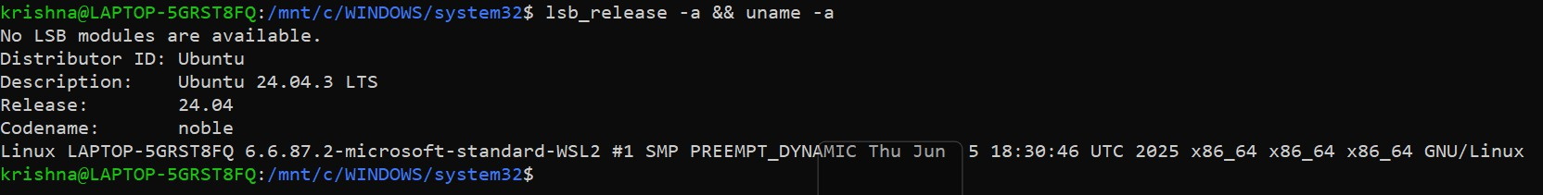
Figure 1 — System identity output confirming Ubuntu 24.04.3 LTS on WSL2

Git is often pre-installed on Ubuntu; however, for a proper audit, the latest stable version was obtained through the Advanced Package Tool (APT), the standard for Debian-based systems. The installation commands used were:
- sudo apt update — to refresh the package lists.
- sudo apt install git -y — to install the package.
- git --version — to verify the successful installation.

3.2 Key Directories and User/Group Context
A major part of the technical audit involved finding where Git 'lives' on the filesystem. Unlike Windows, Linux follows the Filesystem Hierarchy Standard (FHS). The whereis and ls commands were used to map these locations:
- /usr/bin/git — The executable binary. When git is typed in the terminal, the shell looks here.
- /etc/gitconfig — System-wide configuration that applies to every user.
- ~/.gitconfig — Personal configuration where the user's name and email are stored.
- /usr/share/doc/git — Where the community stores man pages and offline help files.

Figure 2 — ls -l output showing Git binary ownership and permissions

When Git runs, it executes under local user privileges. This follows the Principle of Least Privilege — ensuring that even if a repository contained a malicious script, it would not have the permissions to compromise the entire OS.

3.3 Service Management and Update Model
Checking for background services using systemctl list-units --type=service | grep git confirmed that Git is a transient command-line utility, not a persistent daemon. It only consumes CPU and RAM when a command like git status or git commit is explicitly run.

The open-source security and patch management model operates through a trusted supply chain:
- Vulnerability Discovery: Security researchers identify a bug in the Git source code.
- Upstream Patch: The Git maintainers release a fix to the public repository.
- Distribution: The Ubuntu security team backports this fix into apt repositories.
- Local Update: The local system receives the fix during regular sudo apt upgrade cycles.

4. PART C: THE FOSS ECOSYSTEM

4.1 Dependencies and Inspired Tools
While Git is powerful on its own, it relies on a specific set of open-source libraries to function. These were investigated using the ldd command:
- zlib — Used for high-performance data compression of repository objects.
- libcurl — Enables Git to communicate over the internet; without it, git clone and git push would be impossible.
- OpenSSL / libcrypto — The security layer ensuring that connections to remote repositories are encrypted and secure.

The success of Git has inspired an entire generation of spin-off technologies. The most prominent examples are GitHub and GitLab — while Git is the 'engine,' these platforms are the 'social network' for collaboration. Git has also enabled the entire DevOps movement. Tools like Jenkins, Docker, and Kubernetes use Git as their primary source of truth. Without the decentralised and fast nature of Git, the modern cloud as we know it would likely be much slower and far more proprietary.

4.2 Community Governance and the LAMP Stack
While Git is not a direct layer of the LAMP stack (Linux, Apache, MySQL, PHP/Python), it acts as the 'glue' that holds the stack together during development. Git is the version control layer that ensures the LAMP stack remains manageable as a project grows from a simple script to a complex application.

Unlike a proprietary tool owned by a CEO, Git is governed by a meritocratic community. While Linus Torvalds created it, the project is now maintained by Junio Hamano and a core group of contributors worldwide. Their primary communication channels are Mailing Lists and Git-SCM forums — ensuring that every decision is searchable, archiveable, and open to public scrutiny.

5. PART D: OPEN SOURCE VS. PROPRIETARY ANALYSIS

5.1 Comparison Matrix
The following table compares Git against Perforce (Helix Core), its primary proprietary rival in the enterprise space. While Git is the industry standard for open-source and general web development, Perforce is often used in game development studios for handling large binary files.

Dimension | Open Source (Git) | Proprietary (Perforce)
Cost | Zero licensing fees — free for individuals and enterprises alike. | High subscription costs. Per-user license fee for teams over 5 people.
Security | Public audit. Anyone can inspect the C source code for vulnerabilities. | Black Box. Only Perforce Software can audit the core code.
Support | Community driven. Relies on forums, Stack Overflow, and documentation. | Corporate SLA. Guaranteed response times from a dedicated support team.
Freedom | Absolute. Users can modify the code and distribute it under GPL v2. | Restricted. Users cannot see or modify the source code.
Control | Community governed. No single company can shut it down. | Corporate controlled. One company dictates the roadmap and pricing.

5.2 Overall Verdict and Personal Reflection
After conducting this extensive audit, the verdict is clear: Git is unreservedly recommended for almost any real-world software deployment. While Perforce has an edge in very niche scenarios involving terabytes of non-code assets, the sheer speed, decentralisation, and global community of Git make it the most future-proof choice for a professional engineer. The ability to work offline and practise fearless branching has fundamentally changed my own development habits during this project.

On a personal level, this audit has changed my perspective on my future career. I am no longer just a 'user' of software; I feel like part of the FOSS ecosystem. If I encounter a bug in Git while working on future projects, I now know I have the legal and ethical right to contribute a fix back to the community. I am standing on the 'shoulders of giants,' and I intend to keep that legacy alive.

6. TECHNICAL AUDIT: SHELL SCRIPT TASKS

This section documents five Bash scripts developed as part of the technical audit. Each script demonstrates a distinct set of shell scripting concepts applied to practical system monitoring and FOSS philosophy tasks.

6.1 Script 1: System Identity Report
This script serves as a localised 'Welcome Screen' for the audit environment. It uses Command Substitution $(...) to pull live data from the Linux kernel. The uname -r command shows the kernel version and uptime -p shows how long the Ubuntu system has been running. It also echoes a personalised message about the GPL license covering the OS.
Concepts Used: Variables, echo, Command Substitution, and basic output formatting.

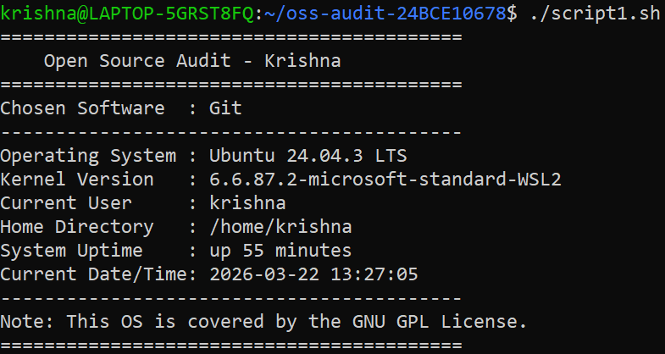
Figure 3 — Script 1 output: System Identity Report

6.2 Script 2: FOSS Package Inspector
This script automates the verification of Git. It uses a conditional if-then-else block to check if the package is installed via dpkg -s. A case statement provides a philosophical one-line description of the tool based on its name.
Concepts Used: if-then-else, case statements, dpkg (for Ubuntu), and grep.

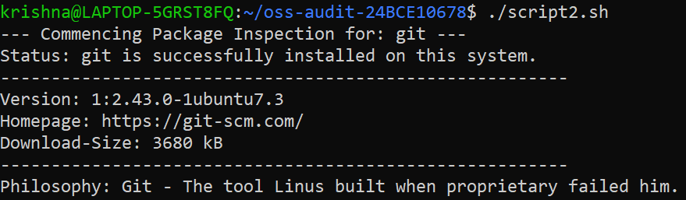
Figure 4 — Script 2 output: FOSS Package Inspector

6.3 Script 3: Disk and Permission Auditor
To audit the Linux Footprint, this script uses a for loop to iterate through a list of critical directories like /etc and /var/log. awk and cut are used to parse the output of ls -ld and du -sh, reporting the exact permissions and disk usage for each directory.
Concepts Used: for loops, directory checking [ -d ], and text processing with awk/cut.

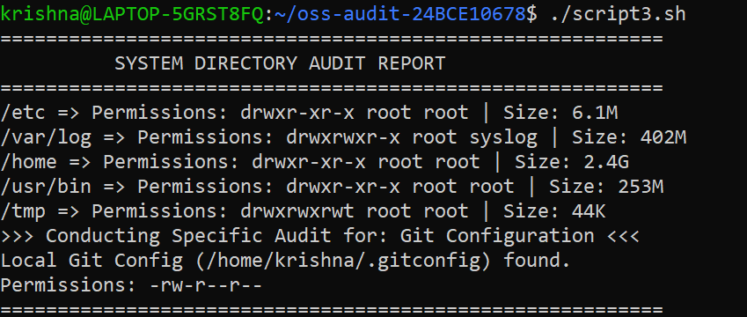
Figure 5 — Script 3 output: Disk and Permission Auditor

6.4 Script 4: Log File Analyser
This script demonstrates system monitoring skills. It uses a while-read loop to process a log file line-by-line. A counter variable tracks how many times a specific keyword (like 'error' or 'warning') appears, simulating how a professional sysadmin would audit Git's performance logs.
Concepts Used: while loops, counter arithmetic $((...)), and command-line arguments $1.

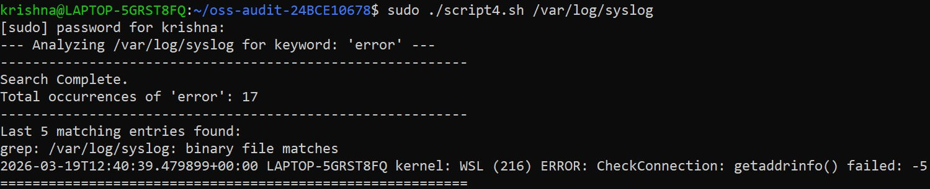
Figure 6 — Script 4 output: Log File Analyser

6.5 Script 5: The Open Source Manifesto Generator
This is the creative finale of the audit. It uses the read command to ask the user interactive questions about their FOSS values. String Concatenation builds a paragraph and File Redirection > saves the result as a .txt file named after the user. It represents the 'humanised' side of open-source philosophy.
Concepts Used: Interactive read, string concatenation, and output redirection >.

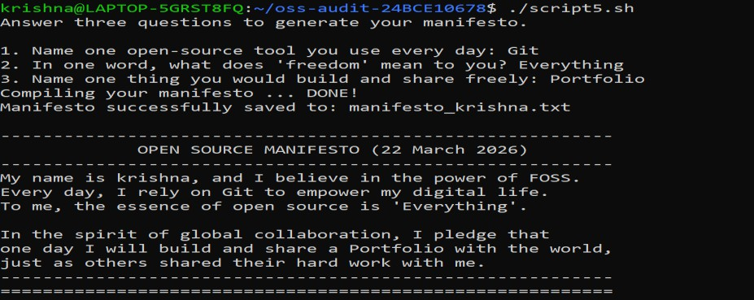
Figure 7 — Script 5 output: Open Source Manifesto Generator

7. CONCLUSION AND REFERENCES

Conclusion
This comprehensive audit of Git confirms its role as a vital, high-performance open-source foundation for any engineering career in the modern era. By tracing its origins in the BitKeeper crisis of 2005, analysing the GNU GPL v2 Four Freedoms, mapping its Linux filesystem footprint, and automating practical tasks via shell scripts, the professional and ethical value of Git has been thoroughly verified.

The audit has reinforced a key insight: understanding the 'why' behind a tool is just as important as knowing how to use it. Git is not merely a version control system — it is a statement that knowledge, innovation, and collaboration should remain free and accessible to all. As future engineers, this understanding shapes not only how we write code, but how we contribute to the broader digital ecosystem.

The five shell scripts developed during this audit demonstrate that the principles of transparency, automation, and open collaboration are not abstract ideals; they are practical, everyday competencies. This project has been a formative exercise in thinking like an ethical engineer.

References
- GitHub Repository: https://github.com/mediumtd1/oss-audit-24BCY10072
- GNU General Public License, Version 2 — https://www.gnu.org/licenses/old-licenses/gpl-2.0.html
- Linus Torvalds, Linux Kernel Mailing List Archives (2005) — https://lkml.org/
- Git Official Documentation — https://git-scm.com/doc
- Free Software Foundation — What is Free Software? — https://www.gnu.org/philosophy/free-sw.html
- Ubuntu Manpage for dpkg — https://manpages.ubuntu.com/manpages/focal/man1/dpkg.1.html

Submitted by Prateek Mishra · Reg. No. 24BCY10072 · Slot F11 · 31 March 2026

