Ministry of Heigher Education and Scientific Research
University of Science and Technology Houari Boumedienne USTHB

Faculty of Computer Science
Module Information and Communication Technologies (ICT)

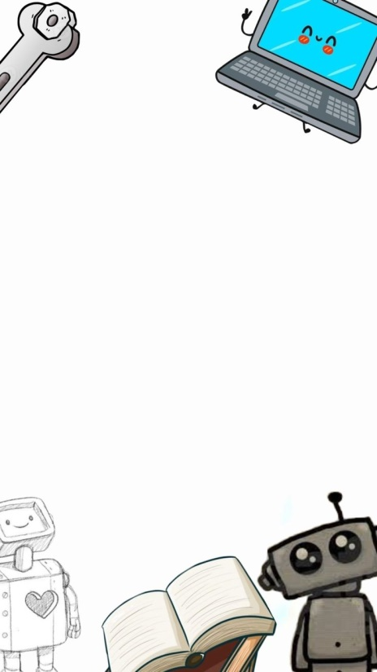
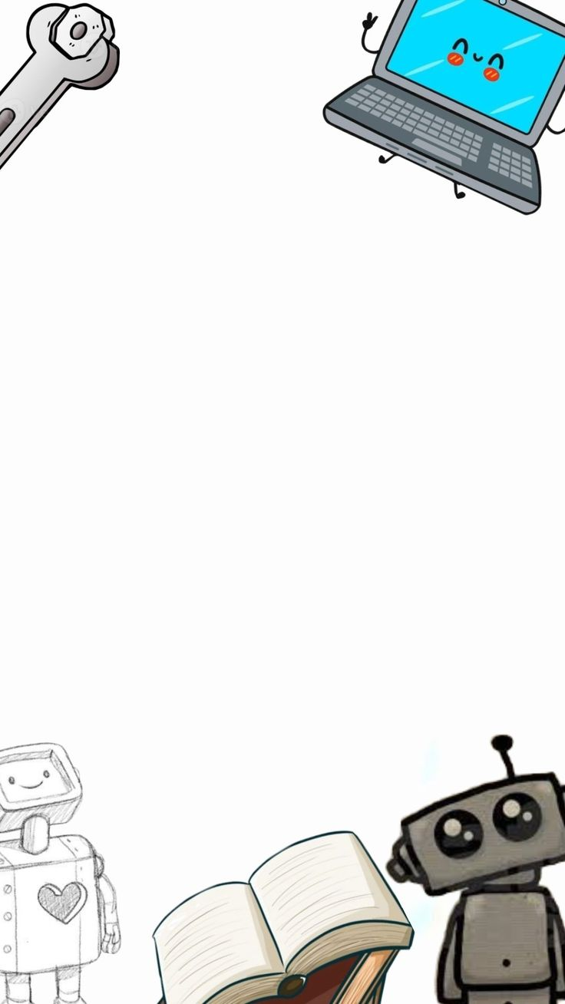

Final project

Prepared by :
Halimi Amel

2025/2026

Content table
Introduction
Définition: 1
Components of ICT 1
Hardware 1
Software 1
Networks and communication 1
ICT tools ans Services 2
Google Services 2
Microsoft tools 2
Git and GitHub 2
Applications of ICT 2
In education 2
In Business 3
In Healthcare 3
Advantages and Disadvantages of ICT 3
Impact of ICT on society 3
Conclusion


Introduction
Information and Communication Technology (ICT) is a broad term that includes all digital technologies used to create, store, process, and exchange information. It involves tools such as computers, smartphones, the internet, software, and communication networks. ICT has become an essential part of modern society because it improves communication, increases access to information, and makes work faster and more efficient. Today, ICT is widely used in many fields, including education, business, healthcare, and entertainment, and it continues to transform the way people learn, work, and interact with each other.

Définition:
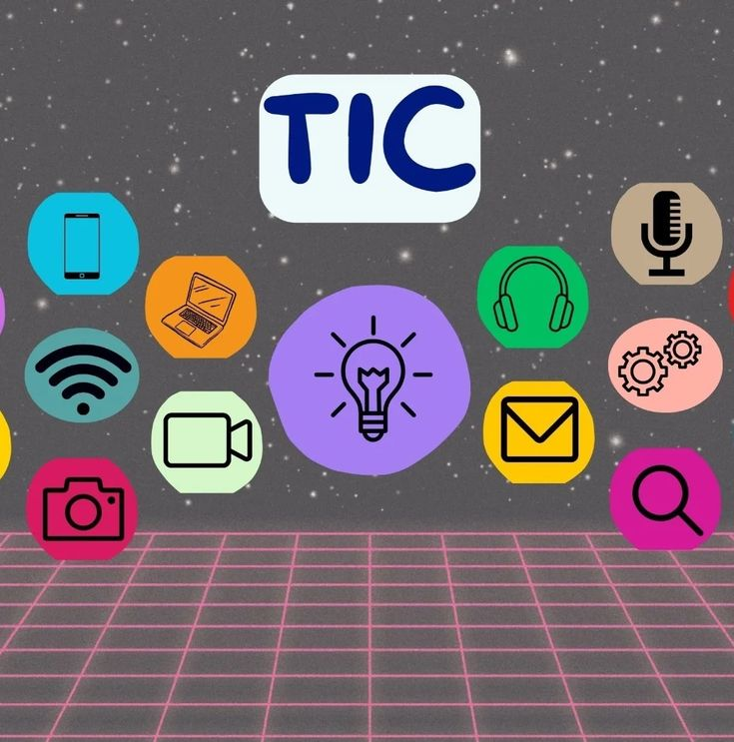
Information and communication include all digital technologies based on computers, networks and telecommunication. These technologies allow information to be handled in diffrent forms such as text,images,audio and video.
Exemples of ICT :
- computers andsmartphones
- internet and networks
- software and applications
- online services

Components of ICT
ICT is based on serveral key components :

Hardware
- Computers
- Servers
- Smartphones
- Tablets

Software
- operating systems
- office software
- web applications

Networks and communication
- internet
- local Area Networks(LAN)
- Wireless Networks(Wi-Fi)

ICT tools ans Services

Google Services
- Google Drive : online storage
- Google Docs : collaborative document creation
- Google meet :Vedio conferencing
- Gmail : electronic mail
These services support collaboration and remote access to documents

Microsoft tools
- Microsoft word : word precessing
- Microsoft Excel : spreadsheets
- Microsoft PowerPoint : presentations
- Microsoft Teams : communication andteam work
These toolsarewidely used in education andbusiness environments.

Git and GitHub
- Git isa version control system
- GitHub is a platform for sharing ana managing projects collaboratively.
They are mainly used in software development.

Applications of ICT

In education
  - E-learning )platforms
  - Online courses
  - Digital resources

In Business
- Data management
- Internal communication
- Collaborativework

In Healthcare
- Electronic medical records
- Telemedcine

Advantages and Disadvantages of ICT
ICT | Advantages | Disadventages
ICT | Fast access to information | Internet dependcy
ICT | Efficient communication | Security issues
ICT | Time saving | Cybercrime risks
ICT | Collaboratoire work | Social isolation

Impact of ICT on society
ICT has transformed communication, education and work methods. It promotes globalization and innovation, but it also requires responsible and secure use.

Conclusion
Information and Communication Technology has greatly transformed the way people communicate, access information, and perform daily tasks. It has improved efficiency in many sectors such as education, business, and healthcare, making services faster and more accessible. As technology continues to evolve, ICT will remain a key driver of innovation and development, helping societies adapt to new challenges and create better opportunities for the future.


