Task 3: Code build

1. create a build project

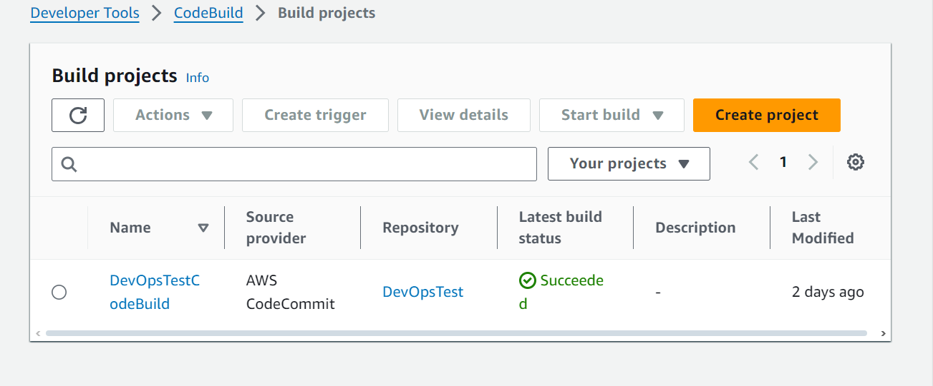

2. configure project settings

This video link offer full guide :

<https://www.youtube.com/watch?v=qGgNyOkZEb0&t=459s>

[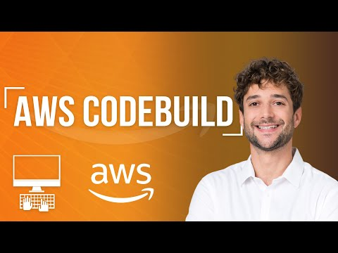](https://www.youtube.com/watch?v=qGgNyOkZEb0&t=459s)

3. create buildspec.yml file

The buildspec.yml file plays a pivotal role in automating and managing the build process within AWS CodeBuild.

It outlines the specific commands and settings necessary to compile and package the application, ensuring consistency and repeatability across builds.

The file is divided into distinct phases:

* **install**, where dependencies are installed;
* **pre_build**, which includes preparatory steps like logging into Amazon ECR;
* **build**, where the core build activities such as Docker image creation and tagging occur;
* **post_build**, which involves final steps like pushing the Docker image to the repository.

/<project-root>

│

├── buildspec.yml

├── requirements.txt

├── Dockerfile

├── .git/

├── .env

├── src/

│ ├── __init__.py

│ ├── app/

│ │ ├── __init__.py

│ │ ├── views.py

│ │ ├── models.py

│ │ └── ...

│ └── manage.py

4. update permission policies :

Navigate to Service Role

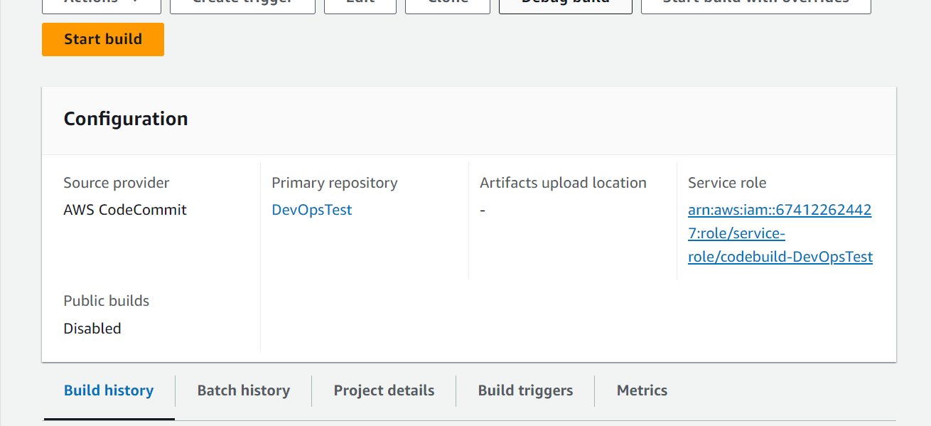

Create inline policy :

Select ECR service and specify action on authorizationToken

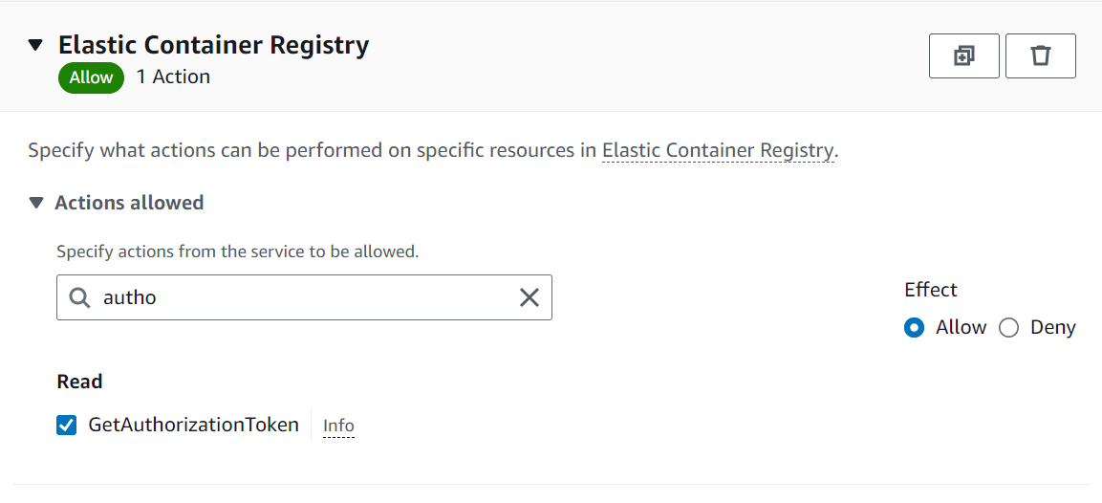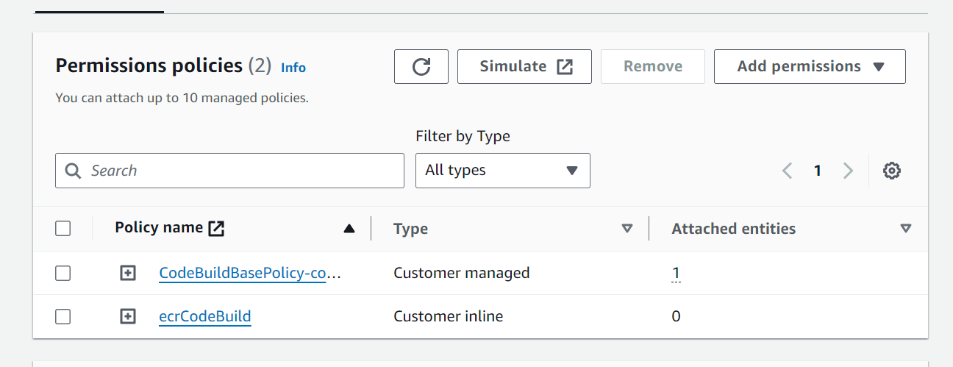

5. create repository in ECR (Elastic Container Registry )

6. update buildspec.yml file to push the docker image in the repository created

