Code Deploy :

1. Navigate to Code Deploy ->Applications

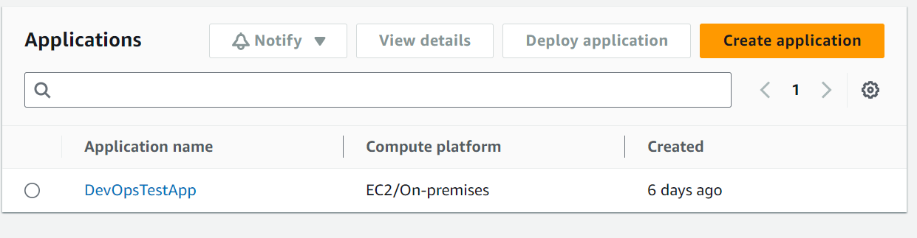

1. Create application
2. Application configuration :

In our example, I chose EC2 as the compute platform.

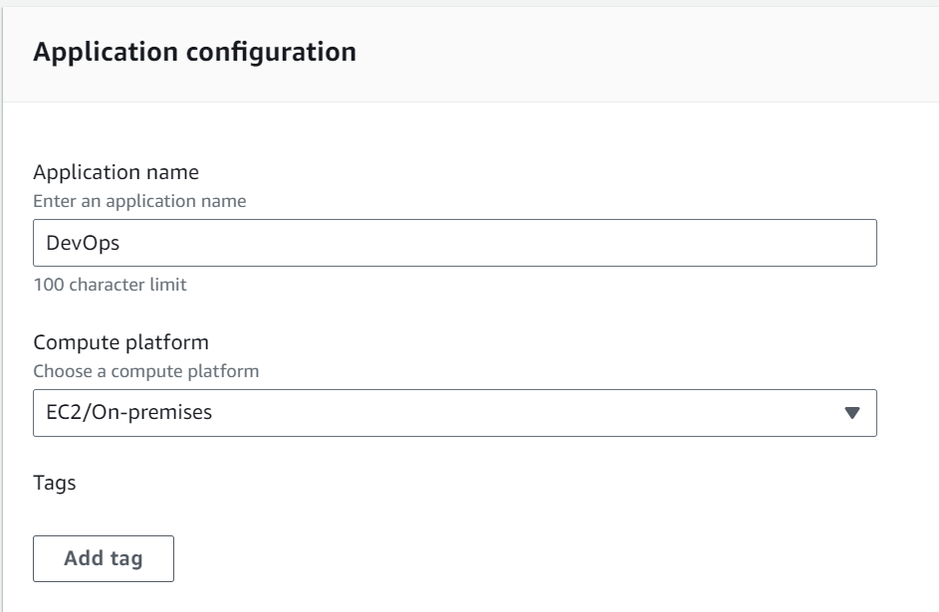

1. Create a Deployement Group

We need to create a service role that gives grants to AWS CodeDeploy to access the targeted instance

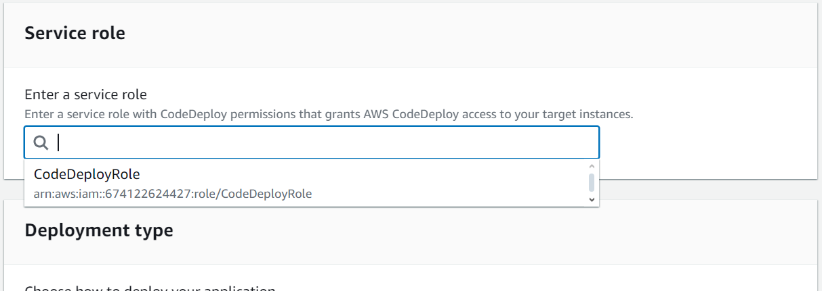

1. Add a Serivce Role

To add a service role navigate to IAM->Roles->create Role

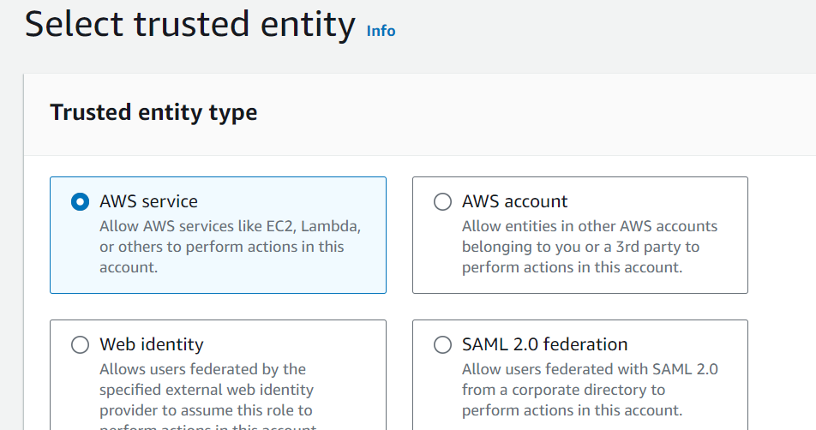

And naviagte to Roles to Verify if the service role was added successfully

6-create appspec.yml file to configuration

